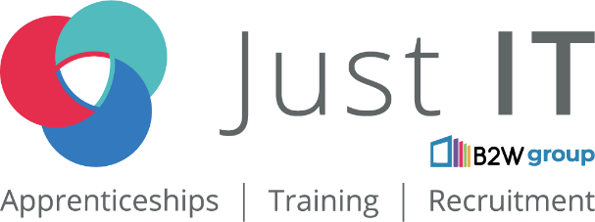

**Data Technician**

|  |
| --- |
|  |

|  |
| --- |
| Name: Arti Rathod |
| Course Date: 24/03/2025 |
|  |

**Table of contents**

Day 1: Task 1 3

Day 1: Task 2 3

Day 1: Task 3 4

Day 2: Task 1 5

Day 3: Task 1 9

Day 3: Task 2 10

Day 3: Task 3 11

Day 4: Task 1 12

Day 4: Task 2 13

1. Scenario Background 13

2. Data Laws and Regulations 14

3. Azure Service Recommendations 14

4. Data Types and Data Modelling 14

5. Data Storage Formats and Structures in Azure 14

6. Additional Considerations 15

Submission Guidelines: 15

Course Notes 17

Additional Information 17

# Day 1: Task 1

Please research and complete the below questions relating to key concepts of cloud.

Be prepared to discuss the below in the group following this task.

|  |  |
| --- | --- |
| What can cloud computing do for us in the real-world? | In simple Cloud Computing refers to the on-demand availability of IT resources over internet |
| How can it benefit a business? | Cloud computing benefits a business in several way:  Cost-effectiveness: Maximize ROI by reducing physical IT footprint and eliminating data centre management.  Scalability: Adapt to market needs efficiently.  Security: Robust framework for safeguarding business data.  Collaboration and accessibility: Work from anywhere.  Business continuity: Ensuring operational resilience. |
| What’s the alternative to cloud computing? | 1. Fog Computing Fog computing (also known as fogging) is decentralized infrastructure that performs a portion of computing somewhere between the data source and the origin server (or the cloud). Here's how a fog-based environment processes data: ...  2. Edge Computing  3. Mesh Computing  4. Bare Metal Cloud (BMC)  5. On-Prem Hosting |
| What cloud providers can we use, what are their features and functions? | List of Top 10 Cloud Platform Service Providers in 2025  Certainly!  Table of Content  List of Top 10 Cloud Platform Service Providers in 2025  1. Amazon Web Services (AWS)  2. Microsoft Azure  3. Kamatera  4. Alibaba Cloud  5. Oracle Cloud  6. IBM Cloud (Kyndryl)  7. Tencent Cloud  8. OVHcloud  9. DigitalOcean  10. Linode (owned by Akamai)  1. Amazon Web Services (AWS)  Launched in 2006, AWS is the best cloud service provider leading in the market. It becomes a major player in AI, database, machine learning, 5G cloud, multi-cloud and serverless deployments. AWS operates in 20 geographical regions across the world. The company reported a revenue of 9 billion dollars in Q3 2019.  AWS offers 175 fully-featured services to meet any kind of business requirements. These services are database storage, computing power, networking and many more  You can virtually host any applications, including networks like firewall, DNS, Load balancing, or even you can have your virtual private cloud.  AWS applications are scalable, flexible, reliable, secure and trustworthy.  Easy sign-up and fast deployment. The best thing is there is no upfront cost and you pay for what you use. It also offers a FREE tier for some of their popular services.  Top Companies using Amazon Web Services (AWS)  Netflix  Spotify  Airbnb  Uber  Peloton  Expedia  Pinterest  Samsung  Sony  Novartis  2. Microsoft Azure  Microsoft Azure was launched in 2010 as Windows Azure, and later in 2014, it was renamed, Microsoft Azure. It was launched years after the release of AWS and Google cloud but still, it is the fastest-growing cloud and giving tough competition to AWS and other cloud service providers. There is a five-year partnership between Microsoft and Disney. In this partnership, the new method will be developed to move production content to the cloud. Azure has 54 data centers regions across the world available in 140 countries.  Azure offers hundreds of services including AI + Machine Learning, Analytics, Blockchain, Compute, Containers, Databases, Developer Tools, DevOps, Identity, Integration, Internet of Things, Management, Media, Microsoft Azure Stack, Migration, Mixed Reality, Mobile, Networking, Security, Storage, Web, and Windows Virtual Desktop.  Microsoft Azure is available with public or private cloud service or hybrid cloud service consists of both private and public.  Scalability, consistency, security, flexibility, and cost-effectiveness.  Azure supports various operating systems, databases, tools, programming languages and frameworks.  It’s easier for users to move their application or framework without any hassle and recoding them again.  24/7 cooperative team paying attention to their customers. A free trial version of Microsoft Azure is available for 30 days.  Top Companies using Microsoft Azure  Walmart  Macy’s  The Home Depot  Starbucks  Coca-Cola  Bank of America  JPMorgan Chase  Citigroup  Fidelity Investments |

# Day 1: Task 2

Please research the below cloud offerings, explain what they are and examples of use cases.

|  |  |  |
| --- | --- | --- |
| Cloud Offerings | Explain what it is | When / how might you use this service in the real-world? |
| IaaS (Infrastructure as a service) | **Infrastructure as a Service (IaaS)** is a cloud computing service model that provides essential IT infrastructure components such as compute, storage, and networking resources on a pay-as-you-go basis over the internet. This model allows businesses to rent virtualized hardware resources instead of investing in and maintaining physical servers and data centers. | IaaS infrastructure is used in real-life scenarios where flexibility, scalability, and cost-effectiveness are essential. Here are some examples:   1. **Startups and Small Businesses**: A tech startup developing a new mobile app can use IaaS to host their app on virtual servers. Instead of buying physical hardware, they rent computing power, storage, and networking capabilities. This allows them to scale resources up or down as user demand grows or fluctuates. 2. **Disaster Recovery**: A mid-sized company can use IaaS for disaster recovery. Instead of maintaining duplicate physical servers at a backup location, they store data in the cloud. In case of a disaster (e.g., server failure or cyberattack), they can quickly restore their operations without significant downtime. 3. **E-Commerce Websites**: An online store experiencing seasonal traffic spikes—like during Black Friday or holiday sales—can use IaaS. They can scale their virtual infrastructure to handle higher traffic temporarily and then scale down afterward, saving on costs compared to a permanent infrastructure investment. 4. **Software Development and Testing**: A software company working on a new product can create virtual test environments using IaaS. Developers can configure multiple server setups for testing different scenarios, and once the project is complete, they can shut them down without any long-term commitments. 5. **Media and Entertainment**: A streaming service that delivers content to a global audience can use IaaS to handle server loads and deliver high-quality streaming. The infrastructure can be adjusted to handle peak viewing times without compromising performance. 6. **Scientific Research**: A research team conducting complex simulations, such as climate modeling or genome sequencing, can use IaaS to access powerful computing resources. They don’t need to buy expensive hardware, and they can use the resources only for the duration of their project. 7. **Event Management**: A company organizing a large-scale virtual event or conference can use IaaS to host the event platform. They can scale resources to accommodate thousands of participants and ensure smooth performance, even during peak usage. |
| PaaS (Platform as a service) | Platform as a Service (PaaS) is a cloud computing model that provides a comprehensive on-demand cloud platform, including hardware, software, and infrastructure, for developing, running, and managing applications. PaaS eliminates the cost, complexity, and inflexibility associated with building and maintaining an on-premises platform by hosting everything servers, networks, storage, operating system software, databases, and development tools at the provider's data center. | Here are some real-life examples:   1. **Building Mobile or Web Applications**: Developers use PaaS platforms like Google App Engine or Microsoft Azure App Services to build, test, and deploy apps. For example, a startup creating a ride-sharing app can use PaaS to simplify the process while scaling resources as needed. 2. **E-commerce Platforms**: Small businesses can use PaaS to launch online stores. Shopify, for instance, provides tools for creating, customizing, and hosting e-commerce sites without needing technical expertise. 3. **Collaborative Development Projects**: Teams working on software can share tools, libraries, and workflows on PaaS platforms, enabling efficient collaboration. For example, a company creating an internal CRM system might use Salesforce’s PaaS features. 4. **AI and Machine Learning**: Researchers or businesses integrate AI features into their applications using PaaS services like Google AI Platform or Azure Machine Learning. For example, adding predictive analytics to a sales application. 5. **IoT Application Development**: A company developing an Internet of Things (IoT) solution (like smart home devices) can use PaaS to create and manage the application. They can easily analyze data from IoT devices without handling complex infrastructure. 6. **Gaming Industry**: Game developers use PaaS for multiplayer game hosting and analytics. For example, a gaming company might rely on AWS GameLift or similar services for scalability and real-time performance.   PaaS is a powerful choice when your focus is on innovation and software development rather than infrastructure management |
| SaaS (Software as a service) | Software as a service (SaaS) is application software hosted on the cloud and used over an internet connection by way of a web browser, mobile app or thin client. | Software as a Service (SaaS) is commonly used when businesses or individuals need ready-to-use software without the hassle of installation, maintenance, or infrastructure management. Here are some real-life examples:   1. **Email Services**: Platforms like Gmail or Microsoft Outlook are SaaS solutions, providing email functionality without needing to manage servers. 2. **Collaboration Tools**: Businesses use SaaS tools like Microsoft Teams or Slack for communication and project collaboration. 3. **Customer Relationship Management (CRM)**: Sales teams use SaaS platforms like Salesforce to manage leads, track sales, and analyze customer data. 4. **Accounting and Finance**: Small businesses utilize SaaS tools like QuickBooks Online for bookkeeping and financial tracking. 5. **Cloud Storage**: Services like Dropbox or Google Drive allow users to store, access, and share files globally. 6. **Streaming Platforms**: Entertainment services like Netflix and Spotify are SaaS models providing content on demand. 7. **E-Learning Platforms**: Educational institutions use SaaS solutions like Coursera or Moodle for hosting online courses.   SaaS is ideal for tasks where convenience, ease of access, and affordability are important—just sign up, log in, and start using |

# Day 1: Task 3

Please research the below terms and explain what they are, when they would be appropriate and a real-world example of where it could be implemented (i.e. what type of organisation).

|  |  |
| --- | --- |
| Public Cloud | **Public cloud services** are a type of cloud computing where resources such as storage, computing power, and applications are provided by third-party providers over the internet. These resources are shared among multiple users and organizations, allowing for cost-effective and scalable solutions.  Real World Example:  A [public cloud](https://www.ibm.com/topics/public-cloud) is a type of [cloud computing](https://www.ibm.com/topics/cloud-computing) in which a third-party service provider (e.g., Amazon Web Services (AWS), Google Cloud Platform, IBM Cloud or Microsoft Azure) makes computing resources (e.g., ready-to-use software applications, [virtual machines (VMs)](https://www.ibm.com/topics/virtual-machines), enterprise-grade infrastructures and development platforms) available to users over the public internet on a pay-per-usage basis. Moreover, a public cloud model enables companies to automatically scale compute and storage resources up or down (along with data security measures and services) to meet their individual needs. |
| Private Cloud | A **private cloud** is a cloud computing environment dedicated exclusively to a single organization. It offers enhanced security, control, and customization compared to public clouds.  Real World Example:  **Healthcare**: Hospitals and healthcare providers use on-premises private clouds to store patient records and comply with HIPAA regulations, ensuring that sensitive data is stored securely and access is controlled. |
| Hybrid Cloud | A **Hybrid Cloud** is a computing environment that combines public cloud, private cloud, and on-premises infrastructure to create a single, flexible, and cost-effective IT infrastructure. This approach allows organizations to leverage the benefits of different cloud environments while maintaining control over sensitive data and applications  Here are some real-life examples:   1. **Netflix**: While Netflix primarily uses public cloud services like AWS for streaming, it employs a hybrid approach by integrating private cloud infrastructure for content delivery through its own Content Delivery Network (CDN), Open Connect. 2. **Healthcare**: Hospitals use hybrid cloud systems to store sensitive patient data securely on private clouds while leveraging public clouds for non-sensitive tasks like appointment scheduling or analytics. 3. **Retail**: Large retailers use hybrid clouds to manage inventory and customer data on private clouds while using public clouds for handling seasonal traffic spikes during sales events. 4. **Financial Services**: Banks use hybrid clouds to process transactions securely on private clouds while using public clouds for customer-facing applications like mobile banking. 5. **Education**: Universities use hybrid clouds to store research data on private clouds while providing students and faculty access to learning resources via public clouds.   Hybrid cloud solutions are ideal for organizations needing a balance between control, cost-efficiency, and scalability. |
| Community Cloud | A **community cloud** is a cloud infrastructure in which multiple organizations share resources and services based on common requirements.  Here are some real-life examples:   1. **Healthcare Sector**: Hospitals and clinics within a region can use a community cloud to share patient records securely while complying with data privacy regulations like HIPAA. 2. **Government Agencies:** Different departments within a government can share resources and data on a community cloud to improve collaboration and efficiency while maintaining strict security protocols. 3. **Educational Institutions:** Universities and research organizations can use a community cloud to share research data, collaborate on projects, and provide access to shared learning resources. 4. **Financial Institutions:** Banks and credit unions can use a community cloud to share fraud detection systems or compliance tools while maintaining data security. 5. **Non-Profit Organizations:** A group of non-profits working on similar causes can use a community cloud to share resources, tools, and data for better coordination and impact.   Community clouds are ideal for organizations with common interests that need a secure, collaborative environment. |

# Day 2: Task 1

Describe, with examples, the **three** major areas that the Computer Misuse Act deals with.

|  |  |  |
| --- | --- | --- |
| Area | Description | Example |
|  |  |  |
|  |  |  |
|  |  |  |

The computer misuse act 1990 is an act where an individual can be criminalised because of computer related offense. Describe three extra powers that the Police and Justice Act 2006 (Computer Misuse) has added.

|  |
| --- |
| Description |
|  |
|  |
|  |

Look at the below website to answer the questions:

<https://www.gov.uk/personal-data-my-employer-can-keep-about-me>

|  |
| --- |
| Write down three items of data which a company can store about an employee. |
|  |
|  |
|  |

|  |
| --- |
| Give three more examples of data that an employer can only store if they first get the employee’s permission. |
|  |
|  |
|  |

Conduct further research to answer the below questions.

|  |  |
| --- | --- |
| Question | Answer |
| Provide one example of: Copyright infringement |  |
| Provide one example of: Plagiarism |  |
| What are two consequences of copyright infringement and software piracy? |  |
| Give three possible consequences for individuals when using pirated software |  |

Listed below are some laws which we have covered today:

1. Computer Misuse Act 1990

2. Police and Justice Act 2006 (Computer Misuse)

3. Copyright, Designs and Patents Act 1988

4. Copyright (Computer Programs) Regulations 1992

5. The Health and Safety (Display Screen Equipment) Regulations 1992

6. Data Protection Act 2018

7. Consumer Rights Act 2015

* Insert a number in the first column of each row to match each of the statements with one of the above Acts.
* One of statements is incorrect and not illegal. For this statement, write ‘Not illegal’.

|  |  |
| --- | --- |
| **Act number** | **Clause** |
|  | With some exceptions, it is illegal to use unlicensed software |
|  | Any product, digital or otherwise, must be fit for the purpose it is supplied for |
|  | Unauthorised modification of computer material is illegal |
|  | It is illegal to create or use a hacking tool for penetration testing |
|  | Personal data may only be used for specified, explicit purposes |
|  | Employers must provide their computer users with adequate health and safety training for any workstation they work at |
|  | It is illegal to distribute hacking tools for criminal purposes |
|  | It is illegal to distribute an illicit recording |
|  | Personal data may not be kept longer than necessary |
|  | Gaining unauthorised access to a computer system is illegal |
|  | Employers must ensure that employees take regular and adequate breaks from looking at their screens |
|  | It is illegal to prevent or hinder access (e.g. by a denial-of-service attack) to any program or data held in any computer |
|  | Personal data must be accurate and where necessary kept up to date |

# Day 3: Task 1

Please complete the below lab (3) *‘Explore relational data in Azure’* and paste evidence of the completed lab in the box provided.

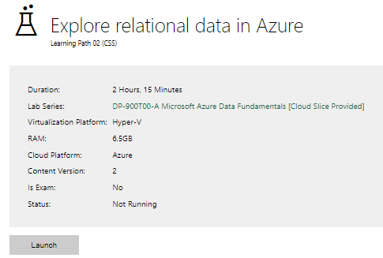

|  |  |
| --- | --- |
| Completed lab |  |

# Day 3: Task 2

Please complete the below lab (4) *‘Explore non-relational data in Azure’* and paste evidence of the completed lab in the box provided.

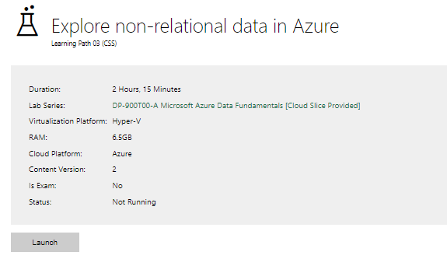

|  |  |
| --- | --- |
| Completed lab |  |

# Day 3: Task 3

Please complete the below lab (5) ‘Explore data analytics in Azure’ and paste evidence of the completed lab in the box provided.

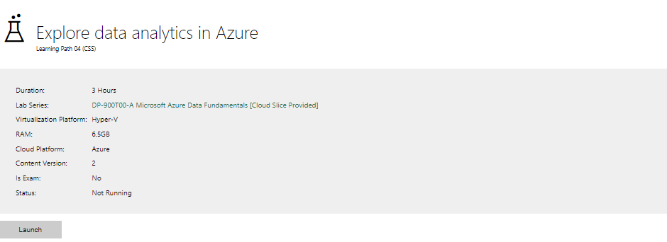

|  |  |
| --- | --- |
| Completed lab |  |

# Day 4: Task 1

In your teams, complete the Azure DP-900 practice exam and paste your result below – this is open book and please research and discuss your answers as a team.

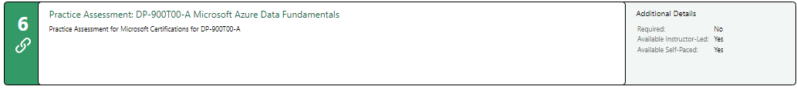

|  |  |
| --- | --- |
| Result |  |

# Day 4: Task 2

#### **1. Scenario Background**

"Paws & Whiskers" is a growing pet shop that aims to improve its business by analysing sales, customer information, and inventory data. Currently, the data is collected manually or stored in spreadsheets. Management is interested in transitioning to Microsoft Azure to streamline data storage, analysis, and reporting, enabling them to make data-driven decisions.

#### **2. Data Laws and Regulations**

Identify and explain the data laws and regulations relevant to handling customer data within the proposal. Ensure you cover the following points:

* **GDPR Compliance**: Highlight the importance of adhering to the General Data Protection Regulation (GDPR), particularly as it relates to storing and processing customer information.
* **Data Protection Act (DPA) 2018**: Outline how the DPA 2018 may affect the way "Paws & Whiskers" collects and stores data, ensuring compliance with UK laws on data privacy.
* **Other Industry Standards**: Research any additional data protection standards or regulations that may apply to pet shop data, particularly if they involve sensitive or payment information.

#### **3. Azure Service Recommendations**

Recommend Microsoft Azure services that would suit the company’s data analysis needs and explain why these services are suitable. Your recommendations should include:

* **Data Storage**: Identify suitable storage options, such as **Azure Blob Storage** or **Azure SQL Database**, and discuss the benefits of each for storing large datasets, including inventory, sales transactions, and customer details.
* **Data Analysis Tools**: Recommend tools such as **Azure Machine Learning** for customer behaviour analysis or **Azure Synapse Analytics** for analysing sales trends.
* **Data Integration and Automation**: Explain how services like **Azure Data Factory** could automate data collection and integration processes, improving efficiency.

#### **4. Data Types and Data Modelling**

Define the types of data "Paws & Whiskers" will need to work with and describe your approach to data modelling:

* **Data Categories**: Identify key data types, such as customer demographics, transaction history, pet inventory, and product categories.
* **Data Modelling Approach**: Outline how you would structure this data using a relational model or a data warehouse approach, considering factors like tables, entities, relationships, and primary keys.

#### **5. Data Storage Formats and Structures in Azure**

Discuss how you would store data within Azure and the formats you would recommend:

* **Data Formats**: Specify recommended formats (e.g., CSV for raw data imports, JSON for structured data, Parquet for analytics) and explain why these formats are suitable for specific data types.
* **Data Security and Encryption**: Include recommendations for securing data using Azure’s built-in encryption features and access controls to ensure compliance with data privacy regulations.

#### **6. Additional Considerations**

Provide any other considerations that might enhance data handling and efficiency in Azure, such as:

* **Backup and Disaster Recovery**: Outline a backup plan using **Azure Backup** or **Azure Site Recovery** to safeguard against data loss.
* **Data Visualisation**: Discuss potential use of **Power BI** within Azure for creating dashboards that provide management with real-time insights into sales and customer trends.
* **Future Scalability**: Comment on how Azure services can scale as the business grows, accommodating larger datasets and more complex analyses.

### **Submission Guidelines:**

1. **Structure**: Ensure your report is well-organised, with sections for each task (e.g., Data Laws, Azure Services, Data Types, etc.).
2. **Formatting**: Include headings, bullet points where appropriate, and any visuals or diagrams that support your explanations.
3. **References**: Cite any resources or regulations referenced in the report.
4. **Length**: Aim for 1500-2000 words.

|  |
| --- |
|  |

|  |
| --- |
| **Course Notes** |

It is recommended to take notes from the course, use the space below to do so, or use the revision guide shared with the class:

|  |
| --- |
| **Additional Information** |

We have included a range of additional links to further resources and information that you may find useful, these can be found within your revision guide.

**END OF WORKBOOK**

**Please check through your work thoroughly before submitting and update the table of contents if required.**

**Please send your completed work booklet to your trainer.**