PizzaCabinInc.

Tec stack: Asp.net core, LiteDB.

Lite DB : <https://www.litedb.org/docs/getting-started/> , <https://www.litedb.org/docs/dbref/>

Run LiteDB.Studio.exe , to see the Tables in your database (select MyData.db )

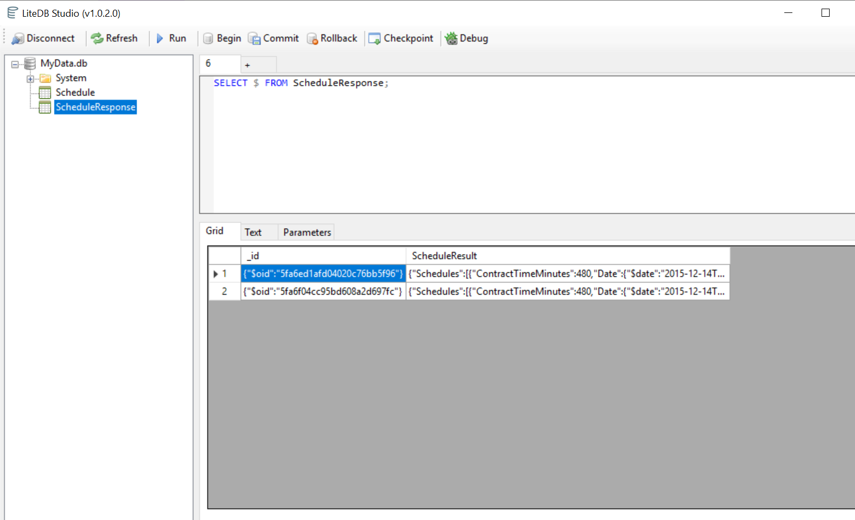

Implementation and Logic :

1. To get the data from the REST service (json output) that the WFM service exposes and store it into a database.
2. Transforms it into a query able database for other systems to access

Create an API with following controller.

WebApiClient :

[HttpGet]

GetPizzacabinicIncResult() : calls GetPizzacabinicIncJsonResult(from PizzaCabinInc.BusinessLogic) to get schedule data from external Rest service PizzacabinicInc

[HttpPost]

PostPizzacabinicIncJsonDataInDB : Inserts the schedule data into LiteDB “MyData.db”

1. The Test project needs more time to implement.
2. I have added Swagger to give the API:

Access url : <https://localhost:44301/swagger/index.html>

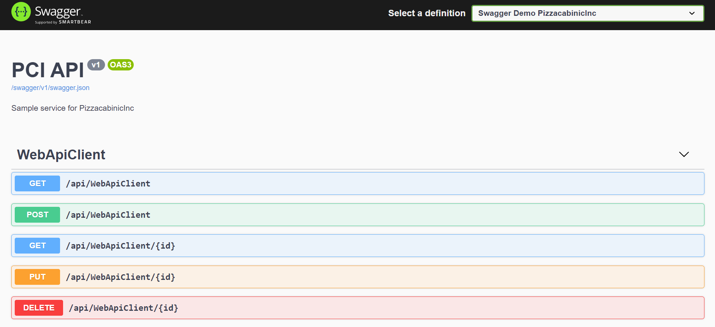

**Note**: SQL express was not working on my system and hence I used Lite DB to store json data. I would have preferred SQL as database to store the data and the following changes in my application to Implement the same.

1. Use Entity framework core, Repository pattern Implementation:

<https://docs.microsoft.com/en-us/aspnet/web-api/overview/data/using-web-api-with-entity-framework/part-5>

<https://www.codeproject.com/Articles/1174271/Entity-Framework-DAL-with-Generic-Seeding-from-JSO>

Future Implementation:

1. Implementation using SQL, Entity framework core.
2. Configure CI/CD AzureDevops pipeline, deployment on Azure Cloud.
3. Add more test cases in Unit test project