**Bugs List:**

1. Description: The spelling of the title of the window is incorrect.

Expected: Factorial

Actual: Factorial

Steps to navigate:

1. Please navigate to “<http://qainterview.pythonanywhere.com/>” to check the window title.

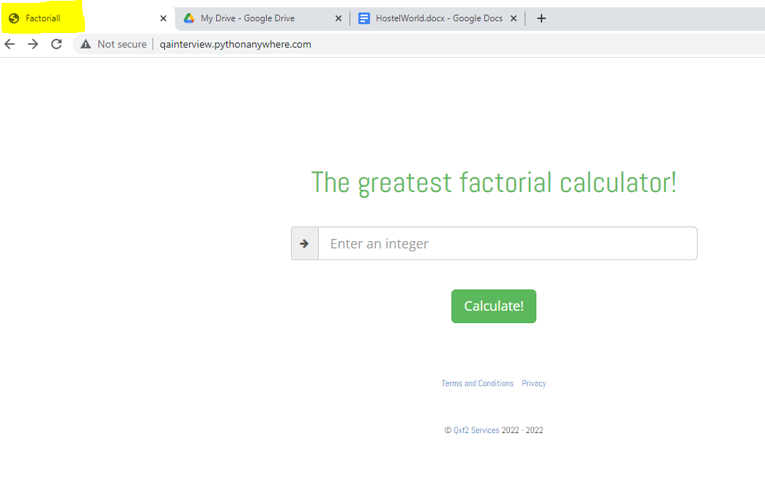

1. Description: Clicking on the terms and condition button is redirecting to a privacy document. The window content and URL is incorrect.

Expected: This is the terms and conditions document. We are not yet ready with it. Stay tuned!

Actual: This is the privacy document. We are not yet ready with it. Stay tuned!

Steps to navigate:

1. Please navigate to “<http://qainterview.pythonanywhere.com/>”.
2. Click on the Terms and Conditions link present on the bottom of the page.

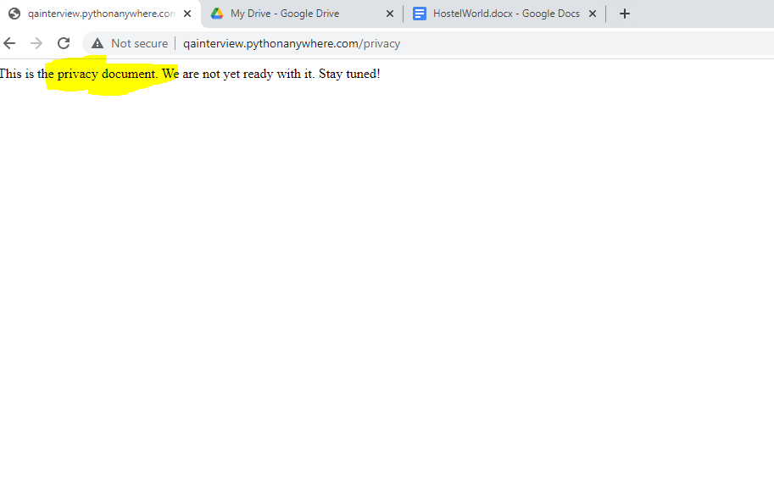

1. Description: Clicking on the privacy button link is redirecting to terms and conditions. The window content and URL is incorrect.

Expected Value: This is the privacy document. We are not yet ready with it. Stay tuned!

Actual Value: This is the terms and conditions document. We are not yet ready with it. Stay tuned!

Steps to navigate:

1. Please to “<http://qainterview.pythonanywhere.com/>”.
2. Click on Privacy link present on the bottom of the page.

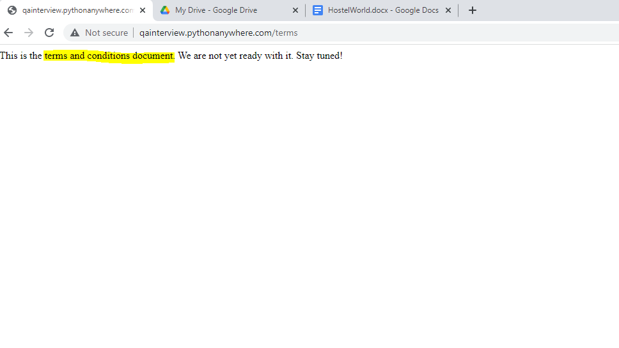

1. Description: The window title for terms and condition window is incorrect.

Expected Value: Terms and Condition

Actual Value: null

Steps to navigate:

1. Please navigate to “<http://qainterview.pythonanywhere.com/>”.
2. Click on Terms and Conditions link present on the bottom of the page.
3. Check the window Title on the new window.

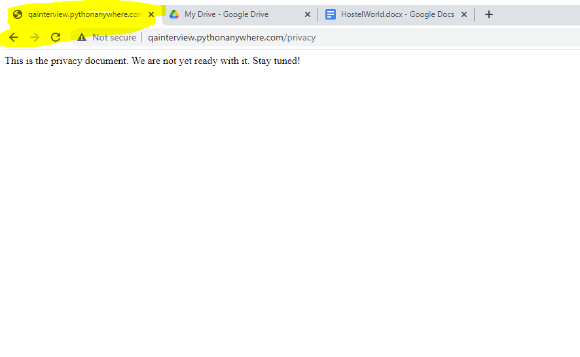

1. The window title for the privacy document is incorrect.

Expected Value: Privacy

Actual Value: null

Steps to navigate:

1. Please navigate to “<http://qainterview.pythonanywhere.com/>”.
2. Click on the Privacy link present on the bottom of the page.
3. Check the window Title on the new window.

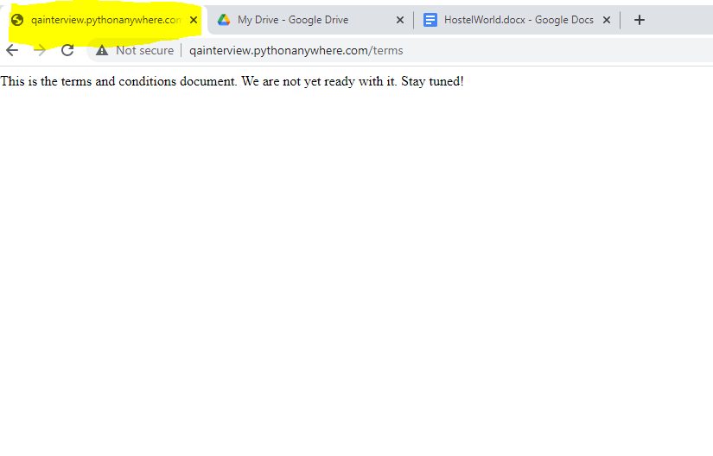

1. Description: In the input box if negative values are given as input and then the calculate button is clicked then there is no result coming on UI.

Expected Value: The Factorial should be calculated and result is provided

Actual Value: No result is coming

Steps to navigate:

1. Please navigate to “<http://qainterview.pythonanywhere.com/>”.

2. Enter a negative value in the input box like “-3”.

3. Click the calculate button.

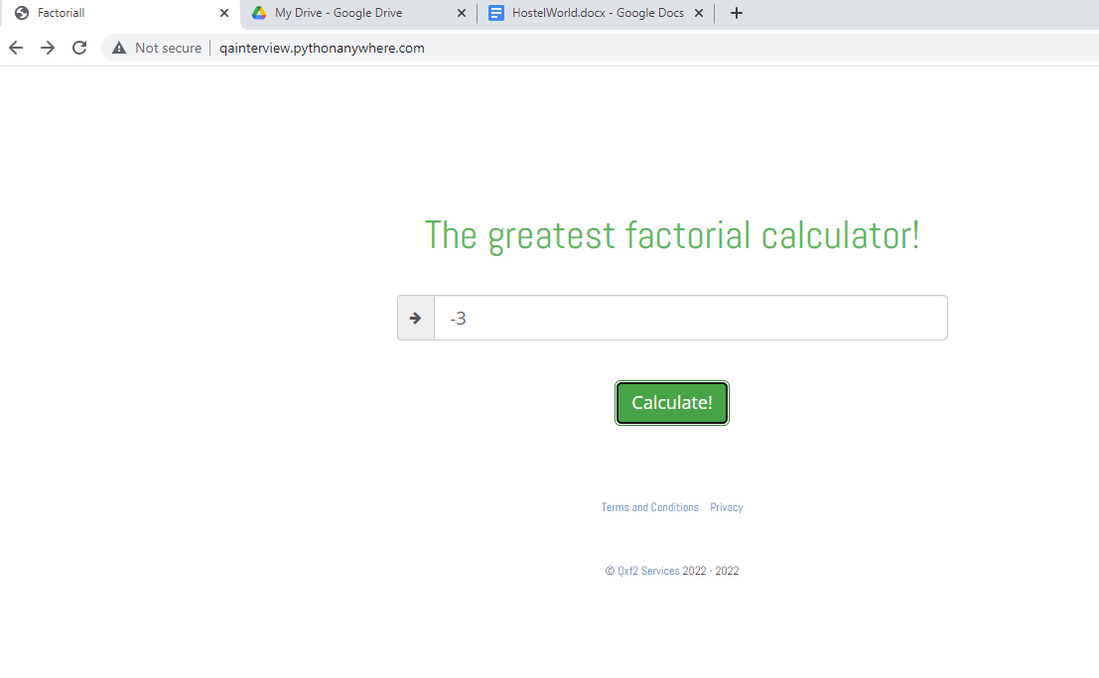

1. Description: There is no limit set for the number that can be entered in the input Box which is creating overflow in the backend.

Steps to navigate:

1. Please navigate to “<http://qainterview.pythonanywhere.com/>”.

2. Enter a negative value in the input box like “3333333333333333333333333333333333333333333333333”.

3. Click the calculate button.

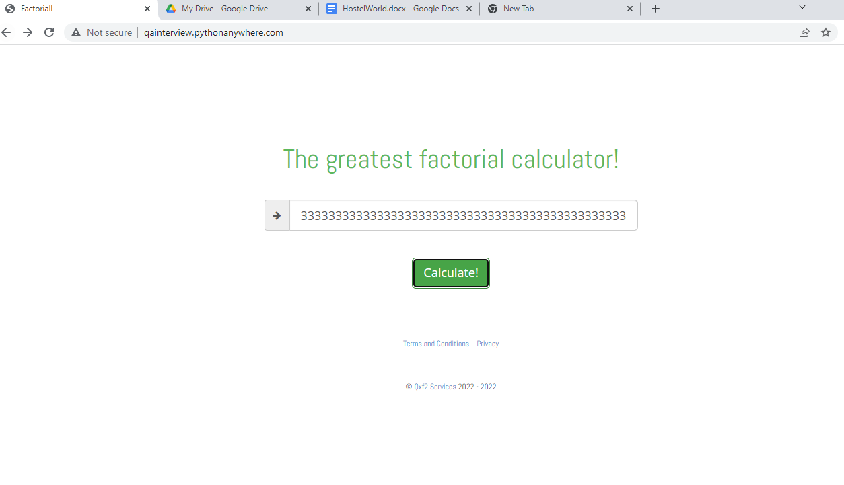

1. Description: The license period mentioned for copyright is incorrect.

Expected Value: 2013-2022

Actual Value: 2022-2022

Steps to navigate:

1. Please navigate to “”.
2. On the bottom of the page there is a license period information available.

