pipeline{

agent {

label{

label 'built-in'

customWorkspace '/mnt'

}

}

environment {

PATH = "/mnt/apache-maven-3.8.6/bin:$PATH"

}

stages{

stage('git-clone'){

steps{

sh "rm -rf game-of-life"

sh "git clone https://github.com/ArtiWavale/game-of-life.git"

}

}

stage('Build-game-of-life'){

steps{

dir('/mnt/game-of-life'){

sh "mvn install"

}

}

}

stage('deploy-WAR'){

steps{

dir('/mnt/apache-tomcat-9.0.65/bin'){

sh "cp -r /mnt/game-of-life/gameoflife-web/target/gameoflife.war /mnt/apache-tomcat-9.0.65/webapps"

sh "scp -i '/mnt/linux.pem' /mnt/game-of-life/gameoflife-web/target/gameoflife.war ec2-user@ec2-43-205-208-121.ap-south-1.compute.amazonaws.com:/home/ec2-user"

}

}

}

stage('install-sof-on-172.31.39.184'){

agent {

label{

label '172.31.39.184'

}

}

steps{

sh "sudo cp -r /home/ec2-user/gameoflife.war /mnt/apache-tomcat-9.0.65/webapps"

sh "sudo sh /mnt/apache-tomcat-9.0.65/bin/startup.sh"

}

}

}

}

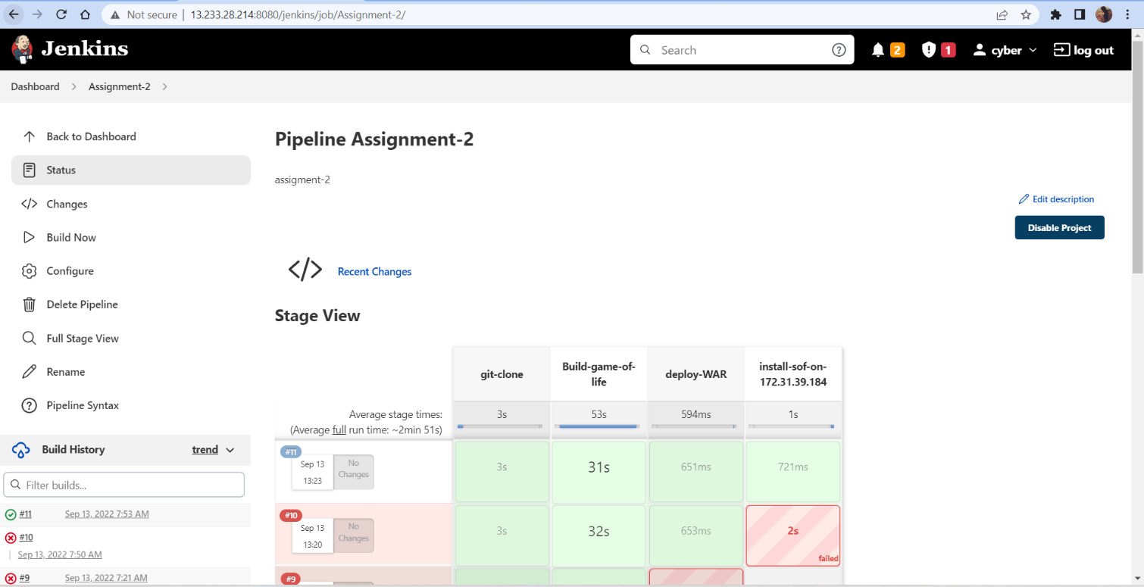

**Jenkins-server:**

**url:** [**http://13.233.28.214:8080/gameoflife/**](http://13.233.28.214:8080/gameoflife/)

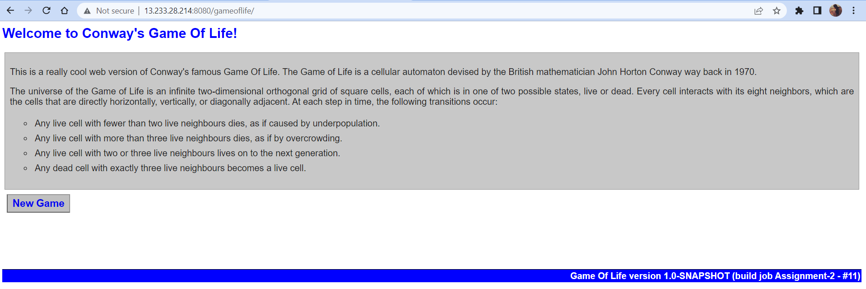

**slave-client:**

**url:** [**http://43.205.208.121:8080/gameoflife/**](http://43.205.208.121:8080/gameoflife/)

