NAME- ANWESH AJITABH DASH
REG NO- 22BME0651

- An AI technique and how it works:
K-Nearest Neighbors is a supervised machine learning algorithm used for classification and regression. It classifies a new data point based on the majority label of its K nearest points in the training dataset.

How it works:

Choose a value for K (number of neighbors).

Calculate the distance between the new data point and all training data points (usually Euclidean distance).

Pick the K closest points.

For classification: return the majority label among the K neighbors.
For regression: return the average of the K neighbors' values.

- CODE:
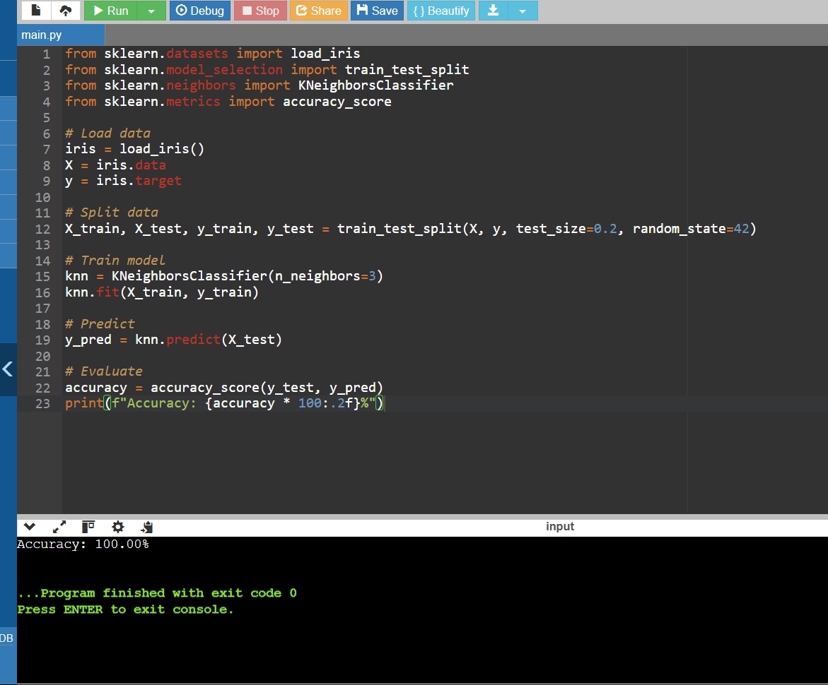

- Working:
The program classifies Iris flower species using the K-Nearest Neighbors (KNN) algorithm. Here's a step-by-step breakdown of what each part of the code does and how it contributes to the final result.

1. Importing Necessary Libraries
python
CopyEdit
from sklearn.datasets import load_iris
from sklearn.model_selection import train_test_split
from sklearn.neighbors import KNeighborsClassifier
from sklearn.metrics import accuracy_score
- load_iris: Loads the Iris dataset from scikit-learn’s built-in datasets.
- train_test_split: Randomly splits the dataset into training and testing sets.
- KNeighborsClassifier: The actual KNN model from scikit-learn.
- accuracy_score: Helps evaluate how well the model performs.

2. Loading the Dataset
python
CopyEdit
iris = load_iris()
X = iris.data
y = iris.target
- iris.data: A 2D array containing features (sepal length, sepal width, petal length, petal width).
- iris.target: The target variable containing numeric labels for the flower species (0, 1, 2).

3. Splitting the Dataset
python
CopyEdit
X_train, X_test, y_train, y_test = train_test_split(X, y, test_size=0.2, random_state=42)
- The dataset is split into 80% for training and 20% for testing.
- random_state=42 ensures the results are reproducible.
- This step is essential for preventing the model from overfitting.

4. Initializing and Training the KNN Model
python
CopyEdit
knn = KNeighborsClassifier(n_neighbors=3)
knn.fit(X_train, y_train)
- n_neighbors=3: This means the model will look at the 3 nearest neighbors to classify any new input.
- .fit(): The model is trained using the training data and learns to associate input features with target labels.

5. Making Predictions
python
CopyEdit
y_pred = knn.predict(X_test)
- The trained model is now tested on unseen test data.
- For each sample in X_test, the model calculates the distance to all training points, picks the 3 closest ones, and uses a majority vote to assign a label.

6. Evaluating the Model
python
CopyEdit
accuracy = accuracy_score(y_test, y_pred)
print(f"Accuracy: {accuracy * 100:.2f}%")
- Compares the predicted labels (y_pred) to the actual labels (y_test).
- Calculates the accuracy as the percentage of correctly predicted labels.
- Prints the result as a formatted percentage.

🧪 Example Output
bash
CopyEdit
Accuracy: 100.00%
Note: The accuracy might vary slightly depending on how the data is split, but KNN performs extremely well on the Iris dataset due to its clear class boundaries.

- IMPLEMENTATION:

Hardware Implementation Idea: Iris Flower Classifier
Application:
Build a simple, portable device that can classify iris flower species based on their features using the K-Nearest Neighbors (KNN) algorithm. This can be useful in agriculture, education, or research.
System Components:
- Input System
  - Option 1: Manual input using buttons or a keypad, where the user enters petal and sepal measurements.
  - Option 2: Use a small camera to take a picture of the flower, then extract measurements using image processing.
- Processing Unit
  - Use a microcontroller like Arduino, ESP32, or Raspberry Pi.
  - For basic input and KNN logic, Arduino or ESP32 is enough.
  - For image processing, use Raspberry Pi or another small computer that can run Python.
- Memory
  - Store the training data (flower measurements and species labels) in the device memory.
  - This data will be used to compare and classify new input.
- KNN Classification
  - When a new flower is measured or captured:
    - The device compares it to stored samples.
    - It calculates which stored samples are closest to the new one.
    - Based on the closest matches, it predicts the flower's species.
- Output Display
  - A small screen or a set of indicator lights can show the result.
  - For example, a display can show "Setosa", "Versicolor", or "Virginica".
Example Use:
A user in a field measures a flower's petal and sepal. They enter the values into the device. The device runs the KNN algorithm on this input and displays the predicted species. This helps identify flowers quickly without needing a computer or internet.

