Matt Price
Centre No.: 15162
Candidate Number: 5293
Component 7517/C

Introduction:
My project is to design a working AQA Assembly interpreter which will allow a user to write their own code into a file, which is then run, and the output of the program is outputted into the terminal.
Background:
I would recommend looking over the AQA Instruction Set (here), and ensuring you understand Python 3.
Research:
To research for this project, I have spoken with my fellow students to see what they would like in an assembly program. To aid with this, I created a form in which the others could outline their wishes. I received 9 responses, a notable desire being to have descriptive error messages and showing syntax errors.
I also looked at the AQA Assembly Language Simulator created by Peter Higginson, shown below. 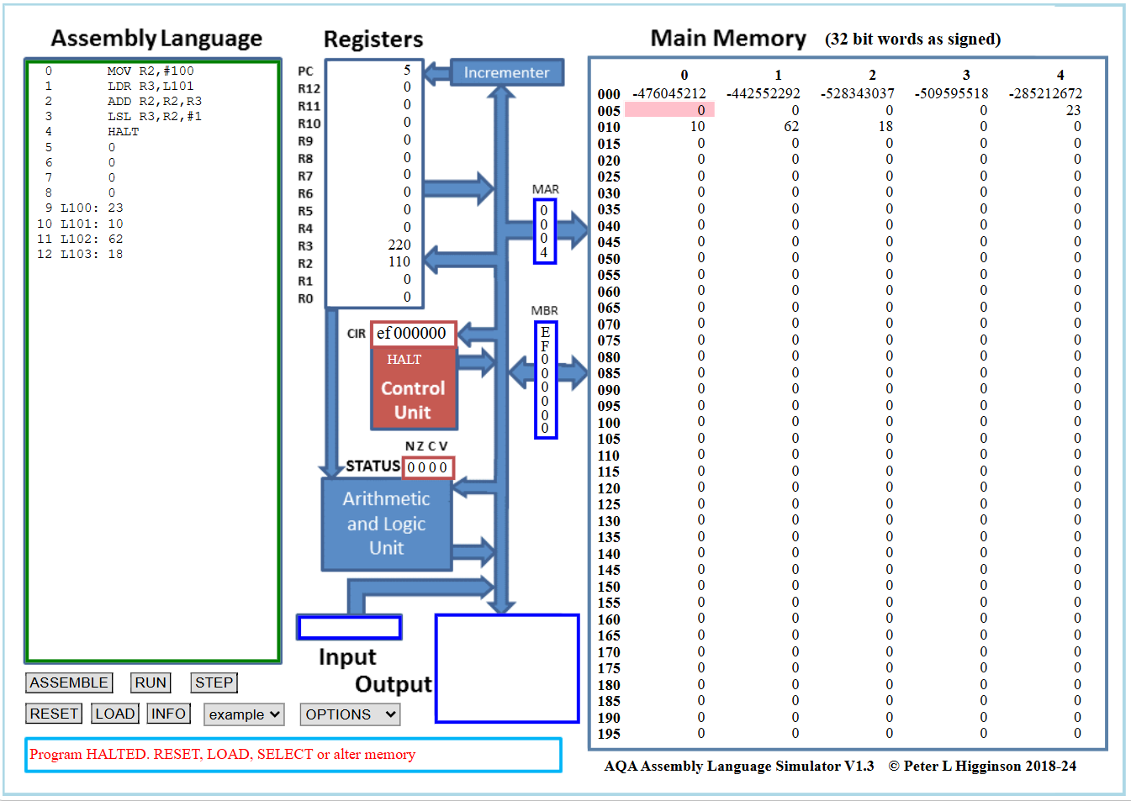
Looking at it, its error handling system is verbose, telling you which line is having the error, and letting you look at the memory directly. This gave me a good ideal to strive for, and inspired me to try to use a website to host the program and let users input their programs from there.
This created a technical challenge in my project - creating a server and having it available for an end user, and parsing their program, as I cannot ensure they write their code exactly how I would like them to. Through further research I found Flask, a python module which aids in the creation of a server. This would prove very useful, allowing me to make my server online.
User:
The form I sent to my fellow students was very insightful. After looking over each response I put their main points into a word cloud, helping me visualise what would be good to put into my program. 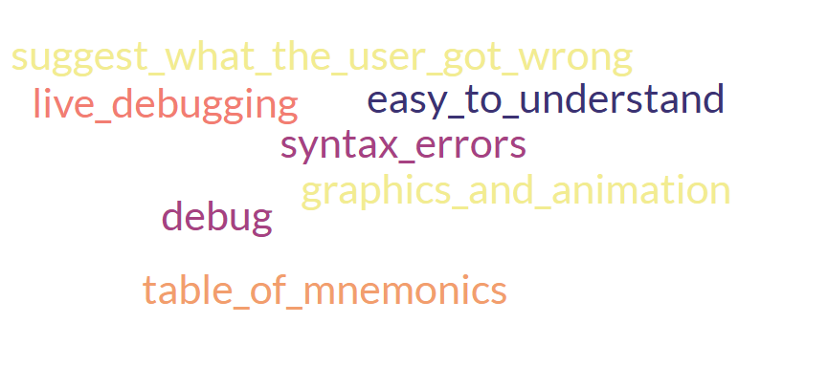
From this I made sure to make my errors clear and understandable.

