

Red Cherries Accounting (Open Source)

Accounts Manager

Admin User Guide

Version 1.0 Beta 1

Table of Contents
Introduction 3
Top Navigation Bar 4
Dashboard 5
Chart of Accounts 6
Prime Entry Books 8
Banks 10
System Configurations 11
General System Configurations 11
Bookkeeping Configurations 13
Reports Configurations 27

Introduction
This user guide aims at giving you the information required to work with “Administration Section” of “Accounts Manager”. This user guide can be downloaded from “Admin Help” screen shown in Figure 2 which is accessible from “Administration → Help” menu as shown in Figure 1.

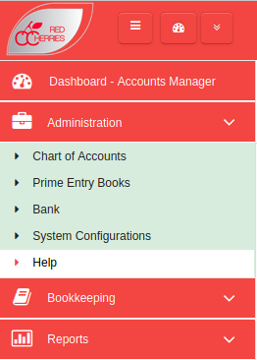

Figure 1

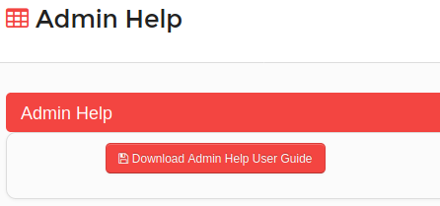

Figure 2

Top Navigation Bar

Toggle Left Menu
Open/Retract System Modules
Change Password
My Language
About System
Logout
System Dashboard
Default Module

Current Module
Figure 3

  - Toggle Left Menu : Show/hide left menu
  - Open/Retract System Modules : Open/retract system module dashboard. Previous screen preserves if user does not select any module.
  - System Dashboard : Opens the system modules dashboard. Previous screen does not preserved.
  - Current Module : Shows the current module that user has selected.
  - Default Module : Selecting current module as default module will allow to go directly to that module on login to the system.

Dashboard
When a user selects the “Accounts Manager” from System Modules Dashboard in Red Cherries Accounting, the user will see the Accounts Manager Dashboard on the screen. The Dashboard shows the statistical information of Accounts Management Activities and Quick Links to Accounts Manager screens. The user can see the Accounts Manager Dashboard as shown in Figure 4.

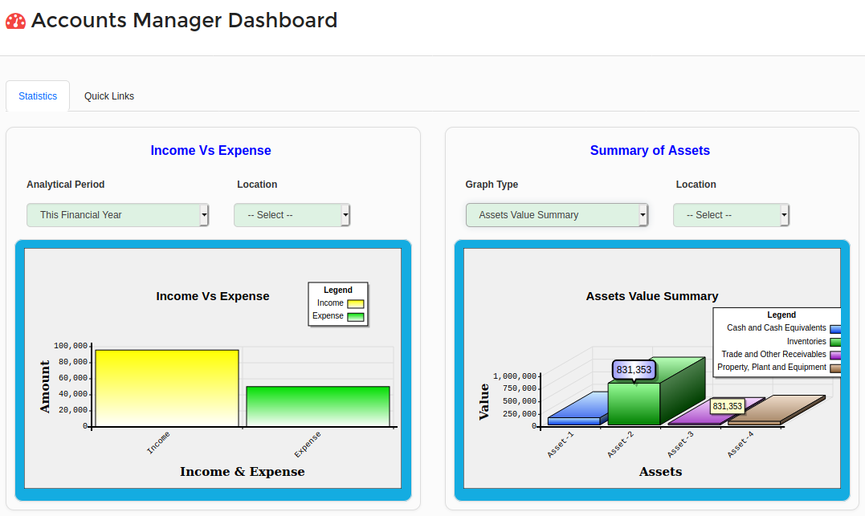
Figure 4

Chart of Accounts
A complete chart of account structure can be maintained in the system and the chart of account list can be accessed from “Administration → Chart of Accounts” menu.
- Chart of Account list is displayed in the system as shown in Figure 5.
- Users can see the complete chart of account list after installing the system.

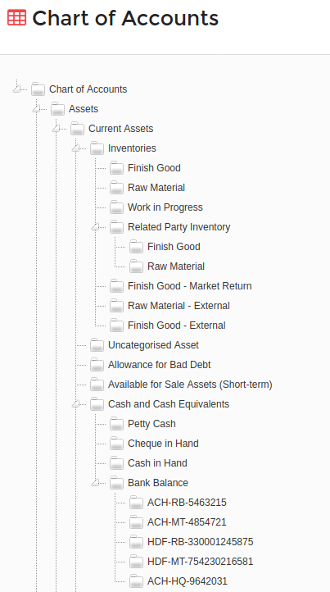

Figure 5

- Users can modify the chart of account structure by right clicking on a particular chart of account name as shown in Figure 6.
- When select “Add” or “Edit” menu, a pop up screen will be displayed on the screen as shown in Figure 7.
- It is possible to specify a chart of account code and a name for each chart of account.
- Users can easily drag and drop a particular chart of account to restructure the chart of account structure as required.
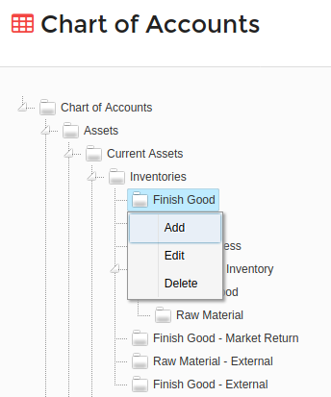

Figure 6

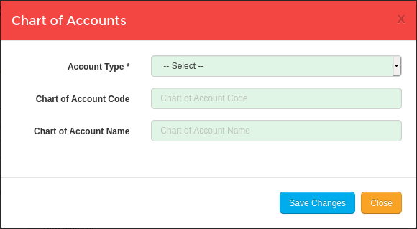

Figure 7

Prime Entry Books
All prime entry books required for accounts journal entry posting can be maintained in prime entry books screen as shown in Figure 8, which is accessible from “Administration → Prime Entry Books” menu.
- There are several default prime entry books added from system installation. When required, users can modify the default prime entry books according to the modifications do for chart of accounts structure.
- Additional prime entry books can be added by clicking on “Add New Prime Entry Book” shown in Figure 8.

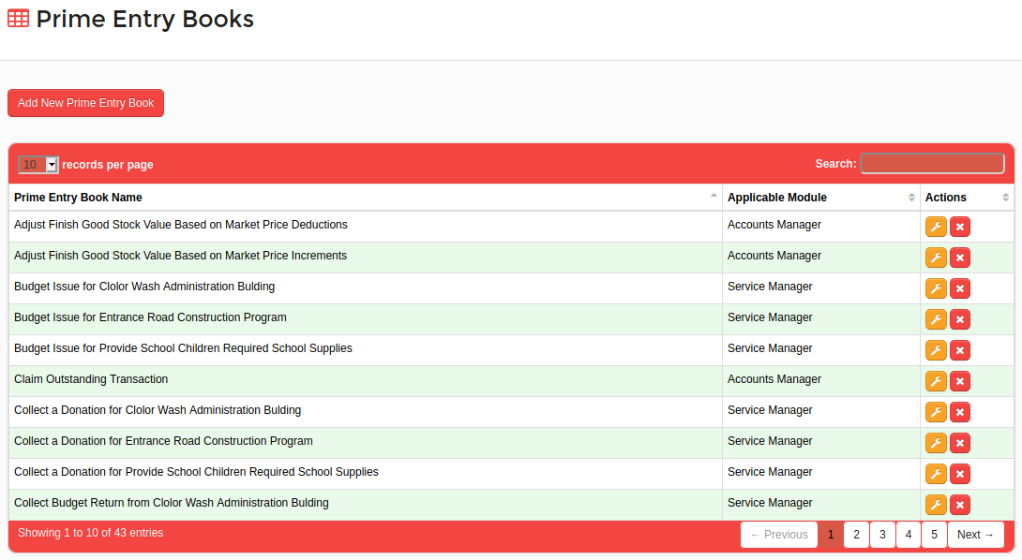
Figure 8

- A new prime entry book can be added on the screen shown in Figure 9.
- Users can specify a name for the prime entry book and a description.
- Users can specify whether for which system module they need to use the prime entry book by specifying the module in “Applicable Module” field.
- Also by selecting “Has reference transaction journal entry” check box, users can force to specify a reference journal entry, when posting a journal entry using the new prime entry book.
Ex : When adding a journal entry for an electricity bill payment, it is required to specify the journal entry for electricity bill.
- Further, the system allows users to select multiple debit or credit accounts for the new prime entry book. Multiple debit or credit accounts can be selected by clicking on “Add Another Debit Ledger Account” or “Add Another Credit Ledger Account” buttons as shown in Figure 9.

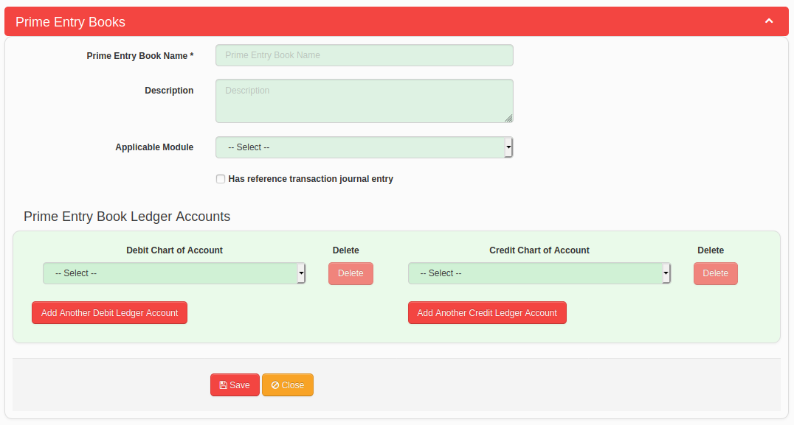
Figure 9

Banks
Banks can be added in the system from “Administration → Bank” menu.
- Bank list is displayed in the system as shown in Figure 10.
- Click on “Add New Bank” button shown in Figure 10 to add a new bank. A new form will be displayed on the screen to add the bank details as shown in Figure 11.
- Bank Name is a mandatory field when adding a bank.
- You can add more than one branch to the new bank. To do so, enter a branch name and click on “Add” button shown in Figure 11. Then proceed by adding another branch.

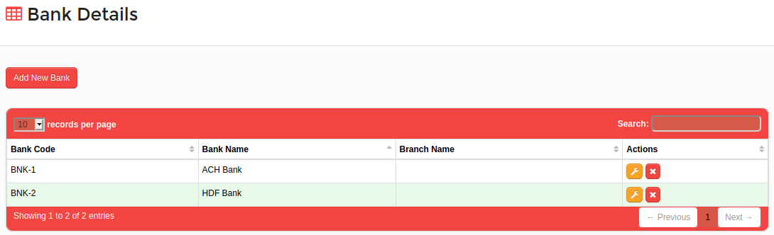
Figure 10

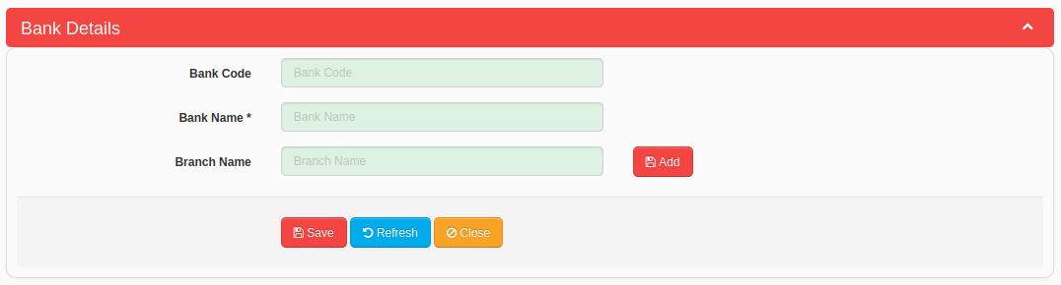
Figure 11

System Configurations
System allows users to control the system behavior via several system configurations. System configurations screen is shown in Figure 10, which is accessible from “Administration → System Configurations” menu. System configurations are categorized into their effective screens and reports as shown in Figure 10.

General System Configurations
System configurations which are common throughout the accounts manager module are categorized under “General” tab which is available under main “Administration” tab as shown in Figure 12.
- Users can specify accounting period starting and end dates into “Financial Year Start” and Financial Year End” fields.
- If users need to maintain accounts for each business locations separately, users should select the “Enable Accounts Management For Locations” check box.
- If any organization is expecting to maintain all sales related information in “Accounts Manager” module, should enable following options for that purpose. When the following options are enabled, the system will show relevant transaction screens in “Accounts Manager” module.
    - Enable Purchase Note
    - Enable Sales Note
    - Enable Customer Return Note
    - Enable Supplier Return Note
- When receive a payment, if it is a must to select a reference transaction for the payment, user should select the “Force To Select A Reference Transaction For Receive A Payment” check box.
- When make a payment, if it is a must to select a reference transaction for the payment, user should select the “Force To Select A Reference Transaction For Make A Payment” check box.

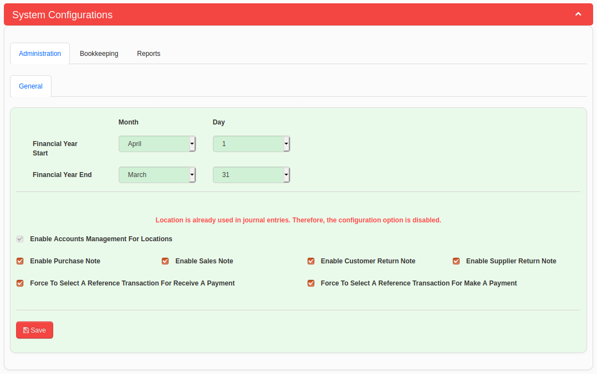
Figure 12

Bookkeeping Configurations
Bookkeeping section's configurations are grouped as follows as shown in Figure 13.
- Purchase Note
- Sales Note
- Customer Return Note
- Supplier Return Note
- Receive Payment
- Make Payment
- Cheque List
- Opening Balances

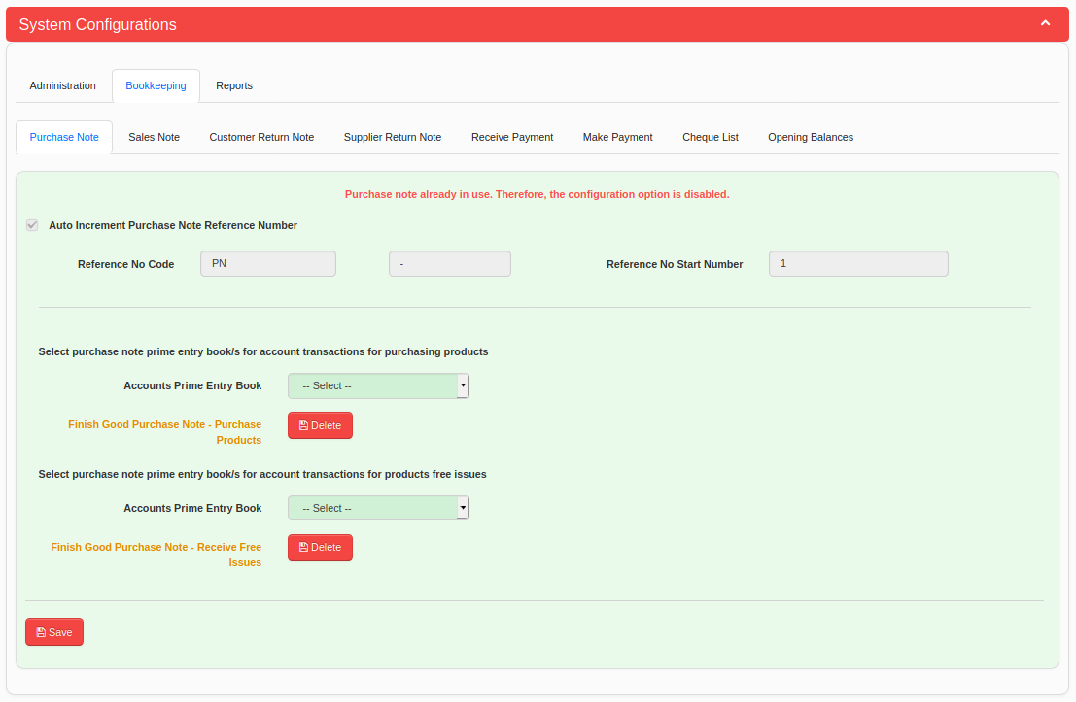
Figure 13

Purchase Note
In Purchase Note Configurations, you can specify the Purchase Note Reference Number auto increment details as shown in Figure 13.
- Select “Auto Increment Purchase Note Reference Number” check box and enter details to following fields.
    - Reference No Code
    - Reference No Separator
    - Reference No Start Number
- After start to using Purchase Note and add transactions, above configuration fields will be disabled for editing as shown in Figure 13 and shows the following message.
Purchase Note already in use. Therefore, the configuration option is disabled.
- Further, you can specify the Accounts Prime Entry Book to post journal entries when you add Purchase Note transactions. “Accounts Prime Entry Book” drop down has default Accounts Prime Entry Books defined in “Accounts Manager” Module. From the list you need to select “Finish Good Purchase Note - Purchase Products” and “Finish Good Purchase Note - Receive Free Issues” prime entry book as shown in Figure 13.

Please refer “Accounts Manager → Administration → Prime Entry Books” screen if you need more information about prime entry books.

Sales Note
In Sales Note Configurations, you can specify the Sales Note Reference Number auto increment details as shown in Figure 14.
- Select “Auto Increment Sales Note Reference Number” check box and enter details to following fields.
    - Reference No Code
    - Reference No Separator
    - Reference No Start Number
- After start to using Sales Note and add transactions, above configuration fields will be disabled for editing as shown in Figure 14 and shows the following message.
Sales Note already in use. Therefore, the configuration option is disabled.
- Specify “Sales Profit Margin (%)” so that the system can calculate the cost of sales when you add a sales note.
- Further, you can specify the Accounts Prime Entry Book to post journal entries when you add Sales Note transactions. “Accounts Prime Entry Book” drop down has default Accounts Prime Entry Books defined in “Accounts Manager” Module. From the list you need to select “Finish Good Sales Note – Sales Entry”, “Finish Good Sales Note – Cost Entry”, “Finish Good Sales Note – Free Issues” and “Finish Good Sales Note – Discount” prime entry book as shown in Figure 14.

Please refer “Accounts Manager → Administration → Prime Entry Books” screen if you need more information about prime entry books.

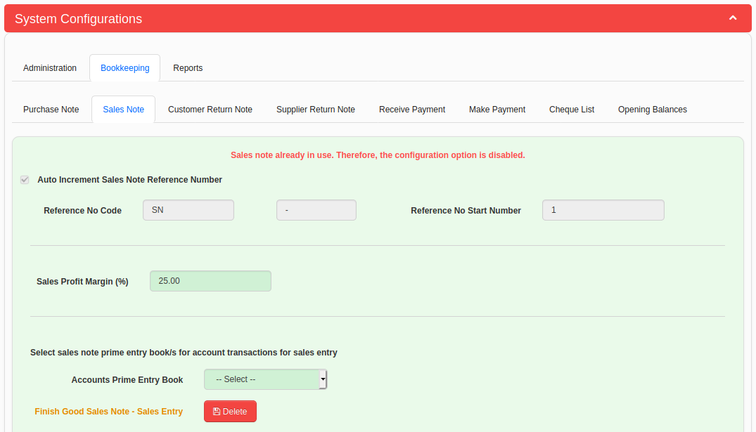
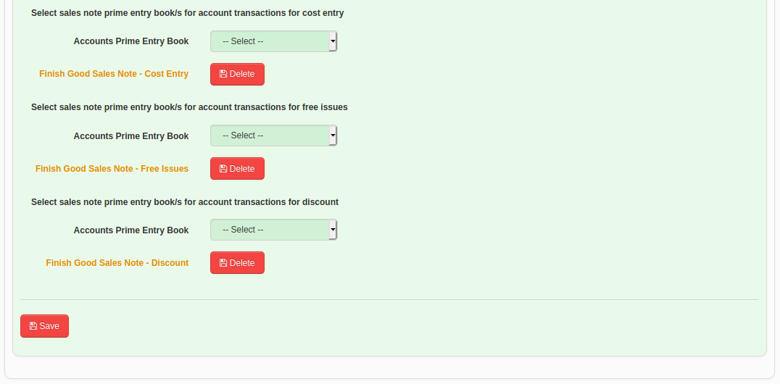
Figure 14

Customer Return Note
In Customer Return Note Configurations, you can specify the Customer Return Note Reference Number auto increment details as shown in Figure 15.
- Select “Auto Increment Customer Return Note Reference Number” check box and enter details to following fields.
    - Reference No Code
    - Reference No Separator
    - Reference No Start Number
- After start to using Customer Return Note and add transactions, above configuration fields will be disabled for editing as shown in Figure 15 and shows the following message.
Customer Return Note already in use. Therefore, the configuration option is disabled.
- Select “Add Customer Market Return Cost Entry with Profit Margin” check box and specify the relevant Chart of Account to add profit margin value, if you need to add customer return cost entry as same as selling price. In this situation, the profit margin will be acquired from supplier when return the products.
- Further, you can specify the Accounts Prime Entry Book to post journal entries when you add Customer Return Note transactions. “Accounts Prime Entry Book” drop down has default Accounts Prime Entry Books defined in “Accounts Manager” Module. From the list you need to select “Customer Saleable Return Note – Sales Entry”, “Customer Saleable Return Note – Cost Entry”, “Customer Market Return Note – Sales Entry” and “Customer Market Return Note – Cost Entry” prime entry book as shown in Figure 15.

Please refer “Accounts Manager → Administration → Prime Entry Books” screen if you need more information about prime entry books.

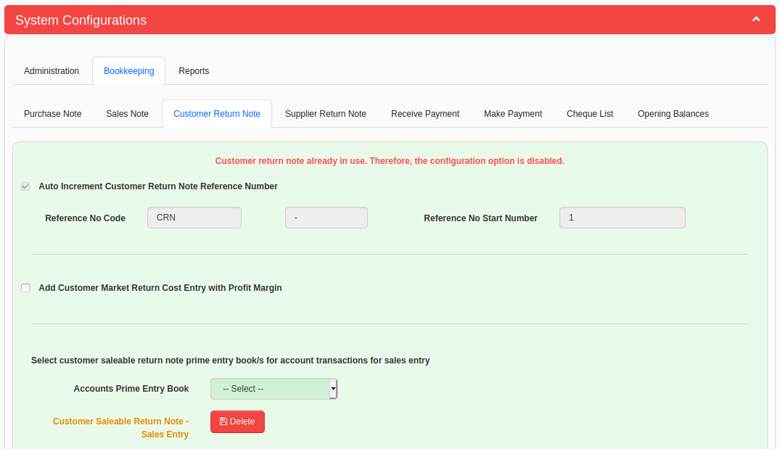
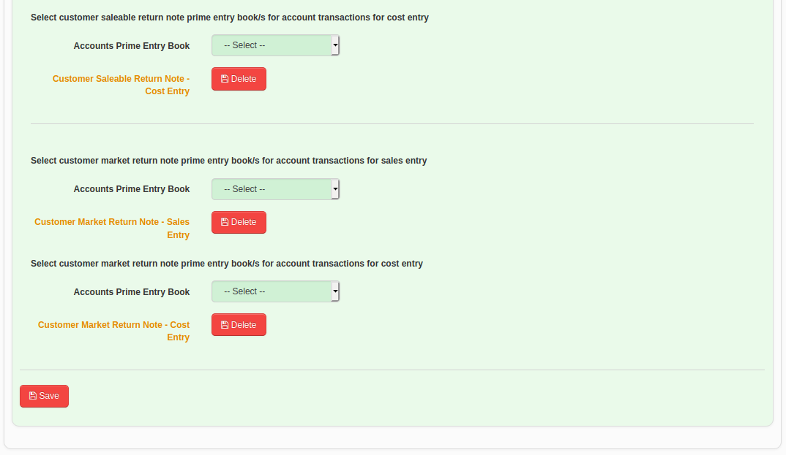
Figure 15

Supplier Return Note
In Supplier Return Note Configurations, you can specify the Supplier Return Note Reference Number auto increment details as shown in Figure 16.
- Select “Auto Increment Supplier Return Note Reference Number” check box and enter details to following fields.
    - Reference No Code
    - Reference No Separator
    - Reference No Start Number
- After start to using Supplier Return Note and add transactions, above configuration fields will be disabled for editing as shown in Figure 16 and shows the following message.
Supplier Return Note already in use. Therefore, the configuration option is disabled.
- Further, you can specify the Accounts Prime Entry Book to post journal entries when you add Supplier Return Note transactions. “Accounts Prime Entry Book” drop down has default Accounts Prime Entry Books defined in “Accounts Manager” Module. From the list you need to select “Supplier Saleable Return Note” and “Supplier Market Return Note” prime entry book as shown in Figure 16.

Please refer “Accounts Manager → Administration → Prime Entry Books” screen if you need more information about prime entry books.

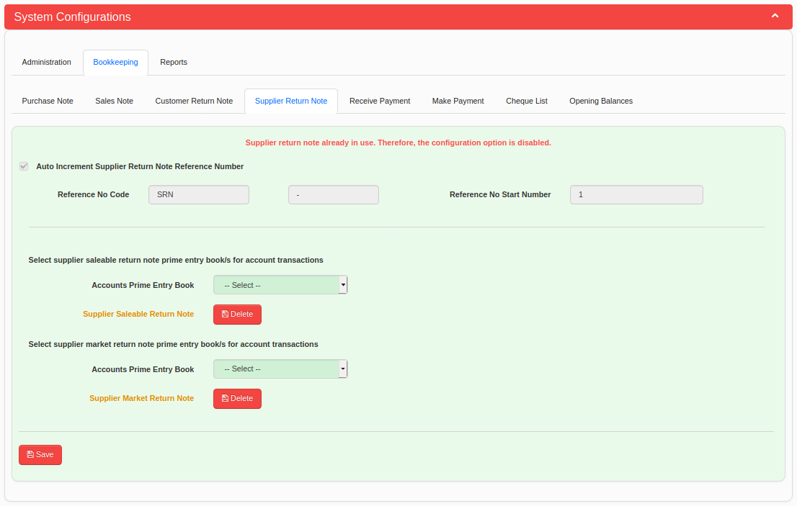
Figure 16

Receive Payment
In Receive Payment Configurations, you can specify the Receive Payment Reference Number auto increment details as shown in Figure 17.
- Select “Auto Increment Receive Payment Reference Number” check box and enter details to following fields.
    - Reference No Code
    - Reference No Separator
    - Reference No Start Number
- After start to using Receive Payment and add transactions, above configuration fields will be disabled for editing as shown in Figure 17 and shows the following message.
Receive Payment already in use. Therefore, the configuration option is disabled.
- Further, you can specify the Accounts Prime Entry Book to post journal entries when you add Receive Payment transactions. “Accounts Prime Entry Book” drop down has default Accounts Prime Entry Books defined in “Accounts Manager” Module. From the list you need to select “Receive Payment from a Debtor in Cash” and “Receive Payment from a Debtor in Cheque” prime entry book as shown in Figure 17.

Please refer “Accounts Manager → Administration → Prime Entry Books” screen if you need more information about prime entry books.

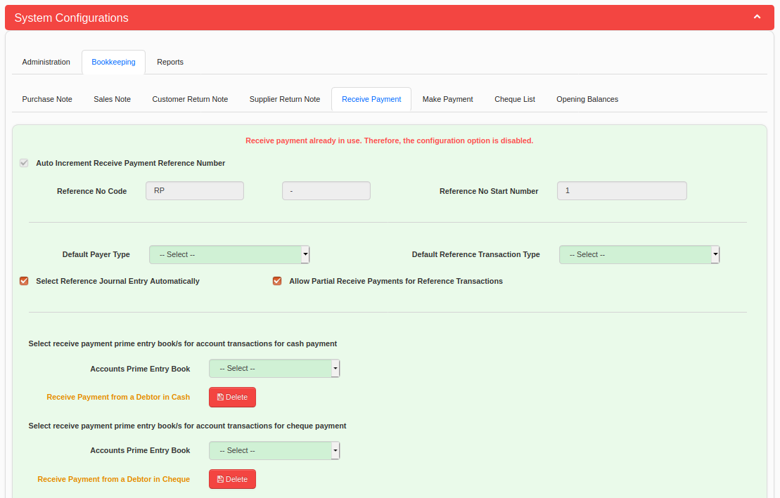
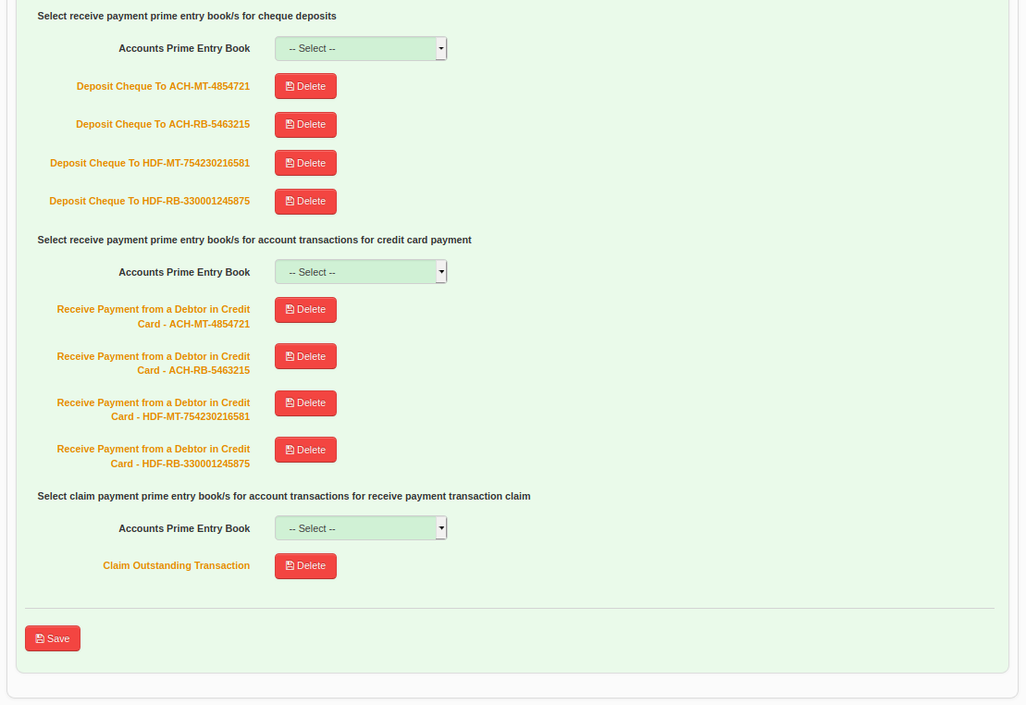
Figure 17
Make Payment
In Make Payment Configurations, you can specify the Make Payment Reference Number auto increment details as shown in Figure 18.
- Select “Auto Increment Make Payment Reference Number” check box and enter details to following fields.
    - Reference No Code
    - Reference No Separator
    - Reference No Start Number
- After start to using Make Payment and add transactions, above configuration fields will be disabled for editing as shown in Figure 18 and shows the following message.
Make Payment already in use. Therefore, the configuration option is disabled.
- Further, you can specify the Accounts Prime Entry Book to post journal entries when you add Make Payment transactions. “Accounts Prime Entry Book” drop down has default Accounts Prime Entry Books defined in “Accounts Manager” Module. From the list you need to select to select appropriate prime entry book as shown in Figure 18. If not available, please make required prime entry books.

Please refer “Accounts Manager → Administration → Prime Entry Books” screen if you need more information about prime entry books.

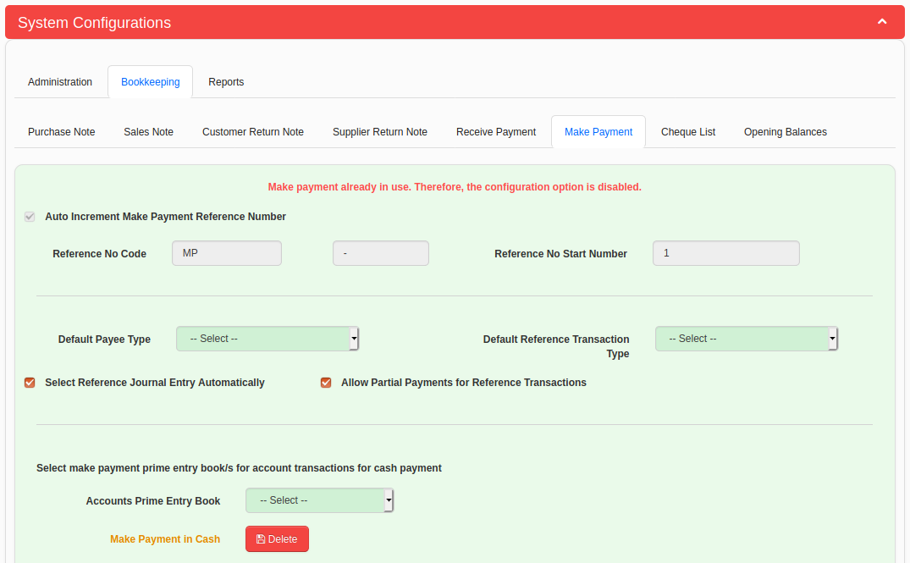
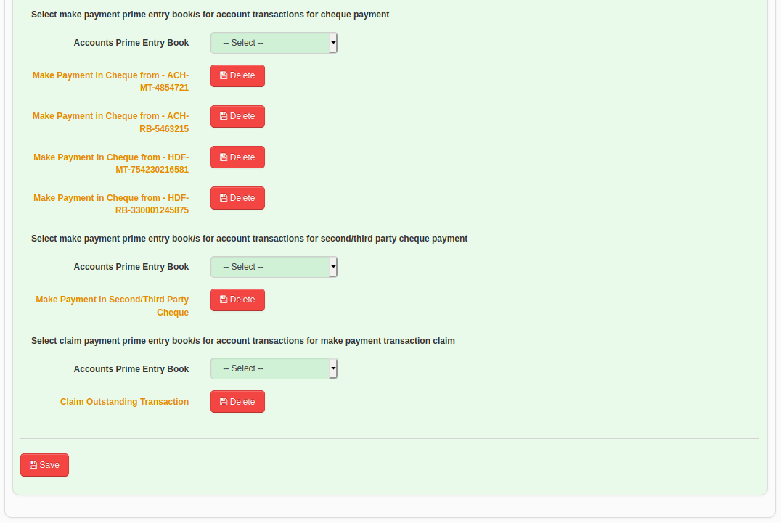
Figure 18
Cheque List
In Cheque List Configurations, you can set cheque details to be processed automatically as shown in Figure 19.
- Select “Automatically Mark Received Cheques As Deposited On Cheque Date” check box if you want to mark cheques as deposited to the bank when current date is the cheque deposit date. Otherwise, you should mark individual cheque as deposited in Cheque List screen.
- Select “Automatically Clear Received Cheques After Deposited to Bank” check box if you want to mark cheques as cleared after mark those as deposited. Otherwise, you should mark individual cheque as cleared in Cheque List screen.
- Select “Automatically Clear Paid Cheques on Cheque Date” check box if you want to mark cheques as cleared when current date is the cheque date. Otherwise, you should mark individual cheque as cleared in Cheque List screen.

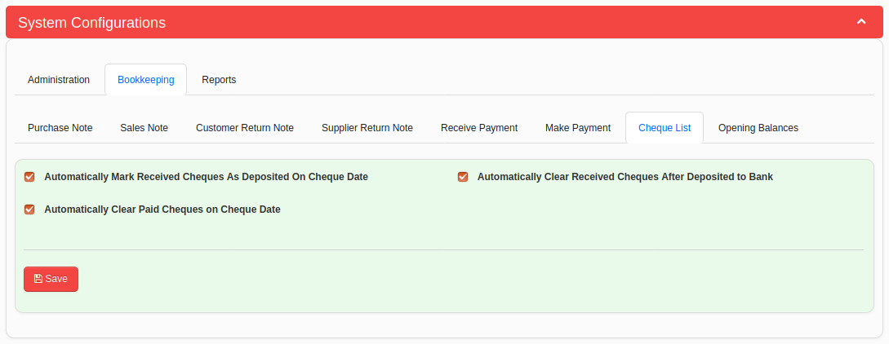
Figure 19

Opening Balances
In Opening Balances Configurations, you can select the “Opening Balance Equity” account in your chart of accounts so that it can be referred when you add accounts opening balances.

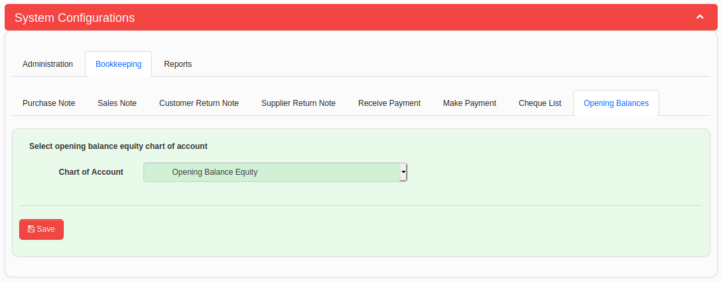
Figure 20

Reports Configurations
Trial Balance Configurations
System configurations available for trial balance report are categorized under the “Trial Balance” tab which is available under “Reports” main tab as shown in Figure 21.
- Users can specify the order of displaying account categories on the trial balance as shown in Figure 21.
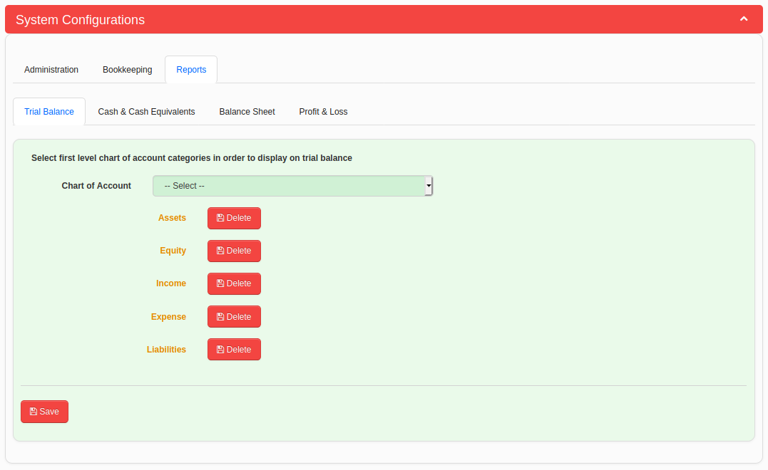
Figure 21

Cash & Cash Equivalents Configurations
In Cash & Cash Equivalents Configurations, you can select the “Cash and Cash Equivalents” account and “Cheque in Hand” account in your chart of accounts so that it can be referred when you generate reports.

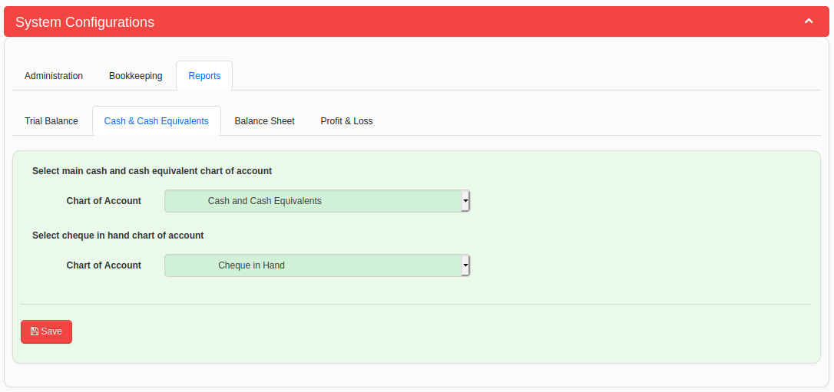
Figure 22

Balance Sheet Configurations
System configurations available for balance sheet report are categorized under the “Balance Sheet” tab which is available under “Reports” main tab as shown in Figure 23.
- Users can specify the main chart of account entry points for balance sheet report generation on this tab as shown in Figure 23.
Note : System does not allow to select a sub chart of account when its one of main chart of account is already selected under a particular category. System shows the message in Figure 25, if a user try to select a sub chart of account.
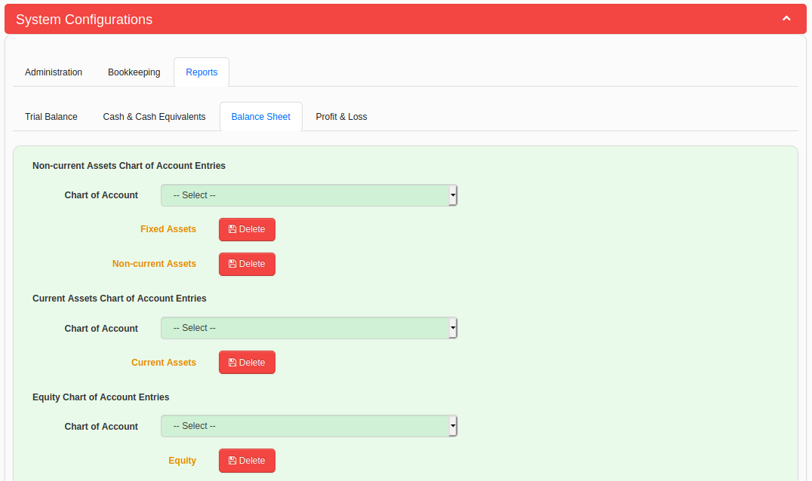
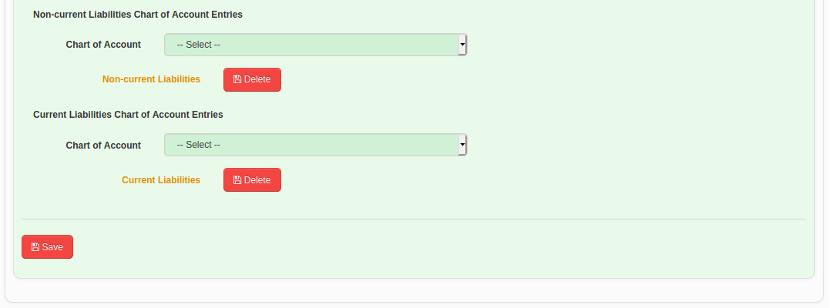
Figure 23
Profit and Loss Configurations
System configurations available for profit and loss report are categorized under the “Profit & Loss” tab which is available under “Reports” main tab as shown in Figure 24.
- Users can select the chart of account entry points as shown in Figure 24, for calculating profit and loss information.
Note : System does not allow to select a sub chart of account when its one of main chart of account is already selected under a particular category. System shows the message in Figure 25, if a user try to select a sub chart of account.
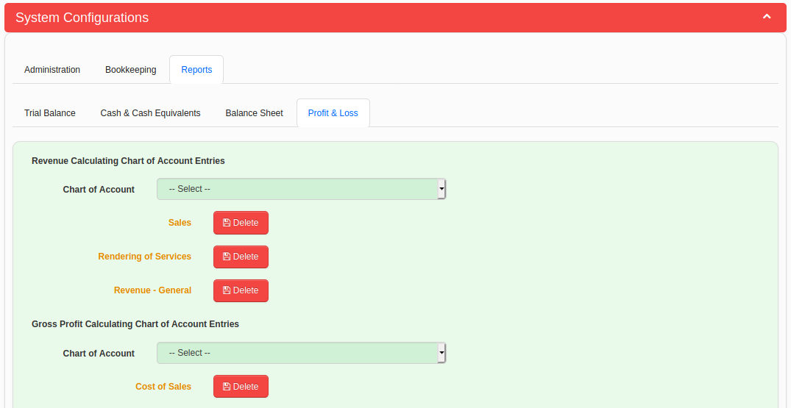
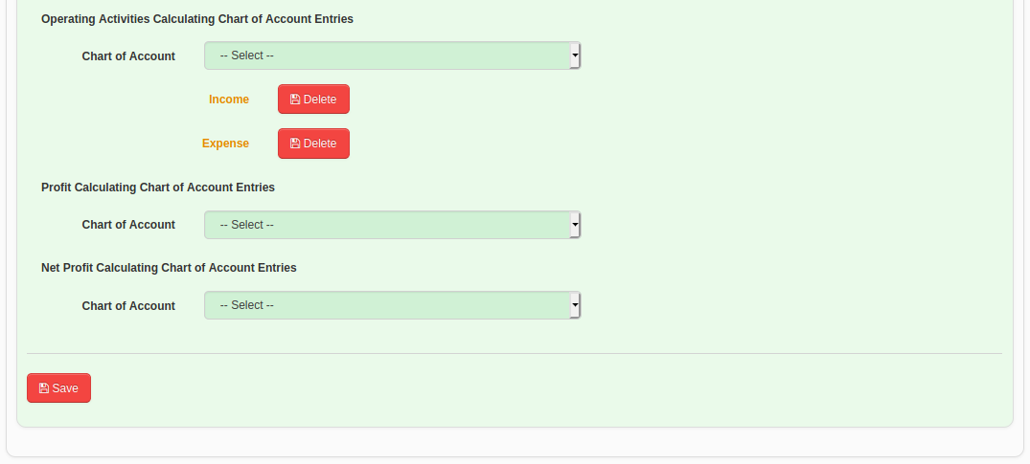
Figure 24

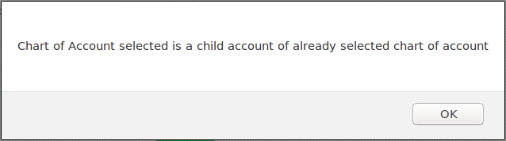

Figure 25

