

Red Cherries Accounting (Open Source)

Accounts Manager

Reports User Guide

Version 1.0 Beta 1

Table of Contents
Introduction 2
Top Navigation Bar 3
Reports 5
Management Reports 6
Financial Reports 15

Introduction
This user guide aims at giving you the information required to work with “Reports Section” of “Accounts Manager”. This user guide can be downloaded from “Reports Help” screen shown in Figure 2 which is accessible from “Reports → Help” menu as shown in Figure 1.

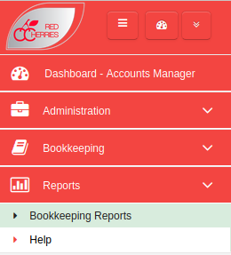

Figure 1

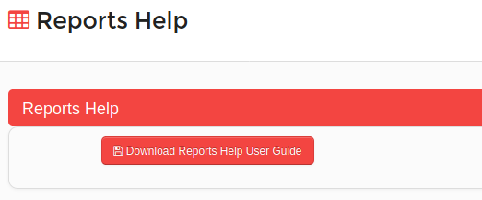

Figure 2

Top Navigation Bar

Toggle Left Menu
Open/Retract System Modules
Change Password
My Language
About System
Logout
System Dashboard
Default Module

Current Module
Figure 3

  - Toggle Left Menu : Show/hide left menu
  - Open/Retract System Modules : Open/retract system module dashboard. Previous screen preserves if user does not select any module.
  - System Dashboard : Opens the system modules dashboard. Previous screen does not preserved.
  - Current Module : Shows the current module that user has selected.
  - Default Module : Selecting current module as default module will allow to go directly to that module on login to the system.

Reports
Users can generate Trial Balance, Sales Payment Details, Debtors and Creditors reports under Management Reports as shown in Figure 4. Balance Sheet and Profit & Loss reports can be generated under Financial Reports as shown in Figure 4.

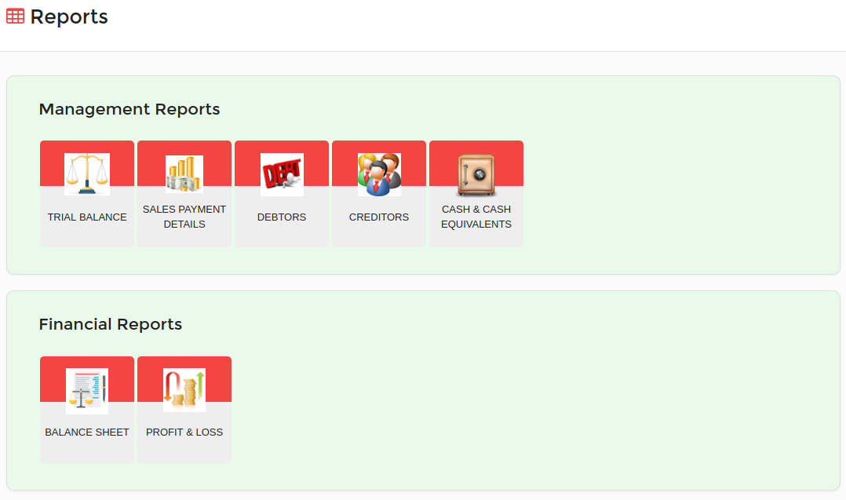
Figure 4

Management Reports
Trial Balance
Trial balance report can be generated under following scenarios as shown in Figure 5.
- Users can select a date, location and an accounting method and generate the report. The report will show the as at date information for the selected location and the accounting method.
- Users can select a date, year, location and an accounting method and generate the report. The report will show the information from 1st of January of selected year till the selected date, for the selected location and the accounting method.
- Users can select a date range, location and an accounting method and generate the report. The report will show the information for the selected date range, location and the accounting method.
- Users can select a year, month, location and an accounting method and generate the report. The report will show the information for the selected year and month, location and the accounting method.
- Further the report generates according to the configuration settings specified under system configurations screen for trial balance.
- Figure 6 shows a sample layout of the trial balance.

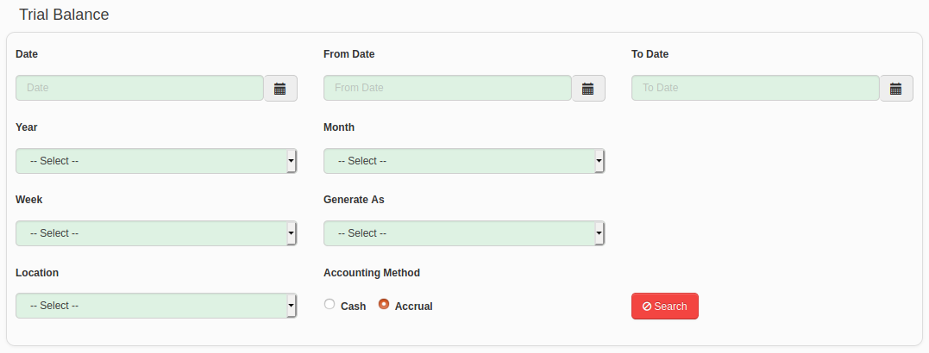
Figure 5

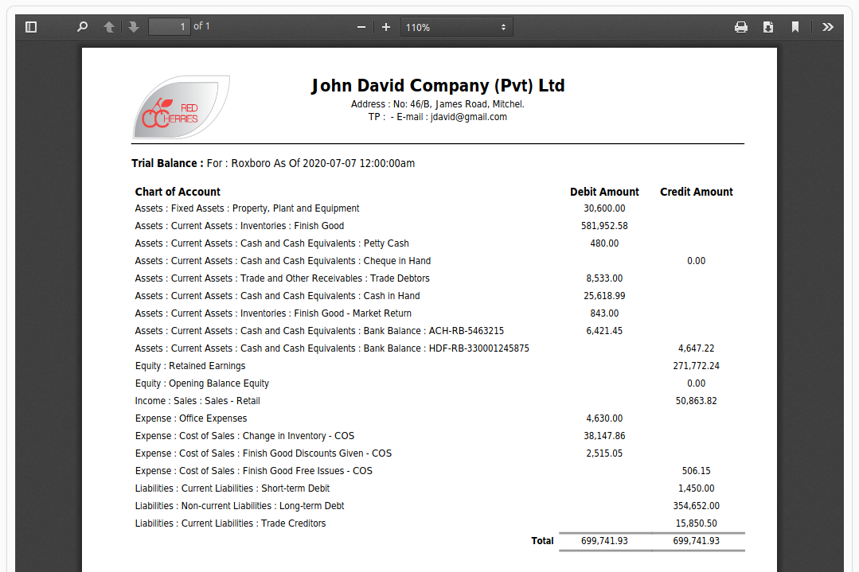

Figure 6

Sales Payment Details
Sales Payment Details report can be generated under following scenarios as shown in Figure 7.
- Users can select a date range, location and territory and generate the report. The report will show the information for the selected date range, location and the territory.
- Users can select a year, month, location and territory and generate the report. The report will show the information for the selected year and month, location and the territory.
- Users can select “Cancelled Sales Note” check box and filter the cancelled Sales Notes.
- Users can select “Detail Report” check box and generate the Sales Note Detail report. The report will show all cash and cheque payment transactions of each Sales Note.
- The report data can be exported to Excel by clicking on button shown in right hand top corner of Figure 8.
- Figure 8 shows a sample data of the Sales Payment Details report.

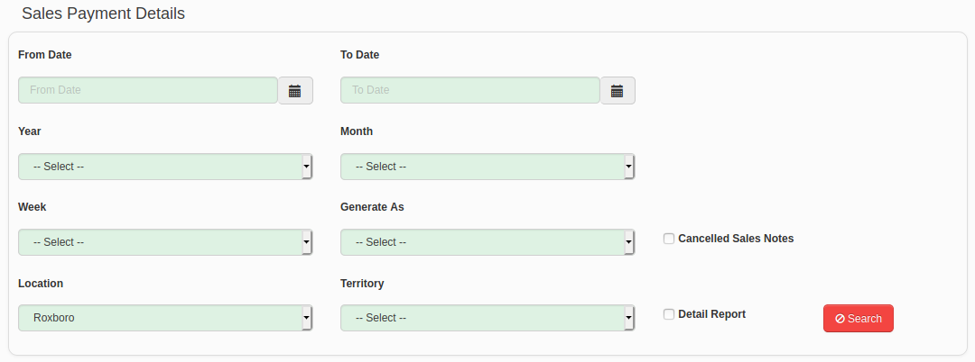
Figure 7

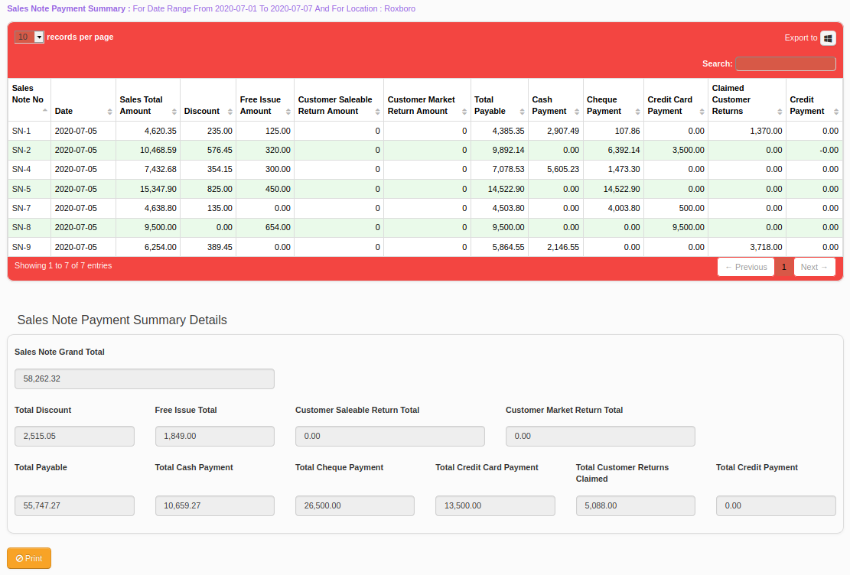
Figure 8

Debtors
Debtors report can be generated under following scenarios as shown in Figure 9.
- Users can select a date, location and a debtor and generate the report. The report will show the as at date information for the selected location and the debtor.
- Users can select a date, year, location and a debtor and generate the report. The report will show the information from 1st of January of selected year till the selected date, for the selected location and the debtor.
- Users can select a date range, location and a debtor and generate the report. The report will show the information for the selected date range, location and the debtor.
- Users can select a year, month, location and a debtor and generate the report. The report will show the information for the selected year and month, location and the debtor.
- Users also can generate a summary report.
- Figure 10 shows a sample layout of the Debtors detail report.
- Figure 11 shows a sample layout of the Debtors summary report.

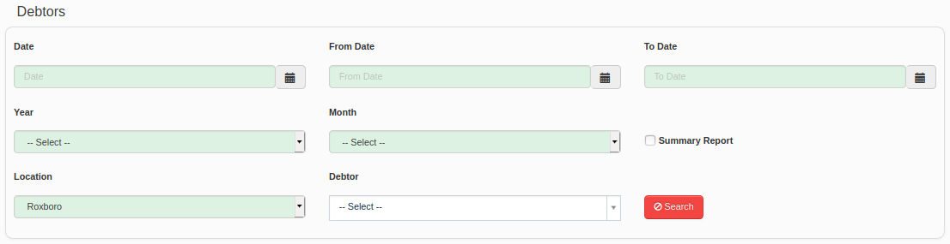
Figure 9

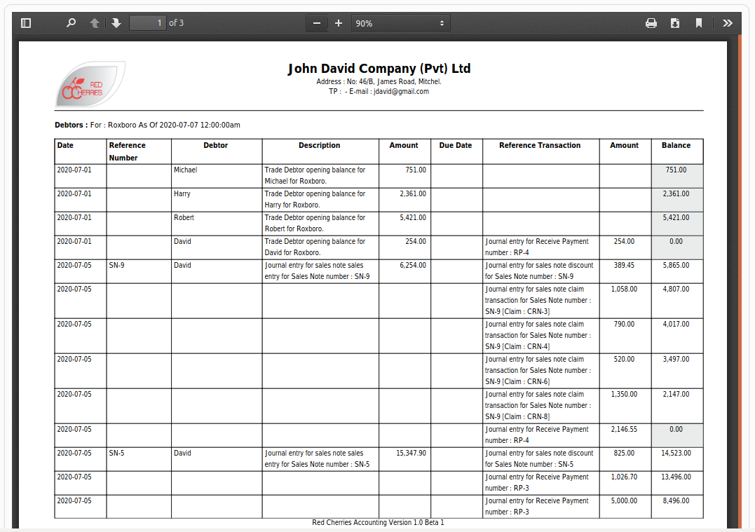
Figure 10

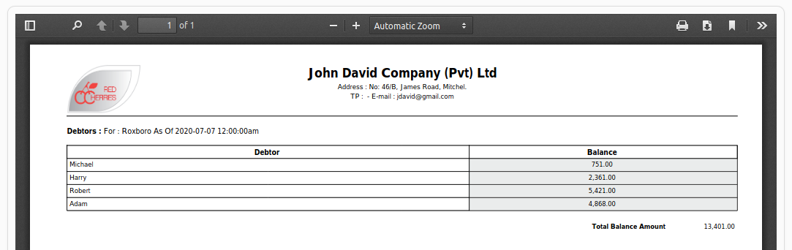
Figure 11

Creditors
Creditors report can be generated under following scenarios as shown in Figure 12.
- Users can select a date, location and a creditor and generate the report. The report will show the as at date information for the selected location and the creditor.
- Users can select a date, year, location and a creditor and generate the report. The report will show the information from 1st of January of selected year till the selected date, for the selected location and the creditor.
- Users can select a date range, location and a creditor and generate the report. The report will show the information for the selected date range, location and the creditor.
- Users can select a year, month, location and a creditor and generate the report. The report will show the information for the selected year and month, location and the creditor.
- Users also can generate a summary report.
- Figure 13 shows a sample layout of the Creditors detail report.
- Figure 14 shows a sample layout of the Creditors summary report.

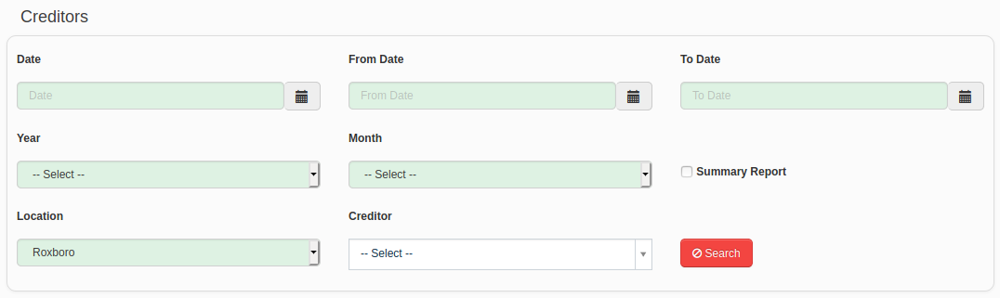
Figure 12

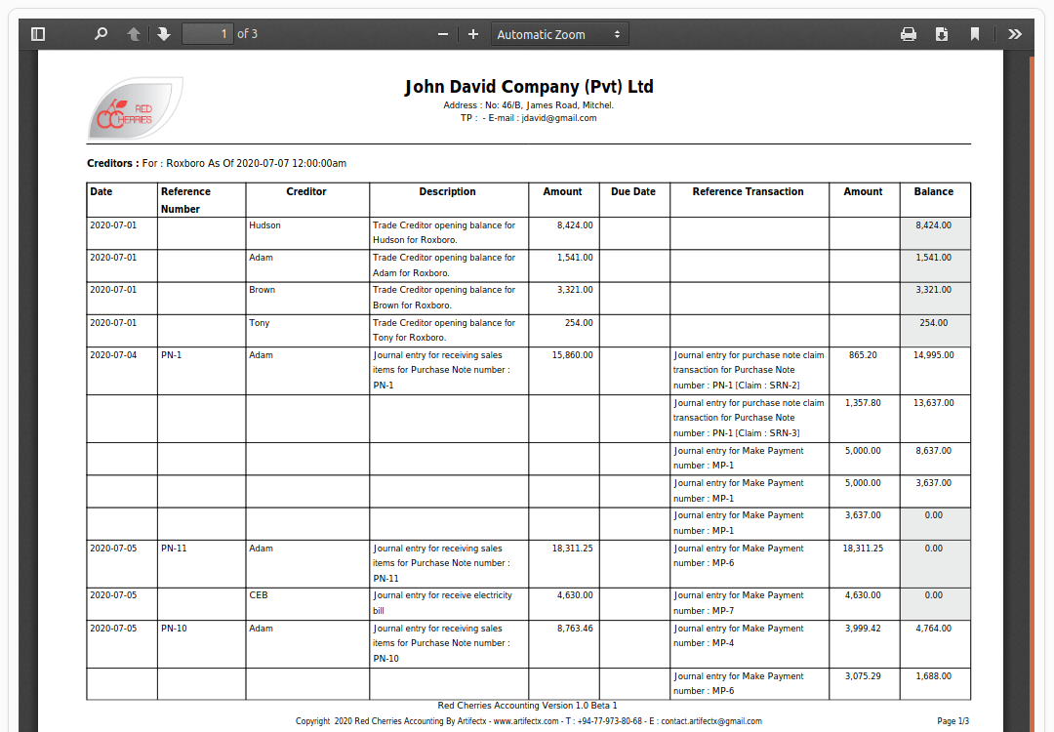
Figure 13

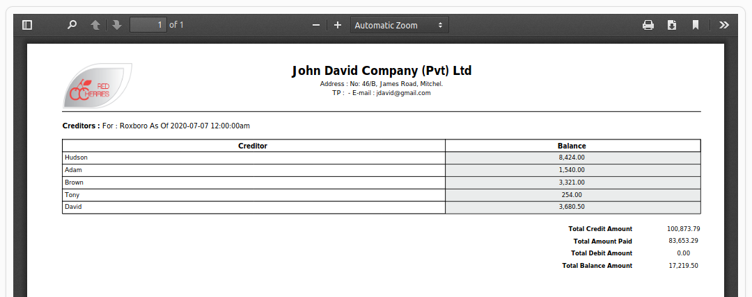

Figure 14
Cash & Cash Equivalents
Cash & Cash Equivalents report can be generated under following scenarios as shown in Figure 15.
- Users can select a location and generate the report. The report will show the as at date information for the selected location as shown in Figure 16.

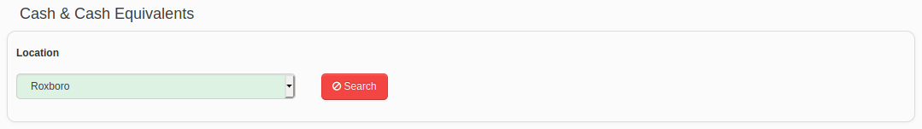
Figure 15

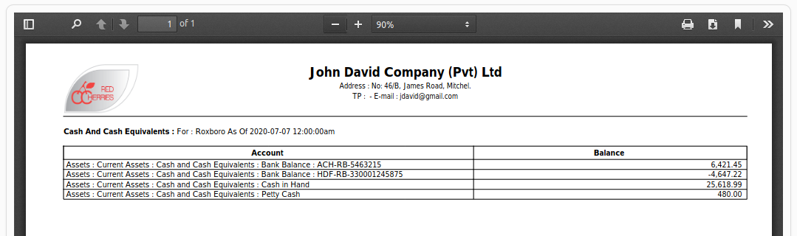
Figure 16

Financial Reports
Balance Sheet
Balance sheet report can be generated under following scenarios as shown in Figure 17.
- Users can select a date, location and an accounting method and generate the report. The report will show the as at date information for the selected location and the accounting method.
- Users can select a date, year, location and an accounting method and generate the report. The report will show the information from 1st of January of selected year till the selected date, for the selected location and the accounting method.
- Users can select a date range, location and an accounting method and generate the report. The report will show the information for the selected date range, location and the accounting method.
- Users can select a year, month, location and an accounting method and generate the report. The report will show the information for the selected year and month, location and the accounting method.
- Further the report generates according to the configuration settings specified under system configurations screen for balance sheet.
- Figure 18 shows a sample layout of the balance sheet.

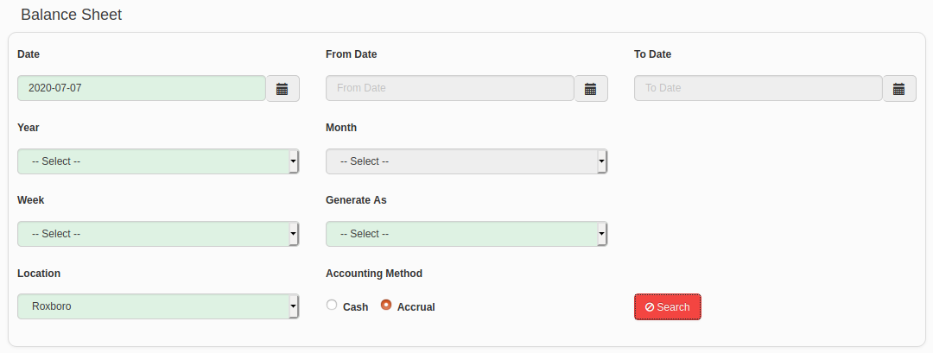
Figure 17

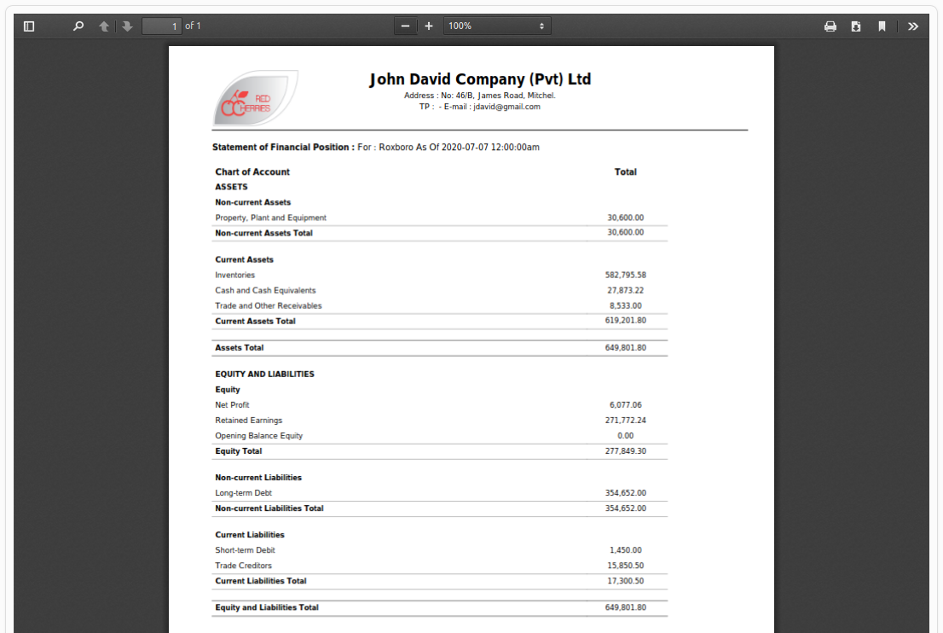
Figure 18

Profit and Loss
Profit and loss report can be generated under following scenarios as shown in Figure 19.
- Users can select a date, location and an accounting method and generate the report. The report will show the as at date information for the selected location and the accounting method.
- Users can select a date, year, location and an accounting method and generate the report. The report will show the information from 1st of January of selected year till the selected date, for the selected location and the accounting method.
- Users can select a date range, location and an accounting method and generate the report. The report will show the information for the selected date range, location and the accounting method.
- Users can select a year, month, location and an accounting method and generate the report. The report will show the information for the selected year and month, location and the accounting method.
- Further the report generates according to the configuration settings specified under system configurations screen for profit and loss.
- Figure 20 shows a sample layout of the profit and loss.

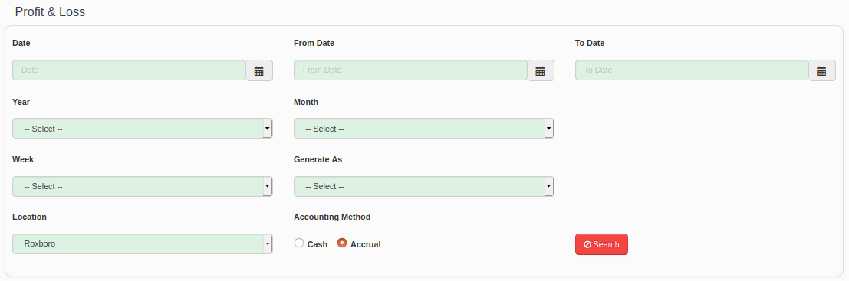
Figure 19

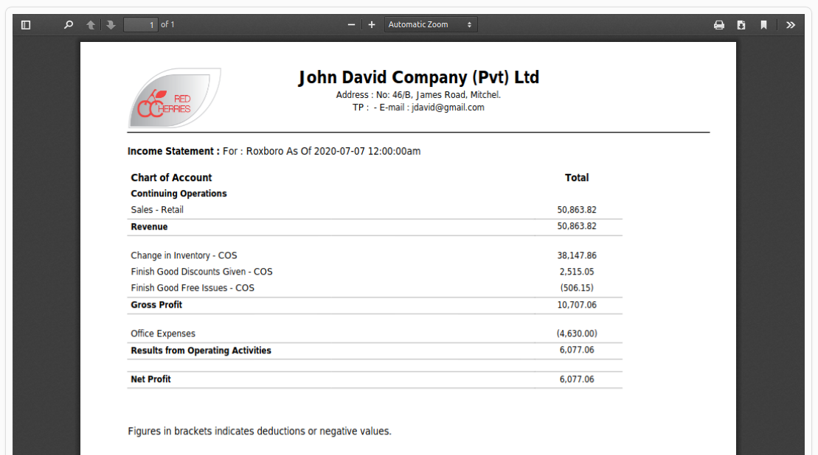
Figure 20

