

Red Cherries Accounting (Open Source)

Donation Manager

Admin User Guide

Version 1.0 Beta 1

Table of Contents
Introduction 2
Top Navigation Bar 3
Programs 4
System Configurations 5
Programs Configurations 5
Collect Donations Configurations 6
Program Progress Configurations 8

Introduction
This user guide aims at giving you the information required to work with “Administration Section” of “Donation Manager”. This user guide can be downloaded from “Admin Help” screen shown in Figure 2 which is accessible from “Administration → Help” menu as shown in Figure 1.

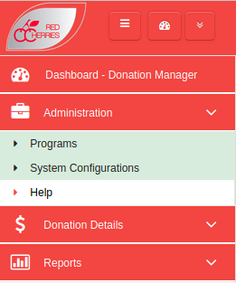

Figure 1

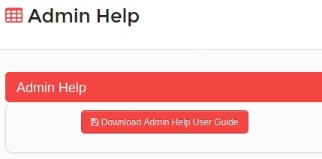

Figure 2

Top Navigation Bar

Toggle Left Menu
Open/Retract System Modules
Change Password
My Language
About System
Logout
System Dashboard
Default Module

Current Module
Figure 3

  - Toggle Left Menu : Show/hide left menu
  - Open/Retract System Modules : Open/retract system module dashboard. Previous screen preserves if user does not select any module.
  - System Dashboard : Opens the system modules dashboard. Previous screen does not preserved.
  - Current Module : Shows the current module that user has selected.
  - Default Module : Selecting current module as default module will allow to go directly to that module on login to the system.

Programs
Programs which you execute using the donations you receive need to be added under Programs screen. Programs can be added in the system from “Administration → Programs” menu.
- Programs list is displayed in the system as shown in Figure 4.
- A new program can be added by clicking on “Add New Program” button shown in Figure 4. A new form will be displayed on the screen to add a new Program as shown in Figure 5.
- “Program Name”, “Coordinator Name” and “Location” are mandatory fields when adding a new Program.

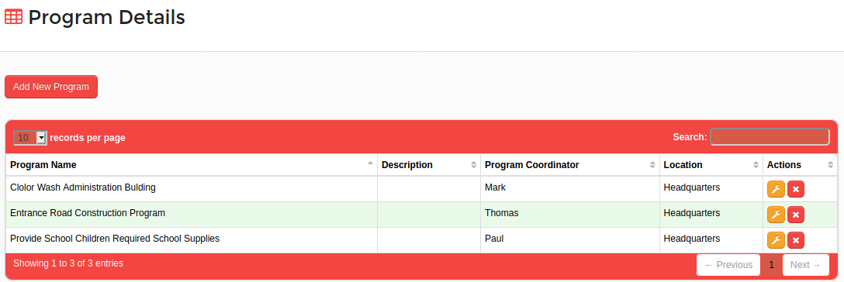
Figure 4

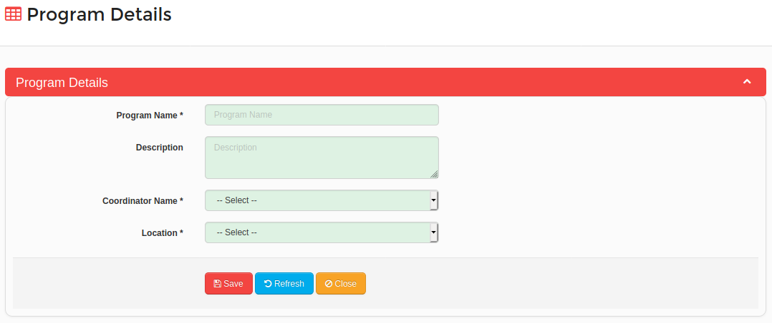
Figure 5

System Configurations
System allows users to control the system behavior via several system configurations. System configurations screen is shown in Figure 6, which is accessible from “Administration → System Configurations” menu. System configurations are categorized into their effective screens as shown in Figure 6.

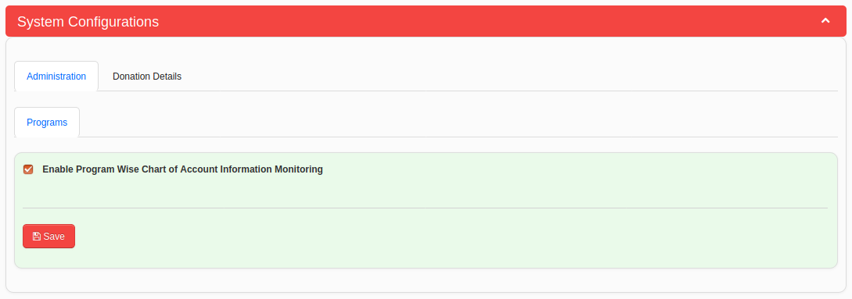
Figure 6

Programs Configurations
System configurations applicable for Programs in Donation Manager module are categorized under “Programs” tab which is available under main “Administration” tab as shown in Figure 6.
- Users can specify whether they need to track accounting information for each program in separate chart of accounts or in a common chart of account in Accounts Manager module. The configuration called “Enable Program Wise Chart of Account Information Monitoring” shown in Figure 6 is available for this purpose.

Collect Donations Configurations
System configurations available for Collect Donations screen are categorized under the “Collect Donations” tab which is available under “Donation Details” main tab as shown in Figure 7.
- If users have enabled “Enable Program Wise Chart of Account Information Monitoring” configuration under Programs configuration tab shown in Figure 6, users can select a prime entry book for each Program as shown in Figure 7 to add journal entries for each donation collect transaction.
- If users have not enabled “Enable Program Wise Chart of Account Information Monitoring” configuration under Programs configuration tab shown in Figure 6, then users can select a common prime entry book for all Programs as shown in Figure 8 to add journal entries for each donation collect transaction.

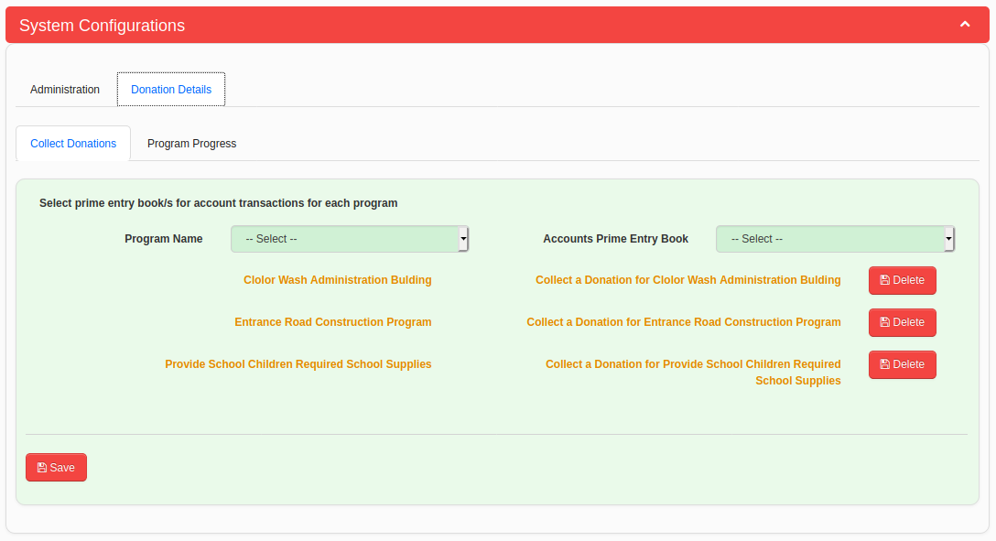
Figure 7

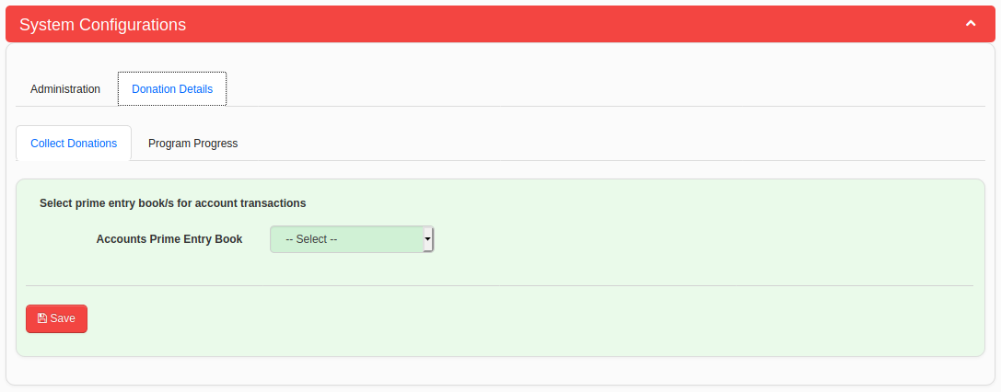
Figure 8

Program Progress Configurations
System configurations available for Program Progress screen are categorized under the “Program Progress” tab which is available under “Donation Details” main tab as shown in Figure 9.
- If users have enabled “Enable Program Wise Chart of Account Information Monitoring” configuration under Programs configuration tab shown in Figure 6, users can select a prime entry book for each Program as shown in Figure 9 to add journal entries for each budget issue or budget return transaction.
- If users have not enabled “Enable Program Wise Chart of Account Information Monitoring” configuration under Programs configuration tab shown in Figure 6, then users can select a common prime entry book for all Programs as shown in Figure 10 to add journal entries for each budget issue or budget return transaction.

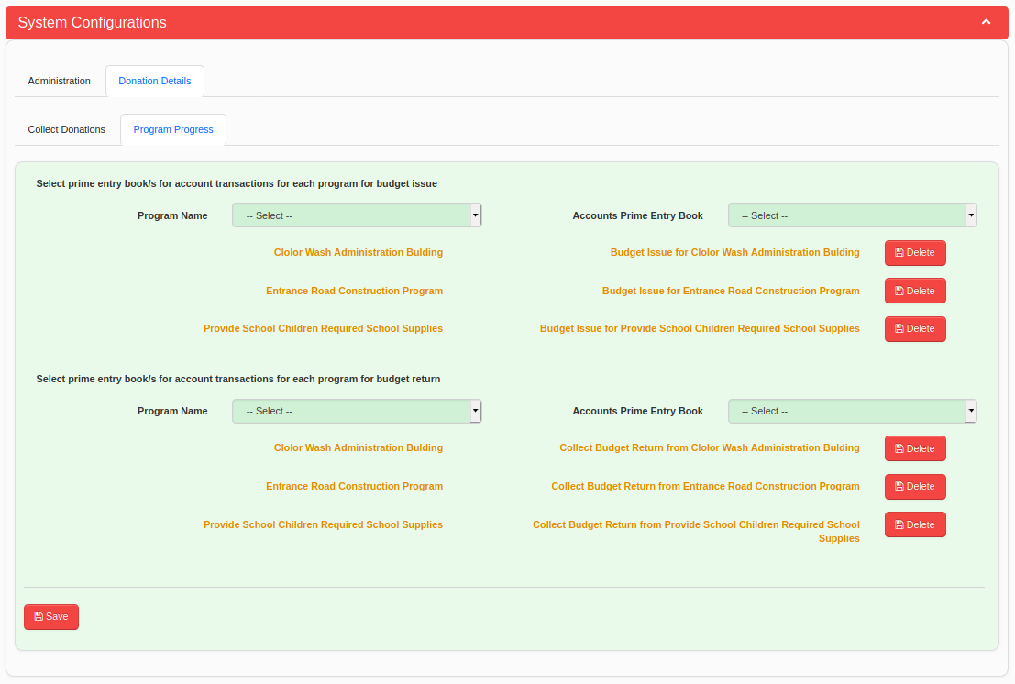
Figure 9

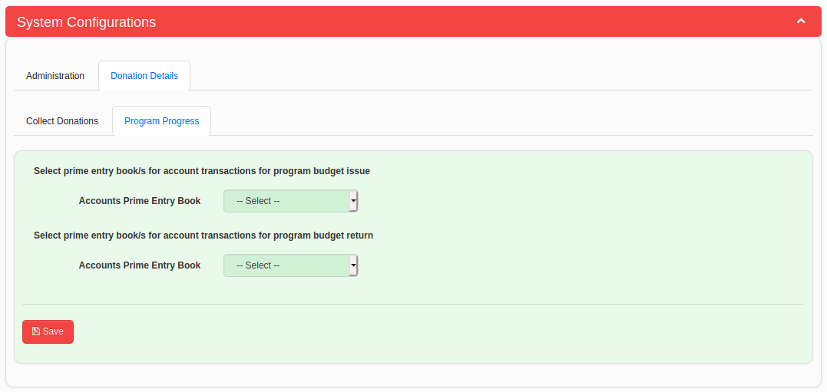
Figure 10

