

Red Cherries Accounting (Open Source)

Accounts Manager

Bookkeeping User Guide

Version 1.0 Beta 1

Table of Contents
Introduction 3
Top Navigation Bar 4
Journal Entries 5
Add a Journal Entry Without Specifying a Prime Entry Book 6
Add a Journal Entry by Specifying a Prime Entry Book Which has no Reference Journal Entry 8
Add a Journal Entry by Specifying a Prime Entry Book Which has a Reference Journal Entry 10
Purchase Note 12
Sales Note 14
Customer Return Note 19
Supplier Return Note 21
Receive Payment 23
Make Payment 26
Cheque List 29
Chart Of Account Balances 30
Stakeholder Account Balances 31
General Ledger 32
Opening Balances 33

Introduction
This user guide aims at giving you the information required to work with “Bookkeeping Section” of “Accounts Manager”. This user guide can be downloaded from “Bookkeeping Help” screen shown in Figure 2 which is accessible from “Bookkeeping → Help” menu as shown in Figure 1.

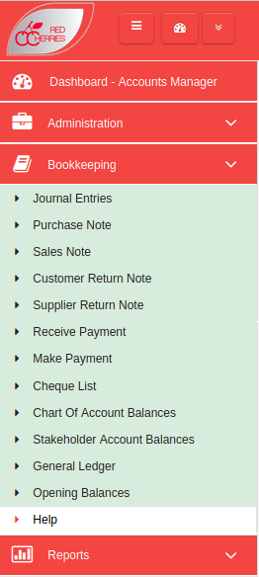

Figure 1
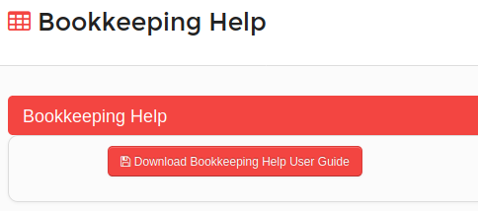

Figure 2

Top Navigation Bar

Toggle Left Menu
Open/Retract System Modules
Change Password
My Language
About System
Logout
System Dashboard
Default Module

Current Module
Figure 3

  - Toggle Left Menu : Show/hide left menu
  - Open/Retract System Modules : Open/retract system module dashboard. Previous screen preserves if user does not select any module.
  - System Dashboard : Opens the system modules dashboard. Previous screen does not preserved.
  - Current Module : Shows the current module that user has selected.
  - Default Module : Selecting current module as default module will allow to go directly to that module on login to the system.

Journal Entries
Journal entries list can be accessed from “Bookkeeping → Journal Entries” menu and the journal entries list can be seen as shown in Figure 4.
- Journal entry list shows the journal entries added manually and also the journal entries posted from the other modules of Red Cherries Accounting.
- A new journal entry can be added by clicking on “Add New Journal Entry” button shown in Figure 4.
- Users can add a journal entry with or without specifying a prime entry book. That means, if there is no prime entry book created for the journal entry which user is going to post, the user can add the journal entry without a prime entry book.
Note : Normal users cannot post a journal entry without a prime entry book if they don't have permissions to do so. Please refer “User Roles Help User Guide” for more information.

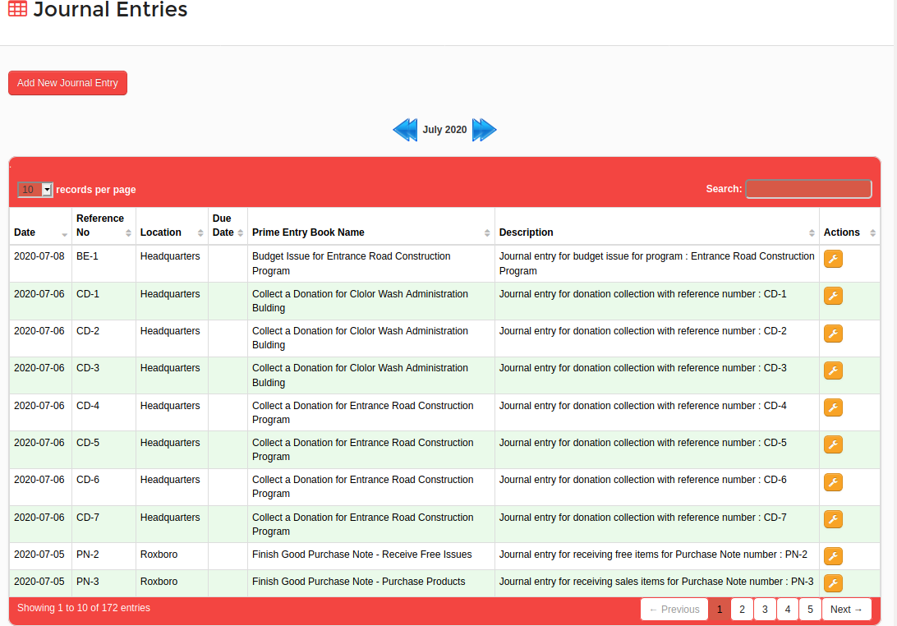
Figure 4

Add a Journal Entry Without Specifying a Prime Entry Book
Users can select the Date, Payee/Payer Type, Payee/Payer Name, Reference No, Location and a Description and save the journal entry. After saving the journal entry users can see the screen as shown in Figure 5.
- Date field is a mandatory field.
- Payee/Payer Name field will be shown only if the user has selected the Payee/Payer Type field value. If selected Payee/Payer Name is a mandatory field.
- Payee/Payer Type has the following options.
  - Supplier
  - Agent
  - Customer
  - Sales Rep
  - Driver
  - Employee

- Location field is shown and is a mandatory field since accounts management for locations is enabled under system configurations.
- “Add as a Prime Entry Book” check box is shown since the user has not selected a prime entry book.
- If user check the “Add as a Prime Entry Book” check box, system will show a field to enter the prime entry book name.
- Users can selects the debit and credit chart of accounts and the journal entry value.
- Also users can select additional debit or credit chart of accounts by clicking on “Add Another Debit Ledger Account” or “Add Another Credit Ledger Account”.
- If the debit and credit values are equal, users can save the journal entry. Otherwise, the system will wait until the user makes the corrections.

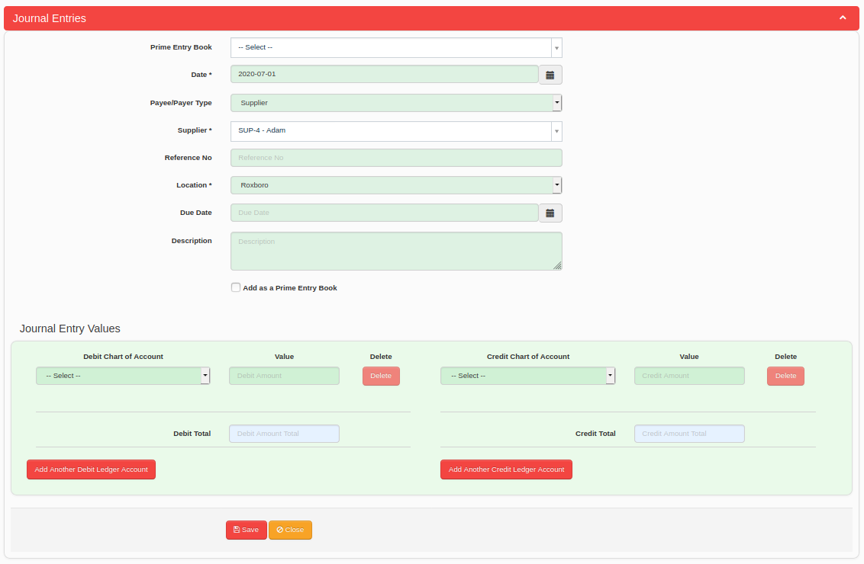
Figure 5

Add a Journal Entry by Specifying a Prime Entry Book Which has no Reference Journal Entry
Users can select the Prime Entry Book, Date, Payee/Payer Type, Payee/Payer Name, Reference No, Location and a Description. Users can see the screen as shown in Figure 6.
- Date field is a mandatory field.
- Payee/Payer Name field will be shown only if the user has selected the Payee/Payer Type field value. If selected Payee/Payer Name is a mandatory field.
- Payee/Payer Type has the following options.
  - Supplier
  - Agent
  - Customer
  - Sales Rep
  - Driver
  - Employee

- The prime entry book that user has selected is not asking for a reference journal entry for the transaction. Therefore, the “Reference Transaction Type” field is not shown.
- Location field is shown and is a mandatory field since accounts management for locations is enabled under system configurations.
- If the debit and credit values are equal, users can save the journal entry. Otherwise, the system will wait until the user makes the corrections.

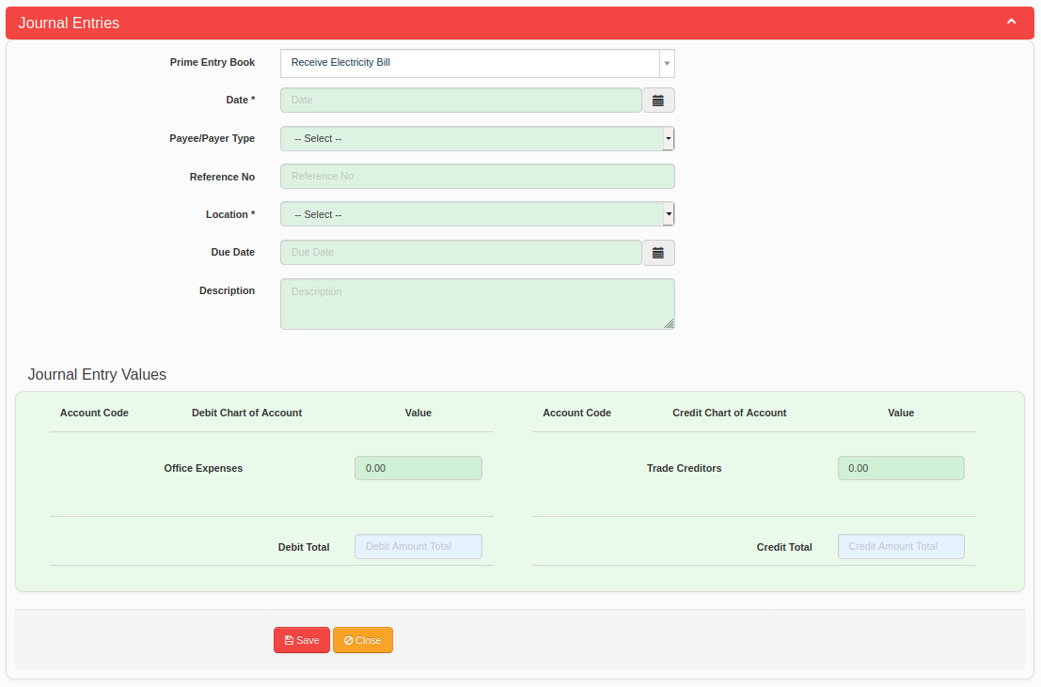
Figure 6

Add a Journal Entry by Specifying a Prime Entry Book Which has a Reference Journal Entry
Users can select the Prime Entry Book, Date, Payee/Payer Type, Payee/Payer Name, Reference No, Reference Transaction Type, Reference Transaction, Reference Journal Entry, Location and a Description. Users can see the screen as shown in Figure 7.
- Date field is a mandatory field.
- Payee/Payer Name field will be shown only if the user has selected the Payee/Payer Type field value. If selected Payee/Payer Name is a mandatory field.
- Payee/Payer Type has the following options.
  - Supplier
  - Agent
  - Customer
  - Sales Rep
  - Driver
  - Employee

- The prime entry book that user has selected is asking for a reference journal entry for the transaction. Therefore, the “Reference Transaction Type” field is shown.
- Reference Transaction Type has the following options.
  - Finish Good Good Receive Note
  - Finish Good Supplier Return
  - Raw Material Good Receive Note
  - Raw Material Supplier Return
  - Sales Invoice
  - Sales Return
  - Other

- If user selects an option from Reference Transaction Type other than the option “Other”, the system will ask for the “Reference Transaction”. If user selects “Other” option from Reference Transaction Type, the system will ask for only the “Reference Journal Entry”.
- If the Reference Transaction field is shown and user selects a transaction, the system will show the relevant journal entries of selected transaction.
- Location field is shown and is a mandatory field since accounts management for locations is enabled under system configurations.
- If the debit and credit values are equal, users can save the journal entry. Otherwise, the system will wait until the user makes the corrections.

Figure 7

Purchase Note
Purchase Notes can be added in “Red Cherries Accounting” from “Bookkeeping → Purchase Note” menu.
Note : Users will see this screen only if the screen is enabled in configurations.
- Purchase Note list is displayed in the system as shown in Figure 8.
- A new Purchase Note can be added by clicking on “Add New Purchase Note” button as shown in Figure 8.
- Add Purchase Note screen is as shown Figure 9.
- User can select “Purchase Products” check box if needs to add saleable products received from a supplier. For a “Purchase Products” Purchase Note, supplier will be credited for payments.
- User can select “Receive Free Issue Products” check box if needs to add free issue products received from a supplier. For a “Receive Free Issue Products” Purchase Note, supplier will not be credited for payments.
- When payments are done for purchase notes from “Make Payment” screen, such purchase notes will be highlighted in green and status will mark as “Paid”.

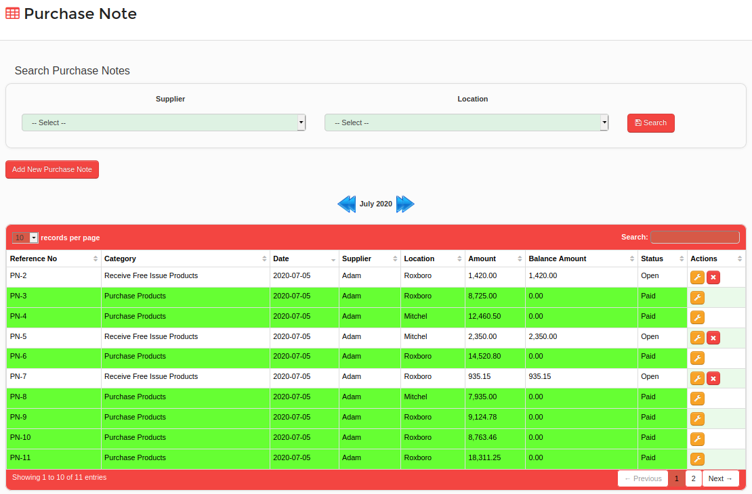
Figure 8

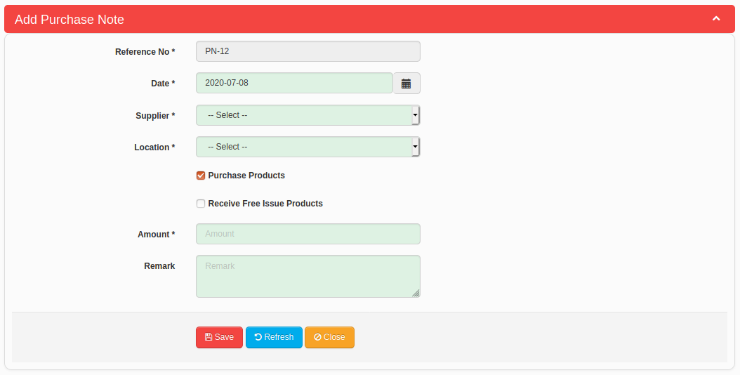
Figure 9

Sales Note
Sales Notes can be added in “Red Cherries Accounting” from “Bookkeeping → Sales Note” menu.
Note : Users will see this screen only if the screen is enabled in configurations.
- Sales Note list is displayed in the system as shown in Figure 10.
- A new Sales Note can be added by clicking on “Add New Sales Note” button as shown in Figure 10.
- Add Sales Note screen is as shown Figure 11. The “Sales Note Details” tab allows users to add basic Sales Note information. The “Customer Returns and Payment Details” tab allows the users to enter Sales Note payment details.
- Users can see the “Customer Returns and Payment Details” tab in Sales Note as shown in Figure 12. The screen allows to add Customer Saleable Return amount and Customer Market Return amount. Further, users can add multiple cash, cheque and credit card payment transactions for a Sales Note.
Note : If you collect a payment for a sales note from “Receive Payment” screen, those payments will be shown in each payment transaction list in sales note. However, system will not allow you to edit or delete such payment transactions from sales note.
- Users can cancel a Sales Note by clicking on “Cancel Sales Note” button shown in Figure 11 and Figure 12.
- A cancelled Sales Note can be activated again by clicking on “Activate Sales Note” button shown in Figure 13.
- When payments are received for sales notes from “Receive Payment” screen, such sales notes will be highlighted in green and status will mark as “Payment Received”.

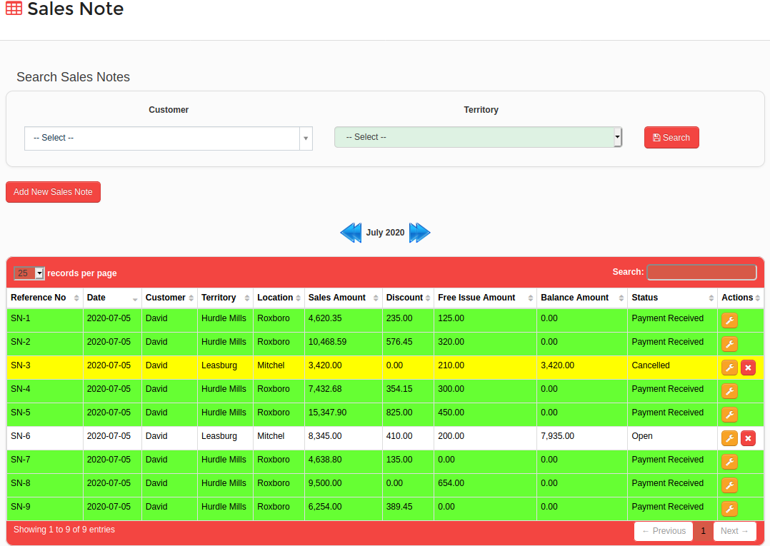
Figure 10

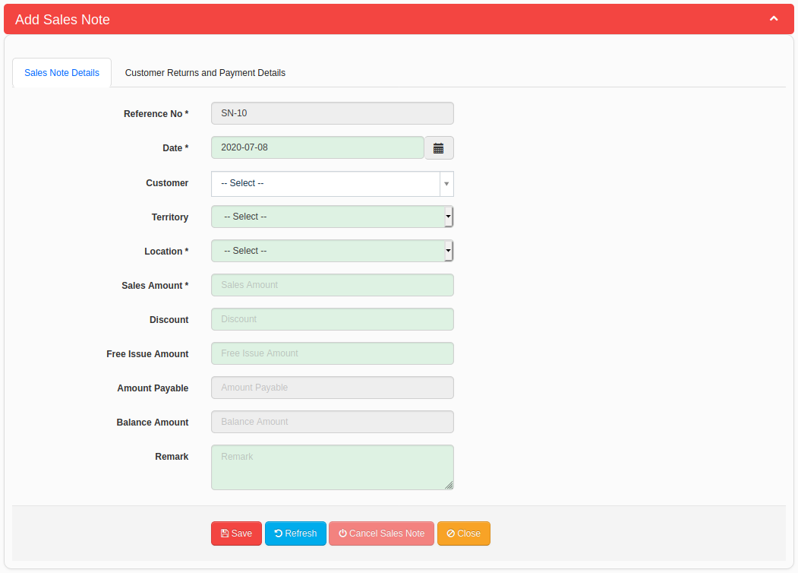
Figure 11

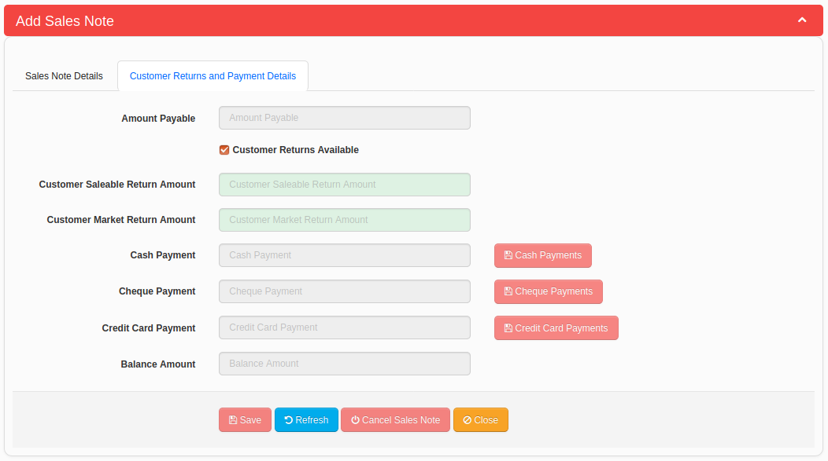
Figure 12

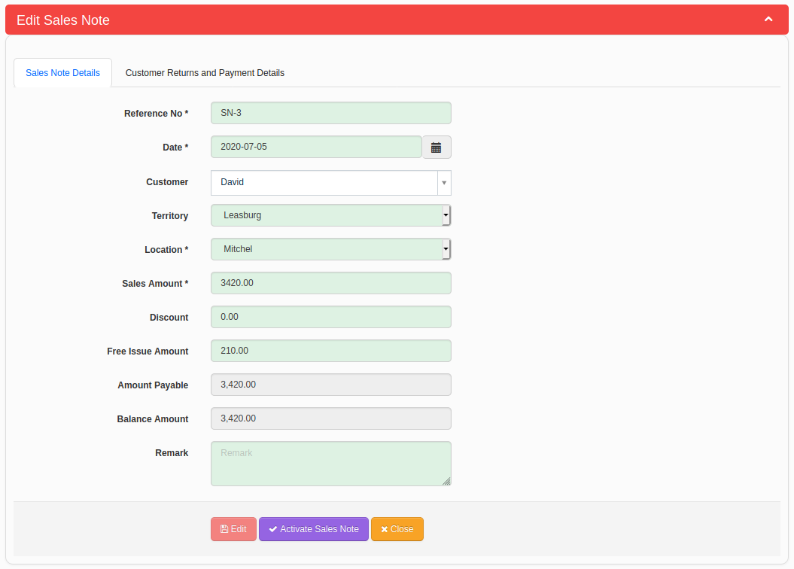
Figure 13

Customer Return Note
Customer Return Notes can be added in “Red Cherries Accounting” from “Bookkeeping → Customer Return Note” menu.
Note : Users will see this screen only if the screen is enabled in configurations.
- Customer Return Note list is displayed in the system as shown in Figure 14.
- A new Customer Return Note can be added by clicking on “Add New Customer Return Note” button as shown in Figure 14.
- Add Customer Return Note screen is as shown Figure 15.
- User can select “Saleable Return” check box if needs to add saleable products received from a customer.
- User can select “Market Return” check box if needs to add damaged/expired products received from a customer.
- When payments are done for customer return notes from “Make Payment” screen, such customer return notes will be highlighted in green and status will mark as “Paid”.

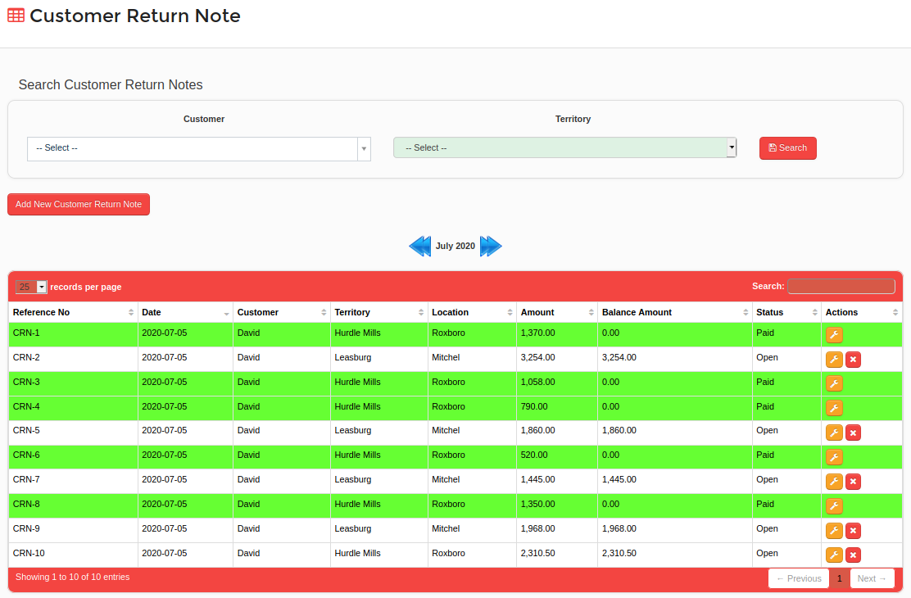
Figure 14

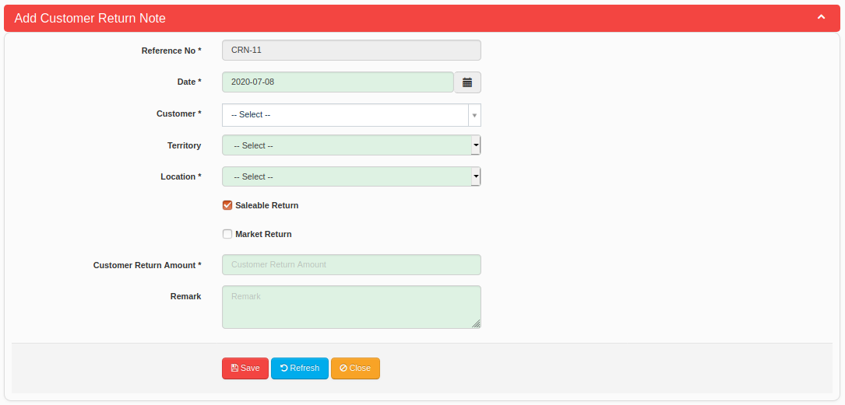
Figure 15

Supplier Return Note
Supplier Return Notes can be added in “Red Cherries Accounting” from “Bookkeeping → Supplier Return Note” menu.
Note : Users will see this screen only if the screen is enabled in configurations.
- Supplier Return Note list is displayed in the system as shown in Figure 16.
- A new Supplier Return Note can be added by clicking on “Add New Supplier Return Note” button as shown in Figure 16.
- Add Supplier Return Note screen is as shown Figure 17.
- User can select “Saleable Return” check box if needs to add saleable products return to a supplier.
- User can select “Market Return” check box if needs to add damaged/expired products return to a supplier.
- When payments are received for supplier return notes from “Receive Payment” screen, such supplier return notes will be highlighted in green and status will mark as “Payment Received”.

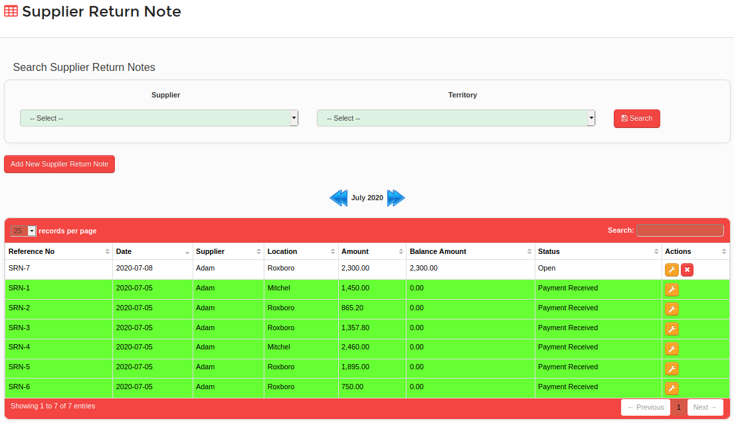
Figure 16

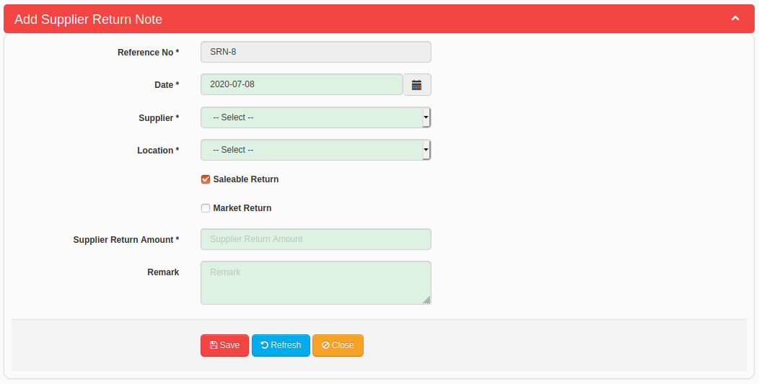
Figure 17

Receive Payment
Receive Payment can be added in “Red Cherries Accounting” from “Bookkeeping → Receive Payment” menu.
- Receive Payment list is displayed in the system as shown in Figure 18.
- A new Receive Payment can be added by clicking on “Add New Receive Payment” button as shown in Figure 18.
- Add Receive Payment screen can be seen as shown Figure 19.
- If “Force To Select A Reference Transaction For Receive A Payment” configuration is enabled, selecting a Reference Transaction is mandatory for the Receive Payment transaction.
- Users can add following transaction types in “Receive Payment” screen.
  - Purchase Note (Adds as a claim transaction and will be a negative amount)
  - Sales Note
  - Supplier Return Note
  - Customer Return Note (Adds as a claim transaction and will be a negative amount)
  - Other (Use this to add other journal entries)
- Users can add following payment methods in “Receive Payment” screen.
  - Cash Payment
  - Cheque Payment
    - For a cheque payment users can add following details.
      - Cheque Number
      - Bank
      - Cheque Date
      - Third Party Cheque
      - Crossed Cheque (If user selects this option system will allow to select Cheque Deposit Account)
      - Amount
      - Cheque Deposit Account
  - Credit Card Payment
    - For a credit card payment users can add following details.
      - Payment Account
      - Card Type
      - Card Payment

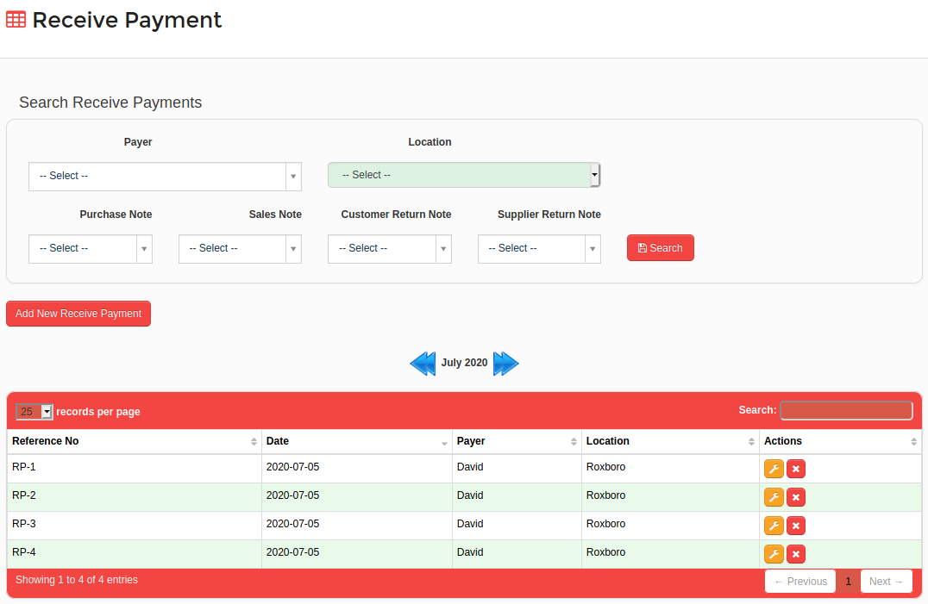
Figure 18

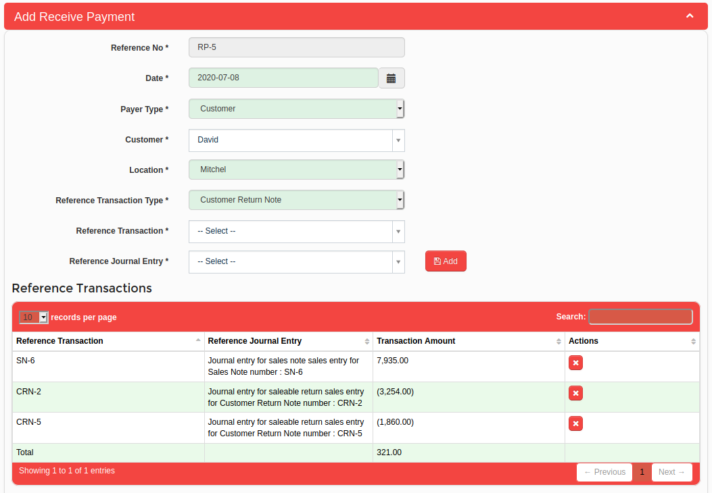
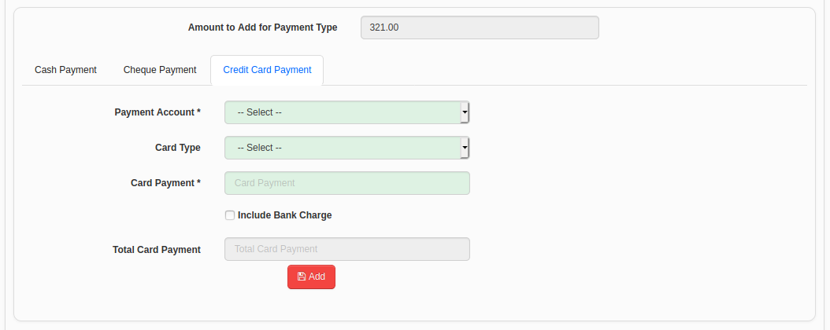
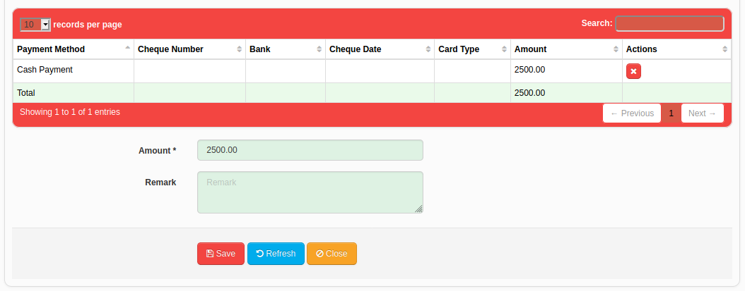
Figure 19

Make Payment
Make Payment can be added in “Red Cherries Accounting” from “Bookkeeping → Make Payment” menu.
- Make Payment list is displayed in the system as shown in Figure 20.
- A new Make Payment can be added by clicking on “Add New Make Payment” button as shown in Figure 20.
- Add Make Payment screen can be seen as shown Figure 21.
- If “Force To Select A Reference Transaction For Make A Payment” configuration is enabled, selecting a Reference Transaction is mandatory for the Make Payment transaction.
- Users can add following transaction types in “Make Payment” screen.
  - Purchase Note
  - Sales Note (Adds as a claim transaction and will be a negative amount)
  - Supplier Return Note (Adds as a claim transaction and will be a negative amount)
  - Customer Return Note
  - Other (Use this to add other journal entries)
- Users can add following payment methods in “Receive Payment” screen.
  - Cash Payment
  - Cheque Payment
    - For a cheque payment users can add following details.
      - Payment Account
      - Cheque Number
      - Bank
      - Cheque Date
      - Amount
  - Second/Third Party Cheque Payment

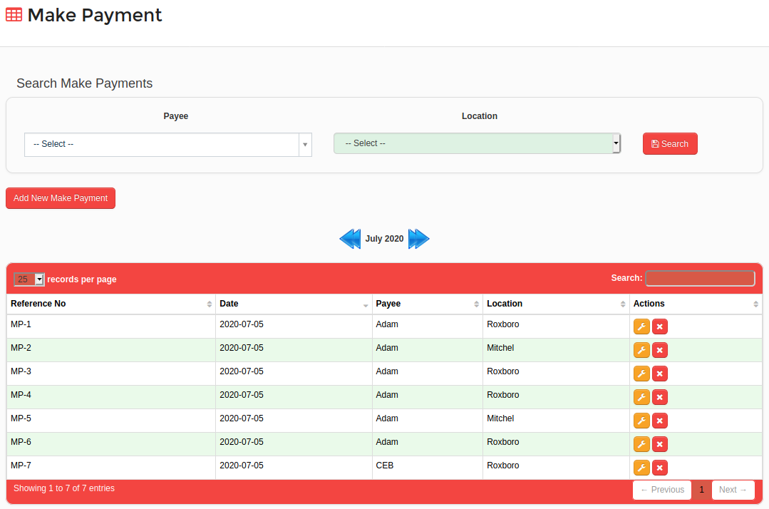
Figure 20

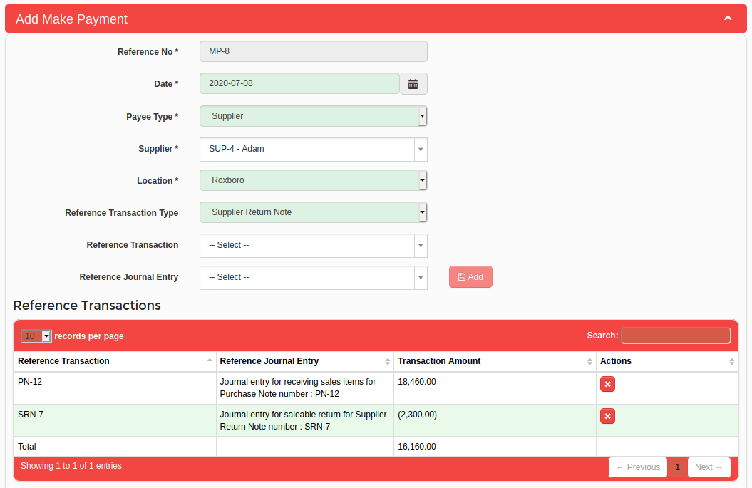
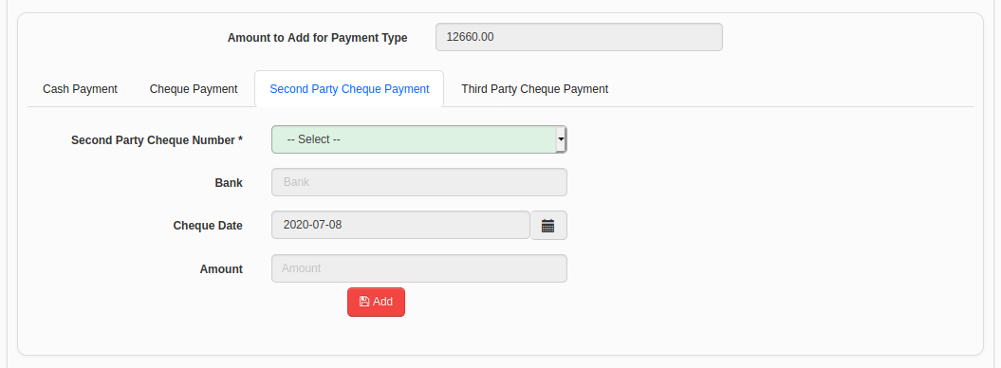
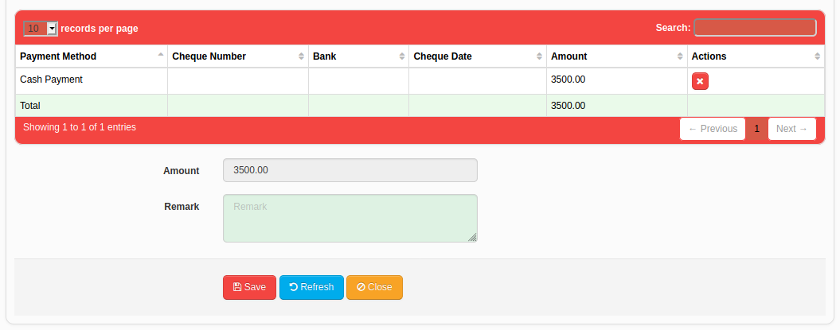
Figure 21

Cheque List
Users can see the cheque list in “Red Cherries Accounting” from “Bookkeeping → Cheque List” menu.
- Users can filter the 'Received” and 'Paid” cheques on the screen shown in Figure 22.
- Received cheques will be highlighted in different colors according to the “Cheque Date' as shown in Figure 22. Following is the list of colors use to highlight cheques.
    - Brown Color – Shows the cheques in hand and Cheque Date has passed.
    - Red Color – Shows the returned cheques.
    - Blue Color – Shows the cheques got cleared from a bank.
    - Yellow Color – Shows the cheques deposited in a bank and pending to be cleared.
    - Dark Purple Color – Shows the cheques which has Cheque Date for today's date.
    - Slightly Dark Purple Color – Shows the cheques which has Cheque Date for tomorrow's date.
    - Light Purple Color – Shows the cheques which has Cheque Date for day after tomorrow's date.
    - White Color – Shows the cheques which has Cheque Date for future date other than above three categories.
Note : If Cheque List configurations are enabled in System Configurations screen, system will update cheque status accordingly.
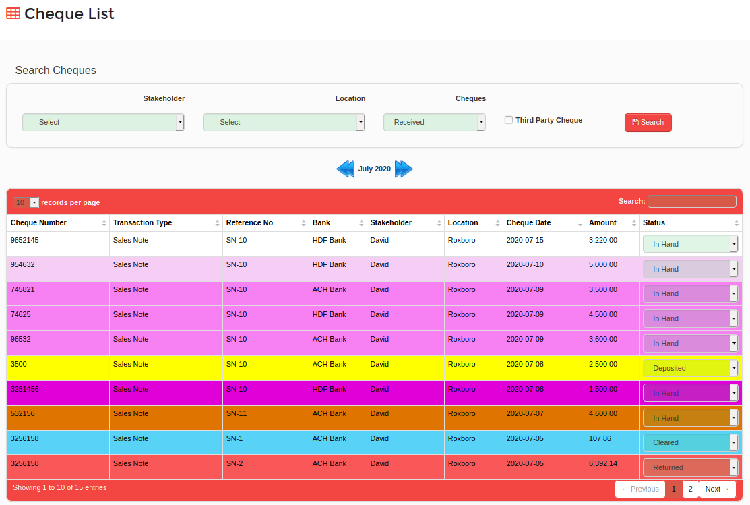
Figure 22

Chart Of Account Balances
Users can see Chart Of Account Balances in “Red Cherries Accounting” from “Bookkeeping → Chart Of Account Balances” menu and balances can be seen as shown in Figure 23.

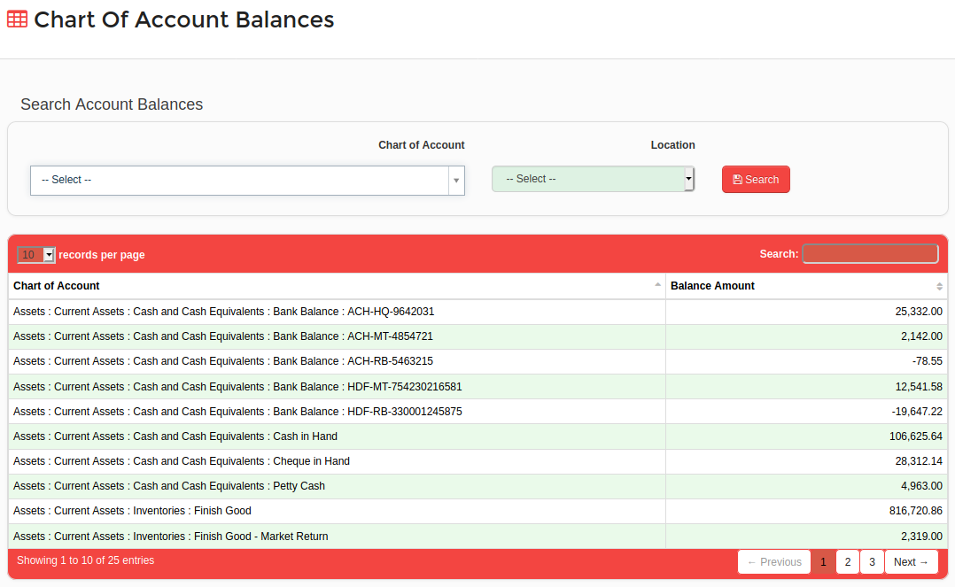
Figure 23

Stakeholder Account Balances
Users can see Stakeholder Account Balances in “Red Cherries Accounting” from “Bookkeeping → Stakeholder Account Balances” menu and balances can be seen as shown in Figure 24.

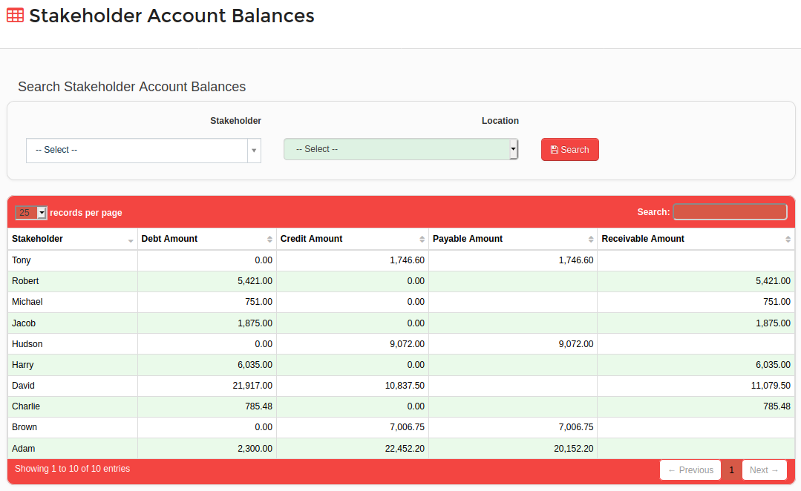
Figure 24

General Ledger
General ledger can be accessed from “Bookkeeping → General Ledger” menu and the general ledger can be seen as shown in Figure 25.
- Users can search the general ledger by date range, prime entry book, chart of account and the location as shown in Figure 25.

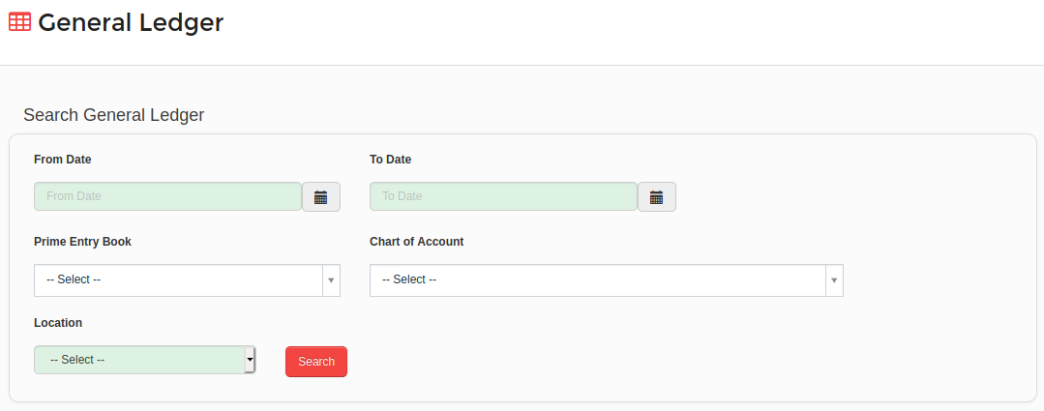
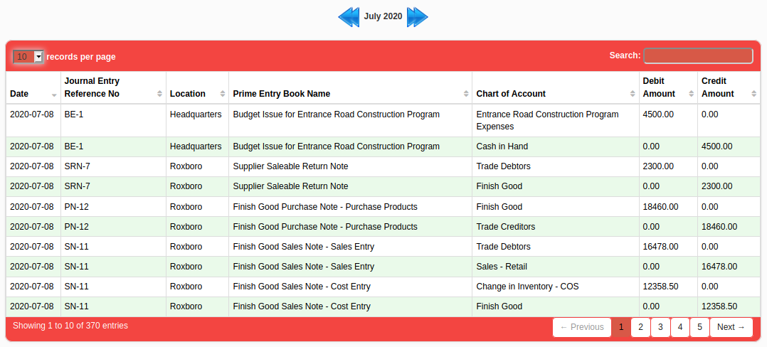
Figure 25

Opening Balances
General ledger can be accessed from “Bookkeeping → Opening Balances” menu and the general ledger can be seen as shown in Figure 26.
- Users can add accounts opening balances as shown in Figure 26.

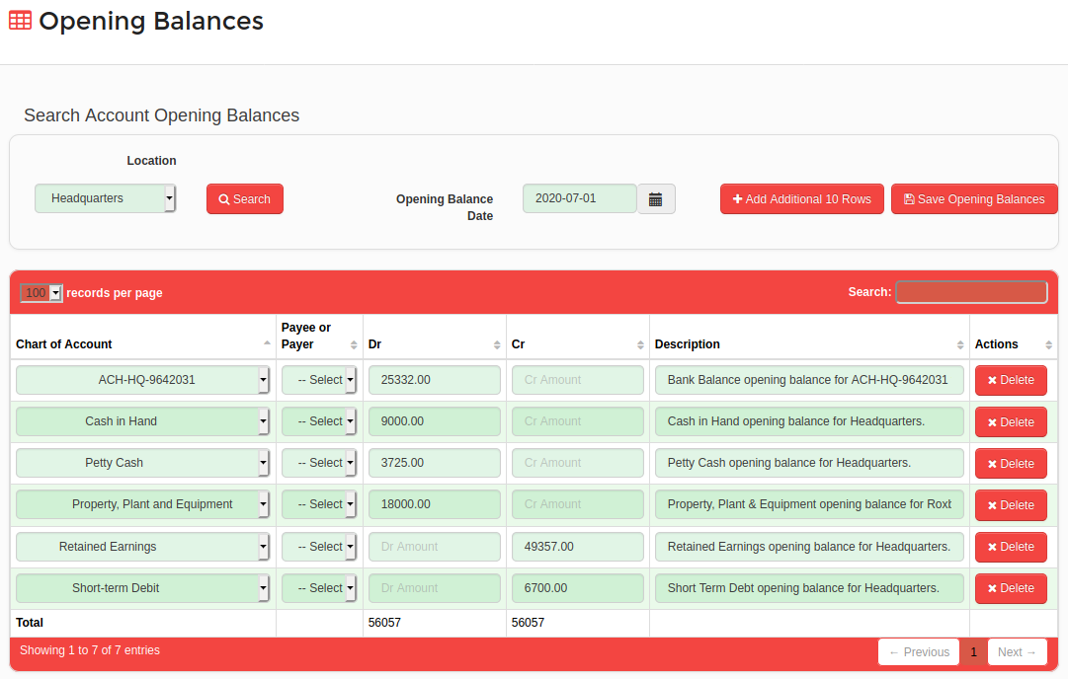
Figure 26

