

Red Cherries Accounting (Open Source)
User Role Manager Module
User Role Manager User Guide
Version 1.0 Beta 1

Table of Contents
Introduction 2
Top Navigation Bar 3
System Module Sections 4
System Module Section Features 5
Default User Roles 6
Derive User Roles 7
Permissions 8
Default User Role Permissions 9
Derive User Role Permissions 11
Users 12

Introduction
This user guide aims at giving you the information required to work with “User Role Manager” module. This user guide can be downloaded from “User Roles Help” screen shown in Figure 2 which is accessible from “ User Roles → Help” menu as shown in Figure 1.

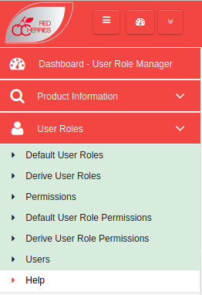

Figure 1

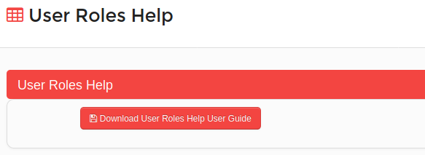

Figure 2

Top Navigation Bar

Toggle Left Menu
Open/Retract System Modules
Change Password
My Language
About System
Logout
System Dashboard
Current Module
Default Module

Figure 3

  - Toggle Left Menu : Show/hide left menu
  - Open/Retract System Modules : Open/retract system module dashboard. Previous screen preserves if user does not select any module.
  - System Dashboard : Opens the system modules dashboard. Previous screen does not preserved.
  - Current Module : Shows the current module that user has selected.
  - Default Module : Selecting current module as default module will allow to go directly to that module on login to the system.

System Module Sections
“Red Cherries Accounting” is structured as “System Modules” and inside each “System Module” there are “System Module Sections”. “System Modules” and “System Module Sections” are enabled in “Red Cherries Accounting” according to the list of modules and sections purchased by a customer. Modules and sections are enabled in a “Red Cherries Accounting” software license file issued to a customer.
System Module Sections screen in “Red Cherries Accounting” can be accessed from “Product Information → System Module Sections” menu.
Figure 4 shows “System Module” list and “System Module Sections” of each “System Module” and their statuses.

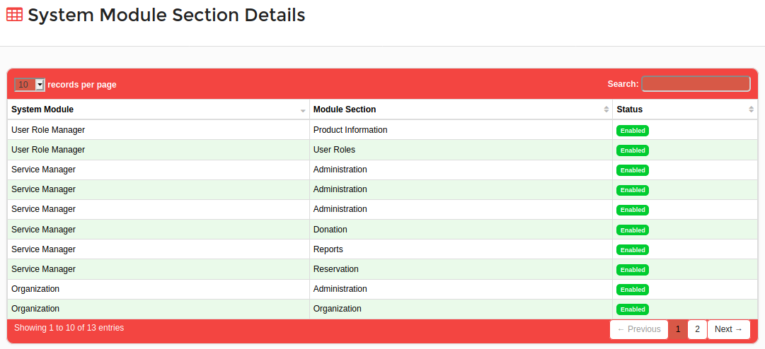
Figure 4

System Module Section Features
Each “System Module Section” of a “System Module” can have one or more “System Module Section Features”. System Module Section Features screen in “Red Cherries Accounting” can be accessed from “Product Information → System Module Section Features” menu.
Figure 5 shows how “Module Section Features” of each an every “System Module Sections” are organized.

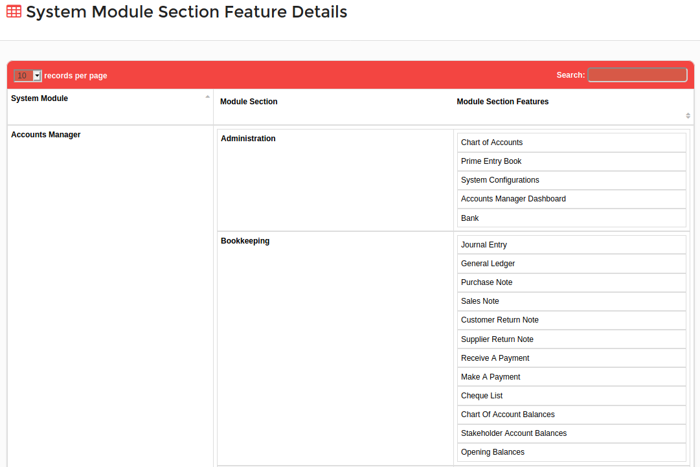
Figure 5

Default User Roles
“Red Cherries Accounting” provides two default user roles shown in Figure 6. Any number of users can be created and assigned these two default user role types. Default User Roles screen in “Red Cherries Accounting” can be accessed from “User Roles → Default User Roles” menu.

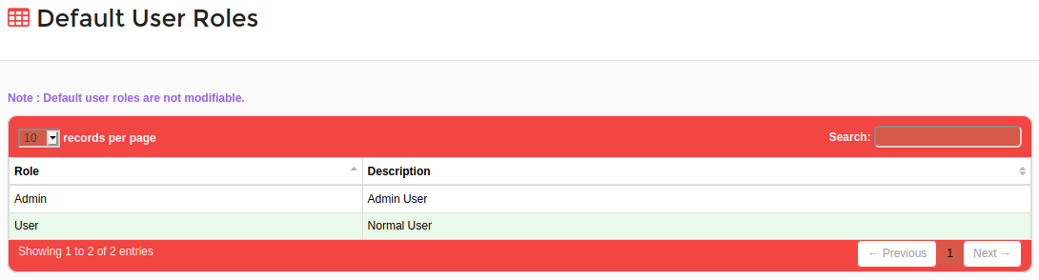
Figure 6

Derive User Roles
If users need to assign custom permissions apart from Default User Role permissions, they should create Derive User Roles using “Admin” or “User” Default User Roles. Derive User Roles screen in “Red Cherries Accounting” can be accessed from “User Roles → Derive User Roles” menu.
- Users can add a Derive User Role by clicking on “Add New Derive User Role” button shown in Figure 7.
- A new form shown in Figure 8 will be opened to add a Derive User Role.
- For “Role” field users has to select a Default User Role type.
- After added a new Derive User Role, the list can be seen as shown in Figure 7.

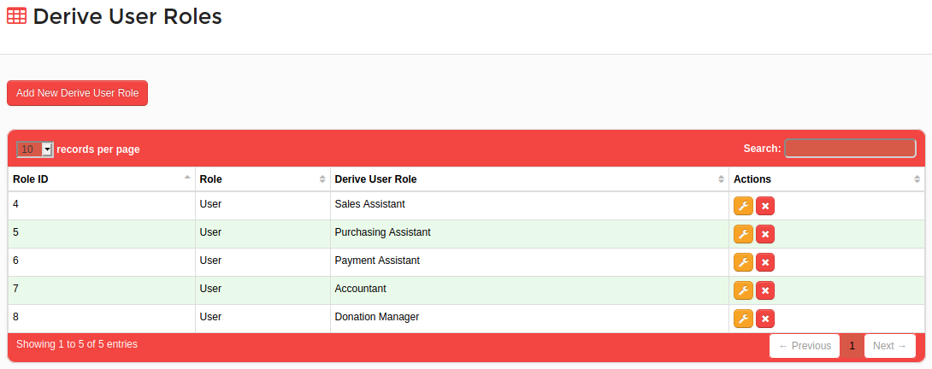
Figure 7

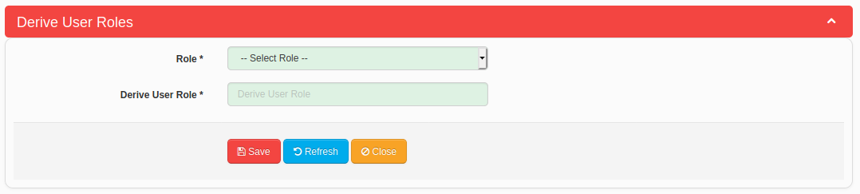
Figure 8

Permissions
In “Red Cherries Accounting” each and every System Module Section Feature has permissions which can be assigned for user roles. There are main four permissions types (Add, Edit, Delete and View). Figure 9 shows how the Permissions are arranged for each System Module Section Feature. Permissions screen in “Red Cherries Accounting” can be accessed from “User Roles → Permissions” menu.

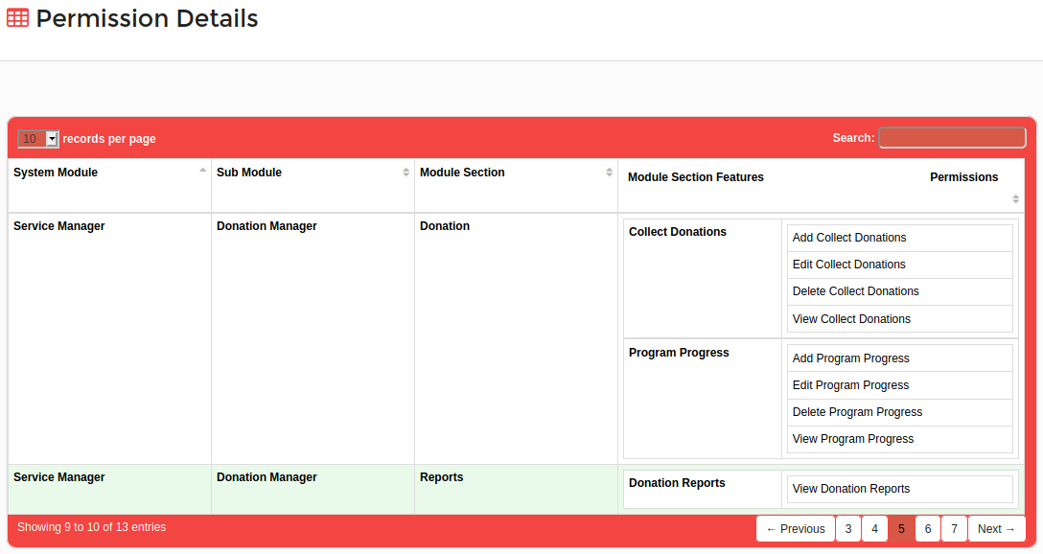
Figure 9

Default User Role Permissions
Each Default User role of “Red Cherries Accounting” has assigned set of Default Permissions. Those Default Permissions cannot be modified. Default User Role Permissions screen in “Red Cherries Accounting” can be accessed from “User Roles → Default User Role Permissions” menu. Figure 10 shows how the Default User Role Permissions are assigned for Default User Roles.
If any System Module Section Feature needs to have permissions other than Add, Edit, Delete or View, such permissions are added as Advanced Permissions in “Red Cherries Accounting”. If any System Module Section Feature has Advanced Permissions, that will be denoted by button as shown in Figure 10.
When clicked on button, users can see a list of Advanced Permissions as shown in Figure 11.

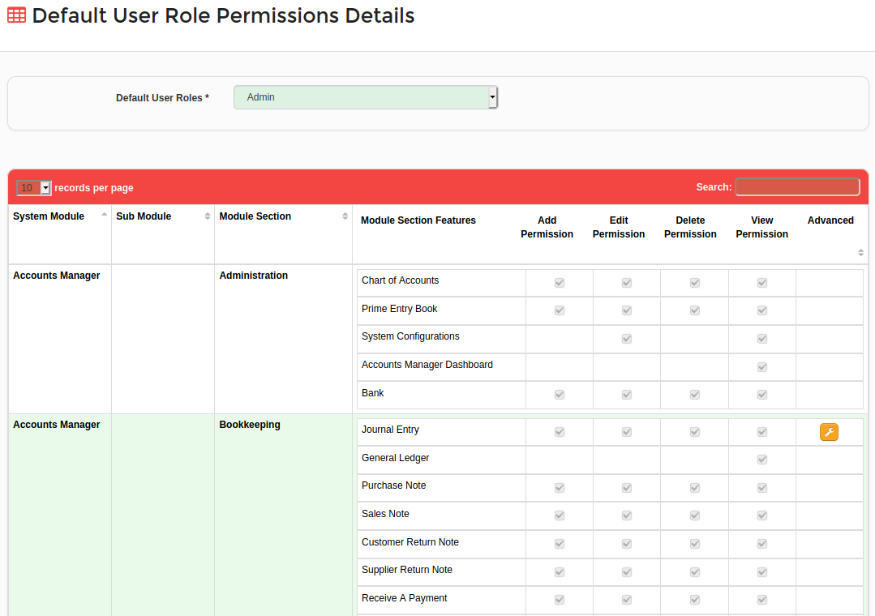
Figure 10

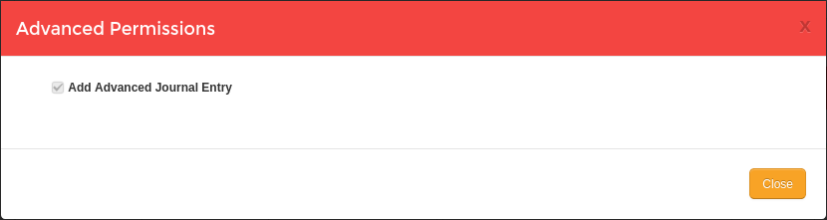
Figure 11

Derive User Role Permissions
Derive User Role Permissions can be assigned for a Derive User Role as required. Derive User Role Permissions screen in “Red Cherries Accounting” can be accessed from “User Roles → Derive User Role Permissions” menu. Figure 12 shows, how users can assign permissions by selecting a Derive User Role.

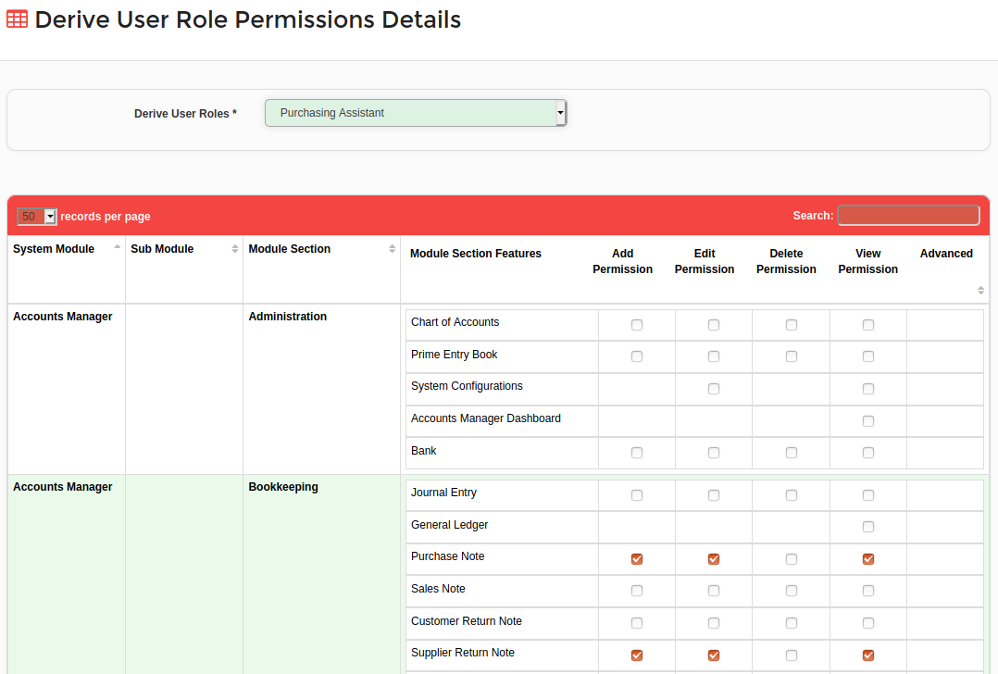
Figure 12

Users
Users of “Red Cherries Accounting” can be accessed from “User Roles → Users” menu.
- Figure 13 show the Users list.
- A new User can be added by clicking on “Add New User” button shown in Figure 13.
- A new form shown in Figure 14 will be opened to add a new User.

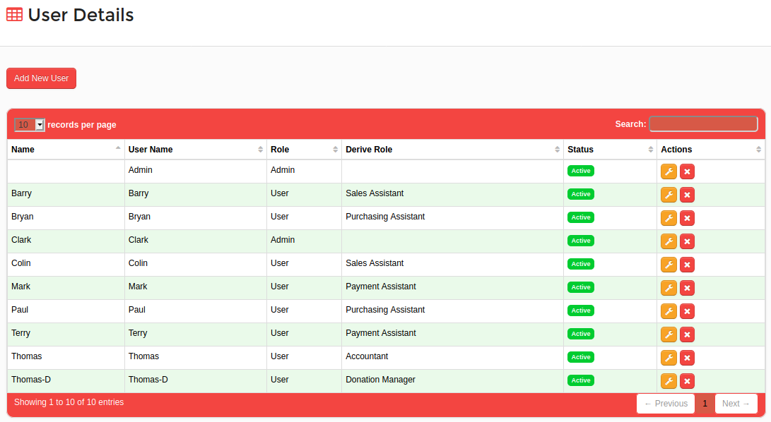
Figure 13

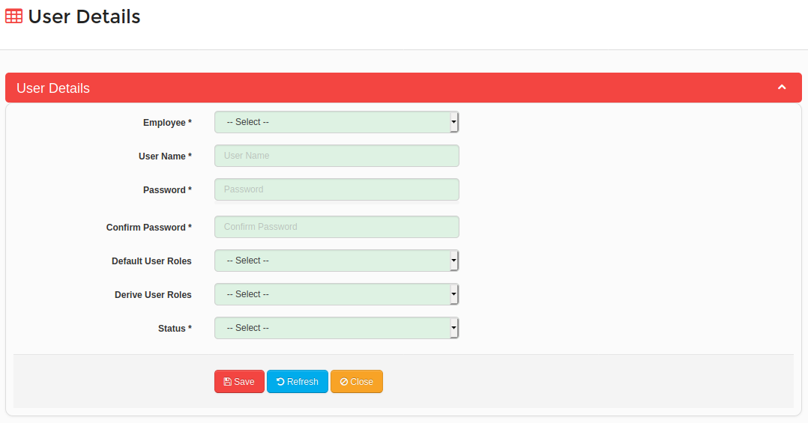

Figure 14

