

e-ER Planner
HR Manager Module
Data Import Workbook User Guide
Version 5.0 Beta 5

Table of Contents
1. Introduction 3
1.1 Data Import Excel Workbook Template Format 5
2. How to Fill Data Import Workbook 7
2.1 Download the Data Import Excel Workbook 7
2.2 Fill Data Import Excel Workbook 8
2.2.1 Fill “Company_Information” sheet 8
2.2.2 Fill “Company_Structure” sheet 9
2.2.3 Fill “Departments” sheet 10
2.2.4 Fill “Locations” sheet 10
2.2.5 Fill “Job_Titles” sheet 12
2.2.6 Fill “Employment_Status” sheet 12
2.2.7 Fill “Job_Categories” sheet 13
2.2.8 Fill “Personal_Details” sheet 13
2.2.9 Fill “Job_Details” sheet 15
2.2.10 Update “Company_List” sheet 17
3. How to Upload Data Import Workbook 19
4. How to Import Data 21
5. FAQ 24

1. Introduction
This user guide gives you information on how to use data import tool of e-ER Planner HR Manager Module. Data import tool allows you to import data when you start using the system. Also the tool can be used while the system is in operations. But there are precautions which should be taken when further using the data import tool. This guide gives all the informations required and it is important to carefully read and understand before start using the tool.
Data import tool can be accessed from “Administration Section”. Menu called “Data Import” is available under “Administration” section as shown in Figure 1.1. When you select “Data Import” menu, system opens the data import screen as shown in Figure 1.2.

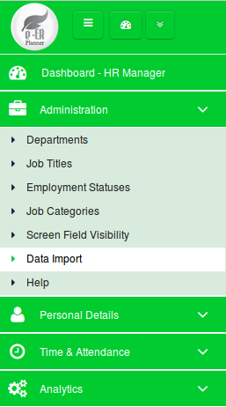

Figure 1.1

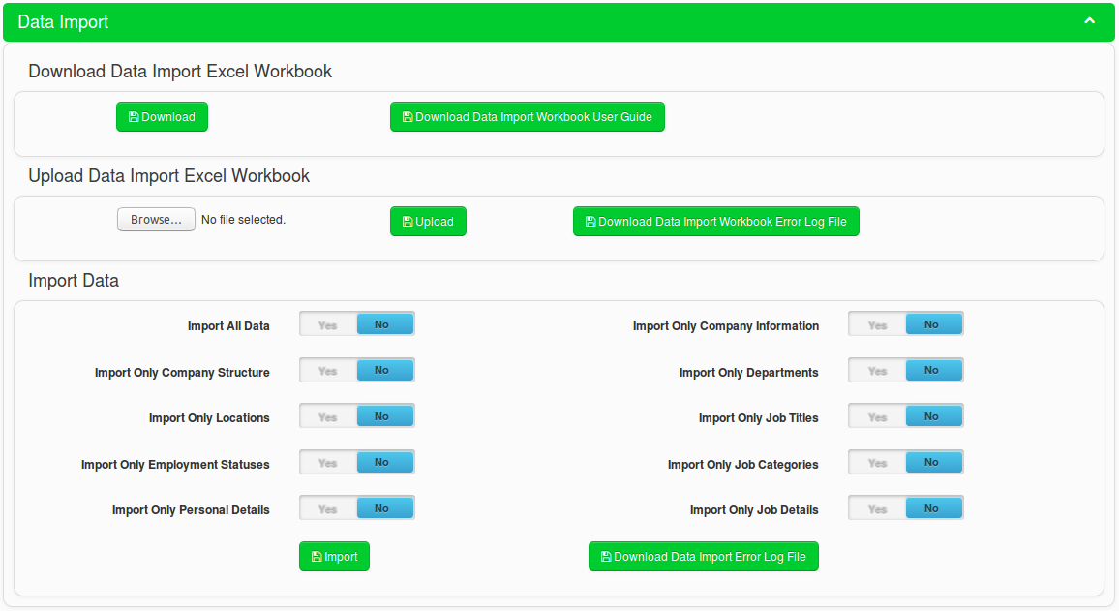
Figure 1.2

The data import process has three steps.
- Download the data import Excel workbook.
- Fill the data import Excel workbook and correct if there are any data issues while uploading.
- Import data to the system from the correctly uploaded data import Excel workbook.

1.1 Data Import Excel Workbook Template Format
The data import Excel workbook has following sheets.
Sheet Name | Description
Instructions | Sheet contains the basic instructions on how to use the template.
Company_Information | Sheet allows you to add the company information. When you import data from this sheet, data will be available in “Company Information” screen available in “Organization” module, under “Organization” section.
Company_Structure | Sheet allows you to add the company structure. When you import data from this sheet, data will be available in “Company Structure” screen available in “Organization” module, under “Organization” section.
Departments | Sheet allows you to add departments. When you import data from this sheet, data will be available in “Departments” screen available in “HR Manager” module, under “Administration” section.
Locations | Sheet allows you to add locations. When you import data from this sheet, data will be available in “Locations” screen available in “Organization” module, under “Administration” section.
Job_Titles | Sheet allows you to add job titles. When you import data from this sheet, data will be available in “Job Titles” screen available in “HR Manager” module, under “Administration” section.
Employment_Status | Sheet allows you to add employment status. When you import data from this sheet, data will be available in “Employment Status” screen available in “HR Manager” module, under “Administration” section.
Job_Categories | Sheet allows you to add job categories. When you import data from this sheet, data will be available in “Job Categories” screen available in “HR Manager” module, under “Administration” section.
Personal_Details | Sheet allows you to add employee personal details. When you import data from this sheet, data will be available in “Employee List” screen available in “HR Manager” module, under “Personal Details” section.
Job_Details | Sheet allows you to add employee job details. When you import data from this sheet, data will be available in “Job Details” screen available in “HR Manager” module, under “Personal Details” section. You have to select an employee from the employee list and click on “View More Details” button to see job details.
TP_Country_Codes | Sheet contains the country list and corresponding telephone codes. This is a reference sheet for following sheets.  - Company_Information  - Locations  - Job_Details
Company_List | Sheet contains the company list. This is a reference sheet for following sheets.  - Departments  - Locations  - Job_Details
Nationality_List | Sheet contains the nationality list. This is a reference sheet for following sheets.  - Personal_Details

2. How to Fill Data Import Workbook
This section gives you information on how to proceed with filling the data import Excel workbook.

2.1 Download the Data Import Excel Workbook

Figure 2.1.1

- Click on the “Download” button from “Download Data Import Excel Workbook” section shown in Figure 2.1.1. to download the data import excel workbook.
- By clicking on “Download Data Import Workbook User Guide” button in Figure 2.1.1 you can download this user guide (Data Import Workbook User Guide).
- Data import Excel workbook has the “Instructions” sheet and gives you the following instructions as shown in Figure 2.1.2.
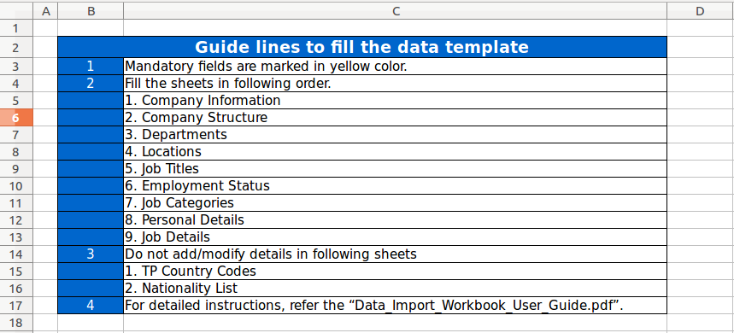
Figure 2.1.2

2.2 Fill Data Import Excel Workbook
This is the most important step of the data import task. You need to make sure your data is filled into the Excel workbook properly before you upload the data template. Therefore, carefully read following sections and fill the data import Excel workbook accordingly. If you have any doubts, refer 5. FAQ section in this guide for information or directly contact support service of e-ER Planner.

2.2.1 Fill “Company_Information” sheet

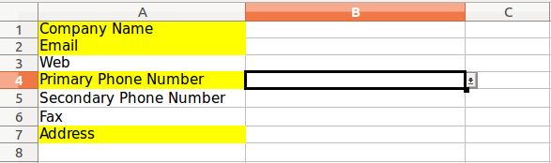

Figure 2.2.1.1
- Enter the company name into B1 cell as shown in Figure 2.2.1.1.
- Enter the company e-mail address into B2 cell as shown in Figure 2.2.1.1.
- Enter the company web address into B3 cell as shown in Figure 2.2.1.1.
- When entering the primary phone number of the company, follow the following steps.
  - First select the country from B4 cell. B4 cell has a drop down box which has country list. To see the list, click on the down arrow button which you can see when clicked on B4 cell.
Note : When system imports data, it will automatically select the telephone country code of
the selected country.

  - Next enter the primary phone number into C4 cell as shown in Figure 2.2.1.1.
- When entering the secondary phone number of the company, follow the following steps.
  - First select the country from B5 cell. B5 cell has a drop down box which has country list. To see the list, click on the down arrow button which you can see when clicked on B5 cell.
Note : When system imports data, it will automatically select the telephone country code of
the selected country.

  - Next enter the secondary phone number into C5 cell as shown in Figure 2.2.1.1.
- Enter the fax number of the company into B6 cell as shown in Figure 2.2.1.1.
- Enter the address into B7 cell as shown in Figure 2.2.1.1.

2.2.2 Fill “Company_Structure” sheet

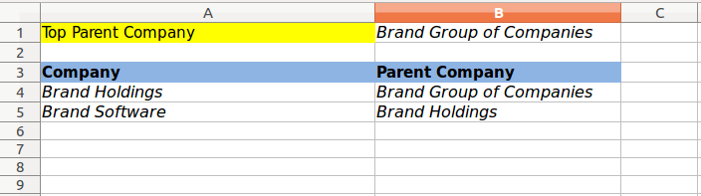

Figure 2.2.2.1
- Enter your top parent company name into B1 cell as shown in Figure 2.2.2.1.
Ex : Brand Group of Companies
Note : If you have only one company, still you have to enter your company name into B1 cell as
shown in Figure 2.2.2.1.

- If you have group of companies, subsidiaries should be entered into the sheet as follows.
  - First enter the second level of subsidiaries. Enter the second level of subsidiary names into A4, A5 etc. At the same time enter the parent company name into B4, B5 etc.
Ex : Brand Holdings is a subsidiary under Brand Group of Companies. So enter Brand Holdings company name into A4 cell as shown in Figure 2.2.2.1. At the same time enter Brand Group of Companies company name into B4 cell as shown in Figure 2.2.2.1.
  - Then enter the third level and fourth level of subsidiary names and their corresponding parent company names.
Ex : Brand Software is a subsidiary under Brand Holdings. So enter Brand Software company name into A5 cell as shown in Figure 2.2.2.1. At the same time enter Brand Holdings company name into B5 cell as shown in Figure 2.2.2.1.
Note : After you add companies in “Company_Structure” sheet, you need to update the
“Company_List” sheet. Refer 2.2.10 Update “Company_List” sheet section to see
instructions on how to update “Company_List” sheet.

2.2.3 Fill “Departments” sheet

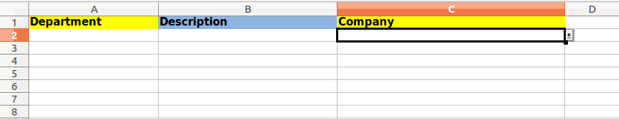
Figure 2.2.3.1
- Enter the department names into A2, A3 etc. cells as shown in Figure 2.2.3.1.
- Enter a description for each departments into B2, B3 etc. cells as shown in Figure 2.2.3.1.
- Select the company name in which each department belongs to from C2, C3 etc. cells as shown in Figure 2.2.3.1. C2, C3 etc. cells have a drop down box which has the company name list. To see the list, click on the down arrow button which you can see when clicked on C2, C3 etc. cells.
Note : Department and Company cells are mandatory when you enter data.

2.2.4 Fill “Locations” sheet

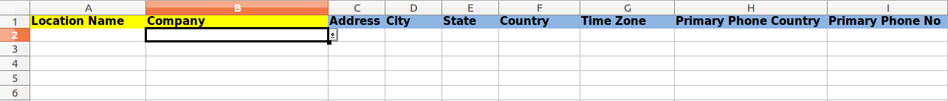
Figure 2.2.4.1
- Enter the locations names into A2, A3 etc. cells as shown in Figure 2.2.4.1
- Select the company name in which each location belongs to from B2, B3 etc. cells as shown in Figure 2.2.4.1. B2, B3 etc. cells have a drop down box which has the company name list. To see the list, click on the down arrow button which you can see when clicked on B2, B3 etc. cells.
Note : Location and Company cells are mandatory when you enter data.
- Enter the address of each location into C2, C3 etc. cells.
- Enter the city of each location into D2, D3 etc. cells.
- Enter the state of each location into E2, E3 etc. cells.
- Select the country name in which each location belongs to from F2, F3 etc. cells as shown in Figure 2.2.4.1. F2, F3 etc. cells have a drop down box which has the country name list. To see the list, click on the down arrow button which you can see when clicked on F2, F3 etc. cells.
- Select the time zone name of each location from G2, G3 etc. cells as shown in Figure 2.2.4.1. G2, G3 etc. cells have a drop down box which has the time zone list. To see the list, click on the down arrow button which you can see when clicked on G2, G3 etc. cells.
- When entering the primary phone number of the location, follow the following steps.
  - First select the country from H2 cell. H2 cell has a drop down box which has country list. To see the list, click on the down arrow button which you can see when clicked on H2 cell.
Note : When system imports data, it will automatically select the telephone country code of
the selected country.

  - Next enter the primary phone number into I2 cell as shown in Figure 2.2.4.1.
- When entering the secondary phone number of the location, follow the following steps.
  - First select the country from J2 cell. J2 cell has a drop down box which has country list. To see the list, click on the down arrow button which you can see when clicked on J2 cell.
Note : When system imports data, it will automatically select the telephone country code of
the selected country.

  - Next enter the secondary phone number into K2 cell.

2.2.5 Fill “Job_Titles” sheet

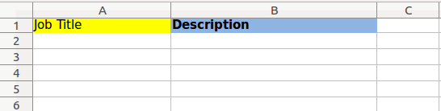

Figure 2.2.5.1
- Enter the job titles into A2, A3 etc. cells as shown in Figure 2.2.5.1.
- Enter the descriptions of job titles into B2, B3 etc. cells as shown in Figure 2.2.5.1.
Note : Job Title cell is mandatory when you enter data.

2.2.6 Fill “Employment_Status” sheet

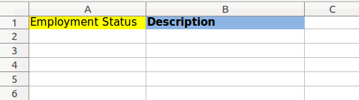

Figure 2.2.6.1
- Enter employment statuses into A2, A3 etc. cells as shown in Figure 2.2.6.1.
- Enter descriptions of employment statuses into B2, B3 etc. cells as shown in Figure 2.2.6.1.
Note : Employment Status cell is mandatory when you enter data.

2.2.7 Fill “Job_Categories” sheet

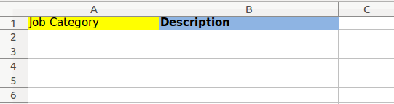

Figure 2.2.7.1
- Enter job categories into A2, A3 etc. cells as shown in Figure 2.2.7.1.
- Enter descriptions of job categories into B2, B3 etc. cells as shown in Figure 2.2.7.1.
Note : Job Category cell is mandatory when you enter data.

2.2.8 Fill “Personal_Details” sheet

Figure 2.2.8.1
- Enter the employee id (A unique integer to identify the employee throughout the system. It should not have any letters. This will be the database level key and will not be sown in the front end of the application) into A2, A3 etc. cells as shown in Figure 2.2.8.1.
- Enter the first name of employees into B2, B3 etc. cells as shown in Figure 2.2.8.1.
Note : Employee ID and First Name cells are mandatory when you enter data. All the other
cells are optional.

- Enter the middle name of employees into C2, C3 etc. cells as shown in Figure 2.2.8.1.
- Enter the last name of employees into D2, D3 etc. cells as shown in Figure 2.2.8.1.
- Select the gender of employees from E2, E3 etc. cells as shown in Figure 2.2.8.1. E2, E3 etc. cells have a drop down box which has the gender list. To see the list, click on the down arrow button which you can see when clicked on E2, E3 etc. cells.
- Select the marital status of employees from F2, F3 etc. cells as shown in Figure 2.2.8.1. F2, F3 etc. cells have a drop down box which has the marital status list. To see the list, click on the down arrow button which you can see when clicked on F2, F3 etc. cells.
- Select the nationality of employees from G2, G3 etc. cells as shown in Figure 2.2.8.1. G2, G3 etc. cells have a drop down box which has the nationality list. To see the list, click on the down arrow button which you can see when clicked on G2, G3 etc. cells.
- Enter the date of birth of employees into H2, H3 etc. cells as shown in Figure 2.2.8.1.
Note : Date of birth date format should be yyyy-mm-dd.
Hint : Do not use a date format. Just use text format and enter the date in yyyy-mm-dd format.
- Enter the nick name of employees into I2, I3 etc. cells as shown in Figure 2.2.8.1.
- Enter other names of employees into J2, J3 etc. cells as shown in Figure 2.2.8.1.
- Select whether the employee is a drinker or not in K2, K3 etc. cells as shown in Figure 2.2.8.1. K2, K3 etc. cells have a drop down box which has Yes/No options. To see the list, click on the down arrow button which you can see when clicked on K2, K3 etc. cells.
- Select whether the employee is a smoker or not in L2, L3 etc. cells as shown in Figure 2.2.8.1. L2, L3 etc. cells have a drop down box which has Yes/No options. To see the list, click on the down arrow button which you can see when clicked on L2, L3 etc. cells.

2.2.9 Fill “Job_Details” sheet

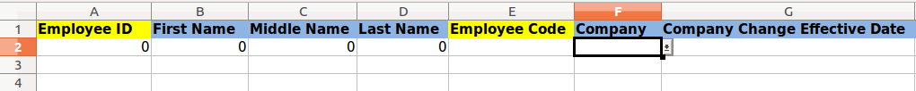
Figure 2.2.9.1
- It is not required to enter values into following cells. Values for those cells will be automaticall taken when you enter data in “Personal_Details” sheet.
  - Employee ID – A2, A3 etc. cells
  - First Name – B2, B3 etc. cells
  - Middle Name – C2, C3 etc. cells
  - Last Name – D2, D3 etc. cells
Note : In order to automatically fill the above fields, you need to copy the formula in each cell
to the other cells of a column. By default the formula is added to A2, B2, C2 and D2
cells. To copy the formula, click on a cell (Ex: A2). You will notice a small box lower
right corner of the cell. Take your mouse pointer onto the small box and drag it down
until you see the last employee in “Personal_Details” sheet. If you see 0s adding when
you drag down, stop draging and make sure to delete 0s. You need to do this for all A, B,
C and D columns.

- Enter the employee code into E2, E3 etc. cells for each employee.
Note : You can decide a convention for the employee code and the code can have integers as
well as characters. Also note that the Employee Code cell is mandatory when you enter
data. Also make sure to add a unique employee code for each employee.

- Select the company name of employee from F2, F3 etc. cells as shown in Figure 2.2.9.1. F2, F3 etc. cells have a drop down box which has the company name list. To see the list, click on the down arrow button which you can see when clicked on F2, F3 etc. cells.
- Enter the company change effective date to G2, G3 etc. cells as shown in Figure 2.2.9.1.
Note : Date format should be yyyy-mm-dd.
Hint : Do not use a date format. Just use text format and enter the date in yyyy-mm-dd format.
- Select the department code of employee from H2, H3 etc. cells (Figure 2.2.9.1 does not show the columns H onwards. Please refer the data template Excel workbook to see those columns). H2, H3 etc. cells have a drop down box which has the department code list. To see the list, click on the down arrow button which you can see when clicked on H2, H3 etc. cells.
- Enter the department change effective date to I2, I3 etc. cells.
Note : Date format should be yyyy-mm-dd.
Hint : Do not use a date format. Just use text format and enter the date in yyyy-mm-dd format.
- Select the location code of employee from J2, J3 etc. cells . J2, J3 etc. cells have a drop down box which has the location code list. To see the list, click on the down arrow button which you can see when clicked on J2, J3 etc. cells.
- Enter the location change effective date to K2, K3 etc. cells.
Note : Date format should be yyyy-mm-dd.
Hint : Do not use a date format. Just use text format and enter the date in yyyy-mm-dd format.
- Select the job title of employee from L2, L3 etc. cells . L2, L3 etc. cells have a drop down box which has the job title list. To see the list, click on the down arrow button which you can see when clicked on L2, L3 etc. cells.
- Enter the job title change effective date to M2, M3 etc. cells.
Note : Date format should be yyyy-mm-dd.
Hint : Do not use a date format. Just use text format and enter the date in yyyy-mm-dd format.
- Select the employment status of employee from N2, N3 etc. cells . N2, N3 etc. cells have a drop down box which has the employment status list. To see the list, click on the down arrow button which you can see when clicked on N2, N3 etc. cells.
- Enter the employment status change effective date to O2, O3 etc. cells.
Note : Date format should be yyyy-mm-dd.
Hint : Do not use a date format. Just use text format and enter the date in yyyy-mm-dd format.
- Select the job category of employee from P2, P3 etc. cells . P2, P3 etc. cells have a drop down box which has the job category list. To see the list, click on the down arrow button which you can see when clicked on P2, P3 etc. cells.
- Enter the job category change effective date to Q2, Q3 etc. cells.
Note : Date format should be yyyy-mm-dd.
Hint : Do not use a date format. Just use text format and enter the date in yyyy-mm-dd format.
Note : Career path is not implemented with version 1.0. So please keep colum R and S empty.
- Select the working country of employee from T2, T3 etc. cells . T2, T3 etc. cells have a drop down box which has the country list. To see the list, click on the down arrow button which you can see when clicked on T2, T3 etc. cells.
- Enter the working country change effective date to U2, U3 etc. cells.
Note : Date format should be yyyy-mm-dd.
Hint : Do not use a date format. Just use text format and enter the date in yyyy-mm-dd format.

2.2.10 Update “Company_List” sheet

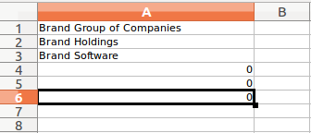

Figure 2.2.10.1

- This sheet is a reference sheet for the following sheets. You need to make sure the sheet is properly updated after you adding the companies in “Company_Structure” sheet.
  - Departments
  - Locations
  - Job_Details

- In order to update the sheet, follow the following steps.
  - You do not need to update A1 cell.
  - If you do not have subsidiaries, A2, A3 etc. cells will show 0s. If so, delete all 0s.
  - If you have subsidiaries more than 5, by default sheet will not show all subsidiaries. To see the other subsidiaries, click on A6 cell. You will notice a small box lower right corner of the cell. Take you mouse pointer onto the small box and drag it down until you see all subsidiaries you have entered in “Company_Structure” sheet. If you see 0s adding when you drag down, stop dragging and make sure to delete 0s.

3. How to Upload Data Import Workbook
After you completed filling data import Excel workbook, next step is to upload the workbook into the system.

Figure 3.1
In order to upload the data import Excel workbook into the system, follow the following steps.

- First select the file by clicking on “Browse” button as shown in Figure 3.1.
- Then click on the “Upload” button as shown in Figure 3.1 and wait until the systems give you a message on the upload status.
- When uploading the data import Excel workbook system verifies the data and make sure you have given data accurately so that data can be imported into the system successfully.
- If data is verified successfully by the system and data you have given in the workbook is accurate, system will display the following success message.
Figure 3.2
- If system finds data issues from the workbook, system will display the following error message.
Figure 3.3
- If there are issues, system creates a error log file and you can download it by clicing the “Download Data Import Workbook Error Log File” button as shown in Figure 3.1. Figure 3.4 shows a sample error details which you can see from the error log file.
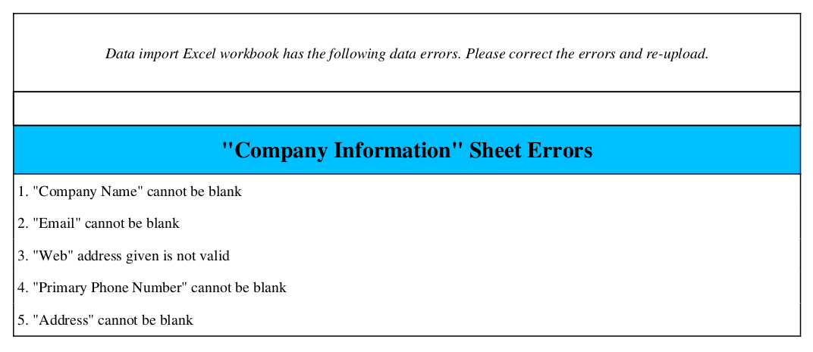
Figure 3.4
- When you have errors you have to correct the errors on data import Excel workbook and again re-upload the workbook.
- Once the data import Excel workbook is successfully uploaded, you are ready to import data.

4. How to Import Data
Once the data import Excel workbook is successfully uploaded to the system, you can import data. Follow the following instructions to proceed with data import.

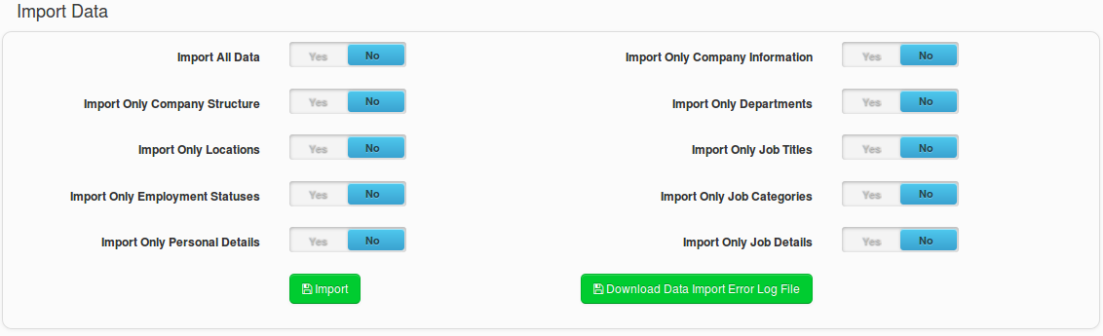
Figure 4.1
- When you import data, you have following options as shown in Table 4.1.
Data Import Option | Description
Import All Data | System imports all data from following sheets in data import Excel workbook.  - Company_Information  - Company_Structure  - Departments  - Locations  - Job_Titles  - Employment_Status  - Job_Categories  - Personal_Details  - Job_Details
Import Only Company Information | System imports data only from “Company_Information” sheet in data import Excel workbook.
Import Only Company Structure | System imports data only from “Company_Structure” sheet in data import Excel workbook.
Import Only Departments | System imports data only from “Departments” sheet in data import Excel workbook.
Import Only Locations | System imports data only from “Locations” sheet in data import Excel workbook.
Import Only Job Titles | System imports data only from “Job_Titles” sheet in data import Excel workbook.
Import Only Employment Statuses | System imports data only from “Employment_Status” sheet in data import Excel workbook.
Import Only Job Categories | System imports data only from “Job_Categories” sheet in data import Excel workbook.
Import Only Personal Details | System imports data only from “Personal_Details” sheet in data import Excel workbook.
Import Only Job Details | System imports data only from “Job_Details” sheet in data import Excel workbook.

Table 4.1

Note : System allows only one import option to be selected at once. If you select multiple
import options, system will show the following error message as shown in Figure 4.2.

Figure 4.2
- If the system is able to successfully import the data from the import option you have selected, the system will show the following success message as shown in Figure 4.3.
Figure 4.3

- If the system is not able to successfully import the data from the import option you have selected, the system will show the following error message as shown in Figure 4.3.
Figure 4.4
- If there are issues with the data import, you can see error log file by clicking on “Download Data Import Error Log File” button as shown in Figure 4.1. Figure 4.5 shows a sample data import error log details.
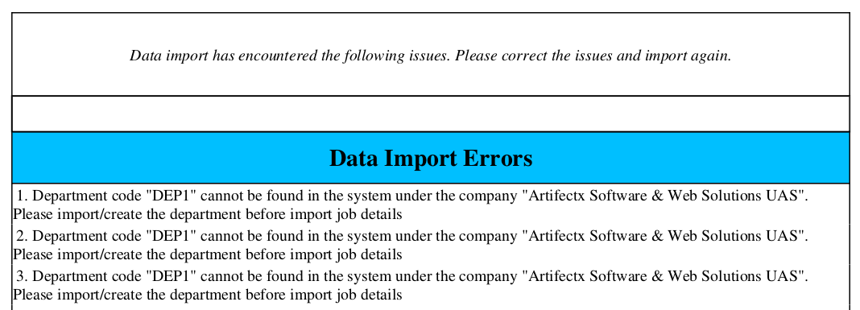
Figure 4.5
- If you have data import errors, correct the errors (If there is any) and then re-upload/re-import data accordingly.

5. FAQ
This section contains Frequently Asked Questions (FAQ) and corresponding answers.
Question - 1 : What time should I use the data import Excel workbook?
Answer - 1 : You can use the data import Excel workbook if you have many data to be added into the system. For an example when you are going to use the system for first time, you have to add all your HR information. If you have less number of information, you can add to the system via screens given in the system. But if you have more information, you can fill data into the data import Excel workbook and import into the system. Also later when you use the system if you have many data to be added/updated, still you can use the data import Excel workbook.

Question - 2 : If I accidentally upload data more than once with no data changes, will the system duplicate data?
Answer - 2 : System will not duplicate data when you import more than once with no data changes. System will update the existing records.

Question - 3 : If I import data multiple times with data changes, will system record the history of data changes?
Answer - 3 : System will capture the history for “Personal Details” and “Job Details” when you import data multiple times with data changes.

Question - 4 : If I use data import in the following scenario, what will be the system behavior?
Scenario : I have used the data import Excel workbook when I start using the system for the first time. After that I have done the data changes/data additions from screens in the system. Now I have to add some more data and I want to use the data import Excel workbook.
Answer - 4 : Using data import Excel workbook in this scenario is risky and may result inconsistent behaviors. It is possible to loose latest data changes. Therefore it is advised to keep your data import Excel workbook updated. That means if you wish to use data import Excel workbook multiple time, it is advised to do all data changes via the data import Excel workbook.

