

e-ER Planner
Organization Manager Module
Data Import Workbook User Guide
Version 5.0 Beta 5

Table of Contents
1. Introduction 3
1.1 Data Import Excel Workbook Template Format 5
2. How to Fill Data Import Workbook 6
2.1 Download the Data Import Excel Workbook 6
2.2 Fill Data Import Excel Workbook 7
2.2.1 Fill “People” sheet 7
3. How to Upload Data Import Workbook 9
4. How to Import Data 11
5. FAQ 13

1. Introduction
This user guide gives you information on how to use data import tool of e-ER Planner Organization Manager Module. Data import tool allows you to import data when you start using the system. Also the tool can be used while the system is in operations. This guide gives all the informations required and it is important to carefully read and understand before start using the tool.
Data import tool can be accessed from “Administration Section”. Menu called “Data Import” is available under “Administration” section as shown in Figure 1.1. When you select “Data Import” menu, system opens the data import screen as shown in Figure 1.2.

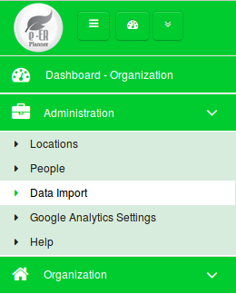

Figure 1.1

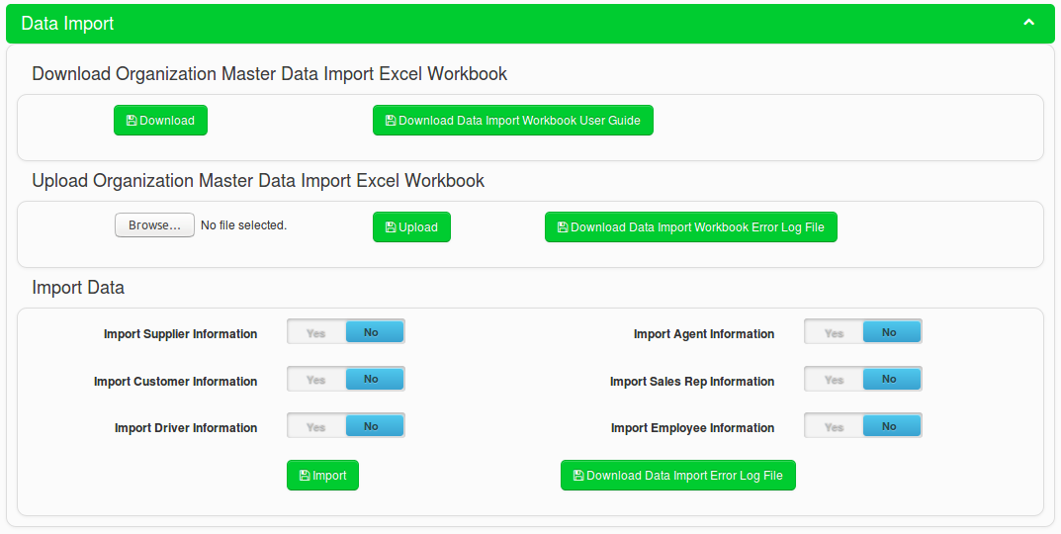
Figure 1.2

The data import process has three steps.
- Download the data import Excel workbook.
- Fill the data import Excel workbook and correct if there are any data issues while uploading.
- Import data to the system from the correctly uploaded data import Excel workbook.

1.1 Data Import Excel Workbook Template Format
The data import Excel workbook is named as “Organization_Manager_Data_Template” and has following sheets.
Sheet Name | Description
Instructions | Sheet contains the basic instructions on how to use the template.
People | Sheet allows you to add people information. When you import data from this sheet, data will be available in “People” screen available in “Organization” module, under “Administration” section.
TP_Country_Codes | Sheet contains the country list and corresponding telephone codes. This is a reference sheet for following sheets.  - People

2. How to Fill Data Import Workbook
This section gives you information on how to proceed with filling the data import Excel workbook.

2.1 Download the Data Import Excel Workbook


Figure 2.1.1
- Click on the “Download” button from “Download Organization Mater Data Import Excel Workbook” section shown in Figure 2.1.1. to download the data import excel workbook.
- By clicking on “Download Data Import Workbook User Guide” button in Figure 2.1.1 you can download this user guide (Organization Data Import Workbook User Guide).
- Data import Excel workbook has the “Instructions” sheet and gives you the following instructions as shown in Figure 2.1.2.
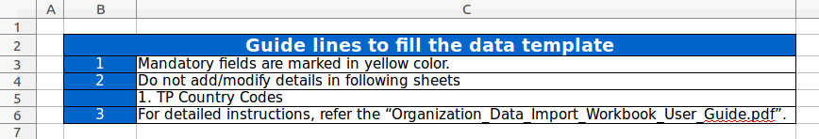
Figure 2.1.2

2.2 Fill Data Import Excel Workbook
This is the most important step of the data import task. You need to make sure your data is filled into the Excel workbook properly before you upload the data template. Therefore, carefully read following sections and fill the data import Excel workbook accordingly. If you have any doubts, refer 5. FAQ section in this guide for information or directly contact support service of e-ER Planner.

2.2.1 Fill “People” sheet

Figure 2.2.1.1
- Enter a unique people code into A1 cell as shown in Figure 2.2.1.1. “People Code” is a mandatory field and therefore highlighted in yellow color.
- Enter a people name into B1 cell as shown in Figure 2.2.1.1. “People Name” field is a mandatory field and therefore highlighted in yellow color.
- Enter an address into C1 cell as shown in Figure 2.2.1.1.
- When entering the primary phone number of a person, follow the following steps.
  - First select the country from D1 cell. D1 cell has a drop down box which has country list. To see the list, click on the down arrow button which you can see when clicked on D1 cell.
Note : When system imports data, it will automatically select the telephone country code of
the selected country.

  - Next enter the primary phone number into E1 cell as shown in Figure 2.2.1.1.
- When entering the secondary phone number of a person, follow the following steps.
  - First select the country from F1 cell. F1 cell has a drop down box which has country list. To see the list, click on the down arrow button which you can see when clicked on F1 cell.
Note : When system imports data, it will automatically select the telephone country code of
the selected country.

  - Next enter the secondary phone number into G1 cell as shown in Figure 2.2.1.1.
- Enter the e-mail address of a person into H1 cell as shown in Figure 2.2.1.1.

3. How to Upload Data Import Workbook
After you completed filling data import Excel workbook, next step is to upload the workbook into the system.


Figure 3.1
In order to upload the data import Excel workbook into the system, follow the following steps.

- First select the file by clicking on “Browse” button as shown in Figure 3.1.
- Then click on the “Upload” button as shown in Figure 3.1 and wait until the system gives you a message on the upload status.
- When uploading the data import Excel workbook system verifies the data and makes sure you have given data accurately so that data can be imported into the system successfully.
- If data is verified successfully by the system and data you have given in the workbook is accurate, system will display the following success message.
Figure 3.2
- If system finds data issues from the workbook, system will display the following error message.
Figure 3.3

- If there are issues, system creates an error log file and you can download it by clicking the “Download Data Import Workbook Error Log File” button as shown in Figure 3.1. Figure 3.4 shows a sample error details which you can see from the error log file.
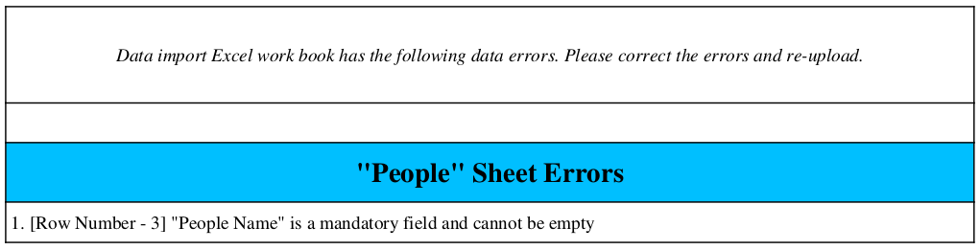
Figure 3.4

- When you have errors you have to correct the errors on data import Excel workbook and again re-upload the workbook.
- Once the data import Excel workbook is successfully uploaded, you are ready to import data.

4. How to Import Data
Once the data import Excel workbook is successfully uploaded to the system, you can import data. Follow the following instructions to proceed with data import.
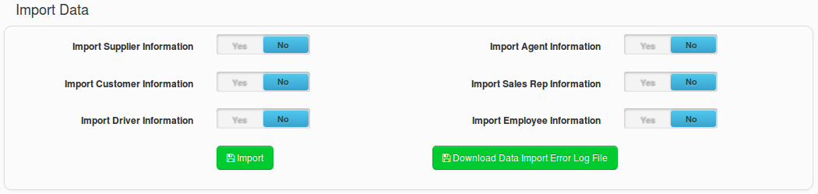
Figure 4.1
- When you import data, you have following options as shown in Figure 4.1 and in Table 4.1.
Data Import Option | Description
Import Supplier Information | System imports data in “People” sheet in data import Excel workbook as suppliers.
Import Agent Information | System imports data in “People” sheet in data import Excel workbook as agents.
Import Customer Information | System imports data in “People” sheet in data import Excel workbook as customer.
Import Sales Rep Information | System imports data in “People” sheet in data import Excel workbook as sales reps.
Import Driver Information | System imports data in “People” sheet in data import Excel workbook as drivers.
Import Employee Information | System imports data in “People” sheet in data import Excel workbook as employees.

Table 4.1

Note : System allows only one import option to be selected at once. If you select multiple
import options, system will show an error message.

- If the system is able to successfully import the data from the import option you have selected, the system will show a success message.
- If the system is not able to successfully import the data from the import option you have selected, the system will show an error message.
- If there are issues with the data import, you can see error log file by clicking on “Download Data Import Error Log File” button as shown in Figure 4.1.
- If you have data import errors, correct the errors (If there is any) and then re-upload/re-import data accordingly.

5. FAQ
This section contains Frequently Asked Questions (FAQ) and corresponding answers.
Question - 1 : What time should I use the data import Excel workbook?
Answer - 1 : You can use the data import Excel workbook if you have many data to be added into the system. For an example when you are going to use the system for first time, you have to add all your people information. If you have less number of information, you can add to the system via screens given in the system. But if you have more information, you can fill data into the data import Excel workbook and import into the system. Also later when you use the system if you have many data to be added/updated, still you can use the data import Excel workbook.

Question - 2 : If I accidentally upload data more than once with no data changes, will the system duplicate data?
Answer - 2 : System will not duplicate data when you import more than once with no data changes. System will update the existing records.

Question - 3 : If I import data multiple times with data changes, will system record the history of data changes?
Answer - 3 : System will not capture history of changes for “People” information.

Question - 4 : If I use data import in the following scenario, what will be the system behavior?
Scenario : I have used the data import Excel workbook when I start using the system for the first time. After that I have done the data changes/data additions from screens in the system. Now I have to add some more data and I want to use the data import Excel workbook.
Answer - 4 : Using data import Excel workbook in this scenario is risky and may result inconsistent behaviors. It is possible to loose latest data changes. Therefore it is advised to keep your data import Excel workbook updated. That means if you wish to use data import Excel workbook multiple time, it is advised to do all data changes via the data import Excel workbook.

Question - 5 : Can I import people information of all people types (Suppliers, Agents Customers etc..) in a single upload?
Answer - 5 : No, you cannot. A single upload will upload people information only for one people type.

Question - 6 : I have purchased HR Manager Module and do I need to use this data import option to import Employee information?
Answer - 6 : No, you should not use this data import option to import Employee data, if you have purchased HR Manager Module. Instead, you should use the data import tool under HR Manager Module.

