

e-ER Planner
Stock Manager Module
Data Import Workbook User Guide
Version 5.0 Beta 5

Table of Contents
1. Introduction 3
1.1 General Data Import Option 5
1.1.1 Stock Manager Master Data Import 5
1.1.2 Data Import Excel Workbook Template Format 5
1.2 Country Wise Data Import Option 6
2. How to Fill Data Import Workbook 7
2.1 Working With Master Data Import Excel Workbook 7
2.1.1 Download the Master Data Import Excel Workbook 8
2.1.2 Fill Master Data Import Excel Workbook 9
2.1.2.1 Fill “Products” sheet 9
2.1.2.2 Fill “Categories” sheet 11
2.1.2.3 Fill “Sub_Categories” sheet 11
2.1.2.4 Fill “Units” sheet 12
2.1.2.5 Fill “Unit_Conversions” sheet 12
2.1.2.6 Fill “Unit_Conversion_Items” sheet 13
2.1.2.7 Fill “Product_Suppliers” sheet 14
2.2 Working With Transaction Data Import Excel Workbook 15
2.2.1 Download the Transaction Data Import Excel Workbook 15
2.2.2 Fill Transaction Data Import Excel Workbook 16
2.2.2.1 Fill “Warehouse_Stock_Balances” sheet 16
3. How to Upload Data Import Workbook 17
3.1 Upload Master Data Import Excel Workbook 17
3.2 Upload Transaction Data Import Excel Workbook 18
4. How to Import Data 20
4.1 Import Master Data 20
4.2 Import Transaction Data 21
5. FAQ 23

1. Introduction
This user guide gives you information on how to use data import tool of e-ER Planner Stock Manager Manager Module. Data import tool allows you to import data when you start using the system. Also the tool can be used while the system is in operations. But there are precautions which should be taken when further using the data import tool. This guide gives all the informations required and it is important to carefully read and understand before start using the tool.
Data import tool can be accessed from “Administration Section”. Menu called “Data Import” is available under “Administration” section as shown in Figure 1.1. When you select “Data Import” menu, system opens the data import screen as shown in Figure 1.2.
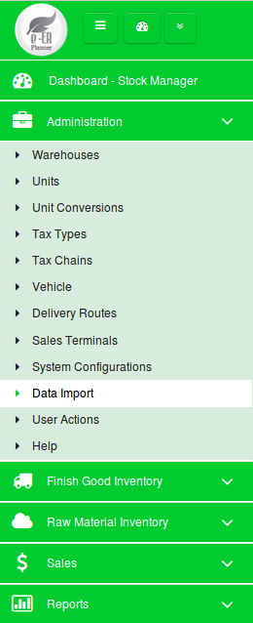

Figure 1.1

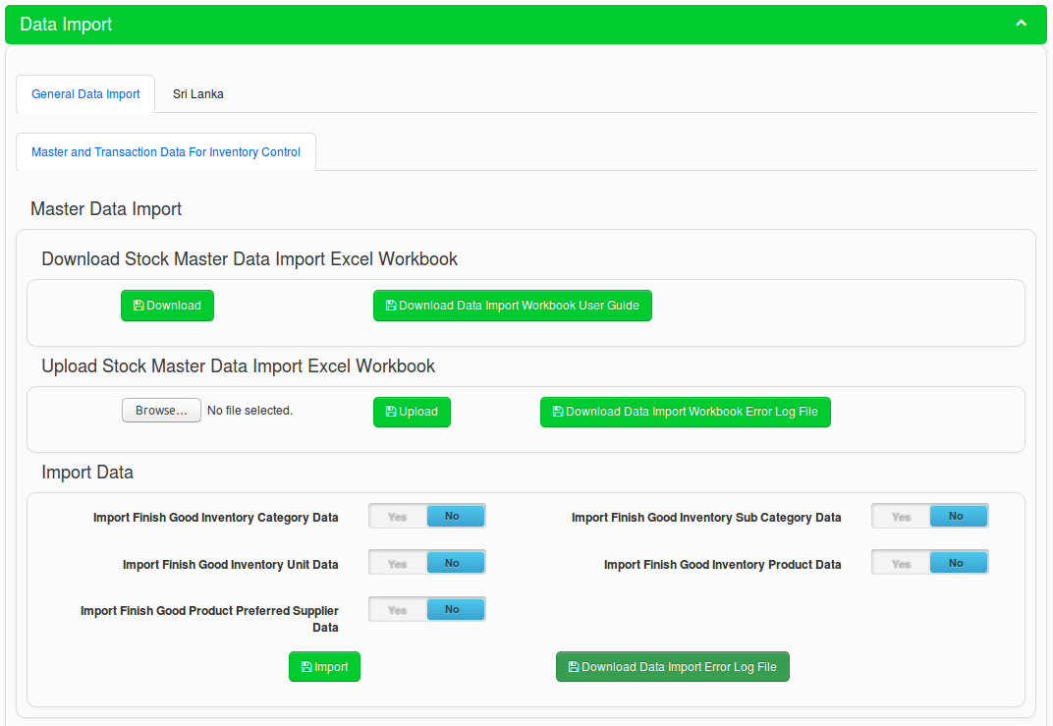
Figure 1.2

System allows users to import data in two different ways.
- General data import option
This method allows users to fill in master and transaction data into Excel sheets and then import to the system.
- Country wise data import option
In this method, the data for different applications are included in the system and depending on
the required application users can populate data into the system database.

Note : In version 4.0 Beta 9, system provides master data for pharmacies and grocery shops in
Sri Lanka. In future versions, more master data will be available for different applications and
more countries.

1.1 General Data Import Option
The general data import option allows users to import Stock Manager master data and transaction data.

1.1.1 Stock Manager Master Data Import
The data import option has three steps.
- Download the data import Excel workbook.
- Fill the data import Excel workbook and correct if there are any data issues while uploading.
- Import data to the system from the correctly uploaded data import Excel workbook.

1.1.2 Data Import Excel Workbook Template Format
The data import Excel workbook is named as “Finish_Good_Inventory_Master_Data_Template” and has following sheets.
Sheet Name | Description
Instructions | Sheet contains the basic instructions on how to use the template.
Products | Sheet allows you to add products information. When you import data from this sheet, data will be available in “Products” screen available in “Stock Manager” module, under “Finish Good Inventory” section.
Categories | Sheet allows you to add product categories. When you import data from this sheet, data will be available in “Categories” screen available in “Stock Manager” module, under “Finish Good Inventory” section. Categories you add in this sheet will be available in “Products” sheet and “Sub_Categories” sheet.
Sub_Categories | Sheet allows you to add product sub categories. When you import data from this sheet, data will be available in “Sub Categories” screen available in “Stock Manager” module, under “Finish Good Inventory” section. Sub categories you add in this sheet will be available in “Products” sheet.
Units | Sheet allows you to add Units. When you import data from this sheet, data will be available in “Units” screen available in “Stock Manager” module, under “Administration” section. Units you add in this sheet will be available in “Products” sheet and “Unit_Conversion_Items” sheet.
Unit_Conversions | Sheet allows you to add unit conversion details. When you import data from this sheet, data will be available in “Unit Conversions” screen available in “Stock Manager” module, under “Administration” section. Unit conversions you add in this sheet will be available in “Products” sheet and “Unit_Conversion_Items” sheet.
Unit_Conversion_Items | Sheet allows you to add unit conversion item details. When you import data from this sheet, data will be available in “Unit Conversions” screen available in “Stock Manager” module, under “Administration” section.
Product_Suppliers | Sheet allows you to add product supplier details. When you import data from this sheet, data will be available in “Products” screen available in “Stock Manager” module, under “Finish Good Inventory” section.

1.2 Country Wise Data Import Option
In version 4.0 Beta 9, system provides master data for pharmacies and grocery shops in Sri Lanka. Users can import master data by clicking on “Populate” button as shown in Figure 1.3.

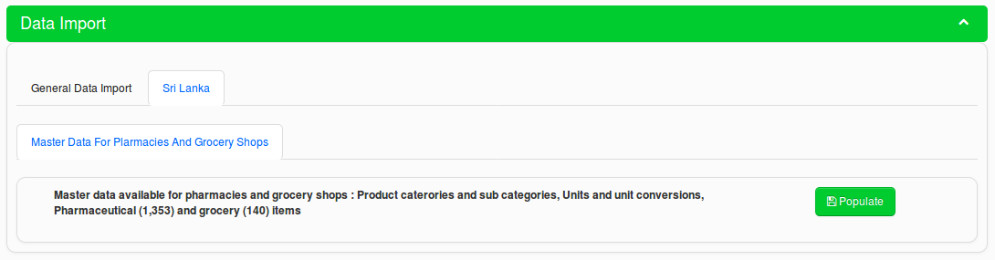
Figure 1.3

2. How to Fill Data Import Workbook
This section gives you information on how to proceed with filling the data import Excel workbook.

2.1 Working With Master Data Import Excel Workbook
You can see the Master Data Import screen as shown in Figure 2.1.1.
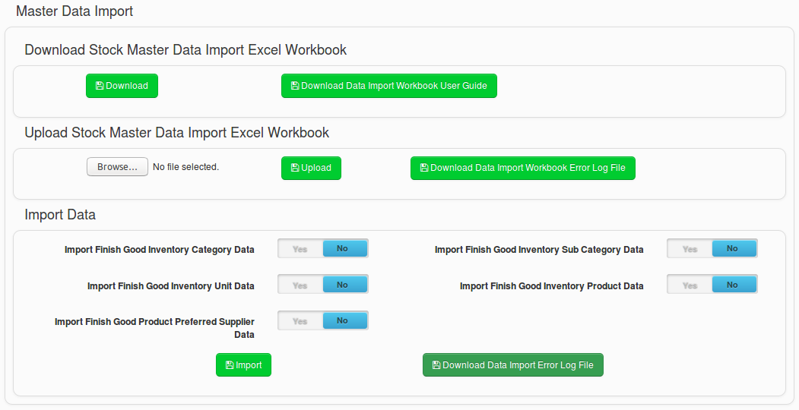
Figure 2.1.1

2.1.1 Download the Master Data Import Excel Workbook


Figure 2.1.1.1
- Click on the “Download” button from “Download Stock Master Data Import Excel Workbook” section shown in Figure 2.1.1.1. to download the data import excel workbook.
- By clicking on “Download Data Import Workbook User Guide” button in Figure 2.1.1.1 you can download this user guide (Stock Manager Data Import Workbook User Guide).
- Data import Excel workbook has the “Instructions” sheet and gives you the following instructions as shown in Figure 2.1.1.2.

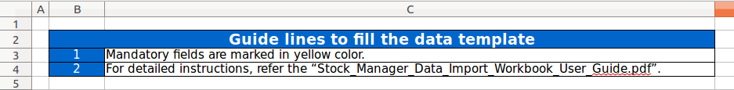
Figure 2.1.1.2

2.1.2 Fill Master Data Import Excel Workbook
This is the most important step of the data import task. You need to make sure your data is filled into the Excel workbook properly before you upload the data template. Therefore, carefully read following sections and fill the data import Excel workbook accordingly. If you have any doubts, refer 5. FAQ section in this guide for information or directly contact support service of e-ER Planner.

2.1.2.1 Fill “Products” sheet

Figure 2.1.2.1.1
- Add your all products into each row in the “Products” sheet.
- Enter a unique Product ID into A2 cell as shown in Figure 2.1.2.1.1. Product ID is a mandatory field and therefore highlighted in yellow color.
- Enter a unique Product Code into B2 cell as shown in Figure 2.1.2.1.1. Product Code is a mandatory field and therefore highlighted in yellow color.
- Select the Category in C2 cell as shown in Figure 2.1.2.1.1 in which each product needs to be added. Cells have a drop down box which has the category name list. To see the list, click on the down arrow button which you can see when clicked on C2, C3 etc. Category is a mandatory field and therefore highlighted in yellow color.
Note : You should have added Categories into “Categories” sheet before fill “Products” sheet.
- Select the Sub Category in D2 cell as shown in Figure 2.1.2.1.1 in which each product needs to be added. Cells have a drop down box which has the sub category name list. To see the list, click on the down arrow button which you can see when clicked on D2, D3 etc.
Note : You should have added Sub Categories into “Sub_Categories' sheet before fill “Products” sheet.
- If the product has a Generic Name, enter that into E2 cell shown in Figure 2.1.2.1.1.
Note : Generic Name is an additional field for Products and it should be enabled via configurations.
- Enter the Product Name into F2 cell as shown in Figure 2.1.2.1.1. Product Name is a mandatory field and therefore highlighted in yellow color.
- Select the Unit in G2 cell as shown in Figure 2.1.2.1.1 in which each product will be measured. Cells have a drop down box which has the Unit name list. To see the list, click on the down arrow button which you can see when clicked on G2, G3 etc. Unit is a mandatory field and therefore highlighted in yellow color.
Note : You should have added Units into “Units” sheet before fill “Products” sheet.
- Select the Unit Conversion in H2 cell as shown in Figure 2.1.2.1.1. Cells have a drop down box which has the Unit Conversion name list. To see the list, click on the down arrow button which you can see when clicked on H2, H3 etc.
Note : You should have added Unit Conversions into “Unit_Conversions” sheet before fill “Products” sheet.
- Select the Display Unit in I2 cell as shown in Figure 2.1.2.1.1. Cells have a drop down box which has the Unit name list. To see the list, click on the down arrow button which you can see when clicked on I2, I3 etc. Display Unit is a mandatory field and therefore highlighted in yellow color.
Note : You should have added Units into “Units” sheet before fill “Products” sheet.
- Select the Re-order Level Unit in J2 cell as shown in Figure 2.1.2.1.1. Cells have a drop down box which has the Unit name list. To see the list, click on the down arrow button which you can see when clicked on J2, J3 etc.
Note : You should have added Units into “Units” sheet before fill “Products” sheet.
- Enter the Re-order Level into K2 cell as shown in Figure 2.1.2.1.1. Re-order Level should be an integer number.
- Enter the Re-order Quantity into L2 cell as shown in Figure 2.1.2.1.1. Re-order Quantity should be an integer number.
- Enter the Product Cost into M2 cell as shown in Figure 2.1.2.1.1. Product Cost should be a decimal number.
- Enter the Customer Selling Price into N2 cell as shown in Figure 2.1.2.1.1. Customer Selling Price should be a decimal number.

2.1.2.2 Fill “Categories” sheet

Figure 2.1.2.2.1
- Add your all product category names into each row in the “Categories” sheet.
- Enter a unique Category ID into A2 cell as shown in Figure 2.1.2.2.1. Category ID is a mandatory field and therefore highlighted in yellow color.
- Enter the Category Name into B2 cell as shown in Figure 2.1.2.2.1. Category Name is a mandatory field and therefore highlighted in yellow color.
- Enter a Description for the Category into C2 cell as shown in Figure 2.1.2.2.1.

2.1.2.3 Fill “Sub_Categories” sheet

Figure 2.1.2.3.1
- Add your all product sub category names into each row in the “Sub_Categories” sheet.
- Enter a unique Sub Category ID into A2 cell as shown in Figure 2.1.2.3.1. Sub Category ID is a mandatory field and therefore highlighted in yellow color.
- Enter the Sub Category Name into B2 cell as shown in Figure 2.1.2.3.1. Sub Category Name is a mandatory field and therefore highlighted in yellow color.
- Select the Category in C2 cell as shown in Figure 2.1.2.3.1. Cells have a drop down box which has the Category name list. To see the list, click on the down arrow button which you can see when clicked on C2, C3 etc.
Note : You should have added Categories into “Categories” sheet before fill “Sub_Categories” sheet.
- Enter a Description for the Sub Category into D2 cell as shown in Figure 2.1.2.3.1.

2.1.2.4 Fill “Units” sheet

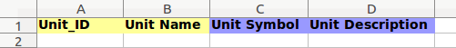

Figure 2.1.2.4.1
- Add your all unit names into each row in the “Units” sheet.
- Enter a unique Unit ID into A2 cell as shown in Figure 2.1.2.4.1. Unit ID is a mandatory field and therefore highlighted in yellow color.
- Enter the Unit Name into B2 cell as shown in Figure 2.1.2.4.1. Unit Name is a mandatory field and therefore highlighted in yellow color.
- Enter a Unit Symbol for the unit into C2 cell as shown in Figure 2.1.2.4.1.
- Enter a Unit Description for the Unit into D2 cell as shown in Figure 2.1.2.4.1.

2.1.2.5 Fill “Unit_Conversions” sheet

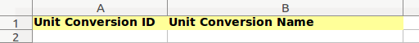

Figure 2.1.2.5.1
- Add all unit conversion names into each row in the “Unit_Conversions” sheet.
- Enter a unique Unit Conversion ID into A2 cell as shown in Figure 2.1.2.5.1. Unit Conversion ID is a mandatory field and therefore highlighted in yellow color.
- Enter the Unit Conversion Name into B2 cell as shown in Figure 2.1.2.5.1. Unit Conversion Name is a mandatory field and therefore highlighted in yellow color.

2.1.2.6 Fill “Unit_Conversion_Items” sheet

Figure 2.1.2.6.1
- Add all unit conversion name item details into each row in the “Unit_Conversion_Items” sheet.
- Select the Unit Conversion Name in A2 cell as shown in Figure 2.1.2.6.1. Cells have a drop down box which has the unit conversion name list. To see the list, click on the down arrow button which you can see when clicked on A2, A3 etc. Unit Conversion Name is a mandatory field and therefore highlighted in yellow color.
Note : You should have added Unit Conversions into “Unit_Conversions” sheet before fill “Unit_Conversion_Items” sheet.
- Enter the From Amount into B2 cell as shown in Figure 2.1.2.6.1. From Amount should be a decimal number. From Amount is a mandatory field and therefore highlighted in yellow color.
- Select the From Unit Name in C2 cell as shown in Figure 2.1.2.6.1. Cells have a drop down box which has the unit name list. To see the list, click on the down arrow button which you can see when clicked on C2, C3 etc. From Unit Name is a mandatory field and therefore highlighted in yellow color.
Note : You should have added Units into “Units” sheet before fill “Unit_Conversion_Items” sheet.
- Select the To Unit Name in D2 cell as shown in Figure 2.1.2.6.1. Cells have a drop down box which has the unit name list. To see the list, click on the down arrow button which you can see when clicked on D2, D3 etc. To Unit Name is a mandatory field and therefore highlighted in yellow color.
Note : You should have added Units into “Units” sheet before fill “Unit_Conversion_Items” sheet.
- Enter the To Amount into E2 cell as shown in Figure 2.1.2.6.1. To Amount should be a decimal number. To Amount is a mandatory field and therefore highlighted in yellow color.

2.1.2.7 Fill “Product_Suppliers” sheet

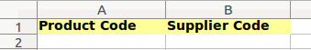

Figure 2.1.2.7.1
- Fill in all product preferred supplier list to “Product_Suppliers” sheet.
- Enter the Product Code into A2 cell as shown in Figure 2.1.2.7.1.
- Enter the Supplier Code into B2 cell as shown in Figure 2.1.2.7.1.
- You can add multiple suppliers for a single product.

2.2 Working With Transaction Data Import Excel Workbook
You can see the Master Data Import screen as shown in Figure 2.2.1.
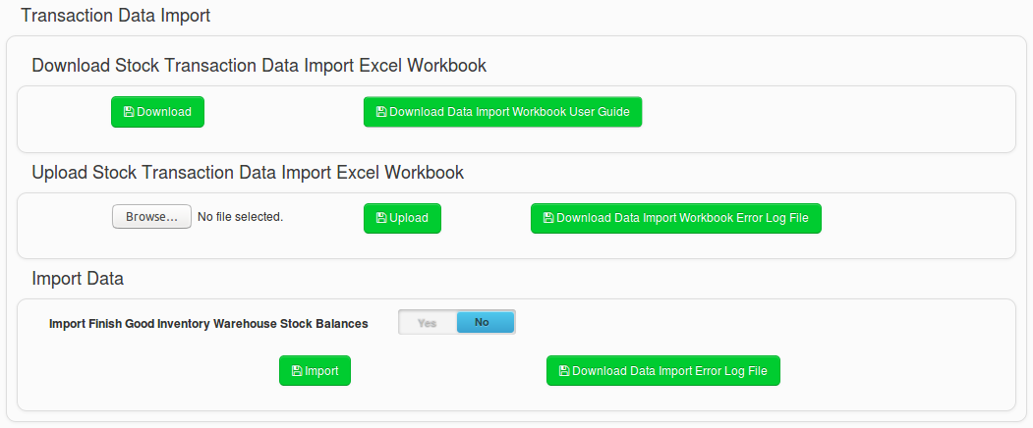
Figure 2.2.1

2.2.1 Download the Transaction Data Import Excel Workbook


Figure 2.2.1.1
- Click on the “Download” button from “Download Stock Transaction Data Import Excel Workbook” section shown in Figure 2.2.1.1. to download the data import excel workbook.
- By clicking on “Download Data Import Workbook User Guide” button in Figure 2.2.1.1 you can download this user guide (Stock Manager Data Import Workbook User Guide).
- Data import Excel workbook has the “Instructions” sheet and gives you the following instructions as shown in Figure 2.2.1.2.

Figure 2.2.1.2

2.2.2 Fill Transaction Data Import Excel Workbook
This is the most important step of the data import task. You need to make sure your data is filled into the Excel workbook properly before you upload the data template. Therefore, carefully read following sections and fill the data import Excel workbook accordingly. If you have any doubts, refer 5. FAQ section in this guide for information or directly contact support service of e-ER Planner.

2.2.2.1 Fill “Warehouse_Stock_Balances” sheet

Figure 2.2.2.1.1
- Add your all product warehouse stock balance details into each row in the “Warehouse_Stock_Balances” sheet.
- Enter the Warehouse Name, exactly as it is added into the system, into A2 cell as shown in Figure 2.2.2.1.1. Warehouse Name is a mandatory field and therefore highlighted in yellow color.
- Enter the Product Code, exactly as it is added into the system, into B2 cell as shown in Figure 2.2.2.1.1. Product Code is a mandatory field and therefore highlighted in yellow color.
- Enter the Unit, exactly as it is added into the system, into C2 cell as shown in Figure 2.2.2.1.1. Unit is a mandatory field and therefore highlighted in yellow color.
- Enter the Stock Value into D2 cell as shown in Figure 2.2.2.1.1. Stock Value should be an integer number. Stock Value is a mandatory field and therefore highlighted in yellow color.

3. How to Upload Data Import Workbook
After you completed filling data import Excel workbook, next step is to upload the workbook into the system.

3.1 Upload Master Data Import Excel Workbook


Figure 3.1.1
In order to upload the data import Excel workbook into the system, follow the following steps.

- First select the file by clicking on “Browse” button as shown in Figure 3.1.1.
- Then click on the “Upload” button as shown in Figure 3.1.1 and wait until the systems give you a message on the upload status.
- When uploading the data import Excel workbook system verifies the data and make sure you have given data accurately so that data can be imported into the system successfully.
- If data is verified successfully by the system and data you have given in the workbook is accurate, system will display the following success message.
Figure 3.1.2
- If system finds data issues from the workbook, system will display the following error message.
Figure 3.1.3
- If there are issues, system creates a error log file and you can download it by clicking the “Download Data Import Workbook Error Log File” button as shown in Figure 3.1.1
- When you have errors you have to correct the errors on data import Excel workbook and again re-upload the workbook.
- Once the data import Excel workbook is successfully uploaded, you are ready to import data.

3.2 Upload Transaction Data Import Excel Workbook


Figure 3.2.1
In order to upload the data import Excel workbook into the system, follow the following steps.

- First select the file by clicking on “Browse” button as shown in Figure 3.2.1.
- Then click on the “Upload” button as shown in Figure 3.2.1 and wait until the systems give you a message on the upload status.
- When uploading the data import Excel workbook system verifies the data and make sure you have given data accurately so that data can be imported into the system successfully.
- If data is verified successfully by the system and data you have given in the workbook is accurate, system will display the following success message.
Figure 3.2.2
- If system finds data issues from the workbook, system will display the following error message.
Figure 3.2.3
- If there are issues, system creates a error log file and you can download it by clicking the “Download Data Import Workbook Error Log File” button as shown in Figure 3.2.1.
- When you have errors you have to correct the errors on data import Excel workbook and again re-upload the workbook.
- Once the data import Excel workbook is successfully uploaded, you are ready to import data.

4. How to Import Data
Once the data import Excel workbook is successfully uploaded to the system, you can import data.

4.1 Import Master Data
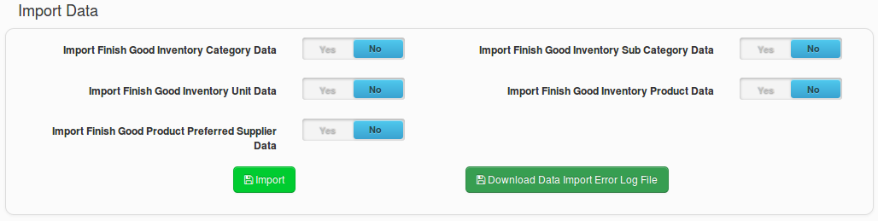
Figure 4.1.1
Follow the following instructions to proceed with data import.
- When you import data, you have following options as shown in Table 4.1.1.
Data Import Option | Description
Import Finish Good Inventory Category Data | System imports data only from “Categories” sheet in data import Excel workbook.
Import Finish Good Inventory Sub Category Data | System imports data only from “Sub_Categories” sheet in data import Excel workbook.
Import Finish Good Inventory Unit Data | System imports data only from “Units” sheet in data import Excel workbook.
Import Finish Good Inventory Product Data | System imports data only from “Products” sheet in data import Excel workbook.  Note : You must have imported Category and Units data before import Products.
Import Finish Good Product Preferred Supplier Data | System imports data only from “Product_Suppliers” sheet in data import Excel workbook.

Table 4.1.1
Note : System allows only one import option to be selected at once. If you select multiple
import options, system will show an error message.

- If the system is able to successfully import the data from the import option you have selected, the system will show a success message.
- If the system is not able to successfully import the data from the import option you have selected, the system will show an error message.
- If there are issues with the data import, you can see error log file by clicking on “Download Data Import Error Log File” button as shown in Figure 4.1.1.
- If you have data import errors, correct the errors (If there is any) and then re-upload/re-import data accordingly.

4.2 Import Transaction Data
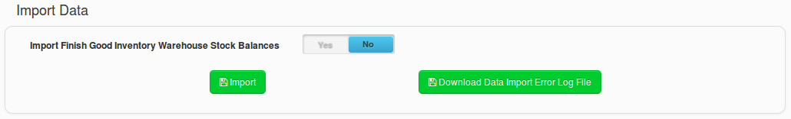
Figure 4.2.1
Follow the following instructions to proceed with data import.
- When you import data, you have following options as shown in Table 4.2.1.
Data Import Option | Description
Import Finish Good Inventory Warehouse Stock Balances | System imports data only from “Warehouse_Stock_Balances” sheet in data import Excel workbook.

Table 4.2.1

- If the system is able to successfully import the data from the import option you have selected, the system will show a success message.
- If the system is not able to successfully import the data from the import option you have selected, the system will show an error message.
- If there are issues with the data import, you can see error log file by clicking on “Download Data Import Error Log File” button as shown in Figure 4.2.1.
- If you have data import errors, correct the errors (If there is any) and then re-upload/re-import data accordingly.

5. FAQ
This section contains Frequently Asked Questions (FAQ) and corresponding answers.
Question - 1 : What time should I use the data import Excel workbook?
Answer - 1 : You can use the data import Excel workbook if you have many data to be added into the system. For an example when you are going to use the system for first time, you have to add your Stock Master data and Warehouse Stock balances. If you have less number of information, you can add to the system via screens given in the system. But if you have more information, you can fill data into the data import Excel workbook and import into the system. Also later when you use the system if you have many data to be added/updated, still you can use the data import Excel workbook.

Question - 2 : If I accidentally upload data more than once with no data changes, will the system duplicate data?
Answer - 2 : System will not duplicate data when you import more than once with no data changes. System will update the existing records.

Question - 3 : If I import data multiple times with data changes, will system record the history of data changes?
Answer - 3 : System will capture the history for “Products” when you import data multiple times with data changes.

Question - 4 : If I use data import in the following scenario, what will be the system behavior?
Scenario : I have used the data import Excel workbook when I start using the system for the first time. After that I have done the data changes/data additions from screens in the system. Now I have to add some more data and I want to use the data import Excel workbook.
Answer - 4 : Using data import Excel workbook in this scenario is risky and may result inconsistent behaviors. It is possible to loose latest data changes. Therefore it is advised to keep your data import Excel workbook updated. That means if you wish to use data import Excel workbook multiple time, it is advised to do all data changes via the data import Excel workbook.

