

e-ER Planner

Donation Manager

Donation Details User Guide

Version 5.0 Beta 6

Table of Contents
Introduction 2
Top Navigation Bar 3
Collect Donations 4
Program Progress 5

Introduction
This user guide aims at giving you the information required to work with “Donation Details Section” of “Donation Manager”. This user guide can be downloaded from “Donation Help” screen shown in Figure 2 which is accessible from “Donation Details → Help” menu as shown in Figure 1.

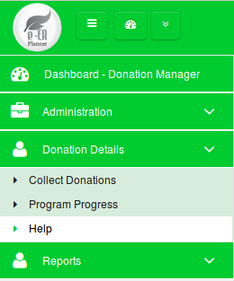

Figure 1

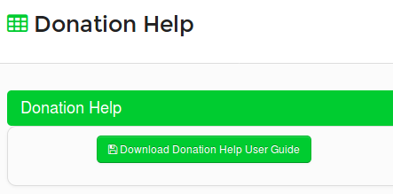

Figure 2

Top Navigation Bar

Toggle Left Menu
Open/Retract System Modules
Change Password
My Language
About System
Logout
System Dashboard
Default Module

Current Module
Figure 3

  - Toggle Left Menu : Show/hide left menu
  - Open/Retract System Modules : Open/retract system module dashboard. Previous screen preserves if user does not select any module.
  - System Dashboard : Opens the system modules dashboard. Previous screen does not preserved.
  - Current Module : Shows the current module that user has selected.
  - Default Module : Selecting current module as default module will allow to go directly to that module on login to the system.

Collect Donations
All Donations you receive for a particular program can be added in Collect Donations screen. Collect Donations screen can be accessed from “Donation Details → Collect Donations” menu.
- Donations list is displayed in the system as shown in Figure 4.
- A new Donation can be added by clicking on “Add New Donation” button shown in Figure 4. A new form will be displayed on the screen to add a new Donation as shown in Figure 5.
- “Reference Number”, “Program Name”, “Date”, “Donor” and “Amount” are mandatory fields when adding a new Donation.

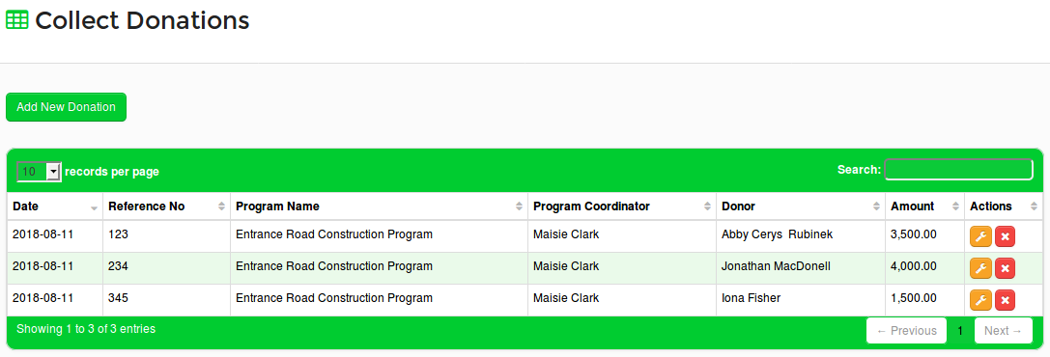
Figure 4

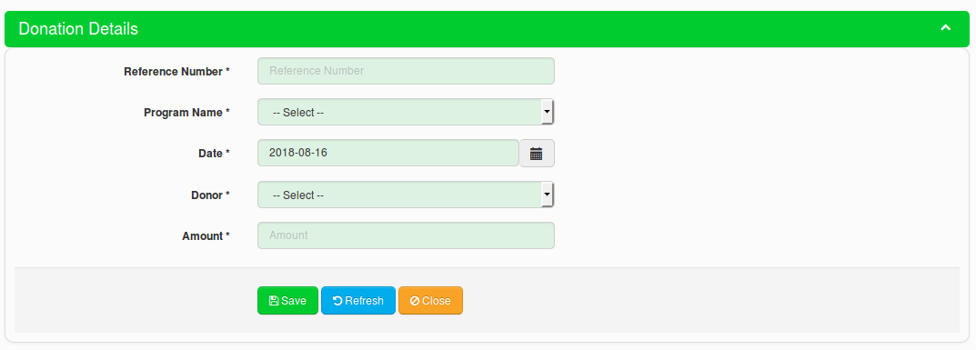
Figure 5

Program Progress
Progress of each program can be seen on Program Progress screen which is accessible from “Donation Details → Program Progress” menu.
- Users needs to select a Program on the screen shown in Figure 6 to see the Program Progress.

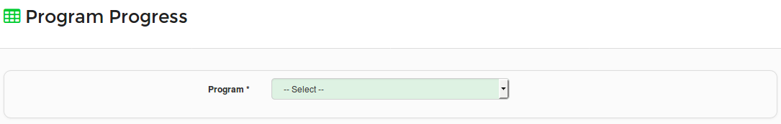
Figure 6

- If the selected Program is not yet configured, system will show a message as shown in Figure 7. Users can configure the Program by adding Program Activities by clicking on the link (here) shown in Figure 7. The system will show a new screen as shown in Figure 8 to add Program Activities.

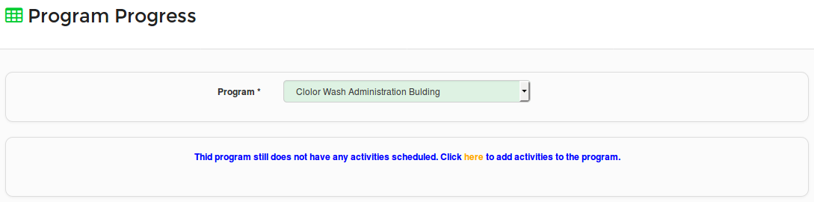
Figure 7

- “Activity Name”, “Start Date”, “Finish Date”, “Activity Owner” and “Activity Budget” are mandatory fields when adding a new Program Activity.

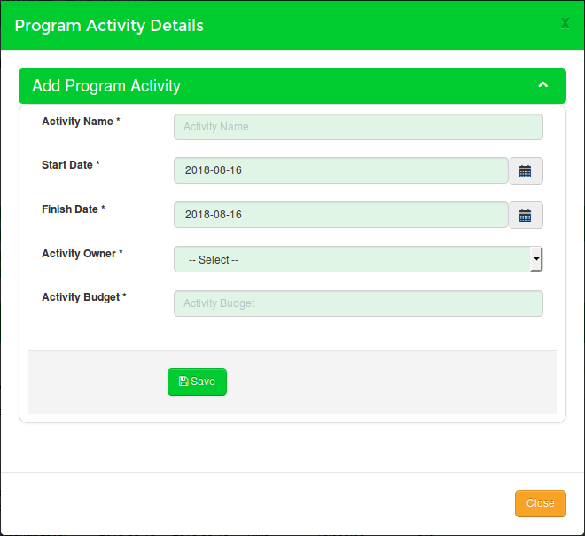

Figure 8

- After adding the first Program Activity, users can see the Program Activity details on the table shown in Figure 9.
- New Program Activities can be added by clicking on “Add New Activity” button shown in Figure 9.
- An existing Program Activity can be edited by clicking on button shown in Figure 9. A new screen will be shown on the screen to edit the Program Activity details as shown in Figure 10.
- Money can be issued for a Program Activity by clicking on button shown in Figure 9. A new screen will be shown on the screen to add budget issue details as shown in Figure 11.
- Money returns for a Program Activity can be collected by clicking on button shown in Figure 9. A new screen will be shown on the screen to add budget return details as shown in Figure 12.
- Program Activity progress can be updated by clicking on button shown in Figure 9. A new screen will be shown on the screen to update the Program Activity progress as shown in Figure 13.
- Users can see the following summary information for a Program as shown in Figure 9.
  - Fund Available (The total amount of Donations received for the Program)
  - Budget Estimated (Total Activity Budget)
  - Budget Deficiency (Shows the difference if Budget Estimated is greater than Fund Available)
  - Activity Cost Total
  - Overall Budget Variance (Shows the difference if Activity Cost Total is greater than Budget Estimated)
  - Program Start Date
  - Program Finish Date
  - Actual Program Start Date
  - Actual Program Finished Date
- Further, users can see the following Program Progress information in the section called “Program Progress Status” section as shown in Figure 9.
  - Program Progress in terms of budget (Percentage ratio of Activity Cost Total and Budget Estimated)
  - Program Progress in terms of activity completion (The average percentage of Activity Completion of all Program Activities)

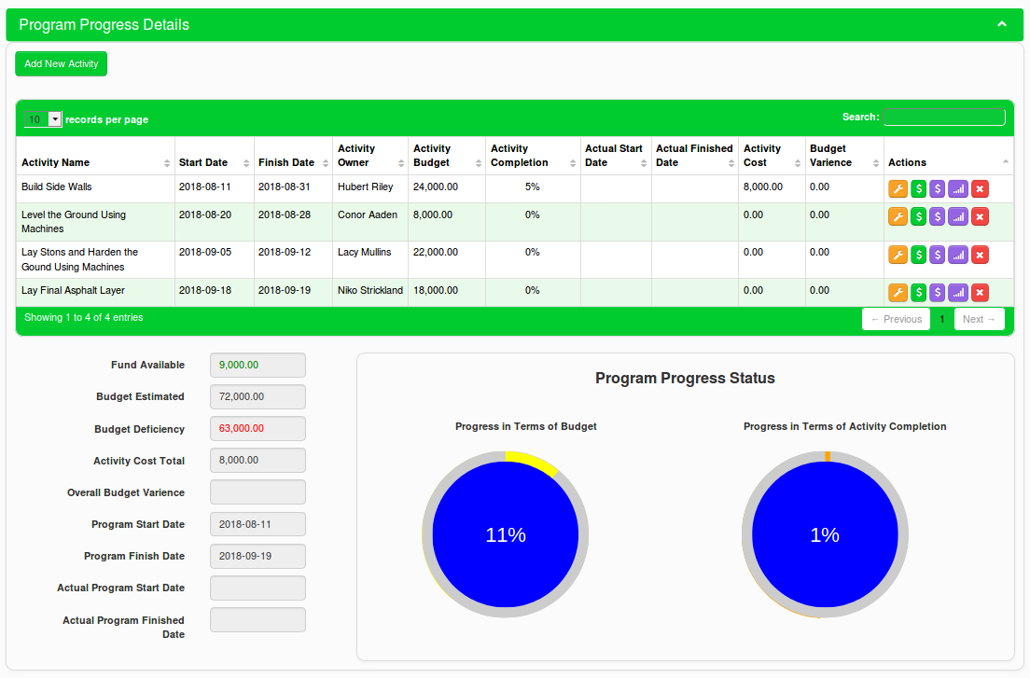
Figure 9

- When editing Program Activity details, users can update “Actual Start Date” and “Actual Finished Date” of each Program Activity as shown in Figure 10.

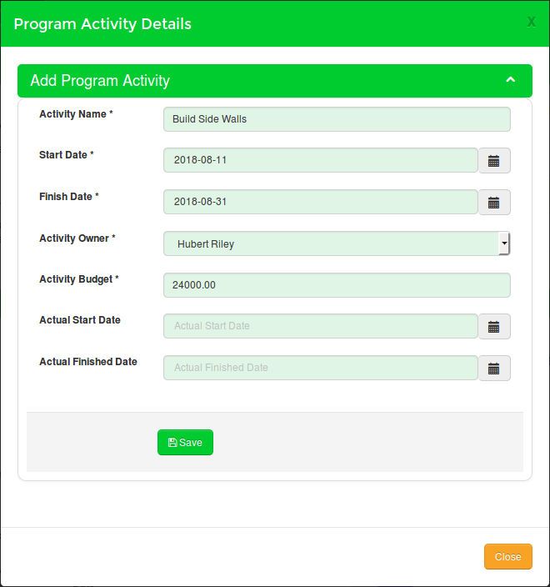

Figure 10

- Users can add Program Activity budget issue details on the screen shown in Figure 11.
- Users can click on “Add New Budget Issue” button shown in Figure 11 to add a new budget issue transaction.

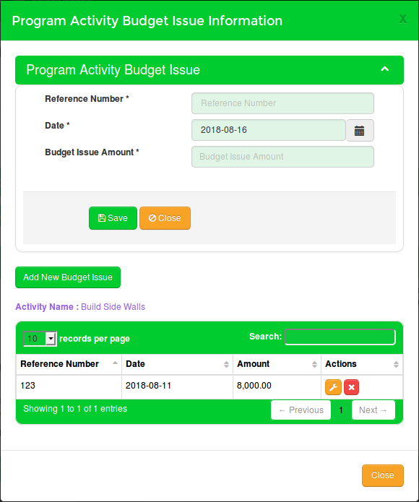

Figure 11

- Users can add Program Activity budget return details on the screen shown in Figure 12.
- Users can click on “Add New Budget Return” button shown in Figure 12 to add a new budget return transaction.

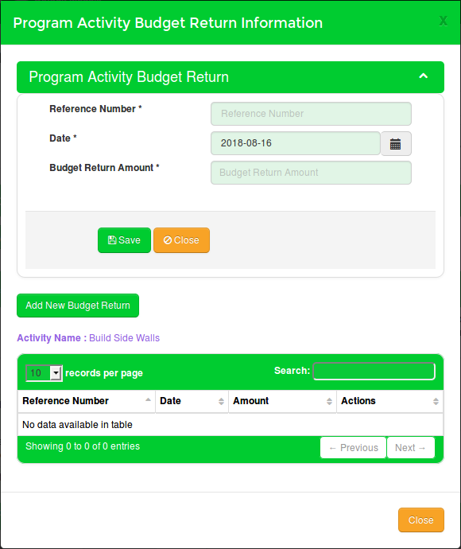

Figure 12

- Users can drag the slider bar shown in Figure 13 to update the Program Activity progress.

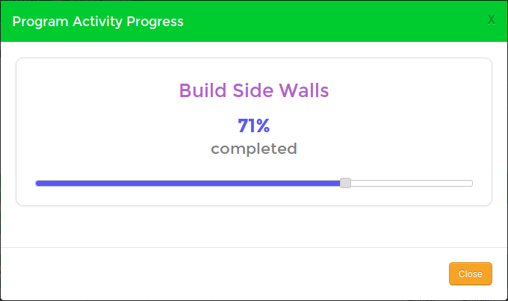

Figure 13

