

e-ER Planner

Donation Manager

Donation Reports User Guide

Version 5.0 Beta 6

Table of Contents
Introduction 2
Top Navigation Bar 3
Donation Reports 4
Donation Details 5
Program Details 6

Introduction
This user guide aims at giving you the information required to work with “Reports Section” of “Donation Manager”. This user guide can be downloaded from “Donation Reports Help” screen shown in Figure 2 which is accessible from “Reports → Help” menu as shown in Figure 1.

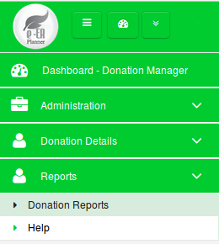

Figure 1

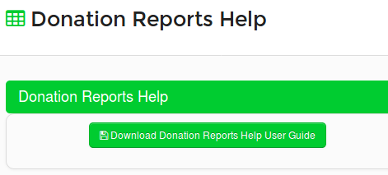

Figure 2

Top Navigation Bar

Toggle Left Menu
Open/Retract System Modules
Change Password
My Language
About System
Logout
System Dashboard
Default Module

Current Module
Figure 3

  - Toggle Left Menu : Show/hide left menu
  - Open/Retract System Modules : Open/retract system module dashboard. Previous screen preserves if user does not select any module.
  - System Dashboard : Opens the system modules dashboard. Previous screen does not preserved.
  - Current Module : Shows the current module that user has selected.
  - Default Module : Selecting current module as default module will allow to go directly to that module on login to the system.

Donation Reports
Donation Reports allows users to filter information of Donations received and to search Program Progress details. Figure 4 shows a list of reports available under Donations Reports.

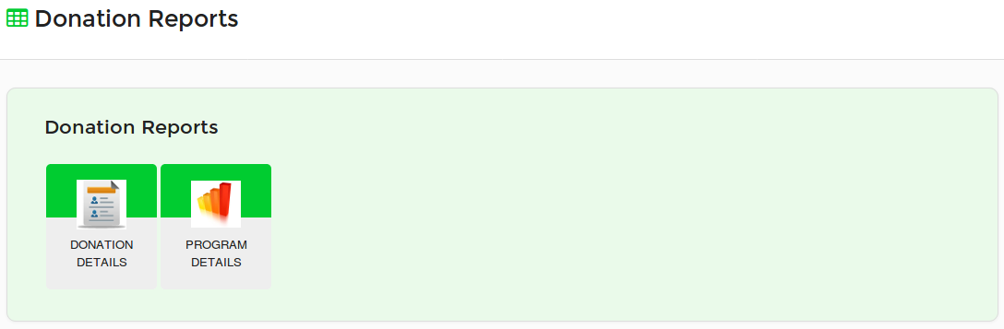
Figure 4

Donation Details
Upon selecting “Donation Details” report from reports list shown in Figure 4, users can see a list of search filters available as shown in Figure 5.
- Without specifying any value for search filters, users can search information and system will show all Donations records.
- If users select a specific Program, the Location of the Program will be automatically selected and users cannot change Location.
- When searched, users can see report results as shown in Figure 6.
- Further users can print the report details.

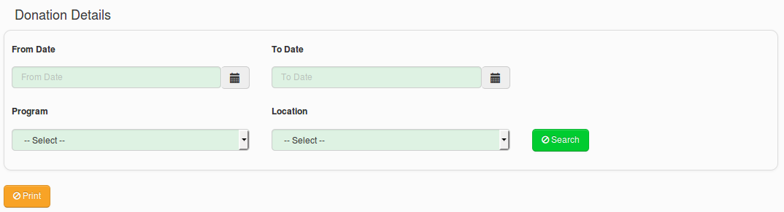
Figure 5

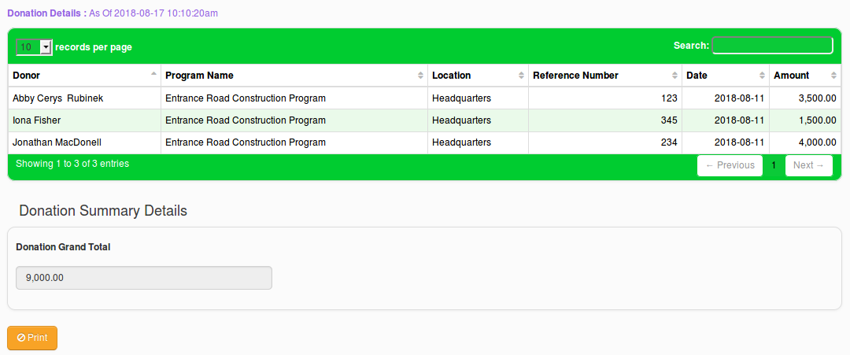
Figure 6

Program Details
Upon selecting “Program Details” report from reports list shown in Figure 4, users can see a list of search filters available as shown in Figure 7.
- Without specifying any value for search filters, users can search information and system will show all Programs detail as shown in Figure 8. Further, users can see Total Fund Available, Total Budget Estimated, Budget Deficiency Total, Activity Cost Total and Budget Variance Total for all projects.
- If users select a specific Program, the Location of the Program will be automatically selected and users cannot change Location.
- When searched by specifying a Program, users can see Program Activity details, Program Budget information and Program Progress information as shown in Figure 9.
- Further users can print the report details.

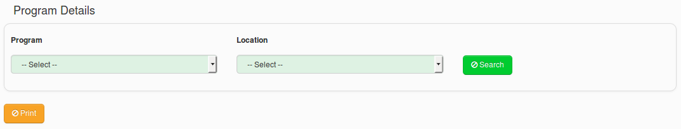
Figure 7

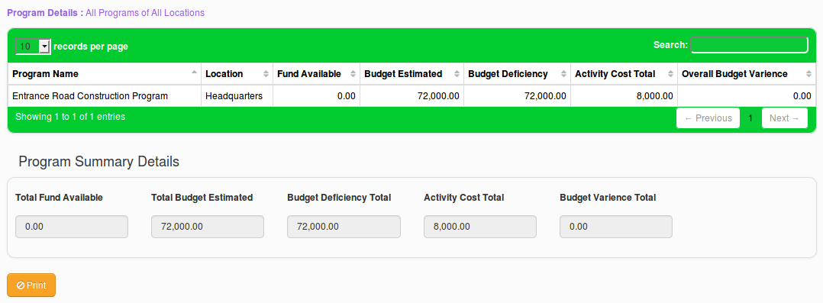
Figure 8

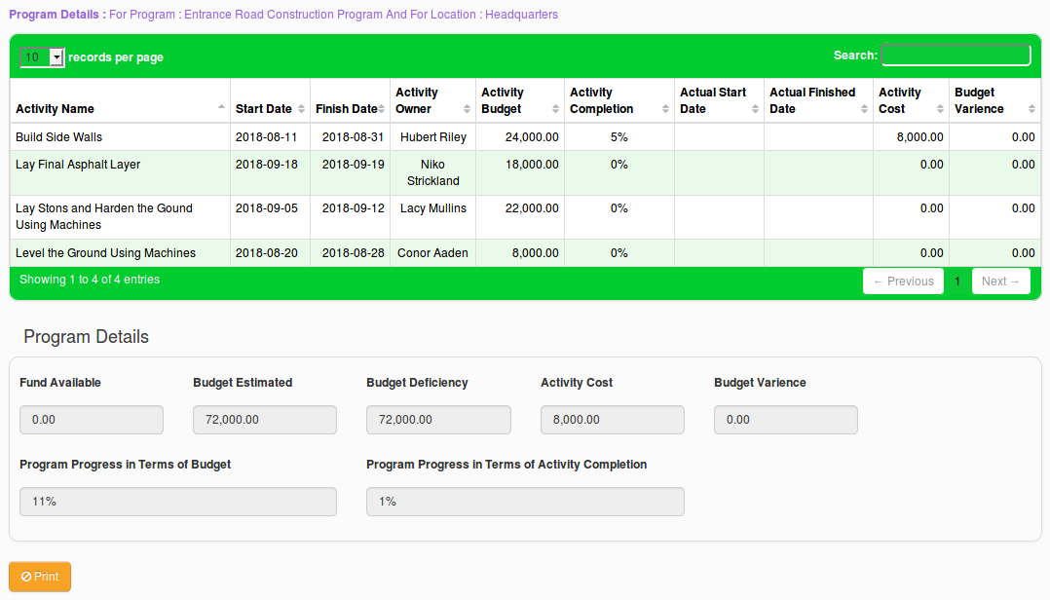
Figure 9

