

Red Cherries Accounting (Open Source)
Organization Module
Admin User Guide
Version 1.0 Beta 1

Table of Contents
Introduction 3
Top Navigation Bar 4
Calendar Day Types 5
Locations 7
Territories 9
People 10
Data Import 14
Google Analytics Settings 15
System Configurations 16

Introduction
This user guide aims at giving you the information required to work with “Administration Section” of “Organization”. This user guide can be downloaded from “Admin Help” screen shown in Figure 2 which is accessible from “Administration → Help” menu as shown in Figure 1.

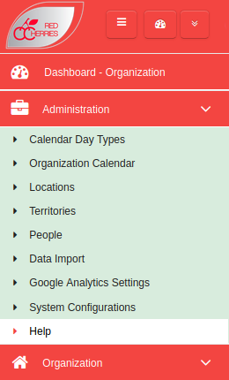

Figure 1

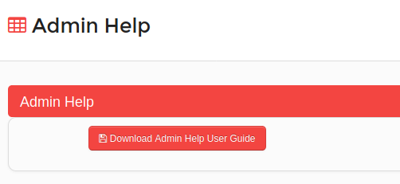

Figure 2

Top Navigation Bar

Toggle Left Menu
Open/Retract System Modules
Change Password
My Language
About System
Logout
System Dashboard
Current Module
Default Module

Figure 3

  - Toggle Left Menu : Show/hide left menu
  - Open/Retract System Modules : Open/retract system module dashboard. Previous screen preserves if user does not select any module.
  - System Dashboard : Opens the system modules dashboard. Previous screen does not preserved.
  - Current Module : Shows the current module that user has selected.
  - Default Module : Selecting current module as default module will allow to go directly to that module on login to the system.

Calendar Day Types
In order to create an organization calendar, the required day types can be added in “Day Types” screen. Day Types can be added in the system from “Administration Module → Day Types” menu.
- Day Types list is displayed in the system as shown in Figure 4.
- A new day type can be added by clicking the “Add New Calendar Day Type” button shown in Figure 4. A new form will be displayed on the screen to add the day type details as shown in Figure 5.
- “Day Type Code” and “Day Type Name” are mandatory fields when adding day types.

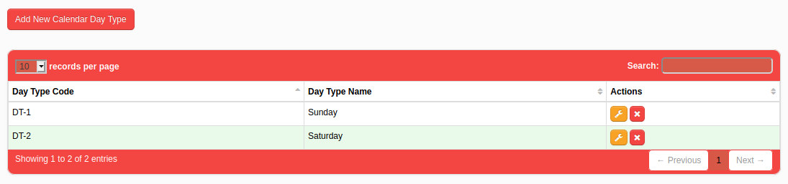
Figure 4

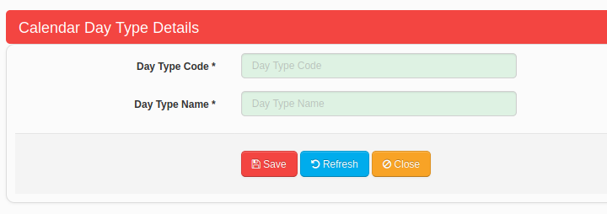

Figure 5

Organization Calendar
Organization Calendar can be created for a company in a particular country as shown in Figure 6. Organization Calendar can be created in the system from “Administration Module → Organization Calendar” menu.
- Day Types can be dragged and dropped to the calendar from “Draggable Day Types” section shown in Figure 6.
- Added day types can be deleted by dragging and dropping day types from the calendar to the “Calendar Days Garbage” section shown in Figure 6.

Note : Saturday and Sunday day types can be populated to the entire organization calendar using the facility provided in “System Configurations” screen. Please refer the “System Configurations” section in this user guide for more information.

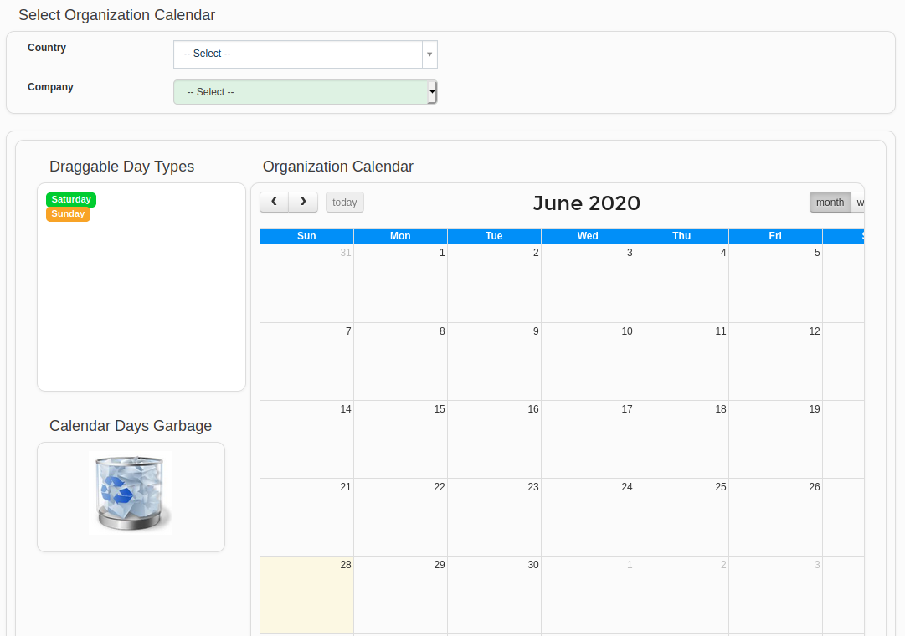
Figure 6

Locations
Physical locations can be added in the system from “Administration Module → Locations” menu.
- Location list is displayed in the system as shown in Figure 7.
- Once locations are defined in the system, can be specified for agents and customers so that their locations can be tracked. Further, the accounting system can be configured to work separately for each location.
- A new location can be added by clicking the “Add New Location” button shown in Figure 7. A new form will be displayed on the screen to add the location details as shown in Figure 8.
- “Location Code” and “Location Name” are mandatory fields when adding locations.
- Country code of telephone numbers can be selected by accessing the country flag .
- There should be a space between country code and telephone number. Ex : +94 0111234567.

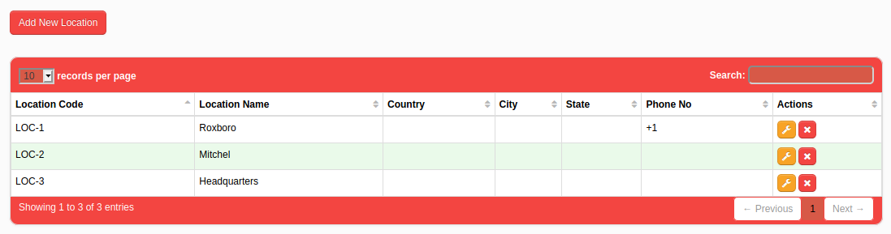
Figure 7

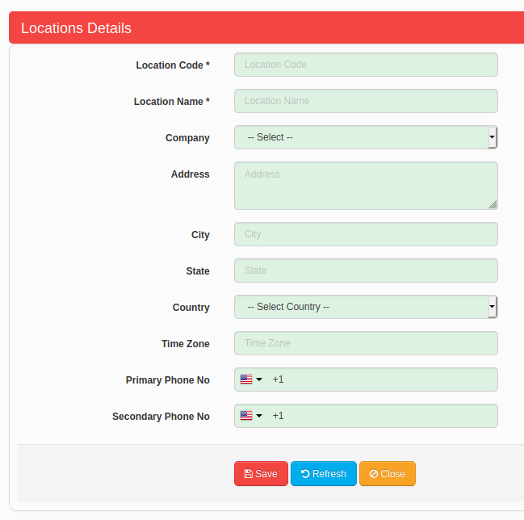

Figure 8

Territories
If a business organization needs to track their sales information territory wise, users can add the territory information on the Territories screen and use in Sales Note and Customer Return Note screens in Accounts Manager module. Territories can be added in the system from “Administration Module → Territories” menu.
- Territories list is displayed in the system as shown in Figure 9.
- A new Territory can be added by clicking the “Add New Territory” button shown in Figure 9. A new form will be displayed on the screen to add the Territory details as shown in Figure 10.
- “ Territory Code” and “ Territory Name” are mandatory fields when adding locations.

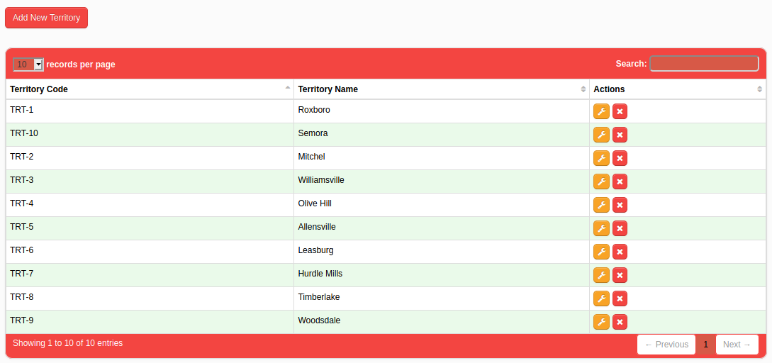
Figure 9

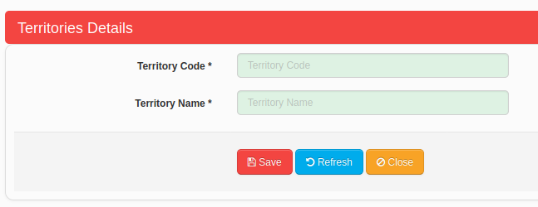

Figure 10

People
There are many people involved when managing an accounting system. Such people information can be stored in the system so that they can be selected when adding transactions. People can be added in the system from “Administration Module → People” menu.
Following people categories can be seen in people screen as shown in Figure 11.
- Supplier
- Agent
- Customer
- Sales Rep
- Driver
- Member
- Employee

- By clicking on “Add New People” button you can add new people into the system. A new form will be displayed on the screen to add the people details as shown in Figure 13.
Note : For each people type there can be additional fields.
- To see a list of people under each category, click on the icon of each category as shown in Figure 11. People under the selected category will be shown as shown in Figure 12.
- Once people are defined in the system, can be specified in following transaction screens under Accounts Manager Module, User Roles Manager Module, Services Manager Module etc.
  - Purchase Note
  - Sales Note
  - Customer Return Note
  - Supplier Return Note
  - Cheque List
  - Users
- “People Type”, “People Code” and “People Name” are mandatory fields when adding people.
- Country code of telephone numbers and fax number can be selected by accessing the country flag .
- There should be a space between country code and telephone/fax number. Ex : +94 0111234567.

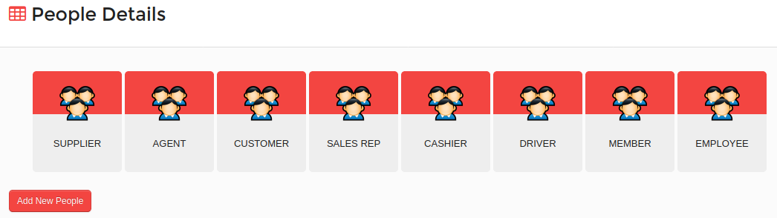
Figure 11

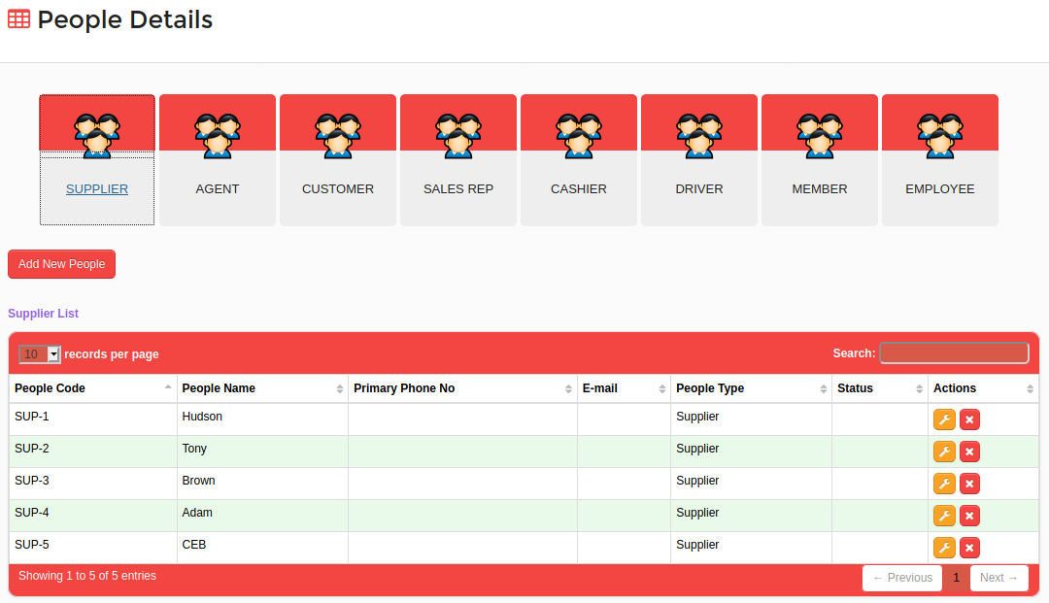
Figure 12

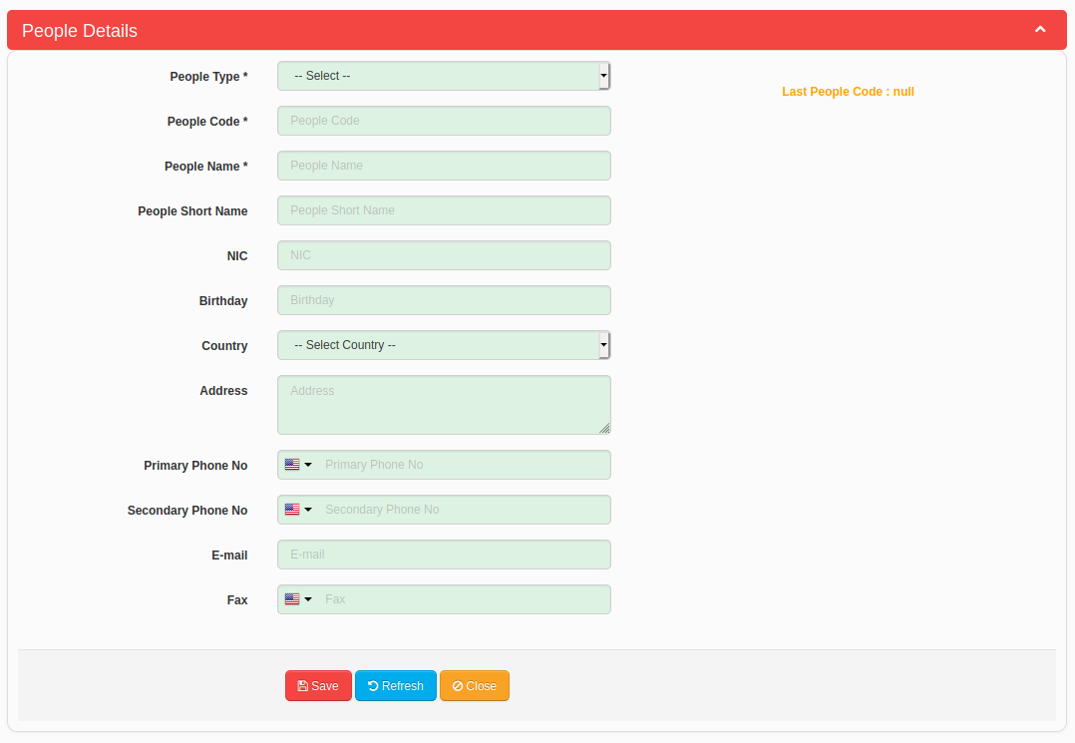
Figure 13
- After adding a new person, user can upload documents for that person by selecting the person from a people category. Users can click on “Upload A Document” button to upload a new document as shown in Figure 14.

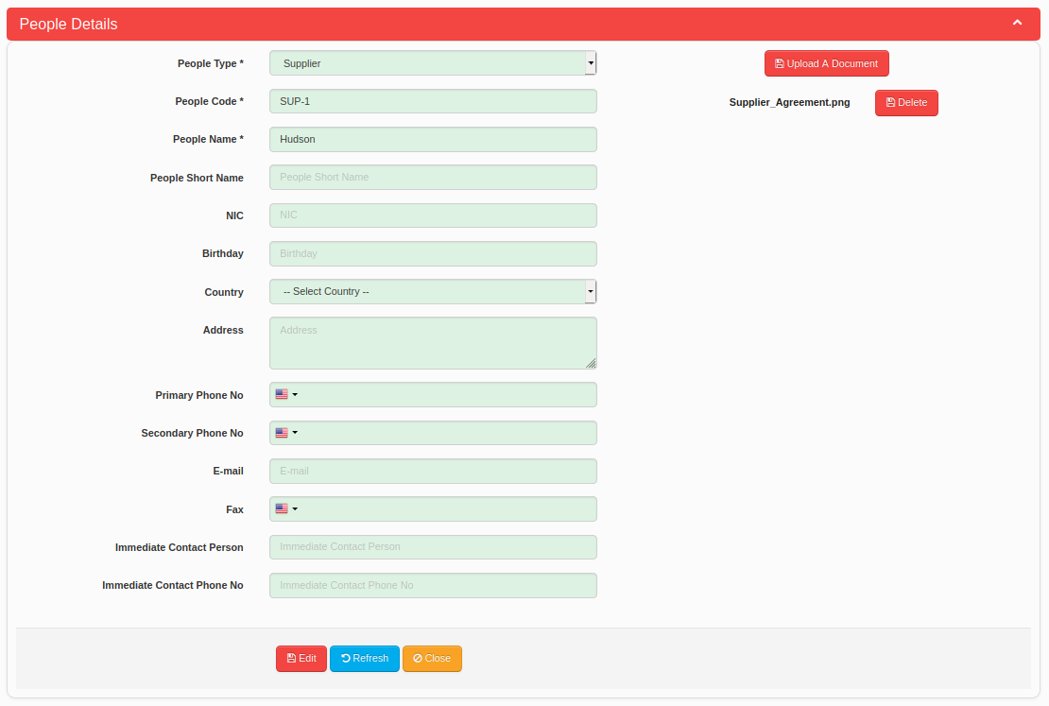
Figure 14

Data Import
Red Cherries Accounting provides master data to be imported during system implementation. Figure 15 shows the data import tool of Organization Manager. Data Import screen can be accessed in the system from “Administration Module → Data Import” menu.
Follow the following instructions to import master data.
- Download the organization master data import Excel workbook by clicking on “Download” button in “Download Organization Master Data Import Excel Workbook” section shown in Figure 15.
- You can download the data import user guide by clicking on “Download Data Import Workbook User Guide” button in “Download Organization Master Data Import Excel Workbook” section shown in Figure 15. You should refer the user guide for detailed instructions.
- After filling the data import Excel workbook, upload the workbook by clicking on “Browse” button in “Upload Organization Master Data Import Excel Workbook” section shown in Figure 15.
- System will verify your data in Excel template while uploading and it will show an error message if your data is not accurate. Click on “Download Data Import Workbook Error Log File” button in “Upload Organization Master Data Import Excel Workbook” section shown in Figure 15 to download the error log file if you get any error message while data uploading.
- If your data is accurate, the system will show a success message after uploading the Excel workbook.
- Finally use the options given in “Import Data” section shown in Figure 15 to import master data.

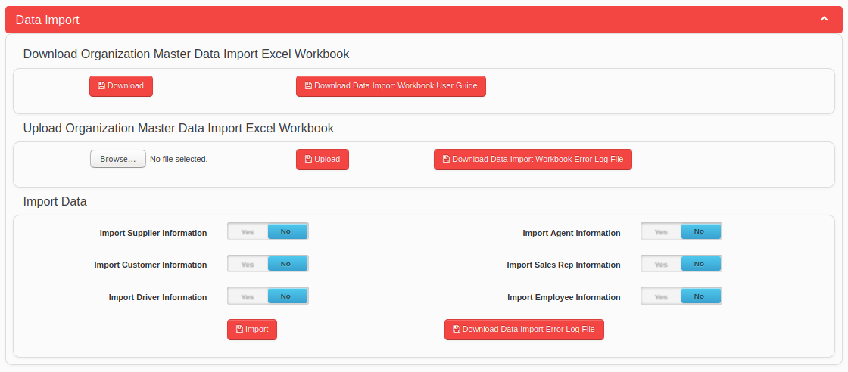
Figure 15

Google Analytics Settings
Red Cherries Accounting allows system administrator to register the system with Google Analytics to track system access details of the users. Google Analytics Settings can be added in the system from “Administration Module → Google Analytics Settings” menu.
Specify the configuration settings in screen shown in Figure 16 so that system will upload required information to the registered Google Analytics account of the company.

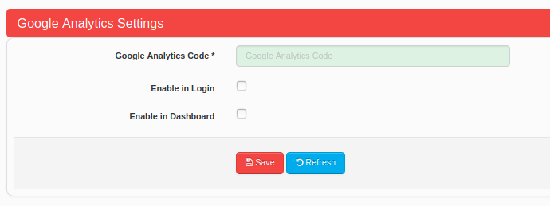

Figure 16

System Configurations
The system allows users to control the behavior of system features using following system configurations. System Configurations can be specified in the system from “Administration Module → System Configurations” menu.
People Configurations
- People related configurations can be controlled in the system as shown in Figure 17.
- It is possible to enable and specify people addition authorizer as shown in Figure 17.

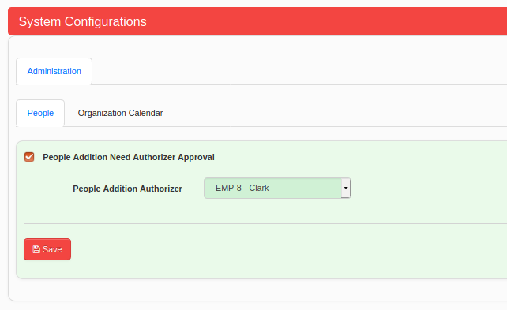

Figure 17

Organization Calendar
- Organization Calendar related configurations can be controlled in the system as shown in Figure 18.
- It is possible to select counties and companies and then populate Saturdays and Sundays for the current year as Shown in Figure 18.
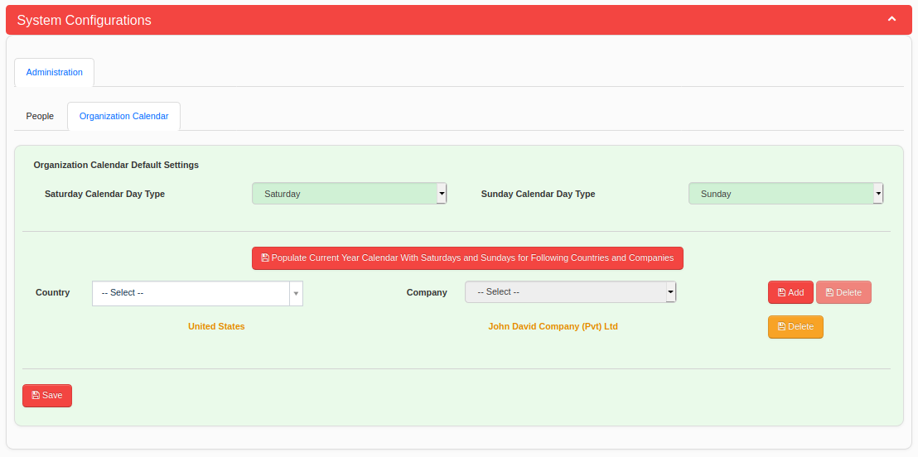
Figure 18

