

Red Cherries Accounting (Open Source)
Organization Module
Organization User Guide
Version 1.0 Beta 1

Table of Contents
Introduction 3
Top Navigation Bar 4
Company Information 5
Company Structure 6

Introduction
This user guide aims at giving you the information required to work with “Organization Section” of “Organization”. This user guide can be downloaded from “Organization Help” screen shown in Figure 2 which is accessible from “Organization → Help” menu as shown in Figure 1.

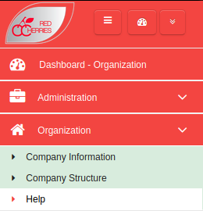

Figure 1

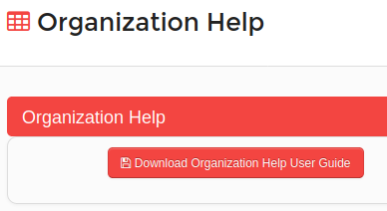

Figure 2

Top Navigation Bar

Toggle Left Menu
Open/Retract System Modules
Change Password
My Language
About System
Logout
System Dashboard
Current Module
Default Module

Figure 3

  - Toggle Left Menu : Show/hide left menu
  - Open/Retract System Modules : Open/retract system module dashboard. Previous screen preserves if user does not select any module.
  - System Dashboard : Opens the system modules dashboard. Previous screen does not preserved.
  - Current Module : Shows the current module that user has selected.
  - Default Module : Selecting current module as default module will allow to go directly to that module on login to the system.

Company Information
Company information can be added in the screen shown in Figure 4. “Company Information” screen is accessible from “Administration Module → Company Information” menu.
- “Company Name”, “E-mail”, “Primary Phone Number” and “Address” fields are mandatory when adding company information.
- Country code of telephone numbers and fax number can be selected by accessing the country flag .
- There should be a space between country code and telephone/fax number. Ex : +94 0111234567.
- Company information is shown on system print outs (Reports, Invoice etc.).

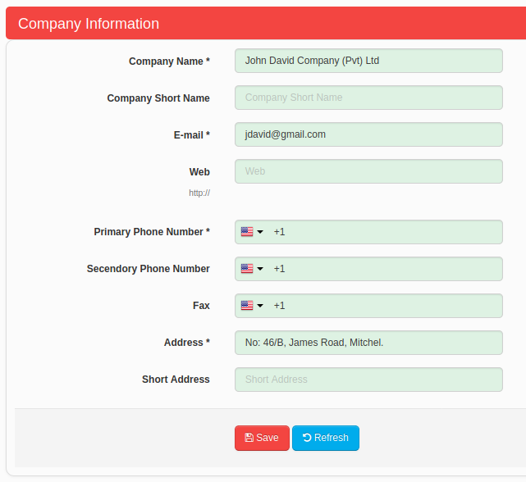

Figure 4

Company Structure
Company organization structure can be created as shown in Figure 5. “Company Structure” screen is accessible from “Administration Module → Company Structure” menu.

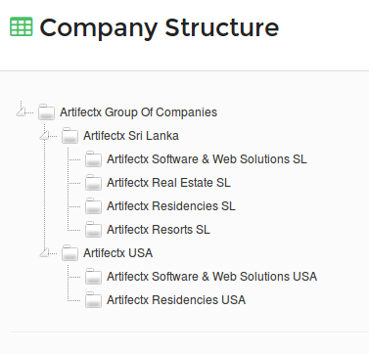

Figure 5
- In order to add the company structure, right click on the top company name.
- A new menu will be displayed as shown in Figure 6.
- When you select “Add” option from the menu, a new screen will be displayed to add the company name.
- Company structure can be arranged by dragging and dropping company names in the structure.
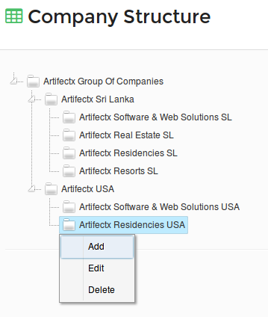

Figure 6

