This section reports on what our team did for the Awesome-Deep-Learning-For-Machine-Vision repository. We made our main contribution by submitting a PR to add extra resources to the README file, but we have not received any feedback yet.

The team submitted PR #113 (https://github.com/ArtificialRay/Awesome-Deep-Learning-For-Machine-Vision/pull/123), and included the two papers “Swin Transformer V2” and “Vision Transformer Adapter for Dense Predictions,” as well as added the MMSegmentation package. “Vision Transformer Adapter for Dense Predictions” (Chen et al., ICLR 2023) and “Scaling Up Capacity and Resolution” (Liu et al., CVPR 2022) were submitted with the MMSegmentation tool (https://github.com/open-mmlab/mmsegmentation) to the right sections on April 28, 2025. We have no conflicts reported on this PR, which is shown in Figure 5.1. This figure shows the page for the PR we created to add resources, all of which we did in the “feature/add-resources” branch.

There is no indication that the PR has been approved as of this moment, as the maintainers have not answered. Our approach for moving ahead will depend on whether the maintainers answer our PR, as changes may be needed based on their review.

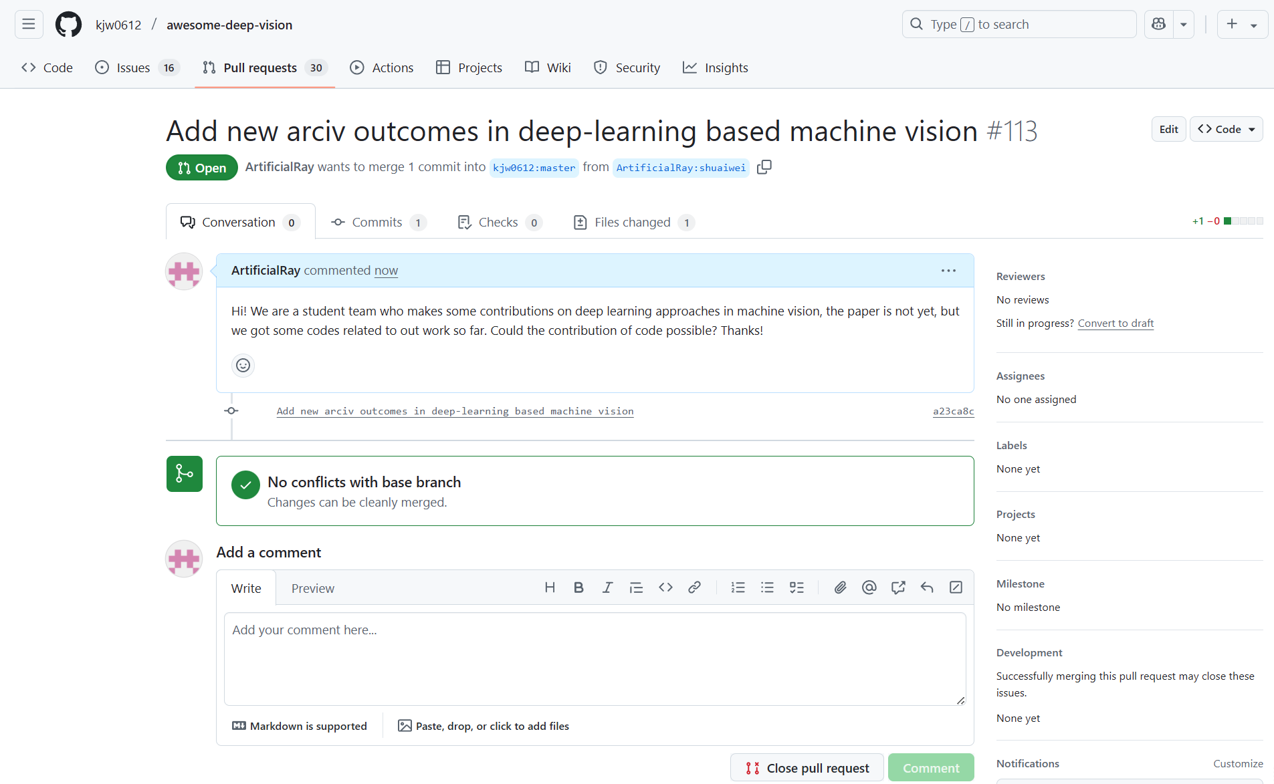

Figure 5.1: Pull Request Status