EDAB 6808
ASSIGNMENT 4
Natural Language Processing of Bitcoin Tweets

Buhle Mbokodo | 2024007920
Lwazi Nhlapo | 2021856345

1. Executive summary
The analysis used the supplied Bitcoin Tweets Dataset 2025–2026 and a reproducible daily stratified modelling sample. After language filtering, 24,187 English-classified tweets across 201 dates were analysed, covering 6 March 2025 to 2 March 2026. The topic analysis compared LDA using count vectors with NMF using TF–IDF. A six-topic NMF solution was retained because it separated interpretable themes such as market trading, NFTs, project promotion, Lightning rewards and game-related posts.
For sentiment, VADER was compared with a frozen Twitter RoBERTa model on 60 manually reviewed tweets. RoBERTa achieved 73.3% accuracy versus 63.3% for VADER. Daily sentiment was then aligned with Bitcoin market data using a one-day-ahead forecast design. On the final 41-day holdout, the training-mean benchmark had the lowest MAE (0.01169), while the best sentiment-enhanced model was the RoBERTa random forest (MAE 0.01221). Adding RoBERTa sentiment to Ridge reduced MAE by 0.78% relative to the market-plus-activity Ridge control, but the notebook reports that this improvement was small, inconsistent across validation periods, and uncertain.
Key Findings
The tweets contain several clear and changing conversation themes, but better sentiment classification does not automatically produce reliable volatility forecasts. The forecasting evidence supports a cautious association rather than a causal claim.

2. Data and methodology

2.1 Dataset and modelling population
The assignment brief requires the Bitcoin Tweets Dataset 2025–2026 from Kaggle, clear documentation of the modelling population, text cleaning, exploratory analysis, two representations, at least two topic methods, evidence-based topic selection, temporal topic analysis, and exported tweet-level topic results. For sentiment, it requires polarity labels, manual validation of at least 50 tweets, daily aggregation, a justified volatility target, time-aware alignment and evaluation.

Stage | Records | Purpose
Stratified sample | 30,083 | Bounded, reproducible sample with up to 150 structurally valid records per observed date.
After duplicate removal | 30,083 | No duplicate records were removed in the final sample.
Eligible English | 24,187 | English probability ≥ 0.90; modelling population for text analysis.
Other/uncertain language | 5,896 | Excluded from English-language modelling.

The notebook also documents source-file repair, timestamp checks, language detection, duplicate policy and daily sampling weights. Because the source contains malformed/quoted records and timestamps without a verified timezone, these are treated as data-quality limitations rather than silently corrected assumptions.

2.2 Text cleaning and representations
- URLs, user mentions, and non-informative formatting were standardised for modelling while retaining useful hashtags and domain-specific terms where appropriate.
- Stopwords and common boilerplate terms such as 'bitcoin', 'btc', 'rt' and URL fragments were removed for topic modelling.
- Two representations were used: count vectors for LDA and TF–IDF for NMF, using the same vocabulary design with unigrams and bigrams.
- A reproducible 5,000-document selection sample was used for topic-count comparison; the final NMF model was fitted using up to 20,000 unique cleaned messages.

3. Question 1: Topic modelling of Bitcoin tweets

3.1 Comparing topic models and selecting the number of topics
Candidate solutions of 4, 6, 8 and 10 topics were tested for both LDA and NMF. The notebook assessed NPMI coherence, top-term diversity and two-seed stability. The numerical ranking initially favoured NMF, while inspection of the actual keywords supported six topics as the most useful balance between separation and interpretability.

Method | Topics | NPMI | Diversity | Stability
NMF | 4 | 0.608 | 0.975 | 1.000
NMF | 6 | 0.471 | 0.950 | 1.000
NMF | 8 | 0.475 | 0.950 | 0.698
NMF | 10 | 0.468 | 0.930 | 0.802
LDA | 4 | 0.144 | 0.775 | 0.557
LDA | 6 | 0.111 | 0.717 | 0.291
LDA | 8 | 0.212 | 0.700 | 0.354
LDA | 10 | 0.055 | 0.630 | 0.307

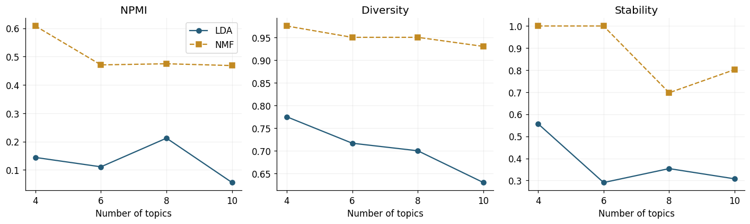
Figure 1. Evidence used to compare topic counts and the two topic-modelling methods.
The final six-topic NMF solution was selected after inspecting candidate keywords. Four topics merged market/trading and NFT discussion too broadly, while eight and ten topics introduced finer splits but lower stability. The choice was therefore an evidence-based interpretability decision rather than a random selection.

3.2 Final topics and dominant themes
Topic | Label | Key terms | Weighted share
0 | Crypto news and altcoin alerts | crypto; cryptocurrency; blockchain; ethereum; cryptonews; trading; altcoin; binance | 14.7%
1 | Coin Hunt World game posts | Coin Hunt World; vault; playing; join; awesome; location | 1.6%
2 | Lightning reward-faucet claims | lightning; sats; faucet; unlock; LightningNetwork; free | 2.4%
3 | Airdrops and project promotion | project; airdrop; BSC; team; future; good; great | 12.0%
4 | Market outlook and trading signals | price; buy; market; bullish; long; sell; target; signals; stop | 47.5%
5 | NFTs and altcoin communities | NFT; ETH; BNB; Ethereum; NFTcommunity; metaverse; OpenSea | 21.9%

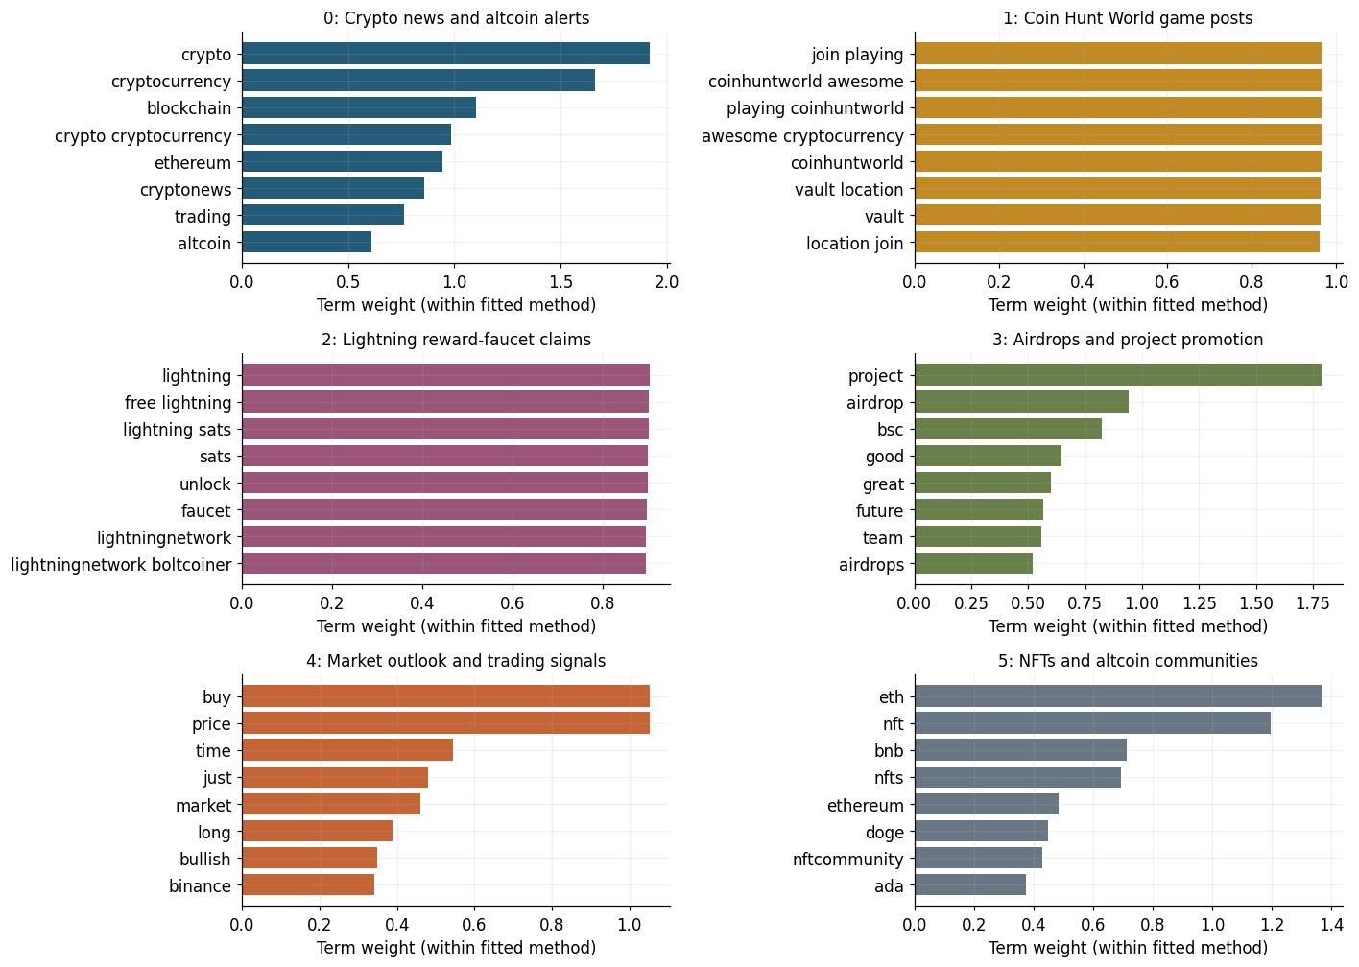
Figure 2. Top terms for the six final NMF topics.
Market outlook and trading signals is the dominant topic, representing approximately 47.5% of assigned weighted records. NFT/altcoin communities account for 21.9%, followed by crypto news and alerts (14.7%) and project promotion/airdrops (12.0%). Coin Hunt World and Lightning reward-faucet posts are much smaller but highly distinctive clusters.

3.3 Representative tweets and interpretation

Topic | Representative example | Interpretation
0 | “The Crypto Prophecies (TCP) went down 11.5 percent…” | Templated crypto news/price-alert content across multiple assets.
1 | “...found #bitcoin in a User vault... Join me playing #coinhuntworld...” | Repeated game/vault messages encouraging participation.
2 | “...tweet this to claim my free Lightning sats.” | Reward-faucet and Lightning sat-claim posts.
3 | “Great giveaway project... one of the best project in the world...” | Airdrop and project-promotion language.
4 | “Long Position... Entry Price... Target... Stop...” | Trading signals, price targets and buy/sell language.
5 | “Check out this account on OpenSea... #nft... #Ethereum...” | NFT, metaverse and altcoin-community promotion.
The full notebook retains three representative tweets per topic, selected using topic similarity and duplicate-text controls. The examples above illustrate why the topic labels are descriptive rather than assumptions about user intent.

3.4 How topics change over time
Weekly topic shares were calculated using the sampling weights and conditioned on assigned English tweets. Missing calendar weeks were preserved rather than treated as zero discussion. This is important because the source is a sampled dataset and not a complete census of all Bitcoin-related tweets.

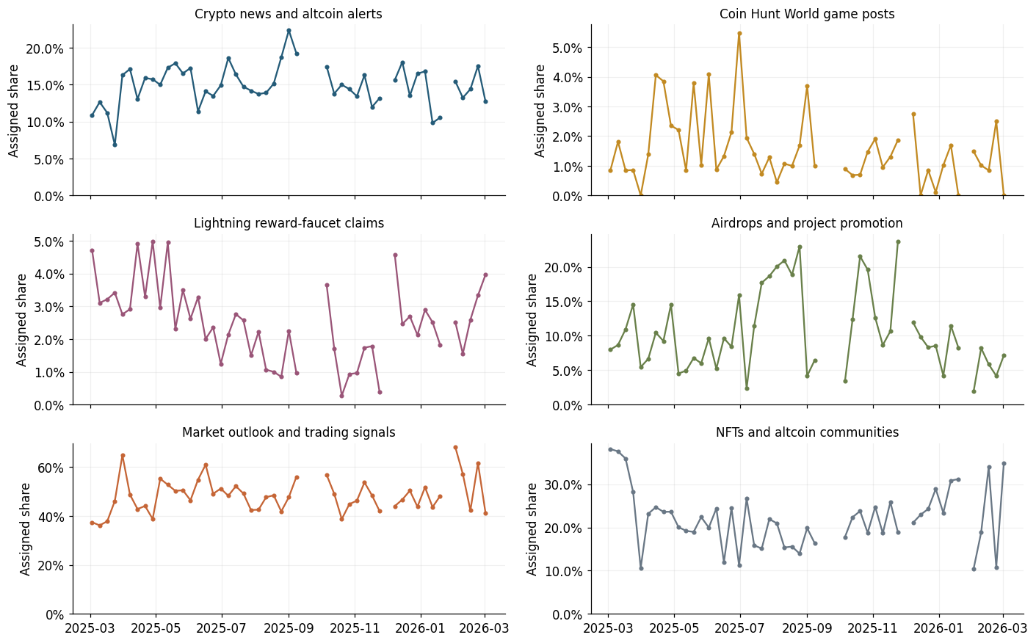
Figure 3. Weekly topic prevalence over the study period.

Topic | First-week share | Last-week share | Change
Market outlook and trading signals | 37.4% | 41.3% | +3.8 pp
Crypto news and altcoin alerts | 10.9% | 12.7% | +1.8 pp
Lightning reward-faucet claims | 4.7% | 4.0% | −0.7 pp
Airdrops and project promotion | 8.0% | 7.1% | −0.8 pp
Coin Hunt World game posts | 0.9% | 0.0% | −0.9 pp
NFTs and altcoin communities | 38.2% | 34.9% | −3.2 pp

The largest weekly movement occurred in the NFT/altcoin topic, while the market/trading topic reached a peak weekly share of about 68.2% in the week beginning 2 February 2026. These changes describe the composition of the sampled conversation; they do not establish why the changes occurred.

4. Question 2: Sentiment polarity analysis and Bitcoin volatility impact

4.1 Sentiment scoring
VADER compound polarity was converted to three labels using the documented thresholds: Positive ≥ +0.05, Negative ≤ −0.05, and Neutral otherwise. The weighted distribution was 56.0% positive, 27.5% neutral and 16.5% negative. A frozen Twitter RoBERTa model was then scored on the same tweets as a second sentiment approach.
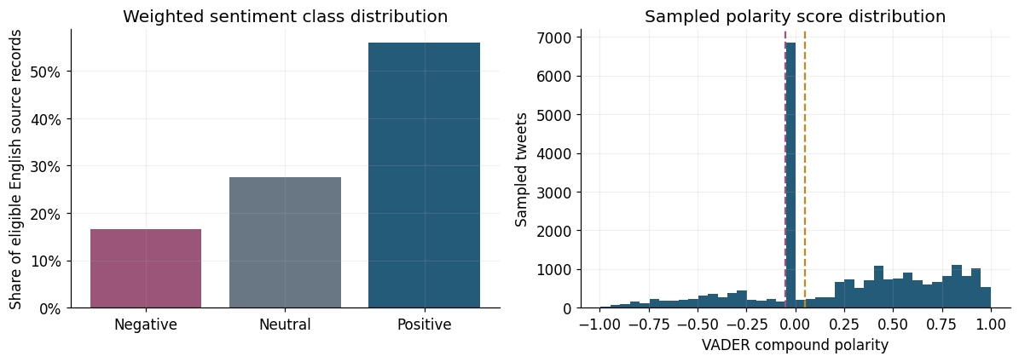
Figure 4. Weighted VADER sentiment distribution across eligible English tweets.

4.2 Human validation of sentiment
The notebook manually reviewed 60 tweets, exceeding the assignment minimum of 50. The sample contained 29 Positive, 28 Neutral and only 3 Negative labels. This small negative class makes negative-class metrics particularly uncertain.

Model | Accuracy | Macro-F1 | Correct / 60
VADER | 63.3% | 0.582 | 38
Twitter RoBERTa | 73.3% | 0.666 | 44
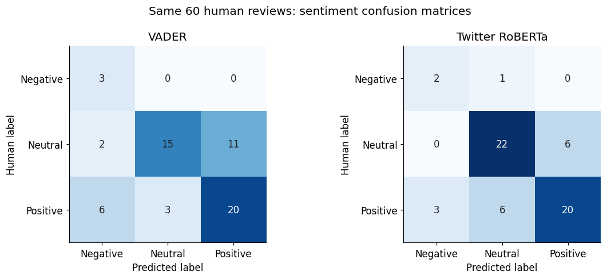
Figure 5. Confusion matrices for VADER and Twitter RoBERTa against the 60 human reviews.
RoBERTa improved neutral recall from 53.6% to 78.6% and achieved higher overall accuracy and macro-F1. Observed disagreements included promotional language, sarcasm/ambiguity, factual price alerts and tweets that praised one asset while criticising another.

4.3 Daily sentiment and volatility design
Daily sentiment features included mean polarity, polarity dispersion, positive share, negative share and activity/coverage controls. Bitcoin volatility was defined as the absolute next-day log return, |log(Pt+1/Pt)|. A trailing seven-day return standard deviation was also used as a market predictor.
- Forecast origin: after the UTC close of day t.
- Target: volatility on day t+1.
- Features and targets were constructed on the complete market calendar before joining tweet dates.
- The final modelling sample contained 200 eligible sentiment/market dates; the chronological holdout contained 41 target dates.
- The final training period used 159 origins, with a one-observation purge before the holdout.

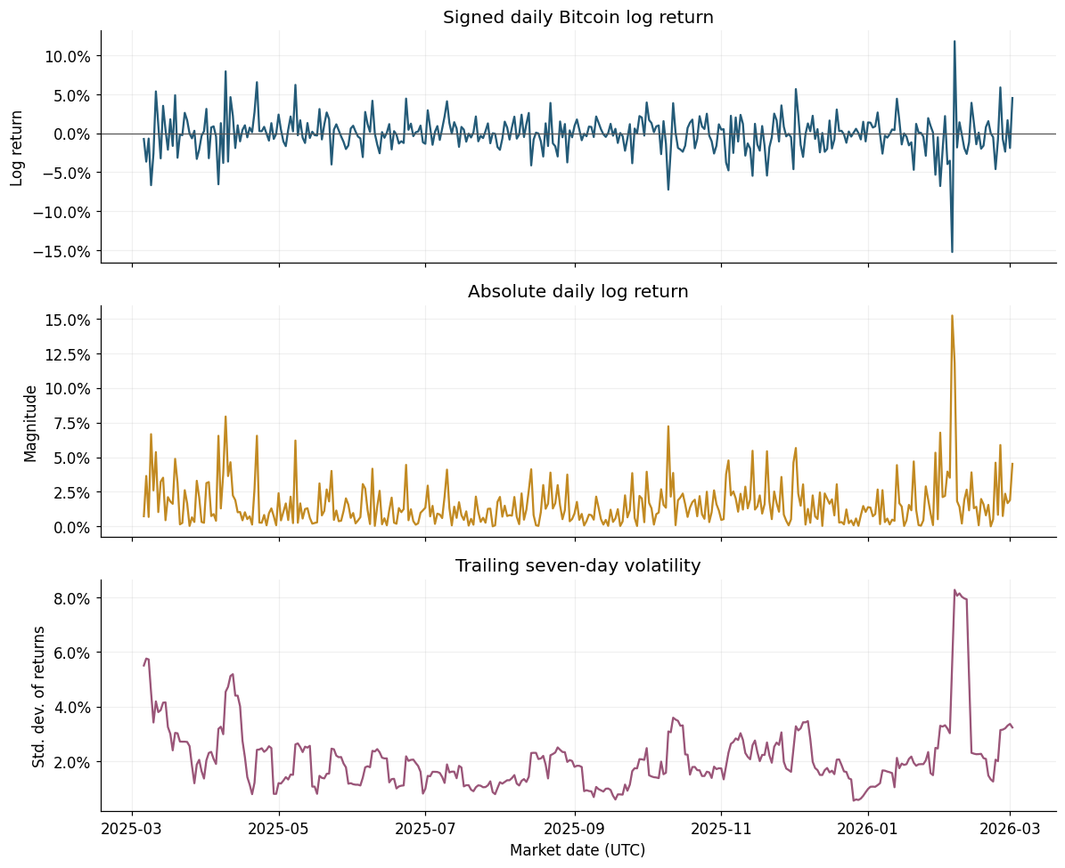
Figure 6. Bitcoin daily returns, absolute returns and seven-day rolling volatility over the study period.
Descriptively, daily mean sentiment had a correlation of −0.069 with next-day target volatility. This is a weak full-sample association and was not used as a substitute for the time-aware forecasting evaluation.

4.4 Forecast model comparison
The controlled comparison included market-only models, market-plus-activity models and models adding VADER or RoBERTa sentiment. Ridge regression and random forest were both evaluated. The first 80% of eligible dates formed development data, the final 20% were an untouched chronological holdout, and four expanding-window validation folds were used inside development.

Final holdout model | MAE | RMSE | High-volatility accuracy
Training mean | 0.01169 | 0.02009 | 53.7%
Market + activity + RoBERTa forest | 0.01221 | 0.01854 | 65.9%
Market + activity forest | 0.01242 | 0.01849 | 65.9%
Market + activity + VADER forest | 0.01264 | 0.01864 | 63.4%
Market Ridge | 0.01304 | 0.01870 | 53.7%
Market + activity + RoBERTa Ridge | 0.01310 | 0.01832 | 56.1%
Market + activity + VADER Ridge | 0.01327 | 0.01831 | 53.7%
Persistence | 0.01725 | 0.02508 | 51.2%
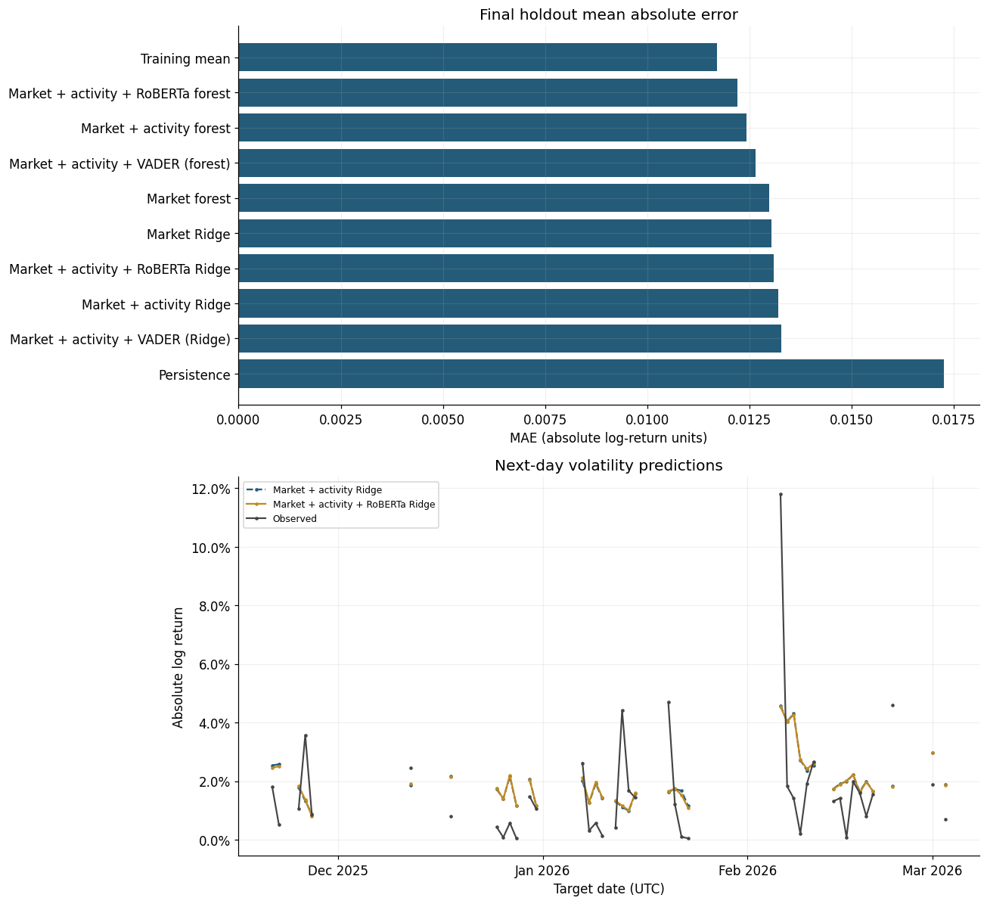
Figure 7. Final holdout MAE and next-day volatility predictions.
The simple training-mean benchmark achieved the lowest MAE on the final holdout. Among sentiment-enhanced models, RoBERTa slightly improved Ridge MAE by 0.78% relative to the market-plus-activity Ridge control, whereas VADER worsened it by 0.52%. RoBERTa improved the corresponding forest MAE by 1.70% relative to the market-plus-activity forest. The notebook's block-bootstrap intervals include zero and improvements were inconsistent across validation folds, so the incremental forecast benefit should be treated as uncertain.

4.5 Direction and interpretation of the sentiment relationship
Conditional association
In the selected RoBERTa Ridge model, the standardised coefficient for daily mean sentiment was approximately −0.000230. Holding the included predictors fixed, more positive sentiment was associated with lower predicted next day movement magnitude. This is not a statement about whether Bitcoin's price rises or falls, and it does not establish causality.

The observational design cannot rule out confounding, reverse influence from market conditions on sentiment, measurement error, or timing limitations. Therefore, the appropriate conclusion is association rather than causation.

5. Overall conclusions and limitations

5.1 Conclusions against the assignment requirements
- Topic modelling: two text representations and two topic methods were compared, topic count was evidence-based, six final topics were interpreted, and topic prevalence was analysed over time.
- Sentiment: polarity scores and labels were generated, 60 tweets were manually reviewed, two sentiment models were compared, and the better-performing RoBERTa model was carried forward.
- Volatility modelling: a transparent next-day absolute-log-return target was created and evaluated using chronological validation and a final holdout.
- Interpretation: sentiment showed a small and uncertain incremental forecasting contribution, so the results do not support a strong predictive or causal claim.

5.2 Limitations
- The source dataset contains malformed/quoted records and unverified tweet timestamps; reconstruction and sampling reduce, but do not eliminate, data-quality concerns.
- The English-only sample may not represent the full multilingual Bitcoin conversation.
- Only three of the 60 manually reviewed tweets were Negative, limiting confidence in negative-class performance.
- Topic clusters contain promotional, templated and cross-asset content; Bitcoin hashtags do not guarantee that a tweet is specifically about Bitcoin.
- The forecasting sample is relatively short, and daily volatility is highly noisy. Large volatility spikes were difficult for all models to predict.
- The sentiment-volatility analysis is observational; coefficients and forecast improvements should not be interpreted as causal effects.

6. Reproducibility and references
The notebook fixes the random seed, records model versions/revisions where relevant, caches market and transformer outputs, exports the modelling datasets and predictions.
- University of the Free State. EDAB 6808 Assignment 4: Natural Language Processing of Bitcoin Tweets. 2026.
- Kaggle. Bitcoin Tweets Dataset 2025–2026. https://www.kaggle.com/datasets/pokeash/bitcoin-tweets-dataset-20252026
- Hutto, C. J., & Gilbert, E. (2014). VADER: A Parsimonious Rule-based Model for Sentiment Analysis of Social Media Text.
- CardiffNLP. Twitter RoBERTa sentiment model. https://huggingface.co/cardiffnlp/twitter-roberta-base-sentiment-latest
- Scikit-learn documentation: LDA, NMF, Ridge, Random Forest and TimeSeriesSplit.
- Yahoo Finance BTC-USD historical data, accessed through yfinance.

