South African inflation forecasting for 2026
  - Statistical and machine learning evidence

EDAB6808 Assignment 2
Lwazi Nhlapo(2021856345)

Fumane Malangabe

Executive summary
The results support SARIMA(1,1,2)(1,0,1)₁₂ as the preferred model for the January to December 2026 forecast. It has the lowest mean absolute error (MAE), root mean squared error (RMSE) and mean absolute percentage error (MAPE) under both shared expanding-window designs: 48 one-month-ahead forecasts and 12 quarterly origins with horizons of one to twelve months. Its pooled MAE is 0.9316 CPI index points, compared with 1.2477 for Random Forest and 1.7483 for Support Vector Regression (SVR). This is a 25.3% reduction against Random Forest and a 46.7% reduction against SVR. Converting the same 144 forecasts and actuals to year-on-year inflation gives SARIMA an MAE of 1.0205 percentage points, using each target month’s observed CPI twelve months earlier as the common denominator.
The central forecast places the headline Consumer Price Index (CPI) at 103.880 in January 2026 and 107.719 in December 2026. The derived year-on-year inflation rate averages 3.51% across the twelve months and reaches 3.98% in December. However, the December 95% prediction interval for inflation is 1.49% to 6.52%. The central path therefore supports a baseline of continued price increases, while the interval shows that the final outcome remains uncertain. A September 2026 risk update links higher fuel inflation to Middle East oil-supply disruption. A weaker rand would amplify imported costs, although SARB reports that the rand has remained resilient (South African Reserve Bank [SARB], 2026). These developments occurred after the December 2025 forecast origin and were not included in model estimation; historical prediction intervals cannot fully represent such new shocks.
The more flexible machine learning models can learn nonlinear patterns, but this ability produced larger forecast errors here. Random Forest is the strongest machine learning alternative, while SARIMA has lower MAE at every tested horizon. SARIMA also has the lowest one-step RMSE (0.2803) and MAPE (0.2364%), and pooled RMSE (1.2595) and MAPE (0.9684%) (Table 3). Separate horizon-level results are reported only for MAE. This supports selecting a model for the actual forecast horizon rather than assuming that a more complex method must perform better.

Purpose and scope
Question 2 requires an official monthly South African CPI series, a statistical and a machine learning model, historical model tuning, time-aware backtesting and a full-year 2026 forecast (University of the Free State, 2026). It does not treat the 2026 predictions as observed inflation.
The study includes the required January 2021 to December 2025 period, but it trains and finally refits on January 2015 to December 2025. Earlier history increases the number of observations available for seasonal and lagged models. The report makes this difference visible instead of describing the saved forecast as a five-year-only fit.

2 Data preparation and the forecast target
The source is the supplied Statistics South Africa CPI workbook, labelled 202605. The exact selected series is: CPS00000, CPI Headline, All urban areas, Index. This avoids mixing an index with a published inflation rate row or a different geographic series. Monthly column labels are converted into month start dates, sorted and placed on a regular monthly frequency (Statistics South Africa, 2026).
The modelling sample contains 132 months, with no missing CPI values or duplicate dates reported. January 2021 is 81.7 and December 2025 is 103.6. The code stops when its quality checks fail, so it does not silently fill gaps. All observations dated after December 2025 are excluded from model training, tuning and backtesting.
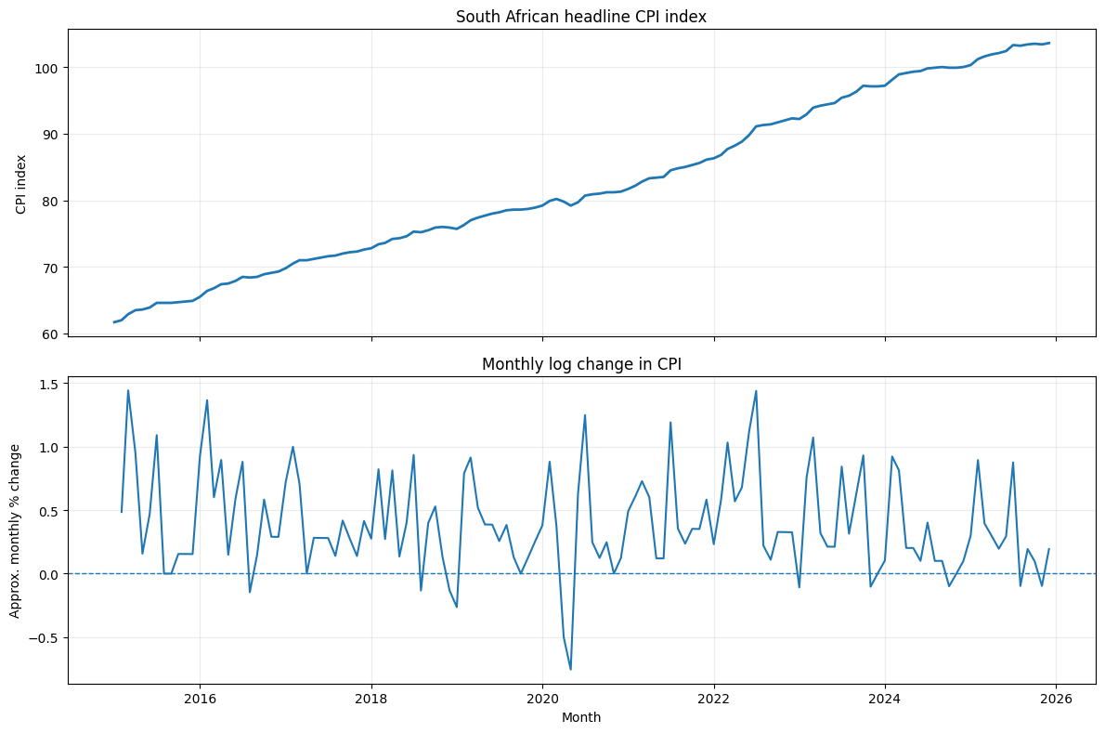
Figure 1. CPI levels and monthly log changes, January 2015 to December 2025. Source: Lwazi (2026), cell 5; Statistics South Africa (2026).
Figure 1 explains why the target transformation matters. CPI rises over time, whereas monthly changes fluctuate around a much more stable level. Modelling changes reduces the risk that a flexible model mainly learns the passage of time. Over the full sample, the CPI mean is 82.4235 with a standard deviation of 12.4209. Monthly log changes have a mean of 0.3956% and a standard deviation of 0.3871%, with a range from −0.7547% to 1.4412%. These are different quantities and cannot be compared as the same measure of volatility.
The monthly transformation is Δlog(CPIₜ) = log(CPIₜ) − log(CPIₜ₋₁). The forecasting target remains the CPI index. Year-on-year inflation is derived afterwards as:
$${\hat{π}}_{t} = 100 × \left(\frac{{\hat{CPI}}_{t}}{{CPI}_{t−12}} − 1\right)$$
Here, π̂ₜ is forecast year-on-year inflation (%) in month t, CPÎₜ is the forecast CPI index, and CPIₜ₋₁₂ is the observed index for the same month one year earlier. The hat denotes a forecast. This keeps model errors on a common index scale and gives the final result an economic meaning. A rise in CPI means prices are higher, it does not by itself mean that the inflation rate is accelerating.

3 What the time series diagnostics imply
The month-of-year profile in Figure 2 shows why annual seasonal information is worth testing. Average monthly log changes are highest in July (0.8575%), February (0.8270%) and March (0.7586%). November averages only 0.1200%. A model that assumes the same expected change every month would miss this pattern. However, these averages use only ten or eleven observations per month and do not identify the economic cause of the pattern. Plausible mechanisms are February medical-insurance surveys, March education-fee surveys and July municipal tariff adjustments (Statistics South Africa, 2025a, 2025b, 2025c). These costs can squeeze household budgets and raise business costs without stronger demand. Seasonal terms may capture recurring timing, but these examples do not establish causality across the full sample or predict unusual shocks.
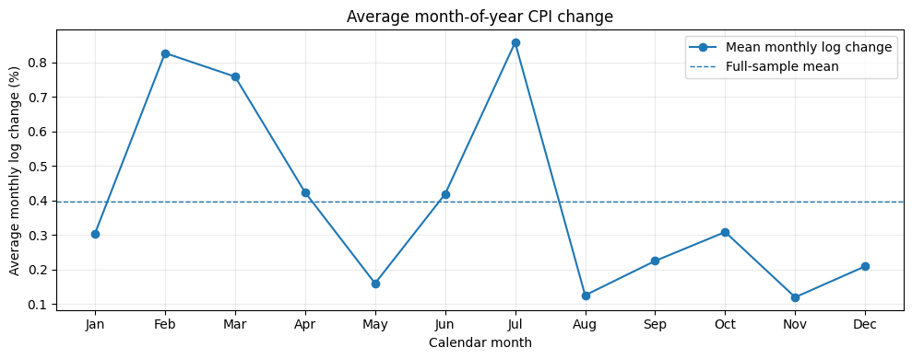
Figure 2. Average monthly log change by calendar month. Source: Lwazi (2026), cell 5.
Robust seasonal and trend decomposition using LOESS (STL) reports trend strength of 0.999 and seasonal strength of 0.394. The trend is dominant, while seasonality is present but incomplete. This supports testing seasonal terms against non-seasonal alternatives rather than imposing a strong seasonal model without comparing forecast performance.
Table 1. Stationarity diagnostics from the saved notebook
Series | ADF p value | KPSS p value | Interpretation
Log CPI level | 0.8151 | 0.0100 | Evidence against level stationarity
First difference of log CPI | 0.3327 | 0.1000 | Mixed evidence after differencing

For the log level, the Augmented Dickey–Fuller (ADF) test does not reject a unit root, and the KPSS test rejects level stationarity at 5%. After first differencing, KPSS does not reject stationarity, but ADF still does not reject a unit root. The tests therefore do not jointly prove that the transformed series is stationary. The KPSS values are reported at the test’s tabulated boundaries; they should not be read as exact probabilities (Lwazi, 2026, cell 5).
Using one log difference is a reasonable working choice because the transformation stabilises the visible series and the selected model forecasts well in the historical comparisons. The claim is practical rather than absolute. Autocorrelation (ACF) and partial autocorrelation (PACF) are also examined, but the model orders are ultimately chosen by forecast error, reducing reliance on a single diagnostic plot. Forecast error measures performance on unseen months, whereas historical fit can be misleading. Time-ordered tests at the required horizon therefore match the forecasting decision (Hyndman and Athanasopoulos, 2021a).

4 Methodology and historical backtesting
An expanding window retains the earlier observations and adds new history at each forecast origin. Every model receives data only through that origin. This reflects a forecasting task more closely than a random split, which can allow later information to influence earlier predictions. Rolling origin evaluation can also assess several steps ahead, making the validation horizon relevant to the intended use (Hyndman and Athanasopoulos, 2021a).
Table 2. Common time structure used in the notebook
Stage | Forecast origins | Forecasts assessed
Historical tuning | Jan 2019 to Oct 2021, quarterly | 12 origins, one step each
One month evaluation | Dec 2021 to Nov 2025, monthly | 48 forecasts, Jan 2022 to Dec 2025
Multi horizon evaluation | Jan 2022 to Oct 2024, quarterly | 12 origins × 12 horizons = 144 errors per model
Final forecast | Dec 2025 | Jan to Dec 2026

Table 2 separates tuning from later evaluation. SARIMA, SVR and Random Forest use the same tuning dates. Once their settings are selected, those settings remain fixed during evaluation, while the models are refitted as history expands. The multi-horizon target dates run from February 2022 to October 2025. The three fitted model families are compared on the same 144 origin–horizon pairs, so differences in their scores do not come from different test dates.

How future information is excluded
A machine learning feature row at month t predicts the log change in month t+1. At an origin t, supervised training therefore ends at feature month t−1, whose outcome is already known. Rolling means, rolling standard deviations and lagged changes use past values only. SVR scaling is fitted within each training window, rather than once on the whole dataset. Calendar features refer to the month being forecast, which is known in advance.
For a twelve-month forecast, each machine learning model is fitted once at the origin. It predicts the next change, reconstructs CPI, appends that predicted CPI to its history and rebuilds the features. It then repeats this process. Actual future CPI is never inserted into this recursive path. SARIMA produces the twelve-step path from its fitted state-space model (Lwazi, 2026, cells 15 and 23–24).

Limits of the evaluation design
Overlapping forecast paths create dependent errors, the same target month can appear at several horizons. The 144 errors are therefore not 144 independent experiments. The multi horizon results are also used to select the final model family, so they are selection evidence rather than a completely untouched final test. In addition, the 2026-vintage workbook provides a retrospective data snapshot. Excluding 2026 rows prevents direct target leakage, but does not establish that every historical value was available in exactly that form at each original forecast date.

5 Statistical and machine learning development

SARIMA captures persistence and seasonal dependence
Six autoregressive integrated moving average (ARIMA) and seasonal ARIMA (SARIMA) candidates are fitted to log CPI, all with first differencing and a constant term. The grid includes four non-seasonal specifications and two seasonal specifications with a twelve-month period. Selection uses the lowest one-step tuning MAE, with RMSE as a secondary measure. The preferred SARIMA(1,1,2)(1,0,1)₁₂ has tuning MAE of 0.1444 and RMSE of 0.2128. The best non-seasonal candidate, ARIMA(0,1,1), has MAE of 0.2491. The selected seasonal model therefore reduces tuning MAE by about 42.0%.
The selected model uses one non-seasonal autoregressive term, two moving-average terms and annual autoregressive and moving-average terms. It does not apply seasonal differencing. The statsmodels SARIMAX implementation allows these seasonal and non-seasonal orders to be specified within a state-space model (statsmodels, n.d.). The tuning result is evidence that annual dependence is useful in this sample, it is not proof that the seasonal pattern will remain unchanged.

SVR models nonlinear changes with scaled predictors
SVR uses a radial basis function (RBF) kernel to model nonlinear relationships between recent CPI behaviour and the next monthly log change. Its predictor set combines lagged changes; three-, six- and twelve-month rolling means; six- and twelve-month rolling standard deviations; the current twelve-month log change; log CPI; and sine/cosine month encoding. Predicting a change, then rebuilding CPI, allows a positive forecast level and avoids directly extrapolating a trending index with the regression model.
The notebook uses StandardScaler inside the SVR pipeline. Optuna’s Tree-structured Parzen Estimator searches lag counts of 3, 6, 9 or 12 and the C, epsilon and gamma parameters over 15 trials, with seed 42. The selected model uses nine lags, C = 70.5219, epsilon = 0.00008641 and gamma = 0.062891. Its tuning MAE is 0.2163. These parameters control the penalty for errors, the error-insensitive range and the kernel’s reach (scikit-learn, n.d.a; Optuna, n.d.). Fifteen trials provide a limited search, so the results should not be read as the best possible performance of every SVR specification.

Random Forest provides a second nonlinear benchmark
Random Forest averages regression trees and can represent interactions without predictor scaling (scikit-learn, n.d.b). Three compact candidate settings are tested. The selected configuration uses six lags, 100 trees, maximum depth 4, minimum leaf size 2 and a feature fraction of 0.7. Its tuning MAE is 0.1625 and RMSE is 0.2711. Shallow trees and a small search restrict complexity in a modest monthly dataset.
Both machine learning methods use the same types of available information, although their selected lag counts differ. Neither model includes exchange rates, fuel prices or other external predictors. The comparison therefore tests how different methods use CPI history, it does not test whether additional economic information could improve the forecasts.

6 Model comparison under the same design
Table 3 provides the main comparison. MAE measures the average absolute error and RMSE gives more weight to large errors. Both are in CPI index points. MAPE and sMAPE measure percentage error in the index, not percentage-point error in year-on-year inflation. MASE scales MAE by the notebook’s fixed historical mean absolute one-month CPI change, approximately 0.3280 index points, calculated through November 2021 (Hyndman and Athanasopoulos, 2021b; Lwazi, 2026, cells 8 and 19).
Table 3A. One month ahead evaluation on 48 common forecast dates
Model | MAE | RMSE | MAPE % | sMAPE % | MASE
SARIMA | 0.2266 | 0.2803 | 0.2364 | 0.2365 | 0.6909
Random Forest | 0.2586 | 0.3186 | 0.2699 | 0.2700 | 0.7884
SVR RBF | 0.3106 | 0.3715 | 0.3229 | 0.3228 | 0.9470
Naive persistence | 0.3854 | 0.5052 | 0.4051 | 0.4065 | 1.1749

Table 3B. Pooled horizons 1 to 12 on 144 common origin–horizon pairs
Model | MAE | RMSE | MAPE % | sMAPE % | MASE
SARIMA | 0.9316 | 1.2595 | 0.9684 | 0.9707 | 2.8398
Random Forest | 1.2477 | 1.6447 | 1.2952 | 1.2873 | 3.8033
SVR RBF | 1.7483 | 2.1698 | 1.7936 | 1.7726 | 5.3294
Naive persistence | Not run | Not run | Not run | Not run | Not run

Source for Table 3: Lwazi (2026), cells 19 and 24; forecast workbook, Model_Comparison sheet. SARIMA denotes SARIMA(1,1,2)(1,0,1)₁₂. All scores are rounded to four decimal places. The naive model is evaluated only in the one-step design.
SARIMA ranks first on every reported metric in both panels. At one month, it lowers MAE by 41.2% relative to persistence and by 12.4% relative to Random Forest. The machine learning models also improve on persistence, showing that recent changes and calendar information contain predictive value. However, their additional flexibility does not overturn the statistical model’s advantage.
For the full year task, SARIMA’s pooled MAE is 25.3% lower than Random Forest’s and 46.7% lower than SVR’s. Its pooled RMSE is also lower by about 23.4% and 42.0%, respectively. Agreement between MAE and RMSE strengthens the ranking because the result is not driven only by how one loss function treats large errors.

7 Forecast horizon and statistical diagnostics
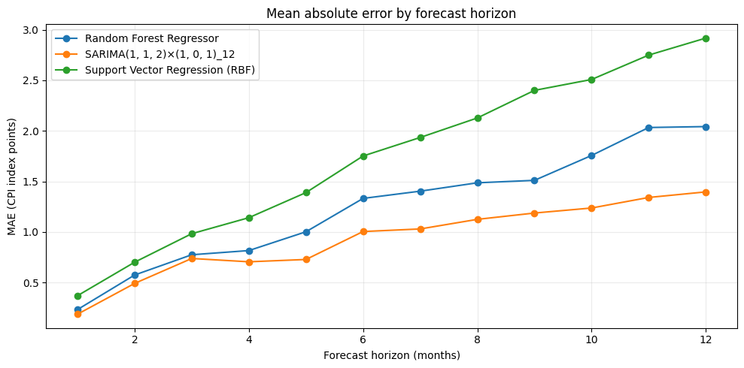
Figure 3. MAE by forecast horizon across twelve common historical origins. Source: Lwazi (2026), cell 24.
Figure 3 shows that SARIMA has the lowest MAE at all twelve horizons. Its MAE grows from 0.1879 at one month to 1.3970 at twelve months. Random Forest increases from 0.2336 to 2.0427, while SVR rises from 0.3707 to 2.9176. At twelve months, SARIMA’s MAE is 31.6% lower than Random Forest’s and 52.1% lower than SVR’s. This supports its selection for a forecast issued once for the whole of 2026.
The machine learning errors are consistent with uncertainty accumulating as predicted values become inputs to later forecasts. This is a plausible mechanism, not a separately tested causal explanation. The one-month values in Figure 3 differ from Table 3A because the figure uses twelve quarterly origins, while Table 3A uses 48 monthly origins. Comparing those values as though they came from the same test sample would be misleading.

Residual evidence supports only a qualified conclusion
The final SARIMA fit reports a seasonal autoregressive coefficient of 0.7943 and a seasonal moving-average coefficient of −0.5801, both with p values below 0.001. The non-seasonal terms have much weaker individual evidence. This is consistent with annual dependence being useful, but coefficient significance does not replace forecast evaluation or establish an economic causal relationship. The custom Ljung–Box tests report p values rounded to 1.0000 at lags 6 and 12.
The summary also reports Jarque–Bera p = 0.57 and heteroskedasticity-test p = 0.56. These do not identify clear departures in the reported checks, but they cannot confirm that future errors will follow the same distribution. The main selection evidence remains the lower historical forecast errors, rather than unusually high diagnostic p values.

8 Monthly forecast for January to December 2026
The selected SARIMA is refitted to all 132 observations from January 2015 to December 2025. Figure 4 connects the recent observed history to the twelve forecast months and the native 95% state-space prediction intervals. Table 4 gives the matching monthly values from the exported workbook (Lwazi, 2026, cells 28–30).
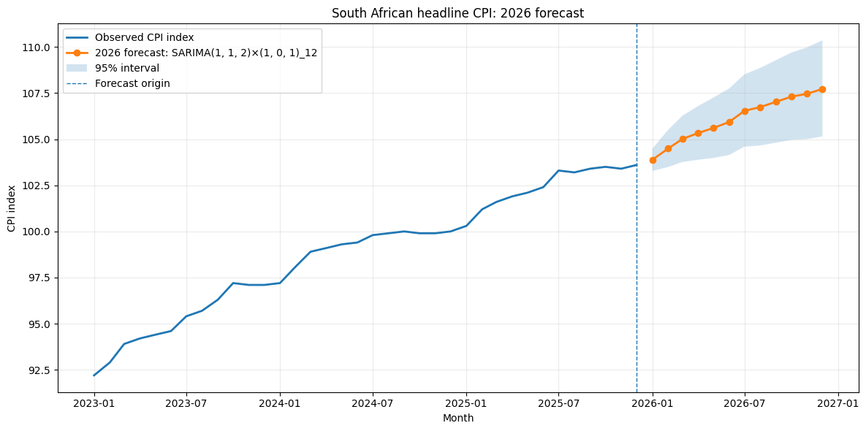
Figure 4. Forecast CPI for January to December 2026 with 95% prediction intervals. Source: Lwazi (2026), cell 30.

Table 4. Forecast CPI and derived year on year inflation
Month 2026 | CPI Forecast | Lower 95% | Upper 95% | YoY % | YoY_Lower95 % | YoY_Upper95 %
January | 103.880 | 103.8800 | 103.2790 | 104.4850 | 3.5700 | 2.9700
February | 104.490 | 104.4900 | 103.4890 | 105.5010 | 3.2510 | 2.2620
March | 105.009 | 105.0090 | 103.7650 | 106.2680 | 3.3550 | 2.1310
April | 105.332 | 105.3320 | 103.8850 | 106.7980 | 3.3680 | 1.9480
May | 105.606 | 105.6060 | 103.9810 | 107.2560 | 3.4340 | 1.8430
June | 105.933 | 105.9330 | 104.1460 | 107.7510 | 3.4510 | 1.7050
July | 106.538 | 106.5380 | 104.5950 | 108.5170 | 3.1340 | 1.2540
August | 106.740 | 106.7400 | 104.6590 | 108.8630 | 3.4300 | 1.4130
September | 107.026 | 107.0260 | 104.8120 | 109.2870 | 3.5070 | 1.3650
October | 107.303 | 107.3030 | 104.9620 | 109.6950 | 3.6740 | 1.4130
November | 107.462 | 107.4620 | 105.0040 | 109.9780 | 3.9290 | 1.5520
December | 107.719 | 107.7190 | 105.1460 | 110.3560 | 3.9760 | 1.4920

The CPI path rises from 103.880 to 107.719. December is 3.976% above the observed December 2025 CPI of 103.6. The YoY column uses each corresponding month of 2025 as its denominator; it does not measure the change from the previous forecast month. Interval bounds are CPI index values, not inflation rates.

9 Interpretation uncertainty and conclusion
The average of the twelve forecast year-on-year inflation rates is 3.51%. This is an average of monthly rates, rather than the percentage change between two annual average CPI levels. The central inflation rate declines from 3.57% in January to 3.13% in July before reaching 3.98% in December. Because each rate depends on the same month of 2025, the shape partly reflects base effects. For example, July CPI rises in the forecast even though July year-on-year inflation is the lowest forecast rate.
This forecast does not imply that prices return to earlier levels. It implies that the overall price level continues to rise at the predicted rates. Possible monthly drivers include higher global oil prices or rand depreciation raising fuel and imported-input costs; poor harvests lifting food prices; and tariff resets raising electricity and water costs. Higher interest rates may restrain demand and support the rand, with inflation effects taking time (SARB, n.d.; Statistics South Africa, 2025c). These are plausible channels, not causes identified by the CPI-only model. Their changing strength could therefore move realised inflation away from the forecast.

How to read the prediction intervals
The CPI interval expands from 103.279–104.485 in January to 105.146–110.356 in December. Its width grows from 1.207 to 5.209 index points. Dividing the December limits by the known December 2025 CPI converts this to an inflation interval of 1.49%–6.52%. The range is wide enough that the 3.98% central rate should be used with alternative scenarios, not as an exact outcome.
The notebook exponentiates the forecast mean on the log scale. Under the model’s Gaussian log-forecast assumption, this gives a median on the CPI scale, not a bias-adjusted arithmetic mean. The same transformation correctly maps the log-scale interval endpoints into CPI quantiles; they are described here as central forecasts (Hyndman and Athanasopoulos, 2021c). These are conditional, month-specific 95% prediction intervals.

Conclusion and limits of the recommendation
SARIMA is the most defensible choice among the tested models because it leads both common backtests and every forecast horizon. Random Forest is a useful alternative, but its lower ranking performs strongly at short horizons. The numerical evidence supports SARIMA at short horizons as well as over the full year.
The model lacks external indicators such as oil prices, the rand exchange rate, food-supply conditions, administered tariffs and interest rates. It therefore cannot directly anticipate sporadic macroeconomic shocks or changes in their transmission. Even forecasts with broader economic information can miss the outcome: in January 2022, SARB forecast average headline inflation of 4.9% for 2022, while the actual annual average was 6.9%, a gap of 2.0 percentage points (SARB, 2022; Statistics South Africa, 2023). This comparison illustrates forecast risk; it does not prove which shock caused the gap or directly compare SARB’s accuracy with this model. The 2026 path should therefore be updated as new indicators and shocks emerge.

References
Hyndman, R. J. and Athanasopoulos, G. (2021a). Forecasting Principles and Practice, 3rd ed., section 5.10, Time series cross-validation. OTexts.
https://otexts.com/fpp3/tscv.html
Hyndman, R. J. and Athanasopoulos, G. (2021b). Forecasting Principles and Practice, 3rd ed., section 5.8, Evaluating point forecast accuracy. OTexts.
https://otexts.com/fpp3/accuracy.html
Hyndman, R. J. and Athanasopoulos, G. (2021c). Forecasting Principles and Practice, 3rd ed., section 3.1, Transformations and adjustments. OTexts.
https://otexts.com/fpp3/transformations.html
Lwazi (2026). Question2_Final_Lwazi.ipynb. Supplied analysis notebook, saved outputs dated 26 September 2026. Accompanying output: Question2_2026_Inflation_Forecast.xlsx, Forecast_2026 and Model_Comparison sheets. Unpublished assignment materials.
Optuna (n.d.). TPESampler. Official API documentation.
https://optuna.readthedocs.io/en/stable/reference/samplers/generated/optuna.samplers.TPESampler.html
scikit-learn (n.d.a). SVR. Official API documentation.
https://scikit-learn.org/stable/modules/generated/sklearn.svm.SVR.html
scikit-learn (n.d.b). RandomForestRegressor. Official API documentation.
https://scikit-learn.org/stable/modules/generated/sklearn.ensemble.RandomForestRegressor.html
South African Reserve Bank (SARB) (2022). Statement of the Monetary Policy Committee, 27 January. https://www.resbank.co.za/en/home/publications/publication-detail-pages/statements/monetary-policy-statements/2022/January-2022/Statement-of-the-Monetary-Policy-Committee-January-2022
South African Reserve Bank (SARB) (2026). September Monetary Policy Committee statement. https://www.resbank.co.za/en/home/publications/publication-detail-pages/statements/monetary-policy-statements/2026/september
South African Reserve Bank (SARB) (n.d.). Monetary policy. https://www.resbank.co.za/en/home/what-we-do/monetary-policy
Statistics South Africa (2023). Inflation softens for a second month, 18 January. https://www.statssa.gov.za/?p=16049
Statistics South Africa (2025a). Consumer inflation holds steady, 19 March. https://www.statssa.gov.za/?p=18234
Statistics South Africa (2025b). Inflation cools on the back of fuel and education, 23 April. https://www.statssa.gov.za/?p=18364
Statistics South Africa (2025c). Inflation hits a 10-month high, 20 August. https://www.statssa.gov.za/?p=18690
Statistics South Africa (2026). Excel – CPI (COICOP) from January 2008 (202605).xlsx. Supplied official CPI workbook, sheet Excel table from 2008; series CPS00000, CPI Headline, All urban areas, Index. Time-series portal:
https://www.statssa.gov.za/?page_id=1847
statsmodels (n.d.). SARIMAX. Official state-space model API documentation.
https://www.statsmodels.org/stable/generated/statsmodels.tsa.statespace.sarimax.SARIMAX.html
University of the Free State (2026). EDAB6808 Assignment 2: Anomaly Detection and Forecasting. Question 2, Inflation Forecasting. Supplied assignment brief, pp. 5–6.

