Understanding Git and GitHub

1. Introduction to Version Control Systems
Software projects rarely stay still. Code changes constantly as features are added, bugs are fixed, and teams experiment with new ideas. Without a system to track these changes, it becomes very difficult to know what changed, who changed it, and why. This is the problem that Version Control Systems (VCS) solve.
A Version Control System is a tool that records changes to files over time so that specific versions can be recalled later. It allows multiple people to work on the same project without overwriting each other's work, and it keeps a complete history of every change made to a codebase.

1.1 Types of Version Control Systems
- Local Version Control Systems — track changes on a single computer using a simple database of patches.
- Centralized Version Control Systems (CVCS) — such as SVN and Perforce, where a single central server holds all versioned files.
- Distributed Version Control Systems (DVCS) — such as Git and Mercurial, where every user has a full copy of the project history on their own machine.
Git belongs to the third category, and this distributed nature is one of the main reasons it has become the industry standard.

1.2 Why Version Control Matters
- Maintains a complete history of a project, allowing any previous state to be restored.
- Enables multiple developers to collaborate on the same codebase safely.
- Provides accountability by recording who made each change and when.
- Supports experimentation through branching, without risking the stability of the main codebase.
- Acts as a backup mechanism, since project history is stored independently of any single machine.

2. What is Git?
Git is a free, open-source, distributed version control system created by Linus Torvalds in 2005 to support the development of the Linux kernel. It was designed to be fast, reliable, and capable of handling projects of any size, from small personal scripts to massive codebases with thousands of contributors.

2.1 Key Characteristics of Git
- Distributed architecture — every developer has a full copy of the repository, including its entire history.
- Speed — most Git operations are performed locally, making them extremely fast compared to centralized systems.
- Data integrity — Git uses SHA-1 hashing to checksum every file and commit, making it nearly impossible to change history without Git noticing.
- Branching and merging — Git makes creating, switching, and merging branches lightweight and fast.
- Non-linear development — Git supports thousands of parallel branches, enabling flexible workflows.

2.2 How Git Tracks Changes
Unlike some older systems that store changes as a list of file-based differences, Git thinks of its data as a series of snapshots. Every time a change is committed, Git takes a picture of what all files look like at that moment and stores a reference to that snapshot. Files that have not changed are not stored again; Git simply links to the previously stored identical file.

2.3 The Three States of Git
A file in Git can exist in one of three main states, which correspond to three areas of a Git project:
- Working Directory — where files are actually edited on disk.
- Staging Area (Index) — a holding area where changes are prepared before being committed.
- Repository (.git directory) — where Git permanently stores committed history.
The basic Git workflow follows these states: a file is modified in the working directory, staged in the index, and then committed to the repository, becoming a permanent part of the project history.

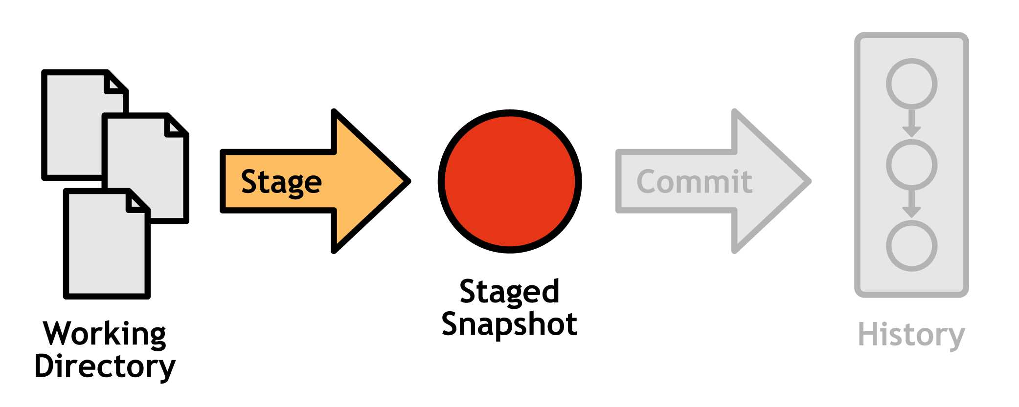

3. Installing and Configuring Git
Git can be installed on Windows, macOS, and Linux. On Windows, it is commonly installed via the official Git for Windows installer; on macOS via Homebrew; and on Linux via the system package manager.
$ sudo apt install git # Debian/Ubuntu $ brew install git # macOS $ winget install Git.Git # Windows
After installation, Git should be configured with a username and email address. This information is attached to every commit made on that machine.
$ git config --global user.name "Your Name" $ git config --global user.email "you@example.com" $ git config --list

4. Essential Git Commands
The following commands form the foundation of everyday Git usage.

4.1 Creating and Cloning Repositories
$ git init # create a new local repository $ git clone <repo-url> # copy an existing repository

4.2 Tracking Changes
$ git status # see the state of the working directory $ git add <file> # stage a specific file $ git add . # stage all changed files $ git commit -m "message" # save staged changes to history

4.3 Reviewing History
$ git log # view commit history $ git log --oneline --graph # compact visual history $ git diff # see unstaged changes $ git show <commit> # view details of a specific commit

4.4 Undoing Changes
$ git restore <file> # discard changes in working directory $ git reset <file> # unstage a file $ git revert <commit> # create a new commit that undoes a previous one

5. Branching and Merging
A branch in Git is simply a movable pointer to a commit. The default branch is traditionally called main (previously master). Branching allows a developer to diverge from the main line of development and work on a feature or fix in isolation, without affecting the stable codebase.
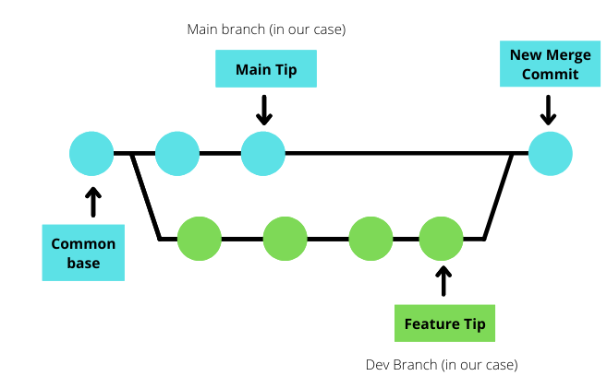

5.1 Working with Branches
$ git branch # list branches $ git branch feature-login # create a new branch $ git checkout feature-login # switch to a branch $ git switch -c feature-login # create and switch in one step

5.2 Merging Branches
Once work on a branch is complete, it can be merged back into the main branch. Git attempts to combine the histories automatically; if the same lines of code were changed in both branches, a merge conflict occurs and must be resolved manually.
$ git checkout main $ git merge feature-login

5.3 Rebasing
Rebasing is an alternative to merging that rewrites a branch's history so it appears as if the work was built directly on top of the latest main branch, producing a cleaner, linear project history.
$ git checkout feature-login $ git rebase main

5.4 Resolving Conflicts
A merge conflict happens when Git cannot automatically decide which changes to keep. Git marks the conflicting sections directly inside the affected files using conflict markers. The developer must manually edit the file to keep the correct content, then stage and commit the resolved file.

6. What is GitHub?
GitHub is a cloud-based hosting platform for Git repositories. Launched in 2008 and acquired by Microsoft in 2018, GitHub has become the most widely used platform for hosting and collaborating on Git projects. It is important to understand that Git and GitHub are not the same thing: Git is the version control tool itself, while GitHub is a service that hosts Git repositories online and adds collaboration features around them.

6.1 Core GitHub Features
- Remote repository hosting — projects can be stored online and accessed from anywhere.
- Pull Requests — a structured way to propose, review, and discuss changes before merging them.
- Issues — a built-in system for tracking bugs, tasks, and feature requests.
- Actions — automation and CI/CD pipelines that run directly from a repository.
- Forks — personal copies of another user's repository, enabling contributions to projects without direct write access.
- GitHub Pages — free static website hosting directly from a repository.
- Wikis and README files — documentation tools built into every repository.
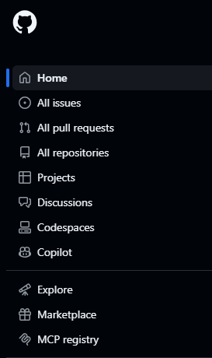

6.2 Alternatives to GitHub
Other popular Git hosting platforms include GitLab and Bitbucket. While each offers similar core functionality, GitHub is distinguished by its large community, extensive third-party integrations, and its role as a hub for open-source software.
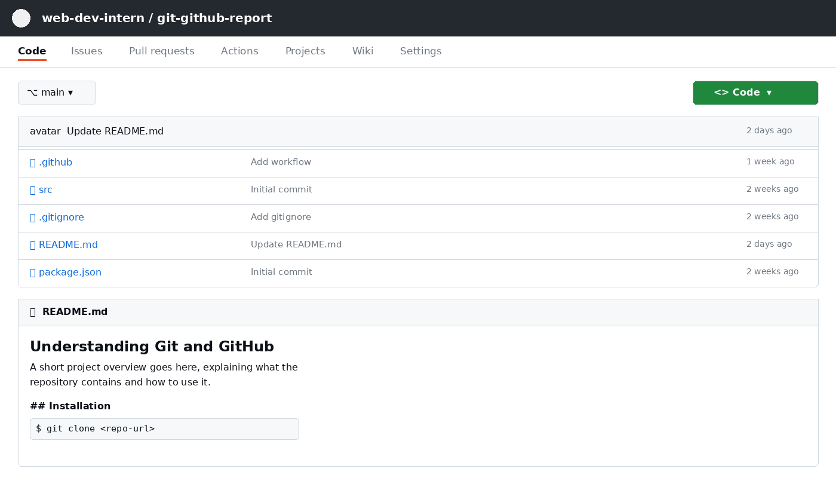
Figure 1: Layout of a typical GitHub repository page — branch selector, file list, and README preview.

7. Working with Remote Repositories on GitHub
To connect a local Git repository to GitHub, a remote is added. A remote is simply a named reference to a repository hosted elsewhere. Before that, a repository first needs to be created on GitHub itself, using the 'New repository' form shown below.
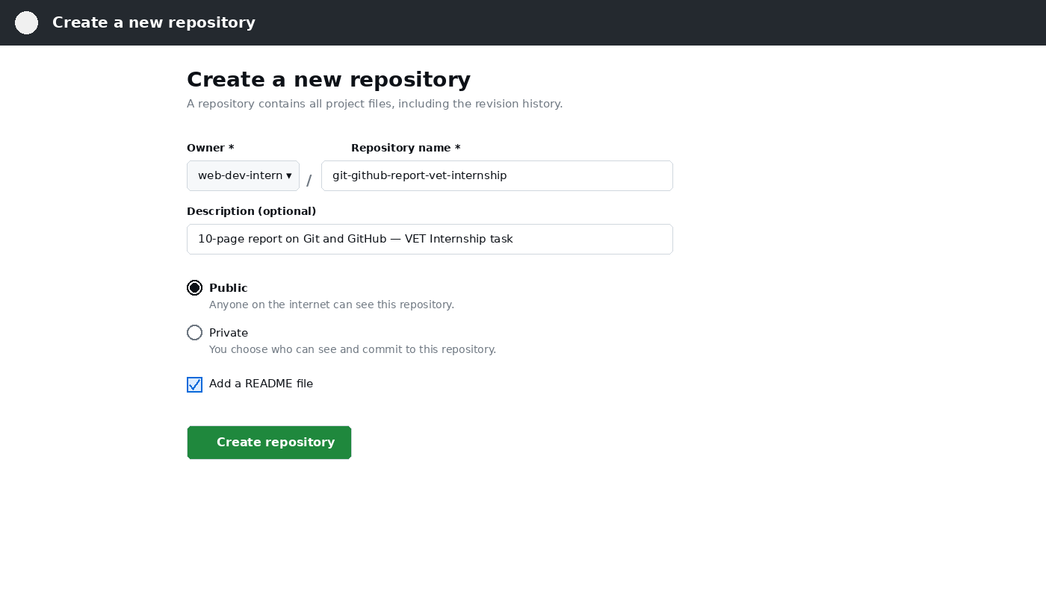
Figure 2: Creating a new repository on GitHub — name, visibility, and initial README option.
$ git remote add origin https://github.com/username/repo.git $ git remote -v

7.1 Pushing and Pulling
$ git push origin main # upload local commits to GitHub $ git pull origin main # download and merge remote changes $ git fetch origin # download changes without merging

7.2 The Fork and Pull Request Workflow
This is the standard workflow used to contribute to open-source projects on GitHub:
- Fork the repository to create a personal copy under your own GitHub account.
- Clone the fork to your local machine using git clone.
- Create a new branch for the change you want to make.
- Commit your changes and push the branch to your fork.
- Open a Pull Request from your branch to the original repository.
- The project maintainers review, discuss, and eventually merge the Pull Request.
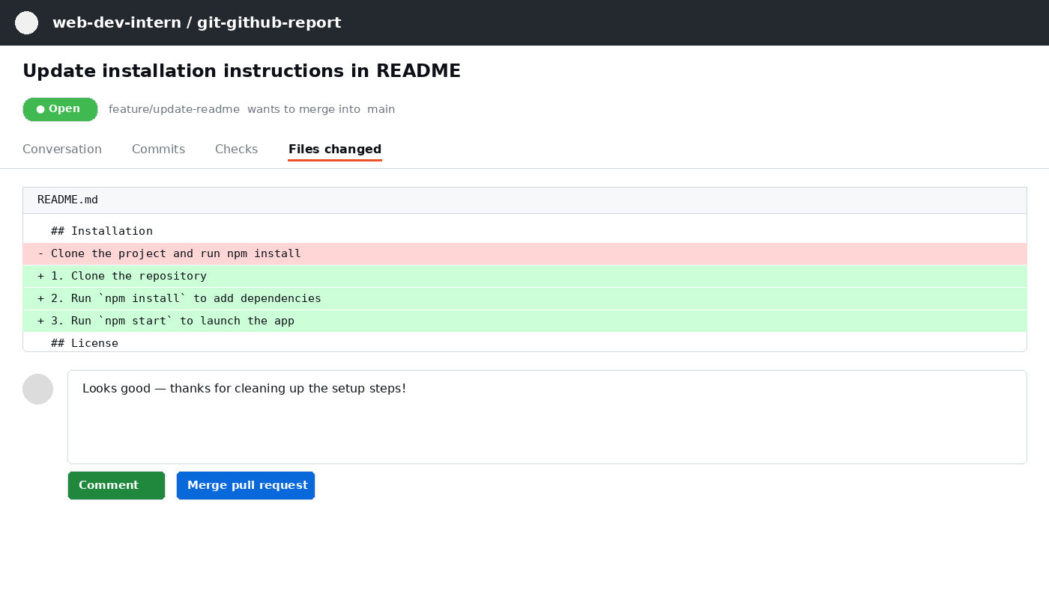
Figure 3: A Pull Request view showing the proposed diff and a reviewer comment before merging.

7.3 README and .gitignore Files
A README.md file is typically the first thing visitors see when they open a repository, and it should explain what the project does and how to use it. A .gitignore file tells Git which files or folders to exclude from version control, such as build artifacts, dependency folders, or environment files containing secrets.

8. Collaboration Workflows and Best Practices

8.1 Common Branching Strategies
- Git Flow — uses dedicated branches such as develop, feature, release, and hotfix for structured releases.
- GitHub Flow — a simpler model where feature branches are created from main and merged back via Pull Requests.
- Trunk-Based Development — developers commit small, frequent changes directly to a shared main branch.

8.2 Writing Good Commit Messages
A good commit message clearly explains what changed and why. A common convention is to keep the first line under 50 characters as a short summary, followed by a blank line and a more detailed explanation if needed.
git commit -m "Fix null pointer error in login handler"

8.3 Code Review Best Practices
- Keep Pull Requests small and focused on a single change.
- Write descriptive PR titles and descriptions explaining the purpose of the change.
- Respond to review comments promptly and respectfully.
- Use automated checks (linters, tests) to catch issues before human review.

8.4 Security Practices
- Never commit passwords, API keys, or other secrets to a repository.
- Use .gitignore and environment variables to keep sensitive data out of version control.
- Enable two-factor authentication on GitHub accounts.
- Regularly review repository access permissions for collaborators.

9. Real-World Applications of Git and GitHub
Git and GitHub are used far beyond individual software projects. Understanding their broader role helps explain why they are considered essential skills for anyone entering the technology industry.

9.1 Open Source Development
The majority of the world's open-source software — including major frameworks, programming languages, and operating system components — is developed collaboratively on GitHub, allowing thousands of independent contributors to work on the same codebase.

9.2 Enterprise Software Development
Companies of every size use Git internally to manage source code, coordinate between teams, and maintain a reliable history of their products, often combining GitHub with automated testing and deployment pipelines.

9.3 Personal Portfolios
For students and job seekers, a GitHub profile often serves as a public portfolio, showcasing personal projects, contributions to open source, and coding activity to potential employers.

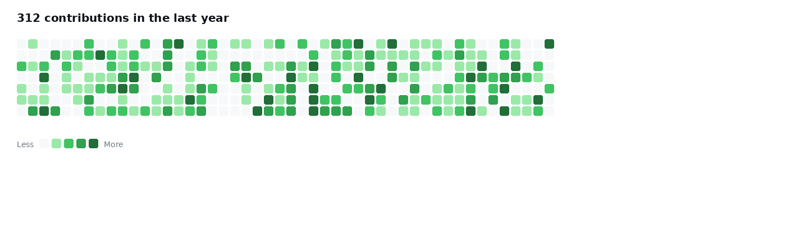

9.4 Documentation and Static Websites
Beyond code, many teams use GitHub repositories to manage documentation, and GitHub Pages allows entire websites to be hosted directly from a repository at no cost.

Git Command Quick Reference
The table below summarizes the most frequently used Git commands covered in this report, for quick reference.
Command | Purpose
git init | Initialize a new local repository
git clone <url> | Copy a remote repository to your machine
git status | Show the state of the working directory and staging area
git add <file> | Stage changes for the next commit
git commit -m "msg" | Save staged changes to the project history
git log | View the commit history
git branch | List, create, or delete branches
git checkout / switch | Move between branches
git merge | Combine changes from one branch into another
git rebase | Reapply commits on top of another base branch
git remote add origin <url> | Link a local repository to a remote one
git push | Upload local commits to a remote repository
git pull | Fetch and merge changes from a remote repository
git diff | Show differences between file versions
git revert | Undo a commit by creating a new, opposite commit

10. Conclusion
Git and GitHub are essential tools in modern software development, enabling efficient version control, collaboration, and project management. Git tracks changes and supports parallel development, while GitHub provides hosting and teamwork features. Learning concepts like commits, branching, merging, and pull requests is a fundamental skill for web developers and software engineers, helping them collaborate effectively and manage real-world projects.

This report was prepared as part of the Web Development VET Internship program, covering the foundational concepts, commands, and collaborative workflows of Git and GitHub.

