**Launching one windows instance with IIS server.**

1. Open the [AWS EC2 Management Console](https://console.aws.amazon.com/ec2/v2/home)
2. Click **Launch Instance**

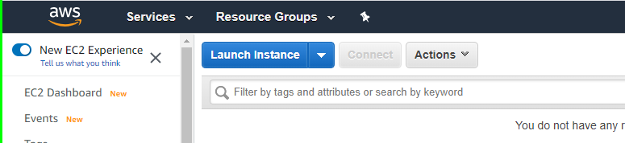

1. Select a Microsoft Windows Server instance (you may want to start with one that is “free tier eligible”

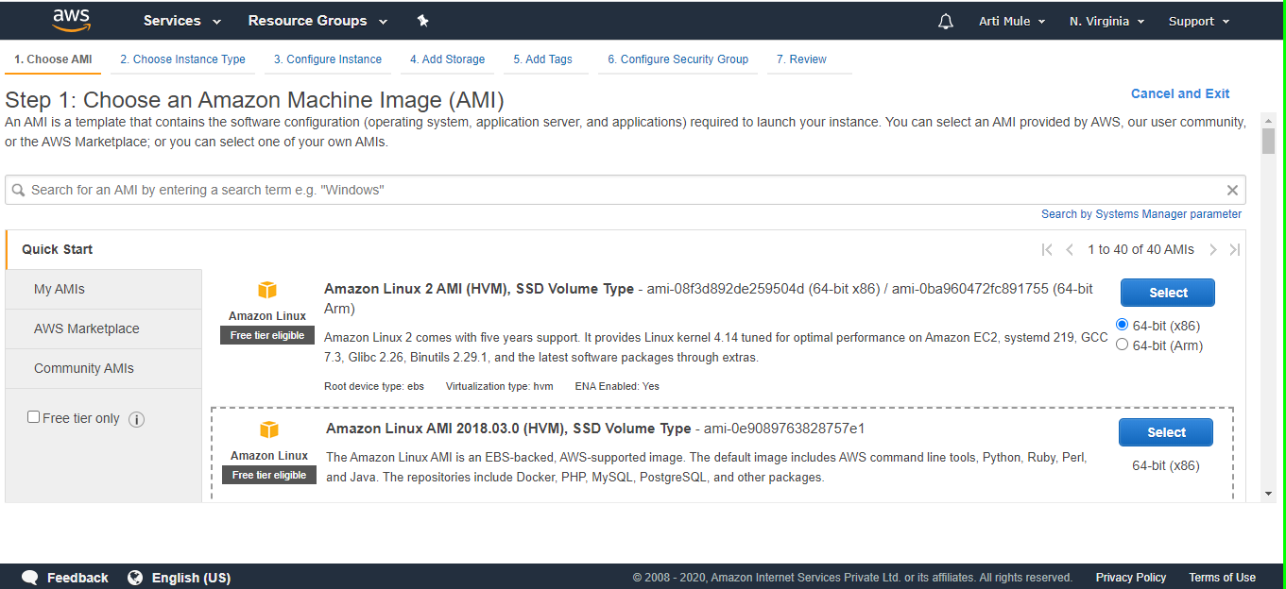

1. Choose an instance type

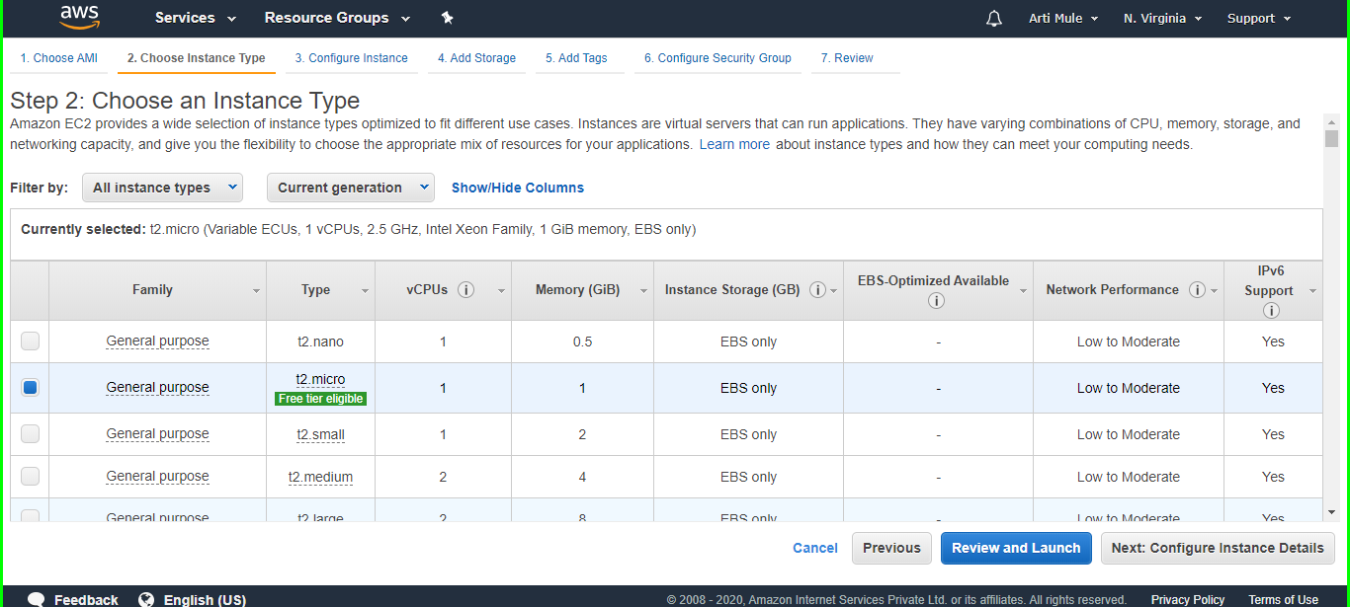

Since we are launching a simple instance click on Next:Configure instance Details, if you may skip all the steps then click **Review and Launch**

1. Select an Configure Instance Detai;s you may be keep default or change it yours choice and click on Next:Add Storage

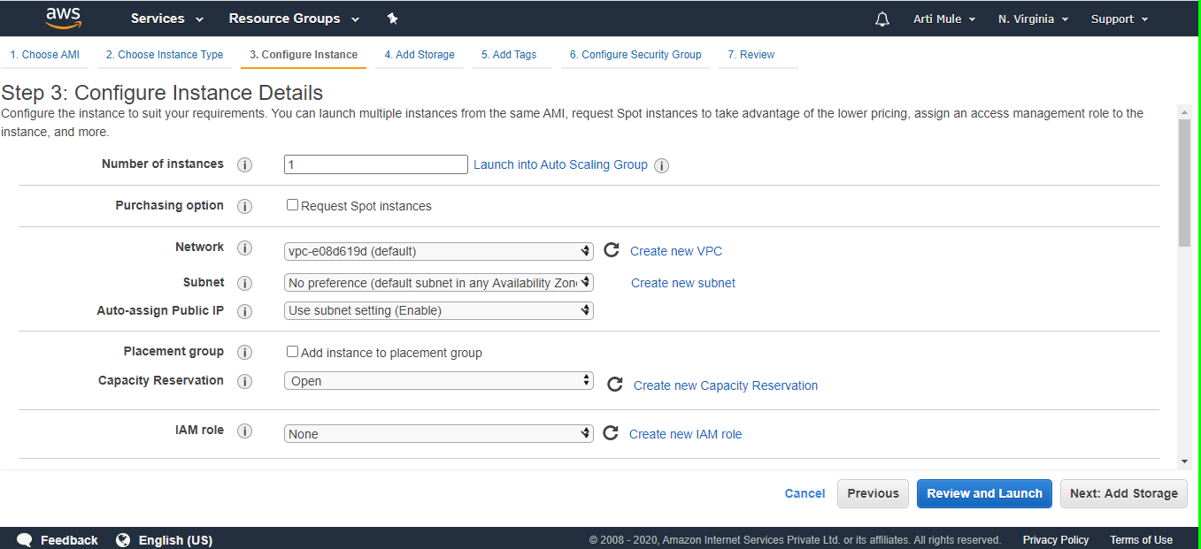

1. Select an Add Storage and click on Next:Add tage

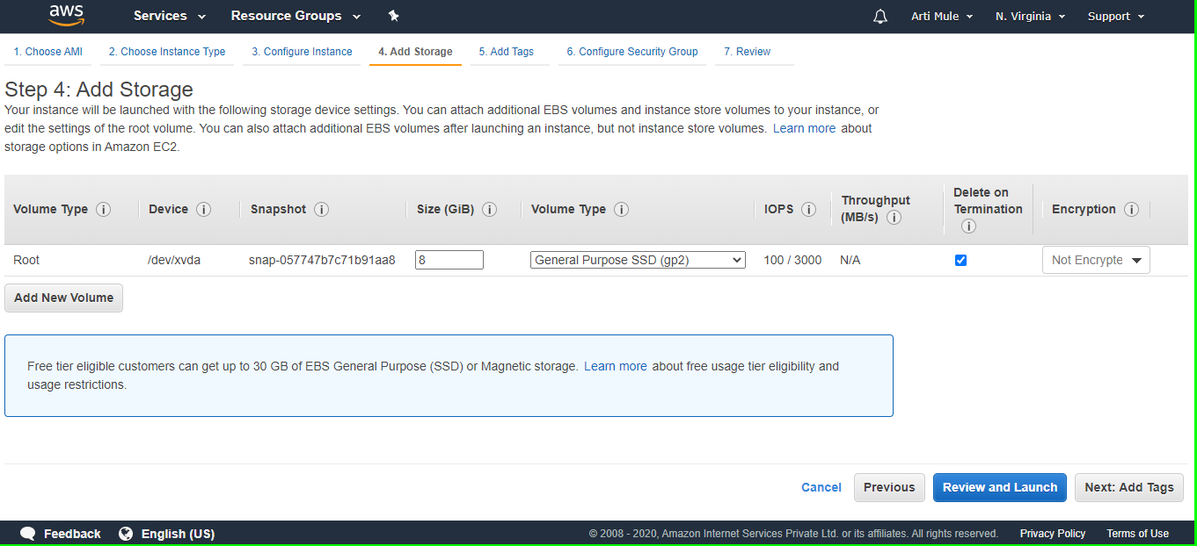

1. Select an Add Tags

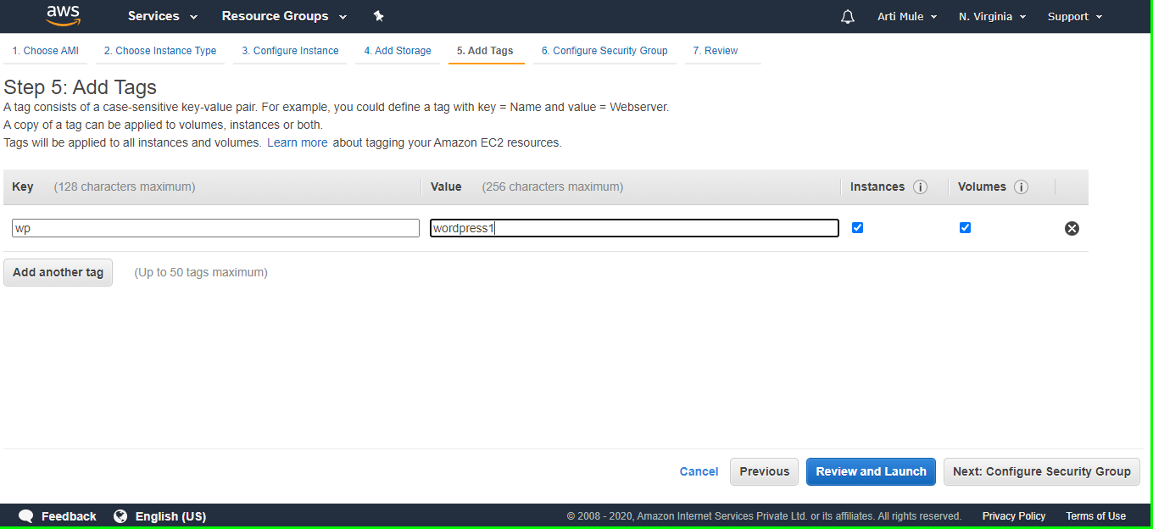

1. Select an Configure and Group you can add more type click Add Rule and you want to choose and select then click on Review and launch.

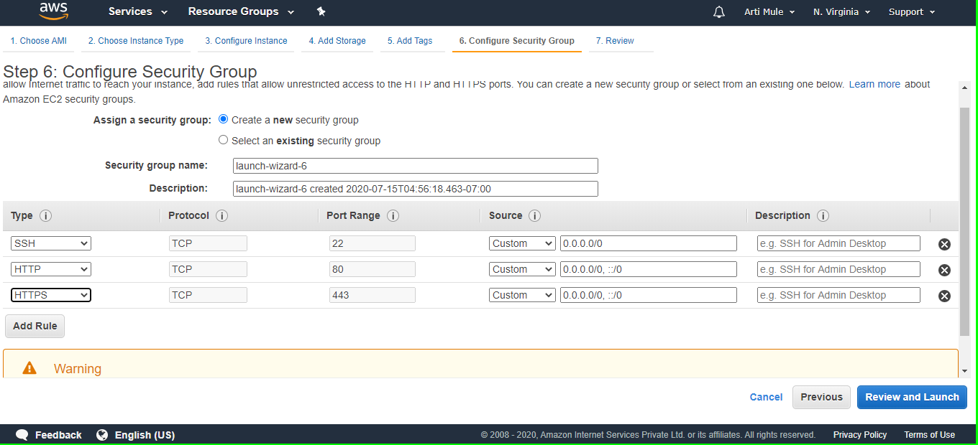

1. Select an Review Instance Launch

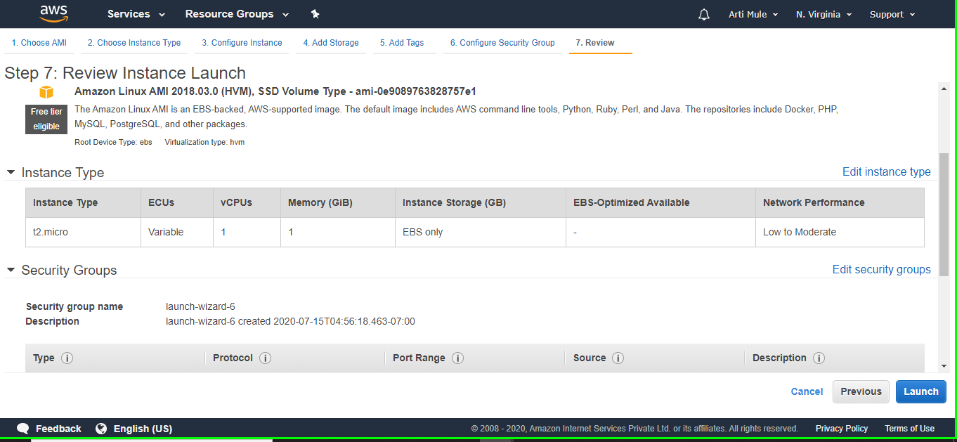

If you want change anything can you choose which you want to change and click on edit and change it ,otherwise click on Launch.

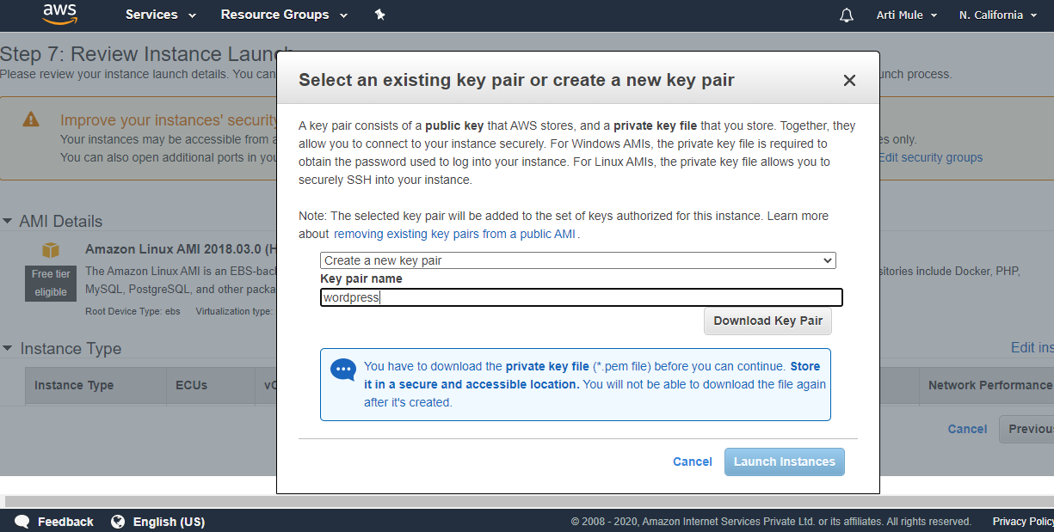

10.Select an existing key pair or Create new key pair ,Download the new key pair and click Launch Instance.

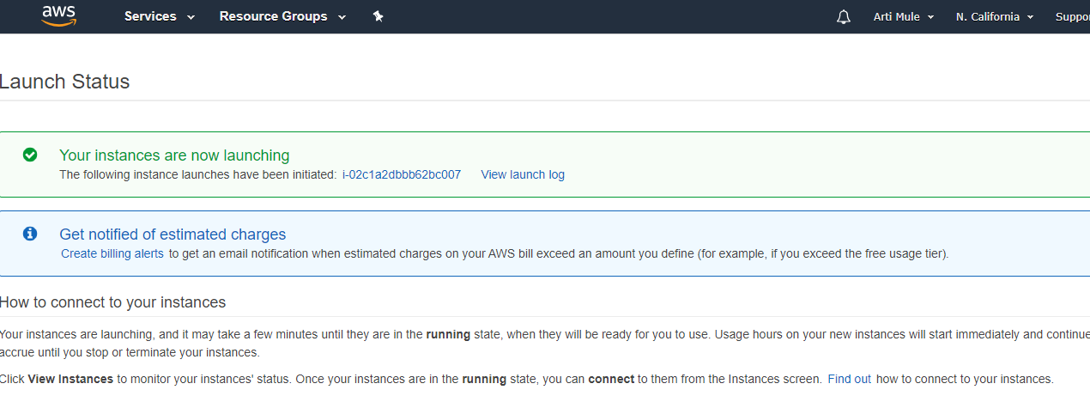

Successfully Launch Instance, Click **View Instances** to open the EC2 Management Console

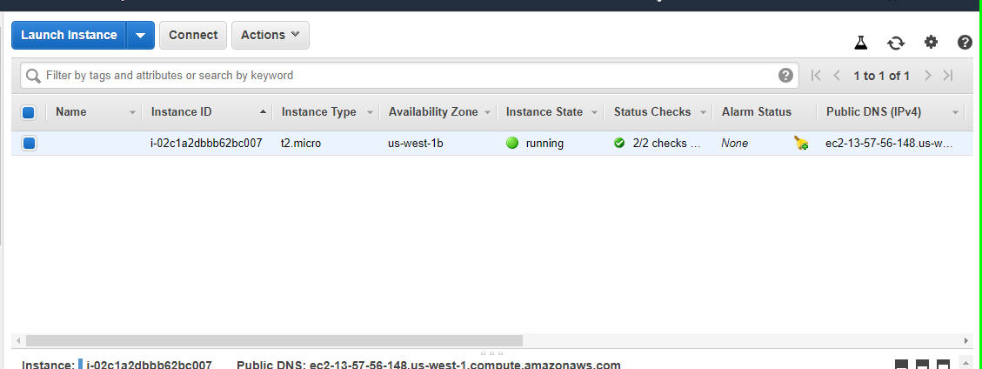

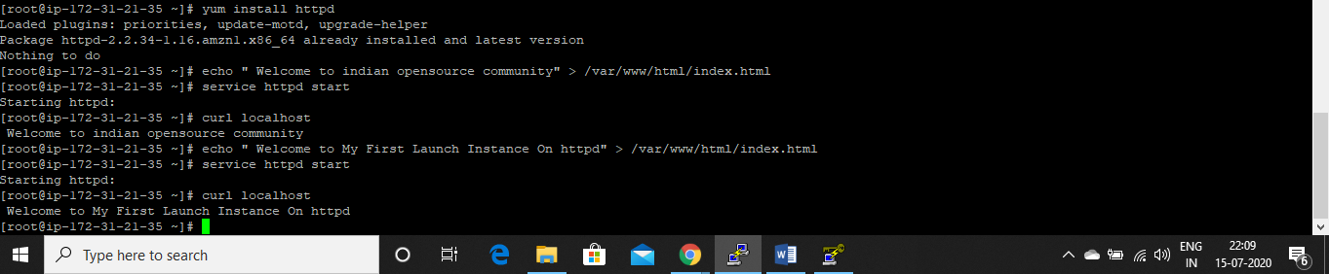

If everything is installed correctly, you should be able to enter the IP address of your EC2 instance in any web browser, and see output.

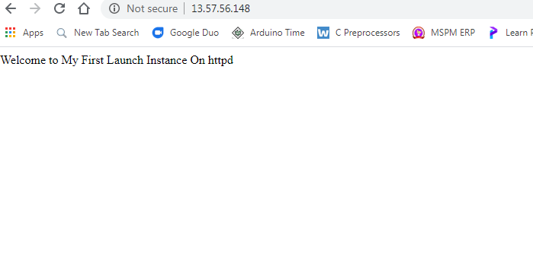

Successfully completed.