|  |  |
| --- | --- |
|  | **Marathwada Shikshan Prasarak Mandal’s**  **Deogiri Institute of Engineering and Management Studies**  **Deogiri Campus,Railway Station Road, Aurangabad - 431001** [**www.dietms.org|**](http://www.dietms.org/)**|admin@dietms.org||0240-2367546 ||Fax: 0240-2367577** |

**Department of Computer Science & Engineering**

**Week-wise Internship Report Academic Year 2019-20**

**___________________________________________________________________________________________**

**Name of Student:** Arti Panjabrao Mule

**Roll number:** 26059

**BATU PRN Number:** 20211420181124210017

**Name of Mentor:** Dr. Padmapani P. Tribhuvan

**Guided by:** Pavan Wankhade sir

**Detailed name of Internship (Training Institute):** Indian OpenSource Community.

**Duration of Internship (In weeks):** 4weeks

**Date of Joining the Internship:** 13/June/2020

**Date of Completion of Internship**: 18/july2020

**Technology / Platform on Which Working**: workshop on cloud service

**WEEK 1:**

**Cloud Computing:**

Cloud computing is the on-demand delivery of IT resources over the internet with pay-as-you go pricing. Instead of buying , owning, and maintaining physical data centers and servers, you can access technology services, such as computing power, storage, and database, on an as needed basis from a cloud provider like Amazon Web Services(AWS)

### **Cloud Computing Services Features and Benefits:**

By now most people have heard about cloud computing services, While cloud services may vary in their particulars, a [cloud computing definition](https://www.akamai.com/us/en/resources/cloud-computing-definition.jsp) identifies the core features and benefits that are common across all clouds.

From the perspective of service users, cloud computing services have these main features:

* Hosted and maintained by the provider. The [cloud hosting](https://www.akamai.com/us/en/resources/cloud-hosting.jsp) provider purchases, hosts, and maintains the necessary hardware and software in their own facility. Service users avoid the capital expenditures and maintenance headaches that they would have if they developed the service themselves on premise.
* Self-service through a web interface. Service users can initiate specific service functions, and increase or decrease their service usage level, though a web interface with little or no interaction with the service provider.
* Pay for use. Service users pay only for the amount of service that they use. This can result in substantial cost savings compared to the traditional approach of developing on-site IT capacities geared toward maximum usage scenarios, and then having that capacity be under-utilized much of the time.
* Near-limitless scalability. Cloud computing services providers typically have the infrastructure to deliver their service at massive scale. For cloud service users, that means that the cloud can easily accommodate business growth or periodic spikes in service usage.

### **Cloud Computing Services Types:**

The wide range of services offered by [cloud computing companies](https://www.akamai.com/us/en/resources/cloud-computing-companies.jsp) can be categorized into three basic types:

* Infrastructure as a Service (IaaS). IaaS contains the basic building blocks for cloud IT. It typically provides access to networking features, computers (virtual or on dedicated hardware), and data storage space. IaaS gives you the highest level of flexibility and management control over your IT resources. It is most similar to the existing IT resources with which many IT departments and developers are familiar.
* Platform as a Service (PaaS). PaaS removes the need for you to manage underlying infrastructure (usually hardware and operating systems), and allows you to focus on the deployment and management of your applications. This helps you be more efficient as you don’t need to worry about resource procurement, capacity planning, software maintenance, patching, or any of the other undifferentiated heavy lifting involved in running your application.
* Software as a Service (SaaS). SaaS provides you with a complete product that is run and managed by the service provider. In most cases, people referring to SaaS are referring to end-user applications (such as web-based email). With a SaaS offering, you don’t have to think about how the service is maintained or how the underlying infrastructure is managed. You only need to think about how you will use that particular software.

OpenStack is a [free](https://en.wikipedia.org/wiki/Free_software) [open standard](https://en.wikipedia.org/wiki/Open-source_software) [cloud computing](https://en.wikipedia.org/wiki/Cloud_computing) platform, mostly deployed as [infrastructure-as-a-service](https://en.wikipedia.org/wiki/Cloud_computing#Infrastructure_as_a_service_.28IaaS.29) (IaaS) in both public and private clouds where virtual servers and other resources are made available to users. The software platform consists of interrelated components that control diverse, multi-vendor hardware pools of processing, storage, and networking resources throughout a [data center.](https://en.wikipedia.org/wiki/Data_center)

Beyond standard infrastructure-as-a-service functionality additional components provide orchestration service, fault management and service management amongst other services to ensure high availability of user applications.

1. Controller
2. Compute
3. Block Storage
4. Object Storage
5. Image Storage Service
6. Networking
7. Dashboard Service 8. Telemetry Service Etc.

Component:

* 1. Nova
  2. Glance
  3. Swift
  4. Cinder
  5. Horizone
  6. Keystone
  7. Neutrone
  8. Celiometer
  9. Heat &many more etc.

# Screenshots of the OpenStack :

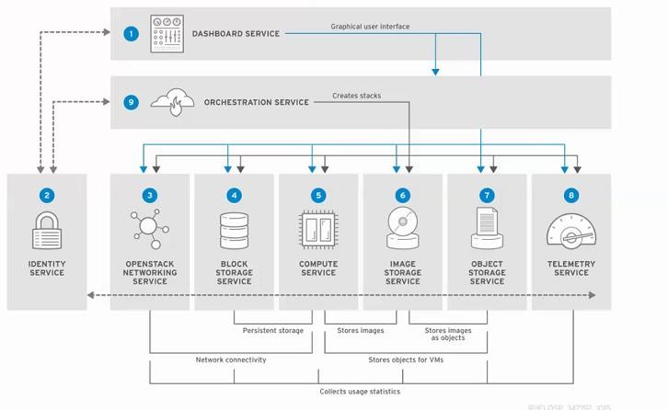

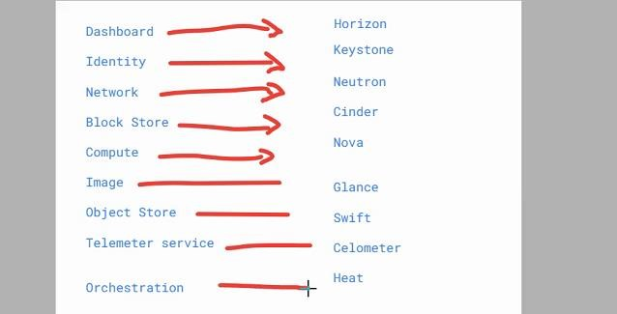

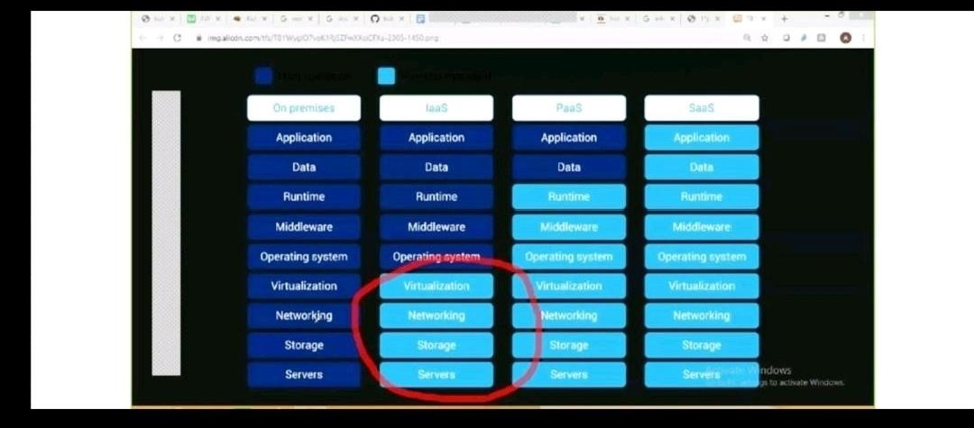

**WEEK 2:**

### **Create a network interface**

You can create a network interface in a subnet. You can't move the network interface to another subnet after it's created, and you can only attach the network interface to instances in the same Availability Zone.

**To create a network interface using the console**

1. Open the Amazon EC2 console at <https://console.aws.amazon.com/ec2/>.
2. In the navigation pane, choose **Network Interfaces**.
3. Choose **Create Network Interface**.
4. For **Description**, enter a descriptive name.
5. For **Subnet**, select the subnet.
6. For **Private IP** (or **IPv4 Private IP**), enter the primary private IPv4 address. If you don't specify an IPv4 address, we select an available private IPv4 address from within the selected subnet.
7. (IPv6 only) If you selected a subnet that has an associated IPv6 CIDR block, you can optionally specify an IPv6 address in the **IPv6 IP** field.
8. To create an Elastic Fabric Adapter, select **Elastic Fabric Adapter**.
9. For **Security groups**, select one or more security groups.
10. (Optional) Choose **Add Tag** and enter a tag key and a tag value.
11. Choose **Yes, Create**.

### Attach a network interface to an instance

You can attach a network interface to any of your stopped or running instances, using either the **Instances** or **Network Interfaces** pages of the Amazon EC2 console. Alternatively, you can specify an existing network interface or attach an additional network interface when you [launch an instance](https://docs.aws.amazon.com/AWSEC2/latest/UserGuide/launching-instance.html).

If the public IPv4 address on your instance is released, it does not receive a new one if there is more than one network interface attached to the instance. For more information about the behavior of public IPv4 addresses, see [Public IPv4 addresses and external DNS hostnames](https://docs.aws.amazon.com/AWSEC2/latest/UserGuide/using-instance-addressing.html#concepts-public-addresses).

**To attach a network interface to an instance using the Instances page**

1. Open the Amazon EC2 console at <https://console.aws.amazon.com/ec2/>.
2. In the navigation pane, choose **Instances**.
3. Select the instance.
4. Choose **Actions**, **Networking**, **Attach network interface**.
5. Select a network interface. If the instance supports multiple network cards, you can choose a network card.
6. Choose **Attach**.

**To attach a network interface to an instance using the Network Interfaces page**

1. Open the Amazon EC2 console at <https://console.aws.amazon.com/ec2/>.
2. In the navigation pane, choose **Network Interfaces**.
3. Select the network interface and choose **Attach**.
4. Select an instance. If the instance supports multiple network cards, you can choose a network card.
5. Choose **Attach**.

### **Manage IP addresses**

You can manage the following IP addresses for your network interfaces:

* Elastic IP addresses (one per private IPv4 address)
* IPv4 addresses
* IPv6 addresses

**To manage the Elastic IP addresses of a network interface using the console**

1. Open the Amazon EC2 console at <https://console.aws.amazon.com/ec2/>.
2. In the navigation pane, choose **Network Interfaces**.
3. Select the network interface.
4. To associate an Elastic IP address, do the following:
   1. Choose **Actions**, **Associate Address**.
   2. For **Address**, select the Elastic IP address.
   3. For **Associate to private IP address**, select the private IPv4 address to associate with the Elastic IP address.
   4. Choose **Allow reassociation** to allow the Elastic IP address to be associated with the specified network interface if it's currently associated with another instance or network interface, and then choose **Associate Address**.
5. To disassociate an Elastic IP address, do the following:
   1. Choose **Actions**, **Disassociate Address**.
   2. In the **Disassociate IP Address** dialog box, choose **Yes, Disassociate**.

**To manage the IPv4 and IPv6 addresses of a network interface using the console**

1. Open the Amazon EC2 console at <https://console.aws.amazon.com/ec2/>.
2. In the navigation pane, choose **Network Interfaces**.
3. Select the network interface.
4. Choose **Actions**, **Manage IP Addresses**.
5. For **IPv4 Addresses**, modify the IP addresses as needed. To assign an IPv4 address, choose **Assign new IP** and then specify an IPv4 address from the subnet range or let AWS choose one for you. To unassign an IPv4 address, choose **Unassign** next to the address.
6. For **IPv6 Addresses**, modify the IP addresses as needed. To assign an IPv6 address, choose **Assign new IP** and then specify an IPv6 address from the subnet range or let AWS choose one for you. To unassign an IPv6 address, choose **Unassign** next to the address.
7. Choose **Yes, Update**.

**WEEK 3:**

Launch one T2 micro type windows server instance on AWS. Configure an IIS server with default web page.

1.Open the [AWS EC2 Management Console](https://console.aws.amazon.com/ec2/v2/home)

2.Click **Launch Instance**

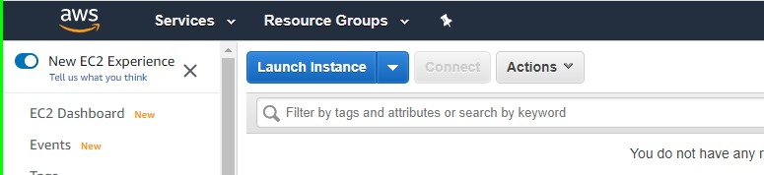

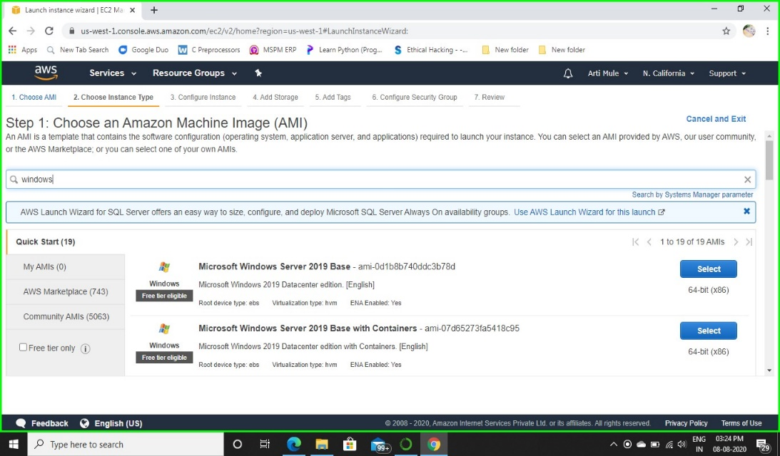3.Select a Microsoft Windows Server instance (you may want to start with one that is “free tier eligible”.

4.Choose an instance type (t2 micro-free-tire eligible)

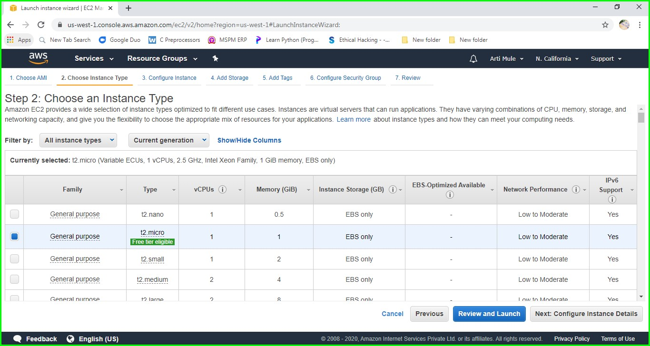

Since we are launching a simple instance click on Next: Configure instance Details, if you may skip all the steps then click **Review and Launch.**

5.Select an Configure Instance Details you may be keep default or change it yours choice, I keep default Instance details and click on **Next: Add Storage**.

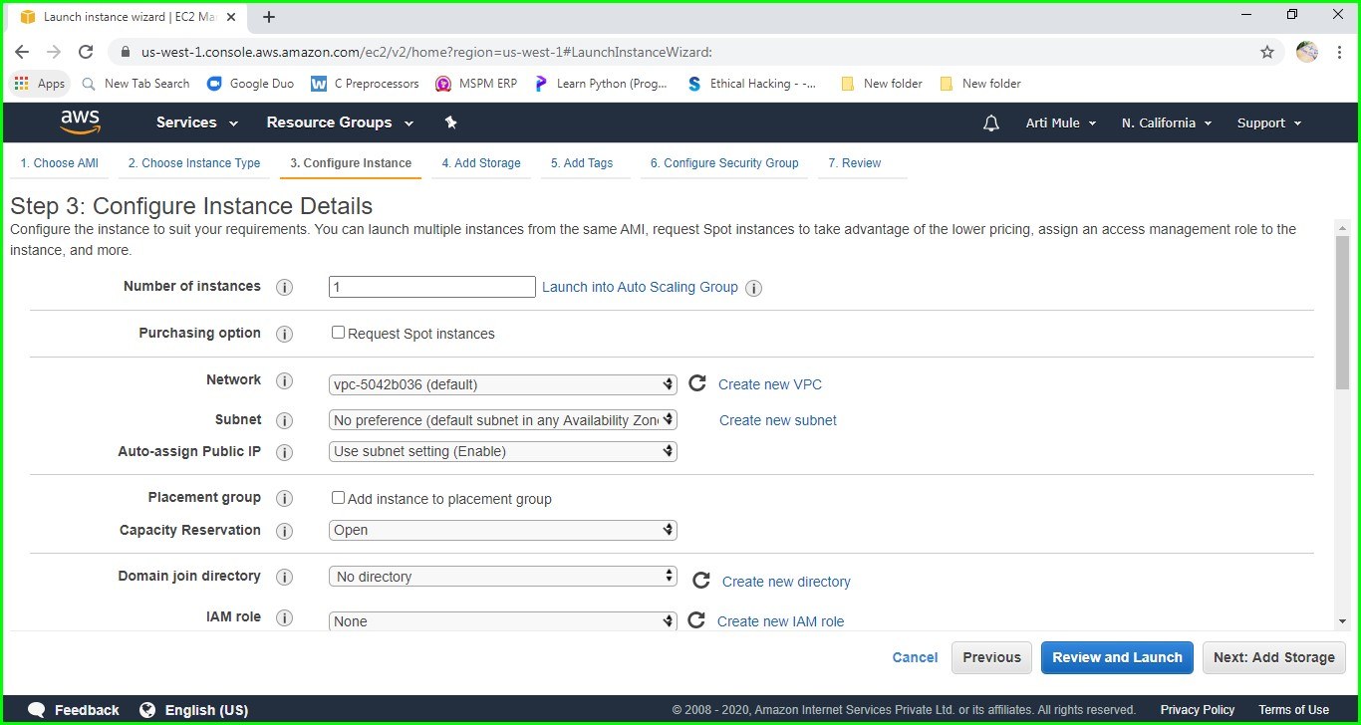

6.Keep the default Storage and click on Next: **Add tags.**

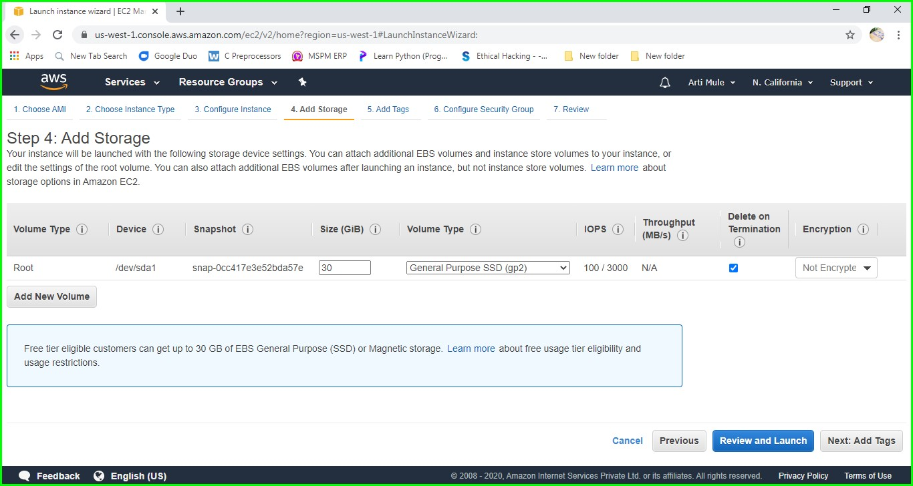

7.Keep it as it is and go ahead.

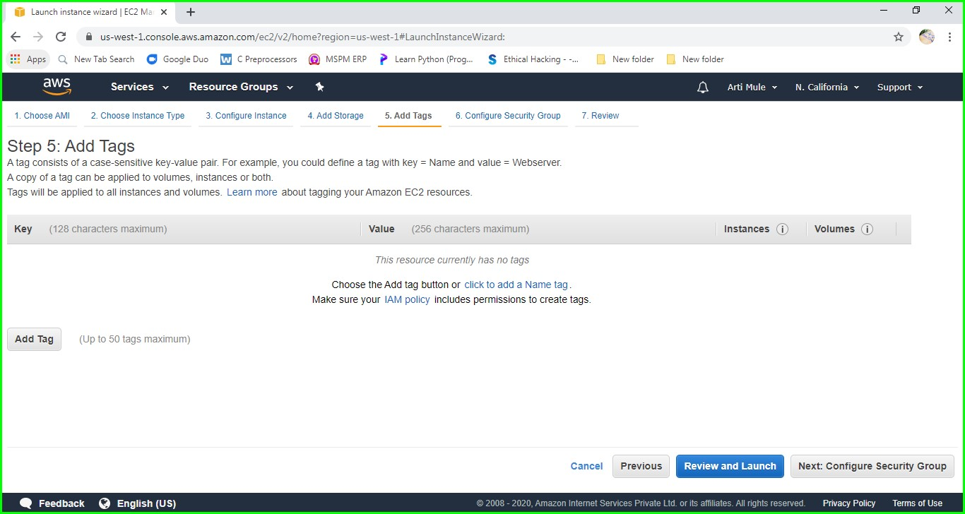

8.Keep default Security Group and click on **Review and Launch.**

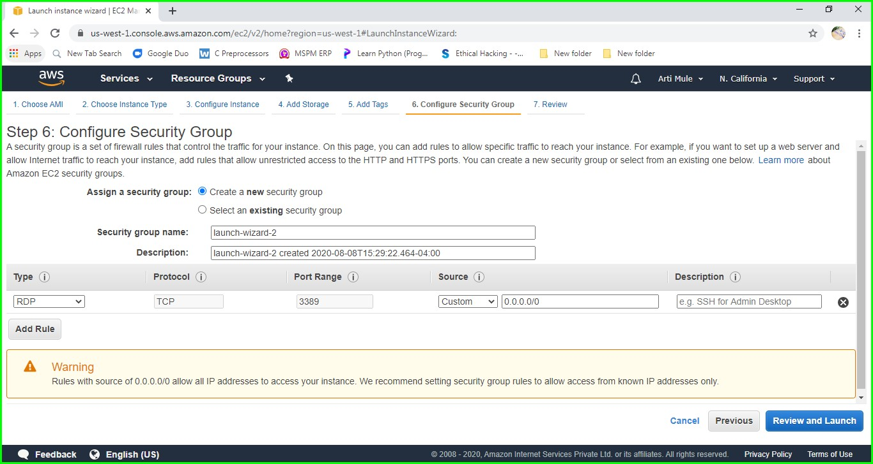

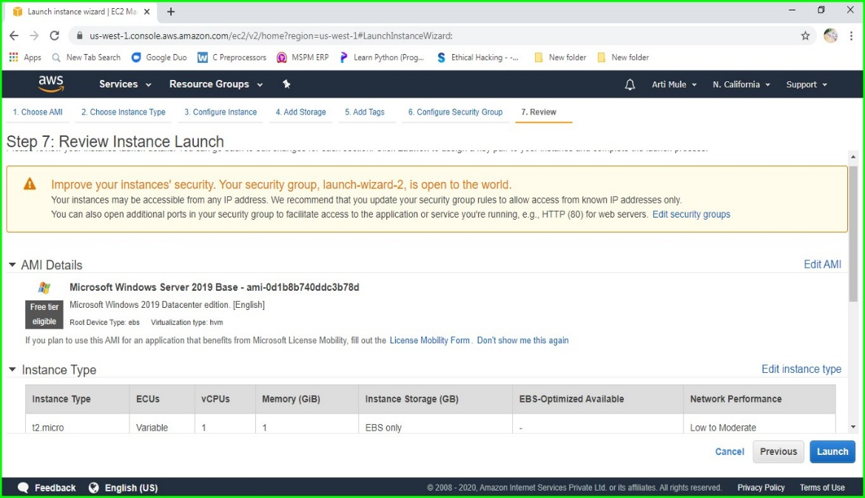9. Launch Instance by clicking Launch.

If you want change anything can you choose which you want to change and click on edit and change it, otherwise click on **Launch**.

10. Once the Instance is launched this screen will appear click on **View Instances**.

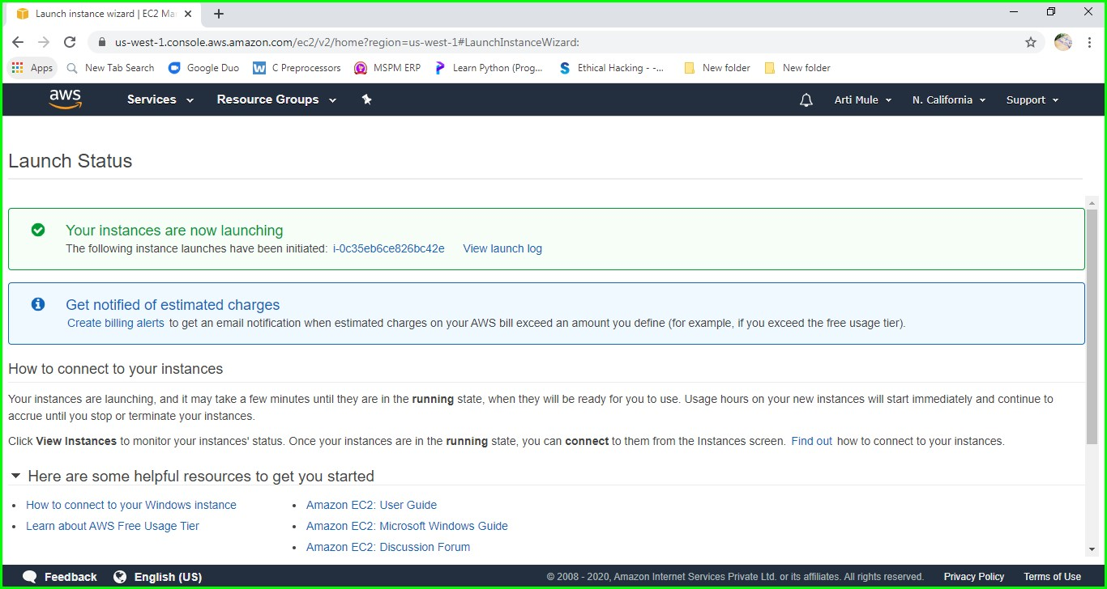

11.Then we will see this window, now open the Remote Desktop with the IPV4 Public IP of Instance then enter Username and Password. (We will get this Username and Password by Clicking **Connect**).

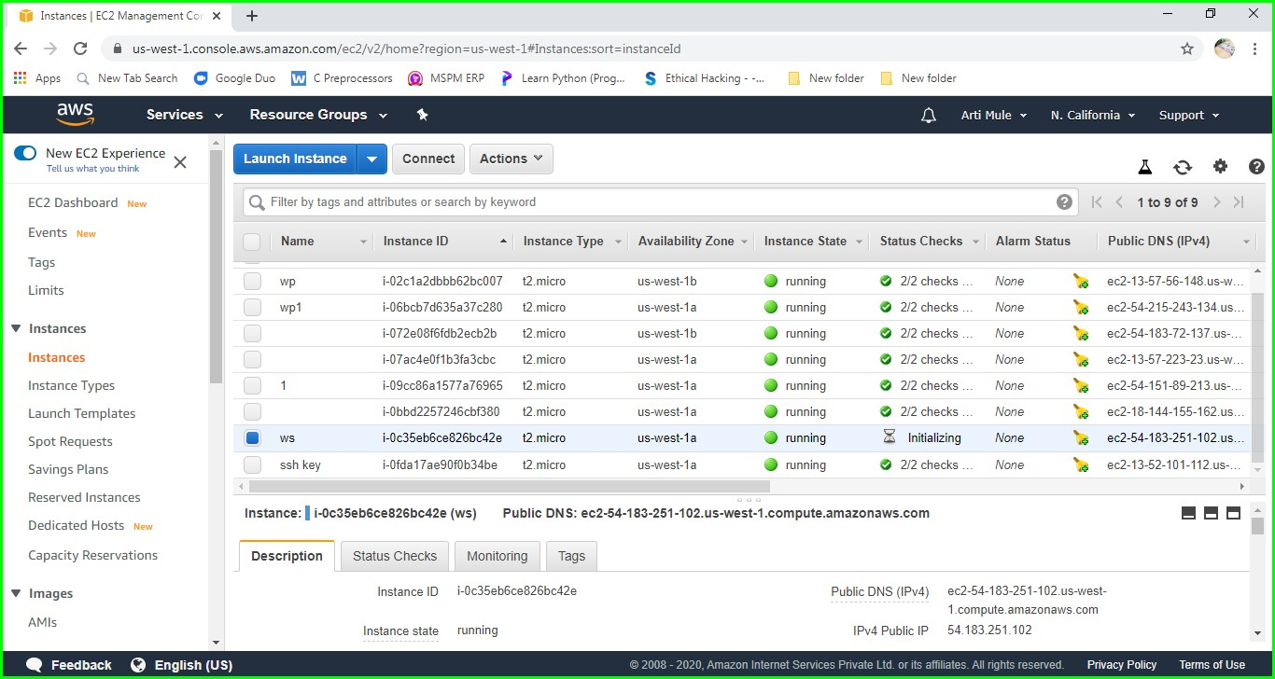

12. Once we have entered the username and password our remote desktop will start and the below screen will be appear.

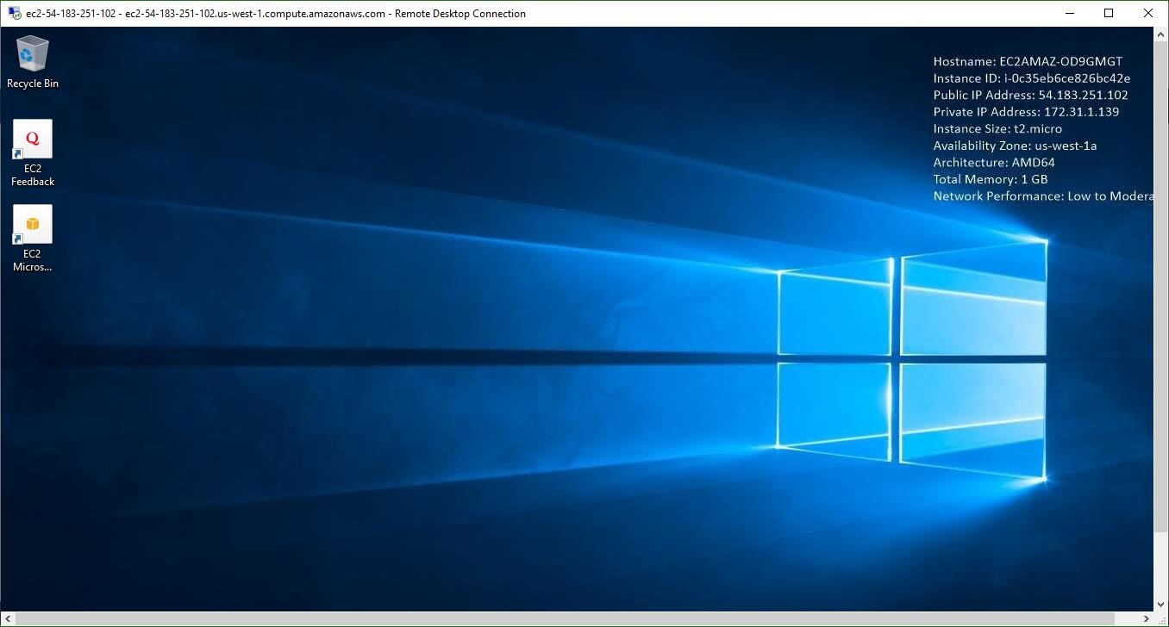

13.Now go to Sever Manager and Click Add role and Features then the below screen will appear.

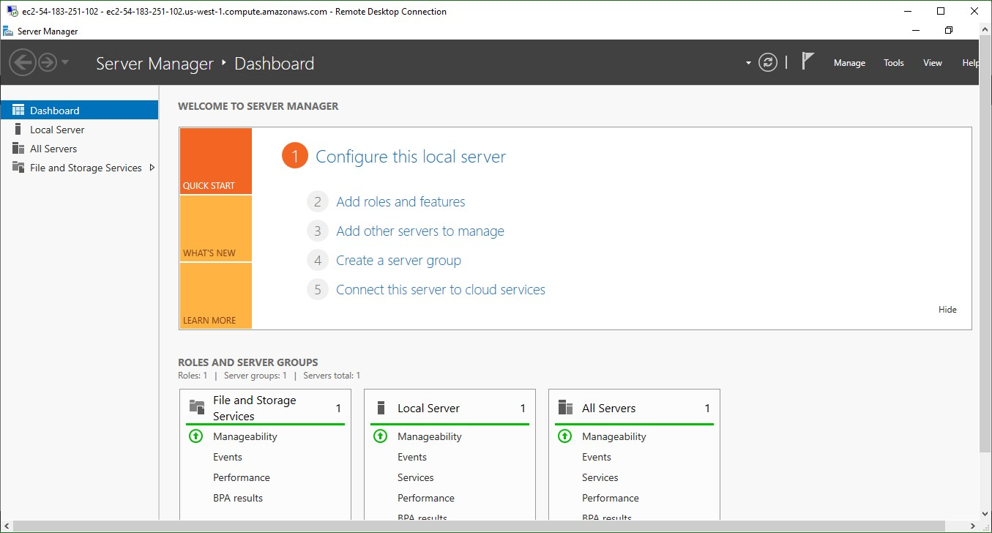

14. Click Next.

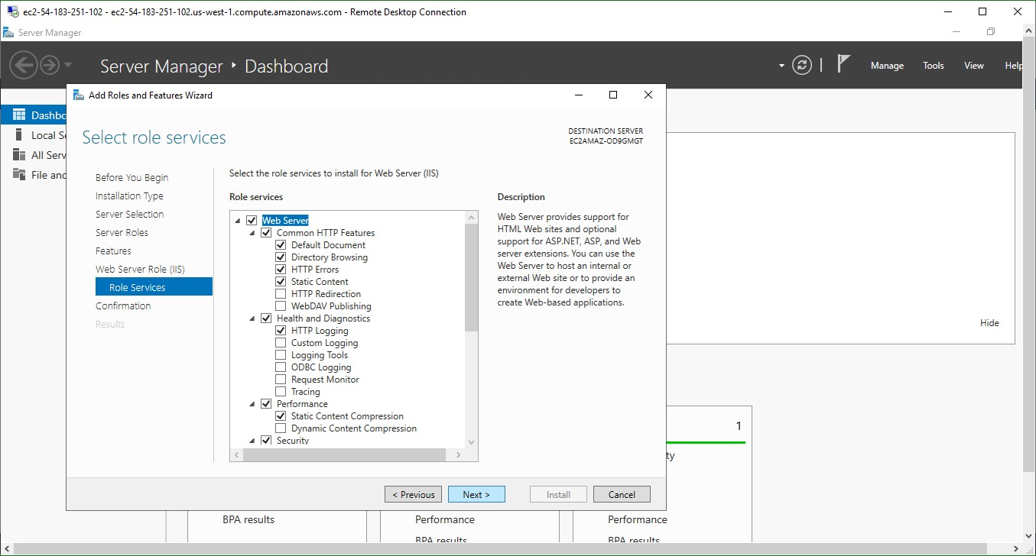

15.Then this Screen will appear. go to Internet Explorer and type <http://localhost/>

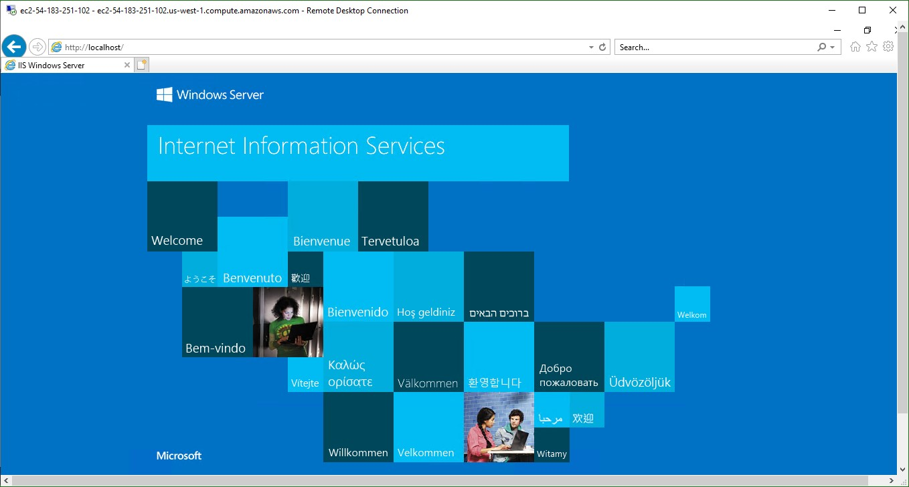

16. Now create web page and Save it at location c:/inetpub/wwwroot as index.html.

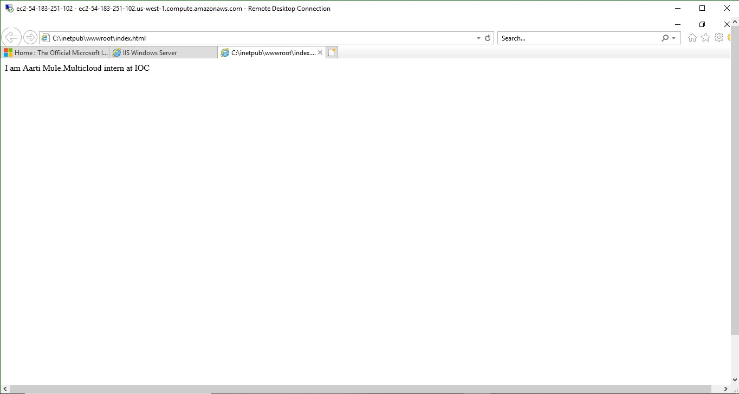

Successfully completed.

**WEEK 4:**

**Google Cloud Platform:**

Google Cloud Platform (GCP), offered by Google, is a suite of cloud computing services that runs on the same infrastructure that Google uses internally for its end-user products, such as Google Search, Gmail and YouTube. Alongside a set of management tools, it provides a series of modular cloud services including computing, data storage data analytics and machine learning.

Registration requires a credit card or bank account details.

Google Cloud Platform provides infrastructure as a service, platform as a service, and serverless computing environments.

Google Cloud Platform is a part of Google Cloud, which includes the Google Cloud Platform public cloud infrastructure, as well as G Suite, enterprise versions of Android and Chrome OS, and application programming interfaces (APIs) for machine learning and enterprise mapping services.

Products which comes under cloud platform as in GCP 90 different products comes under it he explained about four as given in screenshots

**Compute:**

* App Engine - Platform as a Service to deploy Java, PHP, Node.js, Python, C#, .Net, Ruby and Go applications.
* Compute Engine - Infrastructure as a Service to run Microsoft Windows and Linux virtual machines.
* Kubernetes Engine (GKE) or GKE on-prem offered as part of Anthos platform [5][6] - Containers as a Service based on Kubernetes.
* Cloud Functions - Functions as a Service to run event-driven code written in Node.js, Python, or Go. • Cloud Run - Compute execution environment based on Knative.[7] Offered as Cloud Run (fully managed or as Cloud Run for Anthos. Storage
* Cloud Storage - Object storage with integrated edge caching to store unstructured data.
* Cloud SQL - Database as a Service based on MySQL and PostgreSQL.
* Cloud Big table - Managed NoSQL

**Storage:**

* Cloud Storage - Object storage with integrated edge caching to store unstructured data.
* Cloud SQL - Database as a Service based on MySQL and PostgreSQL.
* Cloud Bigtable - Managed NoSQL database service.
* Cloud Spanner - Horizontally scalable, strongly consistent, relational database service.
* Cloud Datastore - NoSQL database for web and mobile applications.
* Persistent Disk - Block storage for Compute Engine virtual machines.
* Cloud MemoryStore - Managed in-memory data store based on Redis.
* Local SSD: High-performance, transient, local block storage.
* Filestore: High-performance file storage for Google Cloud users.

**Big Data:**

* BigQuery - Scalable, managed enterprise data warehouse for analytics.
* Cloud Dataflow - Managed service based on Apache Beam for stream and batch data processing.
* Cloud Dataproc - Big data platform for running Apache Hadoop and Apache Spark jobs.
* Cloud Composer - Managed workflow orchestration service built on Apache Airflow.
* Cloud Datalab - Tool for data exploration, analysis, visualization and machine learning. This is a fully managed Jupyter Notebook service.
* Cloud Dataprep - Data service based on Trifacta to visually explore, clean, and prepare data for analysis.
* Cloud Pub/Sub - Scalable event ingestion service based on message queues.
* Cloud Data Studio - Business intelligence tool to visualize data through dashboards and reports.

**Machine learning:**

* Cloud AutoML - Service to train and deploy custom machine, learning models. As of September 2018, the service is in Beta.
* Cloud Machine Learning Engine - Managed service for training and building machine learning models based on mainstream frameworks.
* Cloud Translation API - Service to dynamically translate between thousands of available language pairs
* Cloud Vision API - Image analysis service based on machine learning
* Cloud Video Intelligence - Video analysis service based on machine learning

**Screenshots:**

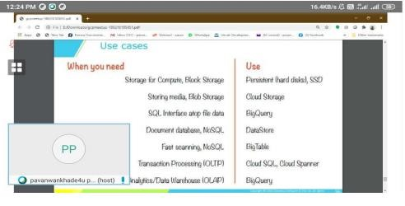

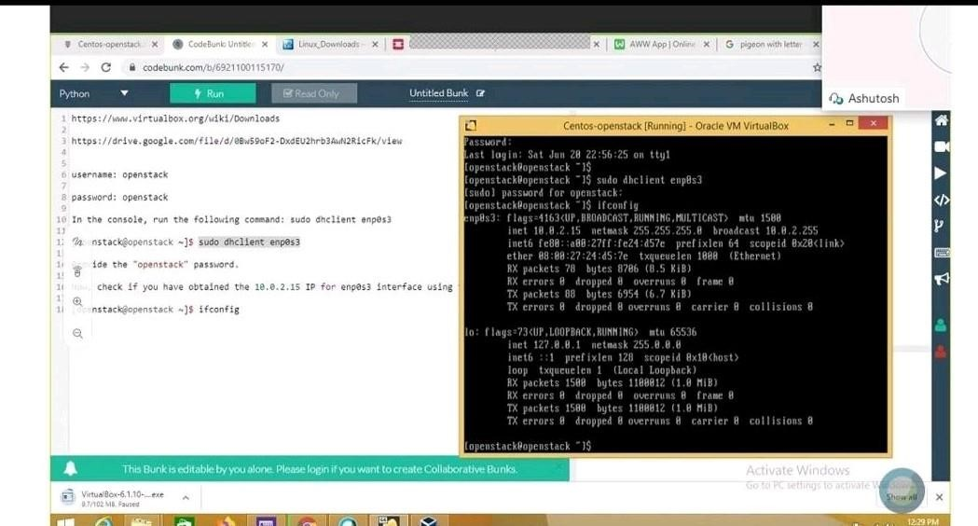

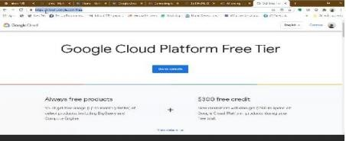

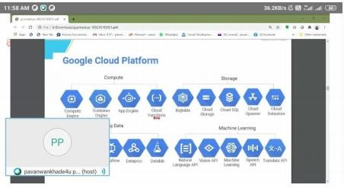

**CERTIFICATION:**

