**Multicloud Project Based Internship at IOC**

**Name**: Arti Panjabrao Mule

**Ambassador Name**: Atharav Panchpor.

**College Name**: Deogiri Institute of Engineering and Management Studies.

**TASK**

Access your AWS account from linux terminal or windows command prompt / power shell and perform following task. launch one instance with one free tier AMI on a free tier instance type and take its remote access (ssh/remote access).

The AWS Command Line Interface (AWS CLI) is an open source tool that enables you to interact with AWS services using commands in your command-line shell.

Firstly open your AWS Command Line Interface then download which you want to operating system click on.

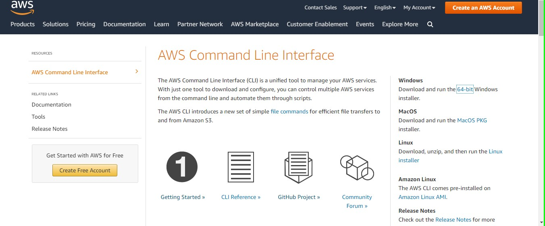

Continue Installing process just click next then finally will be click finish .

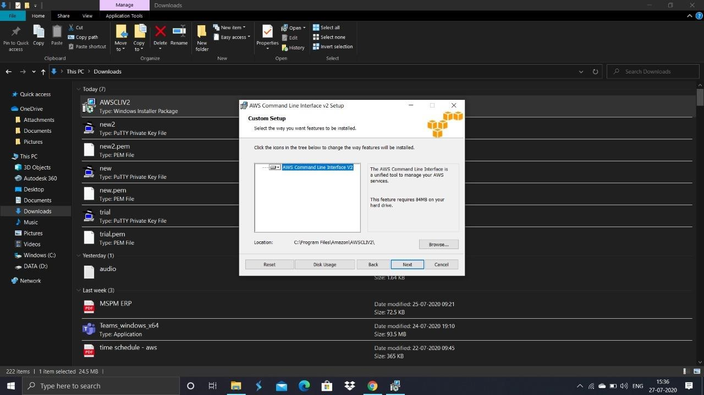

You can check your installing are properly or not ,as open your command prompt and run as administrator then follow the command

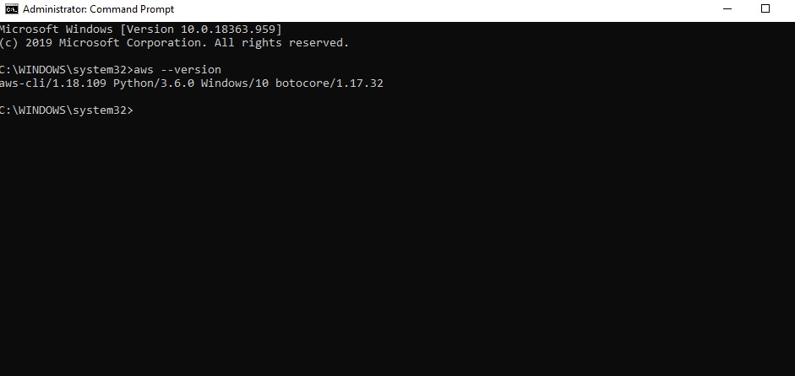

Sucessfully completed your Installation.

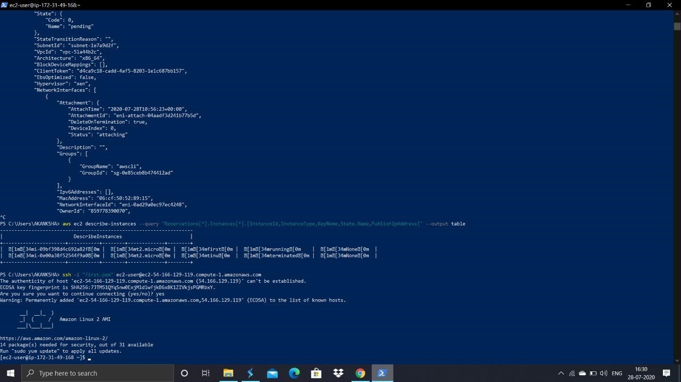

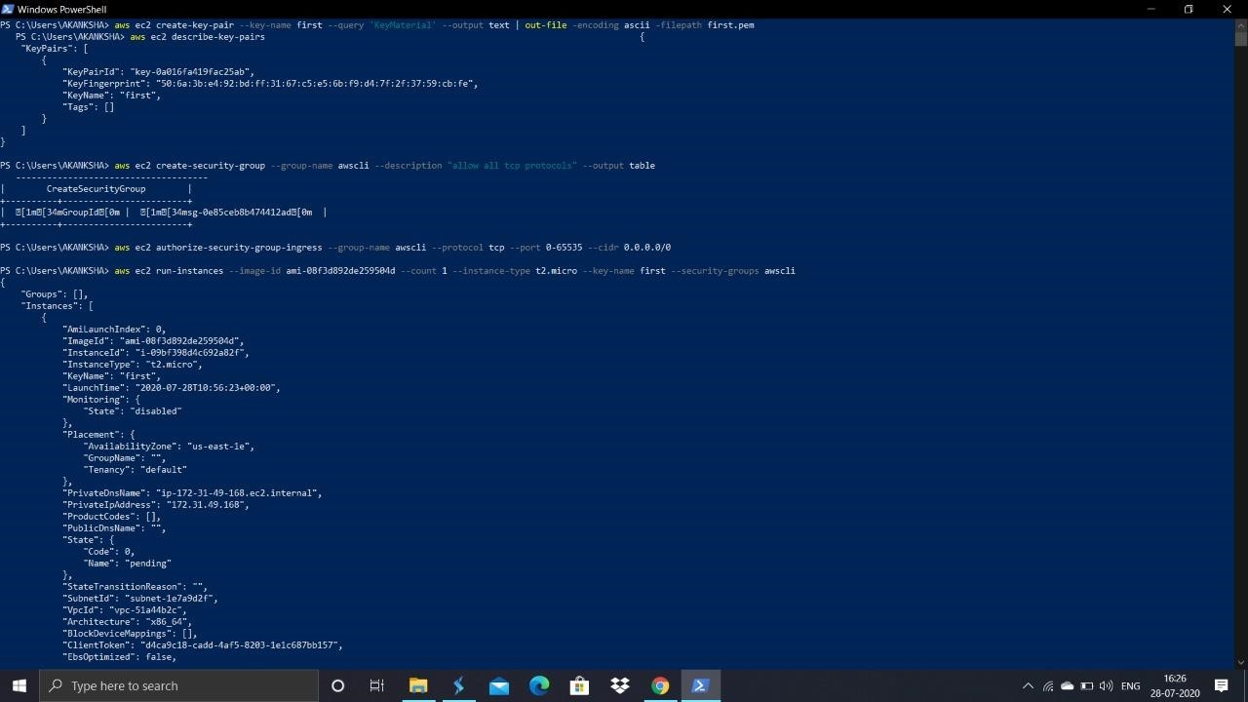

As shown you and follow these command lines.