EC2 - Classic Load Balance

A load balancer distributes incoming application traffic across multiple EC2 instances in multiple Availability Zones. This increases the fault tolerance of your applications. Elastic Load Balancing detects unhealthy instances and routes traffic only to healthy instances.

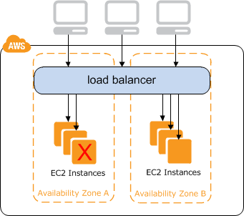

For example, if you have ten instances in Availability Zone us-west-2a and two instances in us-west-2b, the requests are distributed evenly between the two Availability Zones. As a result, the two instances in us-west-2b serve the same amount of traffic as the ten instances in us-west-2a. Instead, you should have six instances in each Availability Zone.

1. Open the Amazon EC2 console, On the navigation pane, under LOAD BALANCING, choose Load Balancers. And click create Load Balancer

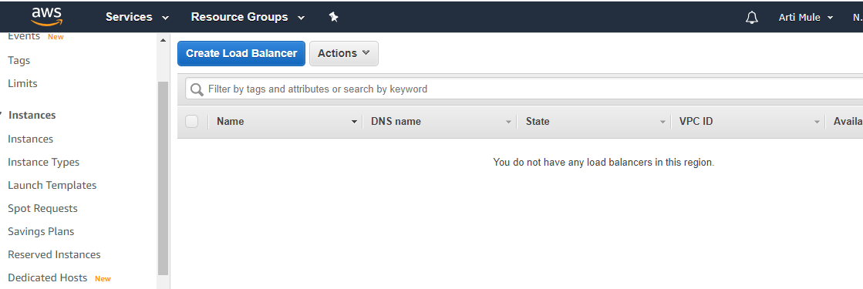

1. Select a load balancer type:

Elastic Load Balancing supports three types of load balancers: Application Load Balancers, Network Load Balancers, and Classic Load Balancers.For create create a Classic Load Balancer

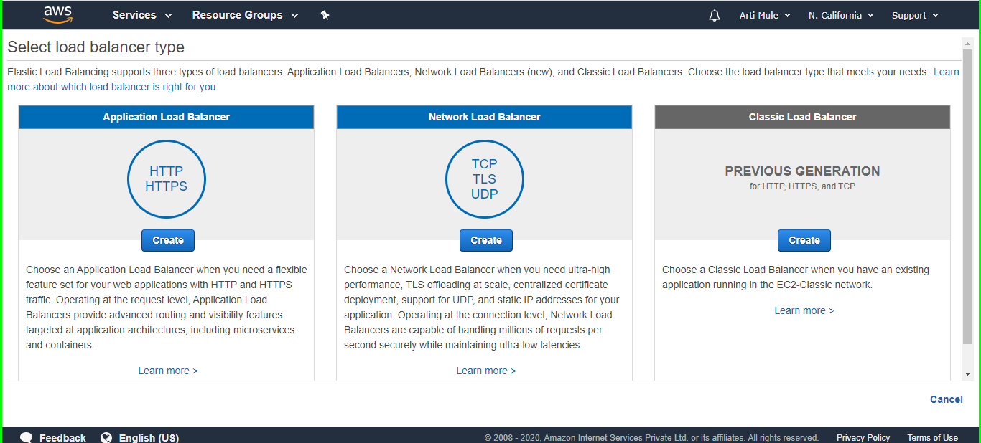

1. For Load Balancer name, type a name for your load balancer.

For Create LB inside, select the same network that you selected for your instances: EC2-Classic or a specific VPC.

[Default VPC] If you selected a default VPC and would like to choose the subnets for your load balancer, select Enable advanced VPC configuration.

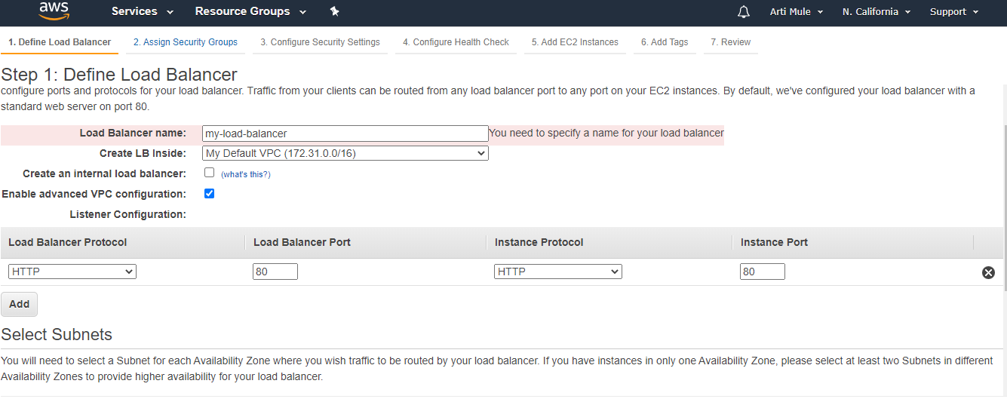

1. Select Available subnets

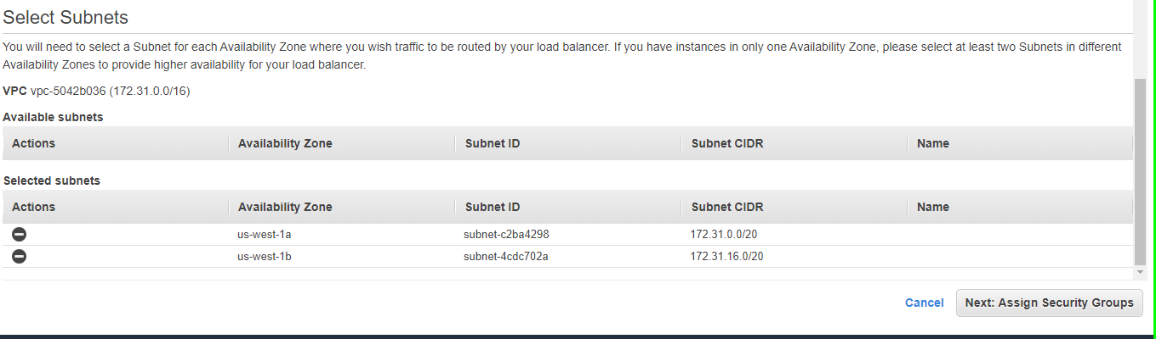

Choose Next: Assign Security Groups.

1. On the Assign Security Groups page, select Create a new security group

Type a name and description for your security group, or leave the default name and description. This new security group contains a rule that allows traffic to the port that you configured your load balancer to use.

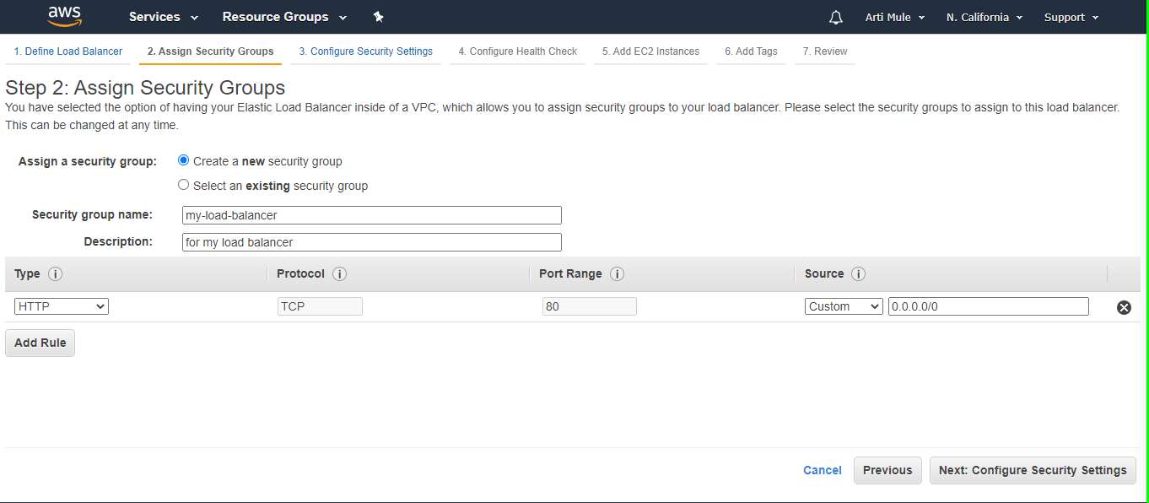

Click Next:Configure Security Setting

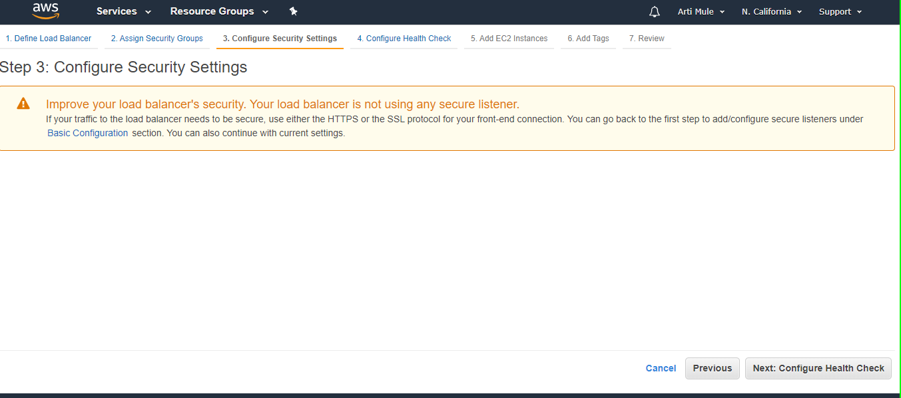

Click Next: Configure Health Check

1. On the Configure Health Check page, leave Ping Protocol set to HTTP and Ping Port set to 80.

For Ping Path, replace the default value with a single forward slash ("/"). This tells Elastic Load Balancing to send health check queries to the default home page for your web server, such as index.html.

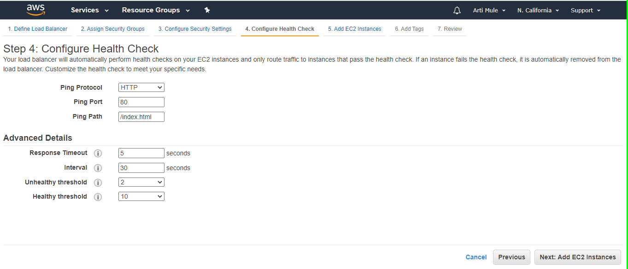

Click Next: Add EC2 Instances.

1. On the Add EC2 Instances page, select the instances to register with your load balancer.

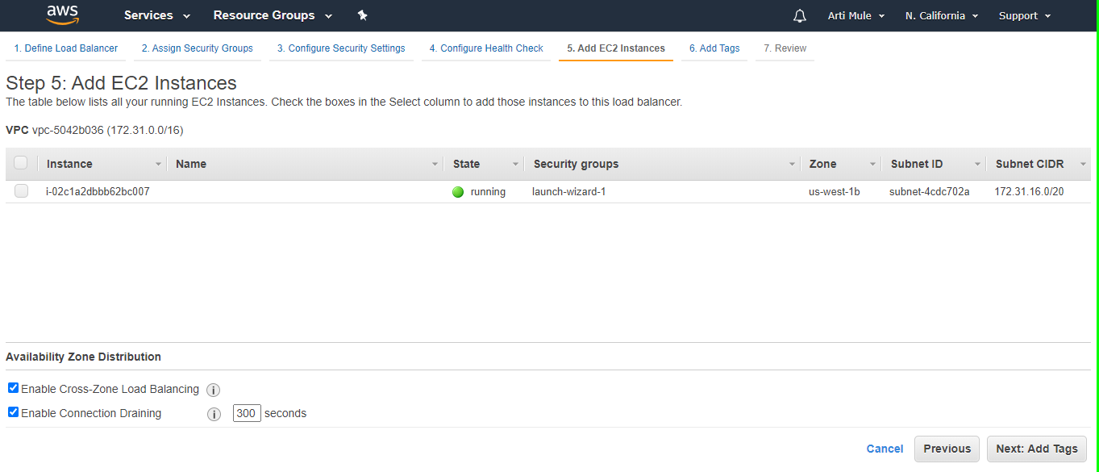

Click Next: Add Tags.

1. check Review status if you want any changes we can do it.otherwise click on create

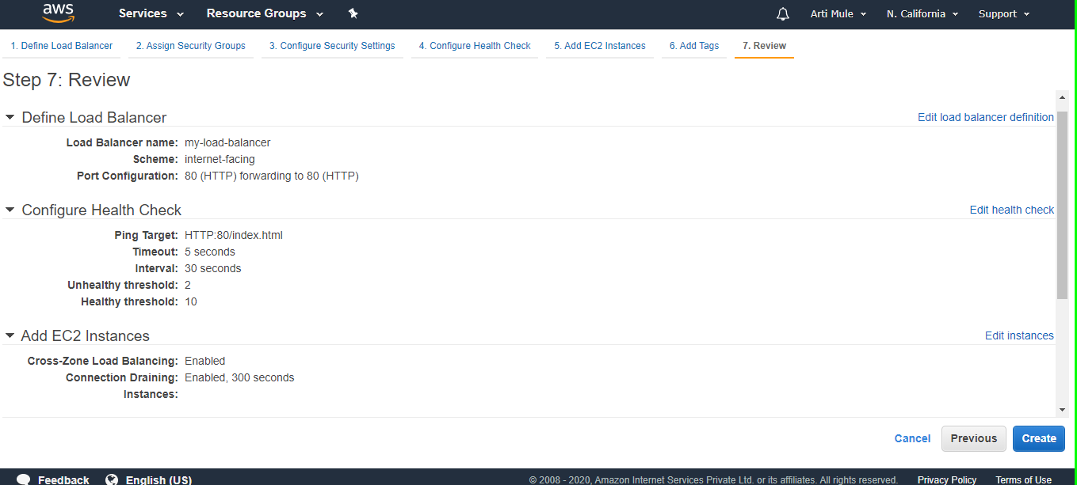

1. Successfully create load balancer

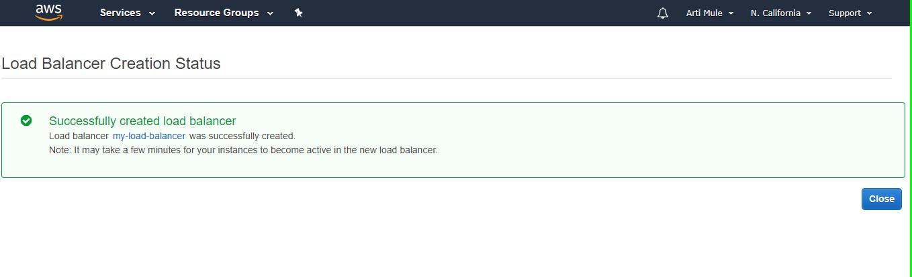

1. check Load Balancer

