Class Diagram

<https://csci-1301.github.io/about#authors>

June 30, 2021 (05:30:19 PM)

Table of Contents

**Unified Modeling Language** (UML) is a tool for visually representing programs. UML is used to represents many different [types of diagrams](https://en.wikipedia.org/wiki/Unified_Modeling_Language#Diagrams). In this lab you will practice interpreting and creating one of them: a *class diagram*.

## Interpreting a UML class diagram

Study the following diagram, then answer follow up questions:

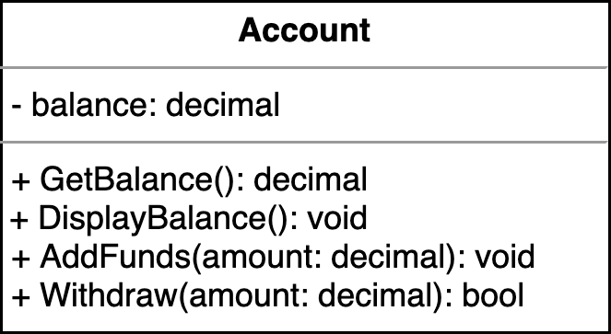

“Class diagram for a bank account”

1. What is the name of this class?
2. How many attributes does this class have?
3. How many methods does this class have?
4. You will notice that there are two similar methods: GetBalance and DisplayBalance
   * based on the name can you interpret the behavior of these methods?
   * can you think of *why* we might need such similar methods?

Class diagram provides a concise way to represent attributes and methods, but it does not explain the implementation of the methods.

Knowing that:

1. GetBalance method returns the current value of balance,
2. DisplayBalance will display the current balance at the screen formatted as currency, for example:

* Your current balance is $1,000,000.00 dollars!

1. AddFunds increments the current balance value by specified amount, and
2. Withdraw performs following operation:
   * if sufficient funds are available, it reduces balance by specified amount and returns true to indicate withdrawl succeeded
   * if funds are insufficient, it does nothing to balance, and returns false

implement your version of this class in C#.

## Writing your own class diagram

In this next exercise you will practice drawing your own diagram, on paper.

1. Draw the UML class diagram of a PreciseRectangle class.
2. It should have two attributes: width and length of type double
3. It should have eight methods:
   * two setters, two getters (i.e., one for each attribute)
   * one method to compute the area of a precise rectangle
   * one method to compute the perimeter of a precise rectangle
   * one method to swap the length and the width of a precise rectangle
   * one method to multiply the length and width of a precise rectangle by an ratio given in argument as an integer

# Pushing Further (Optional)

The following is an independent task, to widen your understanding of UML modelling concepts:

1. Class diagrams are just a special case of UML diagram. Have a look at <https://en.wikipedia.org/wiki/Unified_Modeling_Language#Diagrams>. In which category are class diagrams: behavior, or structure diagram?
2. Besides attributes and methods, class diagrams can also represent relationships between classes.  
   Have a look at <https://en.wikipedia.org/wiki/Class_diagram/> for more examples of class diagrams.
3. Activity Diagram is another type of UML diagram for representing program actions. You will occasionally see activity diagrams in the lecture notes.

* “A flowchart representation of an if-else statement”
* “A flowchart representation of an if-else statement”
* Have a look at <https://en.wikipedia.org/wiki/Activity_diagram> and try to understand the example: “Activity diagram for a guided brainstorming process”.