Section 4 – Simulation example (draft for insertion)
Generated by reports/paper/build_section4.R from the results store _targets_b100k (run of 13 Oct 2026, B = 100,000 per scenario, protocol v0.3). Text in square brackets needs a decision or a check by the authors. Numbering of tables and figures follows the current draft (Table 1–2 and Figure 1 are already used).
4.1 Used dataset
We reanalyse the example dataset of Maringe et al. [36] to check whether the applied clone-censor-weighting (CCW) approach is unbiased, has nominal 95% CI coverage and no type I error inflation. The dataset comprises 200 simulated elderly patients with stage I or II lung cancer, generated by the authors to mimic their cancer registry study and distributed with the tutorial [it is the simulated supplementary dataset, not the registry data of their Table S2; data from the ccwr R package]. Time zero is the date of diagnosis and patients are followed for one year. The treatment of interest is major surgery, received by 106 patients (53.0%), 42 of them on day 1; the median time to surgery among operated patients was 25 days. The endpoint is death within one year, observed in 48 patients (24.0%). All patients alive at one year were followed until day 365, so the only censoring is administrative. Baseline covariates are age, sex, performance status, TNM stage, deprivation score, Charlson comorbidity index and emergency presentation (Table 3).
Table 3: Patient characteristics of the Maringe example dataset by surgery during follow-up
 | Received surgery |  | Did not receive surgery |  | Standardised mean differences (%)
 | N | % | N | % | Standardised mean differences (%)
Total | 106 | 100.0 | 94 | 100.0
Sex
Men | 56 | 52.8 | 51 | 54.3 | -2.9
Women | 50 | 47.2 | 43 | 45.7
Performance status
0 | 46 | 43.4 | 11 | 11.7 | 75.9
1 | 54 | 50.9 | 41 | 43.6 | 14.7
2 | 6 | 5.7 | 42 | 44.7 | -100.7
Charlson's comorbidity index
0 | 48 | 45.3 | 34 | 36.2 | 18.6
1 | 40 | 37.7 | 39 | 41.5 | -7.7
2 | 18 | 17.0 | 21 | 22.3 | -13.5
TNM stage
I | 76 | 71.7 | 53 | 56.4 | 32.3
II | 30 | 28.3 | 41 | 43.6
Route to diagnosis
Emergency | 11 | 10.4 | 20 | 21.3 | -30.2
Non-emergency | 95 | 89.6 | 74 | 78.7
 | Median | Q1 Q3 | Median | Q1 Q3
Age at diagnosis (years) | 76.3 | 73.0 79.9 | 81.2 | 76.7 84.9 | -66.1
Deprivation score | 0.15 | 0.07 0.28 | 0.14 | 0.07 0.26 | 14.0
Time to surgery (days) | 25 | 1 43
Standardised mean differences: one value for binary characteristics, one per category for performance status and Charlson index, continuous scale for age and deprivation score. Deprivation score as coded in the simulated dataset (0–1 scale).
4.2 Model
Reference model. The reference model is the CCW analysis of Maringe et al. [36], comparing the strategies 'surgery within 6 months of diagnosis' and 'no surgery within 6 months' (grace period 182.62 days). Each patient is cloned into both strategies. Clones in the no-surgery strategy are censored on the day of surgery if surgery happens within the grace period. Clones in the surgery strategy are censored at the end of the grace period if they are alive and have not been operated; patients who die within the grace period without surgery remain in both strategies. First, the weights are calculated. In the no-surgery strategy, the probability of remaining uncensored is estimated from a Cox model for time to surgery and the weights are updated at every surgery date; in the surgery strategy, a logistic model for surgery within the grace period among patients alive at its end gives the weights from that time onwards. Both models include age, sex, performance status, stage, deprivation score, Charlson index and emergency presentation. The strategies are compared by a weighted Cox model with the strategy as the only covariate, Efron ties and a robust, patient-clustered variance. Figure 4 shows how example patients are cloned, censored and weighted, and Figure S2 the covariate balance between the strategies at 6 months before and after weighting.
Preserved data. Not only the baseline data are maintained but also each patient's observed date of surgery; patients who were not operated keep no surgery date. Surgery is counted as received only if its date precedes the simulated end of follow-up.
Weibull prediction model. Times to death are predicted from a Weibull proportional hazards model fitted to the original data by maximum likelihood, with the same seven covariates and surgery as a time-varying covariate, h(t | X) = λρt^(ρ−1) exp(γ′X + θ·1{t ≥ s}), where s is the patient's surgery date. The effect of surgery can therefore act only after surgery has taken place. Death times are drawn by inverting each patient's cumulative hazard; patients still alive at day 365 are censored there. Because all survivors in the original data were followed for the full year, there is no loss to follow-up to model in this example: the censoring model of Section 2.3 reduces to administrative censoring at one year. [For datasets with loss to follow-up, the simulation code fits a second Weibull model with the event/censoring indicator switched and treatment as a time-varying covariate.] Parameter estimates are given in Table S1 and the fit to the observed data in Figure S1.
4.3 Calibration
The hazard ratio parameter θ in the Weibull prediction model describes the treatment effect of surgery once received, at fixed covariates. The CCW hazard ratio, on the other hand, compares treatment strategies over the follow-up period and differs from θ because of grace-period dilution (in the surgery strategy, patients are untreated until their surgery date, so the strategy hazard ratio starts at 1 and moves towards θ over time) and because it is a marginal rather than a conditional contrast.
The true CCW hazard ratio in the simulated world, ψ(θ), was defined as the large-sample limit of the CCW analysis: the reference model was applied to 96 independent simulated datasets of 50,000 patients each (stacked copies of the baseline data) and the estimates were averaged. The calibration was performed by a secant search starting from the fitted coefficient θ̂ = -0.41 (HR 0.6605): θ was tuned until ψ(θ) equalled the observed CCW hazard ratio of 0.6206. This needed θ* = -0.70 (Weibull HR 0.4949), which results in HR_CCW = 0.6221 (2 search steps after the two starting values; MCSE of the true log HR 0.002). [Current draft: 'θ = −0.70, which results in HR_CCW = 0.48'; HR_CCW equals the observed HR by construction, and the Weibull HR is exp(θ*) = 0.4949.]
A calibration step is not needed for the type I error rate, as conditional and marginal treatment effects are both HR = 1 in this case. With unlimited data, the CCW analysis would nevertheless estimate HR 0.9645 when surgery has no effect, a small offset that the finite-sample results below include.
4.4 Simulation settings and performance measures
For each of the two scenarios (θ = θ* and θ = 0), 100,000 datasets were simulated and reanalysed with the reference model. Replicate b used the same random numbers in both scenarios (common random numbers). Performance measures were the bias of the log HR, the empirical and the model-based (robust) standard error, the coverage of the nominal 95% CI and the rejection rate of H0: HR = 1 (power under θ*, type I error under θ = 0), each with its Monte Carlo standard error (MCSE); the MCSE of the bias includes the Monte Carlo error of the true value. Failed model fits were recorded and excluded (n = 2).
Adjustment (Section 2.7). The bias-corrected estimate is the observed estimate minus the estimated bias, the confidence interval is widened by the ratio of empirical to model-based SE when this ratio exceeds 1, and the critical value of the test is replaced by the 95th percentile of |z| in the null scenario. To check that the adjusted analysis performs as intended without judging it on the replicates that defined it, the adjustments were estimated on one half of the replicates and applied to the other half (two-fold cross-fitting), in both scenarios.
Software and run time. The simulation was programmed in R 4.6.1 (packages survival, data.table and targets; parallel workers via crew) and is available in the Online Supplement. The simulation took 268.7 minutes with 3 parallel workers on a cloud virtual machine (709.6 minutes of computing time, of which 587.4 minutes for the 2 × 100,000 replicates, 0.18 seconds per replicate).
4.5 Results
The observed CCW analysis estimated HR = 0.6206 (95% CI 0.3691–1.0433) for surgery within 6 months versus no surgery within 6 months (Table 4). With the true CCW HR set to this value, the average estimate across 100,000 simulated studies was HR 0.6127: a bias of -0.015 on the log scale (95% MC interval -0.019 to -0.011; 5.4% of the empirical SE), which is statistically detectable but small. The robust SE was on average 3.6% smaller than the empirical SE, and the coverage of the nominal 95% CI was 93.6% (MCSE 0.1%), a significant departure from 95%. With no effect of surgery, 7.483% (MCSE 0.083%) of the simulated studies rejected H0 at the 5% level, a significant inflation of the type I error; 6.267% were rejections in favour of surgery. Power to detect the observed effect was 48.8% (Table 5, Figures 2 and 3).
The QBA-adjusted analysis gave HR = 0.6301 (95% CI 0.3677–1.0800), with a CI inflation factor of 1.04 and a calibrated critical value of |z| = 2.17 instead of 1.96; the simulation-calibrated p-value was 0.101 (observed p = 0.072). In the cross-fitted evaluation the adjusted analysis had 95% CI coverage of 94.8% and a type I error of 5.007%; its bias is zero by construction (Table 5, Figure 2).
[Discussion, 2nd paragraph: the current draft quotes type I error 7.1% and coverage 93.7%. This run (B = 100,000): bias -0.015, coverage 93.6%, type I error 7.483%.]
Table 4: Observed CCW analysis, prediction model and calibration
 | Value
Observed CCW HR (95% CI) | 0.6206 (0.3691 to 1.0433)
Observed p-value | 0.072
Weibull outcome model: on-treatment HR (exp(theta-hat)) | 0.6605
Calibrated generating HR, exp(theta*) | 0.4949
True CCW HR in the simulated world, exp(psi(theta*)) (MCSE of psi) | 0.6221 (0.002)
Large-sample CCW HR with no treatment effect, exp(psi(0)) | 0.9645
QBA-adjusted HR (95% CI) | 0.6301 (0.3677 to 1.0800)
CI inflation factor (empirical / model SE) | 1.04
Calibrated critical value |z| for a 5% test | 2.17
Simulation-calibrated p-value | 0.101
HR: surgery within 6 months versus no surgery within 6 months. ψ(θ): large-sample CCW log HR when the Weibull prediction model has on-treatment log HR θ. MCSE: Monte Carlo standard error.

Table 5: Performance of the CCW analysis before and after QBA adjustment (100,000 simulated studies per scenario; estimate (MCSE))
Performance measure | CCW as published | CCW + QBA adjustment
Mean estimate, log HR (true value) | -0.490 (-0.475)
Bias, log HR | -0.015 (0.002) | 0 (by construction)
Relative bias, % of empirical SE | -5.4
Empirical SE | 0.282 (0.001)
Model-based (robust) SE | 0.272
Relative error in model SE, % | -3.6
RMSE | 0.282
95% CI coverage, % | 93.6 (0.1) | 94.8 (0.1)
Power, % (true HR = observed) | 48.8 (0.2) | 42.6 (0.2)
Type I error, % (no effect) | 7.483 (0.083) | 5.007 (0.069)
Rejections favouring surgery, % (no effect) | 6.267
Failed replicates, n | 2
Adjusted analysis: bias correction, CI widening and calibrated critical value, each estimated on the other half of the replicates (two-fold cross-fitting). MCSE of the bias includes the Monte Carlo error of the true value.

Figure 2: Bias, 95% CI coverage, type I error and power of the CCW analysis before and after QBA adjustment. Points: estimates; bars: 95% Monte Carlo intervals (±1.96 MCSE); dashed lines: nominal values. The adjusted bias is zero by construction.
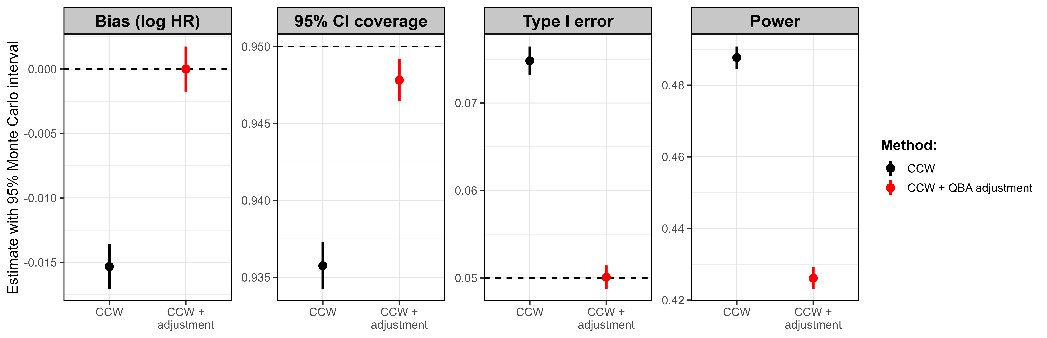
Figure 3: Distribution of the simulated CCW estimates when the true CCW HR equals the observed estimate (left), and of the z statistics when there is no treatment effect (right), with nominal and calibrated critical values.
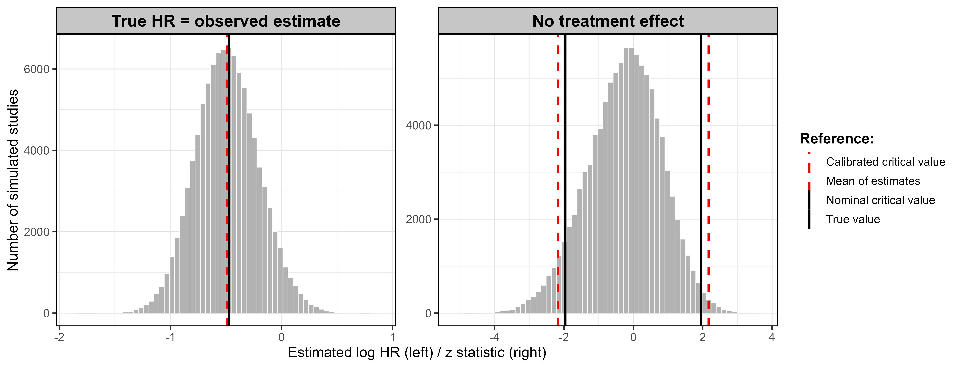
Figure 4: Cloning, artificial censoring and weighting in the CCW analysis, for five example patients. Shaded: grace period.
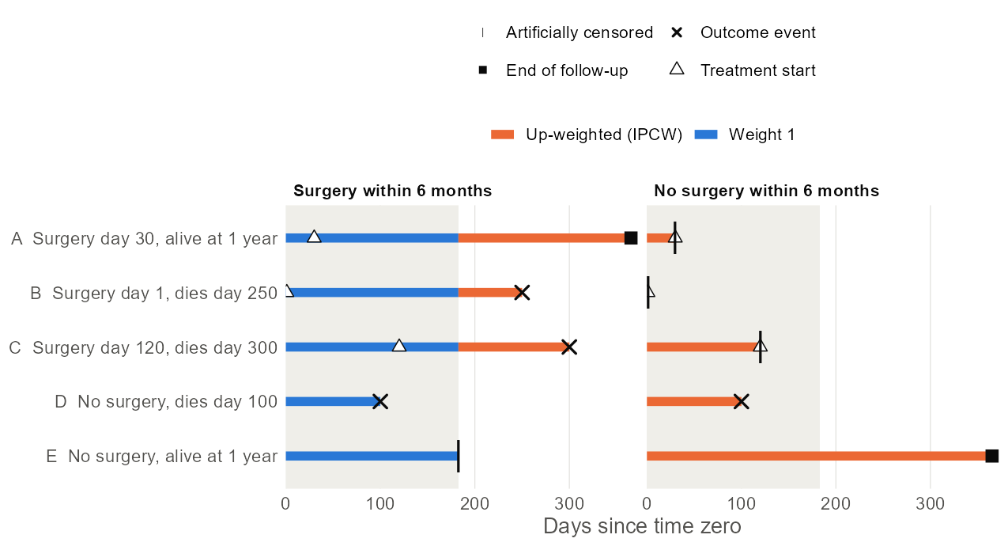

Online Supplement (draft)
Table S1: Weibull prediction model for death (hazard ratios)
Model | Term | HR | 95% CI
Outcome: death | Weibull shape (rho) | 1.29
Outcome: death | Age (per 5 years) | 0.9328 | 0.7102 to 1.2253
Outcome: death | Female | 0.4992 | 0.2678 to 0.9304
Outcome: death | Performance status 1 vs 0 | 1.0329 | 0.4419 to 2.4143
Outcome: death | Performance status 2 vs 0 | 2.4222 | 0.9315 to 6.2985
Outcome: death | TNM stage II vs I | 1.5921 | 0.8822 to 2.8731
Outcome: death | Deprivation score (per 0.1) | 0.9563 | 0.7516 to 1.2168
Outcome: death | Charlson index 1 vs 0 | 0.8601 | 0.4318 to 1.7132
Outcome: death | Charlson index 2 vs 0 | 1.0832 | 0.5035 to 2.3299
Outcome: death | Emergency presentation | 1.1949 | 0.5690 to 2.5090
Outcome: death | On treatment (time-varying) | 0.6605 | 0.3189 to 1.3684
48 deaths. Surgery enters as a time-varying covariate (0 before, 1 from the surgery date).
Figure S1: Fit of the Weibull prediction model: Kaplan–Meier estimate in the original data versus the survival predicted by the Weibull model (averaged over patients, with each patient's observed surgery date).
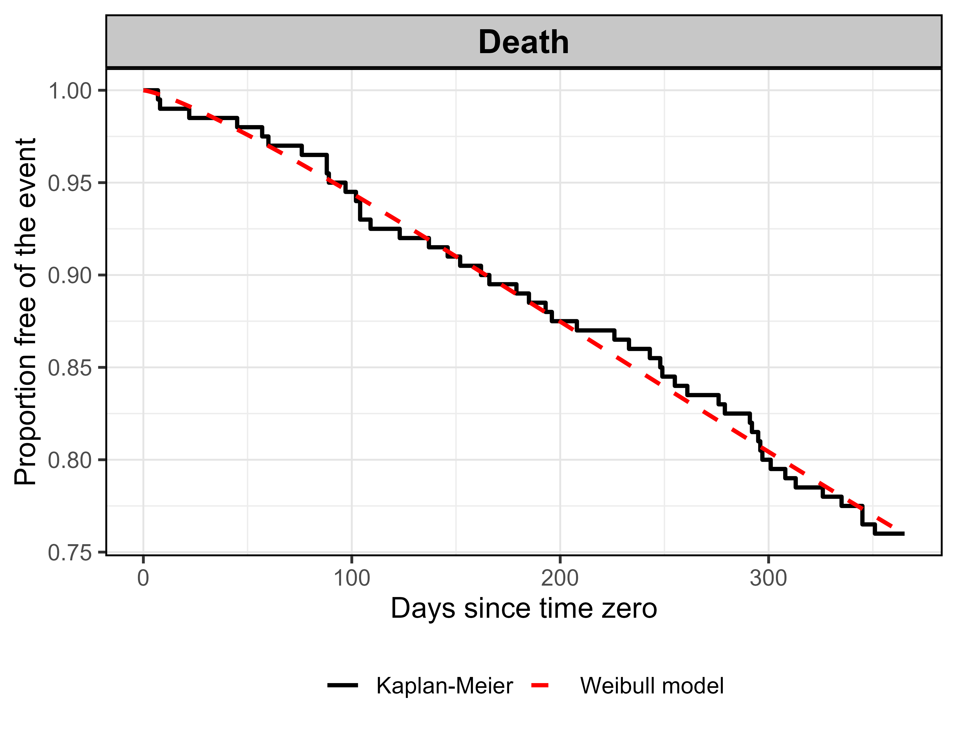
Figure S2: Standardised differences between the surgery and no-surgery strategies among clones at risk at the end of the grace period (98 and 80 clones), before and after censoring weights. Dashed lines: ±10%.
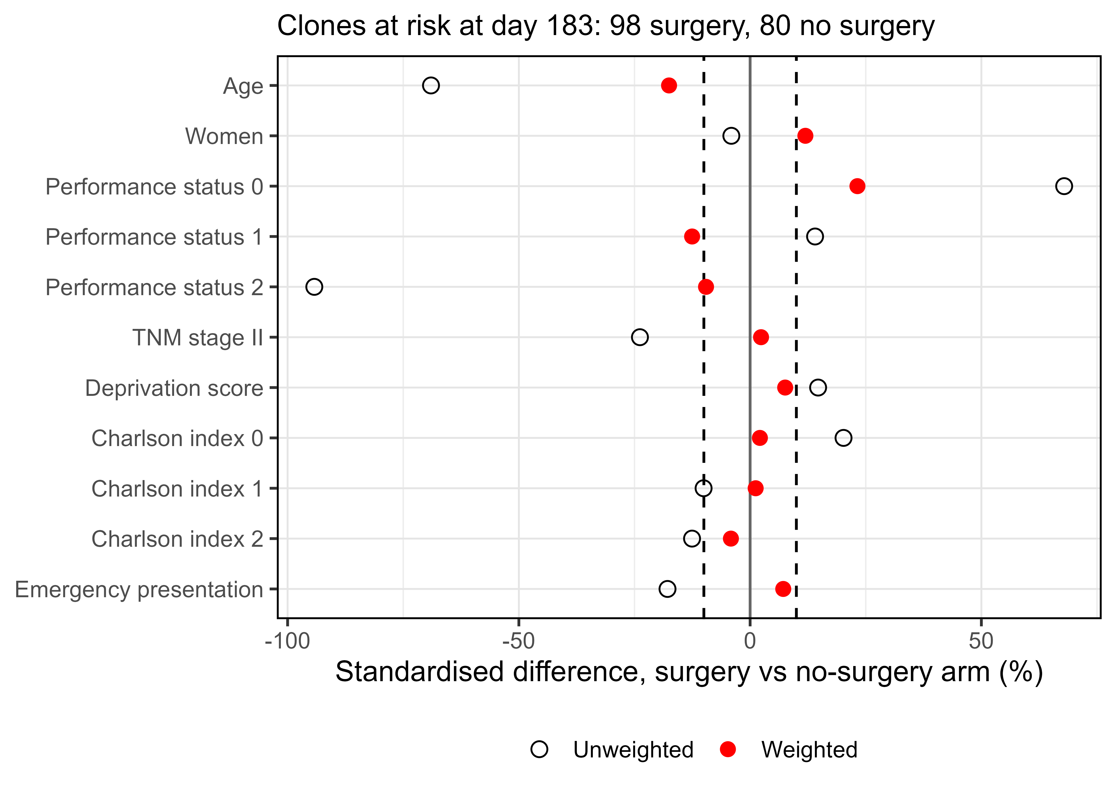
Before weighting 10 of 11 covariate terms differ by more than 10%; after weighting 4 (largest 23.2%). [Maringe et al. report all weighted differences within 10% in their registry data; the 200-patient example does not reach this.]

