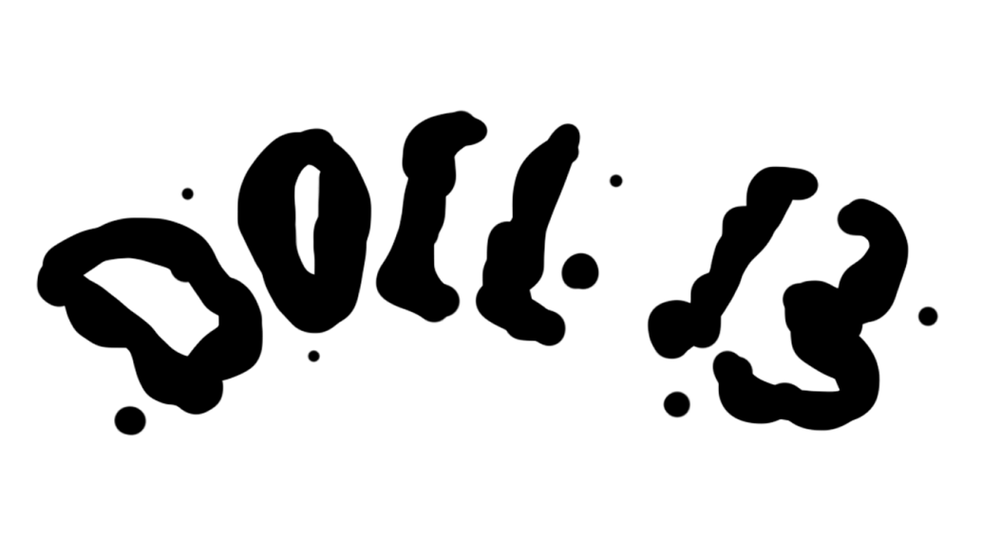

Goldmaster

**G**ame **D**esign **D**ocument

**Contents**

Change Log 4

Vision Statement 5

Story & Setting 5

Gameplay 6

Core Game Loop 6

Detailed Gameplay Mechanics 7

Characters 7

Fetishes 10

Voodoo-powers 11

Controls 16

Characters 16

Clairvoyance 16

Quick Time Event 16

HUDs/Menus 17

Menus 17

Scaling and Proportions 17

Camera 18

Screens/Perspectives 18

UI Elements 18

Assets Needed 19

Level 0 19

Level 1 19

Level 2 19

Level Design 20

Level 0 – Awakening 20

Layout 21

Player Paths 21

Level 1 – The Office 22

Layout 22

Player Paths 23

Level 2 – The Laboratory 24

Layout 24

Player Paths 25

Glossary 27

Index 27

List of Figures 27

# Change Log

|  |  |  |
| --- | --- | --- |
| Date | Changed by | Change |
| 10.04.2018 | Tobias Schuster | Initial creation |
| 18.04.2018 | Tobias Schuster | Restructured document (asset list and vision document outsourced into separate documents) |
| 23.04.2018 | Tobias Schuster | Mechanics elaborated (Spirit energy) |
| 30.04.2018 | Tobias Schuster | Mechanics elaborated (Voodoo-powers) |
| 08.05.2018 | Tobias Schuster | Mechanics elaborated (Characters) |
| 09.05.2018 | Tobias Schuster | Mechanics elaborated (Characters)  HUDs/Menus elaborated |
| 11.05.2018 | Tobias Schuster | Signs & Feedback updated  Edge Cases updated  Level Design updated |
| 22.05.2018 | Tobias Schuster | Review and slight corrections |
| 27.06.2018 | Tobias Schuster | Level 2 added  Assets needed for level 2 |
| 28.06.2018 | Tobias Schuster | Player paths updated |
| 29.06.2018 | Tobias Schuster | Corrections of mechanics  Controls updated |
| 02.07.2018 | Tobias Schuster | Signs & feedback updated  Menus updated |
| 03.07.2018 | Tobias Schuster | Edge cases updated |
| 16.07.2018 | Tobias Schuster | Removed spirit energy |
| 20.07.2018 | Tobias Schuster | Added level 0 |

# Vision Statement

“Doll 13 is a 3D puzzle-adventure for lovers of the occult with minimized stealth-elements.  
The player discovers his surroundings from the perspective of a small doll, finds different items to strengthen his voodoo-powers and possesses guards to ultimately flee from the underground bunker.  
The low camera perspective and dark atmosphere in the beginning make the player feel vulnerable but the interesting mechanics and fun elements within the game lighten up the mood.”

# Story & Setting

For a detailed story see [***Voodoo_StoryDocument***](Voodoo_StoryDocument.docx).

# Gameplay

## Core Game Loop

**Orientation** includes:

* Entering a new room
* Getting a first impression of where your objectives (fetish and control item) are located

**Clairvoyance** can be used anytime. It includes:

* Switching into a voodoo mask and getting an overview of the level

**Offering** includes:

* The way to the fetish
* The way to the control item, consisting of several alternative routes
* Bringing the control item back to the fetish and activating the possession/incineration

**Possession** includes:

* Doing a quick-time-event for achieving control over a guard
* Opening the door to the next room, as the guard
* Pushing objects (like shelves) around to create new ways for the doll to move

***Incineration*** *(Nice-To-Have feature) includes:*

* *Alternative to possession mechanic*
* *Setting a focus to the guard (mechanic parallel to possession)*
* *Transferring self-inflicted damage to the guard (automatically)*

## Detailed Gameplay Mechanics

### Characters

#### Doll 13

* The voodoo doll is the player character
* Is the thirteenth doll that got experimented on
* It is **35 cm** tall

##### Standard Interactions

|  |  |  |
| --- | --- | --- |
| Feature | Purpose | Priority |
| Movement | Be able to move | MH |
| Jumping | Reach higher positions | MH |
| Open drawers | Create steps | SH |

**Movement**

* The PC is able to move in all directions

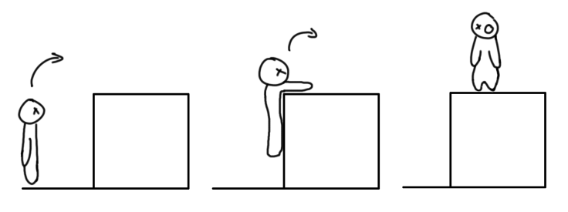

Figure 1 – Jumping on high edges

* Its movement speed is **15cm/s**

**Jumping**

* The PC is able to jump
* The max jump height is at **10cm**
* The max jump width is at **45cm**
* If the PC jumps at an edge (**higher than 30cm**), it will automatically pull itself up
* Climbable edges must have a max height of **40cm**

**Open Drawers**

* The PC can open drawers of desks or filing cabinets
* If the PC stands in front of a drawer (**5cm distance**) the drawer will open on button press

**Signs & Feedback**

|  |  |  |
| --- | --- | --- |
| Action | Signs | Feedback |
| Movement | N/A | * Run-animation * Sound of footsteps (fabric on ground) |
| Jumping | N/A | * Jump-animation * Climb-animation * Pull-up-animation * Sound of impact (fabric on ground) * Moaning sounds |
| Open drawers | * Coloured outlines when in range | * Drawer opens |

#### Guard

* The Guard is **170cm** tall

##### Standard behaviour

* The guard is either still standing or patrolling
* He moves with a speed of **35cm/s** when patrolling
* The PC is spotted, when it is in the guard’s field of view
  + The PC is only spotted, if no object is hindering the view of the guard
    - The PC can hide behind objects and will not be seen by the guard
  + After **3 seconds** the guard will walk to the PC and try to pick it up (SH)  
    If successful the current level will be reset, meaning the player has to play current room again.
* The guards field of view is represented by a cone in front of him
  + The cone has an angle of **30°**
  + The length of the cone is **200cm**
* When standing still the guard looks into different directions
  + The directions are specific to each guard
  + The frequency in which a guard turns around is specific to each guard

##### Possession Interactions

The guard can be controlled by the player through ‘*Possession*’. While possessing a guard, the player has the following interactions available:

|  |  |  |
| --- | --- | --- |
| Feature | Purpose | Priority |
| Movement | Be able to move | MH |
| Open Door | Create an exit | MH |
| Guard Interaction | Restrict player movement | MH |
| Pushing | Open or block ways | NTH |
| Carry Doll | Reach higher positions | CH |

**Movement**

* The guard can move in all directions
* His movement speed is **35cm/s**

**Open Door**

* The guard can open doors by using the handle
* He must be in interaction range (**10cm distance**) to open the door

**Guard Interaction**

* If the guard comes into range (**150cm**) of another guard, possession will end immediately

***Pushing (NTH)***

* *As the guard, the player can push tables and shelves*
* *He has to stand in front of the object (****10cm distance****) to push it*

***Carry Doll (CH)***

* *As the guard, the player can grab the doll from different heights, these are:*
  + *Floor level (0cm – 20cm)*
  + *Desk level (70cm – 90cm)*
  + *Shelf level (140cm – 160cm)*
* *As the guard, the player can put the doll down on different heights, after picking it up.  
  The heights are:*
  + *Floor level (0cm – 20cm)*
  + *Desk level (70cm – 90cm)*
  + *Shelf level (140cm – 160cm)*

##### Signs & Feedback

Standard behaviour

|  |  |  |
| --- | --- | --- |
| Action | Signs | Feedback |
| Walking | N/A | * Walk-animation * Sound of footsteps |
| Turning around | N/A | * Turn-animation * Sound of footsteps |
| Spotting PC | N/A | * Exclamation by the guard (short “huh?” or “hmm?” * Gamepad will vibrate slightly |
| Field of view | N/A | * The edge of the cone is highlighted by a glowing line on the ground * The line will be visible on objects that overlap with the cone |

**Possession interactions**

|  |  |  |
| --- | --- | --- |
| Action | Signs | Feedback |
| Movement | N/A | * Walk-animation * Sound of footsteps |
| Open door | * Coloured outlines when in range | * Open-door-animation * Creaking sound |
| Guard interaction | N/A | * Exclamation by the guard (short “huh?” or “hmm?” |
| Pushing | * Coloured outlines when in range | * Push-animation * Groaning sounds * Dragging sounds |
| Carry doll | N/A | * Pick-up animation |

##### Edge Cases

1. Problem: When a puzzle consists of several guards, the player could just open the door using the first available guard he possesses.  
   Solution: Some can only be opened by a specific guard who has the **keys to that door**.  
   Additionally the **guard interaction** mechanic hinders the player to pass other guards while possessing.

### Fetishes

#### Totem-Fetish

* Unlocks voodoo-powers or enables the player to use a voodoo-power
* Always needs an item to be activated (*OFFERING*)
* At least one is placed per level
* The player must be in range (**10cm**) to be able to interact with the fetish

There are three types, distinguished by the veve (symbol) and the colour of the respective loa spirit:

**Ghede Doubye** – Clairvoyance:

* **[BG-Info]** Is said to gift people with clairvoyance
* Enables the player to use clairvoyance in return of a button eye
* Represented by the colour **green** and **eyes**

**Damballah** – Possession:

* **[BG-Info]** Creator of life; ruler of mind, intellect and cosmic equilibrium
* **[BG-Info]** Makes hissing sounds when speaking and is hard to understand
* Enables the player to possess a specific human (guard)
* Expects a personal object or part of that human in return (*OFFERING*)
* Represented by the colour **white** and **snakes**

***Kalfu*** *– Incineration (NTH):*

* ***[BG-Info]*** *Controls evil forces and allows the crossing of bad luck, deliberate destruction, misfortune and injustice from the spirit world*
* *Enables the player to transfer damage to a specific human (guard*
* *Expects a personal object or part of that human in return (OFFERING)*
* *Represented by the colour* ***red*** *and the* ***moon***

#### Voodoo Mask

* At least one is placed per level
* Can be used by the player to get an overview of the level and identify where objectives are located (*CLAIRVOYANCE*)
* It is possible to switch between the masks, if more than one is present in the same level

### Voodoo-powers

#### Clairvoyance

##### Goal/Purpose

* The player needs to know where the objectives are located and how to get there

##### Description

* Can be activated **anytime**
* There is at least one mask per level
* It is possible to switch between the masks in a certain level, if several are present
* The player takes the perspective of a voodoo mask on the wall
  + The field of view of the voodoo mask is **90°**
  + He can look around to observe the room
    - The angle in which the player can look around must be adjustable for each specific mask in a **vertical** and **horizontal** angle
* The player does not control the voodoo doll while using clairvoyance (the doll falls flat to the ground)

##### Signs & Feedback

* The screen is darkened
* While using clairvoyance the player hears a **faint mumbling**
* A **mini-map** indicates the number of masks in each room and in which mask the player currently is inside of
* Objects like fetishes and control items have **glowing outlines**
* The player sees slowly **fainting footsteps** behind the guard, indicating the path he is walking

##### Edge Cases

1. Problem: The player has no way of seeing where objectives are located.  
   Solution: Clairvoyance mechanic.
2. Problem: The player cannot get a good overview of the level with only one mask.  
   Solution: If necessary there will be more than one mask in a level, allowing the player to switch between perspectives and getting a better overall overview.

#### Offering

##### Goal/Purpose

* Before the PC can use possession or clairvoyance (only the first time), he must bring the fetish an appropriate offering

##### Description

* The PC can “interact” with the fetish in two ways:
  + Without offering: the player sees what item the fetish wants, indicated by a small sign in front of it
  + With offering: the player gives the offering to the fetish and activates his voodoo powers, either possession or incineration
* An offering/control item is either a **personal item** (e.g. pocket watch) or **part of a human** (e.g. strand of hair)

##### Signs & Feedback

* An **icon** on the screen indicates whether or not the player **holds the control item**
* A **sign** indicates what item the fetish expects
* The fetish will **glow** in its respective **loa colour**
* After giving the offering to the fetish, the player will hear a **confirmation sound** from it
  + **Incineration** fetishes respond with the sound of an **igniting flame**
  + **Possession** fetishes respond with the sound of **deep,** **mumbling laughter**
  + **Clairvoyance** fetishes respond with the sound of **water drops**

##### Edge Cases

N/A

#### Possession

##### Goal

* The player must have a way to open doors (MH) or to push large objects (NTH)

##### Description

* Requires a possession fetish
* The guard that the control item belongs to is possessed after a quick-time-event was completed by the player:
  + The QTE must convey the feeling of **breaking through** the mental barrier of the guard
  + The player has to press a button repeatedly
  + This will move the two indicators (left and right) to the middle (see ‘*Figure 2*’)
  + The indicators will move to the border, when the button is not pressed
  + This will be increasingly difficult with each encountered guard
  + The QTE stops after **5 seconds**
    - This counts as a failure
    - The player can try again
    - On each try the QTE will become easier to complete

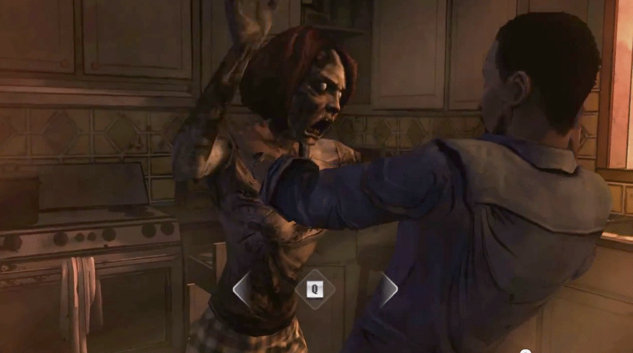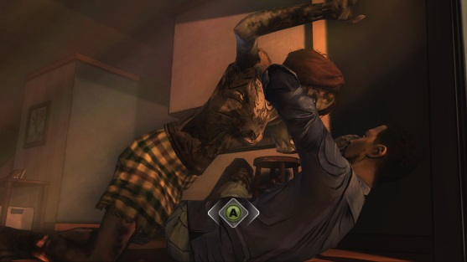

Figure 2 – possession QTE reference

* The player controls the guard
  + The voodoo doll falls down and cannot be controlled
  + For all interactions during possession see ‘*Guard - Possession Interactions*’
* Possession ends automatically after the door has been opened
  + The guard returns to his default position or movement pattern
* Possession ends automatically after the possessed guard comes into range (**150cm**) of another guard
  + After completing the quick-time-event, the guard is possessed again
* When possession ends, the player controls the guard

##### Signs & Feedback

* During the QTE:
  + The camera is **focused on the guard**
  + The guard holds his head in **agony** and will groan occasionally
  + The gamepad will **increasingly vibrate**
  + The button in the middle of the UI will be **glowing**, while the player is still able to complete the QTE in **perfect time**
* When possession ends, the guard will make a **puzzled exclamation** (e.g. “huh?”, “what happened?”)

##### Edge Cases

1. Problem: The player is not able to finish the quick time event due to the difficulty.  
   Solution: After 5 seconds the QTE ends and the player can try again with decreased difficulty.

#### Incineration (Nice-To-Have)

##### *Goal/Purpose*

* *This is an alternative to the possession mechanic*
* *Instead of controlling the guard, the player can inflict damage to a guard and clear the way*

##### *Description*

* *Requires an incineration fetish*
* *The guard that the control item belongs to is focused*
* *When the voodoo doll is damaged, the damage is instead transferred to the focused guard*
* *Sources of damage are:*
  + *Falling from a great height*
  + *The flame of a Bunsen burner*
  + *Cutting with a scalpel*
  + *Stinging with needles*
* *Damage is only transferred if the distance between PC and focused guard is less or equal to* ***10m***

##### *Signs & Feedback*

* *The focused guard will have thin* ***coloured outlines***
* *The reaction of the guard depends on the source of damage:*
  + *Falling – the guard becomes* ***unconscious***
  + *Burning – the guard* ***flees*** *the room* ***in agony***
  + *Cutting/Stinging – the guard* ***flees*** *the room*

##### *Edge Cases*

1. Problem: The player might not be able to identify the focused guard.  
   Solution: The guard will have highlighted outlines.

# Controls

The game only supports gamepad controls. Keyboard and mouse are not included.

## Characters

|  |  |
| --- | --- |
| Action | Control |
| Voodoo Doll | |
| Movement | Left Stick |
| Camera | Right Stick |
| Jump | [A] |
| Interaction (open drawers, offering, pick up control item) | [X] |
| Activate Clairvoyance | [Y] |
| Guard | |
| Movement | Left Stick |
| Camera | Right Stick |
| Open Door | [X] |
| Push/Pull | [B] + Left Stick |

## Clairvoyance

|  |  |
| --- | --- |
| Action | Control |
| Look around | Right Stick |
| End Clairvoyance | [B] |
| Switch to next Mask | [Y] |

## Quick Time Event

|  |  |
| --- | --- |
| Action | Control |
| Press | [X] |

# HUDs/Menus

## Menus

* Main menu
  + Play
  + Controls
  + Settings
  + Credits
  + Exit
* In-game menu
  + Continue
  + Settings
  + Return to main menu
* Controls
  + Return to main menu
* Settings
  + Music volume
  + SFX volume
  + Return
* Credits

## Scaling and Proportions

Every asset and character will be measured in centimetres (cm). Everything has a height, a width and depth.

For the specific measurements of each asset see ‘*Assets Needed*’.

## Camera

The camera is a typical third person camera

**Standard Mode**

* The camera is placed **50cm** behind the PC
* The height of the camera at 0° is at **30cm** height
* The camera rotates around the PC
  + The PC and the camera can be rotated separately
  + The camera is limited in vertical rotation at angles of **50°** and **-18°**
* While colliding with objects, the camera will move towards the player

**Possession**

* The camera is placed **150cm** behind the guard
* The height of the camera at 0° is at **180cm** height
* The camera rotates around the guard
  + The PC and the camera can be rotated separately
  + The camera is limited in vertical rotation at angles of **50°** and **-18°**
* While colliding with objects, the camera will move towards the guard

## Screens/Perspectives

* Voodoo doll perspective
  + The PC is in the middle of the screen
* Mask perspective
* QTE perspective
  + The guard is in the middle of the screen and holds his head in agony, groaning
* Possession perspective
  + The guard is in the middle of the screen

## UI Elements

* Voodoo doll perspective
  + Control item Indicator
* Mask perspective
  + Mini-map
* QTE perspective
  + QTE elements on the bottom side (see ‘*Figure 2*’)

# Assets Needed

See [***AssetListe***](../../_Artbible/Assetliste.xlsx) for a complete list of assets with measurements and other specifications.

Below is a list of the must-have assets for each specific level:

## Level 0

* **Shelf large** (*200cm* height, *200cm* width, *40cm* depth)
* **Shelf small** (16*0cm* height, *200cm* width, *40cm* depth)
* **Office desk**
  + With pull-able drawers (highlighted)
* **Filing cabinet**
  + *With* pull-able drawers (highlighted)
* **Fetish** (highlighted)
* **Stool**
* **Crate**
* **Voodoo** **masks**

## Level 1

* **Shelf** (*200cm* height, *200cm* width, *40cm* depth)
* **Office desk**
  + *With* pull-able drawers (highlighted)
  + *With* door
* **Office chair**
* **Filing cabinet**
  + *With* pull-able drawers (highlighted)
* **Pin board** (*115cm* height, *240cm* width, 5*cm* depth)
* **Fetish** (highlighted)
* **Voodoo masks**
* **Desk lamp**

## Level 2

* **Shelf large** (*200cm* height, *200cm* width, *40cm* depth)
* **Shelf small** (16*0cm* height, *200cm* width, *40cm* depth)
* **Office desk**
  + With pull-able drawers (highlighted)
  + With door
* **Experimenting** **desk**
* **Operations** **table**
* **Filing cabinet**
  + With pull-able drawers (highlighted)
* **Office chair**
* **Stool**
* **Crate**
* **Fetish** (highlighted)
* **Voodoo** **masks**

# Level Design

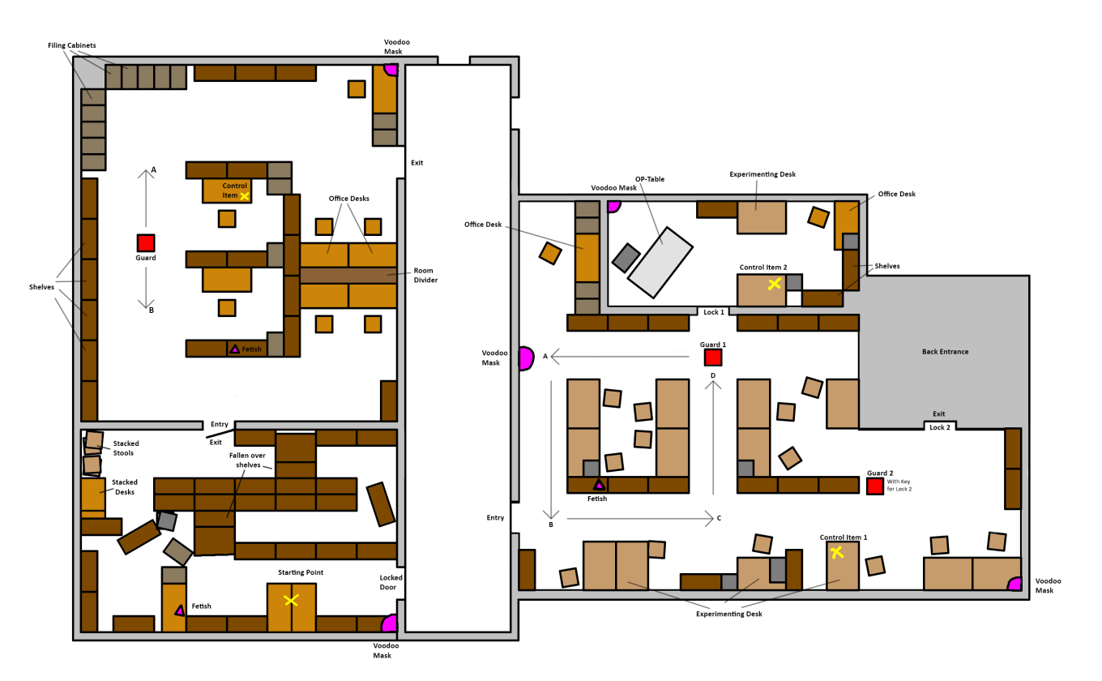

Figure 3 – Level Overview

## Level 0 – Awakening

Level 0 is the tutorial level. The voodoo doll awakes and has to orient itself in the new environment. The player will learn the basic mechanics.

This is the only level in which the clairvoyance fetish will occur, since the player will offer an eye of the voodoo doll in return of the voodoo-power.

Used mechanics:

(Newly introduced mechanics in bold letters)

* **Orientation**
* **Clairvoyance**

### Layout

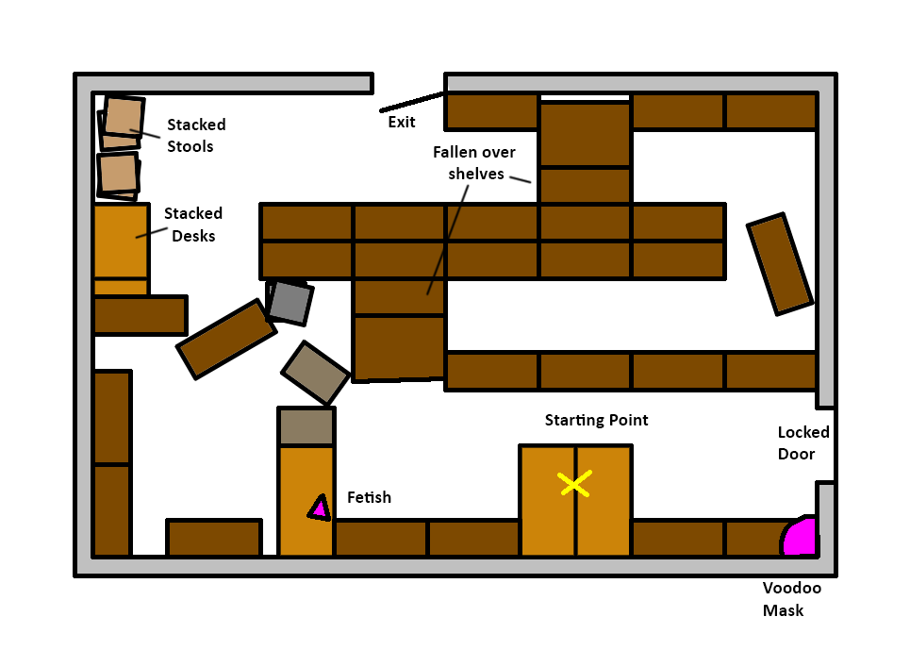

Figure 4 – Level 0 layout

### Player Paths

The yellow cross represents the position of the control item.  
The pink triangle represents the position of the fetish.

|  |  |
| --- | --- |
| Player Path | Comment |
|  | **Way to fetish**  Green path   * Way straight to the fetish |
|  | **Way to exit**  Green path   * Way straight to the open door |

## Level 1 – The Office

The bureau is the first level and full with desks, shelves and filing cabinets.

The room is divided into separate departments and offers different paths to get through it.  
The guard patrols between the points **A** and **B**.

Used mechanics:

* Orientation
* Clairvoyance
* **Offering**
* **Possession**

### Layout

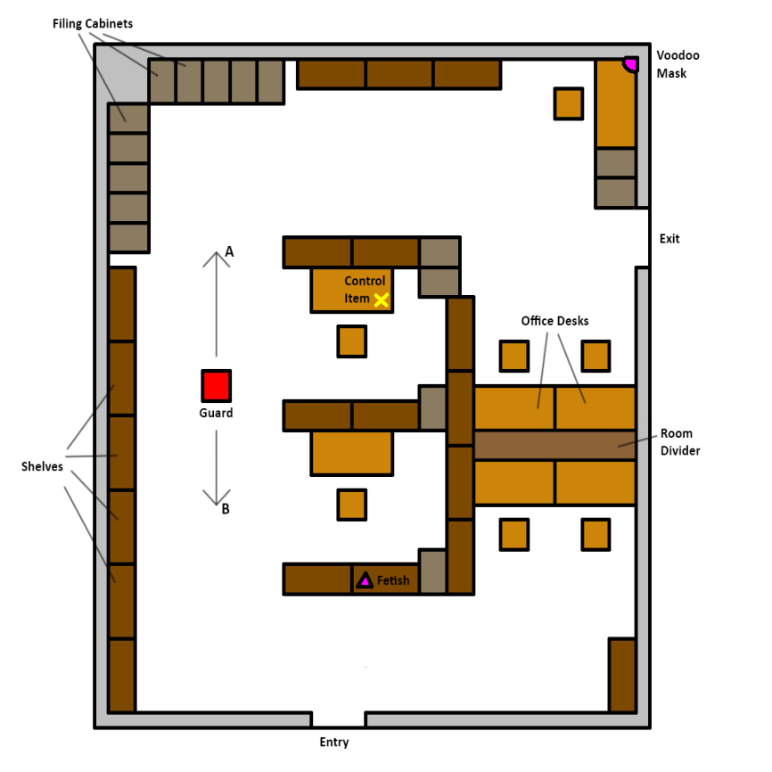

Figure 5 – Level 1 layout

### Player Paths

The yellow cross represents the position of the control item.  
The pink triangle represents the position of the fetish.

|  |  |
| --- | --- |
| Player Path | Comment |
|  | **Way to the control item**  Red path   * Shorter, takes less time to complete * PC might be seen by the guard   Blue path   * Longer, takes more time to complete * Safe from the guard * More jump passages |
|  | **Way to fetish**  Red path   * Longer * PC might be seen by the guard   Blue path   * Shortcut back to the fetish * Safes valuable time |
|  | **Possessing the guard**  Green path   * Way straight to the door to open it |
|  | **Way out of the room**  Red path   * Longer * PC might be seen by the guard   Blue path   * Safe * Short, direct way to the door |

## Level 2 – The Laboratory

The laboratory is the second level. This room is used for experimenting and researching.

The level consists of two rooms and the player needs to figure out a way to get past two guards.

To open the exit, the player must possess the second guard because he holds the keys for this door. The control item for this guard however, can only be accessed using the first guard.

Used mechanics:

* Orientation
* Clairvoyance
* Offering
* Possession
* **Guard interaction**

### Layout

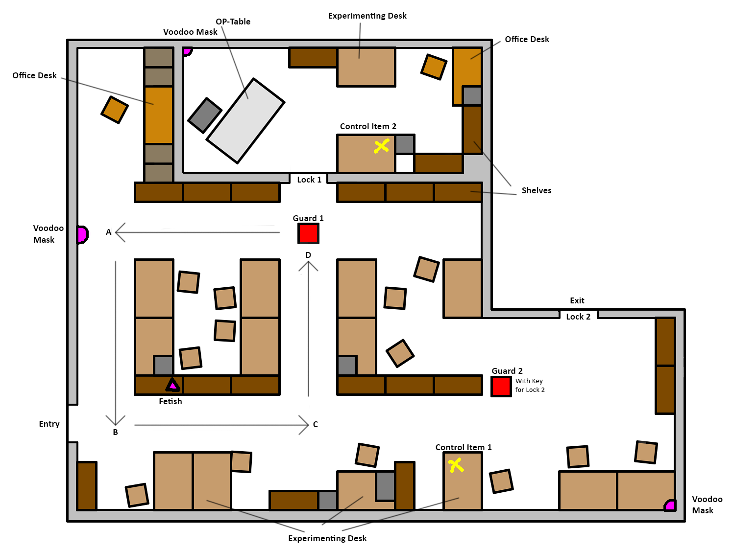

Figure 6 – Level 2 Layout

### Player Paths

The yellow cross represents the position of the control item.  
The pink triangle represents the position of the fetish.

| Player Path | Comment |
| --- | --- |
|  | **Way to fetish**  Red path   * Shorter * PC might be seen by the guard, as the guard walks towards the PC   Blue path   * Longer * Safer, as the guard walks away from the PC |
|  | **Way to the first control item**  Red path   * Easier to overcome * PC might be seen by the guard   Blue path   * Harder to overcome * PC is safe from the guard |
|  | **Way back to the fetish**  Green path   * Way straight back to the fetish |
|  | **Possessing the first guard**  Red path   * Way straight to the second door * Will result in the end of possession   Blue path   * Way straight to the first door to open it |
|  | **Way to the second control item**  Green path   * Way straight to the control item |
|  | **Way back to Fetish**  Green path   * Way straight back to the fetish |
|  | **Possessing the second guard**  Green path   * Way straight to the second door to open it |
|  | **Way out of the room**  Red path   * Might cross ways with the guard   Blue path   * Might cross ways with the guard |

# Glossary

## Index

|  |  |
| --- | --- |
| **BG-Info** | Background information |
| **CH** | Could-Have – describes a feature or component that could be added to the game. |
| **Control Item** | An item that is required for possessing a guard |
| **Fetish** | From [***https://en.wikipedia.org/wiki/Fetishism***](https://en.wikipedia.org/wiki/Fetishism):  “*A fetish […] is an object believed to have supernatural powers, or in particular, a human-made object that has power over others.*” |
| **Loa** | From [***https://en.wikipedia.org/wiki/Loa***](https://en.wikipedia.org/wiki/Loa):  “*Loa (also spelled lwa) are the spirits of Haitian Vodou and Louisiana Voodoo. They are also referred to as "mystères" and "the invisibles" and are intermediaries between Bondye […] and humanity.”* |
| **MH** | Must-Have – describes a feature or component which is necessary for the game to function. The lack of a must-have is game breaking. |
| **NTH** | Nice-To-Have – describes a feature or component which would improve the game quality- or fun-wise. |
| **PC** | Player Character |
| **QTE** | Quick-Time-Event |
| **SH** | Should-Have – describes a feature or component which is necessary for the game to be complete. The lack of a should-have is finance breaking. |
| **Veve** | From [***https://en.wikipedia.org/wiki/Veve***](https://en.wikipedia.org/wiki/Veve):  “*A veve (also spelled vèvè or vevè) is a religious symbol commonly used in different branches of voodoo throughout the African diaspora such as Haitian voodoo. [..] The veve acts as a "beacon" for the Loa, and will serve as a loa's representation during rituals.”* |

## List of Figures

Figure 1 – Jumping on high edges 7

Figure 2 – possession QTE reference 13

Figure 3 – Level Overview 20

Figure 4 – Level 0 layout 21

Figure 5 – Level 1 layout 22

Figure 6 – Level 2 Layout 24