**Voodoo**

Gate 1

**G**ame **D**esign **D**ocument

# Contents

Contents 2

Change Log 4

Vision Statement 5

Story & Setting 5

Brief Story Description 5

Setting 5

Background Information 5

Gameplay 6

Core Game Loop 6

Detailed Gameplay Mechanics 7

Characters 7

Spirit-Energy (Resource) 9

Fetishes 10

Voodoopowers 11

Could-Haves & Ideas 15

Controls 16

Characters 16

Voodoodoll 16

Voodoopowers 16

Clairvoyance 16

Possession 16

HUDs/Menus 17

Menus 17

UI 17

Scaling and Proportions 17

Camera 17

Screens 17

Level Design 18

Level 0 – Awakening 18

Level 1 – The Bureau 18

Layout 18

Player Paths 19

Level 2 – The Laboratory 20

Assets Needed 21

Level 1 21

Glossary 22

Index 22

List of Figures 22

# Change Log

|  |  |  |
| --- | --- | --- |
| Date | Changed by | Change |
| 10.04.2018 | Tobias Schuster | Initial creation |
| 18.04.2018 | Tobias Schuster | Restructured document (asset list and vision document outsourced into separate documents) |
| 23.04.2018 | Tobias Schuster | Mechanics elaborated (Spirit energy) |
| 30.04.2018 | Tobias Schuster | Mechanics elaborated (Voodoopowers) |
| 08.05.2018 | Tobias Schuster | Mechanics elaborated (Characters) |
| 09.05.2018 | Tobias Schuster | Mechanics elaborated (Characters)  HUDs/Menus elaborated |
| 11.05.2018 | Tobias Schuster | Signs & Feedback updated  Edge Cases updated  Level Design updated |

# Vision Statement

“Voodoo is a 3D platformer for lovers of the occult with minimized stealth-elements.  
The player discovers his surroundings from the perspective of a small puppet, finds different items to ossesses his voodoo-powers and ossesses guards to ultimately flee from the underground bunker.  
The low camera perspective and dark atmosphere in the beginning make the player feel vulnerable but the interesting mechanics and fun elements within the game lighten up the mood.”

# Story & Setting

For a detailed story see [***Voodoo_StoryDocument.docx***](Voodoo_StoryDocument.docx).

## Brief Story Description

One day the voodoo doll Nox awakes in a dark storage room full of dismembered voodoo dolls and other terrifying things. He does not know how or why he got there but he knows he must get out of there. A small flower outside a window raises his hopes that there is freedom somewhere.

He searches for a way and has to sneak through the rooms of an underground facility. Using his voodoo-powers he is able to control the guards and open doors. He will eventually get free.

## Setting

* **Era**: 1950s
* **Duration**: One evening
* **Location**: Underground facility/Basement in New Orleans (Louisiana)
* **Conflict**: Freedom

## Background Information

Background is the Voodoo religion of Haiti and in particular Louisiana.

The different loa (spirits) and their respective areas of authority in the religion are inspiration for the mechanics.

In voodoo one must first offer or sacrifice something (specific to each loa) in order to gain what the respective loa has power over (e.g. counsel, wealth, health).

# Gameplay

## Core Game Loop

**Orientation** includes:

* Entering a new room
* Get a first impression of where your objectives are located

**Clairvoyance** can be used anytime but will most likely be used after entering each room.

**Offering** includes:

* Getting to the Fetish
* Getting to the control-object, using one of two alternatives
* Bring the control-object back to the fetish and offer it in exchange for possession powers

**Possession** includes:

* Doing a Quick-Time-Event for achieving control over the guard
* Opening the door to the next room, as the guard
* Exiting the room through the door, as the doll

**Incineration** (Nice-To-Have Feature) includes:

* Alternative to possession mechanic
* Setting a focus on the guard (mechanic parallel to possession)
* Transferring self-inflicted damage to the guard

## Detailed Gameplay Mechanics

### Characters

#### Nox

* Nox is a voodoo doll and the player character
* He is **40cm** tall

##### Standard Interactions

|  |  |  |
| --- | --- | --- |
| Feature | Description | Priority |
| Movement | Basic Movement | MH |
| Jumping | Low jump (10cm) | MH |
| Climbing | Pulling itself up on ledges | SH |
| Pushing/Pulling | Push or pull small objects (drawers, chairs, etc.) | SH |

**Movement**

* Nox is able to move in all directions
* His movement speed is **15cm/s**

**Jumping**

* Nox is able to jump
* The max jump height is at **10cm**
* The max jump width should be around **45cm**

**Climbing**

* Nox climbs edges after jumping
* If Nox jumps to edge he will automatically pull himself up
* Edges can have a max height of **45cm**

**Pushing/Pulling**

* Nox is able to push (e.g. books) or pull objects (e.g. drawers)
* Nox has to stand in a certain range in front of the object to be able to pull
* Objects that can be pulled are highlighted and have some kind of handle
* Drawers will open automatically when pulled and don’t have to be pulled manually

##### Signs & Feedback

* All interactions will be presented by animations
* Pushable or pullable objects will be highlighted with a slight glow

#### Guard

* The guard can be controlled by the player through possession
* He is 170cm tall
* The guard is either still standing or patrolling
* When standing still the guard looks around
  + Nox will be spotted, when he is in the field of view
    - After Nox is spotted, he will lose spirit energy
    - The guard picks him up (NTH)
  + The guard looks alternately into specific directions

##### Possession Interactions

|  |  |  |
| --- | --- | --- |
| Feature | Description | Priority |
| Movement | Basic Movement | MH |
| Open Door | Open doors by using the handle or pushing buttons | MH |
| Carry Doll | Grabbing the doll and put it down | CH |
| Pushing | Push larger objects out of the way | NTH |

**Movement**

* The guard is able to move in all directions
* His movement speed is **35cm/s**

**Open Door**

* The guard is able to open doors by using the handle

**Carry Doll (NTH)**

* The guard is able to grab the doll from different heights, these are:
  + Floor level (0cm)
  + Desk level (76cm)
  + Shelf level (160cm)
* The guard is able to put the doll down on different heights, these are:
  + Floor level (0cm)
  + Desk level (76cm)
  + Shelf level (160cm)

**Pushing**

* The guard is able to push large objects out of the way (e.g. shelves)
* He has to stand in a certain range of that object to be able to push it

##### Signs & Feedback

* When the guard turns around the lights will flicker as an indicator for the player
* When the player is in the guards field of view, the guard will give a short exclamation like ‘Huh?’/’What’s this?’ and the gamepad will vibrate slightly

### Spirit-Energy (Resource)

#### Goal/Purpose

* The player will feel pressured by the energy that is constantly running out
* Possibility for rewarding high risks with additional energy

#### Description

* Spirit-Energy represents the “life” of the voodoo doll
* When it runs out the game is over
* Nox is steadily losing energy
* Beeing seen by a guard accelerates the rate of energy loss
* Nox can collect items to regain spirit energy / Nox regains spirit energy when he is in range of the fetish / Nox regains spirit energy while using clairvoyance
* (Using Clairvoyance accelerates the rate of energy loss)

#### Signs & Feedback

* The level of energy will be represented by an energy-bar on the screen
* If the energy is about to run out there will be a screen effect, similar to first-person shooters
* If energy is refreshed there will be a small particle effect on the energy bar

#### Edge Cases

TBD

### Fetishes

#### Totem-Fetish (Idol)

* Unlocks voodoopowers or enables the player to use a voodoopower
* Always needs an item in return (control-object, eye)
* At least one is placed per level

Three types, distinguished by the veve (symbol) and the colour of the respective loa spirit

**Ghede Doubye** – Clairvoyance:

* Is said to gift people with clairvoyance
* Enables the player to use clairvoyance in return of an eye
* Represented by the color green and an eye

**Damballah** – Possession:

* Creator of life; ruler of mind, intellect and cosmic equilibrium
* Enables the player to possess a specific human
* Expects a personal object or part of that human in return (Offering)
* Represented by color white and snakes
* Makes hissing sounds when speaking and is hard to understand

**Kalfu** – Incineration (*Nice-To-Have*):

* Controls evil forces and allows the crossing of bad luck, deliberate destruction, misfortune and injustice from the spirit world
* Enables the player to transfer damage to a specific human
* Expects a part of that human in return (control object)
* Represented by color red and the moon

#### Fetish-Mask

* At least one is placed per level
* Can be used by the player to get an overview of the level and identify where objectives are located (Claivoyance)
* It is possible to switch between the masks in a certain level

### Voodoopowers

#### Clairvoyance

##### Goal/Purpose

* The player needs to know where the objectives are located and how to get there

##### Description

* Can be activated anytime
* The player takes the perspective of a voodoo mask on the wall
  + He can look around to observe the room
    - The view rotation will be limited by a horizontal and a vertical angle that can be adjusted later
    - Default angles will be **160**° horizontally and **50**° vertically
  + Apart from that he cannot move
* The player does not control the voodoo doll while in clairvoyance
* The objectives (fetishes and control objects) will be visually highlighted
* There will be at least one mask per level

##### Signs & Feedback

* When the player sees through the mask, the camera will have a slight fisheye lens effect
* The screen will also have a foggy green effect on the borders
* There **could** be acoustic feedback like a faint mumbling

##### Edge Cases

1. Problem: The player cannot get a good overview of the level with only one mask.  
   Solution: If necessary there will be more than one mask in a level, allowing the player to switch between perspectives and getting a better overall overview.

#### Offering

##### Goal/Purpose

* This is to allow the player to possess a guard in the first place (as voodoo is all about offering/sacrificing)
* The control object is the main objective in each level and the way to get there is the main challenge

##### Description

* There will be two instances of the player interacting with the offering fetish:
  + The fetish declares what it expects in return either by a speak bubble or a sign
  + The voodoo doll offers the expected object to the fetish

##### Signs & Feedback

* When the player is in interaction range of the fetish, it will glow in its respective loa color
* After giving the offering to the fetish, the player will hear a confirmation sound from it
  + Incineration fetishes respond with the sound of an igniting flame
  + Possession fetishes respond with the sound of drums
* After offering to a possession fetish, the player will immediately switch to possession mode

##### Edge Cases

TBD

#### Possession

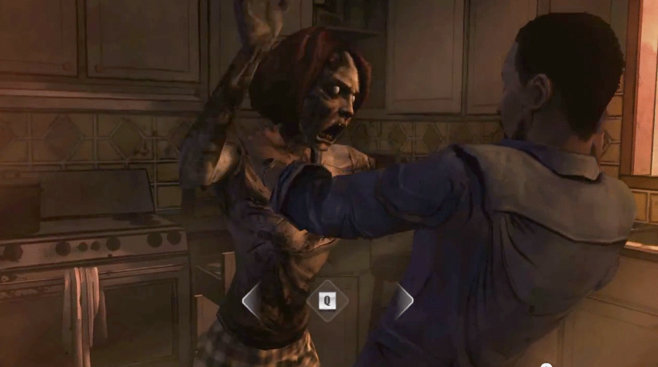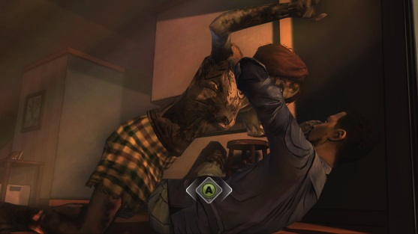

Figure 1 – possession qte reference

##### Goal

* The general goal is to get control of the guard
* When achieving possession, it must convey the feeling of breaking through a barrier

##### Description

* Achieving possession will be represented by a quick time event (see figures)
  + The player has to press a button repeatedly to fill a bar (or to reduce the gap between the two indicators as shown in the figures)
  + After the bar is filled, possession is achieved
  + This will increase in difficulty with each level
* Ends automatically after the door has been opened
* The guard walks back to his default position after possession has ended

##### Signs & Feedback

* During the achieving-possession-phase the guard will give visual feedback by holding his head in agony and acoustic feedback by groaning
* After the possession has ended, the guard gives an acoustic feedback by a confused statement (e.g. ‘Huh?’/’What happened?’)
* While the possession bas fills, the gamepad will vibrate increasingly

##### Edge Cases

* TBD

#### Incineration (Nice-To-Have)

##### Goal/Purpose

* This is an alternative to the possession mechanic
* Instead of controlling the guard, the player needs to hurt or even kill the guard to clear the way

##### Description

* Just as the possession mechanic, the player needs an offering first
* Then the player can focus the guard he wants to hurt
* After this, the player needs to find a way to inflict damage to himself which will then be transferred to the focused guard instead
  + This can be achieved by crushing or burning the doll, or hurting himself with needles
* The guard will flee his default position or become unconscious
  + If the guard runs out of the room, the door would be open for the player

##### Signs & Feedback

* The focused guard will be visually highlighted with a slight glow on his outlines
* If the guard is hurt, he will react accordingly by screaming and running out of the door

##### Edge Cases

TBD

## Could-Haves & Ideas

* Collectibles (to refill the spirit energy)
* (collectable) Skins
* Instead of making the game on big challenge, remove the spirit-energy and make it focused on story and exploration 🡪 with hidden story elements (newspaper) or collectibles

# Controls

The game will only support gamepad controls. Keyboard and mouse will not be included.

## Characters

### Voodoodoll

|  |  |
| --- | --- |
| Action | Control |
| Movement | Left Stick |
| Camera | Right Stick |
| Jump | [A] |
| Push/Pull | [B] + Left Stick |
| Interact with Fetish | [X] |
| Activate Clairvoyance | [Y] |

## Voodoopowers

### Clairvoyance

|  |  |
| --- | --- |
| Action | Control |
| Look around | Right Stick |
| End Clairvoyance | [B] |
| Switch Mask clockwise | [X] |
| Switch Mask counter-clockwise | [Y] |

### Possession

|  |  |
| --- | --- |
| Action | Control |
| Movement | Left Stick |
| Camera | Right Stick |
| Open Door | [A] |
| Push/Pull | [B] + Left Stick |
| End Possession | [Y] |

# HUDs/Menus

## Menus

* Main Menu
* Settings

## UI

* Spirit-Energy Bar

## Scaling and Proportions

Every asset and character will be measured in centimetres (cm). Everything has a height, a width and depth.

For the specific measurements of each asset go to **Assets Needed**.

## Camera

The camera is placed behind the character (Third-Person perspective).

## Screens

1. Voodoo doll perspective
2. Mask perspective
3. Possession perspective
4. Guard perspective

# Level Design

## Level 0 – Awakening

Level 0 is the tutorial level. The voodoo doll awakes and has to orient itself in the new environment.

Used mechanics:

* **Orientation**
* **Clairvoyance**

## Level 1 – The Bureau

The bureau is the first level and full with desks, shelves and filing cabinets.

The room is divided into separate departments.

Used mechanics:

* Orientation
* Clairvoyance
* **Offering**
* **Possession**

### Layout

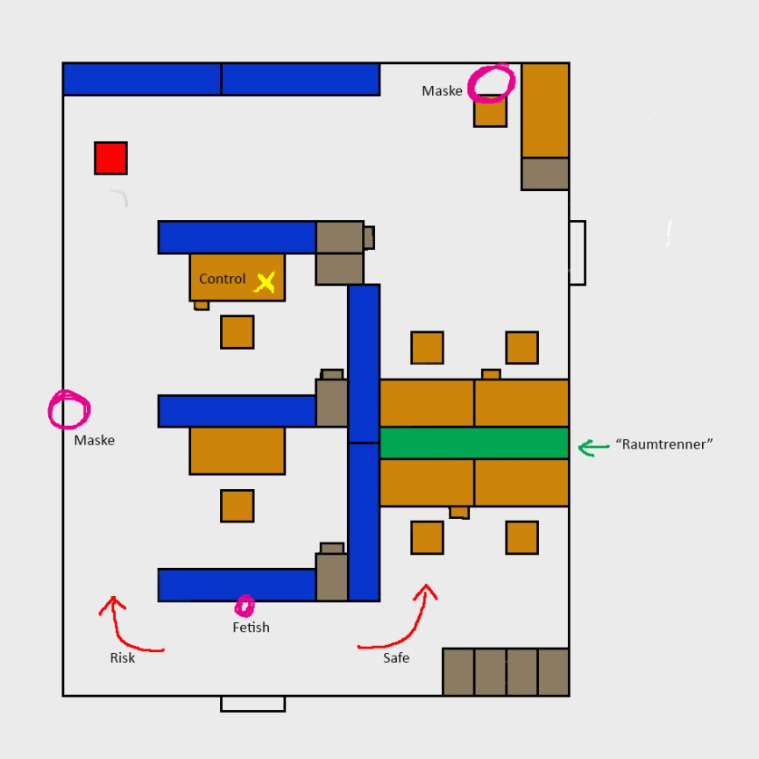

Figure 2 – Level 1 layout

### Player Paths

The yellow cross represents the position of the control object.  
The red dot represents the position of the fetish.

|  |  |  |
| --- | --- | --- |
| **Control object paths** | **Fetish and possession path** | **Exit path** |
|  |  |  |
| There are two diferrent paths:   * The first one, around the left, is very risky, due to the player being exposed to the guard. Therefor it is a much shorter way * The second one, around the right, takes more time but has a low risk, because the player will not be seen by the guard | The player can use a shortcut (pink path) to get back to the fetish more quickly. Alternatively the player could take the risky path from before  When the player has possession over the guard he can walk straight to the door and open it. | After the door has been opened, the player needs to take the path around the left again to get to the door. |

## Level 2 – The Laboratory

The laboratory is the second level. This room is used for experimenting and researching.

Used mechanics:

* Orientation
* Clairvoyance
* Offering
* Possession

# Assets Needed

See [***AssetListe.xlsx***](../../_Artbible/Assetliste.xlsx) for a complete list of assets with measurements and other specifications.

Below is a list of the most important assets for each specific level:

## Level 1

* **Shelf** (*200cm* height, *200cm* width, *40cm* depth)
* **Desk**
  + *With* pull-able drawers (highlighted)
  + *With* door
* **Office Chair**
* **File Cabinet**
  + *With* pull-able drawers (highlighted)
  + *Without* pull-able drawers (not highlighted)
* **Room Divider** (maybe another shelf? Min *115cm* height, *240cm* width, *40cm* depth)
  + If higher than 115cm, there must be some kind of opening or hole with a bottom height of 115cm where the player can walk through
* **Fetish** (highlighted)
* **Desk Lamp**
* Other (typewriter, books, files, etc…)

# Glossary

## Index

|  |  |
| --- | --- |
| **CH** | Could-Have – describes a feature or component that could be added to the game. |
| **Fetish** | From [***https://en.wikipedia.org/wiki/Fetishism***](https://en.wikipedia.org/wiki/Fetishism):  “*A fetish […] is an object believed to have supernatural powers, or in particular, a human-made object that has power over others.*” |
| **Loa** | From [***https://en.wikipedia.org/wiki/Loa***](https://en.wikipedia.org/wiki/Loa):  “*Loa (also spelled lwa) are the spirits of Haitian Vodou and Louisiana Voodoo. They are also referred to as "mystères" and "the invisibles" and are intermediaries between Bondye […] and humanity.”* |
| **MH** | Must-Have – describes a feature or component which is necessary for the game to function. The lack of a must-have is game breaking. |
| **NTH** | Nice-To-Have – describes a feature or component which would improve the game quality- or fun-wise. |
| **SH** | Should-Have – describes a feature or component which is necessary for the game to be complete. The lack of a should-have is finance breaking. |
| **Veve** | From [***https://en.wikipedia.org/wiki/Veve***](https://en.wikipedia.org/wiki/Veve):  “*A veve (also spelled vèvè or vevè) is a religious symbol commonly used in different branches of voodoo throughout the African diaspora such as Haitian voodoo. [..] The veve acts as a "beacon" for the Loa, and will serve as a loa's representation during rituals.”* |

## List of Figures

Figure 1 – possession qte reference 13

Figure 2 – Level 1 layout 18