**Voodoo**

Gate 1

**G**ame **D**esign **D**ocument

# Contents

Contents 2

Change Log 4

Vision Statement 5

Story & Setting 5

Brief Story Description 5

Setting 5

Background Information 5

Gameplay 6

Core Game Loop 6

Detailed Gameplay Mechanics 7

Characters 7

Spirit-Energy (Resource) 9

Fetishes 10

Voodoo-powers 11

Controls 15

Characters 15

Voodoodoll 15

Voodoopowers 15

Clairvoyance 15

Possession 15

HUDs/Menus 16

Menus 16

UI 16

Scaling and Proportions 16

Camera 16

Screens/Perspectives 16

Level Design 17

Level 0 – Awakening 17

Level 1 – The Bureau 17

Layout 17

Player Paths 18

Level 2 – The Laboratory 19

Assets Needed 20

Level 1 20

Glossary 21

Index 21

List of Figures 21

# Change Log

|  |  |  |
| --- | --- | --- |
| Date | Changed by | Change |
| 10.04.2018 | Tobias Schuster | Initial creation |
| 18.04.2018 | Tobias Schuster | Restructured document (asset list and vision document outsourced into separate documents) |
| 23.04.2018 | Tobias Schuster | Mechanics elaborated (Spirit energy) |
| 30.04.2018 | Tobias Schuster | Mechanics elaborated (Voodoopowers) |
| 08.05.2018 | Tobias Schuster | Mechanics elaborated (Characters) |
| 09.05.2018 | Tobias Schuster | Mechanics elaborated (Characters)  HUDs/Menus elaborated |
| 11.05.2018 | Tobias Schuster | Signs & Feedback updated  Edge Cases updated  Level Design updated |
| 22.05.2018 | Tobias Schuster | Review and slight corrections |

# Vision Statement

“Voodoo is a 3D platformer for lovers of the occult with minimized stealth-elements.  
The player discovers his surroundings from the perspective of a small doll, finds different items to strengthen his voodoo-powers and possesses guards to ultimately flee from the underground bunker.  
The low camera perspective and dark atmosphere in the beginning make the player feel vulnerable but the interesting mechanics and fun elements within the game lighten up the mood.”

# Story & Setting

For a detailed story see ***Voodoo_StoryDocument.docx***.

## Brief Story Description

One day a small voodoo doll awakes in a dark storage room full of dismembered voodoo dolls and other terrifying things. It does not know how or why it got there, but it knows it must get out. A small flower outside a window raises its hopes that there is freedom somewhere.

It searches for a way and has to sneak through the rooms of an underground facility. Using its voodoo-powers it is able to control the guards and open doors. It will eventually get free.

## Setting

* **Era**: 1950s
* **Duration**: One evening
* **Location**: Underground facility/basement in New Orleans (Louisiana)
* **Conflict**: Freedom

## Background Information

Background is the voodoo religion of Haiti and in particular Louisiana.

The different loa (spirits) and their respective areas of authority in the religion are references for the games mechanics.

In voodoo one must first offer or sacrifice something (specific to each loa) in order to gain what the respective loa has power over (e.g. counsel, wealth, health).

# Gameplay

## Core Game Loop

**Orientation** includes:

* Entering a new room
* Getting a first impression of where your objectives (fetish, control object) are located

**Clairvoyance** can be used anytime but will most likely be used after entering each room.

* Switching into a voodoo mask and getting an overview of the level

**Offering** includes:

* Getting to the fetish
* Getting to the control-object, using one of two (or more) alternative routes
* Bringing the control-object back to the fetish and offer it in exchange for possession powers

**Possession** includes:

* Doing a quick-time-event for achieving control over the guard
* Opening the door to the next room, as the guard
* Pushing objects (like shelves) around to create new ways for the doll to move
* Exiting the room through the door, as the doll

***Incineration*** *(Nice-To-Have feature) includes:*

* *Alternative to possession mechanic*
* *Setting a focus to the guard (mechanic parallel to possession)*
* *Transferring self-inflicted damage to the guard (automatically)*

## Detailed Gameplay Mechanics

### Characters

#### Voodoo Doll

* The voodoo doll is the player character
* He is **40cm** tall

##### Standard Interactions

|  |  |  |
| --- | --- | --- |
| Feature | Description | Priority |
| Movement | Basic movement | MH |
| Jumping | Low jump | MH |
| Climbing | Pulling itself up on ledges | SH |
| Pushing | Push or pull small objects | SH |
| Open drawers | Open drawers of desks or filing cabinets | SH |

**Movement**

* The voodoo doll is able to move in all directions
* Its movement speed is **15cm/s**

**Jumping**

* The voodoo doll is able to jump
* The max jump height is at **10cm**
* The max jump width should be around **45cm**

**Climbing**

* The voodoo doll climbs edges after jumping
* If the voodoo doll jumps to an edge, it will automatically pull itself up
* Edges can have a max height of **45cm**

**Pushing**

* The voodoo doll is able to push (e.g. books) or pull objects
* The voodoo doll has to stand in a certain range (**5cm**) in front of the object to be able to pull
* Objects that can be pushed/pulled are highlighted (see *‘Signs & Feedback’*)

**Open Drawers**

* The voodoo doll can open drawers of desks or filing cabinets
* If the voodoo doll is near a drawer (**5cm** range) the drawer in front of him will open on button press

**Signs & Feedback**

* All interactions will be presented by animations
* Push-able or pull-able objects will be highlighted by a slight glow on the edge

#### Guard

##### Standard behaviour

* He is **170cm** tall
* The guard is either still standing or patrolling
  + He moves with a speed of **35cm/s** when patrolling
* When standing still the guard looks around
  + The player character will be spotted, when it is in the guard’s field of view
    - After the player is spotted, he will lose spirit energy
    - *The guard picks him up (NTH)*
  + The guard looks alternately into specific directions

##### Possession Interactions

The guard can be controlled by the player through possession.

|  |  |  |
| --- | --- | --- |
| Feature | Description | Priority |
| Movement | Basic movement | MH |
| Open Door | Open doors by using the handle or pushing buttons | MH |
| Carry Doll | Grabbing the doll and put it down | CH |
| Pushing | Push large objects out of the way | NTH |

**Movement**

* The guard is able to move in all directions
* His movement speed is **35cm/s**

**Open Door**

* The guard is able to open doors by using the handle

***Carry Doll (NTH)***

* *The guard is able to grab the doll from different heights, these are:*
  + *Floor level (0cm – 20cm)*
  + *Desk level (70cm – 90cm)*
  + *Shelf level (140cm – 160cm)*
* *The guard is able to put the doll down on different heights, these are:*
  + *Floor level (0cm – 20cm)*
  + *Desk level (70cm – 90cm)*
  + *Shelf level (140cm – 160cm)*

**Pushing**

* The guard is able to push large objects out of the way (e.g. shelves)
* He has to stand in a certain range (**20cm**) of that object to be able to push it

##### Signs & Feedback

* When the guard turns around the lights will flicker as an indicator for the player
* When the player is in the guard’s field of view, the guard will give a short exclamation like ‘Huh?’/’What’s this?’ and the gamepad will vibrate slightly

### Spirit-Energy (Resource)

#### Goal/Purpose

* The player will feel pressured by the energy that is constantly running out
* Possibility for rewarding high risks with additional energy and punishing mistakes or bad decisions with the loss of energy

#### Description

* Spirit-Energy represents the “life” of the voodoo doll
* When it runs out the game is over
* The voodoo doll is steadily losing energy
* Being seen by a guard accelerates the rate of energy loss
* The voodoo doll regains spirit energy when it is in range of the fetish
* Using Clairvoyance accelerates the rate of energy loss

#### Signs & Feedback

* The level of energy will be represented by an energy-bar on the screen
* If the energy is about to run out there will be a screen effect, similar to first-person shooters when the player is hit
* If energy is refreshed there will be a small particle effect on the energy bar

#### Edge Cases

N/A

### Fetishes

#### Totem-Fetish

* Unlocks voodoo-powers or enables the player to use a voodoo-power
* Always needs an item (control-object, eye) in return (*OFFERING*)
* At least one is placed per level
* The player needs to be in range (**10cm**) to be able to interact with the fetish

Three types, distinguished by the veve (symbol) and the colour of the respective loa spirit

**Ghede Doubye** – Clairvoyance:

* **[BG-Info]** Is said to gift people with clairvoyance
* Enables the player to use clairvoyance in return of an eye
* Represented by the colour green and an eye

**Damballah** – Possession:

* **[BG-Info]** Creator of life; ruler of mind, intellect and cosmic equilibrium
* **[BG-Info]** Makes hissing sounds when speaking and is hard to understand
* Enables the player to possess a specific human (guard)
* Expects a personal object or part of that human in return (*OFFERING*)
* Represented by the colour white and snakes

***Kalfu*** *– Incineration (NTH):*

* ***[BG-Info]*** *Controls evil forces and allows the crossing of bad luck, deliberate destruction, misfortune and injustice from the spirit world*
* *Enables the player to transfer damage to a specific human*
* *Expects a personal object or part of that human in return (OFFERING)*
* *Represented by the colour red and the moon*

#### Fetish-Mask

* At least one is placed per level
* Can be used by the player to get an overview of the level and identify where objectives are located (*CLAIRVOYANCE*)
* It is possible to switch between the masks in a certain level, if more than one is present

### Voodoo-powers

#### Clairvoyance

##### Goal/Purpose

* The player needs to know where the objectives are located and how to get there

##### Description

* Can be activated anytime
* There will be at least one mask per level
* It is possible to switch between the masks in a certain level, if more than one is present
* The player takes the perspective of a voodoo mask on the wall
  + He can look around to observe the room
    - The view rotation will be limited by a horizontal and a vertical angle that can be adjusted later
    - Default angles will be **160**° horizontally and **50**° vertically
  + Apart from that the mask cannot be moved
* The player does not control the voodoo doll while in clairvoyance
* The objectives (fetishes and control objects) will be visually highlighted (see *‘Signs & Feedback’*)

##### Signs & Feedback

* When the player sees through the mask, the camera will have a slight fisheye lens effect
* The screen will also have a foggy green effect on the borders
* There **could** be acoustic feedback like a faint mumbling
* If switching between masks is possible, there will be small arrow icons at the bottom of the screen

##### Edge Cases

1. Problem: The player cannot get a good overview of the level with only one mask.  
   Solution: If necessary there will be more than one mask in a level, allowing the player to switch between perspectives and getting a better overall overview.

#### Offering

##### Goal/Purpose

* This enables the player to possess a guard in the first place (since voodoo is all about offering/sacrifice)
* The control object is the main objective in each level and the way to get there is the main challenge

##### Description

* There will be two instances of the player interacting with the fetish:
  + The fetish declares what it expects in return (see *‘Signs & Feedback’*)
  + The player offers the expected object to the fetish
    - The player needs to be in interaction range (see *Totem-Fetish*) to interact with the fetish

##### Signs & Feedback

* The offering that the fetish expects will be depicted by a speaking bubble or a signpost
* When the player is in interaction range of the fetish, it will glow in its respective loa colour
* After giving the offering to the fetish, the player will hear a confirmation sound from it
  + Incineration fetishes respond with the sound of an igniting flame
  + Possession fetishes respond with the sound of drums
  + Clairvoyance fetishes respond with the sound of splashing water
* After offering to a possession fetish, the player will immediately switch to possession mode

##### Edge Cases

N/A

#### Possession

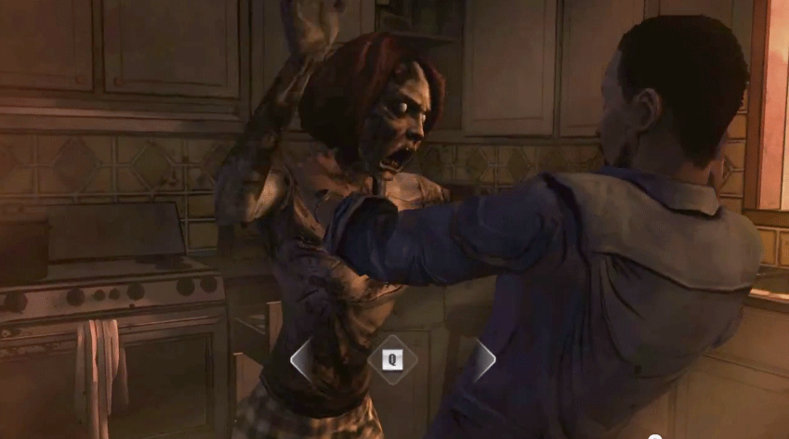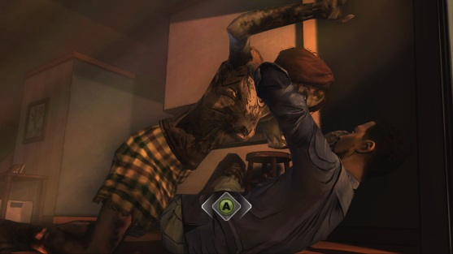

Figure 1 – possession QTE reference

##### Goal

* The general goal is to get control of the guard
* While achieving possession, it must convey the feeling of breaking through a barrier (the player is breaking through the “mental barrier” of the guard)

##### Description

* The player will see the guard and not the player character while achieving possession
* Achieving possession will be represented by a quick-time-event (see *Figure 1*)
  + The player has to press a button repeatedly to fill a bar (or to reduce the gap between the two indicators as shown in the figures)
  + After the bar is filled, possession is achieved
  + This will increase in difficulty with each level
* Ends automatically after the door has been opened
* The guard walks back to his default position after possession has ended
* While the player controls the guard, the voodoo doll stands still and cannot be interacted with
  + *The player is able to pick up the voodoo doll and place him somewhere else (NTH)*
  + For all interactions while possessing the guard see ‘*Guard - Possession Interactions*’

##### Signs & Feedback

* During the achieving-possession-phase the guard will give visual feedback by holding his head in agony and acoustic feedback by groaning
* After the possession has ended, the guard gives an acoustic feedback by a confused statement (e.g. ‘Huh?’/’What happened?’)
* While the possession bar fills, the gamepad will vibrate increasingly

##### Edge Cases

N/A

#### Incineration (Nice-To-Have)

##### *Goal/Purpose*

* *This is an alternative to the possession mechanic*
* *Instead of controlling the guard, the player needs to hurt or even kill the guard to clear the way*

##### *Description*

* *Just as the possession mechanic, the player needs an offering first*
* *Then the player can focus the guard he wants to transfer his damage to*
* *After this, the player needs to find a way to inflict damage to itself which will then be transferred to the focused guard instead*
  + *This can be achieved by crushing or burning the doll, or hurting itself with needles/knifes*
* *The guard will flee his default position or become unconscious*
  + *If the guard runs out of the room, the door will be left open for the player*

##### *Signs & Feedback*

* *The focused guard will be visually highlighted with a slight glow on his outlines*
* *If the guard is hurt, he will react accordingly by screaming and running out of the door*

##### *Edge Cases*

*N/A*

# Controls

The game will only support gamepad controls. Keyboard and mouse will not be included.

## Characters

### Voodoodoll

|  |  |
| --- | --- |
| Action | Control |
| Movement | Left Stick |
| Camera | Right Stick |
| Jump | [A] |
| Push/Pull | [B] + Left Stick |
| Interact with Fetish | [X] |
| Activate Clairvoyance | [Y] |

## Voodoopowers

### Clairvoyance

|  |  |
| --- | --- |
| Action | Control |
| Look around | Right Stick |
| End Clairvoyance | [B] |
| Switch Mask clockwise | [X] |
| Switch Mask counter-clockwise | [Y] |

### Possession

|  |  |
| --- | --- |
| Action | Control |
| Movement | Left Stick |
| Camera | Right Stick |
| Open Door | [A] |
| Push/Pull | [B] + Left Stick |
| End Possession | [Y] |

# HUDs/Menus

## Menus

* Main menu
* Settings

## UI

* Spirit-energy bar

## Scaling and Proportions

Every asset and character will be measured in centimetres (cm). Everything has a height, a width and depth.

For the specific measurements of each asset go to ‘*Assets Needed*’.

## Camera

The camera is in third-person perspective slightly from below.

## Screens/Perspectives

1. Voodoo doll perspective
2. Mask perspective
3. Possession perspective
4. Guard perspective

# Level Design

## Level 0 – Awakening

Level 0 is the tutorial level. The voodoo doll awakes and has to orient itself in the new environment. The player will learn the basic mechanics.

This is the only level in which the clairvoyance fetish will occur, since the player will offer an eye of the voodoo doll in return of the voodoo-power.

Used mechanics:

* **Orientation**
* **Clairvoyance**

## Level 1 – The Bureau

The bureau is the first level and full with desks, shelves and filing cabinets.

The room is divided into separate departments and offers different paths to get through it.  
The guard is stationary and will look around in a frequency of **5 seconds**.

Used mechanics:

* Orientation
* Clairvoyance
* **Offering**
* **Possession**

### Layout

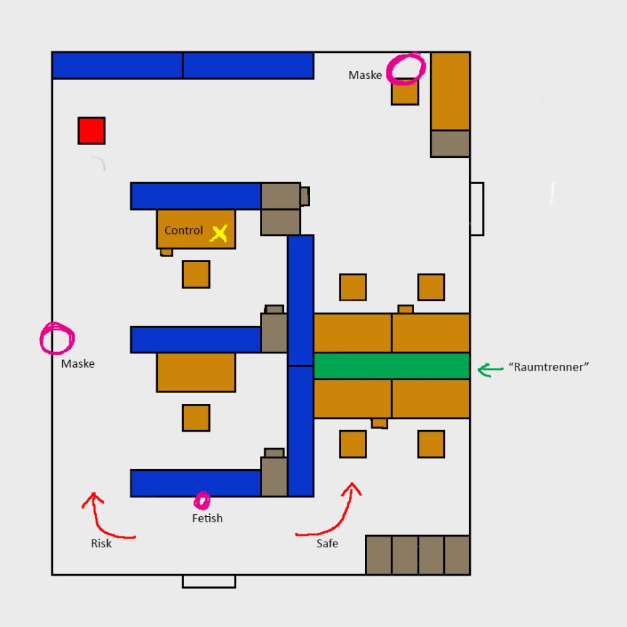

Figure 2 – Level 1 layout

### Player Paths

The yellow cross represents the position of the control object.  
The red dot represents the position of the fetish.

|  |  |  |
| --- | --- | --- |
| **Control object paths** | **Fetish and possession path** | **Exit path** |
|  |  |  |
| There are two diferrent paths:   * The first one, around the left, is very risky, due to the player being exposed to the guard. But it is a much shorter way and will safe the player valuable time * The second one, around the right, takes more time but has a low risk, because the player will not be seen by the guard. The player will have to do more climbing. | * The player can use a shortcut (pink) to get back to the fetish more quickly. Alternatively the player could take the risky path from before * When the player has possession over the guard he can walk straight to the door and open it (red). | * After the door has been opened, the player needs to take the path around the left again to get to the door. |

## Level 2 – The Laboratory

The laboratory is the second level. This room is used for experimenting and researching. Here the player will encounter the first patrolling guard.

Used mechanics:

* Orientation
* Clairvoyance
* Offering
* Possession

# Assets Needed

See ***AssetListe.xlsx*** for a complete list of assets with measurements and other specifications.

Below is a list of the must-have assets for each specific level:

## Level 1

* **Shelf** (*200cm* height, *200cm* width, *40cm* depth)
* **Desk**
  + *With* pull-able drawers (highlighted)
  + *With* door
* **Office Chair**
* **File Cabinet**
  + *With* pull-able drawers (highlighted)
  + *Without* pull-able drawers (not highlighted)
* **Room Divider** (min *115cm* height, *240cm* width, *40cm* depth)
  + If higher than 115cm, there must be some kind of opening or hole with a bottom height of 115cm where the player can jump/climb through
* **Fetish** (highlighted)
* **Desk Lamp**

# Glossary

## Index

|  |  |
| --- | --- |
| **BG-Info** | Background information |
| **CH** | Could-Have – describes a feature or component that could be added to the game. |
| **Fetish** | From [***https://en.wikipedia.org/wiki/Fetishism***](https://en.wikipedia.org/wiki/Fetishism):  “*A fetish […] is an object believed to have supernatural powers, or in particular, a human-made object that has power over others.*” |
| **Loa** | From [***https://en.wikipedia.org/wiki/Loa***](https://en.wikipedia.org/wiki/Loa):  “*Loa (also spelled lwa) are the spirits of Haitian Vodou and Louisiana Voodoo. They are also referred to as "mystères" and "the invisibles" and are intermediaries between Bondye […] and humanity.”* |
| **MH** | Must-Have – describes a feature or component which is necessary for the game to function. The lack of a must-have is game breaking. |
| **NTH** | Nice-To-Have – describes a feature or component which would improve the game quality- or fun-wise. |
| **SH** | Should-Have – describes a feature or component which is necessary for the game to be complete. The lack of a should-have is finance breaking. |
| **Veve** | From [***https://en.wikipedia.org/wiki/Veve***](https://en.wikipedia.org/wiki/Veve):  “*A veve (also spelled vèvè or vevè) is a religious symbol commonly used in different branches of voodoo throughout the African diaspora such as Haitian voodoo. [..] The veve acts as a "beacon" for the Loa, and will serve as a loa's representation during rituals.”* |

## List of Figures

Figure 1 – possession QTE reference 13

Figure 2 – Level 1 layout 17