ASSIGNED IP ADDRESS: 18.0.0.0 /8
FIRST USABLE HOST: 18.0.0.1
LAST USABLE HOST: 18.255.255.254
DEFAULT GATEWAY: 18.0.0.1
SERVER ADDRESS: 18.0.0.2
DNS: 18.0.0.2
SERVER IP: 18.0.0.2
CLIENT IP: DHCP LEASING
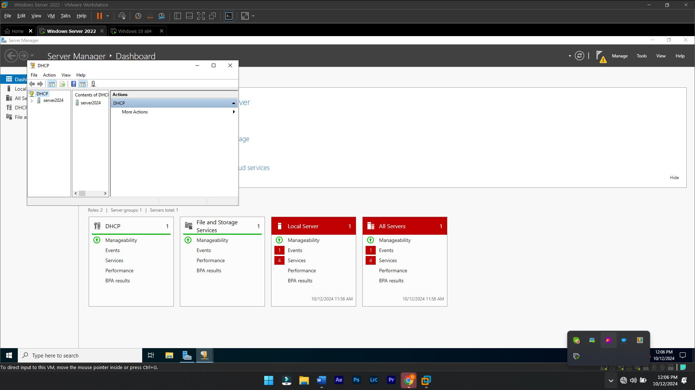
TOOLS > DHCP > ADD NEW SCOPE

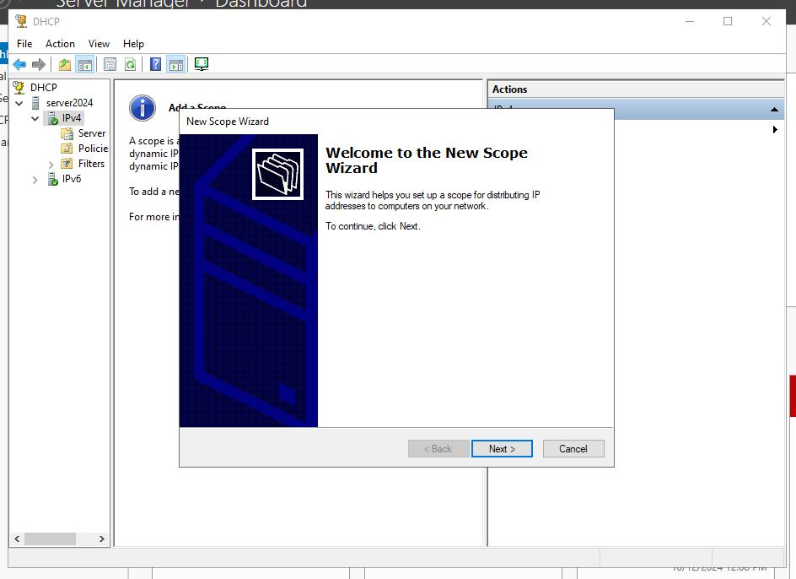

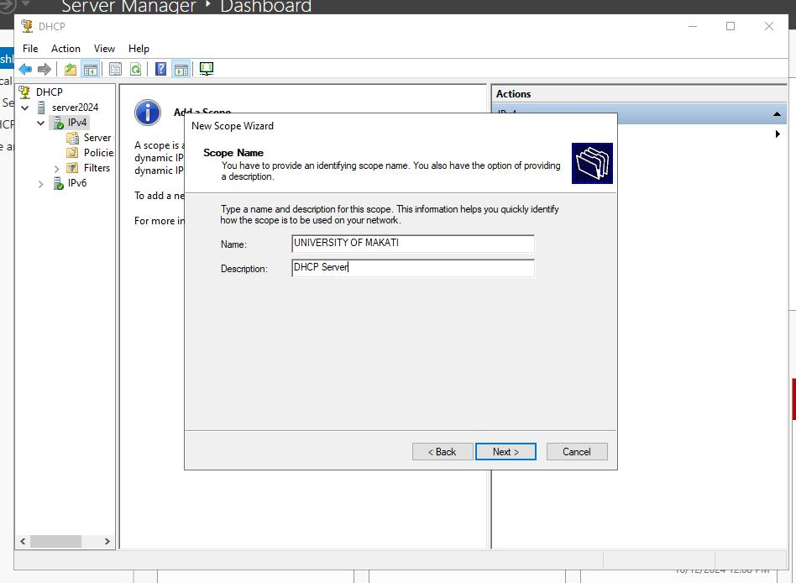
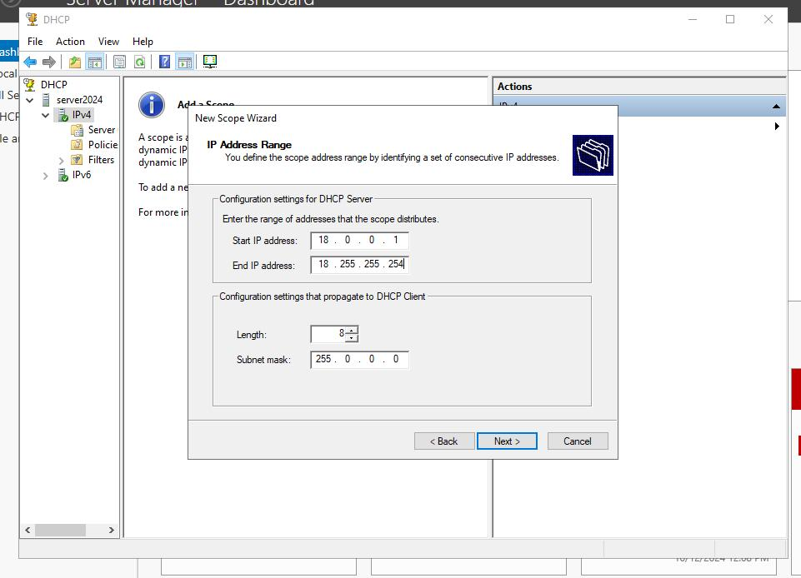
SCOPE NAME, DESCRIPTION, IP RANGE, EXCEPTION RANGE

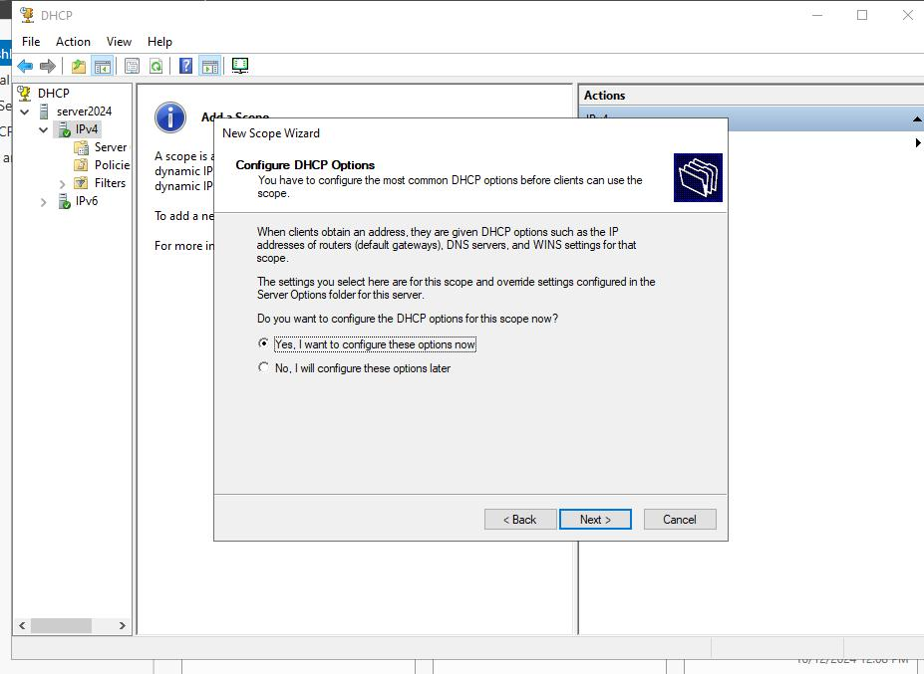
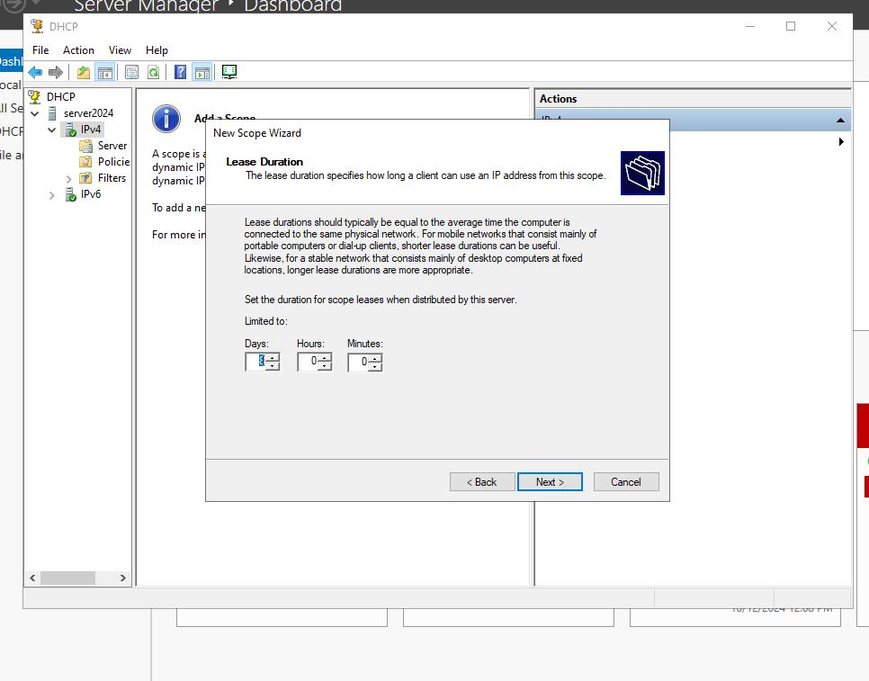
LEASE DURATION, DEFAULT GATEWAY, DNS SETTINGS, WINS, SCOPE ACTIVATION
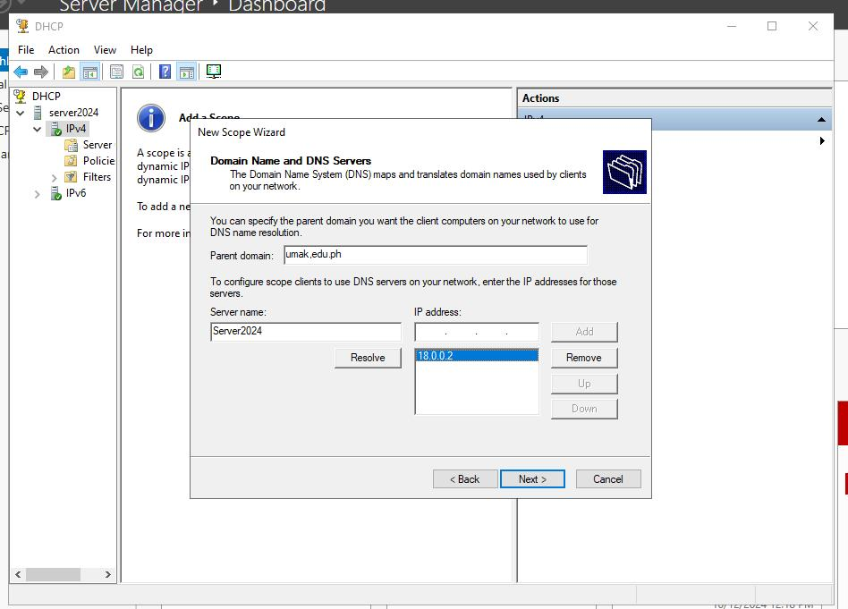
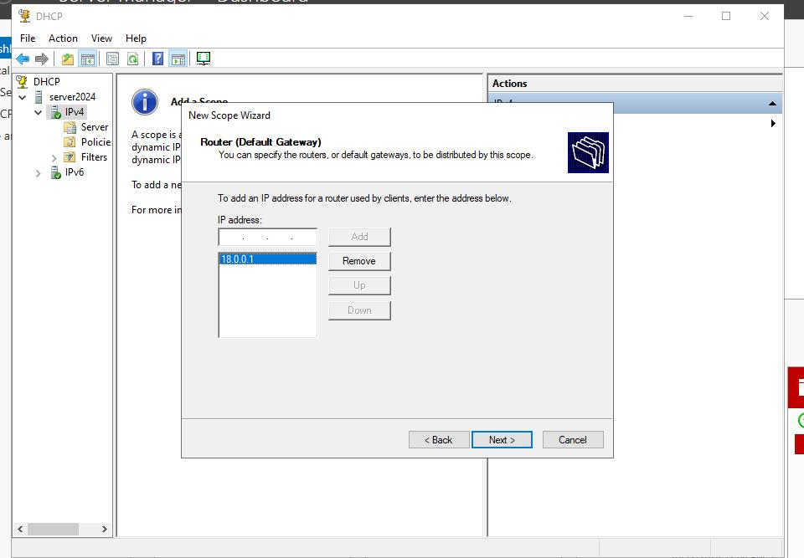

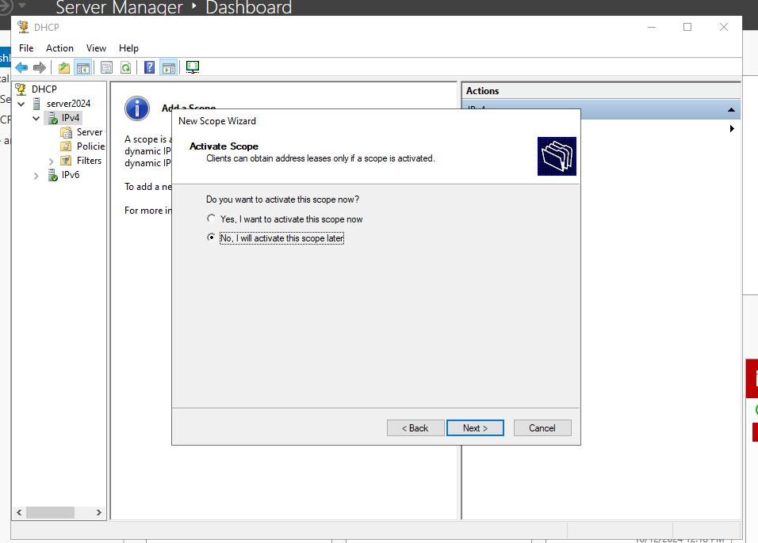
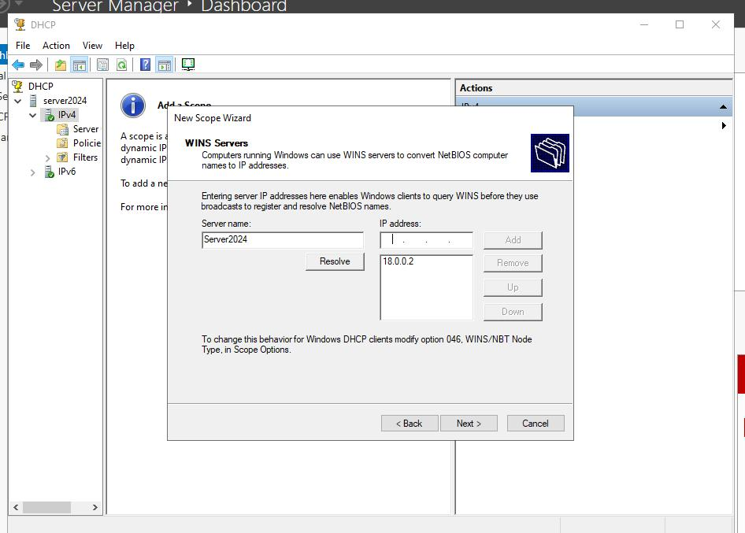

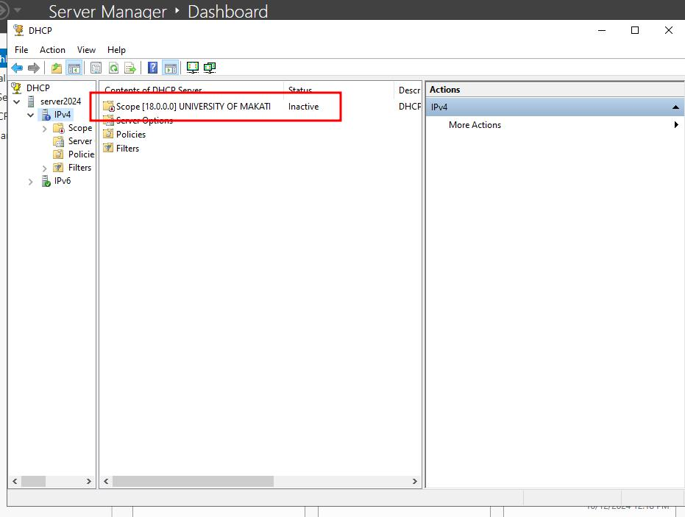

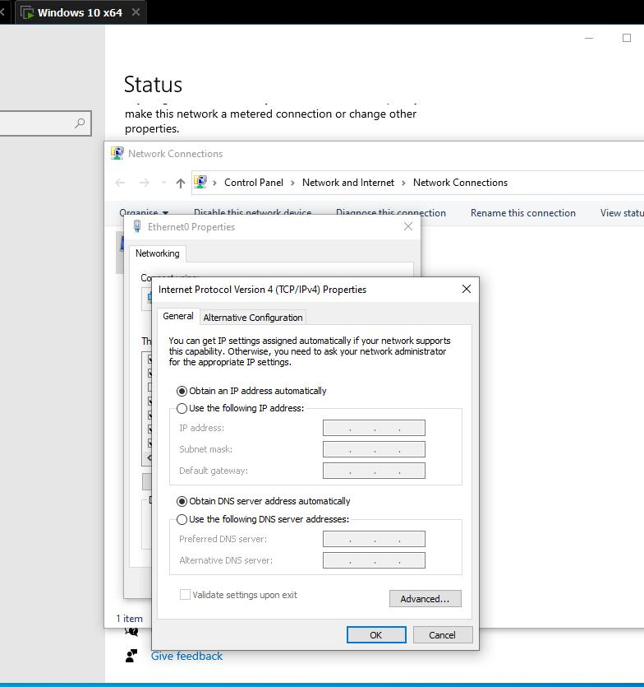
CLIENT SIDE

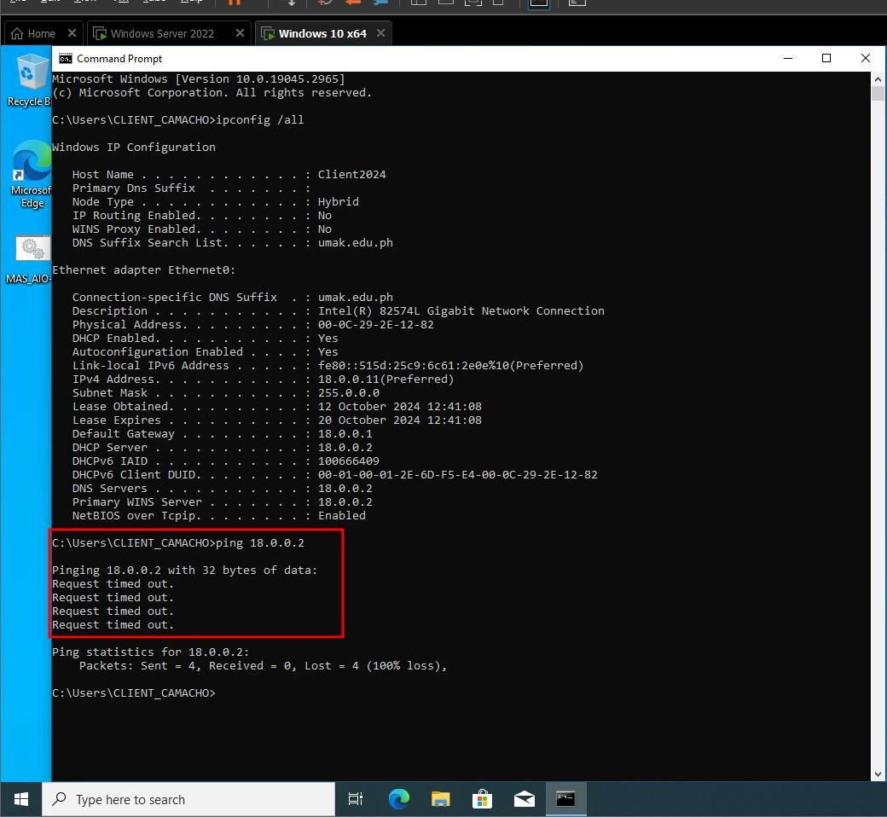
SERVER SIDE LEASING
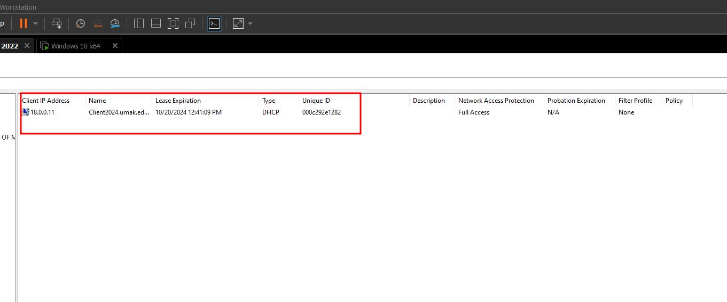

SERVER SIDE CLIENT PING
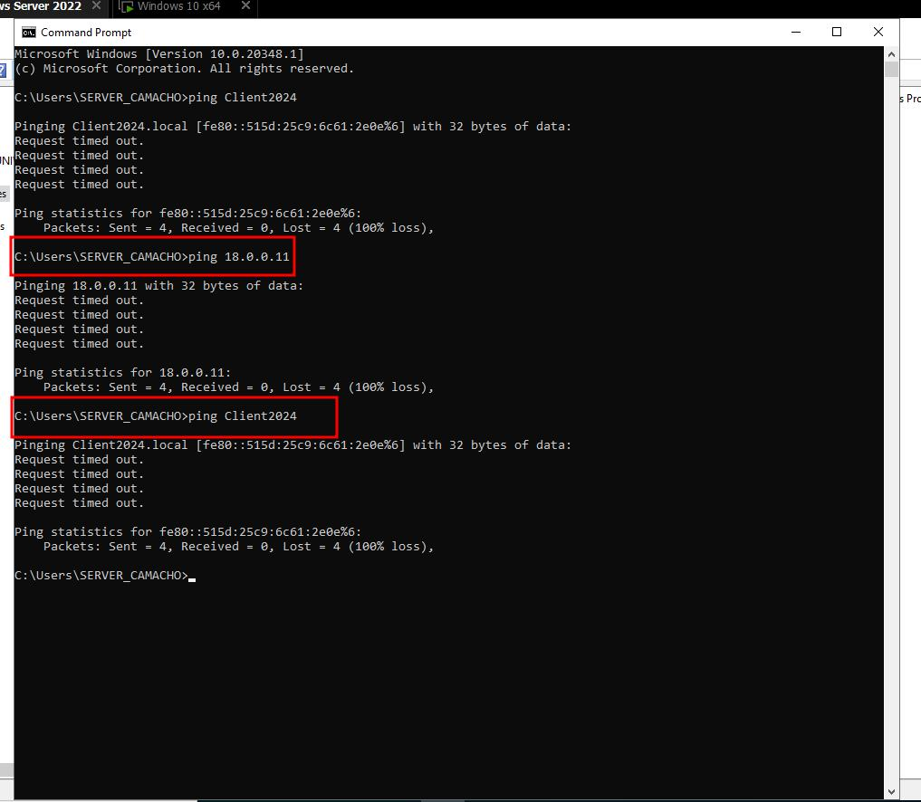

RESERVATION OF IP FOR CLIENT
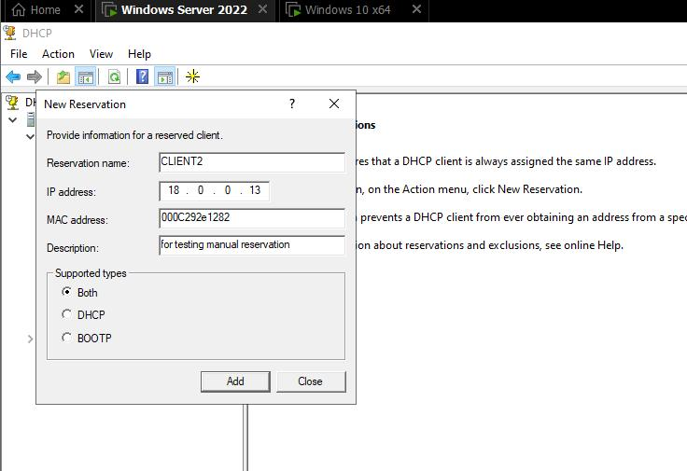

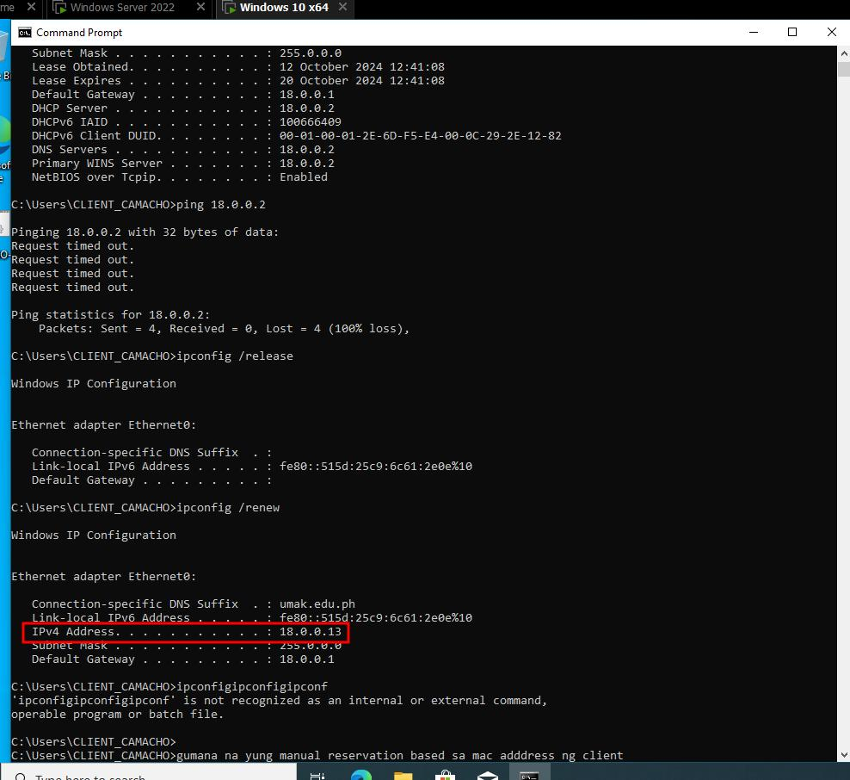
CLIENT SIDE SERVER PING

