**Where do you want to go to:**  
[1. Game Design Document](#_Game_Design_Document_1)

[2. Enemies appendix](#Enemies_Appendix)

[3. Abilities appendix](#Abilities_Appendix)

[4. Runes appendix](#Runes_Appendix)

[5. Quest scenarios appendix (dailies + errands)](#Quest_appendix)

[6. Hidden Mysteries & Easter eggs appendix](#hidden_Mysteries_easter_eggs)

Developed by:

Mad Programmers

# Game Design Document

for:

Prevent From The Darkness

„No matter where, no matter when. In the darkness we all must face our inner demons” ~ Somebody, somewhere...

**Copyright:**

© The entire document belongs to its creator: Paweł Biernacki.

Document’s version: 1.7

Table of contents

[Game Design Document 2](#_Toc517285829)

[Game Design Document (GDD) History 6](#_Toc517285830)

[Introduction 8](#_Toc517285831)

[What you need to know, before you go further: 8](#_Toc517285832)

[1. Concept: short, overall glimpse of the whole game 8](#_Toc517285833)

[2. Game world and the player: WHAT the world is, WHAT contains and WHAT player can do there 8](#_Toc517285834)

[3. Game in details: detailed guide of HOW to do things mentioned in the previous chapters (2) and (1) 9](#_Toc517285835)

[3.1. Other important elements of the game creating process 9](#_Toc517285836)

[Why is this structured in this way? 9](#_Toc517285837)

[Entering changes and adding new stuff 10](#_Toc517285838)

[Chapter 1: Concept (short, overall glimpse of the whole game) 11](#_Toc517285839)

[1. The high concept of the game 11](#_Toc517285840)

[2. Genre of the game 11](#_Toc517285841)

[3. Where the idea of the game came from 11](#_Toc517285842)

[4. Who is the target of the game 12](#_Toc517285843)

[5. What makes this game different from others 12](#_Toc517285844)

[6. Market competition 13](#_Toc517285845)

[7. Who is the player and what will hold his/her attention? 14](#_Toc517285846)

[8. Graphics style and camera view 14](#_Toc517285847)

[9. The final look of the game in just a few words 14](#_Toc517285848)

[10. Business model 14](#_Toc517285849)

[11. Supported operating systems 15](#_Toc517285850)

[12. Supported languages 15](#_Toc517285851)

[Chapter 2: Game world and the player: WHAT the world is, WHAT contains and WHAT player can do there 16](#_Toc517285852)

[1. The history behind the Prevent From The Darkness 16](#_Toc517285853)

[2. The look & description of the Prevent From The Darkness game world. 19](#_Toc517285854)

[a) Overall Description 19](#_Toc517285855)

[b) Look & Key of the map (**for better quality check out the Game\_map\_GDD file**) 20](#_Toc517285856)

[3. Everything about the player 21](#_Toc517285857)

[a) Who the player is 21](#_Toc517285858)

[b) What he/she can do after entering the town (getting started and earning money) 22](#_Toc517285859)

[c) Spending money (economy) 22](#_Toc517285860)

[d) NPC shops (NPC shops stuff and looted/created stuff) 22](#_Toc517285861)

[e) Advancing character 23](#_Toc517285862)

[f) Types of equipment & utility items (and how to get it) 23](#_Toc517285863)

[g) No classes?! (then what?) 24](#_Toc517285864)

[h) Attributes, Abilities & Statistics 25](#_Toc517285865)

[i) What can endanger player’s life? 25](#_Toc517285866)

[j) What if I die?! 26](#_Toc517285867)

[k) Party system 26](#_Toc517285868)

[4. Demons 26](#_Toc517285869)

[a) What are they? 26](#_Toc517285870)

[b) Where do they live? 26](#_Toc517285871)

[c) Are they dangerous? 26](#_Toc517285872)

[d) Can players fight them? 26](#_Toc517285873)

[e) What to fight them for? 26](#_Toc517285874)

[5. Runes 27](#_Toc517285875)

[a) What are they? 27](#_Toc517285876)

[b) How to gain them? 27](#_Toc517285877)

[c) How to use them? 27](#_Toc517285878)

[6. Animals & Creatures 28](#_Toc517285879)

[7. Hidden treasures 28](#_Toc517285880)

[8. NPC quests (idea behind it) 29](#_Toc517285881)

[9. Housing 29](#_Toc517285882)

[Chapter 3: Game in details. HOW to do things mentioned in the previous chapters (2) and (1), HOW they should look like 29](#_Toc517285883)

[1. Specification and hints about the game world (harmony, music, graphics) 30](#_Toc517285884)

[a) Graphics 30](#_Toc517285885)

[b) Music 30](#_Toc517285886)

[2. Player entering the world 30](#_Toc517285887)

[a) Entering the world (game phase from tutorial to achieving freedom) 30](#_Toc517285888)

[b) Attributes & Statistics & Abilities at the start 31](#_Toc517285889)

[3. Player’s graphical interface (before logging in GUI and HUD, after logging in GUI and HUD, in-game GUI and HUD) 31](#_Toc517285890)

[a) Three main wireframes 31](#_Toc517285891)

[b) Style of GUI and HUD 33](#_Toc517285892)

[c) Screenshot mode and hiding elements of GUI 33](#_Toc517285893)

[4. Default controls (moving) and ways of interacting with world (opening doors, talking to NPC’s, fighting, moving items etc.) 33](#_Toc517285894)

[5. Equipment (types, upgrading) 34](#_Toc517285895)

[a) What equipment is? 35](#_Toc517285896)

[b) Requirements 35](#_Toc517285897)

[c) What if player does not meet requirements 35](#_Toc517285898)

[d) Upgrading equipment 35](#_Toc517285899)

[6. Economy (the flow of gold, NPC’s shops) 36](#_Toc517285900)

[7. NPC quests & errands (specification) 36](#_Toc517285901)

[8. Hidden treasures (example of how it should be implemented) 37](#_Toc517285902)

[9. Crafting: Item making (weapons, leather and iron armors all in one profession) 37](#_Toc517285903)

[10. Crafting: Alchemy 39](#_Toc517285904)

[11. Game difficulty level 40](#_Toc517285905)

[12. Storing things and money 41](#_Toc517285906)

[13. Housing 41](#_Toc517285907)

[14. Safe Areas 41](#_Toc517285908)

[15. Enemies (animals & creatures) and player’s attributes 41](#_Toc517285909)

[a) Player’s attributes 42](#_Toc517285910)

[b) Enemies (behaviour, bosses) 42](#_Toc517285911)

[16. Combat 43](#_Toc517285912)

[17. Demons 43](#_Toc517285913)

[18. Handling players’ garbage 44](#_Toc517285914)

[19. Food and regeneration 44](#_Toc517285915)

[20. How attributes work & relations between them (balance) 45](#_Toc517285916)

[21. Abilities 46](#_Toc517285917)

[22. Game objects hierarchy 46](#_Toc517285918)

[23. Game flow 47](#_Toc517285919)

[24. PvP, castle battles, hour of purge (restrictions, rules) 47](#_Toc517285920)

[a) PvP 48](#_Toc517285921)

[b) Hour of purge 48](#_Toc517285922)

[c) Castle battles 48](#_Toc517285923)

[25. Reputation 49](#_Toc517285924)

[26. Death 50](#_Toc517285925)

[27. Runes 50](#_Toc517285926)

[a) Stone runes 50](#_Toc517285927)

[b) Runes and weapons 51](#_Toc517285928)

[c) Runes and defensive equipment 51](#_Toc517285929)

[d) Inappropriate use of runes 52](#_Toc517285930)

[28. Fishing 52](#_Toc517285931)

[29. Party system 52](#_Toc517285932)

[3.1. Other important elements of the game creating process 52](#_Toc517285933)

[1. Promoting game 53](#_Toc517285934)

[2. Game engine 53](#_Toc517285935)

[3. Version control system 53](#_Toc517285936)

[4. License 53](#_Toc517285937)

[5. Hardware requirements 53](#_Toc517285938)

[6. Crazy game design ideas 53](#_Toc517285939)

[a) Replacing map with compass 53](#_Toc517285940)

[b) Demons spawn as players die 53](#_Toc517285941)

[c) Killers’ blackboards 54](#_Toc517285942)

### Game Design Document (GDD) History

This is where the incoming changes made in this file will be documented and versioned.

**Version 1.0 (May 15, 2018)**

This is the very first version of this document. It is a first attempt, to organize all the ideas that have been collected through the whole brainstorm process.

Changes:

1. Three main chapters introduced (three-step GDD). First of them is an overall look at the game. Second one describes the world and the player’s actions with more depth. Third one contains specification of a particular elements of the world.

**Version 1.1 (May 16, 2018)**

Changes:

1. First chapter described in detail.
2. Added some improvements in the introduction to the document.

**Version 1.2 (May 23, 2018)**

Changes:

1. Second chapter added.
2. History behind the world written.

**Version 1.3 (May 25, 2018)**

Changes:

1. The look and description of the game map added.
2. Third chapter added.

**Version 1.4 (June 4, 2018)**

Changes:

1. Everything about the player point added, described and explained (second chapter).

**Version 1.5 (June 13, 2018)**

Changes:

1. Third chapter expanded (most of the things from chapter 2 explained).
2. Housing, demons and runes points added.

**Version 1.6 (June 18, 2018)**

Changes:

1. Third chapter finished.
2. Enemies Appendix added.

**Version 1.7 (June 19, 2018)**

Changes:

1. 3.1 chapter finished.
2. All appendixes finished.

## 

## Introduction

“Soon, you shall know many of the old, powerful spells that can either build and ruin... But first go dig up the garden” ~ The never seen magician to his apprentice.

### What you need to know, before you go further:

This document is designed in a way that allows everyone who works on this project to find any needed information about the particular subject of the game in a fast, easy accessible way. Thinking about the clarity of the GDD, I decided to divide it into three major parts:

### 1. Concept: short, overall glimpse of the whole game

In the first part I discuss (without going into details) about:

1. The high concept of the game.
2. What is the idea behind the game and where it came from.
3. Genre of the game.
4. Graphics style and camera view.
5. Who is the target of the game.
6. What entity is controlled by the player and what is his goal (purpose of the game and drawing attention).
7. What makes this game different from other games.
8. The final look of the game in just a few words.
9. Market competition.
10. Payment model.
11. Supported operating systems.
12. Supported languages.

Some references to a detailed version (chapter 3) of the aspects of the gameplay mentioned there will be also contained in this chapter.

### 2. Game world and the player: WHAT the world is, WHAT contains and WHAT player can do there

In this part I will try to describe every aspect of the game world (the history behind it, the map) and the player (what he can do, what adversities he has to face and many more). The chapter will mention every significant aspect of the game and provide a reference to its equivalent in the chapter 3, which will show that specific aspect of the game in depth. This is going to be a big chapter.

### 3. Game in details: detailed guide of HOW to do things mentioned in the previous chapters (2) and (1)

In this part I am going to talk in details about all aspects of the gameplay mentioned in the previous (2) chapter, first (1) chapter and other things, too. This chapter will provide an information that can be helpful from the technical point of view (for programmers, graphics artists, for example). This is going to be a really, really BIG chapter (god bless text references).

Things described in this chapter are not organized chronological or in any specific order. You just have to find what is interesting for you in the table of contents.

### 3.1. Other important elements of the game creating process

This chapter will provide information about other various aspects of the game design that did not make it to the previous 3 chapters, such as: promoting game, used game engine, license (if needed), hardware requirements and everything else that team will consider as needed to be put there.

This chapter will also have a section carrying some crazy (or very serious ones) ideas that are considered to be added to the game.

This chapter is not related with gameplay itself (slaughtering trolls etc.) that much, as previous 3 chapters are.

### Why is this structured in this way?

I do realize how important clarity becomes when it comes to working together with others. Nobody wants to spend half of the work time digging in the document just to find one or two things he opened it for. This is why, after many hours of trials and failures I finally developed a technique of structuring a GDD in a way that people around me find useful as much as I do. I called it a “three-step GDD”. And this is why: CONCEPT → WHAT → HOW.

Now, let’s take a closer look at it:

If you want to get acquainted with the whole idea (CONCEPT) of a game, you simply go to **chapter 1**. This chapter will give you a short glimpse of what the final product will (or should) look like. If you opened this document, like, five minutes ago, just go there. You will not regret.

If you’re familiar with the idea of a game, but still have tons of questions about WHAT certain parts of it look like, and WHAT player can do there in detail, you should open **chapter 2** which goes more in depth about game mechanics.

If you went through previous chapters (or not) then you will probably think “Slower cowboy, let me ask you some questions. Fighting demons? You’d better tell me how! Beautiful world? That’s not very specific… Economy? I’ve heard of that. PvP? Easily said!” Yeah, I’ve asked myself all of these questions, too (and many more, like in-game balance in economy or strength of players and their enemies). The answer for all of them can be found in the **chapter 3**. Each subject of this chapter also contains its own three-step level of realization that will be changed during the process of creating. It will look like this:

**1 level:** means that the particular subject is not even started or is in the very early stage of creating

|  |  |  |
| --- | --- | --- |
|  |  |  |

**2 level:** means that the particular subject is being developed

|  |  |  |
| --- | --- | --- |
|  |  |  |

**3 level:** means that the particular subject is on the development level that allows it to be implemented to the final product

|  |  |  |
| --- | --- | --- |
|  |  |  |

The **3.1 chapter** is, as I mentioned before, filled with all the stuff that did not make it to the other chapters.

### Entering changes and adding new stuff

Next, very important thing, is about entering changes to the GDD and upgrading it. Three-step GDD allowed me to state it quite clear. That is how I see it:

1 chapter (CONCEPT) of the GDD is NEARLY UNCHANGEABLE and every little thing that is considered to be changed within it should be discussed **very** thoroughly in order to keep the game on the right track not to lose the main idea of it.

2 chapter (WHAT) of the GDD is QUITE CHANGEABLE, therefore not that hardly defended from entering changes within it, but they should be discussed much, too.

3 chapter (HOW) of the GDD is CHANGEABLE. In this chapter many things will be changed over time, but, as always, team should keep their heads cool, not jumping from one idea to another, but discussing about different options and through pros and cons consideration taking the best one.

**!** Remember, that references to all major parts of the GDD are contained in the **Table of Contents**.

**!** Keep in mind, that during the creating process of the game, its GDD will meet many changes that you, as a part of a team, should be aware of.

**THAT IS ALL ABOUT THIS GDD’S STRUCTURE AND DEALING WITH IT.**

## Chapter 1: Concept (short, overall glimpse of the whole game)

“The idea is simple. Just act like you’re one these blueberry bushes out there. I’m going to take them out one by one” ~ Some Elf to her bearded Dwarvish friend.

### 1. The high concept of the game

Prevent From The Darkness is supposed to be a game focused around creating strong alliances made up of players, that struggle to survive in the very unpleasant world haunted by bloody beasts coming out of the shadows at night. Players can also fight between themselves in order to claim their authority over the world. The second, very important aspect of the game is searching for answers about the game world among many, left by a previous generations, scrolls and artifacts hidden in the ancient libraries and other structures all over the world. Beside the knowledge itself, these things will give players powerful grasp of the new methods of annihilating monsters, but used by the wrong hands, will be a serious threat to other players and alliances that struggle to fight for a better day. The mystery behind the world and place left for players’ interpretation is also crucial, because as nothing else creates the world’s immersion and credibility.

### 2. Genre of the game

Prevent From The Darkness is supposed to be a fantasy massive multiplayer online role-playing game (MMORPG), due to a possibilities this genre creates. Here is a short list of these possibilities:

1. Creating alliances and finding allies.
2. Sharing time/emotions/feelings and struggling with the adversities together.
3. Place for epic wars, betrayals, intrigues, plot twists and such.
4. Common exploration of the world, going through the adventure together.
5. Possibility of being the part of a virtual society, that rules the world.

### 3. Where the idea of the game came from

The idea of this game was born when I realized what really attract players to the MMORPG genre. That is:

1. Being a part of a big society (MASSIVE multiplayer online…).
2. Being able to do something that matters in the game world.
3. Creating the character that represents player’s fantasy alter ego.
4. Cooperating with others in order to fight the adversities of the world
5. Competing with others (wars, PvP, equipment, gold, power)

### 4. Who is the target of the game

The target of the game are both men and women of age 14-∞ who are fond of MMORPG genre, of course, and like to take up the demanding, but rewarding challenge and dip into the adventure with all their attention.

### 5. What makes this game different from others

There are some things lacking in the nowadays MMORPG genre. Most of the latest MMORPG games are horribly bad designed, so it is not surprising that many of them dies after a few months due to a lack of players and most of the “giants” of this genre are games created **years** ago! Here is a list of the mistakes made by designers of the new MMORPG games, that we, as a team, should be aware of in order to avoid them:

1. Making game easy and not demanding, what leads to an oddity, where a MMORPG title is simply a single game where you can sometimes see other players walking around. That happens due to an incredibly easy adversities that player has to confront.
2. Placing in-game objects that do not harmonize well with the game world and it’s atmosphere (pink rabbit outfit in the item shop of the medieval MMORPG game for example). Immersion and the climate just die when that happens.
3. Unequal treatment of the players, where the one can pay real money in order to be better than others (classical Pay to Win situation). That happens just too often nowadays…
4. Filling most of the world with useless, non-interactive things in order to make the game world “bigger”. That leads to a situation, where more than 90% of the game world is unused, and all the players stay just in one place. Speaking about non-interactive things, I would like to mention the day and night cycle system in MMORPG games (that is the problem in other genres, too). Many times we have all heard developers praising this feature, but in the end it does not bring anything special to the actual gameplay. In Prevent From The Darkness, the day and night cycle will play a very important role, due to the monsters and threat night will bring. These “empty spaces” and dead day and night cycle system are another things that destroys an immersion.
5. Dividing the world into small areas, where players feel like they are in the cage. Another thing that does not help when it comes to “believe” in the world your character is in.
6. 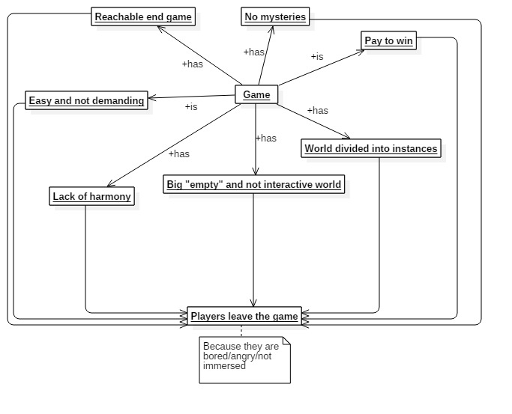Allowing players to reach the end-game content right from the start or just after a few days/weeks after release of the game. If the game is too easy, nobody will be able to shine between others, because everyone, no matter how much effort he or she puts into game, will be just the same. That makes game just… boring. In my opinion, there should not be something like “end-game” in the MMORPG game! Have you ever seen the end game in the real life? Probably yes. It is death. In the game, you reborn every time you die. Therefore, why not to let players decide when and how they want to play the game? Game should be created in the way, that makes player think there are always something more to do, like finding out new spells/artifacts hidden in the game world. Player should never know if he had discovered all of them, or just a few. If everyone is listed in the spell list from the very beginning, then player’s inner curiosity about the game world is just being brutally killed. Do not let it happen ever again!

|  |
| --- |
|  |

These are the main reasons why the old MMORPG games have still more players than the ones released nowadays. As you can see, the **immersion** plays crucial role in attracting players, and there are many factors that together creates that beautiful feeling we all want to achieve by playing any kind of game. Other factors, such as **equal treatment** of all players or the **difficulty level** are important as well.

**The most important thing for the team that creates Prevent From The Darkness is to understand the meaning of these factors, to appreciate the importance of designing and implementing them carefully, until they will turn into something that players will remember for long, long years.**

### 6. Market competition

According to what I know, there are very few MMORPG titles that would meet **half** of the requirements this game is supposed to meet, and even less (if any) that would meet **all** of them. Even such an obvious thing of the genre, as being “massive” disclaims the great amount of titles that are currently on the market from being similar to the Prevent From The Darkness and from being similar to the real MMORPG title. Therefore, the market competition should not be our biggest concern, for sure.

### 7. Who is the player and what will hold his/her attention?

In this game the player is going to take control over virtual human being and lead it as he/she wish in the game world. The player will be allowed to do all the activities mentioned in the point 2 of this chapter and many more, that are thoroughly discussed in the next, second chapter.

Player’s attention will be kept on figuring out the mysteries of the world he’s/she’s dipped into, surviving in the tough environment, finding allies, improving his/her character and discovering the unknown, hard to get to, places which unfold next pieces of the puzzle-like thing about becoming stronger and finding new ways of defending yourself.

### 8. Graphics style and camera view

The game graphics is supposed to be represented entirely by the 3D, low poly models with an isometric camera view.

### 9. The final look of the game in just a few words

This game:

1. Will be demanding (tactical skills when fighting other players and monsters, unfolding the ancient artifacts and mysteries e.g.).
2. Will not give players everything for free and at least minimum effort must be put in player’s actions to achieve something, therefore it will be satisfying.
3. Will be settled in the dark, medieval like fantasy world (with magic).
4. Will be quite punishing when it comes to death (not in the way that makes player quit and never come back again, but in the way that forces player to think twice before… entering the unknown cave, for example)
5. Must put a strong emphasis on the “massive multiplayer” aspect of the gameplay in order to make the experience as deep as possible. Players have to feel united (although we can’t, and should not force them to do it, of course) in order to survive in the tough realities of the game world.

### 10. Business model

Specific game’s business model is not confirmed yet, but there are three options taken into consideration. These are:

1. Free to play model with non-invasive in game shop. All content is free for everyone except some cosmetic stuff (that could be bought in that store).
2. Pay to play model with two possible ways:
   1. All content is free for everyone, including cosmetic stuff (that would be added from time to time to the game).
   2. All content is free for everyone, but cosmetic stuff can be bought from an in-game shop (same as in the free to play business model).

|  |  |  |
| --- | --- | --- |
| **1** | **2 (a)** | **2 (b)** |
| C:\Users\Krzepki Paweł\Desktop\Gry nasze i projekty\Game design\Diagramy\System płatności.jpg | | |

### 11. Supported operating systems

In its earliest stages, the game will provide support for:

1. Windows.

Further expansion to other systems is planned as well, but will not be implemented faster than after the release of the game, when some serious data about players’ needs in this case will be gathered.

### 12. Supported languages

In its earliest stages, the game will provide support for:

1. Polish language
2. English language

Further expansion to other languages will be considered after the release of the game, when some serious data about players’ nationalities will be gathered.

## Chapter 2: Game world and the player: WHAT the world is, WHAT contains and WHAT player can do there

“Something terrible stepped out from this cave last night. The prophecy… The Madman… Gaffer wasn’t that mad, though… It’s coming, Rand. It’s coming for all of us.” ~ Ben, the deputy scout to his friend (while lighting the immeasurable darkness of the cave with his torch)

If you are looking for HOW the world is supposed to be done, you should visit chapter 3.

### 1. The history behind the Prevent From The Darkness

Imagine the world, world similar to the one we live in but with some differences that makes the whole life experience totally different from what we, as a human race, ever went through. Human residents of this world did not have a chance to push the civilization forward, therefore, their technology development stopped around something we would call “early medieval times”. The other, darker residents of this world do not need to think about their technology process. Instead, they got sickle-like claws. They got five inches long teeth. And they got just one desire. Human’s meat. That is the reality people have to confront in Prevent From The Darkness.

But it was not always that way. There were times when nobody even knew the word “Demon” and talking about night monsters was a domain of older people frightening kids in order to make them obedient. According to the legends and rumors, it all started with a dream. Dream of the twins who wanted to gain something more from their lifes than the average person could. Actually, they was looking for something more than even rulers of that world could imagine. They both sought really hard for becoming the transcendent entities. Even though they had the same goal, they divided their efforts in reaching it, to get a chance of trying different methods an the same time. At that time, they were very young. Demar, first of the twins, was one of the smallest kids in the village and a little bit fearful. Despite that, she had this inner need of facing the world and becoming something more than an average human being. Ontis, her brother, was quite different. Thinking more about taking care of his sister than himself or anybody else, he indulged hard into physical and psychical training. But he was not some kind of bully to the others. Always alert, never underestmating the possible strength of the opponent, and willing to overthink about live, the world and the entity itself. The last of his trait was his salvation and the damnation in one. The answers his mind was serving each time he dipped to hard into the labyrinth of his mind started to be overhelming at some point of his life. At the same time, he felt this need deep inside. The need of writing down the results of his mind-journeys. Ontis belived that was one of the right ways to become a transcendent entity. Demar, small and with tiny arms, but unstoppable in her desires, did not want to fall behind, so she decided to focus on a spiritual aspect of the life. To do it, she was sneaking into the small, humble, but the only one temple in the village. The temple was left alone most of the time, wherefore most of the local people were working in their fields. In this way, she read and tried to understand thoroughly every page of „The Higher Gate”, a copy of an ancient book people all over the world treated as the most important artifact of the world left by previous generations. Needless to say, it could not last forever. There was a day when all the people travelled with their goods to the fair. Therefore, Demar hid in the barn, under the haystack. Her family was in a hurry, so, luckily for her, nobody noticed that she is not around. After a short time, just before the first of the sun’s shines appeared on the horizon, everyone left the village, leaving behind swirls of the dust coming out under the horse carts. Denar immediately jumped out of her hideout running towards the temple, and spent as always hours on shifting through many, many pages of the book stunned by its complexity and the mystery behind it. Having lost her alertness, Denar have not noticed people coming back from the fair. Suddenly, the main temple doors opened. The priest stepped in, being freezed as soon as she noticed Denar, so scared that she could not even blink an eye. After that, everything happened just as worst as it could. Denar was taken to the central square of the village and accused of stealing the artifact and desecrating the book with woman’s hands. As a consequence she was strapped to the wooden pillar by her wrists waiting for the punishment. Before her dad came to the scene, the whole village’s population was already there, gossiping and throwing judges towards her. Soon, the infuriated father came along with her brother, Ontis, trying to stop him. Unfortunately, his attempts ended up with a hit directed at his face, that put him down bleeding. After a while the priest decreed a punishment, that her dad was very eager to fulfill. “Fourteen lases of the whip, each for a year Demar went through in her life, not respecting eternal rights, we all humbly follow!”. Crying did not help. When first lash came in, it felt like a strike of thunder leaving the burnt out, twisting sign on her soft back skin. Pitful begging and screaming made it even worse. After fifth hit, she dropped to her knees, madly trying to avoid upcoming hits and free her tied hands. Next hits made her back slowly reminding more of a slush, than a human’s being skin. Although she almost fainted, she gathered all her inner strength and turned around, staring at her father’s eyes. He stopped for a while, just to a second later strike her with all his power, making her right eye explode like an egg yolk. Then, she finally hit the floor, losing her conscious. Few beats of the heart later, just before the judgement was supposed to be done, somebody screamed “Fire! The temple is on fire!”, making all the people gathered around a girl in a circle run for a water to put out the fire. Dinar was left alone for a while. That was the moment, when her brother ran out of the back of the whole scene, cut a rope that was constraining her wrists, lift her up, and just ran for his life towards the forest. That was the last time they were seen.

Now you’re gonna probably say “Ok… but what does it have to do with all the monster and demons at night stuff?” Well… that is the moment of the history, when things get more mysterious.

As it was said, the twins ran away and were never seen again… theoretically. Most of the people would rather say, that they were never seen again in a form they used to be as a human beings. Various legends and rumors were created after an event that was an announcement of the new era. According to the most widely known version of what happened, there was a warm spring night, over a dozen years after the twins escaped the village, when some kind of constant, low toned noise occurred, making people to come out of their cottages. Everyone was confused. After few moments, the ground started shaking hardly. It was the first earthquake those people experienced in their lives, thus the great panic arose among all of the people. But it was just a beginning. A warm up of what was about to happen. Few moments later, the earthquake stopped. For a while, there was an astonishing silence all over the region. As soon as people thought the whole thing was over, the monstrous, thirty feet tall human-like beast came out the shadows of the night, walking slowly among the cottages. Its skin was black and rugged, the mouth looked more like a deformed, wide dog’s mouth, covering dozens of teeth. The whole posture was a little bit hunched and the body was bulky. But it was the hands that made everyone tremble. Each of them contained four fingers ended with a scythe-like claws. The beast seemed like it knew where it wanted to go. The long, uninterrupted by anyone walk ended up just by the cottage where the twins used to live. In front of the building stood a man, grabbing a pitchfork. The beast laughed with an extremely low toned voice, even lower to the one everyone heard a few moments before. “We’re back.” It said, and before the man could even react, his head fell of the body, hitting the ground. That was the time when people literally went mad. None of the words could describe the chaos that occurred at that time in the village. The beast among all the chaos turned the whole twins’ dad cottage down, and then pulled out a colossal amount of dirt and stones of from the ground, just to throw it all towards the temple, as soon as it walked up by the building. Then, the beast destroyed the temple with its own hands, too. Finally, the monster went back to the twins’ house, or rather ruins of it, and picked up the man’s body with one hand. Then, it stepped to the main square of the village and with all its attention impaled the body on the same wooden pillar that Demar was strapped to. Then the beast walked off, as slow and lazily as when it was entering the village. Rest of the night was just as every night before the accident. But nearly all the other nights to come were something we can see every night nowadays, but without any preparation for it. It was nothing more but slaughter and a feast for all the monsters coming out from the shadows. Nearly all the human beings were vanished from the surface of the earth. Only a handful of people managed to survive, mainly by hiding inside some stone-made fortresses or mountains, that were too cold for the beasts that for some reason could not stand low temperatures. Since the event with the monster announcing the end of an old era, gossips and rumor about what happened spread around the world with a speed of thunder. People reminded themselves about the twins’ history that happened years ago and remembering what the monster said, to whom, and what it did next, they immediately connected all these accidents and deduced, that the beast was the twins itself. Later on, they called that beast “Demarontis”, after the names of the twins and eventually, they shorten it to the word “Demon”, calling all the night monsters in this way.

### 2. The look & description of the Prevent From The Darkness game world.

[**Chapter 3: Specification and hints about the game world (harmony, music, graphics).**](#_1._Specification_and)

#### a) Overall Description

The map presented in this point is something, that players are going to see in the game just after its release. Further expand of the game map will occur in updates, after the release. The map is going to provide as many activities as it is important to let the team working on the game prepare next update with the extension of the current map.

The map presented after the release will contain one of the main regions of the whole game world. First one, the Frozen Pikes, is going to be a very, very cold and unfriendly for most of the living things (with few exceptions) place, filled with high mountains, frozen lakes, forests full of snowy spruces and larches, suspicious, dark caves, abandoned cottages, glacial waterfalls, treasures and places that hold the ancient knowledge about the runes and the history of the world and the plague that nearly defeated the human kind. The region has its capital, Frozenig, placed in the center of this land, on the middle trail. Speaking about trails, there are three main. One begins in the north west end of the Frozen Pikes, one mentioned before, begins in the northern area of the whole land and the last one starts in the eastern area of the region. All of them cross in the south. What is funny, frost, the trait that makes this place awfully hard to survive in, is also the thing that saved the land and all the living things inside it. That is because of demons, that can’t stand low temperatures. Although the land does not suffer from demons, it is not very safe due to many hungry, greedy creatures and animals circling around the region looking for food. Travelling during the night, even though without demons in the region, is much more dangerous than the travelling during the day. That is because all the living things are more active then.

The Frozen Pikes in general:

1. Strong mountain climate
2. One of the last shelters for people
3. Has its capital in the center of the land
4. Contains three main roads
5. Covers many ancient artifacts, treasures, runes and mysteries to discover
6. Is a home for many dangerous animals and creatures
7. Dangerous at night

#### b) Look & Key of the map (**for better quality check out the Game\_map\_GDD file**)

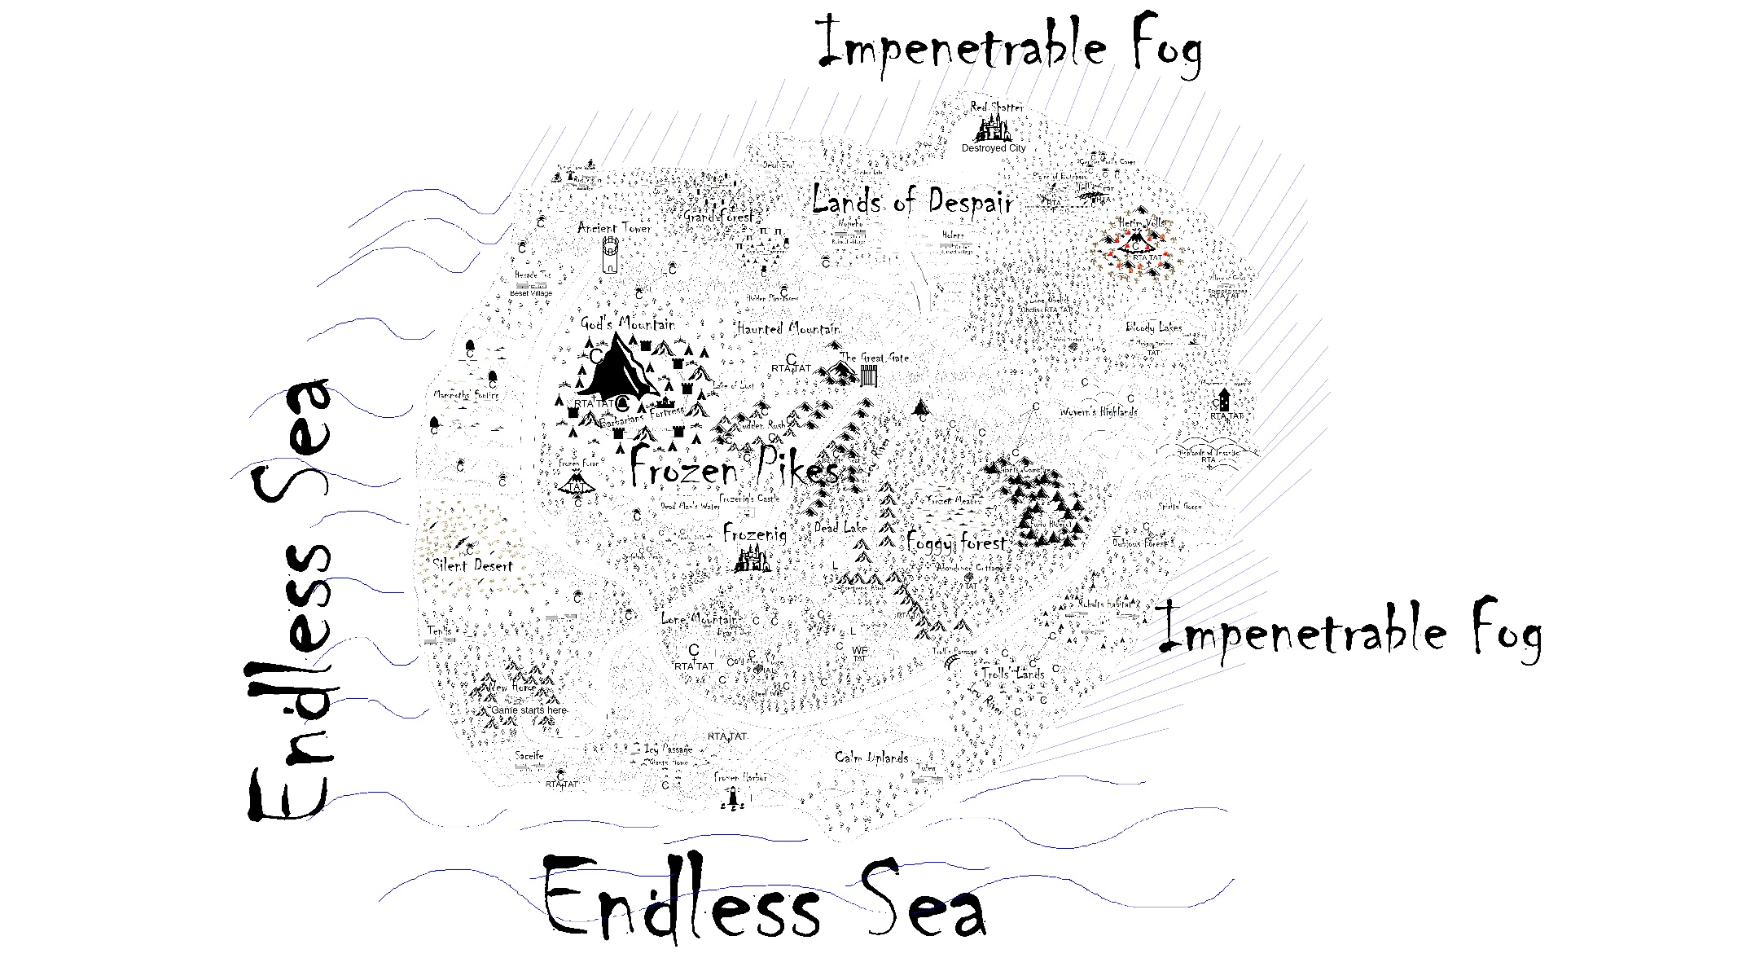

1. RTA - Rune To Achieve, this is the place where player can find some information about the rune to be unlocked. There is this cross-like icon near RTA always.
2. TAT - The Ancient Text, this is the place where player can find some information about the game world and its history as well as about the runes (where the next rune might be, for example).
3. WF - Waterfall.
4. C - Cave.

### 3. Everything about the player

[**Chapter 3: Player’s graphical interface (before logging in GUI, after logging in GUI, in-game GUI)**](#_4._Player’s_graphical)

[**Chapter 3: Default controls (moving) and ways of interacting with world (opening doors, talking to NPC’s, fighting, moving items etc.)**](#_4._Default_controls)

[**Chapter 3: Entering the world (game phase from tutorial to achieving freedom)**](#_a)_Entering_the)

[**Chapter 3: Equipment (types, upgrading)**](#_4._Equipment_(types,)

[**Chapter 3: Crafting: Item making (weapons, leather and iron armors all in one profession)**](#_9._Crafting:_Item)

[**Chapter 3: Crafting: Alchemy (making and using bandages, explosive powders, poisons, potions)**](#_10._Crafting:_Alchemy)

[**Chapter 3: Attributes (and relations between them/balance)**](#_20._How_attributes)

[**Chapter 3: Abilities**](#_21._Abilities)

[**Chapter 3: PvP, castle battles (restrictions, rules)**](#_24._PvP,_castle)

[**Chapter 3: Players death (penalty)**](#_26._Death)

[**Chapter 3: Reputation**](#_25._Reputation)

[**Chapter 3: Economy**](#_3._Economy_(the)

[**Chapter 3: Party system**](#_29._Party_system)

#### a) Who the player is

The player is going to take control over a virtual human being. His journey begins in the mountains located between Saceife and Tenlis villages. The background of the way player appeared here is because the last and the biggest one humans’ city in the known world is searching for new recruiters in order to make the whole human race stronger and more immune to all the dangers in the Frozen Pikes and outside it. Therefore, villages located in the area sends freshmen to the New Home, location that player is going to see after creating his character and entering the game. After the introduction (tutorial) to the game world, the player will be transported on the sleigh to the Frozenig. From that point player can do whatever he/she want to do with his virtual life.

#### b) What he/she can do after entering the town (getting started and earning money)

After entering the town, player has same rights to do everything as every other player. First thing he, she should do is go to one of the guilds (or all, as he/she wishes) and ask for basic equipment and abilities of profession the guild is specialized in. After that, the player can earn some money by killing animals/creatures, taking loot from them and then selling it to appropriate NPCs, Gathering resources (e.g. iron for blacksmithing or flowers for alchemy) either by pick and sickle by finding these resources in the game world or just by killing appropriate creatures. He can also start searching for rune recipes and alchemy recipes hidden all over the game world. This will make players able to fight demons more effective, and that means being awarded with powerful stuff. Beside runes, there will also be many treasures hidden in the game world that players will achieve after finding them just like rune and alchemy recipes. Some of them would be easy to find, and some would require certain things like resolving the puzzle, saying something, standing in correct order etc. Because of the PvP, that will be present in the game, players will be also able to kill each other in order to loot items and gold of a dead man. Castle wars will be also a thing connected with PvP, that will give winners some percent of the entire gold flow within the city that castle belongs to. Last but not least, there will be also an option of doing daily quests and errands given by NPC.

In short, player can earn money by:

* Selling things looted during hunts
* Crafting and selling items (or selling materials found in the game world)
* Discovering treasures and recipes for runes and alchemy (and then selling them)
* Doing daily quests given by NPC
* Doing errands given by NPC
* Killing other players
* Fighting with a guild for a castle

#### c) Spending money (economy)

After player earned some money, he wants to spend it somewhere. This is where game economy begins. Player will be able to spend money by buying basic armors and weapons, basic tools like pick and sickle, food, basic potions and bandages or by paying for upgrading items at blacksmith’s smithy. There will be also a way to make transactions between players. They will be able to do trade between two people or make a shop (by buying booth first) placing it wherever they, so everybody can buy something that is offered in the shop.

#### d) NPC shops (NPC shops stuff and looted/created stuff)

In-game NPC shops will contain basic stuff like basic armors, weapons, food, potions and bandages.

Better armors, weapons, potions and bandages players will be able to gain through crafting or killing creatures.

#### e) Advancing character

Although there are no typical for MMORPG genre levels, that define how advanced your character is, in order to become stronger player will have to train his attributes. It will work just as in the real life. The more player will do something related with certain attribute, the higher level of it he/she will achieve. For example, if one collects flowers/plants and then creates some kind of potion out of it, her/his alchemy attribute will raise. If someone fight monsters with sword, he/she progress in the melee fighting. The more health points player’s character will have the more hits during the game he/she took. Attributes will be also responsible for allowing players to wear certain kind of equipment. That means player will not be able to put certain part of equipment unless he/she meets requirements, like 20 level of melee fighting for “troll’s machete”, for example. That is to prevent situation where very low level puts on best equipment in the game

#### f) Types of equipment & utility items (and how to get it)

Player will be able to put on shoes, legs cover (legs), chest and back cover (armor), weapon (range or melee) and shield. Nearly every item in the game can be crafted (created by player) or looted (all of the looted ones can be created in smithy, either). Therefore, players will have to hunt creatures (Trolls, Giants and Rubalts, for instance) or create them in the smithy by gathering and processing world’s materials (iron, copper).

Same goes with things such as bandages, potions, explosive powders/mixtures. Some of them will be achievable through hunting creatures (same ones will be reachable by alchemy), but some of them will be only achievable via alchemy.

This can be represented in this way: 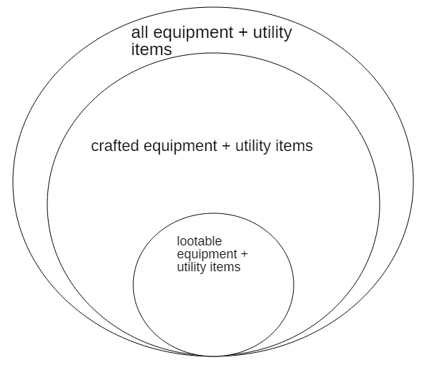

#### g) No classes?! (then what?)

Yes. In this game no one will force you to choose some class in the beginning of your adventure or at any point of it. But, depending on what player do, there will be three main archetypes he/she will approximate to.

These archetypes are:

1. Knight
2. Hunter
3. Alchemist

For example, if player likes to shoot, throw and this kind of stuff, he/she can go straightway to the hunters’ guild and ask for some basic equipment and abilities, so he/she can get acquainted with that. The more player will shoot, the higher his shooting attribute will be, and the more hunters’ abilities he/she will be able to take from the hunters’ guild. However, nothing will stand on his/her way to learn some alchemy, too. In order to do that, he/she will just have to go to the guild and ask for some basic kit to get started with it.

#### h) Attributes, Abilities & Statistics

Attributes that were also mentioned in the “Advancing character” are list of something like player’s talents he/she can develop. They are:

1. Resourcefulness (Overall power)
2. Robustness
3. Melee fighting
4. Range fighting
5. Alchemy
6. Shield mastery
7. Equipment crafting
8. Rune Mastery
9. Fishing

What is important, melee fighting, range fighting and alchemy attributes will have impact on themselves as well as on some of the other attributes. The rest of them is not bounding-like. Player can train them without a concern that it stops him in other attribute.

Abilities are list of “magic like” maneuvers players can make in order to do something in the game world. Most of the times that means: starting a sequence of hits (or one movement) towards player/creature/animal, but also actions like war cries, for example. Each of three main guilds (Alchemists, Hunters, Knights) will offer its own set of these.

There will be also two major statistics, which are:

1. Health
2. Durability

And one minor:

1. Reputation

Amount of health, as everyone knows, will determine how long you will survive in the fight. Durability is player’s amount of points that are used for nearly all in-game actions, such as: attacking players/creatures/animals and using abilities. Durability will be also used in the rune system, as an amount of health points for the rune barrier.

The higher reputation is, the easier player’s life become. Prices in shops/services will be smaller and smaller down to the “lowest” price point. The lower reputation is, the higher prices in shops/services.

The higher fishing attribute is, the easier it becomes for player to pull out of the water a fish.

#### i) What can endanger player’s life?

In case you wonder about that aspect of the game, here is a short list:

1. Other players
2. Creatures (like giants, trolls, wyverns)
3. Animals (like bears, wolves)
4. Demons (outside Frozen Pikes)
5. Nature itself (fire, for example)

#### j) What if I die?!

When you die… You reborn. It is a game! There will be penalties put on the player after death like losing a random item from their equipment and some of their total experience.

#### k) Party system

Player is able to create party by inviting other players. It will help with distinguishing allies from enemies during fight as well as allow players to throw area buffs that affects party members.

### 4. Demons

[**Chapter 3: Enemies**](#_15._Enemies) **and player’s attributes**

[**Chapter 3: Demons**](#_17._Demons)

#### a) What they are?

To be honest, nobody knows. And there is nobody who survived any encounter with them to say some specifics about them.

#### b) Where they live?

Nobody knows that, either. But, there is this one thing everybody knows. They come out of the shadows at night. And they can’t stand low temperatures, therefore they live outside Frozen Pikes, on the Lands of Despair.

#### c) Are they dangerous?

Hell yes! Demons are more powerful than any other creature known in the Prevent From The Darkness world.

#### d) Can players fight them?

Sure, but to do it effectively, they have to have at least their weapons painted with runes. Any other paintings (on the armor, for example) will be another plus when it comes to fighting against demons.

When it comes to defending, players will be able to make a circle of runes creating barrier, which will prevent demons from running inside this barrier. They will be stopped outside it. The barrier will have its life, which will be weakening during due to hits taken by it.

#### e) What to fight them for?

That is a good question. Defeating demons will be highly rewarding. Players will get stuff like “demon rib”, “demon fang” or “demon flesh” which will be needed in Alchemy and Equipment crafting for some powerful equipment. There will be also some errands for killing given amount of demons or other monsters. If one fulfill this task, he/she will be rewarded with some kind of outfit or some amount of money, for example.

### 5. Runes

[**Chapter 3: All about runes**](#_27._Runes)

#### a) What they are?

Runes are ancient technology/magic that gives players power when it comes to fighting demons. These are signs that can be drawn on the ground/stone/armor/weapon, that give these things (after drawing) some special effects (like creating a barrier, protection, damage). They cannot be overrated during fighting with demons.

#### b) How to gain them?

Runes can be found in the many parts of the game world (where he/she will find many tips about how some kind of rune should look like). Players will find some basic ones in the Frozenig’s library (they are written down in the manuscripts). The better rune is, the harder to get to the place that holds the knowledge about it. That means, player will have to get to many awful places in order to find some powerful runes.

After founding a rune (painted on the wall, or in the manuscript, for example), player can add it to his rune diary. In order to do so, he has to paint this rune on the paper (this can be bought cheap in the NPC’s shop). System will detect if the rune is correct or not. If yes, rune will be added to player’s rune diary. After that, player is able to remind himself of the look of the rune (because of the diary) and use it on the rune table to paint on the stones, armors, weapons etc. That means, paper sheet is a tool to unlock any kind of rune. Nevertheless, player will be allowed to paint rune directly on the armor/stone/weapon even if he/she does not have one in the diary.

This is how painting and discovering new rune process will look like: 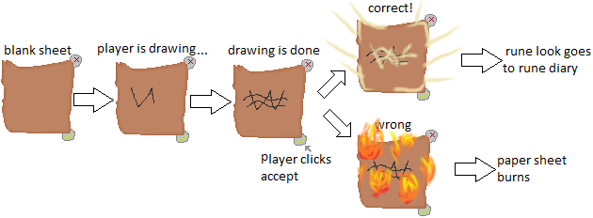

#### c) How to use them?

There will be four main ways of using runes. These are:

1. Painting them on stones (stone rune)
2. Painting them on a ground
3. Painting them on armor
4. Painting them on weapon

First method is about placing these stone runes on the ground (at least two) so they can form a barrier by linking with each other. Each rune of this type will have different impact on demons

Second method is about painting runes on a ground. This works similar to stone runes, but with limited time (after this time barrier breaks) and an amount of health divided by 2.

Third method is about taking hits from demons on our brand new painted (or scribbled, depends on player’s painting skills) armor. In short, the damage will be lower than without runes.

Fourth method is about dealing damage to demons with our rune-painted weapons. The damage of these weapons will be far more higher than damage dealt by mere, not painted weapons.

### 6. Animals & Creatures

[**Chapter 3: Enemies and player’s attributes**](#_15._Enemies)

Let’s make something clear. It is important to distinguish these two things. Animals are:

1. Wolves
2. Bears
3. Deers
4. And many other wee see in our real world

Creatures are:

1. Trolls
2. Giants
3. Rubalts
4. Nearly everything else besides Demons (they are another, third kind of living things)

The main difference between these two type of entities is loot they offer to the player. While hunting wolves, bears and deers you should expect looting paws, skins, teeth etc. But while you’re hunting trolls, giants or rubalts, you will loot things like gold, iron, equipment and this kind of stuff.

### 7. Hidden treasures

[**Chapter 3: Hidden treasures (example of how it should be implemented)**](#_8._Hidden_treasures)

Beside getting equipment and valuable items from creatures and crafting, there will also be other way of achieving cool stuff. Hidden treasures will allow players to get what is inside them as soon as they find them/fight their way towards them. These treasures will be hidden all over the world.

### 8. NPC quests (idea behind it)

[**Chapter 3: NPC quests & errands (specification)**](#_7._NPC_quests)

In this game players will not encounter quests like “Kill 5 wolfs” or “Kill 10 rats in the basement” that has no impact on the game. Even if quests like that were about to take place in Prevent From The Darkness, they should have some kind of reflection in the game world. Chapter 3 covers how I see it thoroughly.

### 9. Housing

[**Chapter 3: Housing**](#_13._Housing)

Players will be able to buy houses in the city in which they can store all kind of things they want. These things will be exposed, so everyone will be able to see them, yet no one will be able to steal them (because they are on a private property!). In house, player will recover fast (regenerating

## Chapter 3: Game in details. HOW to do things mentioned in the previous chapters (2) and (1), HOW they should look like

“Can you hear the roars outside the gate, Furan? Can you hear them dying of lust for our flesh and blood? Tonight, For the first time in the history, they’ll hear our roar, either.” ~ The Captain of The Great Gate, staring down at the raging demons.

If you are looking for WHAT the world is supposed to look like, you should visit chapter 2.

### 1. Specification and hints about the game world (harmony, music, graphics)

|  |  |  |
| --- | --- | --- |
|  |  |  |

#### a) Graphics

The game map and all the fauna of the game world is supposed to be represented fully in 3D low poly models. The palette of colours should make an impression of rather dark, raw, real-like world, than colorful „candy-like” childish world. The reality of the game is tough, therefore the look of it should represent and emphasize that. The game should create the feel of harmony, so the player can believe it and dip into it really hard. That means, there is no way to put in a small area snowy mountain with hot desert just next to it and a guy in a rabbit costume in the middle of all that. The things and their shapes in the game world should fit into times they are put in. That means, medieval-like times with no modern things, or any other things that would not be reliable for the player.

#### b) Music

The music in the game should be mostly compound of sound of nature, such as: howling winds around the mountains and in most of the places of The Frozen Pikes, howling wolfs, roaring bears, rustling wind in the forest, water dripping from the cave’s ceiling, sounds of deers, stomping giants, squeking monstrous spiders and all other animals and creatures living in the certain piece of the game world. All of them are supposed to create the feel of ambience of the land the player goes through. The sounds in the city would be something like: people talking to each other in the distance while walking the streets, sounds of hitting anvil coming from the smithy, barking dogs, knocking plates and cups in the tavern.

### 2. Player entering the world

|  |  |  |
| --- | --- | --- |
|  |  |  |

#### a) Entering the world (game phase from tutorial to achieving freedom)

Player can refuse attending to tutorial. This way, he just have to wait for sleigh to come from the Frozenig to the New Home. This is because driving players to the city by sleigh takes real time. It is not a teleport to the city, but travelling there and everyone can see freshmen coming to the town. The travel time should oscillate between 2-3 minutes for each route. Sleigh can gather up to about 50 players. Everyone who wants to enter it, has to physically walk in there. The NPC standing next to the place of departure will be announcing things such as: how much time players have to wait for sleigh to come and how much time ride will take. The player can also ask this NPC about various things about the city, like: where to go first, where to find certain shops, tavern, bank etc. When sleigh comes, the driver waits about 2-3 minutes for everyone to enter, then closes the sleigh’s side and rush reindeers riding towards the city. The road sleigh will travel through is the same that players after tutorial can walk by, so if anyone stands in sleigh’s way, he/she will be pushed on the side with stun effect for about 5 seconds. If players in sleigh log out (on purpose or by losing connection, for instance) then he/she is automatically teleported to the New Home (starting area) and has to wait for another sleigh to come.

#### b) Attributes & Statistics & Abilities at the start

Player at the start of his/her journey will have one ability “attack” although he/she will not have any weapon to use this (except bare hands… if that pleases anyone).

All of his/her attributes will be at their default level, that is, 0.

Player’s basic statistics will be 100 points of health and 200 points of durability.

Player’s reputation will be neutral (0 points) while entering the town for the first time.

### 3. Player’s graphical interface (before logging in GUI and HUD, after logging in GUI and HUD, in-game GUI and HUD)

|  |  |  |
| --- | --- | --- |
|  |  |  |

Although all aspects of GUI will be thoroughly tested and many of them changed, I created wireframes of how they should look like in general.

#### a) Three main wireframes

This is what player will see before loggin in to his/her account, just after opening game file: 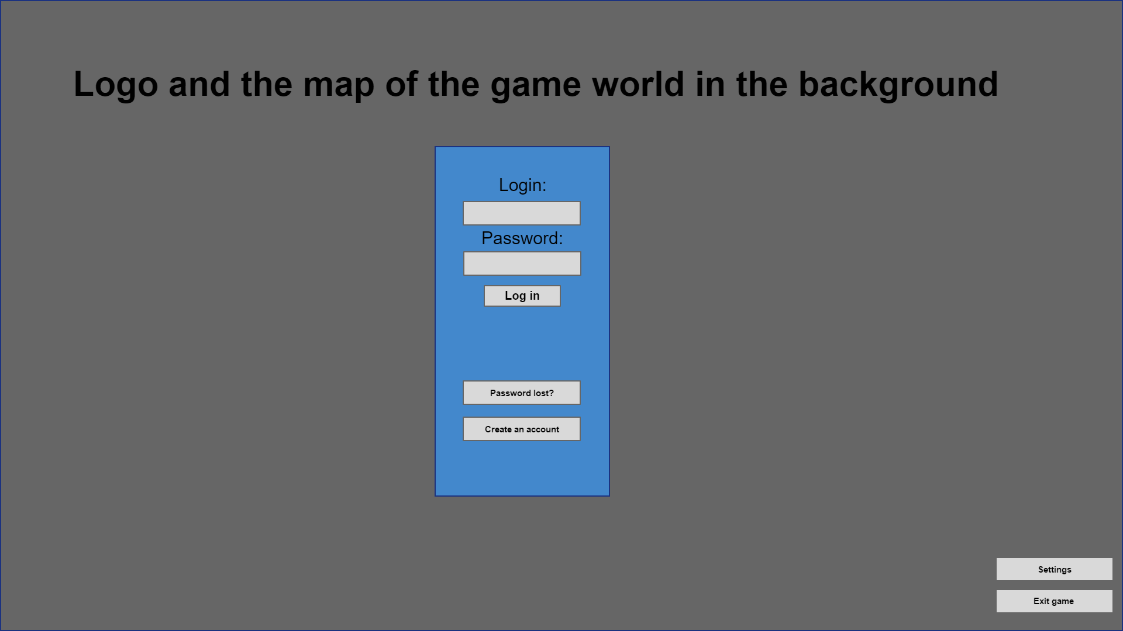

First wireframe contains some basic stuff that every MMORPG game has.

This is what player will see after loggin in, but before jumping into the game world: 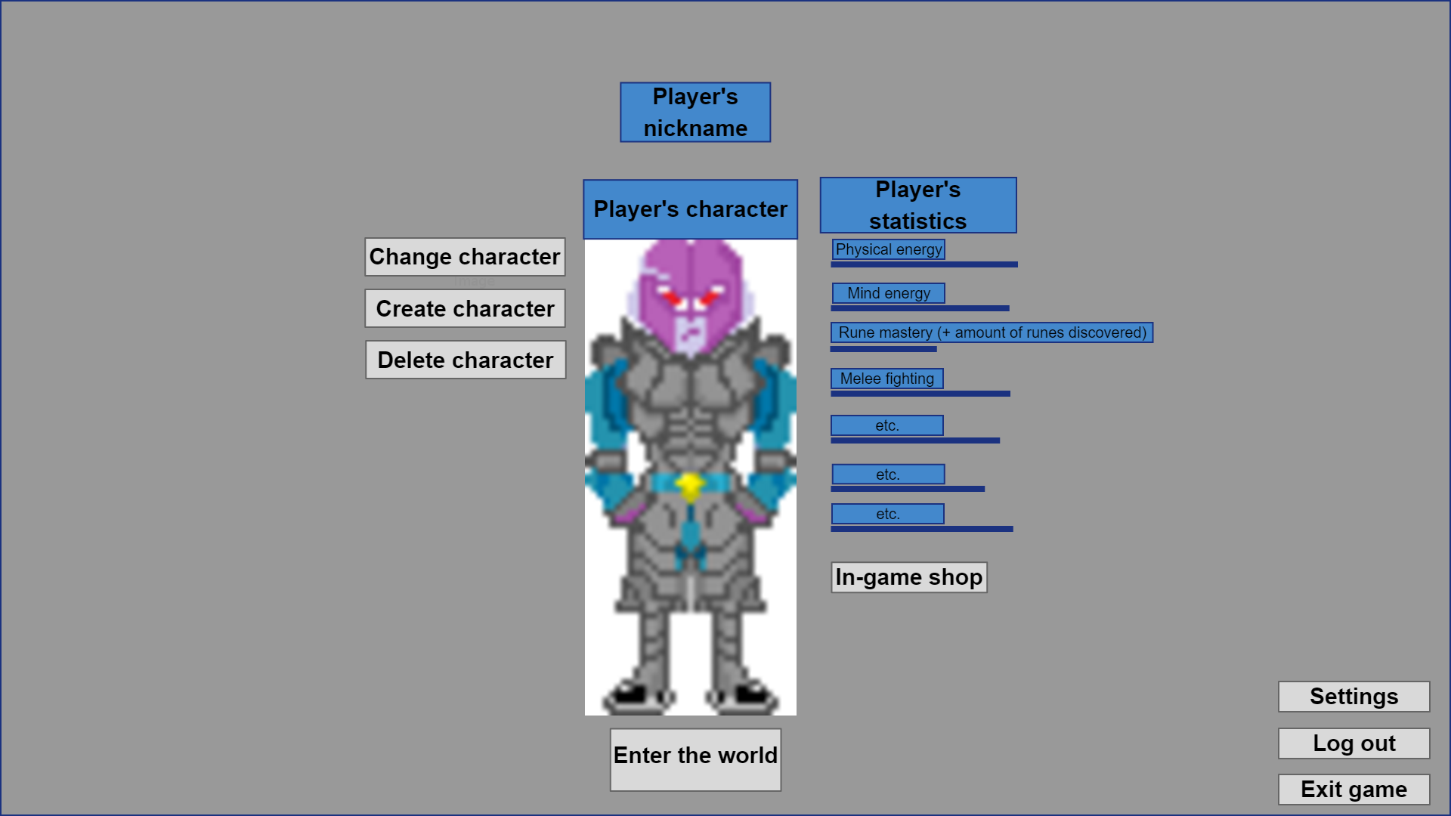

This wireframe contains „In-game shop” button. This buton will transfer player to item shop where he/she will be able to buy some non pay-to-win things for real money. The buton will not be here if the game will not have item shop itself, of course.

Names of player’s statistics can also be changed in time (like Durability instead of Mind Energy etc.).

This is what player will see after entering the world: 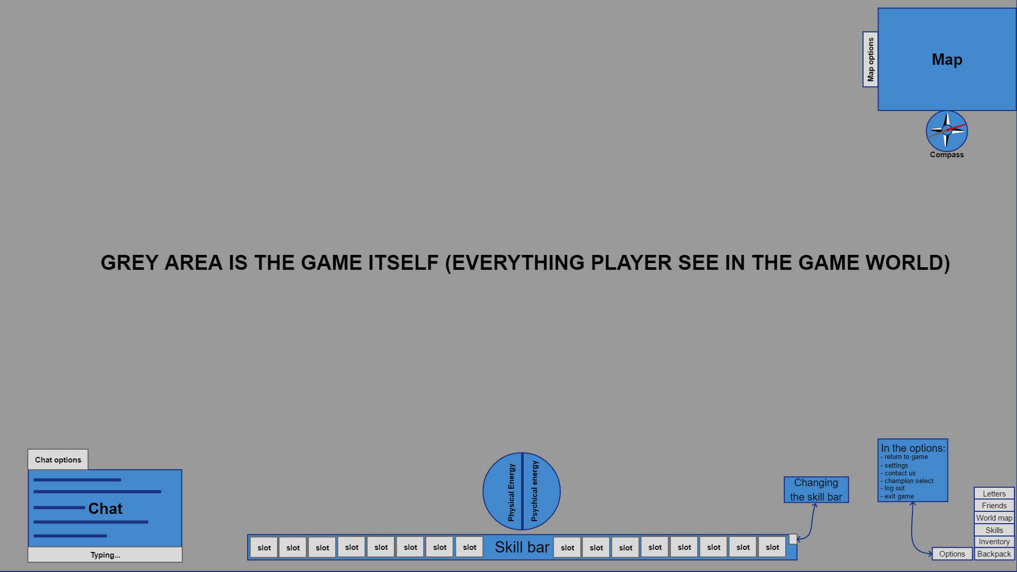

Player’s in game interface should be as easy to understand as it is possible. Again, many things will possibly be changed here during development process.

#### b) Style of GUI and HUD

All three, or at least third wireframe should have look reflecting the in-game feel of the world. I am considering two options here.

First one is about creating one look of a in-game GUI and HUB (frame around the whole window, chat, skill bar, buttons, map) that will show all its elements stylized on a medieval-like elements and main materials. Therefore, borders of these GUI and HUB elements can look like they were made of wood or stone, for example. And that will not change during the game.

Second one is about creating many looks (patterns) of a in-game GUI and HUB (frame around the whole window, chat, skill bar, buttons, map) each for a specific locatization player will be walking through, in a certain moment. For example, if player walks through a forest, then all these frames I talk about will be forest-wood-like with leafs and branches on it. After he enters the cave, they can change into something stone-rock-like with water drops dripping off it. What I mean is that player’s GUI and HUB would adjust to the area player walks through in order to **harmonize** with it.

#### c) Screenshot mode and hiding elements of GUI

There should be an option that will hide all of the buttons and elements of in-game GUI and HUD so player will be able to see just bare game world, in purpose of creating a screenshot, for example (or playing that way, if someone likes so).

There should be also a possibility of hiding each element of the GUI and HUD separately. That is because there are players that actually do not like having chat or skill bar displayed all the time.

### 4. Default controls (moving) and ways of interacting with world (opening doors, talking to NPC’s, fighting, moving items etc.)

|  |  |  |
| --- | --- | --- |
|  |  |  |

Default controls will cover:

1. W,A,S,D for moving character. When pressing W, character goes north. When adding D to that, character goes north-east. Same goes with every other direction. When W is pressed first and then S, player goes south but face turned into the north. Same happens with every other direction. When buttons are released, character stops immediately
2. Moving by pointing and clicking mouse right buton.
3. Changing character’s looking direction by left clicking mouse left buton
4. After player set direction by clicking left mouse button (east, i.e.), he/she can push CTRL + S button to move in the opposite direction (west) but staring at the direction set by mouse. When this activates, player can use mouse to do other actions in the game and character will still walk in this way. CTRL can be released, too. This button is needed to activate this specific walking mode. Only S button has to be pushed all the time character is walking. When this button is released, character stops immediately. When pushed again, character walks south with face turned into south, not in the direction set by mouse, as before.
5. Way of moving is improtant because of the fighting system the game will contain. The player’s character will not turn automatically to the direction of the monster, but player will have to do it himself by left clicking mouse or W,A,S,D keys. This will be really important because if player is turned to the west, and monster is on the east side, player will not have a chance of hitting it or throwing spear/bomb or shooting with bow/crossbow towards his/her target, even if it is targeted by right clicking it.
6. Interacting with game objects such as doors (opening them), chests (opening them) will be possible by coming close to these and pressing E button, right click or by CTRL + mouse right click (unveiling list of things possible to do with certain object) and selecting „use” option.
7. Targeting monsters is possible by right clicking them or pressing CTRL + mouse right click (unveiling list of things possible to do with the monster) and selecting „attack”. Right clicking again or pressing CTRL + mouse right click and choosing „stop attack” will stop targeting monster.
8. Throwing things, like explosive powders, toxic fluids or bombs will not be targeted, but player will have to aim himself/herself. First, he/she will have to right click this kind of item in the backpack, or use it by pressing button this item is assigned to in skill bar and then point and click by mouse in the certain area on the screen. This is the area where the projectile will be thrown at.
9. Player can use CTRL + mouse right click at any in-game object. That will unveil list of things possible to do with this object. Mainly it will be option like „what is it” when it is a non-interactive thing or „use” in addition to that when it is an interactive thing, such as doors.
10. I button for opening inventory, M button for opening full map, F button for opening friend list, T for attributes
11. By dragging item from inventory (or ground) player will be able to „throw” it somewhere else by dropping it in the certain area of the screen he/she choose with mouse.
12. To talk to the NPC player has to type „Hello”, „Hi”, or „Good morning/afternoon/evening”. Then interaction windows will occur. Player will have to write what he/she wants to do. Available options will be highlighted. This can look like this: Hello (starting) → Sell (choosing what to do) → Troll Armor (what to sell) → 5 (amount) → yes (accepting offer) → Bye (ending conversation).

Button attribution wil be changeable in options.

### 5. Equipment (types, upgrading)

|  |  |  |
| --- | --- | --- |
|  |  |  |

#### a) What equipment is?

By term “equipment” I mean:

1. Defensive parts of player’s outfit (shoes, legs cover, armor, shield)
2. Weapons
3. Utility items (potions, runes, bandages, bombs, explosive powders etc.)

#### b) Requirements

Equipment player will be able to get in the game will not be divided into level barriers, as we can see in every othe MMORPG, and not only MMORPG game. Instead of that, players will have to meet other than level requirements (because there are no levels).

When it comes to the defensive equipment (shoes, legs cover, armor, shield) factor that will decide whether player can or can’t wear some item will be player’s **robustness** attribute (the stronger player is, the better equipment he can wear).

When it comes to the weapons, the factor is: **melee/range attribute** (depending on the weapon player wants to wear, of course)

When it comes to utility items, the factor will be mainly **resourcefulness** (for all items of this kind) plus some of the utility items, like bombs and explosive powders will demand some **range** attribute, in order to use it correctly.

#### c) What if player does not meet requirements

When that happens at player’s will of putting on some defensive clothes or weapons, he/she simply will not be able to wear it (communicate like „I am not strong enough for that…” can occur on the player’s screen).

But when it comes to utility items, let’s say bomb that requires 30 resourcefulness attribute and 20 range attribute. Player will be able to throw it if he/she meets at least the resourcefulness requirement (if he/she does not meet the requirement, then he/she can’t use the utility item), but with some side effects depending on how much of the second attribute he is lacking. Side effects can be:

1. 50% chance of dropping bomb under his/her own feet and therefore damaging himself/herself. Happens when the level of second required attribute is under 1/3 of the required level.
2. throwing in the wrong direction (even if player aims correctly). Happens if level of second required attribute is under 1/2 of the required level.

#### d) Upgrading equipment

In order to upgrade equipment players will have to go to the Smith and pay for upgrading their stuff.

There will be 5 levels of upgrading:

1. from 0 to 1 - 20 % chances of breaking an item
2. from 1 to 2 - 40% chances of breaking an item
3. from 2 to 3 - 60% chances of breaking an item
4. from 3 to 4 - 80% chances of breaking an item
5. from 4 to 5 - 95% chances of breaking an item

Broke item is being destroyed.

### 6. Economy (the flow of gold, NPC’s shops)

|  |  |  |
| --- | --- | --- |
|  |  |  |

In chapter 2 I described ways of earning money. Here is something more about the whole gold flow in the game.

Money earned by player can be spent in NPCs’ shops or other services such as upgrading equipment at smithy. This will prevent the inflation and the endless flow of generated gold (killing creatures and selling items to NPCs)

Other way of disposing money out of the game world is paying for new abilities and titles in the alchemist/knight/hunter guilds.

To slower inflation process, earning gold in game should be quite difficult. For example, basic potion from NPC shop will cost about 40 coins. One hour of hunting bears and collecting skins, teeth, paws etc. will give player (depends on the loot, of course) from 500 to 3000 gold selling these things at NPC’s shop. Therefore player will be able to buy from 12 to 75 potions which he/she will use in a matter of minutes of fighting against something stronger (creatures/demons/animals/players). The tougher enemies, the higher reward will be, of course. Thanks to that money in the game world will be valuable and worth fighting for. Players will also have to think twice before jumping into fight or a cave they do not know.

### 7. NPC quests & errands (specification)

|  |  |  |
| --- | --- | --- |
|  |  |  |

This is how I see quests in this game:

Player accepts quest from the Smith Ben. The NPC tells player to bring him some amount of iron. In order to do that, player have to go hunt some creatures that drop iron or dig it up himself/herself. After completing the quest, ALL PLAYERS that come to Smith Ben will have higher chance of upgrading stuff for some time (30 minutes, for example). Besides that, player that fulfilled the quest will get some amount of reputation and after some time (after completing this quest 50 times, for example) an outfit (like iron guardian, or iron supplier/contractor).

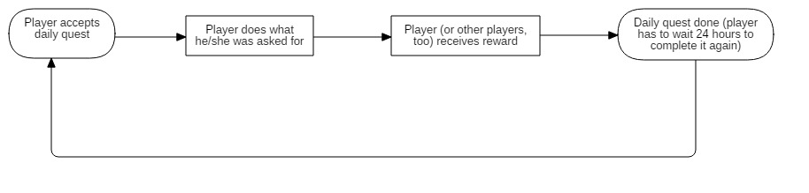The flow of the daily quests:

So, as you can see, after completing the quest player will have a feeling of impact into the world (everyone will gain something because he did a quest) and still everyone can do that in order to get reputation, higher upgrading chance (if no one did quest in last 30 minutes) and an outfit after fulfilling quest many times.

Beside quests, there will be also errands player can take on from a given NPC. During errand player have to kill some amount of monsters in order to receive a prize. They are repeatable, with no cooldown.

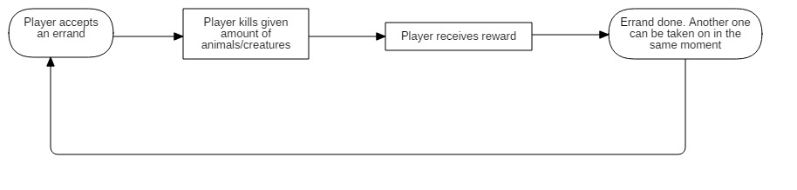This is the flow of errands:

### 8. Hidden treasures (example of how it should be implemented)

|  |  |  |
| --- | --- | --- |
|  |  |  |

Treasures, mostly in the form of chests located in the variety of places in the game world will be achievable by everyone who manages to find them or fight his/her way towards the treasure. Some of them will require certain amount of resourcefulness to be opened. That is in order to prevent beginners from achieving powerful stuff just because somebody lead them to the treasure. In this case the following communicate “I do not know how to open it” will occur on the player’s screen.

### 9. Crafting: Item making (weapons, leather and iron armors all in one profession)

|  |  |  |
| --- | --- | --- |
|  |  |  |

Crafting and doing things related to crafting will improve player’s “Item making” attribute. Player will be able to craft things in the smithy at the one of a few prepared posts. Player can start his/her journey with “item making” by starting a talk with a smith and asking him for some easy-to-make things. This is when he/she will get some basic recipes and will be able to go craft them using one of the crafting posts.

Most of the things player will craft in his/her game life will be recipes found in the game world (in treasures or from creatures). Another way of getting recipes will be “studying” items. What I mean is player will be able to do CTRL + right click on the item and then choose “study” option in order to get a recipe of this certain item. In order to do that, player will have to have at least one paper sheet for each recipe he/she will get by studying things. Player will get a recipe from studying item if his/her item making attribute is high enough. If not, the following communicate will occur “I have no idea how this piece was made.” On player’s screen. Player will not know what item making level he/she needs in order to study some kind of equipment. This information will be written on the recipe after he/she succeeds in one of the attempts. Player will be able to make many recipes in order to sell them to others, for example.

There will be two three ways of increasing item making attribute:

1. Studying equipment (and getting recipes out of it)
2. Studying crafting items (like iron, leather)
3. Crafting things

Thanks to housing system, player will be able to craft items in his/her property, by buying blacksmith tools (same goes with alchemy).

**!** Keep in mind that “recipes” are paper sheets (same as needed for painting runes) filled with a formula of making some kind of thing (wearable item or bomb, for example). Player will be able to use this recipe at the crafting post by putting it into the post. After that, he/she can craft items using this recipe. Recipe will fall apart after a few uses. That means that constant flow of recipes will be needed (that strengthen gold flow in game). Player can make many recipes out of one item (an armor, for example)

If player’s attribute in item making is too low for a recipe he/she is using, then item made by that player will be weaker than it would be if player looted it from creature. If player’s item making attribute is higher, then crafted item will be better than it would be if player looted it from creature. This can be shown in this way:

1. Player has less than 50% item crafting level needed (item is from 100% to 50% worse than by default)
2. Player’s item crafting level is from 50% to 100% of needed (item is from 50% to 0% worse than by default)
3. Player’s level is from 0% to 50% better than needed (item is from 0% to 50% better than by default)
4. Player’s level is from
5. 50% to 100% better than needed (item is from 50% to 100% better than by default)
6. Player’s level is more than 100% better than needed (item is between 100% to 200% better than by default)

These crafted items can be marked with colored names in order to distinguish better from worse. Their statistics will distinguish them, too.

### 10. Crafting: Alchemy

|  |  |  |
| --- | --- | --- |
|  |  |  |

Gathering plants and things needed for alchemy crafting will not improve alchemy attribute, but studying these things will certainly do. Studying them will. There will be two ways of studying. First is studying certain alchemy equipment, like: bombs, potions, bandages which (if studied successfully) will give player recipe (same as needed for painting runes, so player will have to carry a few of them) which he/she will be able to use at one of the alchemy posts located in alchemy guild or in his/her house after buying alchemy post on his/her own. Second way of studying is studying items like herbs and plants that will not give player any recipe but will slightly improve his/her alchemy attribute. There will be three options of increasing alchemy attribute level:

1. Studying Equipment (bombs, bandages, potions)
2. Studying crafting items (like herbs, plants)
3. Crafting things

**!** Keep in mind that “recipes” are paper sheets (same as needed for painting runes) filled with a formula of making some kind of thing (wearable item or bomb, for example). Player will be able to use this recipe at the crafting post by putting it into the post. After that, he/she can craft items using this recipe. Recipe will fall apart after a few uses. That means that constant flow of recipes will be needed (that strengthen gold flow in game). Player can make many recipes out of one item (a potion, for example)

If player’s attribute in item making is too low for a recipe he/she is using, then item made by that player will be weaker than it would be if player looted it from creature. If player’s item making attribute is higher, then crafted item will be better than it would be if player looted it from creature. This can be shown in this way:

1. Player has less than 50% item crafting level needed (item is from 100% to 50% worse than by default)
2. Player’s item crafting level is from 50% to 100% of needed (item is from 50% to 0% worse than by default)
3. Player’s level is from 0% to 50% better than needed (item is from 0% to 50% better than by default)
4. Player’s level is from
5. 50% to 100% better than needed (item is from 50% to 100% better than by default)
6. Player’s level is more than 100% better than needed (item is between 100% to 200% better than by default)

### 11. Game difficulty level

|  |  |  |
| --- | --- | --- |
|  |  |  |

There will not be too many strong animals and creatures near the town, but in order to keep the game world real, there will be some tough enemies. What I mean is setting difficulty level in this way:

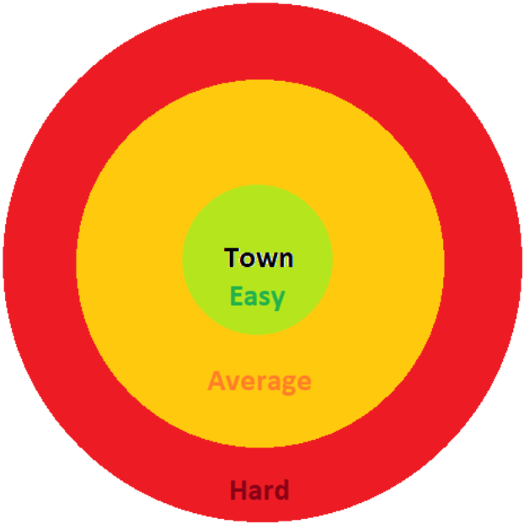

Is boring and takes player’s feeling of immersion and genuineness of the game world out. The borders between easy and average difficulty level should not be precisely outlined. The way I think it should look like is something like this:

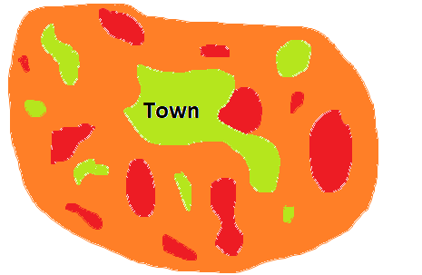

Placing animals and creatures in order to paint difficulty level in this way makes player to:

1. Think twice before jumping in the closest cave outside the town (which creates a feeling of unknown hidden in the game world thus making immersion higher)
2. Explore the world in order to find appropriate location for fighting creatures/animals (while the ones near the town can be occupied by other players). That prevents game from becoming boring and supports player’s inner voyager’s nature (if someone has one, though).

### 12. Storing things and money

|  |  |  |
| --- | --- | --- |
|  |  |  |

Players will be able to store their things in the special safe. Every player will have to beforehand speak to the NPC banker and pay for a unique key (numbers and letters) he/she will further use each time he/she will want to open his/her safe. Player can give the key to another player so they can open his/her safe. NPC banker will be also responsible for managing players’ money. They will be able to open their bank account with the same unique key they use for storing items. The difference here is in the fact, that items can be put and manager inside the safe by player, while money are managed by NPC banker. Player will be able to deposit and withdraw money, as well as check his/her account balance and compare it to average amount of money players have.

### 13. Housing

|  |  |  |
| --- | --- | --- |
|  |  |  |

In the house player will recover twice as fast as in the game world outside the safe areas (because inside them he/she will not regenerate, at all). When sleeping, he/she will recover four times faster than outside safe areas.

Character has to have at least 20 resourcefulness attribute to buy a house (by a starter price) and one house can be assigned to one character in the same time. Player will be able to sell the house to other players establishing his/her own price. He/she will be also able to invite guests in to the house, as well as throw them out. In order to do that, player will have to write or delete somebody’s name on the „guest card” placed by the left/right side of the entrance door.

### 14. Safe Areas

|  |  |  |
| --- | --- | --- |
|  |  |  |

Places such as tavern, smithy, temple, safe and bank (and many other, too) will be excluded from PvP, just to keep any semblance of rules of law! All other areas will allow PvP.

### 15. Enemies (animals & creatures) and player’s attributes

|  |  |  |
| --- | --- | --- |
|  |  |  |

### a) Player’s attributes

The stronger enemy (every type of enemy, excluding player) the more melee/range, shield and robustness attributes player gets. This is the mechanism that will encourage players even more to fighting stronger and stronger enemies. Player will know whether monster which he/she is killing are appropriate for his skills by attributes’ colors itself. There will be 5 main steps in this matter:

1. Dark green color of the attribute says that training is extremely efficient (100%)
2. Bright green color of the attribute says that training is very good (75%)
3. Orange color of the attribute says that training is proper (50%)
4. Red color of the attribute says that training is bad and slow (25%)
5. Black color of the attribute says that training does not occur (0%)

These states will be calculated via in-game formula that will take into consideration player’s attribute level (melee fighting and shield mastery, for example) and hidden from players level of monster power. This will work like that:

1. Player’s attribute is weaker than enemy’s power (Dark green = 100%)
2. Player’s attribute is equal or 25% higher than enemy’s power (Bright green = 75%)
3. Player’s attribute is higher from 25% to 50% than enemy’s power (Orange color = 50%)
4. Player’s attribute is higher from 50% to 75% than enemy’s power (Red color = 25%)
5. Player’s attribute is higher from 75% to 100% than enemy’s power (Black color = 0%)

#### b) Enemies (behaviour, bosses)

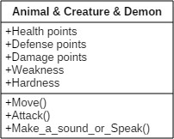This is what all enemies are compound of:

Animals and creatures will follow player up to the border of their spawn point. After that point, they come back twice as fast to the point where they were spawned.

Animals and creatures fight with other animals and creatures and player is not their priority. Nevertheless when player hit them, they stop attacking anything else and attack player. If they do not see any other animal, they immediately attack player.

Not all animals attack player without his attempt of killing them. These are deers and rabbit, for example.

2% chance of respawning a boss of the given entity (if there are furry wolves, it could be The Homicidal Fang, for example) each day (game day). The boss has higher statistics and gives a possibility of getting better loot of out it.

### 16. Combat

|  |  |  |
| --- | --- | --- |
|  |  |  |

In-game combat will not happen automatically just after targeting enemy. In order to hit the enemy, player will have to:

1. Target it/him/her with right click of the mouse
2. Use one of his/her abilities (like a simple hit while being melee or bow/slingshot/crossbow shot while being range, for example)
3. Stand within the appropriate angle relatively to his/her enemy (no more than 90 degrees)

There will also be a possibility of blocking incoming hit. In order to do that player have to:

1. Have a shield and appropriate ability (achievable in level 20 of melee fighting)
2. Be in the appropriate angle relatively to his/her enemy (no more than 90 degrees)
3. Wait to the appropriate moment (during monster’s hit animation) and press button with assigned block ability to it.

If block is successful, player will get less or none damage than he/she would without using block. Nevertheless, block will not work everytime even if player uses it correctly (that is because of the formula taking into consideration player’s shield mastery and monster’s power)

There will also be a possiblity of dashing incoming hit. In order to do that player have to:

1. Have an appropriate ability (achievable in level 20 of range fighting)
2. Wait no longer than to the moment of monster’s hit animation and press button with assigned dash ability to it.

If dash is successful, player will bounce to the side (the side will be chosen by pressing W/A/S/D button previously, just before the dash. If dash is not successful, then player will get more damage than he/she would without attempting to dash upcoming hit (25% more).

Players will have to wait 1.5 second between each attack dealt (cooldown).

All damage dealt when enemy stands with his back to player is increased by 50%.

### 17. Demons

|  |  |  |
| --- | --- | --- |
|  |  |  |

This is what enemies (including demons) are compound of:

Demons will be highly immune for player’s hitting them with weapons are not covered with runes. This kind of damage will be lowered by 75% (from 100% to 25%).

Demons themselves will be very, very strong (weakest demon’s strength will be comparable to the strength of the strongest animals/creatures living in the game).

Demons live and hunt in groups. It is a rare situation in which demon travels alone through the land.

They spawn at the beginning of the night (after the last ray of light is gone)

They hide in the nearest cave they find when the morning comes. If players block cave entrance by placing runes, then demons goes mad dealing twice as much damage, they should also yell more then and have some visual effect on themselves, that will add more fury to their look. If players withstand demons’ powerful attacks, demons dies burning cause of the sun light. Then, players can loot them.

Demons seek for any meat they can find, therefore they kill every living thing they meet (deers, bears etc.). If they see player, he/she is their priority.

Demons change their target quite often and follow it to the end of the world.

### 18. Handling players’ garbage

|  |  |  |
| --- | --- | --- |
|  |  |  |

Players will be able to throw unneeded items to the trash can. Things thrown on the ground will be taken after a few minutes by the flying bird (yeah, I know, it is ridiculous) that will physically fly to the item, grab it into its claws and throw it to the water (whatever it is). This is just so funny and different from what we can see in games nowadays.

### 19. Food and regeneration

|  |  |  |
| --- | --- | --- |
|  |  |  |

Player will regenerate his/her health and durability by eating food.

1. If player is full (100% - ate approximately 5 chicken legs) his/her regeneration is doubled (10 hp every 5 seconds and 20 durability every 5 seconds)
2. If player’s feed state is from 50% to 100% (2 chicken legs), his/her regeneration is basic (5 hp every 5 seconds and 10 durability every 5 seconds)
3. If player’s feed state is from 0% to 50% (no food or 1 chicken leg) his/her regeneration is lower than basic (2 hp every 5 seconds and 5 durability every 5 seconds)

### 20. How attributes work & relations between them (balance)

|  |  |  |
| --- | --- | --- |
|  |  |  |

A list of attributes:

1. Resourcefulness (Overall power)
2. Robustness
3. Melee fighting
4. Range fighting
5. Alchemy
6. Shield mastery
7. Equipment crafting
8. Rune Mastery
9. Fishing

Resourcefulness is calculated by summarizing all levels of player’s attributes together and it increases player’s overall durability and slightly increases his/her moving speed. It strengthen damage player can deal.

Robustness grows while player is being hit by animals/creatures/other players/demons and it increases player’s amount of health.

Melee fighting grows while player is hitting animals/creatures other players/ demons by any kind of melee weapon and it increases player’s damage while using melee weapons.

Range fighting grows while player is hitting animals/creatures other players/demons by any kind of range weapon and it increases player’s damage while using range weapons.

Alchemy grows while player is studying equipment, studying crafting items or crafting items himself/herself and it increases player’s chance of studying equipment/items as well as a chance for successful and better crafting.

Shield mastery grows while player uses block ability and succeeds in it and it lowers damage taken by player while blocking incoming hit.

Equipment crafting grows while player is studying equipment, studying crafting items or crafting items himself/herself and it increases player’s chance of studying equipment/items as well as a chance for successful and better crafting.  
  
Rune mastery grows as player paints runes. It adds a great amount of resourcefulness.  
  
Fishing is described below, in [point 28](#_28._Fishing).

Three of these attributes will have impact on the others. They are

1. Melee fighting
2. Range fighting
3. Alchemy

Each time melee fighting attribute raises, player’s talent for training range fighting and alchemy lowers by as many % as player’s melee fighting attribute is.

Each time range fighting raises, player’s talent for training melee fighting and alchemy lowers by as many % as player’s range fighting attribute is.

Each time alchemy raises, player’s talent for training melee fighting and range fighting lowers by as many % as player’s alchemy attribute is.

These conditions summarizes when player trains both range fighting and alchemy, for example. If his/her range fighting is 30 and alchemy is 20, then his talent for training melee fighting is lowered by 50%.

### 21. Abilities

|  |  |  |
| --- | --- | --- |
|  |  |  |

Each time player uses ability, his/her durability statistic lowers by certain amount of points specified by certain ability requirement (cost).

Each ability will have its cooldown with length depending on how powerful ability is.

Player will be able to learn ability at one of the guilds in the game world as soon as he/she meets requirements and has money to pay for the ability. After buying it, ability goes to player’s ability diary. Then, he/she can grab and assign each ability to hotkey on the skill bar.

### 22. Game objects hierarchy

|  |  |  |
| --- | --- | --- |
|  |  |  |

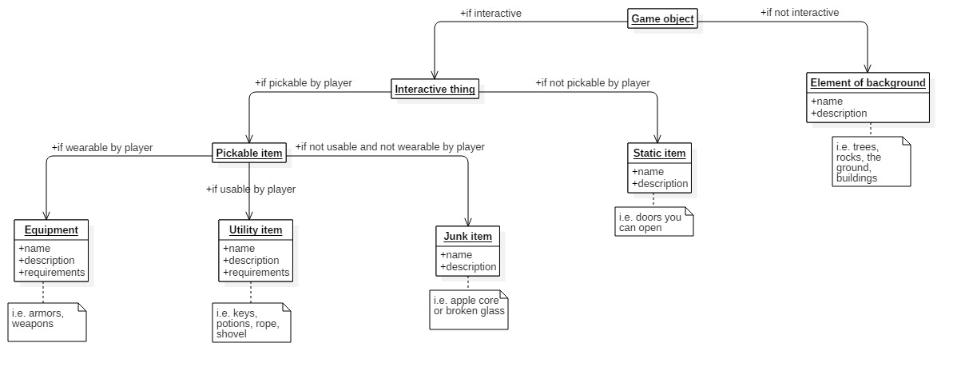The chart describes how all game objects should be described:

### 23. Game flow

|  |  |  |
| --- | --- | --- |
|  |  |  |

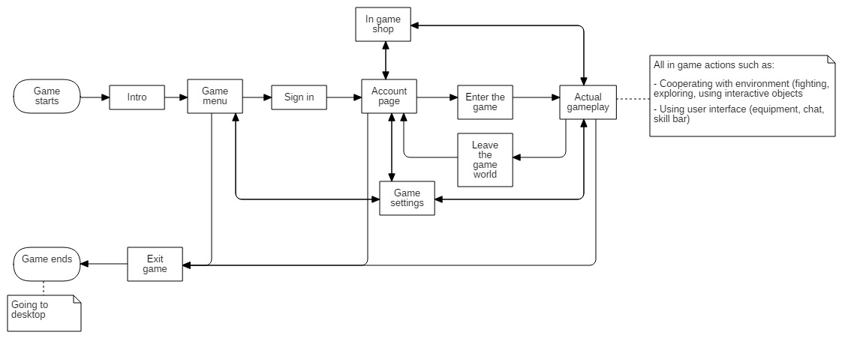This is a flow chart of all the actions user can choose from inside the program.

### 24. PvP, castle battles, hour of purge (restrictions, rules)

|  |  |  |
| --- | --- | --- |
|  |  |  |

#### a) PvP

Oh… killing. Who does not like this feeling of pure power while standing on the corpse of his/her dead opponent? I love it. And I hope players do too, because this game… it is going to be like a PvP simulator!

Players will be able to attack everyone everywhere unless they are in the safe zone (tavern, bank, smithy, for example).

To attack another player, players just have to right click him. In this moment, red clenched fist will appear next to the aggressor’s head/nickname. Everyone will be able to see it. In the moment of attack player also get condition that forbids him/her from entering the safe zone for next 5 minutes. After killing other player this turns into 10 minutes. After this amount of time (5 or 10 minutes) player can enter safe zones and he loses this red clenched fist hanging around his head/nickname.

If attacked player defense himself fighting with aggressor, he/she gets only 1 minute of condition forbidding him from entering safe zones. He/she will also have an icon of shield hanging around his/her head/nickname. If he/she kills the aggressor, he/she still have just 1 minute of condition.

Any other player who hits the aggressor gets 1 minute of condition and 5 minutes after killing him/her. Players like that have the icon of crossed swords hanging around their heads.

Conditions do not stack. They refresh each time player hit/kill someone.

There are some conditions while being aggressor (not just for hitting others, but for killing them). Aggressor’s reputation drops heavily each time he/she kills someone down to the point where it would be extremely hard for him to do anything in the town (NPCs will not talk to him and items in shops will be extremely expensive). If player kills more than 10 people per day or 20 people per week he/she will be teleported to jail for a few days (real days).

#### b) Hour of purge

But there will be a game mechanic called “hour of purge” in which killing others will not be considered as a bad act and NO CONDITIONS will be put on the player (no jail, no reputation drop).

### c) Castle battles

Near Frozenig (capital) will be a castle that once a week players will have to fight for.

To take part in the fight players have to be in the guild. Only guild will be able to win the castle (although players withouth guild can fight for the castle, too). All the week players will be able to sign up for the castle fight (the ones with no guild, too) so they will not get any conditions for killing each other within the time of castle fight.

The fight will last about from 6:00 PM on Saturday to the time when battle is won. In order to win the battle, guild members have to stand within certain borders in the castle hall. Only they (players without any guild can stay there too), without any player from enemies’ guilds. They have to stand for about 15 minutes. If they manage to do this, they win the battle and own it for next 7 days, when

Steward of the castle (leader of the guild that won the battle) do not have to sign up the guild for the next fight. It is done automatically.

There will be no number limit of guild and players that can take part in castle battles.

Guild that manages the castle (won the battle) gets 10% of all city income into its “treasure room”. Income is gold that players spend in all NPCs’ shops/services. Gold fills castle’s treasure room everytime any transaction is done.

Only guild leader has a right to enter treasure room and take gold out of it. He/she has to talk this case through with his/her guildmates.

### 25. Reputation

|  |  |  |
| --- | --- | --- |
|  |  |  |

Reputation increases when player do something for NPCs and when he/she kills demons.

Reputation drops when player kills other players.

There will be 8 steps of reputation:

1. More than 10000 reputation (all prices in NPCs shops are divided by two)
2. From 1000 to 10000 (all prices in NPCs shops are lowered by 20%)
3. From 500 to 1000 (all prices in NPCs shops are lowered by 10%)
4. From 0 to 500 (normal prices)
5. From -500 to 0 (all prices in NPCs shops are increased by 10%)
6. From -1000 to -500 (all prices in NPCs shops are increased by 20%)
7. From -10000 to -1000 (all prices in NPCs shops are multiplied by two + some of the NPCs will not talk to that player)
8. Less than 10000 reputation (all prices in NPCs shops are multiplied by five + some of the NPCs will not talk to that player)

Beside that, depending on the amount of reputation, player will have a possibility of showing everyone their reputation rank by choosing right option in his/her character window if reputation is higher than 0. If it is below 0, they do not have a choice. It is always shown to the others. Player’s nickname will change its color to one of the following:

1. More than 10000 reputation (dark blue color)
2. From 1000 to 10000 (middle-bright blue color)
3. From 500 to 1000 (very bright blue color)
4. From 0 to 500 (default, white color)
5. From -500 to 0 (very bright red color)
6. From -1000 to -500 (middle-bright red color)
7. From -10000 to -1000 (dark red color)
8. Less than 10000 reputation (black color)

If player with reputation higer than 0 refuses to show his/her reputation, then it will be default color (white)

### 26. Death

|  |  |  |
| --- | --- | --- |
|  |  |  |

After death, player have 10% chance of losing one of his/her equipment (excluding backpack, it drops everytime) and this is calculated for each item separately. Beside that, his/her attributes (excluding resourcefulness, because this attribute is calculated by taking into consideration all other statistics) drops by 1% (if someone has 50 melee fighting, he/she will have 49 and a half, for example).

### 27. Runes

|  |  |  |
| --- | --- | --- |
|  |  |  |

If player has idea of how rune should look like, he can open empty paper sheet he bought previously in the shop and start drawing (the process is shown in the chapter 2). If he succeeds (his/her rune is similar in at least 70% of the model rune in the data base), look of the rune goes to his/her diary but recipe itself disappear. Player will be able to draw working rune (or not working) on the paper again and then sell it to other player (this player will not know if it works until he accepts paper sheet).

There are four ways of using runes (also mentioned in chapter 2):

1. Painting them on stones (stone rune)
2. Painting the on a ground
3. Painting them on defensive equipment
4. Painting them on weapon

#### a) Stone runes

If rune is painted on the stone, it can be placed on the ground. At least two runes are needed to create a link between them that stops all the demons from walking through it. Thanks to that, players will be able to hide behind the runes (they can create some kind of room or circle by placing them appropriate). Players will not be able to hit demons from inside. Everyone can pick up rune and destroy its continuity. Players are able to fight between themselves (PvP) inside the barrier.

Link is created between two runes when they are no farther than a few metres from each other.

Demons hit the barrier weakening it. The barrier has its own inner amount of health (first health) depending on the amount of runes it is created of (each rune gives it 100 hp). This amount of health is increased by accumulated power of players durability (second health). This amount drops first. When it reaches 0, then barrier’s default amount of health points drops. When it reaches 0, barrier breaks and stone runes are being destroyed. Players can use durability potions and eat food in order to regenerate their durability. It can be presented in this way:

There are 4 runes on the ground and 2 players inside it (one has 50 durability left and second one has 130 durability left). That means, that barrier’s first life is 400 (4 runes x 100 health points each) and barrier’s second life is 180 (50 + 130). When demons hit the barrier, players’ durability drops by some certain amount of damage dealth to the barrier. Players can “fight” demons by regenerating their durability (it gives them time) or fight for real and step out from the barrier.

There will be also an option of drawing rune in dirt, but this kind of rune will be destroyed after some amount of time (after approximately 5 minutes) and will have its health lowered by 50% for each rune creating a barrier.

#### b) Runes and weapons

Each weapon will have its own slot for a painting. Therefore, player will be able to paint a rune there that will give this weapon some extra damage while fighting with demons. The painting can be removed in a Rune guild in a city after paying for that service. (if someone failed, or even if he/she did not failed). If not removed by player, painting will last forever on the weapon.

When It comes to range weapons, player will have to paint ammunition for these weapons. He/she will not have to paint every single arrow, of course, but a stack of arrows ( from 1 up to 100 at once)

#### c) Runes and defensive equipment

Every piece of defensive equipment (armor, helmet, shield etc.) will have its slot for a rune painting. Runes on the defensive equipment will give player extra defense when it comes to fighting with demons. Paintings can be removed. If they are not removed by player, they remain forever.

#### d) Inappropriate use of runes

If player wants to paint an offensive rune on armour or defensive rune on weapon the following communicate will occur: “I do not think it can work like that”. This action will not be allowed.

### 28. Fishing

|  |  |  |
| --- | --- | --- |
|  |  |  |

Players can buy a fishing rod and some bait in a NPC’s shop and go to one of the reservoirs all over the game world.

Players can put a fishing rod on the skill bar and use it by pressing appropriate button or by CTRL + right clicking rod, then selecting use option, or just by right clicking it. After that, player will have to choose where he/she wants to throw a float. Then he/she has to wait approximately 5-30 seconds in order to see float moving (shaking). Then player has to use fishing rod again to put up the float out of the water. Then, depending on player’s luck and fishing mastery attribute he/she gets a fish, or do not.

Rarity of the fish does not depend on the player’s fishing mastery attribute, but what does depend on player’s fishing mastery attribute, is the fact if player is able to put the fish out of a water.

There will be also a possibility of catching an item during fishing.

### 29. Party system

|  |  |  |
| --- | --- | --- |
|  |  |  |

Player will be able to create party by pressing CTRL + right clicking other player and then selecting „invite to party” option. Then, player who invited other player is automatically the leader of a party. There is a limit of 20 people in one party. Players in the party see their party collegues in the HUD. Party members are also marked with an open green hand icon hangin around their head. Party leader is also able to throw any party member out.

Party members receive 50% less damage dealt by players in the party (area damage dealt by accident, for example). Area buffs used by the member of a party affects all members of the party, unless they are not too far (the distance range could be twice as much as player see on his/her screen).

## 3.1. Other important elements of the game creating process

“We all stared at the beginning of the time. Yet no one remembers the process. The flash of pure fury blinded our fragile eyes of dust.” ~ Berq, the old alchemists to his curious students.

### 1. Promoting game

Promoting game will include:

1. Contacting all MMORPG related sites that write daily news about this genre (showing parts of gameplay, concept arts and trailers)
2. Releasing same things as mentioned in point 1 on the game forum and social media, YouTube etc.
3. Creating a link with people interested in the game (answering questions on forum, encouraging people to give feedback and suggestions about the game so that they have real impact on the game)
4. Ads
5. Contacting YouTube channels and other social media creators that might be interested in the game

### 2. Game engine

Prevent From The Darkness will be created with Unreal Engine 4.

### 3. Version control system

Git

### 4. Hardware requirements

(info provided by the technical staff needed)

### 5. Crazy game design ideas

#### a) Replacing map with compass

I am not too sure abou this idea, but I think it could strengthen the feeling of immersion. Player would have to think where he/she goes in order to remember the direction he/she came from. This is the thing that could possibly make game experience deeper. The downside of this is that for some people this feature could be just annoying.

#### b) Demons spawn as players die

While thinking about whole demons thing I came up with the idea of linking demons’ spawn rate with player’s death rate. This could work like that: All players’ deaths are counted during the day and then, at night, there are as many demons spawned as the numer of players’ deaths points. It could be also a numer of killed animals and creatures or something like that. Maybe only some amount of demons would be spawned that way and not all of them. The downside of this idea is that one night there would be like 500 demons walking around and the other it would be 50 or 10. As I think about this issue, I think it could an upside either, because it would be hard for players to oversee the danger that awaits them in the darkness, thus it would make game more mysterious.

#### c) Killers’ blackboards

That is the idea of putting a blackboard in a city with listed names and prices on it. The task would be simple. Accept the task and kill a specific person in order to get a reward. Players would be able to write there names of other players whose reputation is under some point (0… or 5000, for example) or write names of all players, even the ones with reputation above 0. (that would cause a slaughter I suppose). The system would take some amount of „employer’s” money and give it to the player who accepted the task and fulfilled it (killed other player).

Enemies appendix

**Copyright:**

© The entire document belongs to its creator: Paweł Biernacki.

This is the place where I listed **some** of the animals & creatures & demons that occur in the game world.

1. Animals

1. Furry Wolves  
   Area: All around the Frozen Pikes and Lands of Despair  
   Habitats: Mountains south from the Abandones Cottage, Forest and cave between WF (waterfall), Steel Web and the south road, forest around Lone Obelisk, Grand Forest
2. Bears  
   Area: Individual representatives all over the Frozen Pikes and Lands of Despair  
   Habitats: Bear’s Den, some of the caves between Giant’s Campfire and the beginning of the Icy river, lowlands east from the Haunted Mountain, one of the caves south from Mammoths’ Footing
3. Icy Spiders  
   Area: Steel Web, Silent Desert, a few units around the Lone Mountain, a few units around the Spirits’ Gorge, inside the Haunted Mountain
4. Mammoths  
   Area: A few units around the Calm Uplands  
   Habitat: Mammoths’ Footing
5. Boars  
   Area: Individual representatives all over the Frozen Pikes and Lands of Despair.  
   Habitats: Cave and forests locates north-west from the WF (waterfall), between Frozenig and WF (waterfall), Cave east from the main road crossing, south from the Derfualds’ Peaks
6. Deers  
   Area: All over the Frozen Pikes and Lands of Despair  
   Habitats: Many groups consisting of dozen or more units all over the Frozen Pikes and Lands of Despair
7. Rabbits  
   Area: All over the Frozen Pikes and Lands of Despair  
   Habitats: Many groups consisting of dozen or more units all over the Frozen Pikes and Lands of Despair
8. Wyvern  
   Area: None  
   Habitats: Wyverns’ Highlands

2. Creatures

1. Derfulads  
   Area: None  
   Habitats: Derfulads’ Peaks
2. Snowy Mutants  
   Area: None  
   Habitats: Sudden Rush
3. Phantasms  
   Area: None  
   Habitats: Hidden Phantasms, Highlands of Insanity, Haunted Mountain
4. Cyclops  
   Area: None  
   Habitats: Cyclops’ Hammer
5. Barbarians  
   Area: Single units all over the game world  
   Habitats: Barbarians Fortress
6. Giants  
   Area: Single units at the Mammoths’ Footing and Silnet Desert  
   Habitats: Giants’ Home, Giant’s Campfire
7. Trolls  
   Area: Small groups around the Frozen Furan and North from the God’s Mountain  
   Habitats: Trolls’ Lands
8. Rubalts  
   Area: Single units around the Madman’s Tower  
   Habitats: Rubalts Habitat
9. Furries  
   Area: Dubious Forest, Frozen Meadow, Cave at the beginning of the Icy River  
   Habitats: Furry Hideout
10. Spirits  
    Area: Holepn, Nopeho, Plains of Butchery, Bloody Lakes, Highlands of Insanity  
    Habitats: Village of Cries, Spirits’ Gorge
11. Freaks  
    Area: Lone Mountain, Foggy Forest  
    Habitats: Freaks’ Defile
12. Bandits  
    Area: Single units in many places of the game world  
    Habitats: Bandits’ Seat

3. Demons

Demons have no names. They’re just… demons. Nevertheless, we can define them by their look.

1. Robust Demons  
   Description: Big, huge Demons dealing very high melee damage   
   Area: Single units all over Lands of Despair  
   Habitats: All caves at Lands of Despair, Hetim Volls
2. Rapid Demons  
   Description: Rather small, but very fast (in moving and attacking) Demons dealing from 1/3 to 1/5 melee damage Robust Demons can deal.  
   Area: All over Lands of Despair  
   Habitats: All caves at Lands of Despair, Hetim Volls (a big habitat of this kind), Hell’s Scar
3. Spitting Demons  
   Description: Middle-sized Demons dealing range damage.  
   Area: Big groups around Bloody Lakes and single units following groups of Rapid Demons  
   Habitats: All caves at Lands of Despair, Hetim Volls
4. Hybrid Demons  
   Description: Middle\_sized Demons dealing melee damage. They can either attack with their claws (melee damage) or attack by spitting (range damage)  
   Area: Single units all over the Lands of Despair  
   Habitats: Hetim Volls, Bloody Lakes, Caves around Hell’s Scar
5. Elastic Demons  
   Description: Big demons dealing range damage by throwing stones and melee damage using their claws. They can camouflage, take the form of a stone, tree, grass etc.  
   Area: Single units al over the Lands of Despair  
   Habitats: Hetim Volls, Grand Forest
6. Digger Demons  
   Descripton: Demons that can easily go underground while fighting with player and run away or get out of the ground dealing damage.  
   Area: Small groups all over the Lands of Despair  
   Habitats: Caves around Hell’s Scar, Hetim Volls

Abilities appendix

**Copyright:**

© The entire document belongs to its creator: Paweł Biernacki.

This is the place where I listed **some** of the abilities available in a game.

1. Knights’ guild

1. Double Strike  
   Description: Player strikes two times in the time of a one single attack  
   Required Melee Attribute: 5  
   Effect: Damage  
   Cost: 30 durability  
   Cooldown: 5 seconds
2. Smash of Fury  
   Description: Player does a stronger hit than basic one.  
   Required Melee Attribute: 10  
   Effect: Damage  
   Cost: 25 durability  
   Cooldown: 3 seconds
3. Spinnin’ Steel  
   Description: Player spins with his/her sword dealing area damage.  
   Required Melee Attribute: 15  
   Effect: Area Damage  
   Cost: 50 durability  
   Cooldown: 8 seconds
4. Kill Them All  
   Description: Player’s bloodlust gives him/her bonus to damage.  
   Required Melee Attribute: 15  
   Effect: Increases Melee Fighting Attribute by 20 and lowers player’s defense by 50% for 10 minutes.  
   Cost: 80 durability  
   Cooldown: 10 minutes
5. Block It!  
   Description: Player block incoming hit.  
   Required Melee Attribute: 20  
   Effect: Blocks incoming hit (less or no damage)  
   Cost: 10 durability  
   Cooldown: 3 seconds
6. Raging Bloodlust  
   Description: Player cries cheering everyone to fight.  
   Required Melee Attribute: 25  
   Effect: Increases players’ Melee Fighting Attribute, Range Fighting Attribute and Alchemy Attribute by 15 for 10 minutes. Works on players in party. If players are not in party, bonus works for everyone in a small circle.  
   Cost: 100 durability  
   Cooldown: 10 minutes
7. Flying Hate  
   Description: Player throws his/her sword with unstoppable power  
   Required Melee Attribute: 40  
   Effect: Player throws his/her Weapon towards enemy dealing heavy damage.  
   Cost: 150 durability  
   Cooldown: 1 minute

2. Hunters’ guild

1. Nailed It  
   Description: Player pulls a string much stronger than normal, causing a projectile hit the enemy harder.  
   Required Range Attribute: 5  
   Effect: Damage  
   Cost: 15 durability  
   Cooldown: 2 seconds
2. Faster!   
   Description: Player focuses and thus is able to hit twice as fast as normal.  
   Required Range Attribute: 15  
   Effect: Player’s attack speed increases two times for 30 seconds.  
   Cost: 40 durability  
   Cooldown: 1 minute
3. It’s a TRAP!  
   Description: Player sets a trap on the ground  
   Required Range Attribute: 15  
   Effect: A trap waits for the enemy to step on it. Then stuns him for 4 seconds and deals damage.  
   Cost: 30 durability  
   Cooldown: 30 seconds
4. Dodge!  
   Description: Player leaps dodging the hit  
   Required Range Attribute: 20  
   Effect: Player dodges incoming attack (no damage)  
   Cost: 25 durability  
   Cooldown: 4 seconds
5. Machine Shooting  
   Description: Player shoots three projectiles in a row.  
   Required Range Attribute: 25  
   Effect: Damage  
   Cost: 50 durability  
   Cooldown: 15 seconds
6. Don’t Run  
   Description: Player shoots a projectile with an inhuman power, stunning enemy and dealing heavy damage  
   Required Range Attribute: 40  
   Effect: Heavy damage and stun for 5 seconds  
   Cost: 100 durability  
   Cooldown: 30 seconds

1. Alchemists’ guild

1. Watch Your Back!  
   Description: Player jumps over his/her enemy.  
   Required Alchemy Attribute: 10  
   Effect: Player stands on the opposite side of the enemy (if used correctly, can help with stabbing in the back)  
   Cost: 15 durability  
   Cooldown 5 seconds
2. Stab  
   Description: Player knows exactly how to stab in order to make opponent bleed.  
   Required Alchemy Attribute: 10

Effect: Bleeding & doubled damage from poison (dealt in time) if it is put on a weapon  
Cost: 20 durability  
Cooldown: 10 seconds

1. Treat me!  
   Description: Player uses all his/her knowledge to focus and be better at healing.  
   Effect: Healing others with bandages,potions and other utility items is 50% more efficient for 5 minutes.  
   Required Alchemy Attribute: 20  
   Cost: 50 durability  
   Cooldown 5 minutes
2. Blow-kick  
   Description: Player does a sequence of hits (blow followed by a kick)  
   Required Alchemy Attribute: 20  
   Effect: Some amount of damage and stun effect for 2 seconds  
   Cost: 15 durability  
   Cooldown: 5 seconds
3. Transcendency  
   Description: Player clears his/her mind in order to be able to concentrate more on everything he/she does.  
   Required Alchemy Attribute: 30  
   Effect: All player’s cooldown are being reduced by 50% for 5 minutes.  
   Cost: 150 durability  
   Cooldown: 5 minutes

Runes appendix

**Copyright:**

© The entire document belongs to its creator: Paweł Biernacki.

This is the place where I listed **only a few** of the runes that will occur in the game. Just to give you an idea of what it will look like.

1. List of runes

1. C:\Users\Krzepki Paweł\Desktop\Gry nasze i projekty\Game design\PFDD GDD\Prevent from the darkness\Informacje o świecie (runy)\runy\1_run defensywny.pngBasic defensive rune  
   Description: This can be a lifesaver when it come to fighting demons. Demons struggle hard to destroy barrier made of this rune.  
   Effect: Creates a barrier while connecting with other runes. Each rune of this type contains 50 built in health points. While painted on the armor provides better protection from demons’ attacks. Does not work when put on a weapon.  
   Look:
2. C:\Users\Krzepki Paweł\Desktop\Gry nasze i projekty\Game design\PFDD GDD\Prevent from the darkness\Informacje o świecie (runy)\runy\1_run ofensywny.pngBasic offensive rune  
   Description: You will regret if you do not paint it on your weapon before fighting demons. This rune hurts them. Like a lot.  
   Effect: While painted on the weapon, enables player to hit demons with a high power. Does not work when put on defensive equipment or on a stone/ground  
   Look:
3. C:\Users\Krzepki Paweł\Desktop\Gry nasze i projekty\Game design\PFDD GDD\Prevent from the darkness\Informacje o świecie (runy)\runy\2_run defensywny.pngStrengthen defensive rune  
   Description: Barrier made of these runes have a great chance of hit them back.  
   Effect: Each time demon hits the barrier, there is 25% chance of it getting stun for 4 seconds. Does not work with weapons. Each rune of this type contains 100 built in health points.  
   Look:
4. C:\Users\Krzepki Paweł\Desktop\Gry nasze i projekty\Game design\PFDD GDD\Prevent from the darkness\Informacje o świecie (runy)\runy\2_run ofensywny.pngStrengthen offensive rune  
   Description: Demons can’t stand the power of this rune. It makes them bleed.  
   Effect: Besides high power while hitting demon, each time player hit one of them, they bleed for 10 seconds. This rune does not work when put on defensive equipment or on a stone/ground.  
   Look:

Quest scenarios appendix (dailies + errands)

**Copyright:**

© The entire document belongs to its creator: Paweł Biernacki.

This is the place where I listed **a few dailies and errands** just to give you a snapshot of how they would look like in a game.

1. Dailies

Daily quests cover things such as bringing some kind of items to NPC in order to help him/her with doing his/her chores. Their flow looks like that:

1. NPC: Smith Ben  
   What NPC says: “I can’t spare any time for bringing supplies. Just look at my sweaty face! Would you mind, fella, bringing me some iron so I can go on with my ungrateful job?”  
   Task: Bring 10 iron ores.  
   Reward: Higher chance of upgrading for everyone for 30 minutes and reputation for the player that fulfilled the quest. After 50 times an outfit.
2. NPC: Alchemist Nukat  
   What NPC says: “These days, it is really hard to get some fresh and quality stuff that would make my mixtures more powerful than ever. You can try to bring me some of these, and I’ll see what I can do with this stuff.”  
   Task: Bring 10 haunted herbs.  
   Reward: NPC sells upgraded potions for everyone for 30 minutes. Beside that, Player that fulfilled the quest gets reputation and an outfit after completing this daily 50 times.

2. Errands

Player will be able to take on an errand at a NPC Arya the Slaughterer living in Frozenig. Errands are about killing some, given amount of animals/creatures in order to get a reward.

The flow of errands:

An example of errand:

1. NPC: Arya the Slaughterer  
   What NPC says: “These horrible, hairy spiders goes further and further into the land. There are rumors they’ve even crossed the line set by a Lone Mountain. Will you take care of that, <player’s nickname>?”   
   Task: Kill 500 icy spiders.  
   Reward: Some amount of gold and an outfit after completing the quest at least 20 times.
2. NPC: Arya the Slaughterer  
   What NPC says: “People living in Hexade keep complaining about Mammoths rushing their fences. Slice some heads off from these furry beasts and then come back to me, all right?”   
   Task: Kill 100 mammoths.  
   Reward: Some amount of gold and an outfit after completing the quest at least 10 times.
3. NPC: Arya the Slaughterer  
   What NPC says: “Another children got lost in the woods. We can only pray its death wasn’t as brutal as last time when that happened… Will we ever get rid of these ugly pieces of mammoths’ shit?”  
   Task: Kill 300 Derfulads.  
   Reward: Some amount of gold and an outfit after completing the quest at least 15 times.
4. NPC: Arya the Slaughterer  
   What NPC says: “I know this can be really tough task for unexperienced warriors, but we have to keep trying to stop Giants. We just can’t let them repopulate as we did over a decade ago.”   
   Task: Kill 100 Giants.  
   Reward: Some amount of gold and an outfit after completing the quest at least 10 times.
5. NPC: Arya the Slaughterer  
   What NPC says: “A few years ago even in our boldest dreams we wouldn’t even think about encountering them. Now it is finally possible. Let’s beat the hell out of them!”  
   Task: Kill 50 Demons of any kind.  
   Reward: Some amount of gold and an outfit after completing the quest at least 20 times.

Hidden Mysteries & Easter eggs appendix

**Copyright:**

© The entire document belongs to its creator: Paweł Biernacki.

This is the place where I listed **some** of the mysteries & easter eggs of the game world.

1. Look of the runes

If you look closely, you will notice that two of the runes presented in the rune appendix have their reflection in the look of the game map and the placement of other runes.

These are: Strengthen defensive rune

1. 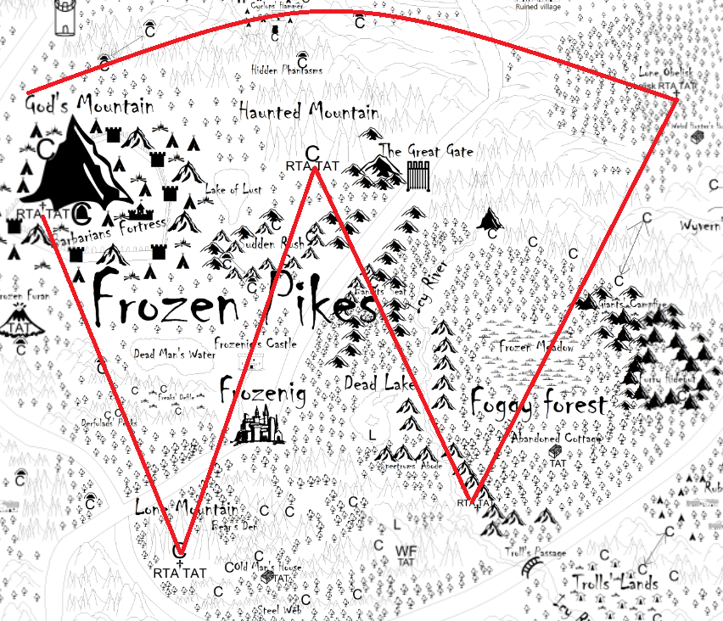C:\Users\Krzepki Paweł\Desktop\Gry nasze i projekty\Game design\PFDD GDD\Prevent from the darkness\Informacje o świecie (runy)\runy\2_run defensywny.pngStrengthen defensive rune  
   Its look in game:   
   Its look on a map:   
     
     
     
   Description: (5 Runes To Achieve (RTA) and the mountains as a red curve). Three curved lines goind through this rune are winds howling always from the west. The information about the winds and the whole rune would be provided through TATs (The Ancient Texts) and other in-game sources such as libraries etc.
2. 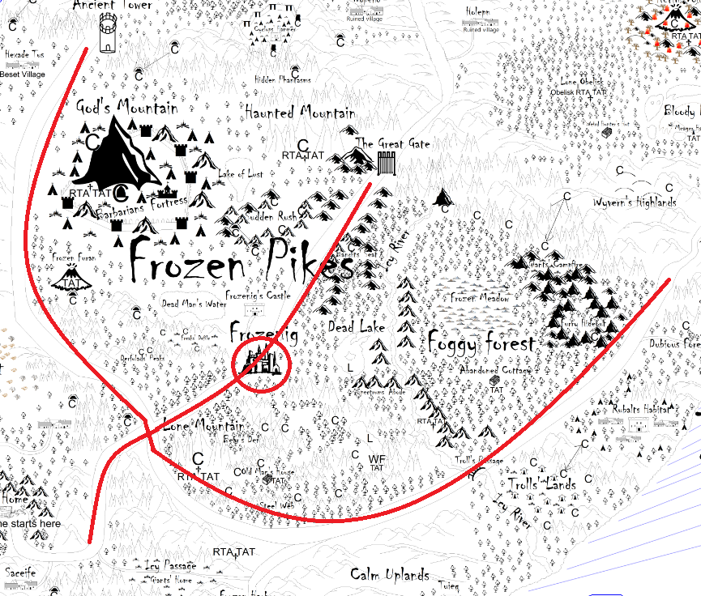C:\Users\Krzepki Paweł\Desktop\Gry nasze i projekty\Game design\PFDD GDD\Prevent from the darkness\Informacje o świecie (runy)\runy\2_run ofensywny.pngStrenghten offensive rune  
   Its look in game:   
   Its look on a map:   
     
   Descritpion: Three main roads going through the Frozen Pikes reflects the look of a rune and a look of the ancient weapon in one. Frozenig placed on a middle of a road reflects the circle on a rune. The name of a city “Frozenig” is a anagram of a Frozen Ring and this can be a tip.

2. Names of the cities & villages

Many names of a cities & villages in a game are anagrams of English words.

These are:

1. Frozenig (Frozen Ring, because it reflects the ring on a rune that is connected with this city in a historical way).
2. Red Shatter (Shattered, because it was shattered when demons fought their way to the city).
3. Tuieq (Quiet, because it is placed in a rather calm area).
4. Saceife (Safe ice).
5. Hexade Tus (Exhausted, because the people living there are being bullied by barbarians living near them).
6. Holepn (No help, because the habitants of this village got no help when demons came).
7. Nopeho (No hope, because there was no hope for the people living there, as demons killed every single one of them).
8. Ros Visurv (Survivors, because the people living there survived thanks to the runes provided by Masters from the Masters’ Stronghold).
9. Teslis (Listen and Silent, because habitants from this village have to listen to the howling winds from the sea or to the silence “coming” from the Silent Desert).
10. Hetim Volls (Hell’s Vomit, because people keep saying that it was a vomit of hell that send Demons to the earth).

3. Names of the creatures

Same names of a creatures that occur in a game are anagrams of English words.

These are:

1. Rubalts (Brutals, because of their brutal and uncontrollable nature).
2. Derfulads (Dreadfuls, because of their ugly appearance and abhorrent habits)