ActionTarget Checkout Edge Cases – Automated QA Report
Part A – test cases A-00 to A-14
Item | Value
Environment | ActionTarget Staging
Framework | Playwright + TypeScript
Browser | Chromium (Desktop Chrome)
Date | 2026-10-22
Final result | 25 tests – 24 passed, 0 failed, 1 BLOCKED (A-13)
Contents
1. Executive Summary
2. Test Environment / Safety
3. Test Case Documentation
A-00 – Baseline: US-50 (Ohio) address offers UPS
A-01 – OH-NEG-001 – Canada: no UPS, only Will Contact
A-02 – OH-NEG-002 – Puerto Rico: no UPS, only Will Contact
A-03 – OH-NEG-003 – APO/FPO: no UPS, only Will Contact
A-04a – OH-NEG-004 – Alaska: no UPS, only Will Contact
A-04b – OH-NEG-004 – Hawaii: no UPS, only Will Contact
A-05 – OH-NEG-006 – Blocked country cannot be used (RU, VE, CU, IR, KP, SY)
A-06 – OH-NEG-010 – US B2C without Wire opt-in: no Wire Transfer, no On Account
A-07 – OH-NEG-014 – Guest is not offered On Account
A-08a – OH-NEG-015 – US guest is not offered Wire Transfer
A-08b – OH-NEG-015 – International guest is offered Wire Transfer
A-09a – OH-NEG-016 – Guest is never offered Pay by Link
A-09b – OH-NEG-016 – B2C is never offered Pay by Link
A-10a – OH-NEG-017 – Guest is never offered ACH
A-10b – OH-NEG-017 – B2C is never offered ACH
A-11a – OH-NEG-018 – Ohio guest is never offered USPS
A-11b – OH-NEG-018 – Hawaii guest is never offered USPS
A-12 – OH-NEG-019 – Legacy UPS HOME is never offered
A-13 – OH-NEG-024 – Invoiced order cannot be cancelled
A-14 – OH-CARD-002 – Guest sees no saved-card UI
4. Summary Results Table
5. Findings / Limitations
6. Architecture / Automation Quality
7. Final Conclusion

1. Executive Summary
The ActionTarget checkout edge cases from Part A of the implementation brief (A-00 to A-14) were automated as Playwright tests against ActionTarget staging. They cover shipping-method rules by destination, blocked countries, payment-method rules for guests and logged-in B2C customers, the invoiced-order cancellation restriction and the saved-card UI for guests.
Metric | Count
Tests (A-00 to A-14 incl. a/b variants and 6 blocked countries) | 25
Passed | 24
Failed | 0
BLOCKED (skipped) | 1 – A-13

- All tests are read-only: they stop on the checkout confirm page (A-13: on the account order list).
- No order is submitted – Place Order is never clicked.
- No card data is entered and no payment is submitted.
- No cancel action is clicked.
- A-13 remains BLOCKED because the required test data – an invoiced Done order belonging to the configured B2C customer – is unavailable. No evidence was fabricated for it.

2. Test Environment / Safety
Aspect | Details
Environment | ActionTarget staging storefront (project profile "actiontarget", base URL and HTTP basic auth supplied through environment variables)
Spec | tests/client/actiontarget-checkout-edge-cases.spec.ts
Browser / execution | Chromium; final validation with --workers=1; Playwright HTML report with embedded evidence
Credentials | Environment-based only (ACT_B2C_EMAIL, ACT_B2C_PASSWORD, ACT_INVOICED_ORDER_NUMBER, ACT_INVOICED_INVOICE_NUMBER). Nothing hardcoded, logged or visible in screenshots.
Guest cleanup | Guest customers created by guest registration are deleted by the existing cleanup teardown (test e-mail prefix/domain).
Logged-in cart cleanup | The B2C cart is emptied before and after every logged-in test, and emptiness is verified.
Order data generation | tests/data-generation/** is excluded from every normal Playwright project (npm test, smoke, regression, client and CI shards collect 0 generator tests). It runs only through its own configuration via "npm run generate:orders" – it was not run. Before any such run, Order Sync to Sage must be explicitly controlled or disabled.
Destructive actions | None: no Place Order, no payment submission, no card entry, no cancel click, no Sage or Shopware business-data changes.

3. Test Case Documentation
Each subsection describes one test case: objective, context, steps, expected and actual result, and the embedded Playwright evidence screenshots captured during the final validation run. Screenshots are full-page captures of the verified final state; the B2C e-mail address is masked.

A-00 – Baseline: US-50 (Ohio) address offers UPS
Test ID / Name | A-00 – Baseline: US-50 (Ohio) address offers UPS
Objective | Prove that shipping and payment method lists load correctly for a standard US address, so later negative checks are trustworthy.
Customer / Context | Guest checkout – synthetic guest customer "QA Tester" created by the guest-registration flow
Address / Destination | 100 E Broad St, 43215 Columbus, Ohio, United States of America
Preconditions | Product 530-OC is purchasable on staging. Guest checkout is enabled. Write access for guest registration is allowed.

Test Steps
- Add 530-OC – 5 Bull's-Eye Targets w/ Orange Centers, quantity 25 (storefront minimum) to the cart.
- Open the cart, verify the quantity is 25 and proceed to checkout.
- Register as a guest with the address 100 E Broad St, 43215 Columbus, Ohio, United States of America.
- Verify the checkout confirm page is reached (URL /checkout/confirm, ActionTarget confirm page).
- Read the complete visible shipping and payment method lists.
- Capture the evidence screenshot. The test stops here – Place Order is never clicked.
Expected Result | UPS GROUND is offered; every visible UPS method is in the allowed list (UPS GROUND, UPS 2ND DAY AIR, UPS 2ND DAY AIR AM, UPS 3 DAY AIR, UPS OVERNIGHT AM, UPS NEXT DAY AIR SAVER); EBizCharge Credit Card is offered.
Actual Result | Shipping methods: UPS GROUND. Payment methods: EBizCharge Credit Card.
Status | PASS
Automation Notes | UPS 2ND DAY AIR is whitelisted but not required, because staging does not offer it. The street is synthetic (not defined in the brief).

Evidence
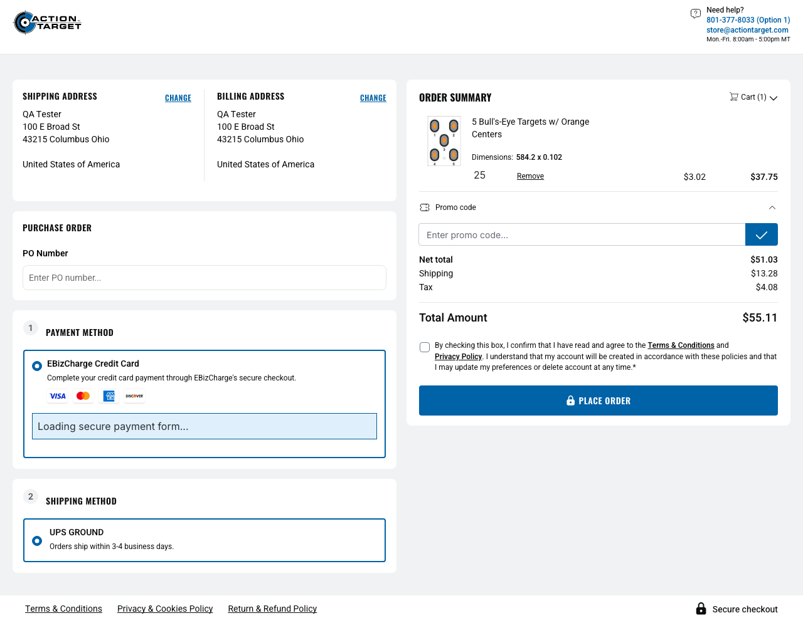
Figure 1 – Ohio guest confirm page – address, UPS GROUND and EBizCharge Credit Card (attachment: A-00-context-result-ohio-guest-ups-payment)

A-01 – OH-NEG-001 – Canada: no UPS, only Will Contact
Test ID / Name | A-01 – OH-NEG-001 – Canada: no UPS, only Will Contact
Objective | A Canadian destination must not get UPS; it gets Will Contact shipping and the international payment set.
Customer / Context | Guest checkout – synthetic guest customer "QA Tester" created by the guest-registration flow
Address / Destination | 290 Bremner Blvd, M5V 2T6 Toronto, Ontario, Canada
Preconditions | Product 530-OC is purchasable on staging. Guest checkout is enabled. Write access for guest registration is allowed.

Test Steps
- Add 530-OC – 5 Bull's-Eye Targets w/ Orange Centers, quantity 25 (storefront minimum) to the cart.
- Open the cart, verify the quantity is 25 and proceed to checkout.
- Register as a guest with the address 290 Bremner Blvd, M5V 2T6 Toronto, Ontario, Canada.
- Verify the checkout confirm page is reached (URL /checkout/confirm, ActionTarget confirm page).
- Read the complete visible shipping and payment method lists.
- Capture the evidence screenshot. The test stops here – Place Order is never clicked.
Expected Result | No shipping method starting with "UPS"; Will Contact is offered; payment methods are exactly EBizCharge Credit Card and Wire Transfer; On Account is not offered.
Actual Result | Shipping methods: Will Contact. Payment methods: EBizCharge Credit Card, Wire Transfer.
Status | PASS
Automation Notes | Ontario is selectable as the province. The payment set is asserted exactly.

Evidence
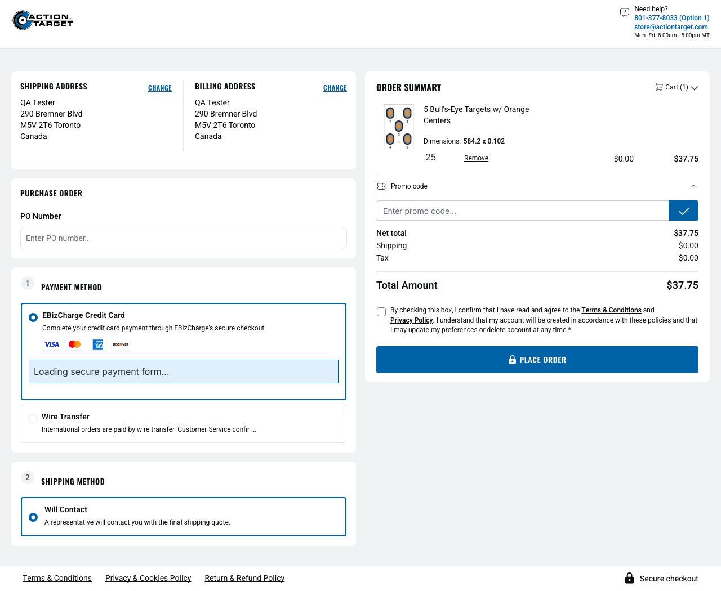
Figure 2 – Canada guest confirm page – Will Contact, EBizCharge Credit Card and Wire Transfer (attachment: A-01-context-result-canada-guest-will-contact-payment)

A-02 – OH-NEG-002 – Puerto Rico: no UPS, only Will Contact
Test ID / Name | A-02 – OH-NEG-002 – Puerto Rico: no UPS, only Will Contact
Objective | Puerto Rico must not get UPS; it gets Will Contact.
Customer / Context | Guest checkout – synthetic guest customer "QA Tester" created by the guest-registration flow
Address / Destination | 151 Calle San Francisco, 00901 San Juan, Puerto Rico (separate country on staging)
Preconditions | Product 530-OC is purchasable on staging. Guest checkout is enabled. Write access for guest registration is allowed.

Test Steps
- Add 530-OC – 5 Bull's-Eye Targets w/ Orange Centers, quantity 25 (storefront minimum) to the cart.
- Open the cart, verify the quantity is 25 and proceed to checkout.
- Register as a guest with the address 151 Calle San Francisco, 00901 San Juan, Puerto Rico (separate country on staging).
- Verify the checkout confirm page is reached (URL /checkout/confirm, ActionTarget confirm page).
- Read the complete visible shipping method list.
- Capture the evidence screenshot. The test stops here – Place Order is never clicked.
Expected Result | Will Contact is offered; no shipping method starting with "UPS".
Actual Result | Shipping methods: Will Contact.
Status | PASS
Automation Notes | Staging models Puerto Rico as its own country without states, not as a US state – the brief allowed using the actual staging representation.

Evidence
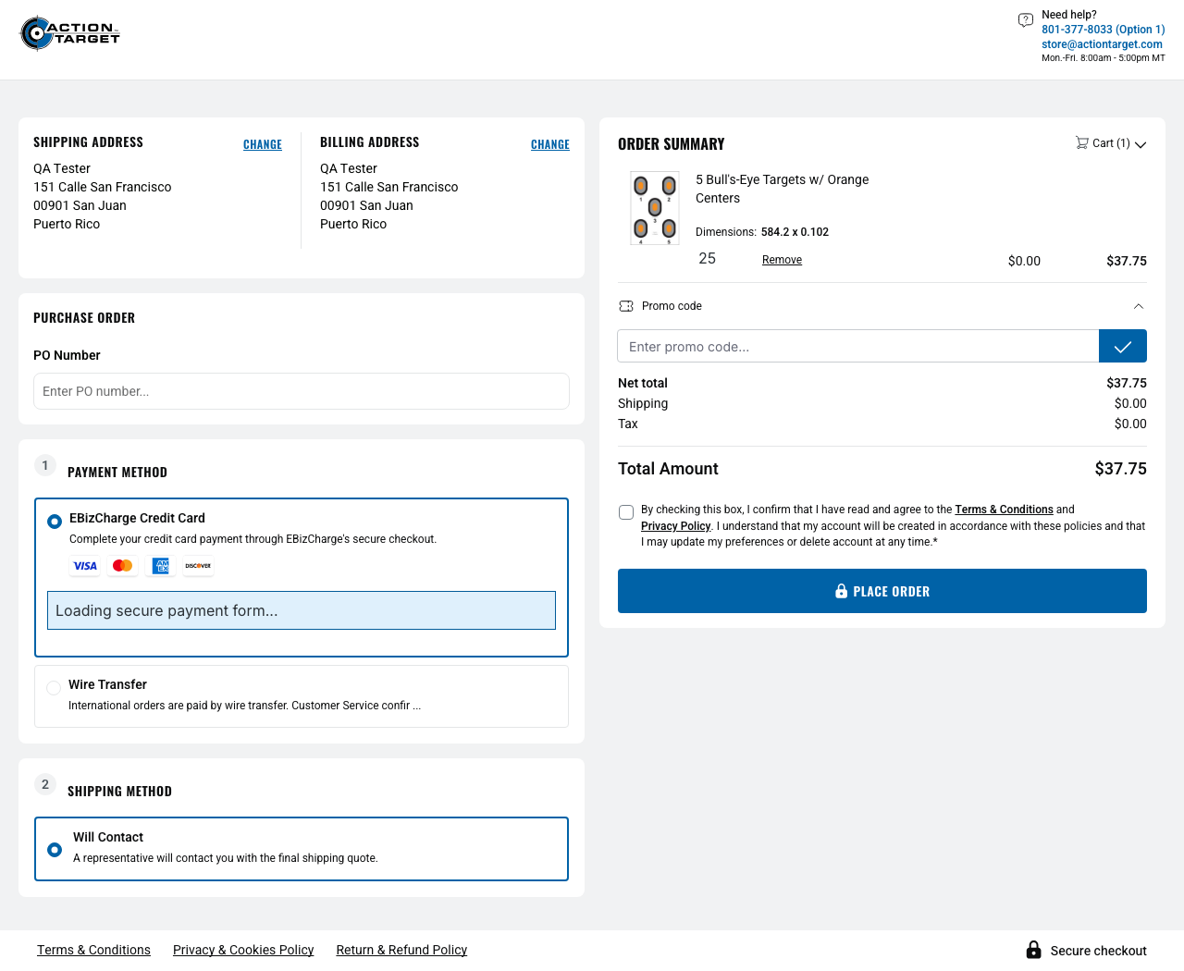
Figure 3 – Puerto Rico guest confirm page – Will Contact only (attachment: A-02-context-result-puerto-rico-guest-will-contact)

A-03 – OH-NEG-003 – APO/FPO: no UPS, only Will Contact
Test ID / Name | A-03 – OH-NEG-003 – APO/FPO: no UPS, only Will Contact
Objective | A military APO/FPO address must not get UPS; it gets Will Contact.
Customer / Context | Guest checkout – synthetic guest customer "QA Tester" created by the guest-registration flow
Address / Destination | PSC 123 Box 456, 96522 APO, Armed Forces Pacific, United States of America
Preconditions | Product 530-OC is purchasable on staging. Guest checkout is enabled. Write access for guest registration is allowed.

Test Steps
- Add 530-OC – 5 Bull's-Eye Targets w/ Orange Centers, quantity 25 (storefront minimum) to the cart.
- Open the cart, verify the quantity is 25 and proceed to checkout.
- Register as a guest with the address PSC 123 Box 456, 96522 APO, Armed Forces Pacific, United States of America.
- Verify the checkout confirm page is reached (URL /checkout/confirm, ActionTarget confirm page).
- Read the complete visible shipping method list.
- Capture the evidence screenshot. The test stops here – Place Order is never clicked.
Expected Result | Will Contact is offered; no shipping method starting with "UPS".
Actual Result | Shipping methods: Will Contact.
Status | PASS
Automation Notes | The staging state option is labelled "Armed Forces Pacific" (without the "(AP)" suffix used in the brief).

Evidence
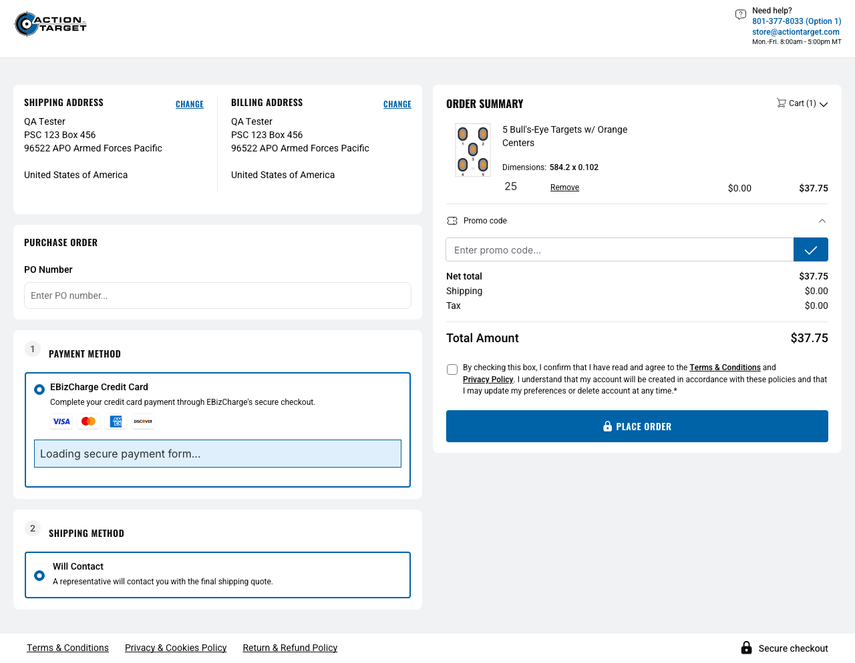
Figure 4 – APO guest confirm page – Will Contact only (attachment: A-03-context-result-apo-guest-will-contact)

A-04a – OH-NEG-004 – Alaska: no UPS, only Will Contact
Test ID / Name | A-04a – OH-NEG-004 – Alaska: no UPS, only Will Contact
Objective | Alaska (non-contiguous US) must not get UPS; it gets Will Contact.
Customer / Context | Guest checkout – synthetic guest customer "QA Tester" created by the guest-registration flow
Address / Destination | 632 W 6th Ave, 99501 Anchorage, Alaska, United States of America
Preconditions | Product 530-OC is purchasable on staging. Guest checkout is enabled. Write access for guest registration is allowed.

Test Steps
- Add 530-OC – 5 Bull's-Eye Targets w/ Orange Centers, quantity 25 (storefront minimum) to the cart.
- Open the cart, verify the quantity is 25 and proceed to checkout.
- Register as a guest with the address 632 W 6th Ave, 99501 Anchorage, Alaska, United States of America.
- Verify the checkout confirm page is reached (URL /checkout/confirm, ActionTarget confirm page).
- Read the complete visible shipping method list.
- Capture the evidence screenshot. The test stops here – Place Order is never clicked.
Expected Result | Will Contact is offered; no shipping method starting with "UPS".
Actual Result | Shipping methods: Will Contact.
Status | PASS
Automation Notes | Shipping assertions only, as specified.

Evidence
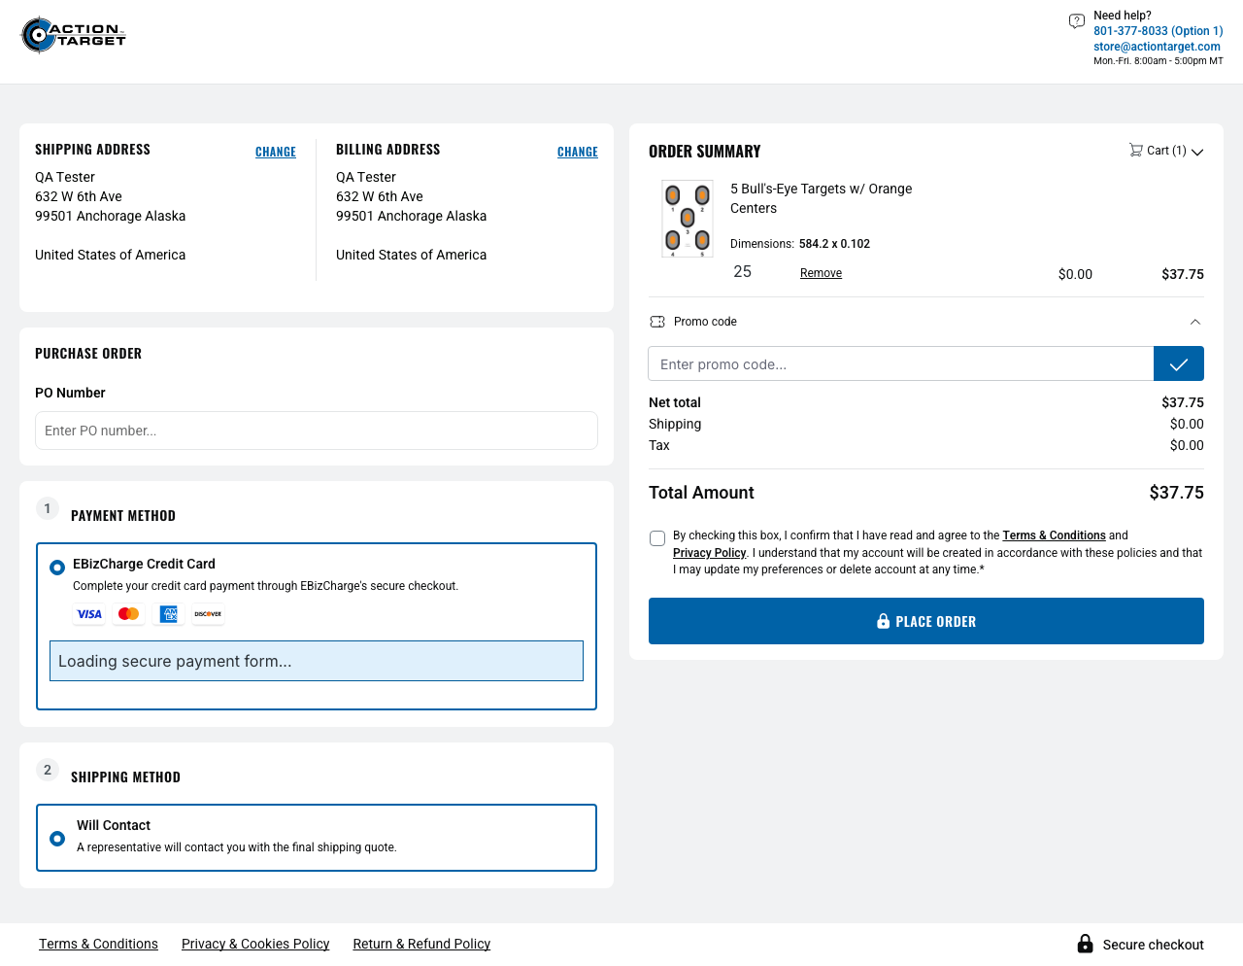
Figure 5 – Alaska guest confirm page – Will Contact only (attachment: A-04a-context-result-alaska-guest-will-contact)

A-04b – OH-NEG-004 – Hawaii: no UPS, only Will Contact
Test ID / Name | A-04b – OH-NEG-004 – Hawaii: no UPS, only Will Contact
Objective | Hawaii (non-contiguous US) must not get UPS; it gets Will Contact.
Customer / Context | Guest checkout – synthetic guest customer "QA Tester" created by the guest-registration flow
Address / Destination | 1001 Bishop St, 96813 Honolulu, Hawaii, United States of America
Preconditions | Product 530-OC is purchasable on staging. Guest checkout is enabled. Write access for guest registration is allowed.

Test Steps
- Add 530-OC – 5 Bull's-Eye Targets w/ Orange Centers, quantity 25 (storefront minimum) to the cart.
- Open the cart, verify the quantity is 25 and proceed to checkout.
- Register as a guest with the address 1001 Bishop St, 96813 Honolulu, Hawaii, United States of America.
- Verify the checkout confirm page is reached (URL /checkout/confirm, ActionTarget confirm page).
- Read the complete visible shipping method list.
- Capture the evidence screenshot. The test stops here – Place Order is never clicked.
Expected Result | Will Contact is offered; no shipping method starting with "UPS".
Actual Result | Shipping methods: Will Contact.
Status | PASS
Automation Notes | Shipping assertions only, as specified.

Evidence
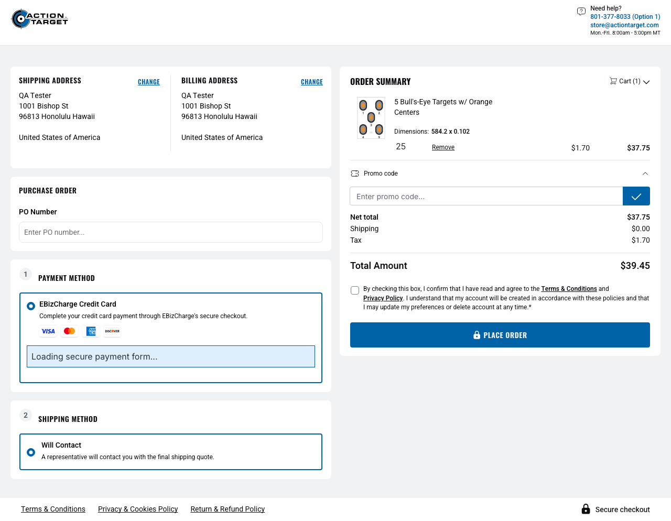
Figure 6 – Hawaii guest confirm page – Will Contact only (attachment: A-04b-context-result-hawaii-guest-will-contact)

A-05 – OH-NEG-006 – Blocked country cannot be used (RU, VE, CU, IR, KP, SY)
Test ID / Name | A-05 – OH-NEG-006 – Blocked country cannot be used (6 tests, one per country)
Objective | None of the documented blocked countries – Russia, Venezuela, Cuba, Iran, North Korea, Syria – can be used to complete a checkout.
Customer / Context | Guest checkout. For Cuba no customer is created (the check stops at the country selector).
Address / Destination | Representative: 1 Test Street, 101000 Moscow, Russian Federation. Others: Caracas (VE), Havana (CU), Tehran (IR), Pyongyang (KP), Damascus (SY) – synthetic street "1 Test Street".
Preconditions | Product 530-OC is purchasable on staging. Guest checkout is enabled. Write access for guest registration is allowed. The blocked list is admin-configurable; the tests verify the current staging configuration.

Test Steps
- Add 530-OC – 5 Bull's-Eye Targets w/ Orange Centers, quantity 25 (storefront minimum) to the cart and proceed to the checkout register page.
- Read the complete list of countries offered in the guest-registration country selector.
- Cuba: verify Cuba is not offered and stop – no guest customer is created.
- RU, VE, IR, KP, SY: verify the country is offered exactly once, then register a guest with that address.
- On the confirm page verify the blocked-shipping alert, an empty shipping method list and no order submit control.
- Capture the RU evidence screenshot. Place Order is never clicked.
Expected Result | The blocked country cannot be used: either it is not offered in the country selector, or checkout shows the alert "We are unable to ship to this destination.", offers no shipping method and has no order submit control.
Actual Result | Cuba is not offered in the selector. RU, VE, IR, KP and SY are selectable, but checkout is blocked with the alert, no shipping methods and no submit control.
Status | PASS (6 of 6)
Automation Notes | Each country is pinned to its observed staging mechanism, so a staging configuration change fails the test by design. The "no submit control" check is a DOM assertion; the alert and the empty shipping list are the main visual proof. Blocked-country confirm pages still list EBizCharge Credit Card and Wire Transfer (not covered by the brief).

Per-country result
Country | ISO | Country selector | Mechanism verified | Status
Cuba | CU | Not offered | Absent from the country selector | PASS
Russian Federation | RU | Offered | Blocked at checkout | PASS
Venezuela (Bolivarian Republic of) | VE | Offered | Blocked at checkout | PASS
Iran (Islamic Republic of) | IR | Offered | Blocked at checkout | PASS
Korea (Democratic People's Republic of) | KP | Offered | Blocked at checkout | PASS
Syrian Arab Republic | SY | Offered | Blocked at checkout | PASS

Evidence – Cuba (CU): country selector
A closed country selector cannot show that an option is missing, so the evidence is the complete option list the test read from the selector (attachment A-05-CU-result-country-selector-options, JSON):
Check on the selector option list | Result
Countries offered (excluding the "Country*" placeholder) | 170
Options containing "Cuba" | None – Cuba is not offered
Countries offered starting with "C" (where Cuba would appear) | Canada, Chile, Congo, Costa Rica
Other documented blocked countries in the list | Russian Federation; Venezuela (Bolivarian Republic of); Iran (Islamic Republic of); Korea (Democratic People's Republic of); Syrian Arab Republic

Evidence – Russian Federation (RU): blocked checkout
VE, IR, KP and SY were verified with the same blocked-checkout mechanism and the same assertions; identical screenshots are not repeated.
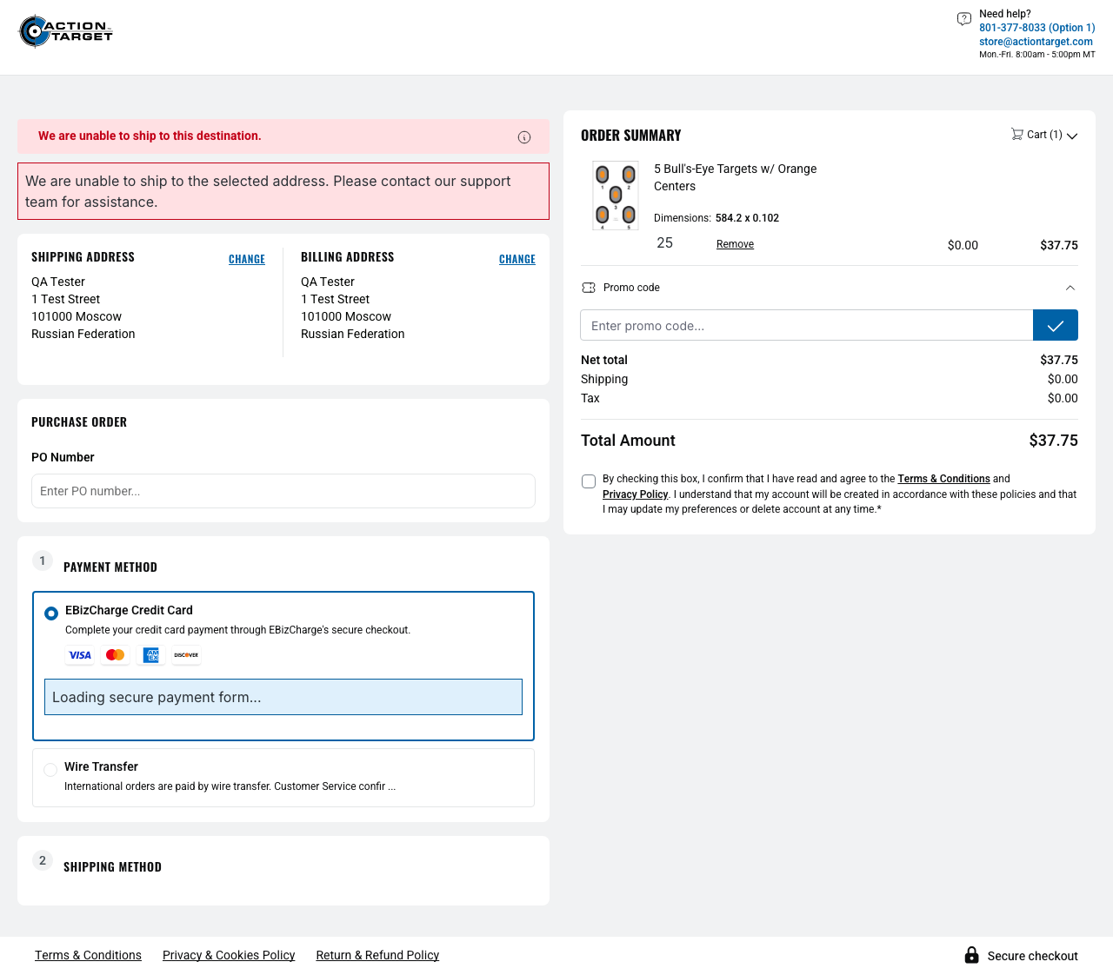
Figure 7 – Russian Federation guest confirm page – blocked-shipping alert, empty shipping method section, no Place Order (attachment: A-05-RU-context-result-blocked-shipping-alert)

A-06 – OH-NEG-010 – US B2C without Wire opt-in: no Wire Transfer, no On Account
Test ID / Name | A-06 – OH-NEG-010 – US B2C without Wire opt-in: no Wire Transfer, no On Account
Objective | A logged-in US/Ohio B2C customer without the Wire opt-in sees EBizCharge Credit Card but neither Wire Transfer nor On Account.
Customer / Context | Logged-in B2C QA customer "Artonnnnnn Test" (customer no. 0010105); credentials from environment variables, never shown
Address / Destination | Default billing/shipping address of the QA B2C account: 100 E Broad St, OH 43215 Columbus, Ohio, United States of America
Preconditions | ACT_B2C_EMAIL / ACT_B2C_PASSWORD are configured (otherwise the test is skipped with a clear reason). The B2C account has an Ohio default address.

Test Steps
- Log in as the configured B2C QA customer.
- Open the account overview and capture the context screenshot (e-mail masked).
- Empty the persistent cart, add 530-OC – 5 Bull's-Eye Targets w/ Orange Centers, quantity 25 (storefront minimum) and verify the quantity.
- Open the checkout confirm page and verify it is reached.
- Verify the confirm page address is in Ohio, then read the complete visible payment method list.
- Capture the result screenshot. After the test the cart is emptied again. Place Order is never clicked.
Expected Result | EBizCharge Credit Card is offered; Wire Transfer is not offered; On Account is not offered.
Actual Result | Address: Columbus, Ohio. Payment methods: EBizCharge Credit Card only.
Status | PASS
Automation Notes | The "without Wire opt-in" state cannot be read by the test; it is assumed from the configured QA account. Observation (not asserted): no shipping method is preselected on the B2C confirm page.

Evidence
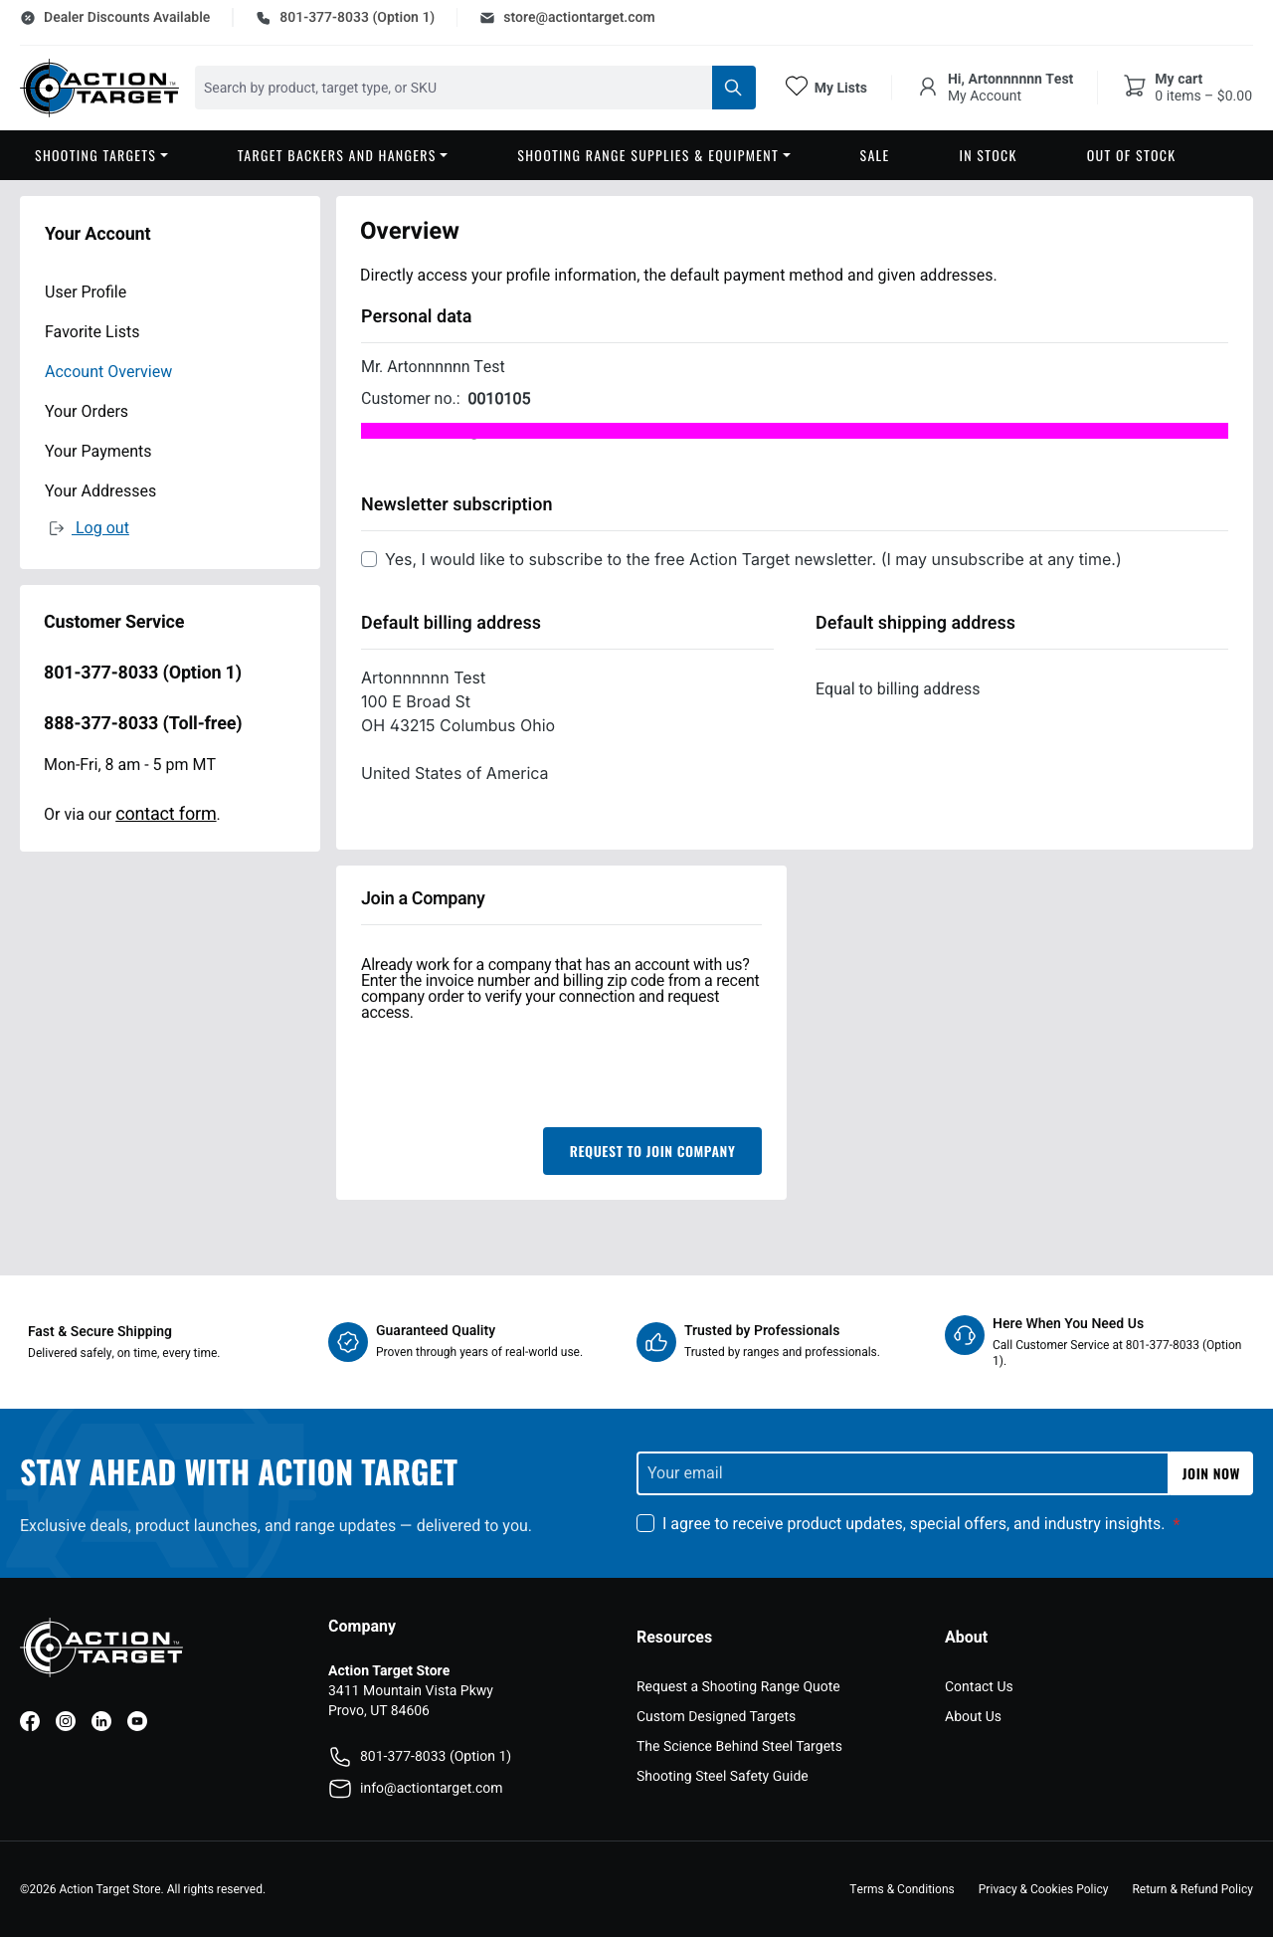
Figure 8 – Logged-in B2C account overview – customer name and Ohio default address (e-mail masked) (attachment: A-06-context-b2c-ohio)
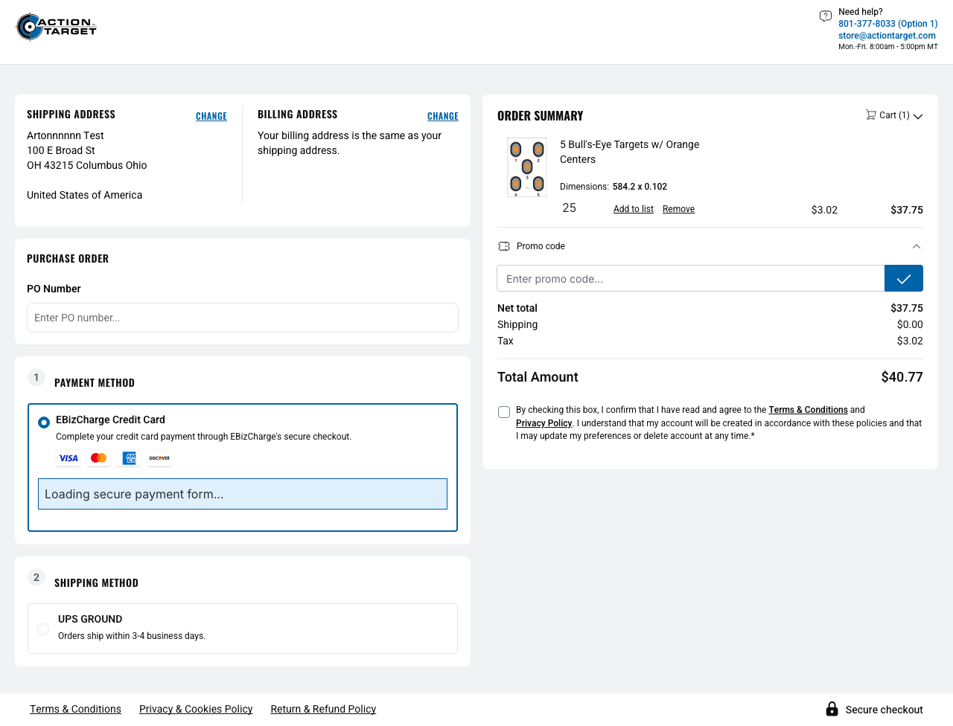
Figure 9 – B2C confirm page – EBizCharge Credit Card only; no Wire Transfer, no On Account (attachment: A-06-result-payment-methods)

A-07 – OH-NEG-014 – Guest is not offered On Account
Test ID / Name | A-07 – OH-NEG-014 – Guest is not offered On Account
Objective | A guest must never be offered On Account.
Customer / Context | Guest checkout – synthetic guest customer "QA Tester" created by the guest-registration flow
Address / Destination | 100 E Broad St, 43215 Columbus, Ohio, United States of America
Preconditions | Product 530-OC is purchasable on staging. Guest checkout is enabled. Write access for guest registration is allowed.

Test Steps
- Add 530-OC – 5 Bull's-Eye Targets w/ Orange Centers, quantity 25 (storefront minimum) to the cart.
- Open the cart, verify the quantity is 25 and proceed to checkout.
- Register as a guest with the address 100 E Broad St, 43215 Columbus, Ohio, United States of America.
- Verify the checkout confirm page is reached (URL /checkout/confirm, ActionTarget confirm page).
- Read the complete visible payment method list.
- Capture the evidence screenshot. The test stops here – Place Order is never clicked.
Expected Result | EBizCharge Credit Card is offered; On Account is not offered.
Actual Result | Shipping methods: UPS GROUND. Payment methods: EBizCharge Credit Card.
Status | PASS
Automation Notes | —

Evidence
Figure 10 – Ohio guest confirm page – no On Account (attachment: A-07-context-result-ohio-guest-no-on-account)

A-08a – OH-NEG-015 – US guest is not offered Wire Transfer
Test ID / Name | A-08a – OH-NEG-015 – US guest is not offered Wire Transfer
Objective | Wire Transfer is reserved for international guests; a US guest must not get it.
Customer / Context | Guest checkout – synthetic guest customer "QA Tester" created by the guest-registration flow
Address / Destination | 100 E Broad St, 43215 Columbus, Ohio, United States of America
Preconditions | Product 530-OC is purchasable on staging. Guest checkout is enabled. Write access for guest registration is allowed.

Test Steps
- Add 530-OC – 5 Bull's-Eye Targets w/ Orange Centers, quantity 25 (storefront minimum) to the cart.
- Open the cart, verify the quantity is 25 and proceed to checkout.
- Register as a guest with the address 100 E Broad St, 43215 Columbus, Ohio, United States of America.
- Verify the checkout confirm page is reached (URL /checkout/confirm, ActionTarget confirm page).
- Read the complete visible payment method list.
- Capture the evidence screenshot. The test stops here – Place Order is never clicked.
Expected Result | EBizCharge Credit Card is offered; Wire Transfer is not offered.
Actual Result | Shipping methods: UPS GROUND. Payment methods: EBizCharge Credit Card.
Status | PASS
Automation Notes | —

Evidence
Figure 11 – Ohio guest confirm page – no Wire Transfer (attachment: A-08a-context-result-ohio-guest-no-wire)

A-08b – OH-NEG-015 – International guest is offered Wire Transfer
Test ID / Name | A-08b – OH-NEG-015 – International guest is offered Wire Transfer
Objective | An international guest is offered Wire Transfer.
Customer / Context | Guest checkout – synthetic guest customer "QA Tester" created by the guest-registration flow
Address / Destination | 10 Test Lane, SW1A 1AA London, United Kingdom
Preconditions | Product 530-OC is purchasable on staging. Guest checkout is enabled. Write access for guest registration is allowed.

Test Steps
- Add 530-OC – 5 Bull's-Eye Targets w/ Orange Centers, quantity 25 (storefront minimum) to the cart.
- Open the cart, verify the quantity is 25 and proceed to checkout.
- Register as a guest with the address 10 Test Lane, SW1A 1AA London, United Kingdom.
- Verify the checkout confirm page is reached (URL /checkout/confirm, ActionTarget confirm page).
- Read the complete visible payment method list.
- Capture the evidence screenshot. The test stops here – Place Order is never clicked.
Expected Result | Wire Transfer is offered; EBizCharge Credit Card is offered; On Account is not offered.
Actual Result | Payment methods: EBizCharge Credit Card, Wire Transfer. Shipping methods: Will Contact.
Status | PASS
Automation Notes | The staging country label is "United Kingdom"; no state is required.

Evidence
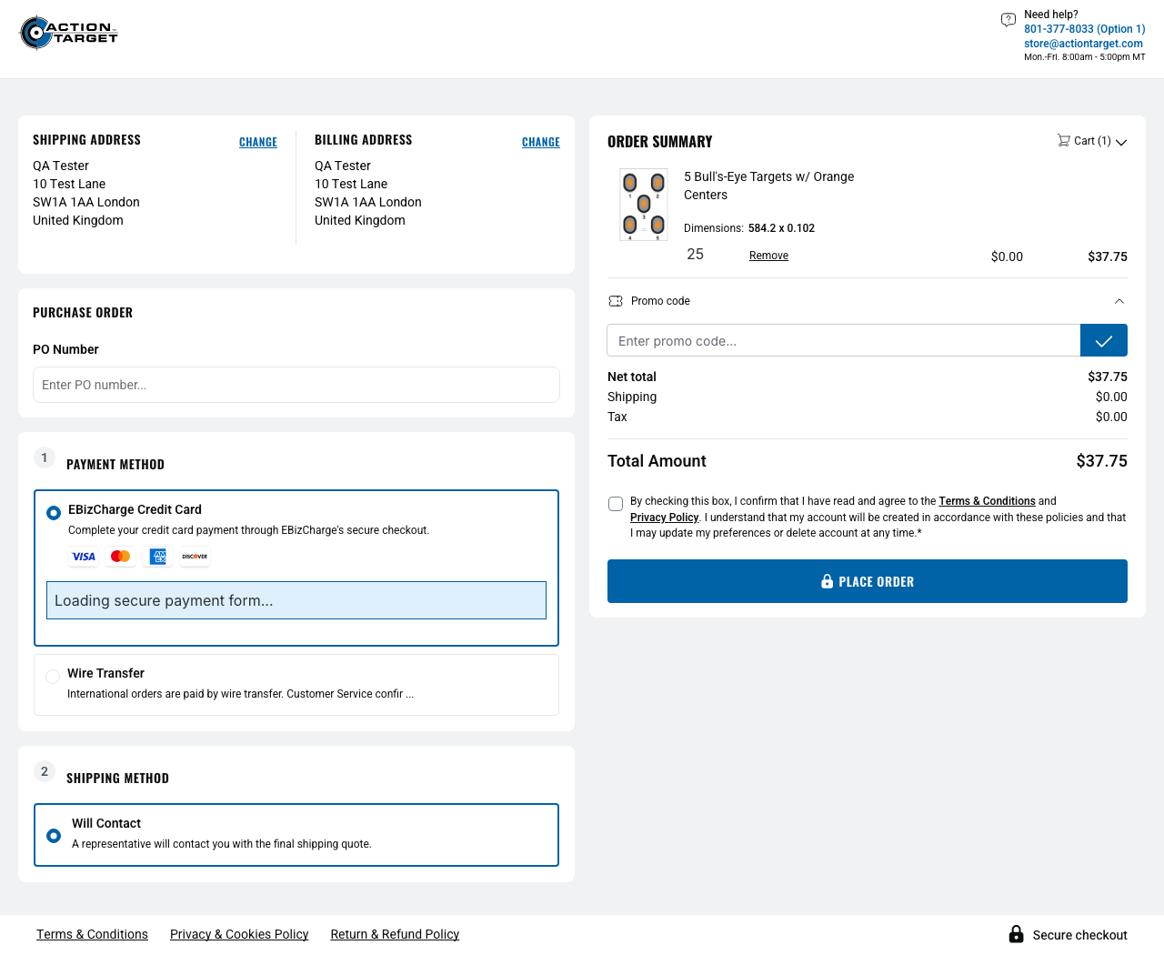
Figure 12 – UK guest confirm page – EBizCharge Credit Card and Wire Transfer (attachment: A-08b-context-result-uk-guest-wire-payment)

A-09a – OH-NEG-016 – Guest is never offered Pay by Link
Test ID / Name | A-09a – OH-NEG-016 – Guest is never offered Pay by Link
Objective | Pay by Link must never be offered to a guest.
Customer / Context | Guest checkout – synthetic guest customer "QA Tester" created by the guest-registration flow
Address / Destination | 100 E Broad St, 43215 Columbus, Ohio, United States of America
Preconditions | Product 530-OC is purchasable on staging. Guest checkout is enabled. Write access for guest registration is allowed.

Test Steps
- Add 530-OC – 5 Bull's-Eye Targets w/ Orange Centers, quantity 25 (storefront minimum) to the cart.
- Open the cart, verify the quantity is 25 and proceed to checkout.
- Register as a guest with the address 100 E Broad St, 43215 Columbus, Ohio, United States of America.
- Verify the checkout confirm page is reached (URL /checkout/confirm, ActionTarget confirm page).
- Read the complete visible payment method list.
- Capture the evidence screenshot. The test stops here – Place Order is never clicked.
Expected Result | No payment method matches "Pay by Link" (regex /pay\s*by\s*link/i).
Actual Result | Shipping methods: UPS GROUND. Payment methods: EBizCharge Credit Card.
Status | PASS
Automation Notes | —

Evidence
Figure 13 – Ohio guest confirm page – no Pay by Link (attachment: A-09a-context-result-ohio-guest-no-pay-by-link)

A-09b – OH-NEG-016 – B2C is never offered Pay by Link
Test ID / Name | A-09b – OH-NEG-016 – B2C is never offered Pay by Link
Objective | Pay by Link must never be offered to a logged-in B2C customer.
Customer / Context | Logged-in B2C QA customer "Artonnnnnn Test" (customer no. 0010105); credentials from environment variables, never shown
Address / Destination | Default billing/shipping address of the QA B2C account: 100 E Broad St, OH 43215 Columbus, Ohio, United States of America
Preconditions | ACT_B2C_EMAIL / ACT_B2C_PASSWORD are configured (otherwise the test is skipped with a clear reason). The B2C account has an Ohio default address.

Test Steps
- Log in as the configured B2C QA customer.
- Open the account overview and capture the context screenshot (e-mail masked).
- Empty the persistent cart, add 530-OC – 5 Bull's-Eye Targets w/ Orange Centers, quantity 25 (storefront minimum) and verify the quantity.
- Open the checkout confirm page and verify it is reached.
- Read the complete visible payment method list.
- Capture the result screenshot. After the test the cart is emptied again. Place Order is never clicked.
Expected Result | No payment method matches "Pay by Link" (regex /pay\s*by\s*link/i).
Actual Result | Payment methods: EBizCharge Credit Card only.
Status | PASS
Automation Notes | —

Evidence
Figure 14 – Logged-in B2C account overview (e-mail masked) (attachment: A-09b-context-b2c-ohio)
Figure 15 – B2C confirm page – no Pay by Link (attachment: A-09b-result-no-pay-by-link)

A-10a – OH-NEG-017 – Guest is never offered ACH
Test ID / Name | A-10a – OH-NEG-017 – Guest is never offered ACH
Objective | ACH must never be offered to a guest.
Customer / Context | Guest checkout – synthetic guest customer "QA Tester" created by the guest-registration flow
Address / Destination | 100 E Broad St, 43215 Columbus, Ohio, United States of America
Preconditions | Product 530-OC is purchasable on staging. Guest checkout is enabled. Write access for guest registration is allowed.

Test Steps
- Add 530-OC – 5 Bull's-Eye Targets w/ Orange Centers, quantity 25 (storefront minimum) to the cart.
- Open the cart, verify the quantity is 25 and proceed to checkout.
- Register as a guest with the address 100 E Broad St, 43215 Columbus, Ohio, United States of America.
- Verify the checkout confirm page is reached (URL /checkout/confirm, ActionTarget confirm page).
- Read the complete visible payment method list.
- Capture the evidence screenshot. The test stops here – Place Order is never clicked.
Expected Result | No payment method matches "ACH" (regex /\bACH\b/i).
Actual Result | Shipping methods: UPS GROUND. Payment methods: EBizCharge Credit Card.
Status | PASS
Automation Notes | —

Evidence
Figure 16 – Ohio guest confirm page – no ACH (attachment: A-10a-context-result-ohio-guest-no-ach)

A-10b – OH-NEG-017 – B2C is never offered ACH
Test ID / Name | A-10b – OH-NEG-017 – B2C is never offered ACH
Objective | ACH must never be offered to a logged-in B2C customer.
Customer / Context | Logged-in B2C QA customer "Artonnnnnn Test" (customer no. 0010105); credentials from environment variables, never shown
Address / Destination | Default billing/shipping address of the QA B2C account: 100 E Broad St, OH 43215 Columbus, Ohio, United States of America
Preconditions | ACT_B2C_EMAIL / ACT_B2C_PASSWORD are configured (otherwise the test is skipped with a clear reason). The B2C account has an Ohio default address.

Test Steps
- Log in as the configured B2C QA customer.
- Open the account overview and capture the context screenshot (e-mail masked).
- Empty the persistent cart, add 530-OC – 5 Bull's-Eye Targets w/ Orange Centers, quantity 25 (storefront minimum) and verify the quantity.
- Open the checkout confirm page and verify it is reached.
- Read the complete visible payment method list.
- Capture the result screenshot. After the test the cart is emptied again. Place Order is never clicked.
Expected Result | No payment method matches "ACH" (regex /\bACH\b/i).
Actual Result | Payment methods: EBizCharge Credit Card only.
Status | PASS
Automation Notes | —

Evidence
Figure 17 – Logged-in B2C account overview (e-mail masked) (attachment: A-10b-context-b2c-ohio)
Figure 18 – B2C confirm page – no ACH (attachment: A-10b-result-no-ach)

A-11a – OH-NEG-018 – Ohio guest is never offered USPS
Test ID / Name | A-11a – OH-NEG-018 – Ohio guest is never offered USPS
Objective | USPS / PREMS shipping methods must never be offered (contiguous US).
Customer / Context | Guest checkout – synthetic guest customer "QA Tester" created by the guest-registration flow
Address / Destination | 100 E Broad St, 43215 Columbus, Ohio, United States of America
Preconditions | Product 530-OC is purchasable on staging. Guest checkout is enabled. Write access for guest registration is allowed.

Test Steps
- Add 530-OC – 5 Bull's-Eye Targets w/ Orange Centers, quantity 25 (storefront minimum) to the cart.
- Open the cart, verify the quantity is 25 and proceed to checkout.
- Register as a guest with the address 100 E Broad St, 43215 Columbus, Ohio, United States of America.
- Verify the checkout confirm page is reached (URL /checkout/confirm, ActionTarget confirm page).
- Read the complete visible shipping method list.
- Capture the evidence screenshot. The test stops here – Place Order is never clicked.
Expected Result | No shipping method matches USPS or PREMS (regex /USPS|PREMS/i).
Actual Result | Shipping methods: UPS GROUND.
Status | PASS
Automation Notes | —

Evidence
Figure 19 – Ohio guest confirm page – no USPS/PREMS (attachment: A-11a-context-result-ohio-guest-no-usps)

A-11b – OH-NEG-018 – Hawaii guest is never offered USPS
Test ID / Name | A-11b – OH-NEG-018 – Hawaii guest is never offered USPS
Objective | USPS / PREMS shipping methods must never be offered (Hawaii).
Customer / Context | Guest checkout – synthetic guest customer "QA Tester" created by the guest-registration flow
Address / Destination | 1001 Bishop St, 96813 Honolulu, Hawaii, United States of America
Preconditions | Product 530-OC is purchasable on staging. Guest checkout is enabled. Write access for guest registration is allowed.

Test Steps
- Add 530-OC – 5 Bull's-Eye Targets w/ Orange Centers, quantity 25 (storefront minimum) to the cart.
- Open the cart, verify the quantity is 25 and proceed to checkout.
- Register as a guest with the address 1001 Bishop St, 96813 Honolulu, Hawaii, United States of America.
- Verify the checkout confirm page is reached (URL /checkout/confirm, ActionTarget confirm page).
- Read the complete visible shipping method list.
- Capture the evidence screenshot. The test stops here – Place Order is never clicked.
Expected Result | No shipping method matches USPS or PREMS (regex /USPS|PREMS/i).
Actual Result | Shipping methods: Will Contact.
Status | PASS
Automation Notes | —

Evidence
Figure 20 – Hawaii guest confirm page – no USPS/PREMS (attachment: A-11b-context-result-hawaii-guest-no-usps)

A-12 – OH-NEG-019 – Legacy UPS HOME is never offered
Test ID / Name | A-12 – OH-NEG-019 – Legacy UPS HOME is never offered
Objective | The legacy UPS HOME method must never be offered, and every UPS method must be whitelisted.
Customer / Context | Guest checkout – synthetic guest customer "QA Tester" created by the guest-registration flow
Address / Destination | 100 E Broad St, 43215 Columbus, Ohio, United States of America
Preconditions | Product 530-OC is purchasable on staging. Guest checkout is enabled. Write access for guest registration is allowed.

Test Steps
- Add 530-OC – 5 Bull's-Eye Targets w/ Orange Centers, quantity 25 (storefront minimum) to the cart.
- Open the cart, verify the quantity is 25 and proceed to checkout.
- Register as a guest with the address 100 E Broad St, 43215 Columbus, Ohio, United States of America.
- Verify the checkout confirm page is reached (URL /checkout/confirm, ActionTarget confirm page).
- Read the complete visible shipping method list.
- Capture the evidence screenshot. The test stops here – Place Order is never clicked.
Expected Result | No shipping method matches UPS HOME (regex /UPS\s*HOME/i); every visible UPS method is in the allowed list.
Actual Result | Shipping methods: UPS GROUND (whitelisted).
Status | PASS
Automation Notes | The screenshot shows the UPS labels; the whitelist comparison is against the allowed list in the ActionTarget profile.

Evidence
Figure 21 – Ohio guest confirm page – UPS GROUND only, no UPS HOME (attachment: A-12-context-result-ohio-guest-ups-whitelist)

A-13 – OH-NEG-024 – Invoiced order cannot be cancelled
Test ID / Name | A-13 – OH-NEG-024 – Invoiced order cannot be cancelled
Objective | A Done, invoiced order of the B2C customer must not be cancellable: the cancel action is absent or disabled.
Customer / Context | Logged-in B2C QA customer (credentials from environment variables).
Address / Destination | Not applicable – account order list.
Preconditions | An invoiced Done order belonging to the configured B2C customer, provided through ACT_INVOICED_ORDER_NUMBER and ACT_INVOICED_INVOICE_NUMBER. No fallback order is used.

Test Steps (as automated – not executed)
- If no invoiced order is configured, mark the test BLOCKED before logging in.
- Log in as the configured B2C QA customer and open Account → Your Orders.
- Search for the configured order number (the overview lists only the 10 most recent orders).
- Verify the order is listed – if it is not found, the test fails (it never turns into a skip).
- Expand the order details; verify status "Done" and the configured invoice number.
- Inspect the cancel controls without clicking: none may be enabled.
Expected Result | Order status is Done; the expected invoice number is visible; no enabled cancel action exists.
Actual Result | Not executed – required test data is unavailable.
Status | BLOCKED
Automation Notes | Cancel is never clicked; any enabled cancel control fails the test. The cancel selector is the Shopware core default and still needs validation against a real ActionTarget cancel control once data exists.

Evidence
BLOCKED – No valid invoiced Done order is available for the configured B2C customer. No screenshot evidence was produced because the scenario was not validated.

A-14 – OH-CARD-002 – Guest sees no saved-card UI
Test ID / Name | A-14 – OH-CARD-002 – Guest sees no saved-card UI
Objective | A guest with EBizCharge available must not see any saved-card selector, list or "use saved card" UI.
Customer / Context | Guest checkout – synthetic guest customer "QA Tester" created by the guest-registration flow; EBizCharge Credit Card selected
Address / Destination | 100 E Broad St, 43215 Columbus, Ohio, United States of America
Preconditions | Product 530-OC is purchasable on staging. Guest checkout is enabled. Write access for guest registration is allowed.

Test Steps
- Add 530-OC – 5 Bull's-Eye Targets w/ Orange Centers, quantity 25 (storefront minimum) to the cart, open the cart and proceed to checkout.
- Register as a guest with the address 100 E Broad St, 43215 Columbus, Ohio, United States of America.
- Verify the checkout confirm page is reached and EBizCharge Credit Card is offered.
- Select EBizCharge Credit Card (already selected on staging, so no change). No card data is entered.
- Wait until the EBizCharge embedded form has finished initialising.
- Check that no saved-card UI is visible, then capture the evidence screenshot. Payment is never submitted.
Expected Result | EBizCharge Credit Card is offered; after EBizCharge initialisation, no saved-card UI is visible.
Actual Result | EBizCharge Credit Card offered; embedded form initialised (loading message gone, secure-form frame shown); no saved-card UI.
Status | PASS
Automation Notes | Initialisation signal (from the staging EBizCharge plugin): the frame wrapper [data-ebiz-embedded-frame-wrap] is unhidden and the iframe [data-ebiz-embedded-frame] has its EBizCharge source URL; the test then waits for the iframe document to load. On a plugin error the wrapper stays hidden and the test fails. Limitation: the saved-card selectors ([data-ebiz-saved-card-checkout], [data-ebiz-saved-method-select], [data-ebiz-payment-select]) come from the plugin code and are proven only by absence – no customer with saved cards was available.

Evidence
The screenshot was captured after EBizCharge initialisation. The "Loading secure payment form…" status has disappeared and the initialised secure-form frame is visible. The body of the cross-origin EBizCharge iframe may appear blank in the screenshot; initialisation was verified through the page state, not the iframe content.
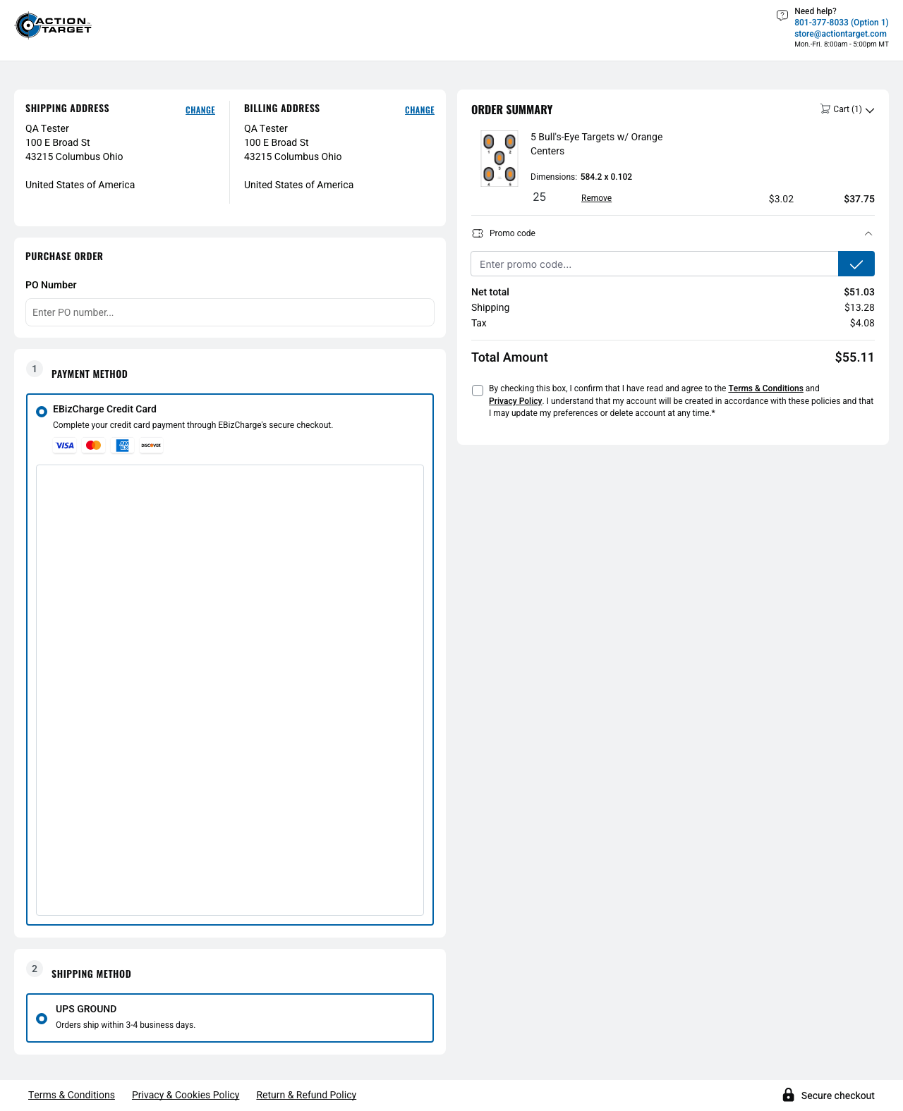
Figure 22 – Ohio guest confirm page after EBizCharge initialisation – no saved-card UI (attachment: A-14-context-result-ohio-guest-ebiz-no-saved-card)

4. Summary Results Table
Test ID | Scenario | Context | Expected | Actual | Status
A-00 | Ohio baseline offers UPS | Guest | UPS GROUND; UPS whitelist; EBizCharge | UPS GROUND; EBizCharge | PASS
A-01 | Canada – no UPS | Guest | No UPS; Will Contact; EBizCharge + Wire only; no On Account | Will Contact; EBizCharge + Wire | PASS
A-02 | Puerto Rico – no UPS | Guest | No UPS; Will Contact | Will Contact | PASS
A-03 | APO/FPO – no UPS | Guest | No UPS; Will Contact | Will Contact | PASS
A-04a | Alaska – no UPS | Guest | No UPS; Will Contact | Will Contact | PASS
A-04b | Hawaii – no UPS | Guest | No UPS; Will Contact | Will Contact | PASS
A-05 CU | Blocked country Cuba | Guest (selector only) | Cannot be used | Not offered in selector | PASS
A-05 RU | Blocked country Russia | Guest | Cannot be used | Checkout blocked | PASS
A-05 VE | Blocked country Venezuela | Guest | Cannot be used | Checkout blocked | PASS
A-05 IR | Blocked country Iran | Guest | Cannot be used | Checkout blocked | PASS
A-05 KP | Blocked country North Korea | Guest | Cannot be used | Checkout blocked | PASS
A-05 SY | Blocked country Syria | Guest | Cannot be used | Checkout blocked | PASS
A-06 | B2C without Wire opt-in | Logged-in B2C | EBizCharge; no Wire; no On Account | EBizCharge only | PASS
A-07 | Guest – no On Account | Guest | EBizCharge; no On Account | EBizCharge only | PASS
A-08a | US guest – no Wire | Guest | EBizCharge; no Wire | EBizCharge only | PASS
A-08b | International guest – Wire | Guest | Wire + EBizCharge; no On Account | EBizCharge + Wire | PASS
A-09a | Guest – no Pay by Link | Guest | No Pay by Link | None offered | PASS
A-09b | B2C – no Pay by Link | Logged-in B2C | No Pay by Link | None offered | PASS
A-10a | Guest – no ACH | Guest | No ACH | None offered | PASS
A-10b | B2C – no ACH | Logged-in B2C | No ACH | None offered | PASS
A-11a | Ohio – no USPS | Guest | No USPS/PREMS | UPS GROUND only | PASS
A-11b | Hawaii – no USPS | Guest | No USPS/PREMS | Will Contact only | PASS
A-12 | No legacy UPS HOME | Guest | No UPS HOME; UPS whitelisted | UPS GROUND only | PASS
A-13 | Invoiced order not cancellable | Logged-in B2C | Done; invoice visible; no enabled cancel | Not executed – no test data | BLOCKED
A-14 | Guest – no saved-card UI | Guest | EBizCharge; no saved-card UI after init | Initialised; no saved-card UI | PASS

5. Findings / Limitations
- A-13 blocked: no invoiced Done order belonging to the configured B2C customer is available. To unblock, configure ACT_INVOICED_ORDER_NUMBER and ACT_INVOICED_INVOICE_NUMBER.
- A-13 cancel selector: still needs validation against a real ActionTarget cancel control once a suitable order exists.
- A-14 saved-card selectors: proven only by absence – no customer with saved cards was available to show the UI.
- A-06 Wire opt-in: the "without Wire opt-in" state is assumed from the configured QA account; the test cannot read it.
- Transient add-to-cart HTTP 400: seen twice during development (/checkout/line-item/add) and passed on re-run; not seen in the final runs.
- A-05 configuration dependency: the blocked-country behaviour is tied to the current, admin-configurable staging configuration; a configuration change fails the tests by design.

6. Architecture / Automation Quality
Check | Status | Notes
Existing page objects reused | ✔ | CheckoutPage, CartPage, AuthPage, AccountPage and the existing fixtures were extended – no new page objects or fixtures.
Selectors outside the spec | ✔ | All selectors live in the selector layer, with ActionTarget overrides in the project profile.
No fixed sleeps | ✔ | No waitForTimeout; waits use Playwright assertions, polling, load states and network responses.
Credentials env-based | ✔ | B2C credentials and invoiced-order data come only from environment variables.
Guest cleanup | ✔ | Guest customers are removed by the existing cleanup teardown.
Logged-in cart cleanup | ✔ | The cart is emptied before and after each B2C test.
Data generation isolated | ✔ | Excluded from all normal runs; only "npm run generate:orders" runs it.
Screenshots safely masked | ✔ | All screenshots were inspected: no passwords, tokens, card numbers or CVVs; the B2C e-mail is masked.
No destructive actions | ✔ | No order submission, card entry, payment submission or cancel click.

7. Final Conclusion
- Part A (A-00 to A-14) was automated successfully against ActionTarget staging.
- 24 tests passed.
- 0 tests failed.
- A-13 remains BLOCKED due to missing test data (no invoiced Done order for the configured B2C customer).
- Part B has not been started.
- The full storefront regression has not yet been run.

