**Cover Page**

Project contributor: Artour Konstantinov (just me)

**Table of Contents:**

* Coverpage Pg1
* Table of Contents Pg2
* No Login/ Patient / Account management Pg3
* Doctor Pg4,5
* Admin Pg6-9
* Notes Pg10+

**No Login / Patient** **/ Account management**

Patient can also login.

At the moment, functionally same as not logged in

Home Page (the navbar “home” button goes here):

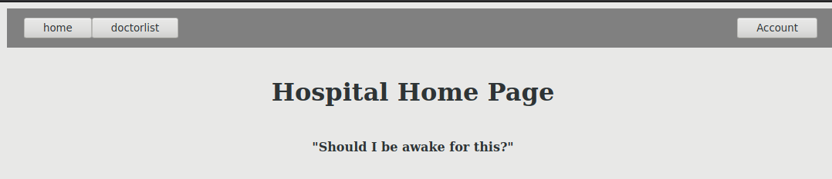

Press the “Account” button on top left to login / logout

Login page:

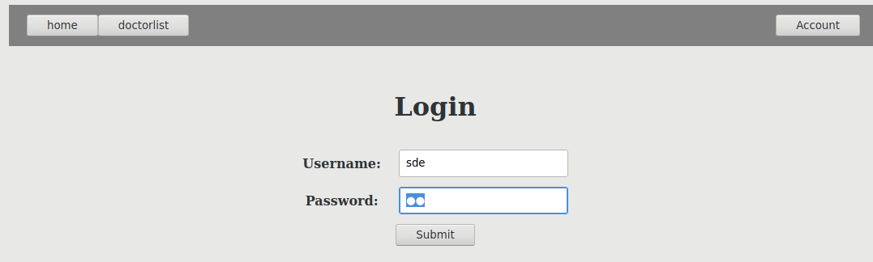Log out page:

show username (sde)

show user type(Patient)

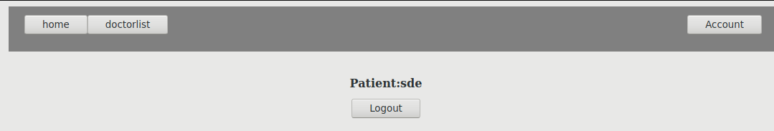doctorlist (no login/patient/doctor version):

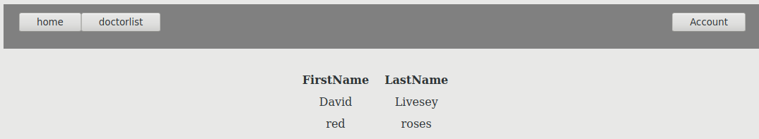

**Doctor**

patientlist (doctor version):

can only see patients assigned to you.

If you search you will only see matching entries. Empty field will not filter (show all)

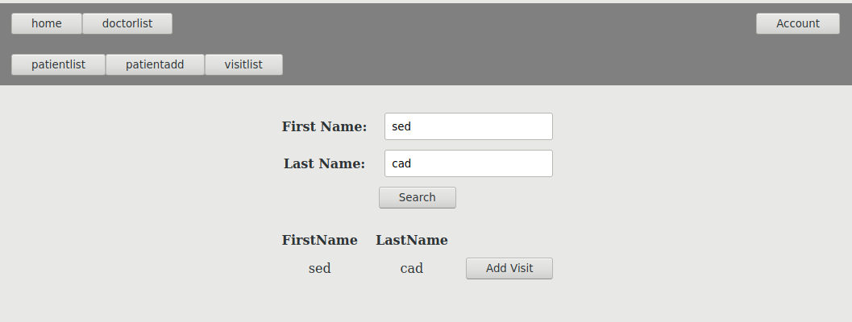

Add patient (doctor version):

doctor id automatic, hidden

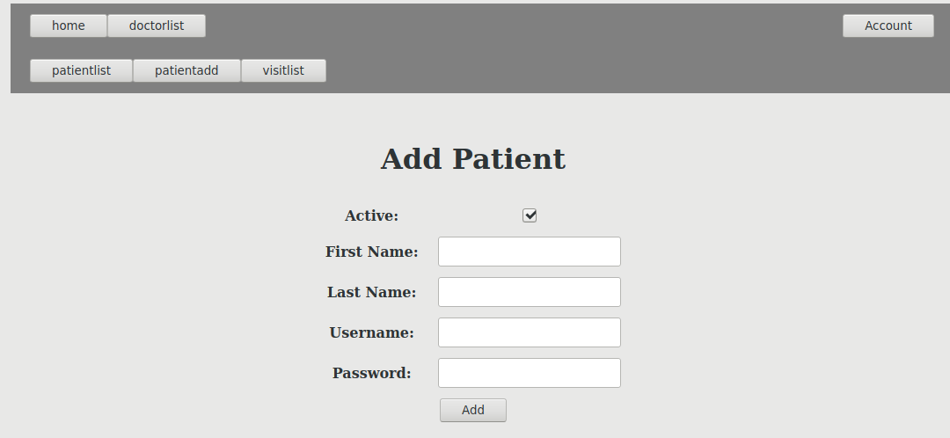

Add visit (doctor version):

doctor id automatic, hidden

patient id defaults to patient id of the row of “Add Visit” button pressed, can be changed

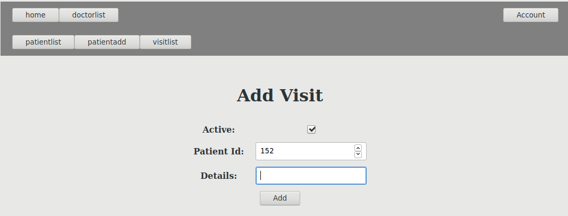

vistlist page (doctor version):

only visits of logged in doctor show

delete button deletes the row and reloads updated page

doctor id not shown (all shown entries match logged in doctor’s id)

visit id shown (Id)

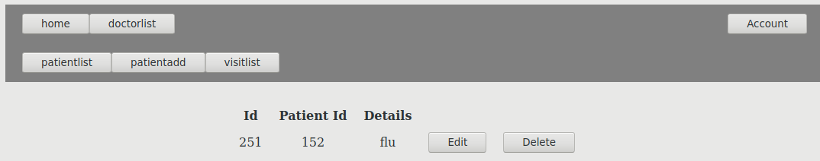

edit visit page (doctor version):

fields automatically filled in, can be changed

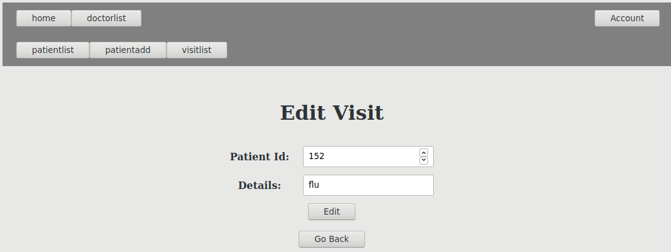

doctor list: same as patient/ no login

**Admin**

Admin is able to access all the above pages.

In the admin versions, more data is visible and has more permissions:

* id visible
* active property visible
* username and password visible
* entries with active property false are visible (invisible for everyone else)
* all doctors’ patients and visits are visible
* can delete and edit visits, patients, and doctors (doctor can only edit and delete visit)
* can add doctor

doctor list (admin version)

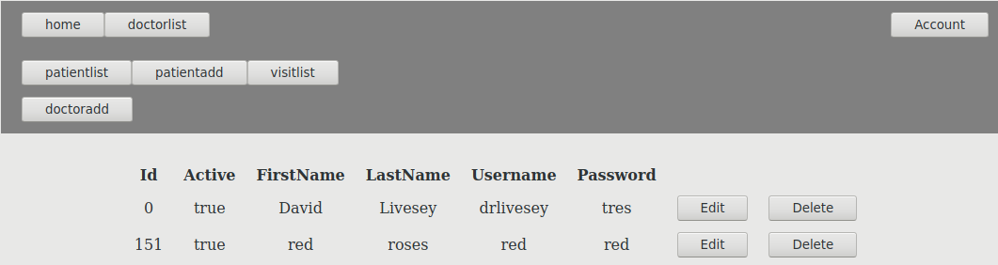

patient list(admin version):

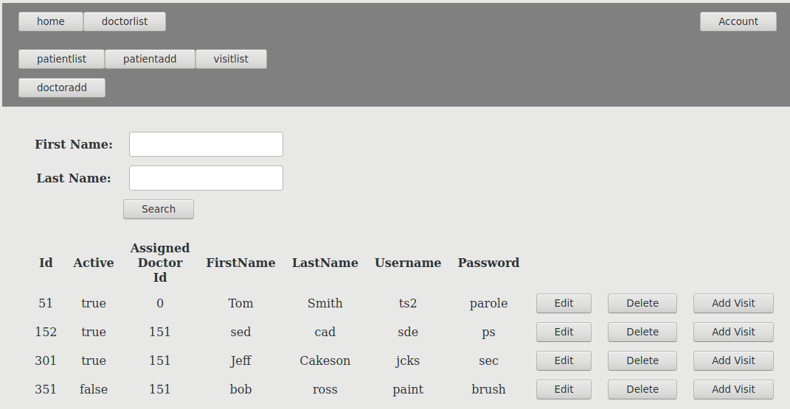

visit list page(admin version):

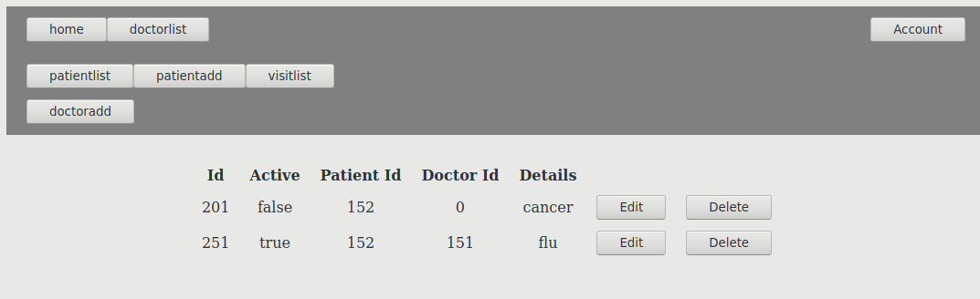

add visit(admin version): doctor can be chosen. If admin is a doctor, the doctor id is filled in, editable

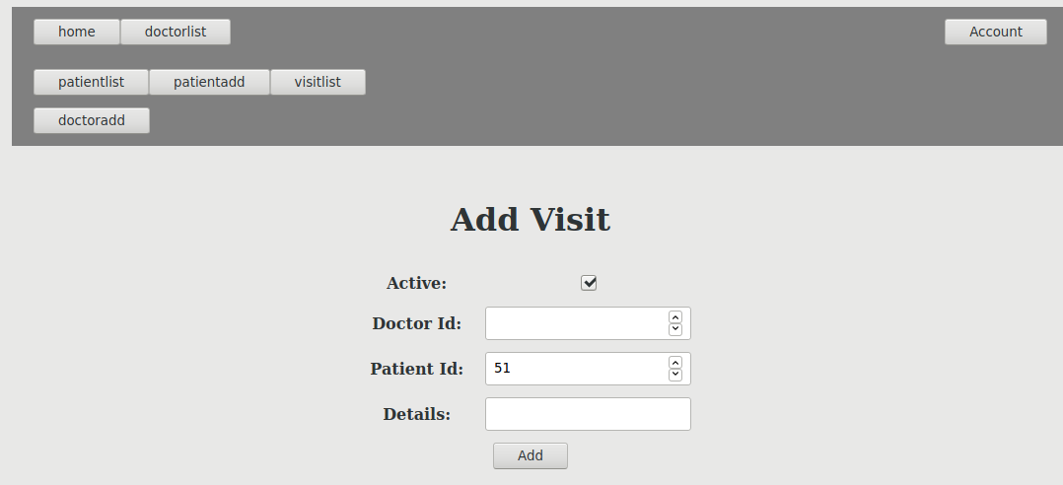

edit visit (admin version):

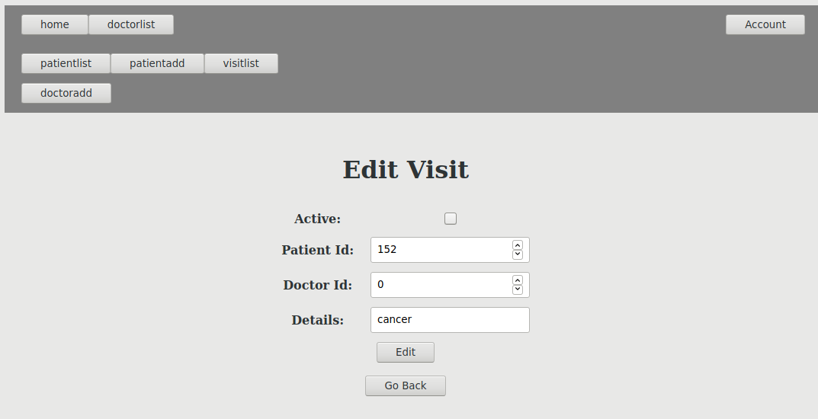

add doctor page (admin exclusive):

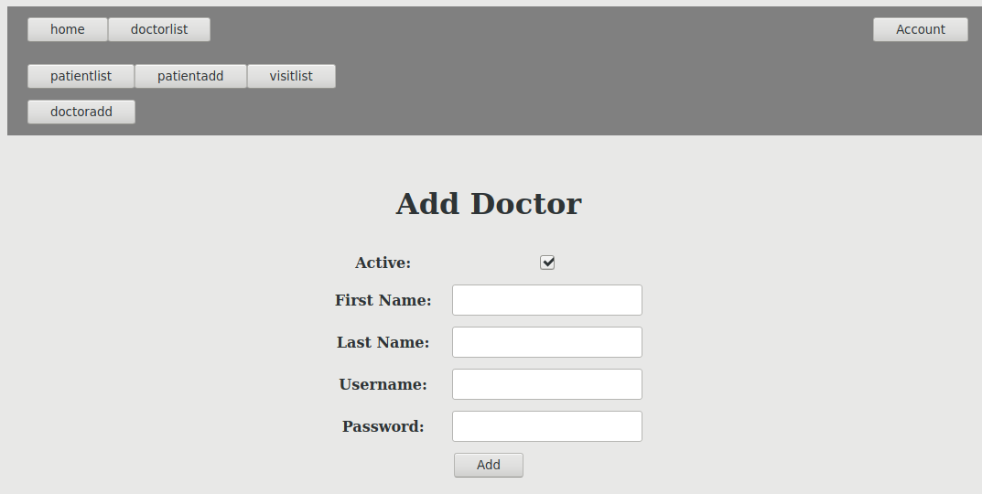

Edit patient (admin excusive):

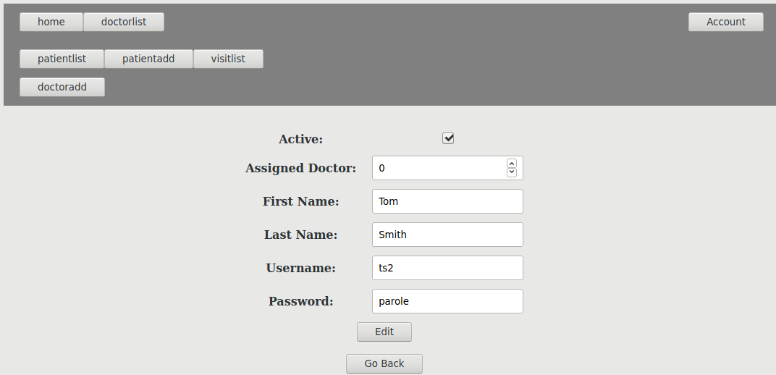

Doctor edit (admin excusive):

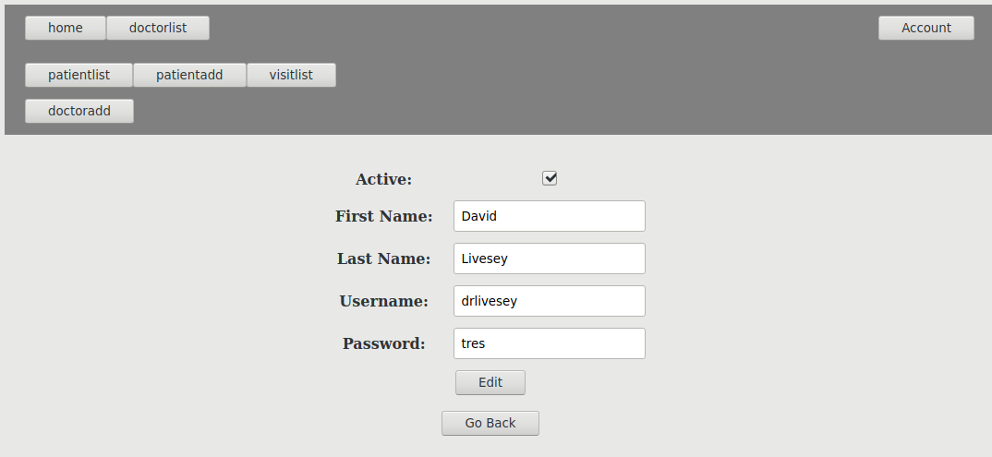

**Notes**

* “home” is the home page, it is also the landing page, etc (configured in web.xml)
* I do not use jsp since I call template anyways. Also I was unable to access EJB with jsp. All my pages, urls, etc are servlets
* edit pages fill in info in the fields (editable)
* some pages have illegal URL access protection (not all) that prevent accessing without appropriate privilege
* patient is a type of user, does not have doctor permissions. Has a higher privilege value than no login but there are no functions that care about that at the moment.
* I do not use sample database as my machine does not recognize it and can’t create it either. It uses “java:comp/DefaultDataSource” data source. Can be changed in ‘hospital-final-ejb/Configuration Files/persistence.xml’
* action servlets (that do something then redirect. e.g. delete, make edit, login, log out) are found in the action package
* page servlets are found in the pkg package
* helper package does not have servlets. In contains helper classes
* helper/HtmlGen has:
  + top bar html
  + page template that is used for all templates
  + my custom html generating helper methods
* helper/Vals has login permission level method
* helper/Vals also has method myVals for shared servlet logic. Does not contain anything but may be used if this project was continued
* helper/Style has html style information. Currently only has the style that goes in the <head> tag of the page
* only admin can see inactive entries
* delete buttons delete the row that they are on and load the page again
* go back buttons go to the corresponding table view page
* The helper/HtmlGen methods were made during different stages of development so they are not used 100% consistently (sometimes I don’t use them when I could have because they were not made yet when I wrote the particular html strings)
* glassfish 4.1.1 used (my installation of netbeans also has 4.1.2, it shouldn’t be used and probably doesn’t work with this project but consider it if anything)
* Sometimes deploying fails. If this happens, trying again after a clean and build works.