1. Install Node js

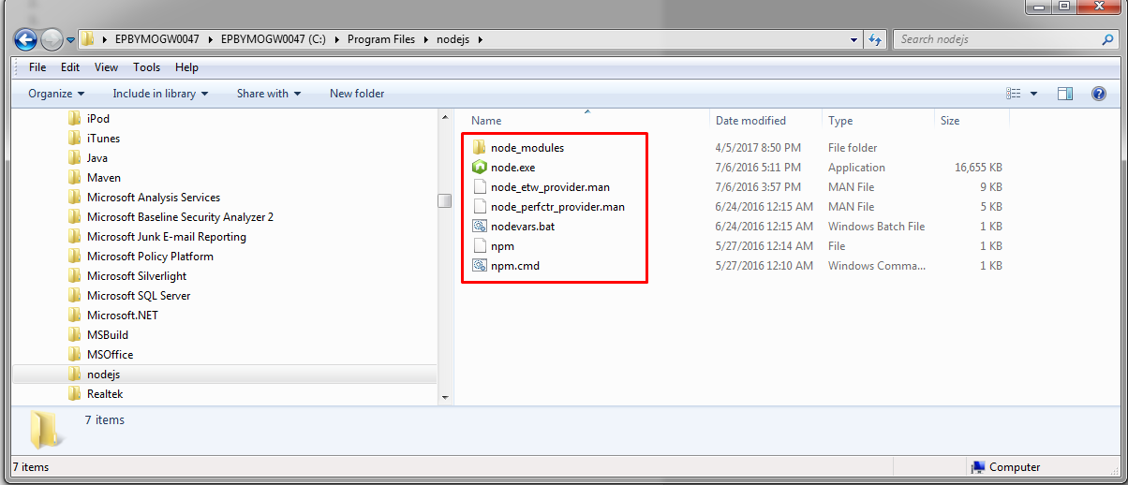

Environment Variables cannot be screenshotted by lightshot so I’ll show them here:

PATH: C:\Users\Artur_Shamsutdzinau\AppData\Roaming\npm;C:\Program Files\nodejs;C:\Program Files\nodejs\node_modules\npm\bin;

1. Download Java JDK

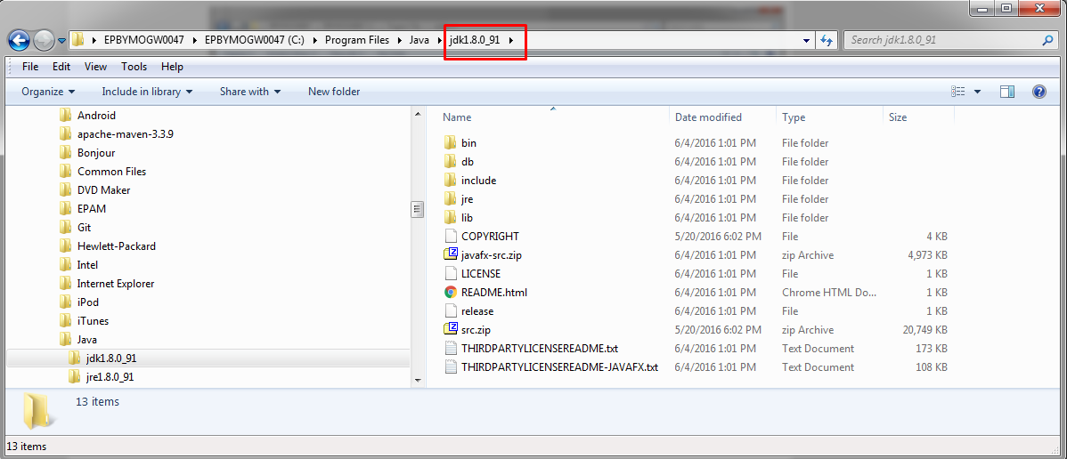

JAVA_HOME: c:\Program Files\Java\jdk1.8.0_91

PATH: C:\Program Files\apache-maven-3.3.9\bin

1. Install Android SDK

ANDROID_HOME: C:\Program Files\Android\Android Studio

PATH: %ANDROID_HOME%\tools;%ANDROID_HOME%\platform-tools;

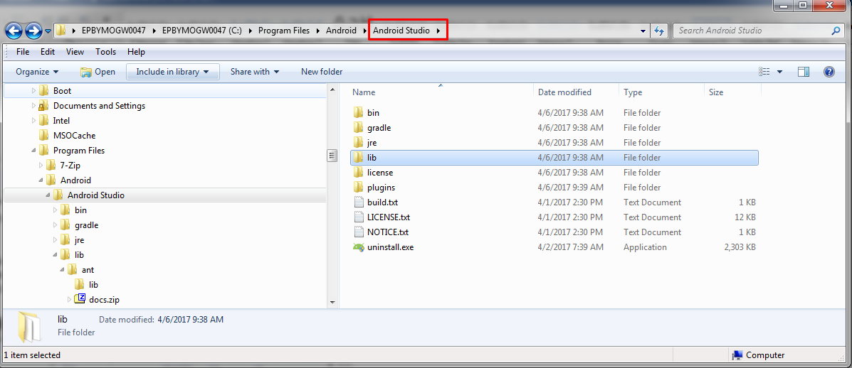

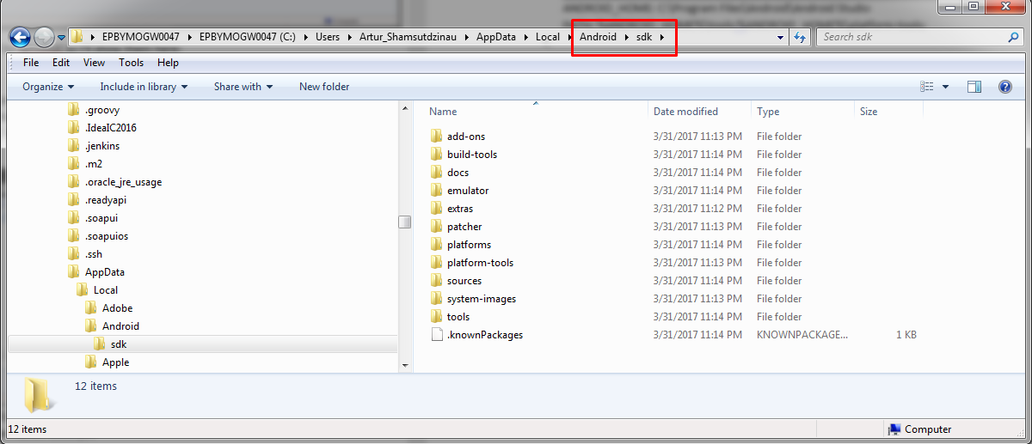

1. Install Apache Ant

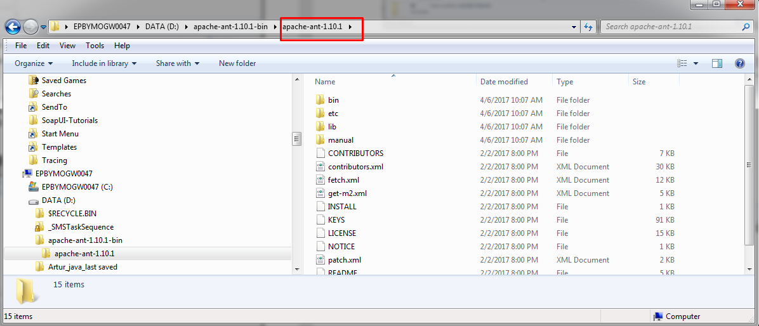

PATH: D:\apache-ant-1.10.1-bin\apache-ant-1.10.1\bin

1. Install Apache Maven

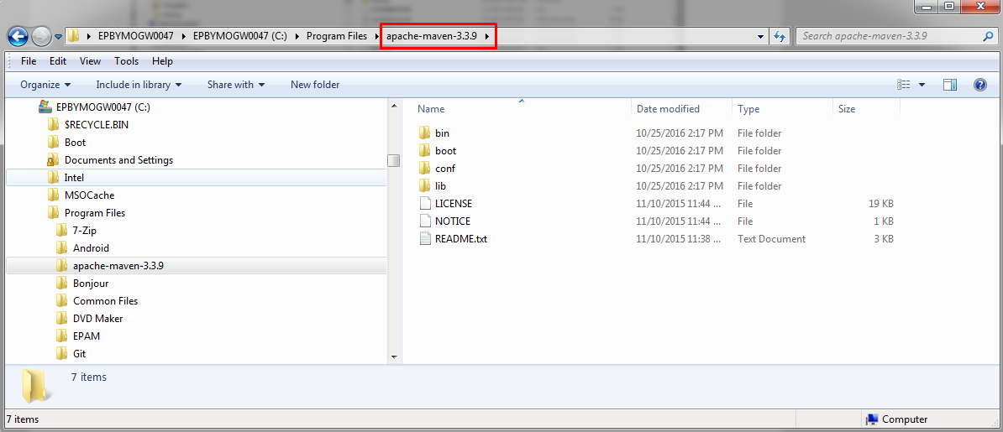

M2_HOME: C:\Program Files\apache-maven-3.3.9

M2: C:\Program Files\apache-maven-3.3.9\bin

PATH: C:\Program Files\apache-maven-3.3.9\bin

6-7. Open admin cmd and run command: npm install –g appium

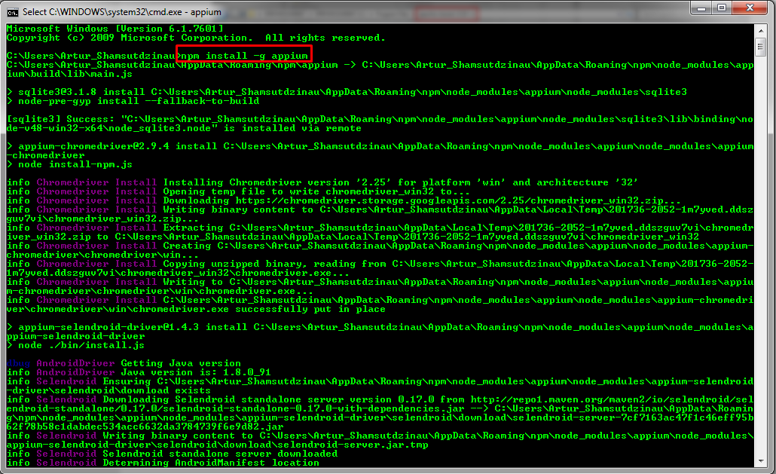

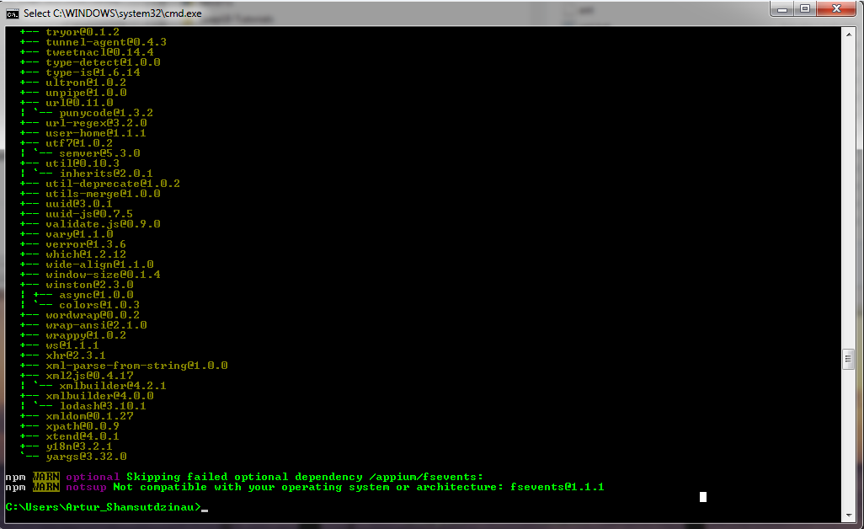

8. run command: appium

