Report of
OO Analysis & Design Project 2026

Module: OO Analysis and Design
Lecturer: Nasir Ahmad
Due Date: April 26, 2026

Submitted By:
Name: Taras Ivanysenko
Student ID: R00273556
Group: SD2-B

Name: Artur Romanov
Student ID: R00286804
Group: SD2-A

TABLE OF CONTENTS
PART A 3
Question №1 3
Question №2 4
Question №3 6
Question №4 9
Question №5 12
Question №6 13
PART B 14
Question №2 14
Question №3 15
BIBLIOGRAPHY 17
STUDENT DECLARATION 18

PART A

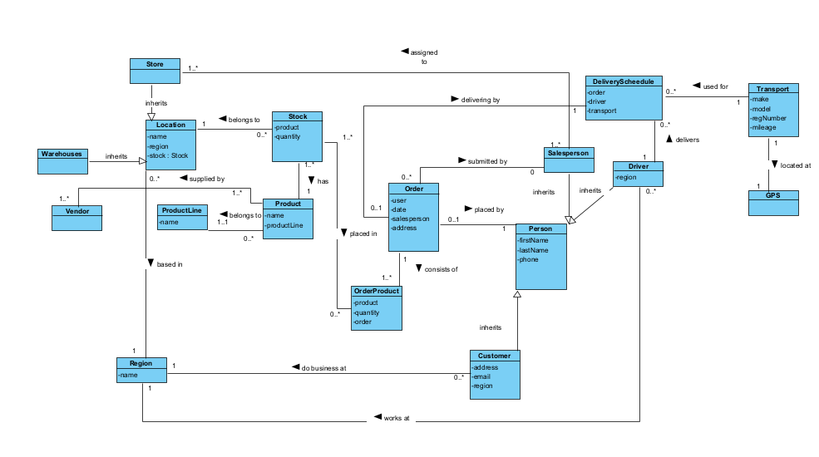
Question №1
Figure A.1 – Domain Diagram

In this task we implemented the general view of the system. There were some main architecture decisions:
Location is an abstract class, because Store and Warehouse are similar entities - both have a name and belong to a region. Similarly, Person is an abstract superclass for Driver, Customer and Salesperson, since they all share the same identifying attributes (firstName, lastName, phone) but play different roles in the system.
We also implemented a Stock entity to track the current availability of each product for each location. This allows the system to determine if a product is available in the region where the customer is located.
To manage the many-to-many relationship between orders and products, we introduced an OrderProduct association class, which also stores the quantity of each product in a given order.
DeliverySchedule was implemented to determine which Driver uses which Vehicle for a particular delivery, and to link the delivery to the order being delivered.
Eircode is implemented into address field of the Order model.
Other specifics of the system are clearly shown on the Figure A.1.

Question №2
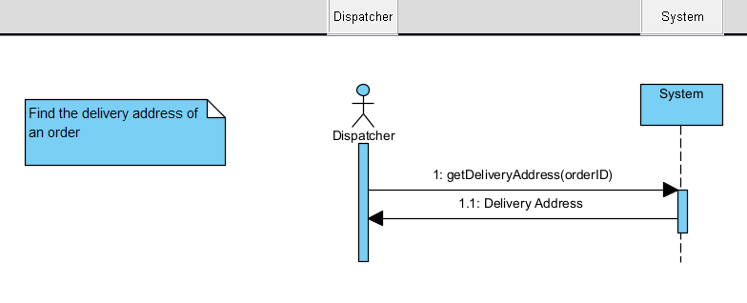
1) Find the delivery address of an order.
Figure A.2 – Find the delivery address of an order
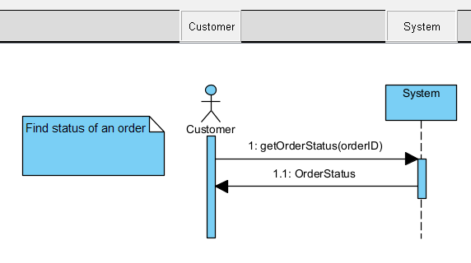
2) Find the status of an order.
Figure A.3 – Find the status of an order
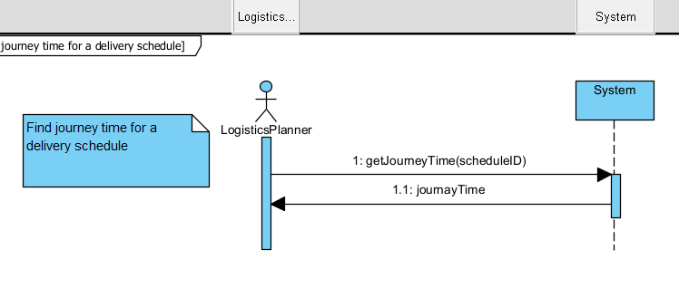
3) Find the journey time for a particular delivery schedule.
Figure A.4 – Find the journey time for a particular delivery schedule
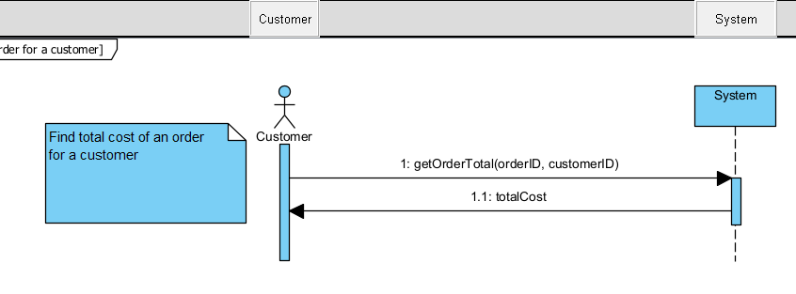
4) Find the total cost of an order for a particular customer.
Figure A.5 – Find the total cost of an order for a particular customer

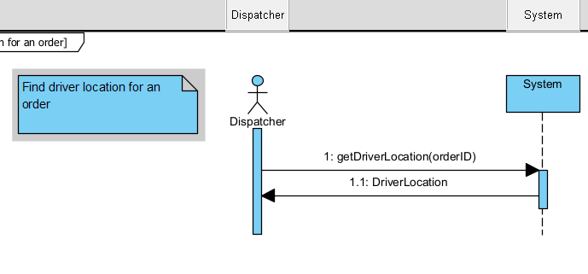
5) Find the current location of a driver who is out on a delivery of a customer order.
Figure A.6 – Find the current location of a driver who is out on a delivery of a customer order

Question №3
Class: OakValleySystem, Role: Controller (Singleton)
Operation Signature:
+getInstance() : OakValleySystem
+ getOrderStatus(orderID) : String
+ getOrderTotal(orderID, customerID) : double
"Find status of an order" and "Find total cost of an order" diagrams. A single System lifeline handles all incoming requests from the Customer actor, which is the typical role of a singleton front controller.
Class: Customer, Role: Service / Boundary Controller
Operation Signature:
+getInstance() : CustomerService
+ getOrder(orderID) : Order
CustomerService diagram. Acts as a boundary between the customer and the domain; it could be a singleton service.
Class: Dispatcher, Role: Controller
Operation Signature:
+getInstance() : Dispatcher
+ getOrder(orderID) : Order
+ getDriverLocation(orderID) : Location
Real-time location diagram. Orchestrates driver location retrieval; a single dispatcher instance is often used as a singleton.
Class: Order, Role: Domain Entity
Operation Signature:
+ getOrder(orderID) : Order
+ orderUpdate()
+ getStatus() : String
+ getTotalCost() : double
+ getDriverLocation() : GPS
Several diagrams (CustomerService, status diagram, total cost, real-time location).
Class: Product, Role: Domain Entity
Operation Signature:
+ getPrice() : double
Total cost iteration diagram.
Class: LogisticsPlanner, Role: Service (Singleton)
Operation Signature:
+getInstance() : LogisticsPlanner
+ getJourneyTime(scheduleID) : double
+ getSchedule(scheduleID) : DeliverySchedule
LogisticsPlanner diagram and DeliverySchedule logic diagram. Works as a centralised planner and is a natural singleton.
Class: DeliverySchedule, Role: Domain Entity / Aggregate
Operation Signature:
+getJourneyTime() : double
+getTransport() : Vehicle
+getDriver() : Driver
Class: RouteService, Role: Service (Singleton)
+getInstance() : RouteService
+ calculateDistance(origin, dest) : double
DeliverySchedule logic and real-time location diagrams.
Class: Vehicle, Role: Domain Entity
Operation Signature:
+ getAverageSpeed() : double
+ getCurrentLocation() : GPS
DeliverySchedule logic and real-time location diagrams.
Class: Driver, Role: Domain Entity
Operation Signature:
+ getVehicle() : Vehicle

Question №4
1) The order has a stored delivery address (or falls back to the customer’s address) and returns it.The order returns its current status (Figure A.7).
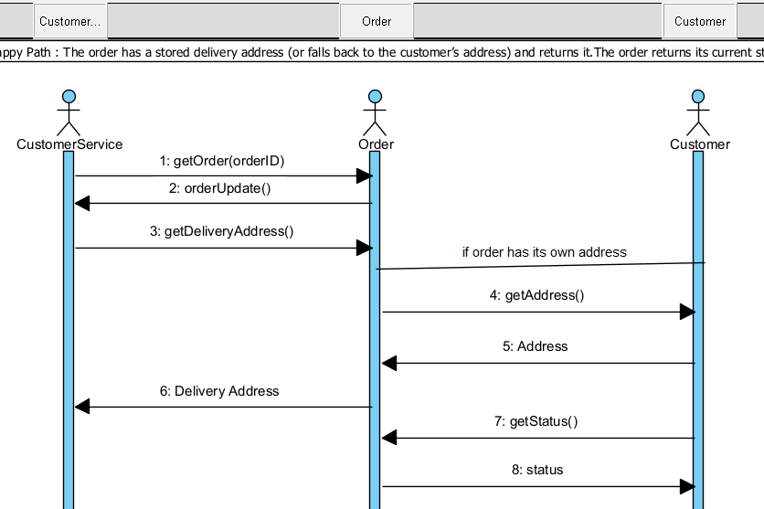
Figure A.7 – Happy Path 1

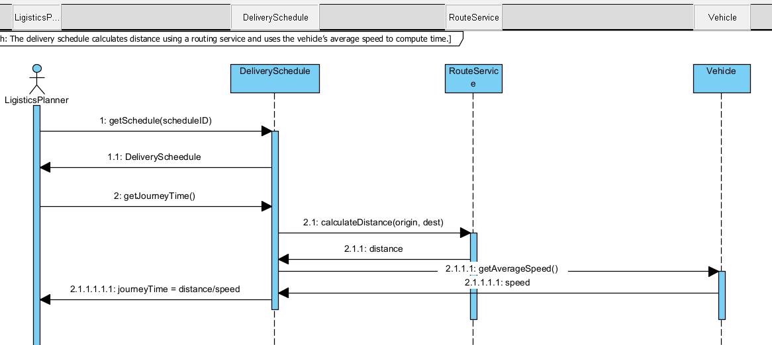
2) The delivery schedule calculates distance using a routing service and uses the vehicle’s average speed to compute time (Figure A.8).
Figure A.8 – Happy Path 2

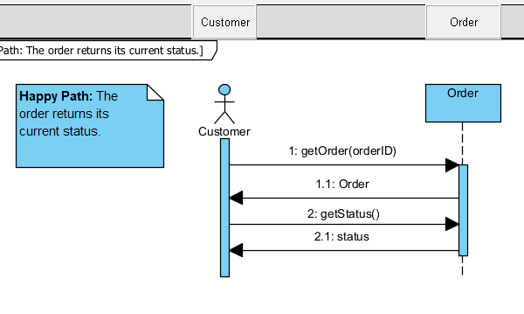
3) In this alternative interaction, the Customer actor directly retrieves the Order by ID and calls getStatus() on it, bypassing any facade. This simplified path is used for read-only, low-risk queries where no additional logic is required (Figure A.9).
Figure A.9 – Happy Path 3
4) The order iterates through its line items, gets each product’s price, and sums the total (Figure A.10).
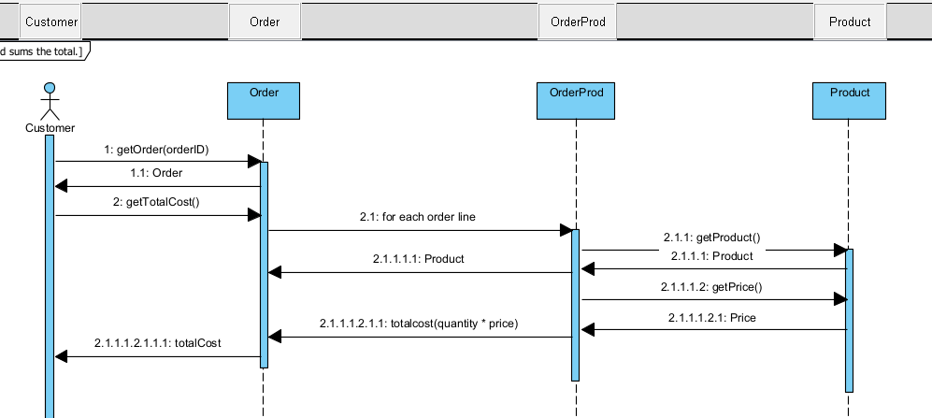
Figure A.10 – Happy Path 4

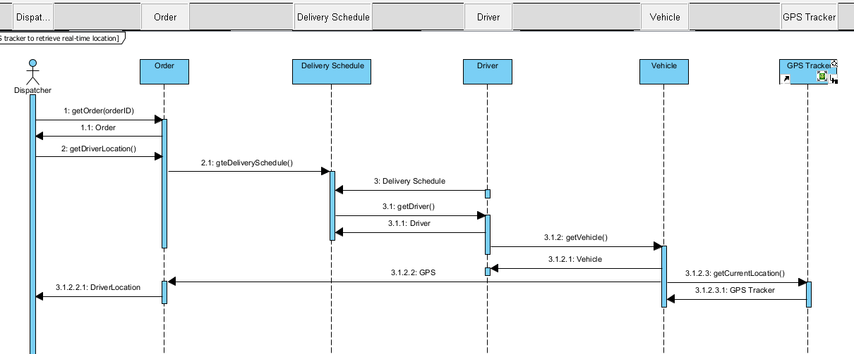
5) The Dispatcher actor initiates location retrieval without knowing the internal structure. The lookup follows the ownership chain Order → DeliverySchedule → Driver → Vehicle → GPS Tracker. This preserves encapsulation: the dispatcher cannot skip layers and directly access a vehicle or GPS device (Figure A.11).
Figure A.11 – Happy Path 5

Question №5
In this task we created a Design Class Diagram to support the sequence diagrams created in Question 4. We implemented five Singleton controllers, each handling a specific feature: CustomerService (find delivery address), OakValleySystem (order status and total cost), LogisticsPlanner (journey time), Dispatcher (driver location) and RouteService (distance calculation).
All five follow the Singleton pattern with a private static instance field and a public static getInstance() method. Domain classes from the Domain Model were extended with attributes and operations identified in Question 3. Each operation was assigned to the classes.
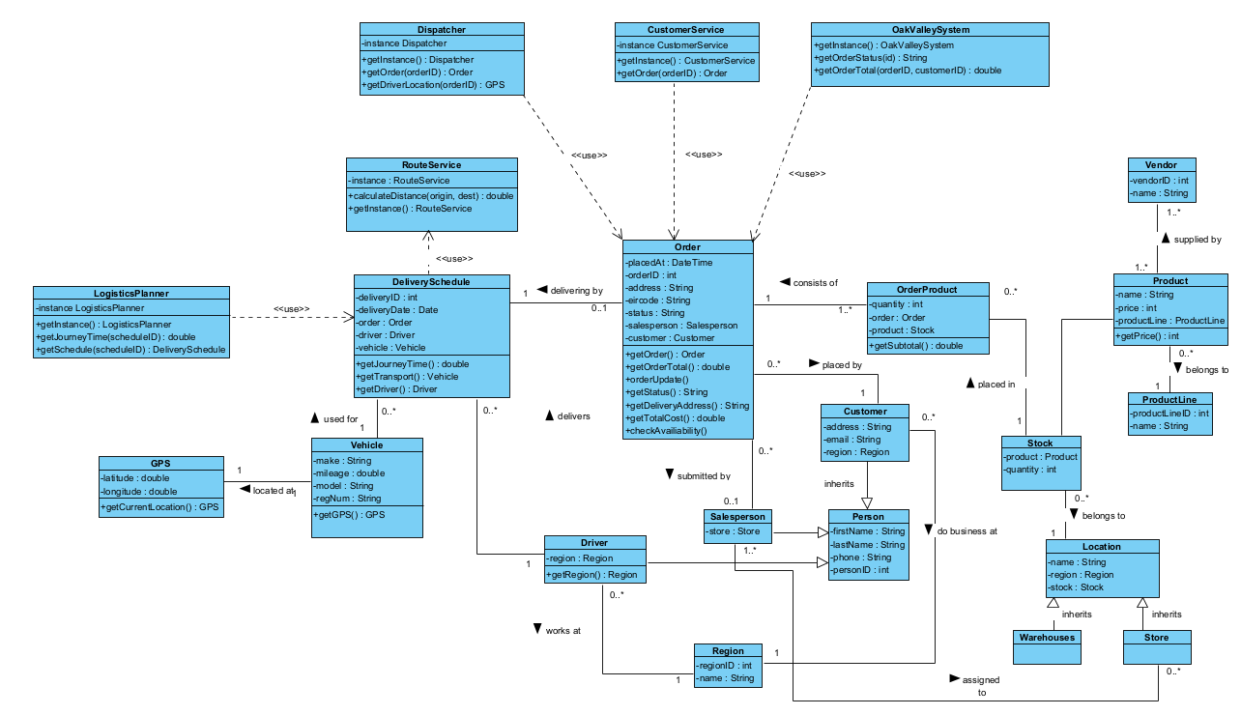
Figure A.12 – Class Diagram

Question №6
In this task we extended the Design Class Diagram to allow a customer to return a product that was ordered and delivered. We created OrderReturn class with the fields:
order – reference on the Order class
reason – description of the returning
createdAt – date and time of the submitted application
returnedAt – date and time when the order was returned
isAccepted – flag to inform that the order is a subject to refund
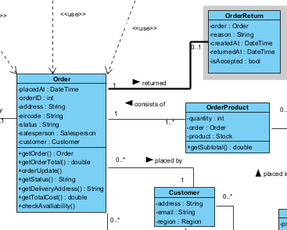
The relation means that the Order can have zero or one OrderReturn; and OrderReturn can have just one Order reference.
Figure A.13 – Fragment of the class diagram that shows the new feature

PART B

Question №2
In this task we created a design class diagram to model a home entertainment system and the ability for a user to be able to use a single remote control to control multiple digital devices.
We implemented the interface Device with two methods (turnOn() and turnOff()). All three devices use the interface, this is following to the principle of “Programming to an Interface” that enables polymorphism.
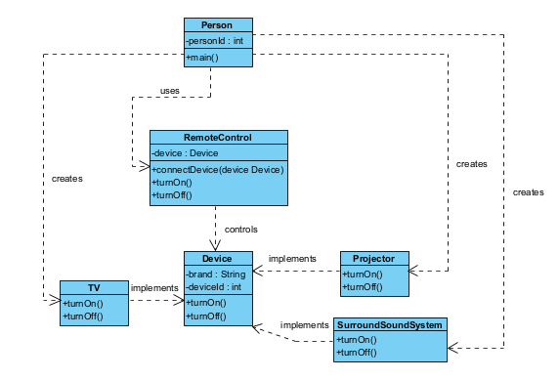
RemoteControl works with abstraction. The device: Device field is stored inside RemoteControl. This means that the remote can control any object that implements the Device.
Figure B.1 – Class diagram of the Remote-Control System

Question №3
1) The Facade pattern provides a unified, high-level interface to a set of interfaces in a subsystem, making the subsystem easier to use. It hides the complexity of multiple classes and their interactions behind a single, simplified entry point.
In the given code:
- The subsystem consists of CPU, Memory, and HardDrive – each with its own distinct operation (processData, load, readData).
- The class Computer acts as the Facade. It creates and holds references to all subsystem components, and its single run() method orchestrates the whole startup/execution sequence by calling the required methods in the right order.
- The client (User) only interacts with the Computer facade. It does not need to know about CPU, Memory, or HardDrive at all; it simply calls computer.run().
This decouples the client from the complicated subsystem, reduces dependencies, and makes the system easier to use and maintain.

2) We reversed engineer code into a UML class diagramComposition (filled diamond on Computer side): Computer owns instances of CPU, Memory, and HardDrive. They are created inside the constructor and exist only as long as the Computer object exists.
Dependency: User depends on Computer because it creates an instance and calls its run() method.
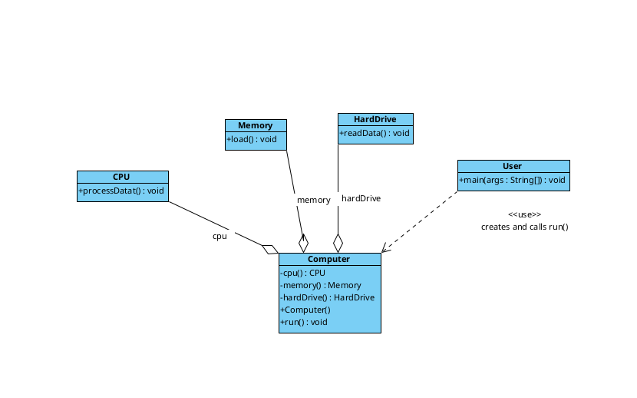
3) We drew a sequence diagram to illustrate main method
Figure B.2 – Diagram Composition
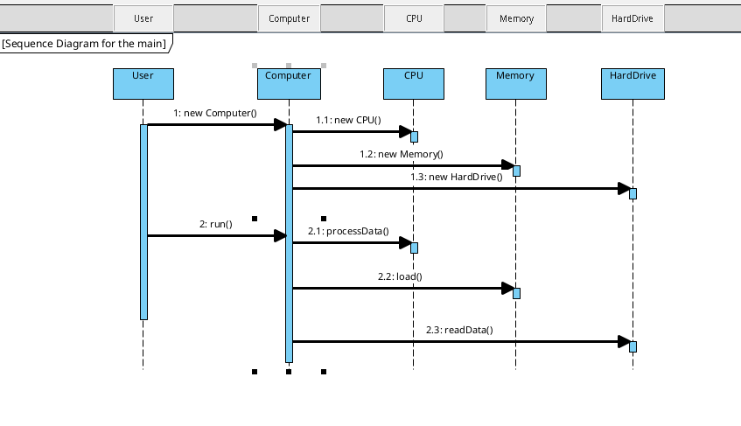
Figure B.2 – Sequence diagram

BIBLIOGRAPHY
- Refactoring.Guru (2024) Design Patterns. Available at: https://refactoring.guru/design-patterns (Accessed: 26 April 2026).
- SourceMaking (2024) Design Patterns and Refactoring. Available at: https://sourcemaking.com/design_patterns (Accessed: 26 April 2026).
- GeeksforGeeks (2024) SOLID Principles in Object-Oriented Design. Available at: https://www.geeksforgeeks.org/solid-principle-in-programming-understand-with-real-life-examples/ (Accessed: 26 April 2026).
- Baeldung (2024) Open/Closed Principle in Java. Available at: https://www.baeldung.com/java-open-closed-principle (Accessed: 26 April 2026).
- Oracle (2024) The Java Tutorials — Interfaces. Available at: https://docs.oracle.com/javase/tutorial/java/IandI/createinterface.html (Accessed: 26 April 2026).

STUDENT DECLARATION
I can confirm the following details:

Student ID/Registration number: R00273556
Name: Taras Ivanysenko

Student ID/Registration number: R00286804
Name: Artur Romanov

Module Name: OO Analysis and Design
Lab Lecturer: Nasir Ahmad
Due Date: April 26, 2026 @midnight

