**DiskImager User Guide**

All basic info about DiskImager can be found in README file.

**Contents**

* **Creating a backup copy of SD card/USB stick**
* **Restoring a SD card/USB stick from backup image**
* **Troubleshooting, additional information & links**

Creating a backup copy of SD card/USB stick

In this tutorial I will be using SD card with firmware for TRIK robot which I want to back up to `.img` file zipped in XZ archive.

Plug in Your computer the SD card/USB stick you would like to back up. Then, open the DiskImager. You will see main window of a program.

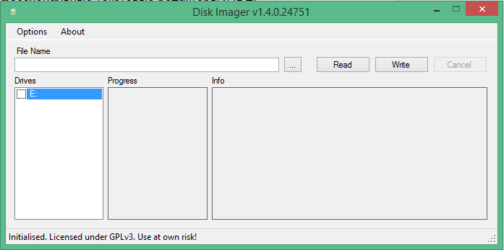

* Select the drive that You want to back up.
* After selecting a drive press `...` button to bring up dialog where You can choose a path and name for backup image that would be created.

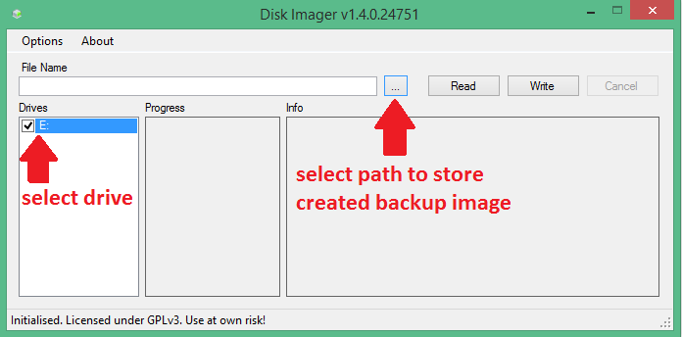

* Specify directory (it is a simple Windows file explorer dialog, so navigate as usual to a folder You like), name and file type for your backup image.

*\*Note: if you do not know which file type to choose, select XZ archive, because the resulting image will take less disk space on your computer.\**

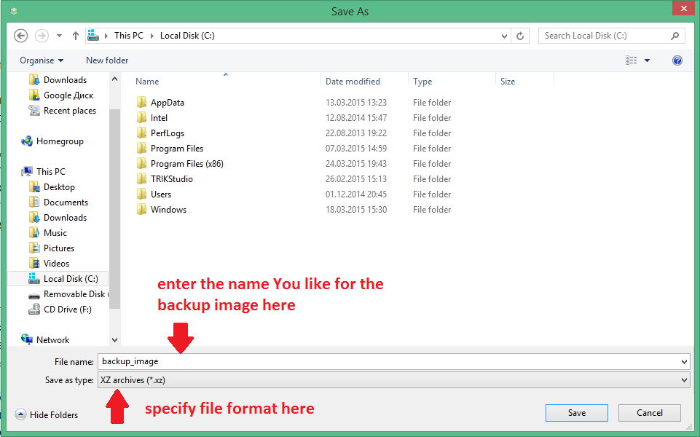

* Press `Read` button to start backing up.

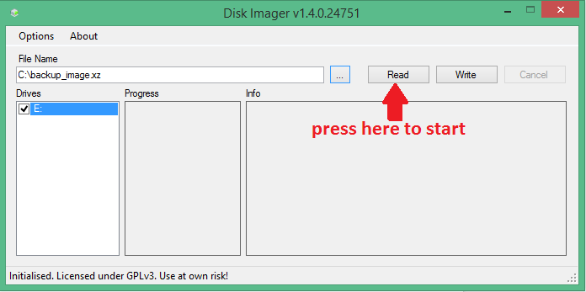

* Wait until utility performs requested operation.

Restoring a SD card/USB stick from backup image

In this tutorial, as an image, I will be using firmware for TRIK robot, which is `.img` file zipped in XZ archive.

Plug in Your computer the SD card/USB stick you would like to restore from your image. Then, open the DiskImager. You will see main window of a program.

* Choose the drives You want to restore

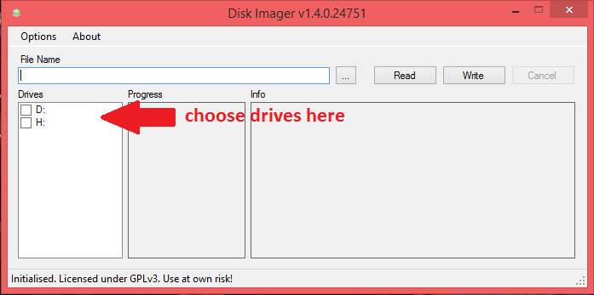

* Press `...` button to bring up dialog where You will be asked to choose a backup image. You can choose filter in the bottom of the dialog to set up extension filter.

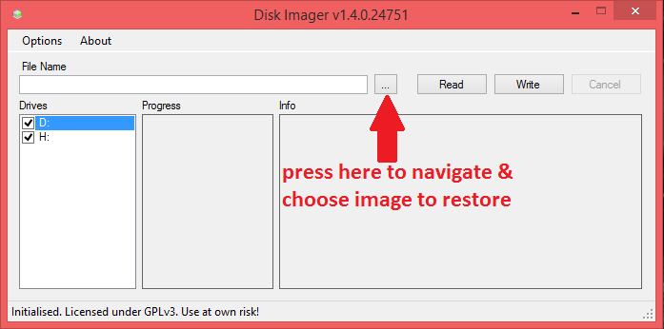

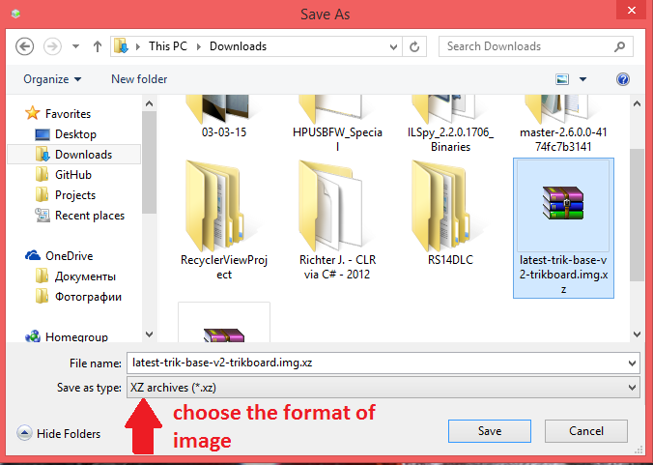

* Press `Write` button to start restoring from backup.

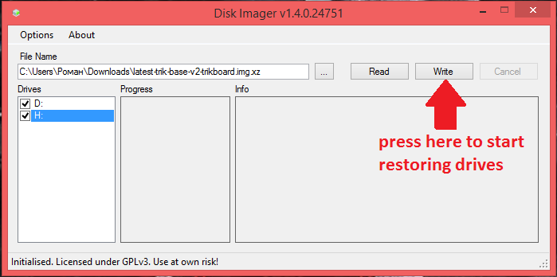

* Wait until utility performs requested operation.

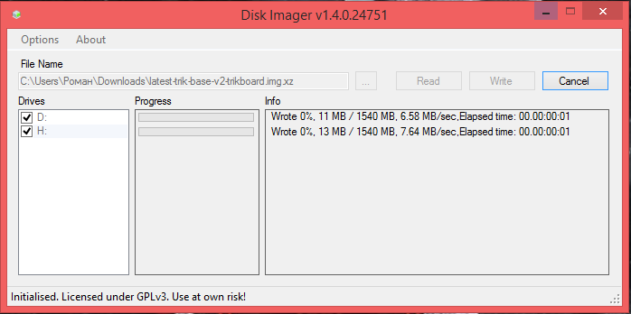

Troubleshooting

**Question**: I have plugged my SD card/USB stick in my computer, but DiskImager does not show it as available in the list of drives.

**Answer**: You can check out `Display all drives` in `Options` menu to show all drives attached to Your computer. \**Be careful when turning this option on because it is possible to damage the data on Your main HDD if You accidentally pick it as a drive to read or write*.* If it still would not be listed, You should check consistency of this drive.

Additional information

There are two options available at your choice at the `Options` menu

* `Use MBR sizes` allows you to read only data that is written in allocated MBR partitions. *\*By default this option is on, but You can turn it off to get a complete backup of Your drive.\**
* `Unmount drives after write` safely removes drives from the system so You can unplug them after write without caring about data losses. *\*By default this option is on, but You can turn it off if You want to perform some operations with drives after writing image on them.\**