Contents
VS Code Shortcuts 2
Shortcuts 2
Debug in visual studio 3
Terminal Shortcuts 4
Environmental variables 4
Screens 4
Aliases 4
Run multiple models in sequence in terminal 4
Excel Hints 5
GIT 5
Github – search for other project examples 5
Clone one branch into another – code freeze 5
Compare two branches 6
Merge two branches 6
Setup login and email in git 6
Push changes before pull request 6
Creation of common functionalities 6
See git history 7
Git fetch 7
Git branch 7
Git Stash 7
Git Delete Branch 7
Git Revert 7
Git Delete Commits and their history 8
SQL Hints 8
See all schema/view pairs 8
Coding Hints 8
3 Bad python habits to get rid of 10
Good python habits 10
DefaultDict 11
Try except finally 12
Threading.lock 13
Libraries 13
Pandas 13
Async Semaphore 13
DATABRICKS 14
Change job parameters in databricks 15
Poetry 16
Ruff 17
Polars 17
Config 17
Filter and collect 18
.collect() 18
Pl.col as c 18
Creating a new column with_columns 18
Create expressions without df, apply them later 18
Selecting columns based on criteria 18
Polars When then otherwise 19
pl.select 19
pl.select regex 19
Window function 19
Filter columns based on null 19
Whole outputs in jupyter 19
.pipe() 20
.Struct() 20
Plotly 20
Extensions 20
Debug Visualizer 20
Autodocstrings 21

VS Code Shortcuts

Shortcuts
- To search for a string in all the files of VS Code, use ctrl + shift+ F and type the string.
- To open search bar in VS Code use CTRL+SHIFT+P
- To search for a file, use CTRL+P
- Escape to the command mode then click A to create a cell above, and B to create a cell below in Jupyter.
- Find pieces of code or symbol inside the file: CTRL+P and use @
- Find pieces of code or symbol in the whole project (all files): CTRL+P and use #
- Ctrl +D will select the whole word. You don’t need to use ctrl+shift+arrow. If you click ctrl+D multiple times, it will select all cases in the file, where the text is written, so you can refactor everything in one place.
- By clicking in multiple places holding ALT, you can put your cursor and write simultaneously
- To select the whole row, you don’t need to play with Shift. Use CTRL+L!!!
- To open a new terminal (Open Terminal) in VS code, use CTRL + `
- Close Terminal: Ctrl + J
- CTRL+K in terminal to clear it
- To create nested folders
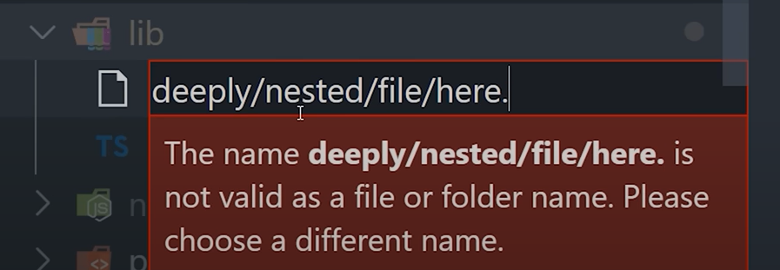
- To rename a variable function in the whole project, select it, Right Click->Find All References (or Shift+Alt+F12), then rename
- To add row numbers for each cell, use shift + L

Debug in visual studio
If you want to debug in visual studio code, do these steps:
VS Code:
- Create a .vscode directory in your project folder (if it doesn't already exist). -> I created here /home/artur/src/model/.vscode
- In that directory, create a launch.json file if it doesn't already exist.
- Inside launch.json, you can configure the "cwd" (current working directory) for your debugging configuration. Here's an example:
json
{
"version": "0.2.0",
"configurations": [
{
"name": "Python: Current File",
"type": "python",
"request": "launch",
"program": "${file}",
"cwd": "${fileDirname}", // Set the working directory to the script's directory
}
]
}
Or try this one
{
// Use IntelliSense to learn about possible attributes.
// Hover to view descriptions of existing attributes.
// For more information, visit: https://go.microsoft.com/fwlink/?linkid=830387
"version": "0.2.0",
"configurations": [
{
"name": "Python: Current File",
"type": "python",
"request": "launch",
"program": "${file}",
"console": "integratedTerminal",
"cwd": "${fileDirname}",
"justMyCode": true
}
]
}

IF at some point debug fails with Qt error, paste this to terminal: export QT_QPA_PLATFORM=offscreen

Terminal Shortcuts
To export notebook as html, simply run jupyter nbconvert --execute --to html --no-input "population_demography.ipynb"

To activate condas environment
# Create a new virtual environment
conda create -n profiling_env python=3.8

# Activate the new environment
conda activate profiling_env
To delete conda environment
conda remove --name your_env_name --all
conda install -c conda-forge ydata-profiling
to activate your virtual environment. To do it, use . src/venv/bin/activate command from the console

to quickly get back to /home/, use cd without any ..

Environmental variables
You can create environmental variables in your shell which can be then used as inputs for Python or whatever. To create an environmental variable, use:
(base) artur@artur-notebook:~/src/model$ export MYVARIABLE=foobar
(base) artur@artur-notebook:~/src/model$ echo $MYVARIABLE → this command simply shows it
foobar

Screens
To see all the screens use screen -ls

Aliases
To add aliases, you need to do ls -a; use vim .bashrc to open the command; add aliases there using insert mode (type I). After you finish, click on Esc and then shift+:. Type wq to save the changes.

To activate in the old terminal changes, use source .bashrc. Otherwise, you don’t need it if the terminal is new

Run multiple models in sequence in terminal
How to run something in terminal in for loop:
Create .sh file, in terminal give permissions to the file:
chmod u+x run_backtest_loop.sh
And then execute the file:
./run_backtest_loop.sh
Example how to do it in shell
for i in 01 02 03 04 05 06 07 08 09 10 11 12 13 14 15 16; do
export predict_port="81${i}"
python run_predict.py "2023-11-${i}" /home/artur/output/miso/m1.12/2023-10-25_2023-11-15 --cutoff_hour 8
done
ts_api = TimeSeriesAPI('192.168.15.10', int(os.environ['predict_port']))

To run multiple models in sequence, you also can define shell for that. And simply put multiple line of code one by one. They will be executed sequentially

Excel Hints
Switch off Scroll lock when cells don’t move in Excel. Use Fn+S shortcut

GIT

Github – search for other project examples
To see how other people do stuff in github
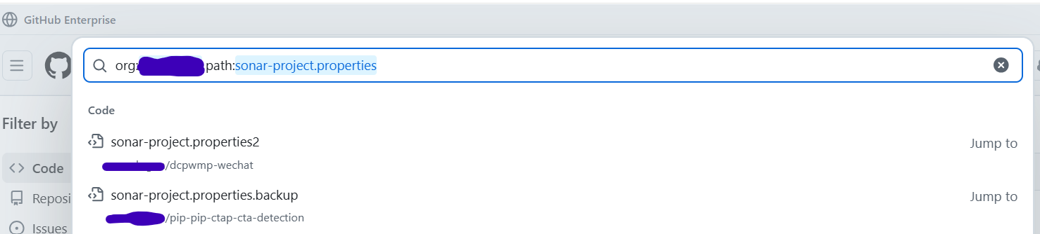

Clone one branch into another – code freeze
Do step by step
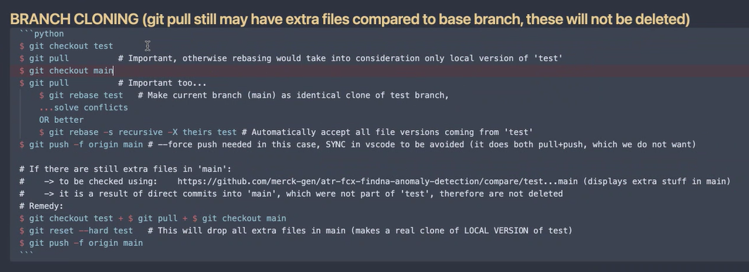
$ git checkout test
$ git pull # Important, otherwise rebasing would take into consideration only local version of 'test'
$ git checkout main
$ git pull # Important too...
$ git rebase test # Make current branch (main) as identical clone of test branch,
...solve conflicts
OR better
$ git rebase -s recursive -X theirs test # Automatically accept all file versions coming from 'test'
$ git push -f origin main # --force push needed in this case, SYNC in vscode to be avoided (it does both pull+push, which we do not want)

# If there are still extra files in 'main':
# -> to be checked using: https://github.com/<anon>-gen/atr-fcx-findna-anomaly-detection/compare/test...main (displays extra stuff in main)
# -> it is a result of direct commits into 'main', which were not part of 'test', therefore are not deleted
# Remedy:
$ git checkout test + $ git pull + $ git checkout main
$ git reset --hard test # This will drop all extra files in main (makes a real clone of LOCAL VERSION of test)
$ git push -f origin main

Compare two branches
https://github.com/<anon>-gen/atr-fcx-findna-anomaly-detection/compare/develop...test

Merge two branches
algorithm to merge two branches, where B1 is your branch and B2 is the merging branch from where you want to get changes into B1:
git checkout B2
git pull
git checkout B1
git merge B2

B2: data_api_isone_test-PJM_data_API-global_v1
B1: data_api_isone_test-dart_basline_isone
Changes from B2 go to B1
data_api_ercot_test-dart_basline_ercot
data_api_miso_test-dart_basline_miso

Setup login and email in git
to setup your login and email in git, paste these in terminal:
git config --global user.name "dragunoa_<anon>"
git config --global user.email "artur.dragunov@<anon>.com"

Push changes before pull request
Steps to push your changes in a sub-branch.
- Git fetch origin
- Git merge origin/develop
- Git commit and push your changes in your branch.

Creation of common functionalities
Steps to merge common functions correctly:
You have developed a function which you want to share, you need to
- Be in the folder you are working on. e.g. src/model
- Do git pull
- Do git checkout main branch you need. e.g. git checkout sktime_main
- Do git checkout -b sktime_main-<your-new-branch-name> Use only -, not _. Give it a name representing your function changes. E.g. git checkout -b sktime_main-plot-diagnostics
- Then, you do your changes there and push them
- Then, you go to bitbucket and do a pull request. Someone should approve it. While it’s being approved, you can merge your sktime_main_plot_diagnostics with your other branch to start using the function. Later you would do merge once again with the sktime_main.
- Don’t forget to click on Delete the branch after pull request approved
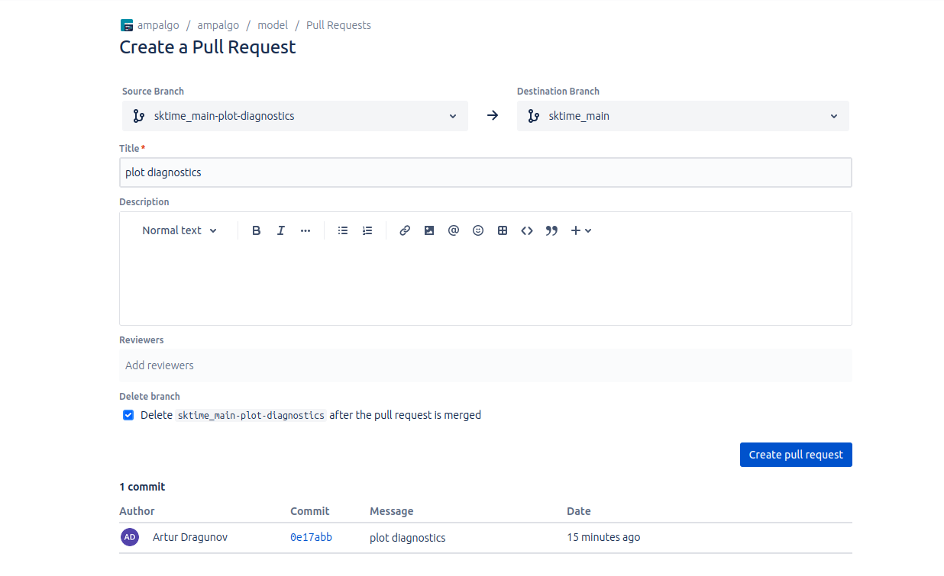

See git history
commands to help understand what’s happening in the repository are
git log --graph --decorate --oneline
To see your merge history: git log --oneline --graph --all --decorate

Git fetch
- git fetch – to get all the repository names and history from bitbucket. E.g. when you don’t see a repository name which should be there (new one)

Git branch
- git branch shows all the branches which you have used in the past
- To find out a branch to which a commit belongs to use: git branch --contains <commit-hash>
- git branch -av|grep new → -a shows all the branches, | is like %>% in R. It takes outputs of what were in the left and provides to the stuff to the right. Grep is like a filter, it takes all the strings and filters those which have new in the name.

Git Stash
- git stash drop stash@{0} to fully drop/delete unnecessary stash
- To apply specific stash: git stash apply stash@{0}
- See what is stashed: git stash list
- git stash pop: Apply and remove latest stash

Git Delete Branch
git branch -d branch_name to delete from local
git push origin --delete branch_name to delete from remote

Git Revert
to revert the merge commit, do git revert -m 1 <merge_commit_hash>

Git Delete Commits and their history
- git reset --hard 4711b0e (where 47... is the hash where I want to get (hash from where I created my repository, or from where clean commits are located), all commits after this hash will be deleted)
- After that git push -f origin fcx-641-cleaning-context-file-generation, enforcing changes in your branch in online/origin repository
- Use git pull in the end just in case

SQL Hints
Don’t use FORMAT() in SQL. USE SELECT CONCAT(LEFT(CAST(getdate() as date),7),'-01'). It’s Faster!

See all schema/view pairs
SELECT
schemaname,
viewname
FROM
pg_catalog.pg_views
ORDER BY
schemaname, viewname;

Dbeaver and SQL
- To execute sql expression in dbeaver, use CTRL+ENTER
- To find tables based on their name, use the query below. New views always have _ai_vw in their names
- SELECT table_name
- FROM information_schema.views
- WHERE table_name LIKE '%_ai_vw%'

Coding Hints
Put comments on 1 level:
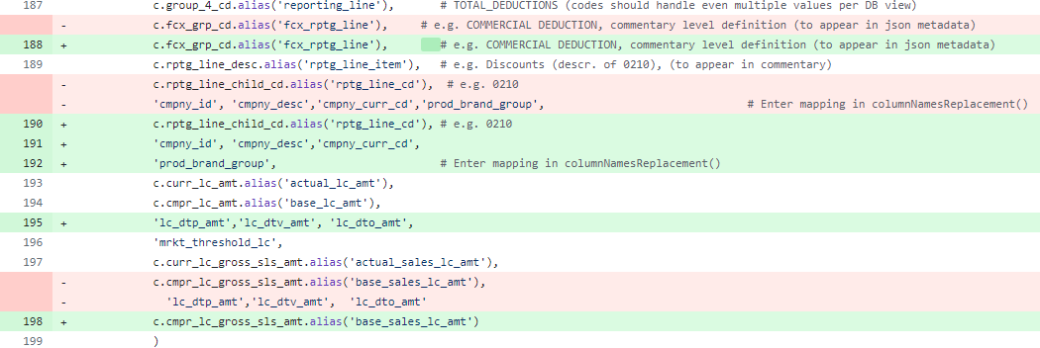

Required parameters should be passed positionally, while optional parameters should be passed by keyword. For example:

replaceOthersCategory(results_cont,
reporting_line=reporting_line)
so, just to clarify: if a parameter is optional, then we should explicitly define it in the function:
othersCategoryReplacement(reporting_line=reporting_line)
And if parameter is mandatory, then the below version is enough
othersCategoryReplacement(reporting_line)

To ignore warnings in jupyters:
- Warnings.filterwarnings(‘ignore’)

Always wrap return statements into ()
Return( … )
The line if __name__ == '__main__': is a common Python idiom used to determine whether a script is being run directly or being imported as a module. Here's a brief explanation:
- When it's triggered:
  - This condition is true when the script is run directly.
  - It's false when the script is imported as a module into another script.
- Why we need it:
  - It allows you to write code that only executes when the script is run directly.
  - This is useful for including test code or initialization routines that shouldn't run when the script is imported as a module.
- How it works:
  - Python sets the special __name__ variable to '__main__' when the script is executed directly.
  - When a script is imported as a module, __name__ is set to the name of the module.
This construct helps in creating reusable code that can both be imported as a module and run as a standalone script.

Parser gives a person who runs the script, run it with additional arguments. Then args object goes into another function with defined parameters by a user
• parser = argparse.ArgumentParser()
- This creates an ArgumentParser object. It's the main interface for defining and parsing command-line arguments.
• parser.add_argument("--mode", help="Calculation mode to limit reporting lines", default='default', required=False)
- This adds an argument to the parser:
  - "--mode": The name of the argument. Users will use this on the command line like --mode somevalue.
  - help=...: Provides a description of the argument for the help message.
  - default='default': Sets the default value if the argument isn't provided.
  - required=False: Makes this argument optional.
• args = parser.parse_args()
- This parses the command-line arguments and returns them as an object.
- After this, you can access the value of the 'mode' argument using args.mode.
driver02_variance_explanation.py
globals() is a built-in Python function that returns a dictionary representing the current global symbol table. This dictionary contains all global variables and functions in the current module, including those defined in the file and those imported from other modules. It provides a way to dynamically access or modify the global namespace of a Python program at runtime.
Example usage:
calc_function = globals()[plan['calc_function'][icalc]]
Here, globals() consists of all functions which are in the module, and we dynamically take the one we need. Particularly, it takes functions from here:
from src.utils.variance_explanation_wrapper_functions import *

3 Bad python habits to get rid of
Never use except without clear explanation, what exactly is with the error. Always try to catch the error
try:
total += float(user_input)
except ValueError:
print('Please enter a valid number...')
except Exception as e:
print(repr(e))

Avoid using mutable default arguments in Python functions: This approach avoids the common pitfall of using mutable objects as default arguments, which can lead to unexpected behavior when the function is called multiple times

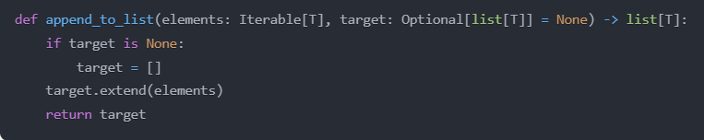
Do not convert range, map, filter into a list directly. It takes a lot of memory!
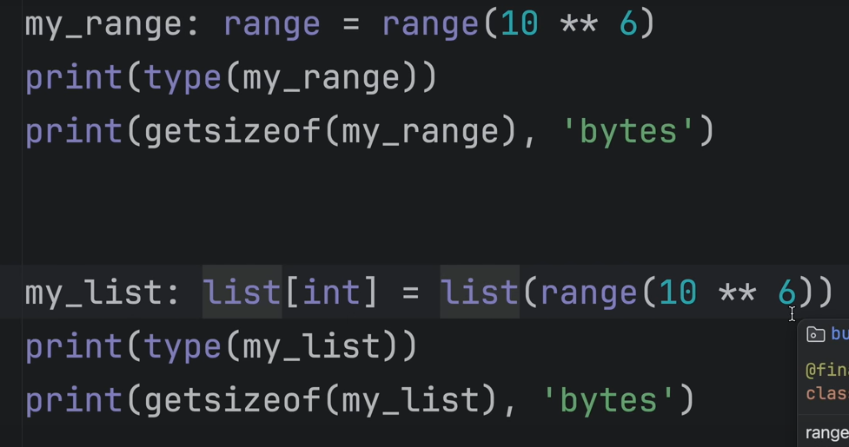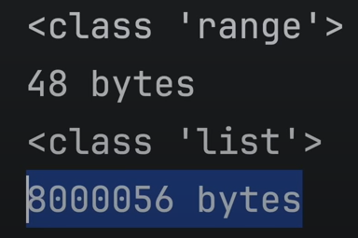

Good python habits
- Always use if __name__==’__main__’ in python code if you create a module or function, and you want also to be able to execute this module/function within the same file. Otherwise, it would be executed twice if triggered in another file.
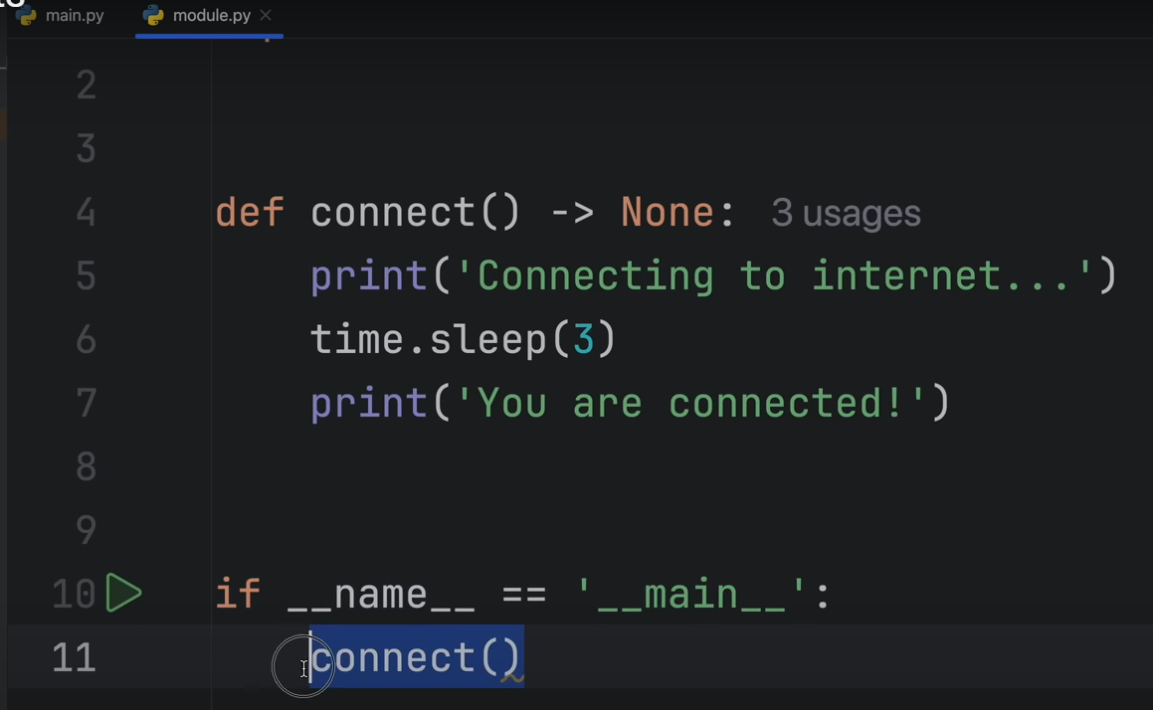
Basically, in any .py file which is meant to be run at a certain point, use the syntax below and then start writing your code. If .py is assumed to be purely as a function/class holder, then you don’t need it.
if __name__ == '__main__':

- Keep your functions simple. Don’t write too much functionality in 1 function. Instead, use multiple functions, so that they could be reusable
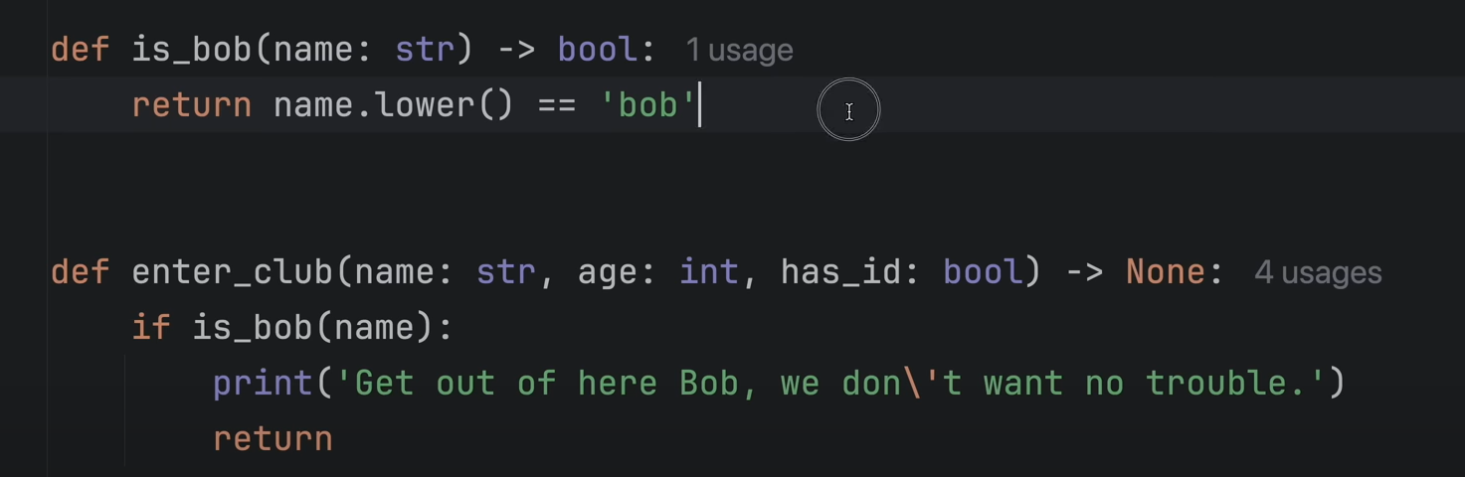
- Use type annotations. They should help the user to understand what type of data is allowed to be used in your function
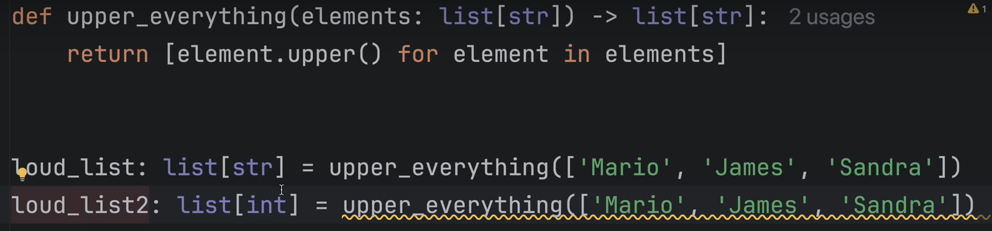
- Use list comprehension where possible
long_names: list[str]=[name for name in names if len(name) > 7]

DefaultDict
In Python, defaultdict is a subclass of the built-in dict class, provided by the collections module. It is a specialized dictionary that provides a default value for missing keys.
The syntax for creating a defaultdict is:
from collections import defaultdict

my_dict = defaultdict(list)
Here's how it works:
- When you try to access a key that doesn't exist in a regular dictionary, you'll get a KeyError. With defaultdict, instead of raising a KeyError, it will automatically create a new entry for the missing key and assign it the default value, which in this case is an empty list [].
- This is particularly useful when you want to build a dictionary of lists, where you can easily append values to the list associated with each key, without having to check if the key already exists or initialize the list manually.
For example:
python
Copy
from collections import defaultdict

# Create a defaultdict of lists
word_counts = defaultdict(list)

# Add some words and their counts
word_counts['apple'].append(5)
word_counts['banana'].append(3)
word_counts['apple'].append(2)

# Access the counts for each word
print(word_counts['apple']) # Output: [5, 2]
print(word_counts['banana']) # Output: [3]
print(word_counts['orange']) # Output: []
In this example, when we try to access the counts for the key 'orange', which doesn't exist, defaultdict automatically creates a new entry with an empty list as the default value.
The defaultdict is useful when you want to build a dictionary of lists, sets, or any other data structure, without having to check for the existence of keys or initialize the values manually.

Try except finally
The finally block is executed after the try block completes, including after any return statement. Here's a simple example to prove it:
def test_finally():
try:
print("1. In try")
return "2. Returning"
finally:
print("3. In finally")

print(test_finally())
This will output:
1. In try
3. In finally
2. Returning
The execution order is:
- Execute try block
- Hit return statement
- Execute finally block
- Actually return the value
The return value is "cached" when the return statement is hit, then the finally block executes, and only after that the cached return value is actually returned from the function.
This is why finally is perfect for cleanup operations like closing files, database connections, or in your case, finishing observability tracking - it ensures these cleanup tasks happen even if the function returns early or raises an exception.

Threading.lock
A thread lock (threading.Lock) is a synchronization primitive used to prevent multiple threads from simultaneously accessing shared resources. It works like this:
from threading import Lock

# Create a lock
lock = Lock()

def critical_section():
# Thread waits here if lock is held by another thread
lock.acquire()
try:
# Only one thread can execute this at a time
shared_resource.modify()
finally:
# Always release the lock
lock.release()

# Or using context manager (preferred way):
def better_critical_section():
with lock: # automatically acquires and releases
shared_resource.modify()
Key points:
- If thread A has the lock, thread B must wait until A releases it
- Only one thread can hold the lock at a time
- Used to prevent race conditions
- Always release locks in finally to avoid deadlocks
- with statement is safer as it automatically releases the lock

Libraries

Pandas
To see whole output in pandas jupyter, use

pd.set_option('display.max_rows', None)
pd.set_option('display.max_columns', None)

Async Semaphore
Async in Python serves two main purposes:
- Parallelization: It allows multiple operations to run concurrently (in parallel), which is especially useful for I/O-bound tasks like:
  - API calls
  - Database queries
  - File operations
  - Network requests
- Concurrency Control: Using tools like Semaphore, you can control how many operations you want to run in parallel
semaphore = asyncio.Semaphore(max_parallel_tasks) # Limits concurrent executions
Async (Asynchronous)
Imagine you're at a restaurant, and you order a pizza. While the chef is preparing your pizza, you don't just sit there doing nothing. Instead, you might:

Chat with friends.
Check your phone.
Order a drink.
You're doing other things while waiting for your pizza. This is similar to how async works. It allows your program to do other tasks while waiting for something else to finish (like an API call).

Best for: Tasks that involve waiting (e.g., network requests, file I/O).
How it works: Tasks can pause and resume, allowing other tasks to run during wait times.
Threading
Now, imagine you have multiple friends at the restaurant, and each of them orders a pizza. The chef can cook multiple pizzas at the same time because he has multiple ovens and assistants.

Each friend is like a separate thread.
The chef and his assistants (the CPU) can work on multiple pizzas (tasks) simultaneously.
Threading allows your program to do multiple things at the same time by creating multiple "threads" of execution.

Best for: Tasks that can run independently and simultaneously (e.g., processing multiple files).
How it works: Multiple threads run in parallel, each doing its own task.
Key Differences
Concurrency vs. Parallelism:

Async is about concurrency: doing multiple things by switching between tasks during wait times.
Threading is about parallelism: doing multiple things simultaneously.
Resource Usage:

Async is generally more lightweight because it doesn't create new threads.
Threading can use more resources because each thread requires its own memory and management.
Use Cases:

Use async when your tasks involve a lot of waiting (e.g., network requests).
Use threading when your tasks can run independently and you want to utilize multiple CPU cores.
In summary, async is like multitasking while waiting, and threading is like having multiple workers doing tasks simultaneously.

DATABRICKS
These two libraries are needed in databricks to track your experiments:
- Import mlflow
- Import mlflow.sklearn

To create secrets in databricks, run this code
import requests

# Replace these placeholders with your information
workspace_url = "https://<your-databricks-instance>"
token = "dapi<your-personal-access-token>" # Get from account settings
scope_name = "<your-scope-name>"
key_name = "<your-key-name>"
new_secret_value = "<your-secret-value>"

# Define the API endpoint
url = f"{workspace_url}/api/2.0/secrets/put"

# Prepare the request headers and payload
headers = {
"Authorization": f"Bearer {token}"
}
payload = {
"scope": scope_name,
"key": key_name,
"string_value": new_secret_value
}

# Make the request to update the secret
response = requests.post(url, headers=headers, json=payload)

# Check the response
if response.status_code == 200:
print(f"Secret '{key_name}' was successfully updated in scope '{scope_name}'.")
else:
print(f"Error: {response.status_code}, {response.text}")

Change job parameters in databricks
import requests

# LAB
DATABRICKS_INSTANCE = '' #url
token = '' # secret you generate
JOB_ID = ''# FCX pipeline – ID of your databricks job

def main():
# Step 1: Retrieve the current job configuration
response = requests.get(
f'{DATABRICKS_INSTANCE}/api/2.1/jobs/get',
headers={'Authorization': f'Bearer {token}'},
params={'job_id': JOB_ID}
)

job_settings = response.json().get('settings', {})

# Step 2: Modify the job parameters
# >>>
# change parameters in config file
job_settings['tasks'][0]['spark_python_task']['parameters'] = \
["--mode","comm_regeneration_test01"] # comm_regeneration_test02 # comm_regeneration_test03 [0] indicates the task index (first one)
# <<<

# Step 3: Update the job with the new settings
update_response = requests.post(
f'{DATABRICKS_INSTANCE}/api/2.1/jobs/update',
headers={'Authorization': f'Bearer {token}', 'Content-Type': 'application/json'},
json={
'job_id': JOB_ID,
'new_settings': job_settings
}
)

if update_response.status_code == 200:
print('Job updated successfully!')
else:
print('Error updating job:', update_response.json())
if __name__=="__main__":
main()
#<eof>

Poetry
To install poetry:
- First, install pipx. Open powershell, and run py -m pip install --user pipx
- Run py -m pipx ensurepath
- Close powershell, open a new one
- Run pipx install poetry
- Test it with poetry –version
How to start working with poetry?
- Navigate to your project directory:
Copy
cd C:\Repository\my-project
- Install the project dependencies:
Copy
poetry install
This command will create a virtual environment for your project and install all the dependencies specified in the pyproject.toml and poetry.lock files.
- use poetry run to execute commands within the virtual environment:
Copy
poetry run python your_script.py
These methods will work without changing the execution policy, but you'll need to prepend poetry run to your Python commands.
Additional notes:
- The presence of both poetry.lock and requirements.txt suggests the project supports both Poetry and pip workflows. Poetry will use the poetry.lock file for more precise dependency resolution.
- If you need to add new dependencies later, use:
Copy
poetry add package-name
- To deactivate the virtual environment when you're done, simply type exit or close the terminal.
- If you need to update dependencies in the future:
Copy
poetry update

Ruff
How to use ruff:
- Ruff check . -> checks all the problems in all the files. You can do it also for individual files. You should use it!
- Ruff check . --fix -> fixes all the errors in all the files
- Add to pyproject.toml for yourself extend-select = [“C4”,”SIM”, “TCH”]
  - C4 stands for making comprehensions better (list comprehensions)
  - TCH stands for type checking (
  - SIM stands for simplification of code (removing nested for loops)

Polars
A vertical concatenation won’t work well when you have schema changes. (e.g. new column in one of the dataframes added). This is where diagonal concatenation in Polars comes in. Even though results might be similar, diagonal concat is more robust for schema changes.

Config
You can set config rules for polars at the first cell of jupyter.
_ = pl.Config.set_thousands_separator(',')
_ = pl.Config.set_float_precision(2)
_ = pl.Config(fmt_str_lengths=50)

Filter and collect
.filter(True) means that you set True to all the rows. So, you are not actually filtering. Good way how to create a variable, and if there’s a filter, then you define it, otherwise, True.
df.filter(pl.col('brand').is_in(['apple', 'samsung', 'motorola'])).head()

.collect()
In Polars, operations are lazy by default, meaning they aren't executed immediately but instead build up a query plan. The collect() method is used to execute the query and materialize the results into memory.
.group_by(group_by_cols).agg( amount = c(amount_column).sum() ).collect()
Here, collect() is ensuring that the grouping and aggregation operations are actually performed and the results are materialized into a DataFrame that you can work with further.

Pl.col as c
from polars import col as c
you can use c.() instead of pl.col to make the code cleaner.

Creating a new column with_columns
Df = df.with_columns(yr_mo = pl.lit(requested_period))
is the same as df['yr_mo'] = requested_period in pandas. Pl.lit is for constants. With_columns in polars is used for column operations (add or adjust a column)
Another way of creating a column is using alias()
df.with_columns([pl.lit(requested_period).alias('yr_mo')])

You can directly change/affect multiple columns inside 1 with_columns function, and they will be triggered in parallel
df_top = df_top.with_columns([ ("brand-" + pl.col("brand")).alias("brand2"), (pl.col("price") * 100).alias("price2") ])

Create expressions without df, apply them later
With polars you can actually create rules without dataframe itself and then apply this set of conditions on the dataset later.
return(
pl.when( (c(base_per) > opts['close_to_zero_thresh']) &
(c(actual_per)> opts['close_to_zero_thresh']) ) # + + case
.then( c(actual_per)/c(base_per)-1 )

.when( c(base_per) < (-opts['close_to_zero_thresh']),
c(actual_per) < (-opts['close_to_zero_thresh']) ) # - - case
.then( (-1)*(c(actual_per)/c(base_per)-1) ) # flipped sign does not really matter for threshold calculation
.otherwise( pl.lit(filter_pass_level) )
)

Selecting columns based on criteria
• pl.selectors:
- This is a module in Polars that provides various methods to select columns based on certain criteria.
- Selectors are powerful tools for choosing columns in a more flexible and dynamic way than just listing column names.
• pl.selectors.string():
- This specific selector chooses all columns in the DataFrame that have a string (or object) dtype.
- It's a convenient way to apply operations to all string columns without having to name them explicitly.
pl.selectors.string().str.replace('__Others__', 'Others')

Polars When then otherwise
When you have , separation between two conditions, it means that there are AND conditions
pl.when(c.children_to_process.list.len()==0,
c.generated_json=='')

pl.select
Select multiple specific columns
df.select(pl.col(['my_col', 'mycol2']))

You can also do broadcasting (creating a constant for the whole dataframe)
df_top = df_top.select([ pl.all(), pl.col("price").mean().alias("price_avg") ])
Same way would be:
df_top = df_top.with_columns([ pl.col("price").mean().alias("price_avg") ])

pl.select regex
you can directly use regex expressions in select. It will find columns based on your condition
.select('^snippet.*$')

Window function
Similarly to SQL, you can use over() which takes a sample of code (so called group by), does calculations, and assigns values with respect to the group by column. So, in this example, we calculated average grouping by category_code.
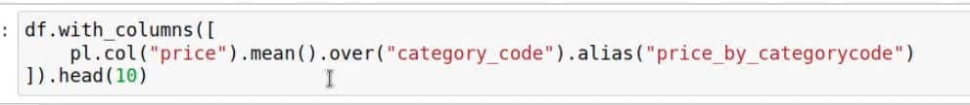

Filter columns based on null
# for a specific column
filtered_df = results_cont.filter(pl.col("snippet_PQ_variance").is_null())
# for all columns
results_cont.filter(pl.any_horizontal(pl.all().is_null()))

Whole outputs in jupyter
In polars it is:
pl.Config.set_tbl_rows(-1)
pl.Config.set_tbl_cols(-1)

.pipe()
.pipe() is used to apply custom functions or complex operations to a DataFrame that can't be easily expressed using standard DataFrame methods. It allows you to include user-defined functions in method chains, making your code more readable and maintainable.
In your renaming example, .pipe() is used because the renaming operation involves a lambda function that creates a dictionary comprehension. This complex operation is easier to express and read when wrapped in a .pipe() call.
.pipe(lambda df: df.rename({col:col.replace('actual_','') for col in df.select('^actual_.*$').columns}))

.Struct()
Instead running for loop per each row for cases where there is a list inside a row and extracting values, we can use pl.struct which vectorizes this operation -> speed is the same as doing math with two separate columns.
# Struct creates temporary struct rows. Vectors are bundled together like:
# Row 1: {'user_vec': [1,2,3], 'ai_vec': [1,2,3]}
# Row 2: {'user_vec': [4,5,6], 'ai_vec': [7,8,9]}
# It combines vector columns into row-wise structures for efficient processing
# Used when custom functions need access to multiple columns simultaneously
# More efficient than row-by-row iteration while maintaining vectorized operations
df = (df
.with_columns(
pl.struct(["user_vec", "ai_vec"])
.map_elements(lambda row: _cosine_similarity(row["user_vec"], row["ai_vec"]), return_dtype = pl.Float64)

Plotly
To have interactive plotly charts, add also this code below to the first cell
import plotly.io as pio
pio.renderers.default = 'notebook'

Extensions

Debug Visualizer
You can use debug visualizer to visualize what’s happening with your code while debugging.
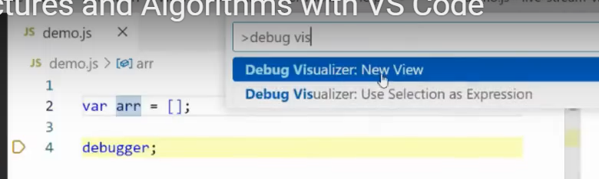Select variable and click shift+F1
If you put variables in dict, you will see what variable name is referred to which object in graph
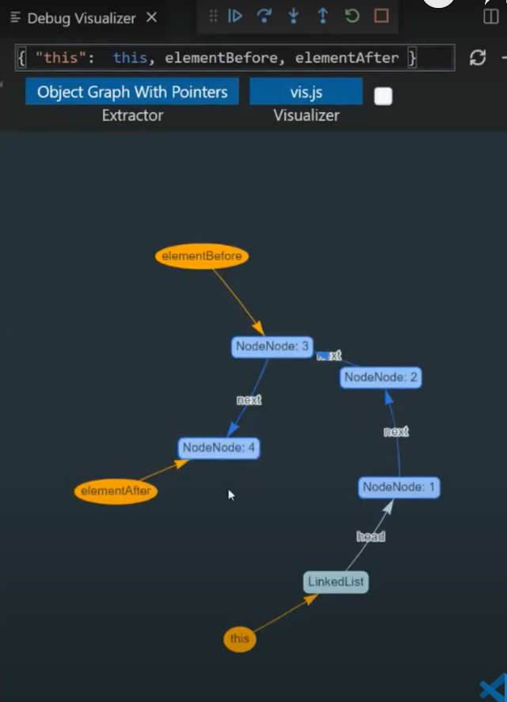
You can destructure strings into arrays, and the second object defines pointers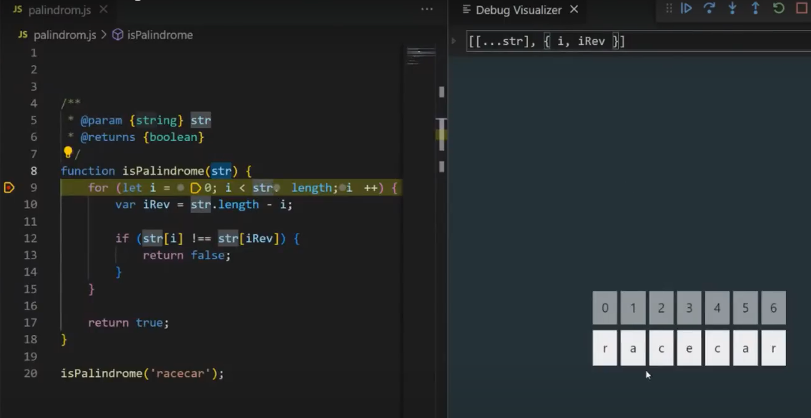

Autodocstrings
Generate autodocstring field for your function.
