|  |  |  |  |
| --- | --- | --- | --- |
|  |  |  | SHAPELESS  **“This is the color run!” ™**  by  **ZigZag** **Games** |



## Produced as freeware by ZigZag, UCI students, 2017. Visit <https://zigzag113.herokuapp.com/> for more information, technical assistance, or to download the latest working release.

## System Requirements

 **Windows 7**

* **Graphics:** DX9 (Shader model 3.0) or DX11 with feature level 9.3
* **CPU:** SSE2 instruction set support
* **Memory:** < 300Mb
* **Storage:** TBD

 **Windows 10**

* **Graphics:** Integrated graphics or better
* **CPU:** Intel i3-2100 or better; AMD FX-4350 or better
* **Memory:** < 300Mb
* **Storage:** TBD

 

|  |  |  |  |
| --- | --- | --- | --- |
| Table of Contents  Intro 1  Player Controls 1  Lore 2  Characters 3  Cube 3  Pyramid 4  Sphere 5  System Requirements back |  |  | **Offensive Ability: Titanize**  **The Sphere isn’t one of the big leaders for no reason. It can transform into a giant, in both size and weight, to crush foes and obstacles alike.**  **Trait: Wall Jump**  **Sphere is a well-rounded fighter, giving it more athletic prowess than its fellow Shapes. It can bounce off walls to reach greater heights.**  **Trait: Wall Friction**  **Sometimes it is important to take things slow and advance strategically. Sphere can slowly slide down walls to optimally time its next move.** |

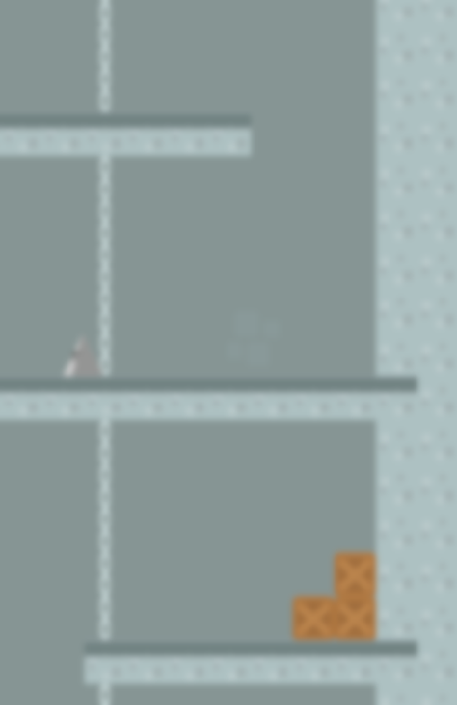

**Sphere**

**5**

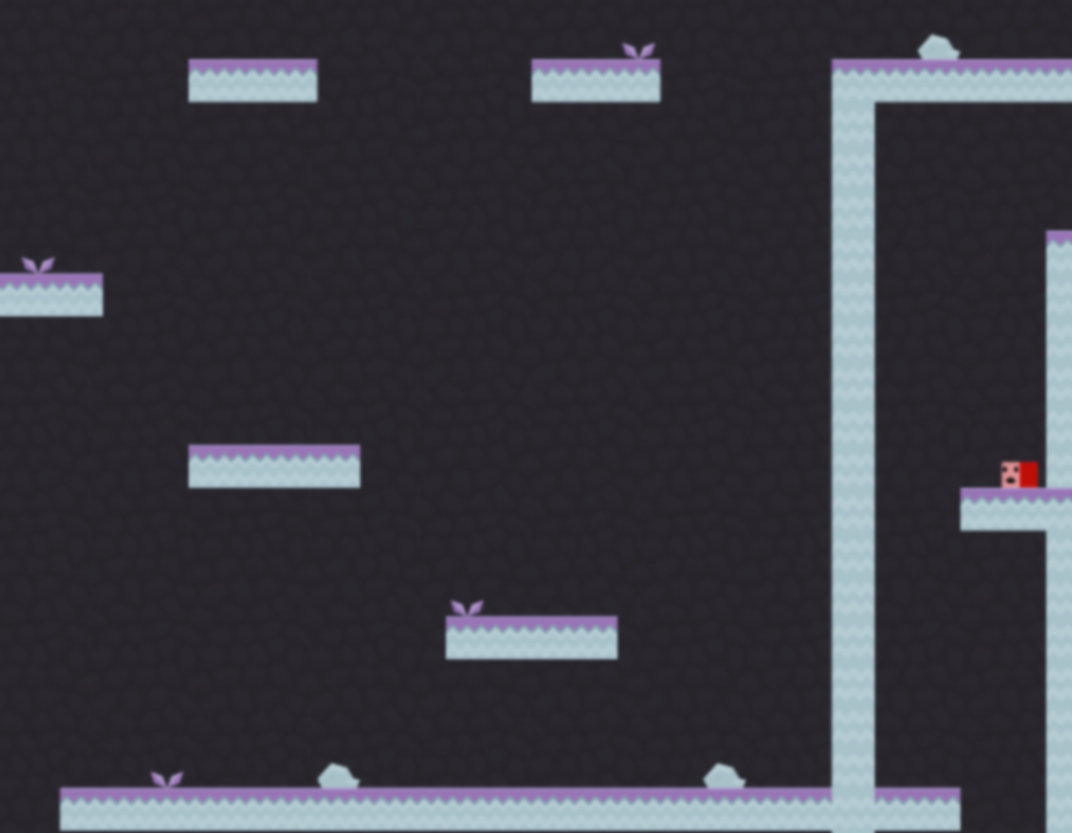

**Lore**

**The world was once a peaceful place filled with unique Shapes and vibrant Colors that made up the lush forests, soaring mountains, vast plains, and ever-changing seasons. The ones who upheld this peace were Cube, Pyramid, and Sphere. These three leaders ensured the world maintained its prosperity and happiness by driving away those who feed on it, the Slimes.**

**The Slimes are Shapeless and Colorless creatures who seek to consume the environment that defies their existence. The three Shapes worked tirelessly to purge their sworn enemies, and one day, the Slimes were driven to the very edge of the world bringing them close to extinction. However, one Slime in its desperation, jealousy, and spite against the Shapes launched a surprise attack against the leaders. The attack consumed Pyramid and Sphere, while stripping away Cube’s power. This dealt a fatal blow to the world, allowing the Slimes to absorb all Color from the world, leaving only a few Colorless Shapes to fend for themselves. Now the Slimes seek complete annihilation by ridding the world of Shapes and Color as was happening to them; this became known as the Shapeless Era.**

**Among the survivors was the leader, Cube, but having lost its Color it could no longer defend itself. After spending years running from the all-consuming Slimes, Cube has taken refuge in the mountains only to plan its next escape if the Slimes were to discover it. But on one fateful night, as Cube slept in a cave, it dreamt that it was approached by a Colored figure that also resembled a cube, but somehow seemed deformed in shape.**

**The figure told Cube, “This is not the way it should be. Take back your color, and bring things to their rightful place… Restore balance to the world.”**

**3**

**2**

**Cube**

** The Cube is one of the few remaining Shapes in existence. One day it regained its Color and now it is attempting to restore balance to the world of Shapes and Color by finding its lost allies to support the cause.**

**Offensive Ability: Stomp**

**Cube quickly leaps upward and then slams the ground with devastating force. Any foe caught under this attack is crushed to bits.**

**Support Ability: Glide**

**While in the air, Cube can harness the power of Shapes to morph into a paper-thin sheet, allowing cube to flow seamlessly through various obstacles and enemies.**

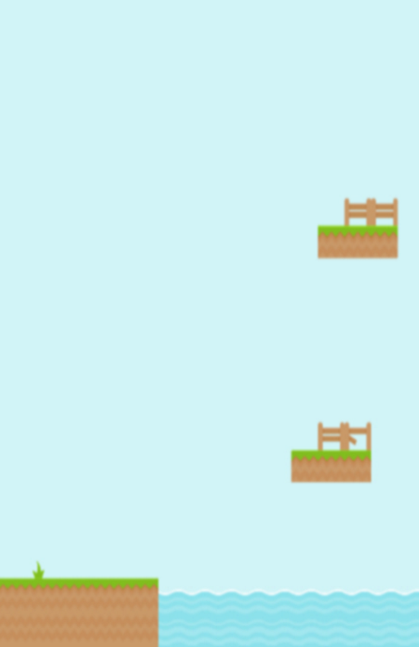

**Intro**

**Shapeless is a 2D platformer where the player will explore and face various obstacles to save the world of Shapes and Color. Unlike traditional 2D platformer games, Shapeless introduces dynamic character switching to traverse levels. The Cube, Pyramid, and Sphere each have their own unique traits and abilities, and it is up to the player to decide which shape will best overcome each approaching obstacle.**

**Pyramid and Sphere**

**Pyramid and Sphere were leaders alongside Cube before the Shapeless era; these beings were pillars that maintained prosperity in the world of Shapes. They were consumed by Slimes and are thought to be lost forever, along with the peaceful world they upheld.**

**1**

**4**

**Pyramid**



**Offensive Ability: Rocket Drill**

**The Pyramid is stern and has a point to make. It can spin at an incredible rate and launch skyward to pierce any airborne enemy in its path.**

**Support Ability: Illuminate**

**Once a leader to all Shapes, Pyramid can light the way for its allies.**

**Trait: Double Jump**

**The Pyramid stands above its foes and is able to jump a second time while midair.**

# **Player Controls**

|  |  |
| --- | --- |
| **Key Binding** | **Action** |
| Left arrow ← | Move left |
| Right arrow → | Move right |
| Space bar ⌴ | Jump |
| Z | Ability 1 (offense) |
| X (hold) | Ability 2 (support) |
| Shift | Switch Character |