Картинки по запросу github blue iconКартинки по запросу skype blue icon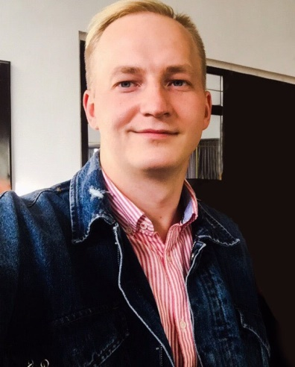

https://github.com/ArturKudlo8

ArturKudla8



Arturkudla15@gmail.com



+375293322228

**Artur Kudla**

Junior Frontend Developer



**Education**

**LEARNING**  
1 Year

* BIP - Institute of Law (2014-2018)
* The Rolling Scope School (09/2018 - currently)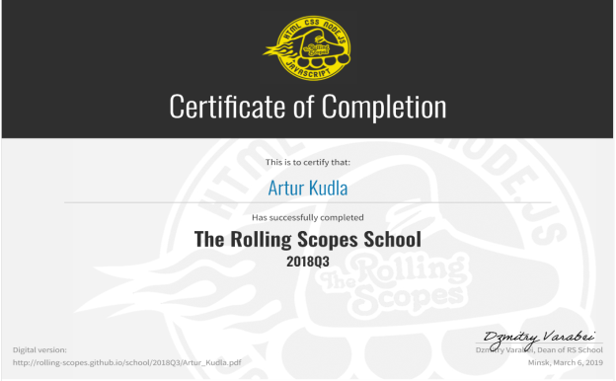
* Programming course “Modern frontend” in the company “TeachMeSkills” (10/2018 – 03/2019)



**Professional Qualifications and Affiliations**

* HTML, CSS, Sass;
* JS;
* React;
* Jquery, Bootstrap;
* Git



**Career Proactivity**

* TOP 50 The Rolling Scope School
* Teamwork experience
* Permanent self-education



**Languages**

* English A2+ (speaking and writing skills)
* English course (2017 - currently)

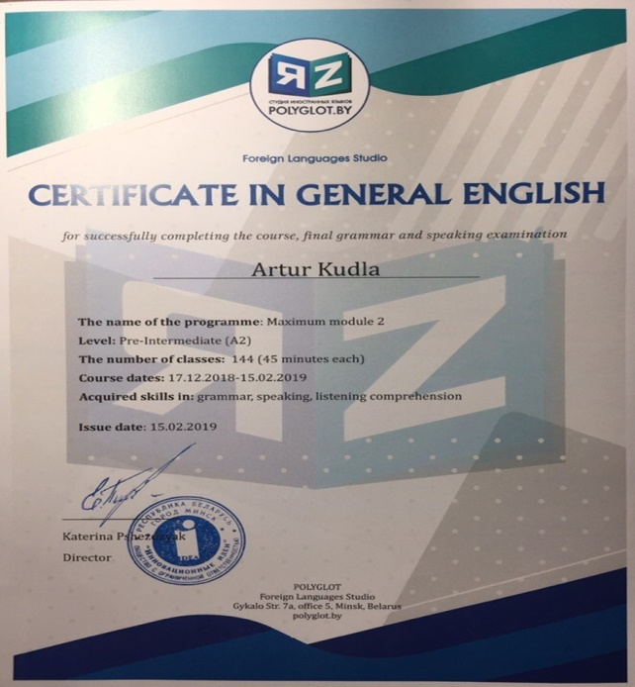

|  |  |
| --- | --- |
|  | |
|  | |
|  |  | |



**Personal Details**

Birthday: August 15, 1993 Marital Status: Single  
Gender: Male Nationality: Belorussian