Картинки по запросу github blue iconКартинки по запросу skype blue icon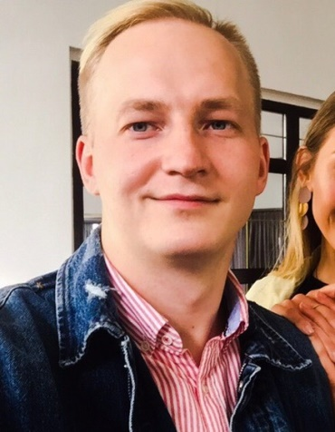

https://github.com/ArturKudlo8

ArturKudla8



Artukapes@gmail.com



+375293322228

**Artur Kudla**

Junior Frontend Developer



**Education**

**LEARNING**  
1 Year

* Higher State College of Communications 2012-2015
* The Rolling Scope School 2018/Q3 (from September 2018 to today)
* Programming course “Modern frontend” in the company “TeachMeSkills”



**Professional Qualifications and Affiliations**

* HTML, CSS, Sass,
* JS core,
* Jquery, Bootstrap
* Git



**Career Proactivity**

* TOP 50 The Rolling Scope School
* Teamwork experience
* Permanent self-education



**Languages**

* English A2+ (speaking and writing skills)



**Personal Interests**

|  |  |
| --- | --- |
| * Self-education |  |
| * Swimming |  |
|  |  |



**Personal Details**

Birthday: August 15, 1993 Marital Status: Single  
Gender: Male Nationality: Belorussian