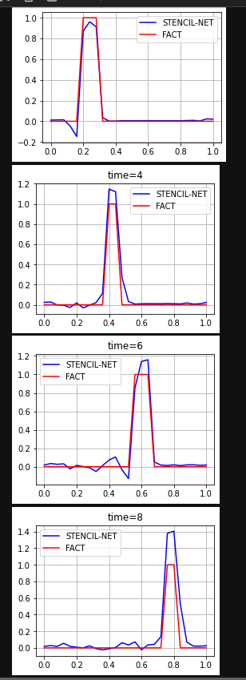MLPConv (RK3 vs E1)

|  |  |
| --- | --- |
| **Поле** | **Значение** |
| Fs | 7 |
| Neurons | 64 |
| Activation_func | ELU |
| Epoch | 1000 |
| Lr | 0.01 |
| Tau | 0.009 |
| H | 0.01 |
| N | 101 |
| Decay_const | 0.9 |
| m | 2 |
| T_factor | 10 |
| S_factor | 4 |
| Has_backward | TRUE |
| Train_size | 0.7 |

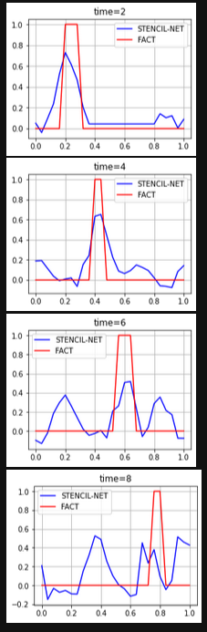

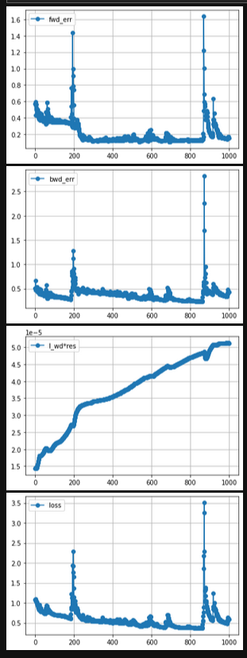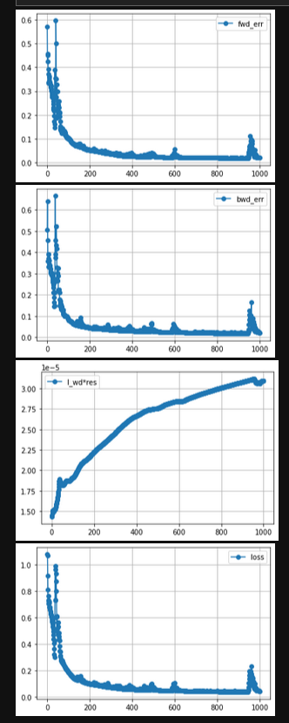

|  |  |
| --- | --- |
| **Поле** | **Значение** |
| Fs | 7 |
| Neurons | 64 |
| Activation_func | ELU |
| Epoch | 1000 |
| Lr | 0.01 |
| Tau | 0.009 |
| H | 0.01 |
| N | 101 |
| Decay_const | 0.9 |
| m | 2 |
| T_factor | 10 |
| S_factor | 4 |
| Has_backward | FALSE |
| Train_size | 0.7 |

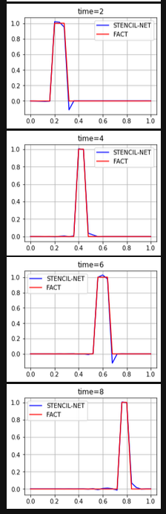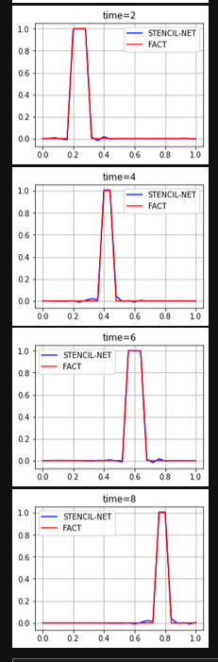

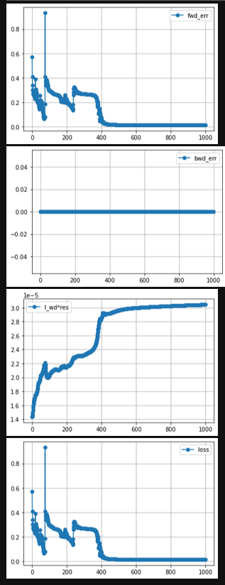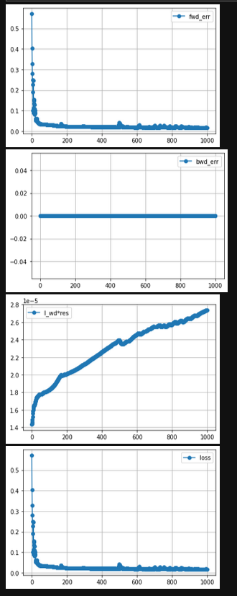

|  |  |
| --- | --- |
| **Поле** | **Значение** |
| Fs | 7 |
| Neurons | 64 |
| Activation_func | ELU |
| Epoch | 4000 |
| Lr | 0.01 |
| Tau | 0.009 |
| H | 0.01 |
| N | 101 |
| Decay_const | 0.9 |
| m | 2 |
| T_factor | 10 |
| S_factor | 4 |
| Has_backward | TRUE |
| Train_size | 0.7 |

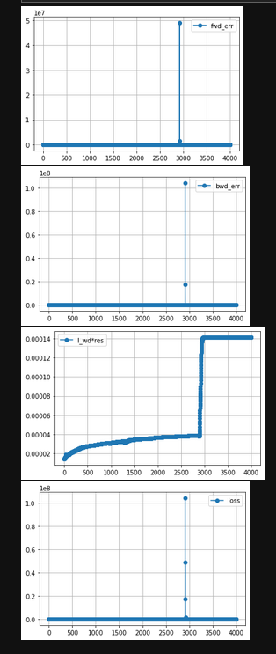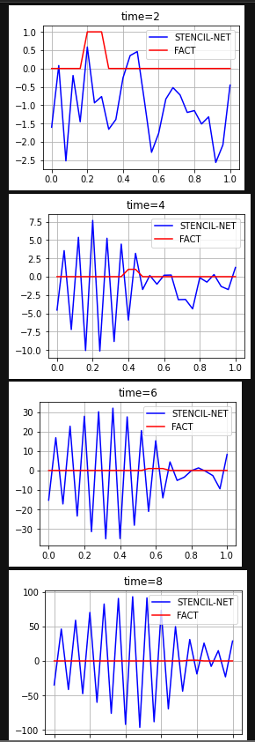

|  |  |
| --- | --- |
| **Поле** | **Значение** |
| Fs | 7 |
| Neurons | 64 |
| Activation_func | ELU |
| Epoch | 1000 |
| Lr | 0.001 |
| Tau | 0.009 |
| H | 0.01 |
| N | 101 |
| Decay_const | 0.9 |
| m | 2 |
| T_factor | 10 |
| S_factor | 4 |
| Has_backward | TRUE |
| Train_size | 0.7 |

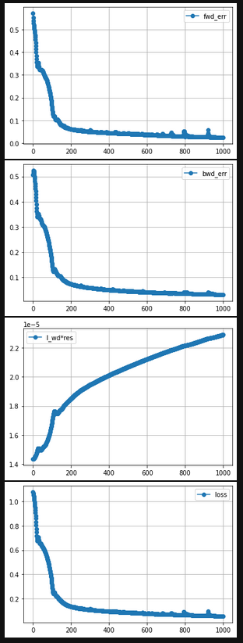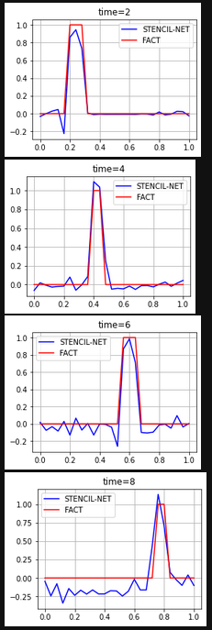

|  |  |
| --- | --- |
| **Поле** | **Значение** |
| Fs | 7 |
| Neurons | 64 |
| Activation_func | Sigmoid |
| Epoch | 2000 |
| Lr | 0.01 |
| Tau | 0.009 |
| H | 0.01 |
| N | 101 |
| Decay_const | 0.9 |
| m | 2 |
| T_factor | 10 |
| S_factor | 4 |
| Has_backward | False |
| Train_size | 0.7 |

