Go to CSVGenerator directory and run groovy script:

$ groovy CSVGenerator.groovy

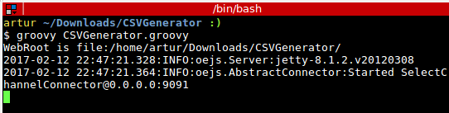

Open in browser following url:

<http://localhost:9091/test.html>

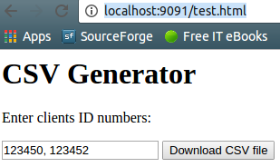

Click ‘Download CSV file’ button

And open csv file - it should be default located in Download directory:

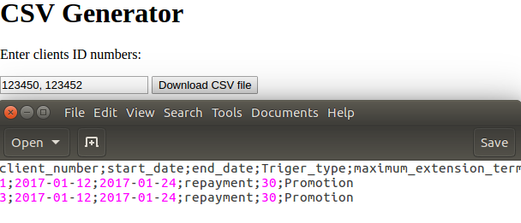

Database is located in application directory - it is sqlite file named test.db

In DBOperations.sql you can find queries that were used to create and populate table CLIENTS.

CSVGenerator uses classes loacted in ‘util’ directory.