**Webhooks**

* Log into Bitbucket or Github
* Select your repository
* On the left pane menu select Settings
* From the settings menu select ‘Webhooks’

and click on ‘Add Webhooks’

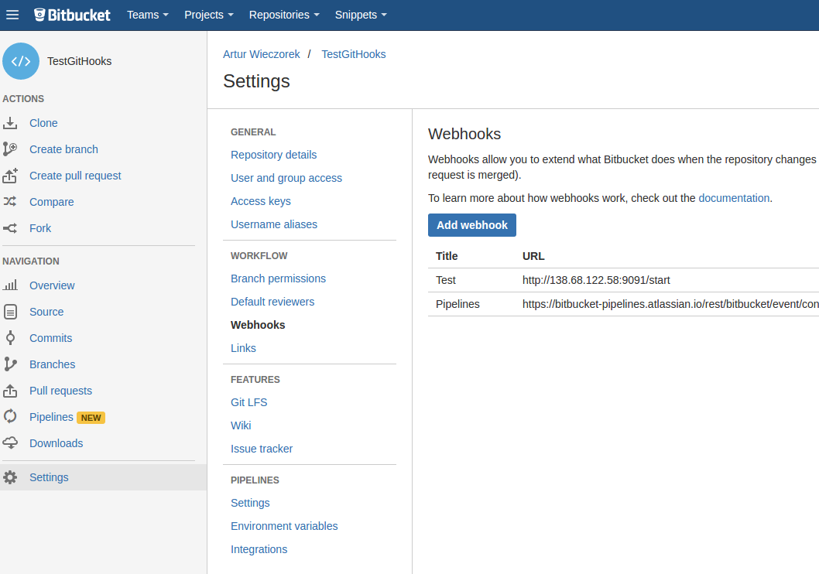

1. Add new Webhook:

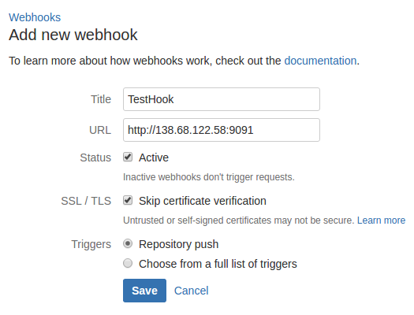

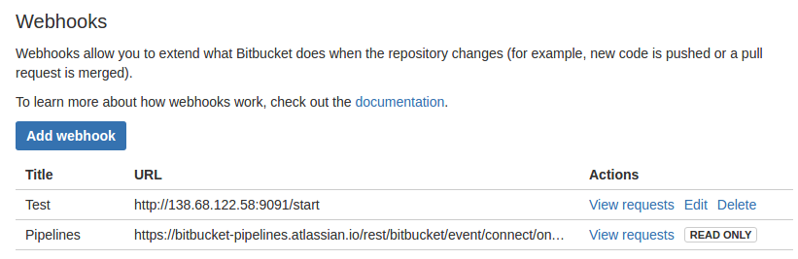

2. Write simple server to handle WebHook events sent from Atlassian when code was pushed to your remote repository:

* Netcat & BASH minimalistic server

$ while true; do { echo -e 'HTTP/1.0 200 OK\r\n'; sh test; } | nc -l 8080; done

Where test is the file with bash script:

$ vim test

#!/bin/bash

echo "*** Git WebHook Event Received ***\n"

* Groovy Script

import javax.servlet.*  
import javax.servlet.http.*  
import org.eclipse.jetty.server.*  
import org.eclipse.jetty.servlet.*  
import org.eclipse.jetty.util.resource.*  
  
  
@Grapes([  
 @Grab('org.eclipse.jetty.aggregate:jetty-server:8.1.2.v20120308'),  
 @Grab('org.eclipse.jetty.aggregate:jetty-servlet:8.1.2.v20120308'),  
 @Grab(group='javax.servlet', module='javax.servlet-api', version='3.0.1')  
])  
class Main extends HttpServlet {  
  
 protected void doGet(HttpServletRequest request, HttpServletResponse response) throws ServletException, IOException {  
 println "GitHub Event Received"  
 }  
   
 protected void doPost(HttpServletRequest request, HttpServletResponse response) throws ServletException, IOException {  
 doGet(request, response)  
 }  
  
 public static startServer() {  
 def jetty = new Server(9091)  
 def context = new ServletContextHandler(jetty, '/', ServletContextHandler.SESSIONS)  
 context.addServlet(this, '/start')   
   
 jetty.setHandler(context);  
 jetty.start()  
 jetty.join()  
 }  
}  
Main.startServer()

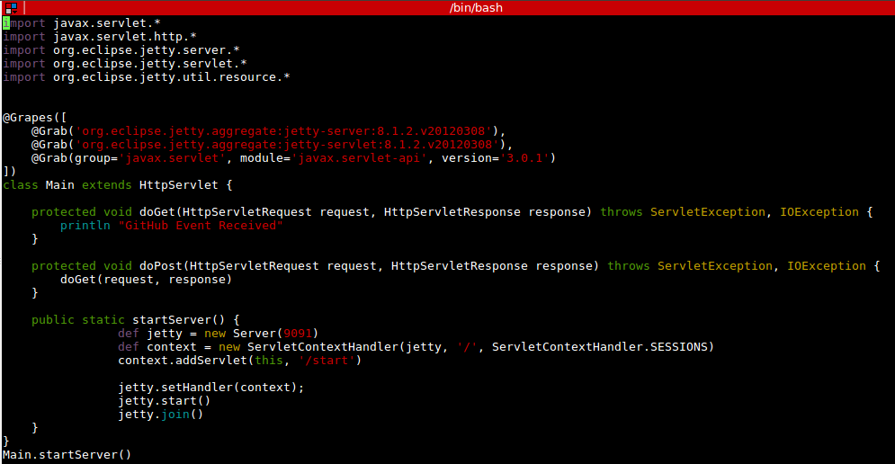

3. Demonstration of push to remote repository and console showing that event is being received and message is displayed on screen (Groovy script was used in this case)

