First start jmx example from Oracle then…

Go to application folder JMXWebHandler

Make the file JMXWebHandler.groovy executable

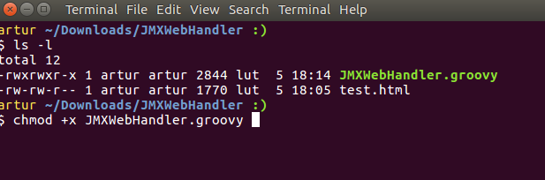

Open console and run:

groovy JMXWebHandler.groovy

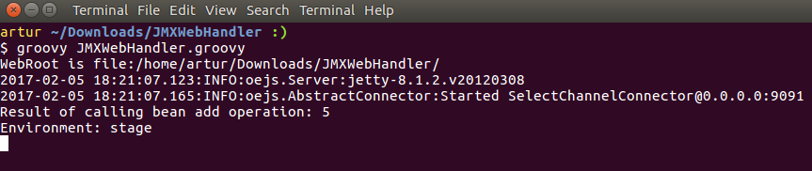

Open in browser:

localhost:9091/test.html

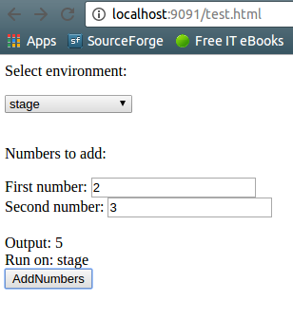

Send some requests and observe console output