Case Study Exam

Problem Statement
A company designs small electronic circuits. Each circuit contains several pins that must be connected using wires. The goal is to connect all pins while minimizing the total amount of wire used.
The circuit contains the following pins:
A, B, C, D, E, F
The possible wires between pins and their lengths are:
Wire | Lenght
A-B | 4
A-C | 2
A-D | 7
B-C | 1
B-E | 5
C-D | 3
C-E | 8
D-E | 2
D-F | 6
E-F | 4

The company wants to obtain a circuit that connects all pins with the minimum total wire length.

Question 1
Identify well-known algorithms that solve this optimization problem. Briefly describe each one and justify its suitability for meeting the company’s requirements.

Possible Student Response
This problem can be solved using different graph algorithms. One possible algorithm is DFS, because DFS visits all the nodes of a graph. Since the company wants all pins to be connected, DFS is useful because it checks whether all pins can be reached.
Another possible algorithm is BFS, which also visits all the nodes. BFS may be better than DFS because it explores the closest nodes first, so it can probably find a short connection between pins.
Prim’s algorithm can also be used. It starts from one node and keeps adding nearby nodes until the graph is connected. Kruskal’s algorithm is another option because it orders the edges by their weight and adds them to the solution.
I think both Prim and Kruskal have complexity O(n), because each node is visited once. Therefore, they are suitable for the company because they are fast and can connect all the pins.
Cycles should be avoided because they would add unnecessary wires, although BFS and DFS can also avoid cycles if we mark visited nodes.

Question 2
Implement an algorithm that, given the optimized circuit obtained in the previous section, identifies the two pins whose distance, defined as the length of the shortest path between them, is maximum. The algorithm must return that distance and the intermediate pins forming the shortest path between the corresponding pair of pins. The code must include comments explaining how it works. Show an example of how to call the algorithm from a main program, specifying the initial parameter values.

Possible Student Response
The goal is to find the pair of pins whose shortest-path distance is the largest. Therefore, we must compute the shortest path between every pair of pins and then select the maximum among those distances.
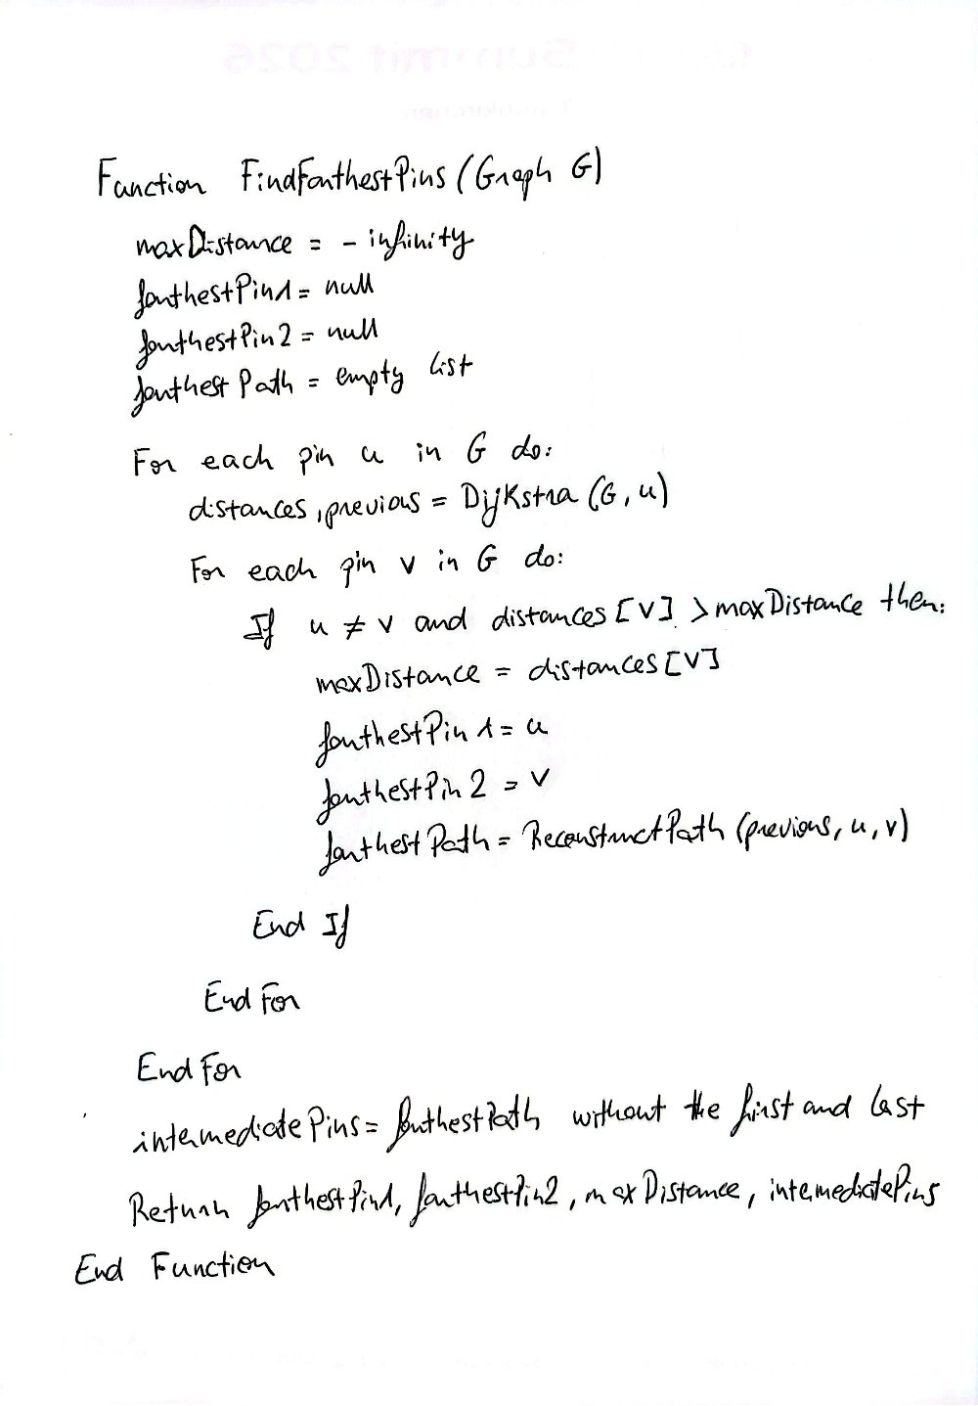

The algorithm works by doing this:
- Pick one pin as the starting pin.
- Calculate the shortest distance from that pin to every other pin.
- Repeat that for every pin.
- Keep the pair with the largest shortest-path distance.
- Reconstruct the path between those two pins.

