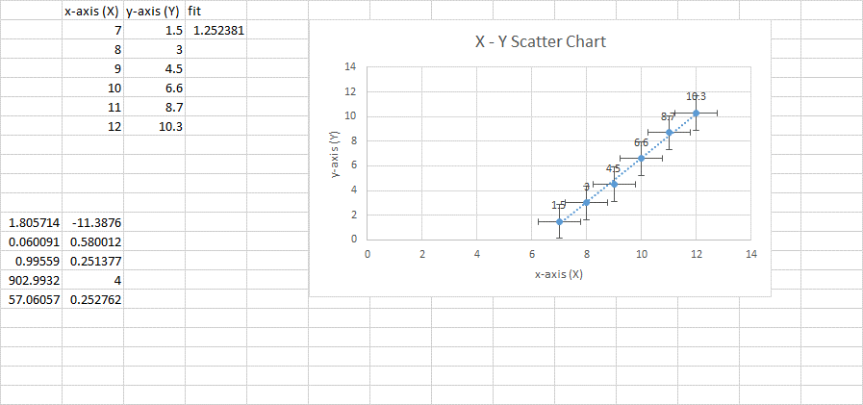Randy McMillan – rmcmillan1@mail.usf.edu