1. Download and install Open Server
2. Unpack the files from archive to D:\OpenServer\domains or whichever folder openserver is installed in.
3. Run Open Server panel, right click icon in bottom left corner of the screen got to Settings->Domains
4. Add the desirable domain name and the folder/public of this domain as you see on the sample

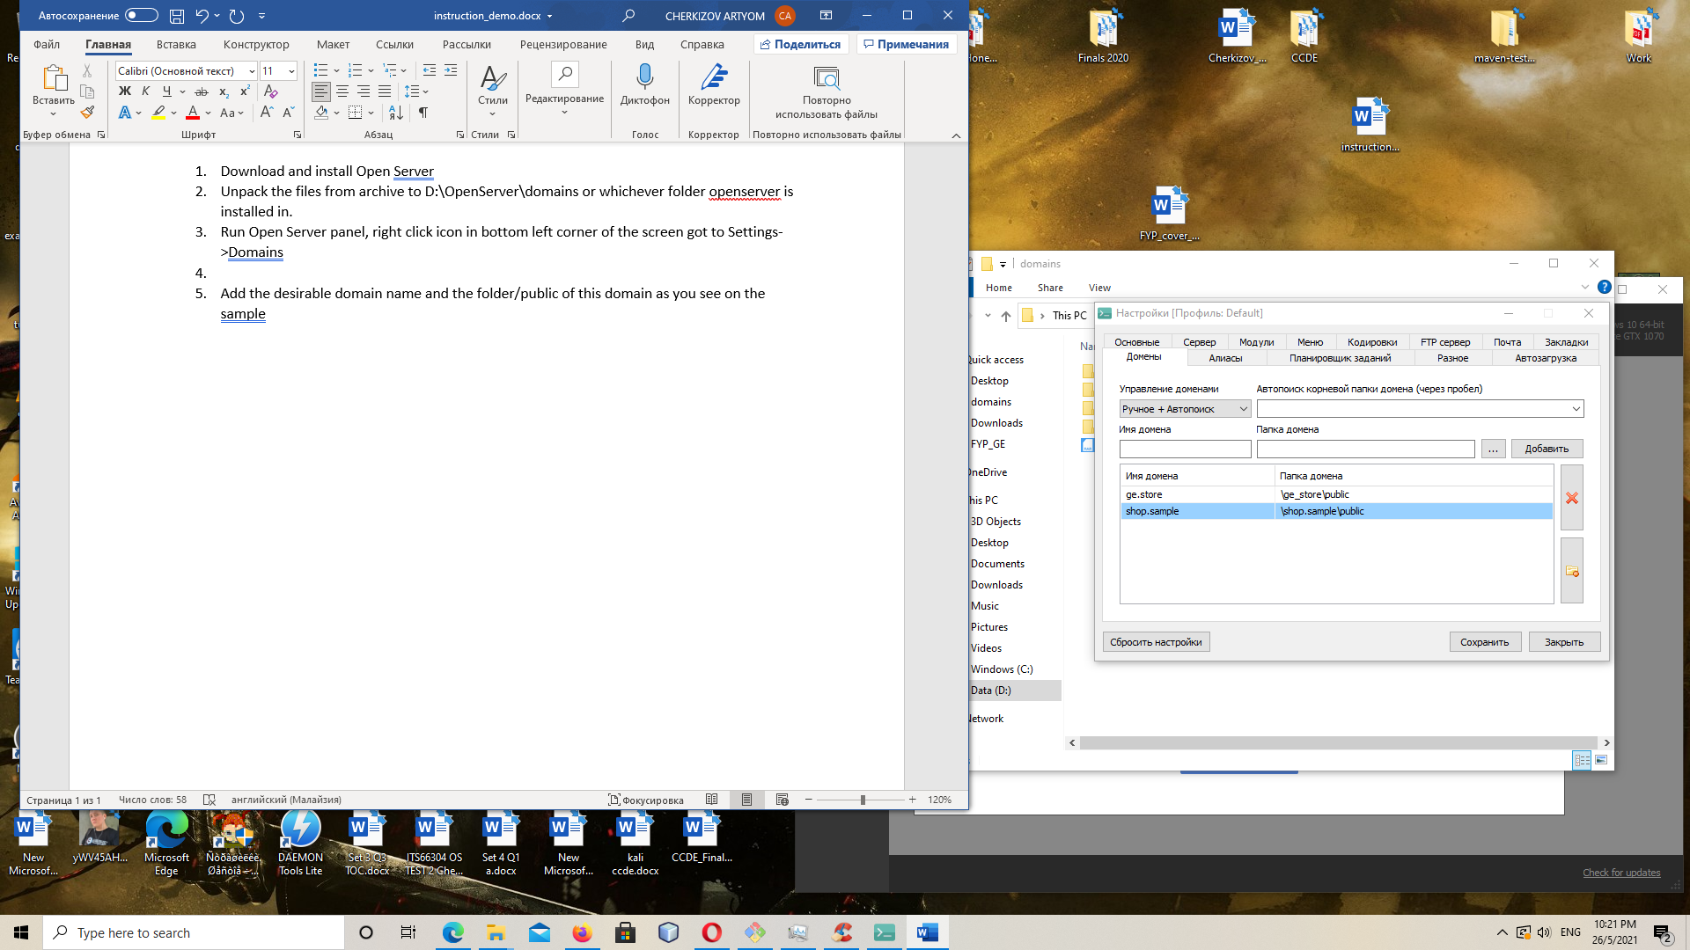

1. Open the Open Server console
2. Cd into the project folder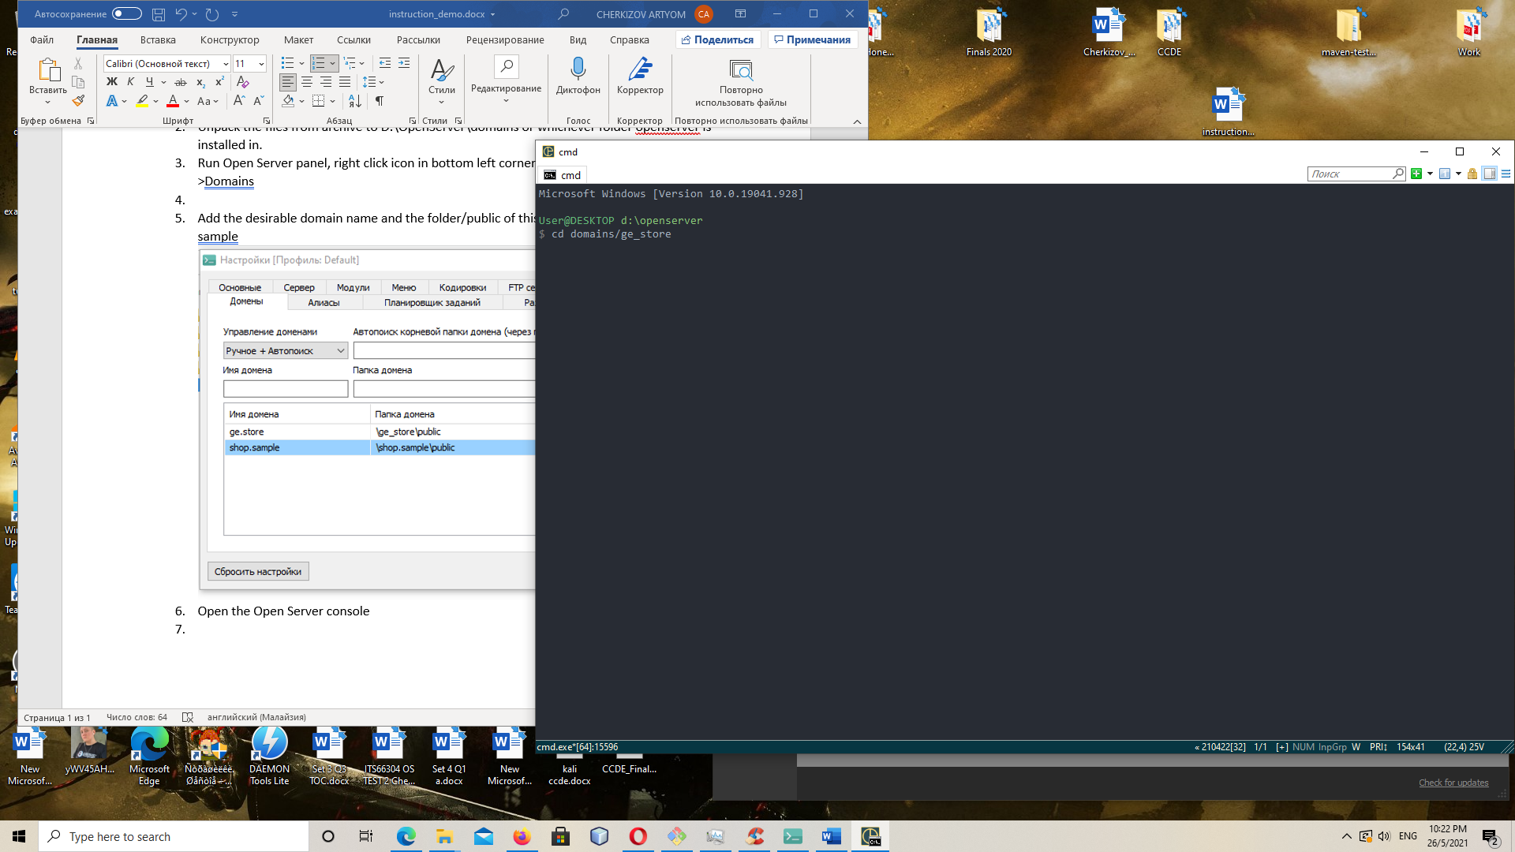
3. Find .env file inside the project folder and adjust the following settings: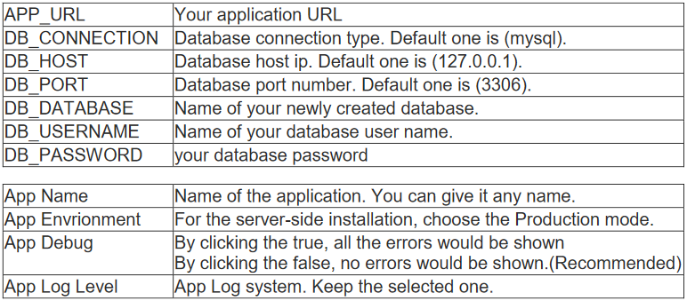
4. Run “composer install” in console.
5. Go to Open Server Panel -> My projects and run your project from there 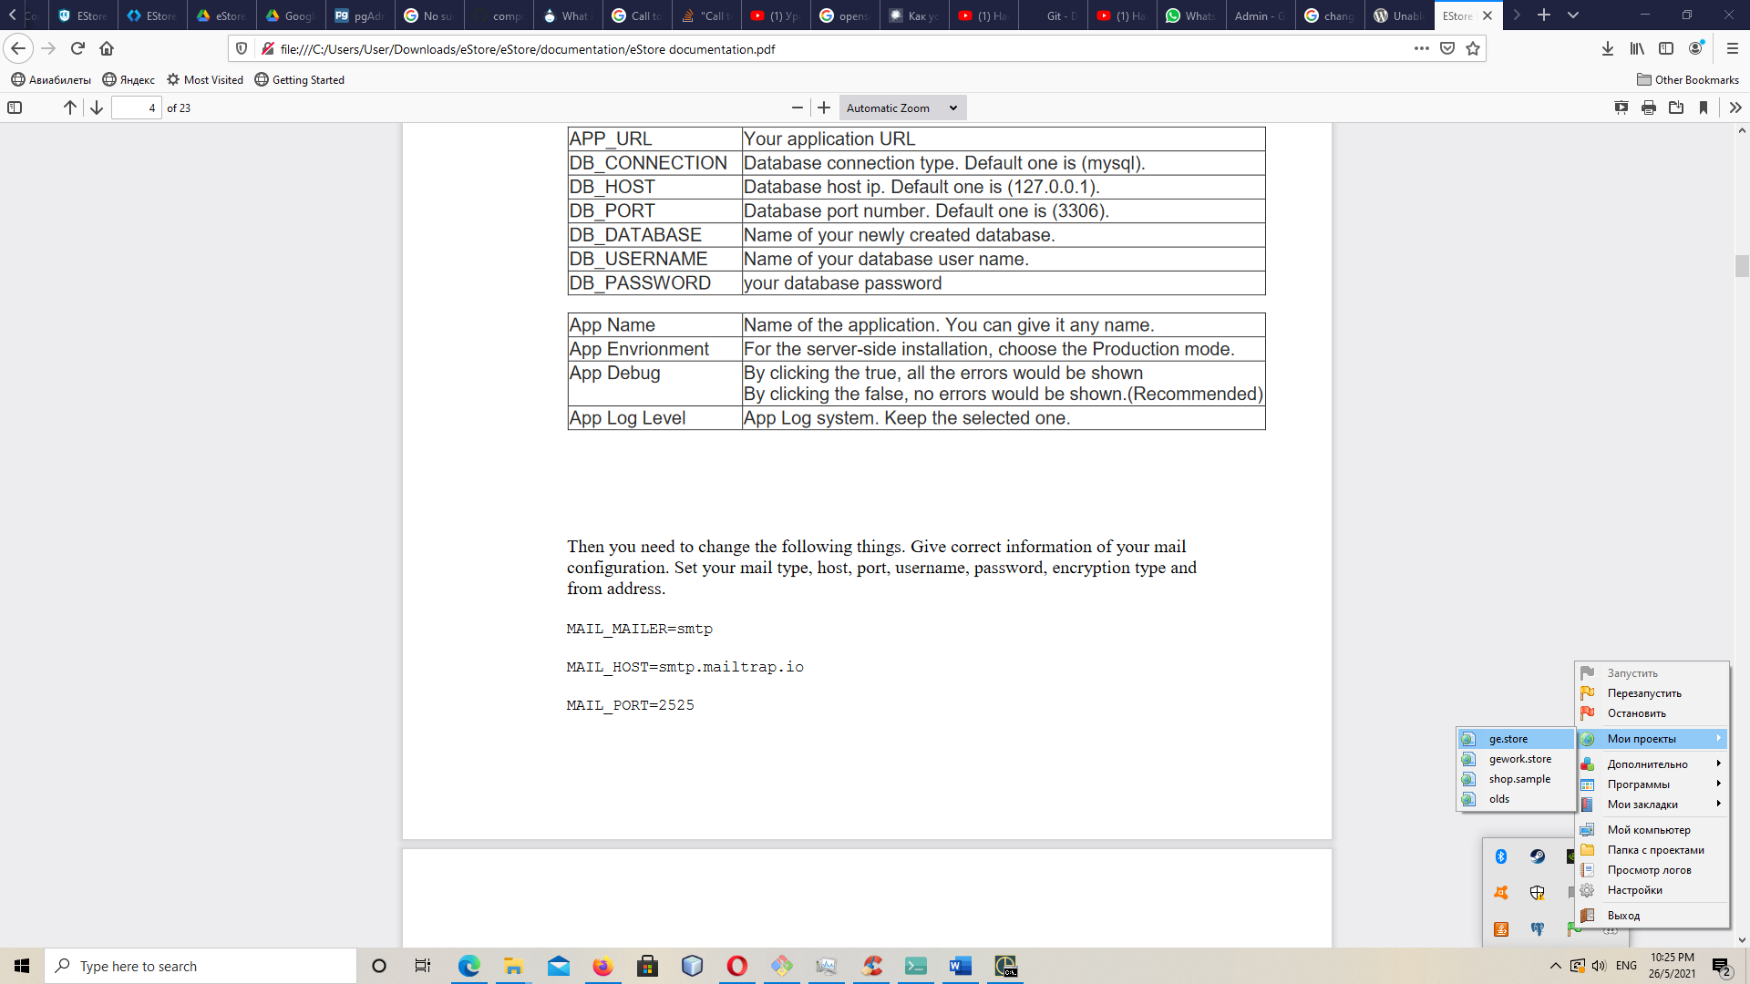
6. Enjoy the store

