

Database processing Course Project
Technical & User Documentation

Student’s name: Artjoms
Student’s surname: Voroncovs
St. code: st83663

RIGA

TABLE OF CONTENTS

1. Introduction 3
1.1 Scenario Description 3
Business Requirements Summary 3
2.1 Key Business Questions 3
2.2 Key KPIs (Summary) 4
Data Model Overview 4
3.1 Tables and Relationships 4
3.2 Design Rationale 5
Technical Design 5
4.1 Report Structure 5
4.2 Key Business Rules (Implementation) 6
4.3 Regional Breakdown 6
4.4 Assumptions and Simplifications 6
How to Run the Project 6
5.1 Execution Order 6
5.2 Parameters 6

1. Introduction

1.1 Scenario Description
This project is about video streaming platform which is fully subscription based, platform name is StreamNova. StreamNova provides high quality digital video streaming with exclusive content worldwide. Content provided to individual users under monthly subscription plans. Users able to acquire different subscription plans with varying prices and features online. There is possibility to upgrade or downgrade plans, cancel or reactivate subscription. System is designed to support detailed business analysis of platform revenue, engagement and user lifecycle behavior, underlying system is Oracle database.

1.0 StreamNova platform logo

1.2 Report Purpose
The Monthly Performance and Engagement Report update management with a aggregated monthly description of:
- Revenue and discounts
- Active subscriber base
- Plan performance
- User engagement
- Unsubscribe activity, retention, and subscriber movement
- Potential data quality issues
The report is generated using Oracle engine directly with help of a PL/SQL programming language and printed via DBMS_OUTPUT facility.

Business Requirements Summary

2.1 Key Business Questions
The report answers the following business core questions.
Revenue and Subscription Base
- How much net revenue was generated during selected month?
- How much discount was applied to subscriptions?
- How many paid subscriptions were billed?
- How many active subscribers exist per plan?
Engagement / Usage
- How much total streaming time occurred in the month?
- What is the average usage per active user?
- Who are the top users by engagement?
- Which device types are most used?
Churn and Customer Movement
- How many users churned, joined, or reactivated in the month?
- What is the churn and retention rate?
Data Quality
- Are there invalid or suspicious payments?
- Are there subscriptions or usage records with inconsistent dates or values?

2.2 Key KPIs (Summary)
KPI: Monthly Net Revenue
Description: Payments minus discounts for the report month
KPI: Total Discounts
Description: Sum of all discounts applied
KPI: ARPU
Description: Net revenue divided by active subscribers
KPI: Active Subscribers
Description: Users with an active subscription during the month
KPI: Churn Rate
Description: Churned subscribers divided by active subscribers at month start
KPI: Retention Rate
Description: One minus churn rate
KPI: Total Usage Time
Description: Sum of streaming minutes
KPI: Average Usage per User
Description: Total usage divided by active users
KPI: Trial Conversions
Description: Trials converted to paid plans
KPI: Data Quality Issues
Description: Count of detected bad data records

Data Model Overview

3.1 Tables and Relationships
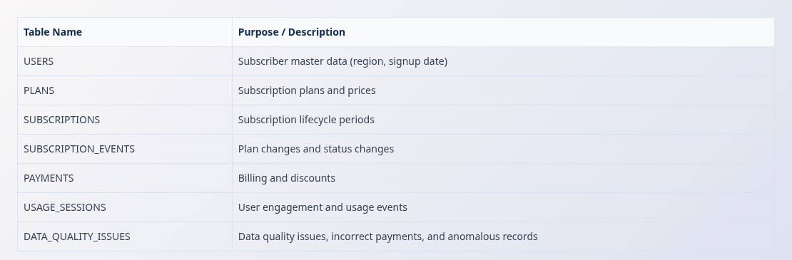
Relationships table:
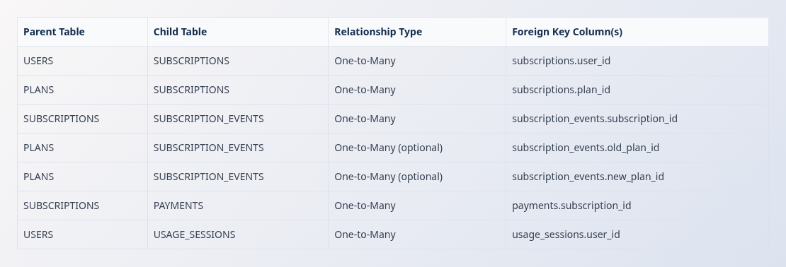

3.2 Design Rationale
The table is intentionally small with seven tables and is denormalized only where helpful for sake of reporting. Each table directly supports one or more KPI metrics. Historical accuracy is preserved by modeling subscription periods and events separately.

Technical Design

4.1 Report Structure
The PL/SQL report is divided into the following sections:
- Header Information
- Revenue and Subscription Summary
- Plan Performance
- Engagement and Usage Metrics
- Churn and Retention
- Data Quality Checks
Each section uses SQL aggregation queries executed inside PL/SQL blocks and prints results using internal DBMS_OUTPUT.PUT_LINE function.

4.2 Key Business Rules (Implementation)
Active Subscriber Definition
A subscriber considered active if the subscription start date is on or before the last day of the report month, the end date is null or after the start of the report month, and the status is ACTIVE.
New Subscribers
Subscriptions which start date fall within the selected report month.
Churned Subscribers
Subscriptions with an end date in the report month and status set to CANCELLED.
Reactivated Subscribers
Users with a cancelled subscription before the month and a new active subscription starting in the report month.
Revenue Inclusion Rule
Payments are included if the payment date falls inside the report month.
Churn Formula
Churn Rate equals churned subscribers divided by active subscribers at the start of the month.
Retention Rate equals one minus the churn rate.

4.3 Assumptions and Simplifications
- A single currency is assumed.
- Taxes are ignored.
- Subscription overlap edge cases are not handled.

How to Run the Project

5.1 Execution Order
- Run the DDL script: project_ddl_vorontsov.sql
- Run the DML script: project_dml_vorontsov.sql
- Run the report script after enabling server output: project_report_vorontsov.sql

5.2 Parameters
- Modify p_report_month to change the analyzed month.
- Modify p_region_filter to filter by region or use ALL.

Limitations and Ideas for Improvement
Current Limitations
- No indexing or performance optimization.
- Small data volumes only.
- No time zone handling.
- Simplified churn logic.
Possible Improvements
- Add indexes and partitions for large datasets.
- Introduce daily snapshots for subscriptions.
- Extend usage analytics with content-level metrics.
- Convert the report into a stored procedure or dashboard feed.

